UAT Support Document

Login
Login to the application using your respective credentials.check if you have the right access.
- Caseworker :- access to cases and dashboard (create, edit and update)
- Supervisor :- access to dashboard and cases (view only)

Check Forms
- Check if all the forms are included in the configuration.
- Check if the forms are in proper order.
- Then go through each form and check if any fields from any form is missing. If any additional fields are to be addedd in any form, note the form name and fields and add it in the UAT feedback.

Entering Data(caseworker)
- Fill up each form in order of case management steps and save the from in each step(Identification/Registration -> assessment -> caseplan -> Services)
- While entering the values check if each field type is proper. Check, in case of drop down field if any options are missing from the selection.
- Save the form after each section is filled up.
- Check the status bar to see if it shows the right status of the case.

BIA approval
- Once the assessment is completed, ask for approval from the supervisor.
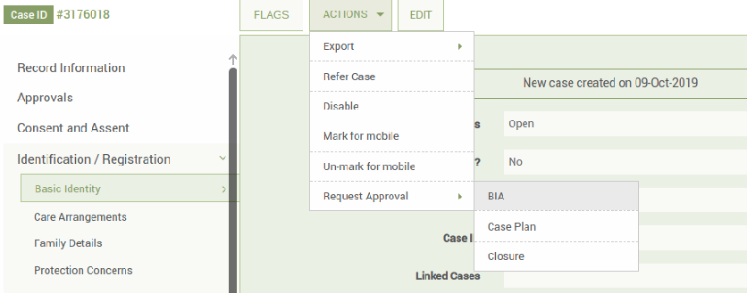
- Supervisor should check if he has got the e-mail notification for the approval. Also check in the dashboard if they have recieved proper notification.
- Then the supervisor can accept/reject the approval. When the supervisor accepts/rejects a approval the caseworker should get a e-mail notifying the same.
- Check the status bar, whether it shows the proper status

Case Plan approval
- The caseworker can then add caseplan.
- Once the caseplan is added, ask for approval from the supervisor.
- Supervisor should check if he has got the e-mail notification for the approval. Also check in the dashboard if they have received proper notification.
- Then the supervisor can accept/reject the approval. When the supervisor accepts/rejects a approval the caseworker should get a e-mail notifying the same.
- Check the status bar, whether it shows the proper status

Adding Services
- Caseworker can now add Services i.e fill the services form.

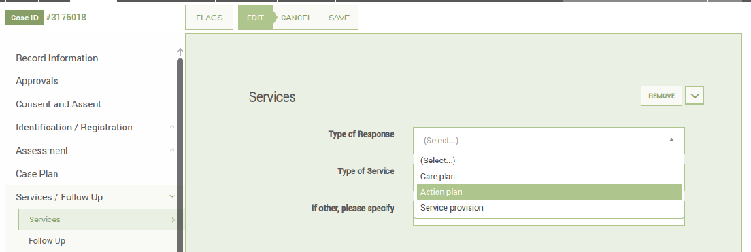
- Once all the services are implemented, the status bar will move to Services implemented.

Referrals
- A case can be referred by a caseworker to another caseworker.

- Fill up the referral form and save. Go to the actions and click on refer tab.For a case to be referred the consent should be obtained from the child/caregiver.
- When a case is referred to another caseworker, the referred caseworker will receive a notification in his email and in his CPIMS+ dashboard.
- The referred caseworker, after completing the task, may complete the referral by submitting the done button.
- Whenever a case is referred the case ownership is shared by both the caseworkers till the time the referral is completed. After completion the ownership is returned back to original caseworker.

Transfers
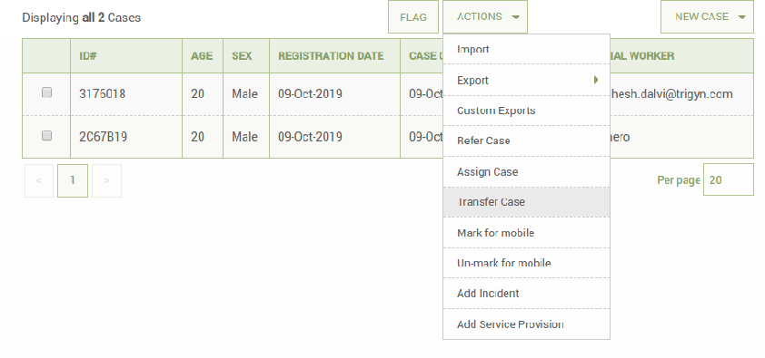
- A supervisor can request a transfer of case from on caseworker to another after internal discussion.
- Supervisor can go to the case and click on transfer from the actions tab and select the caseworker he wants to transfer the case. The manager will have to obtain consent from the child/caregiver for transferring the case.
- Once supervisor initiates a transfer, the new caseworker will receive a email notification about the same and an notification in his dashboard.
- Then the caseworker might accept / reject the case. If he accepts the ownership will change from the old caseworker to the himself.
- If the caseworker rejects the transfer, the ownership returns to the previous caseworker.
- However the ownership is shared till the new caseworker accepts/rejects the case.

Assigning a Case
- A manager can directly assign a case to another caseworker in case of emergency. In this, the new caseworker won’t be asked for permission and the case will be directly assigned to him.
- The new caseworker will get a notification in his email.

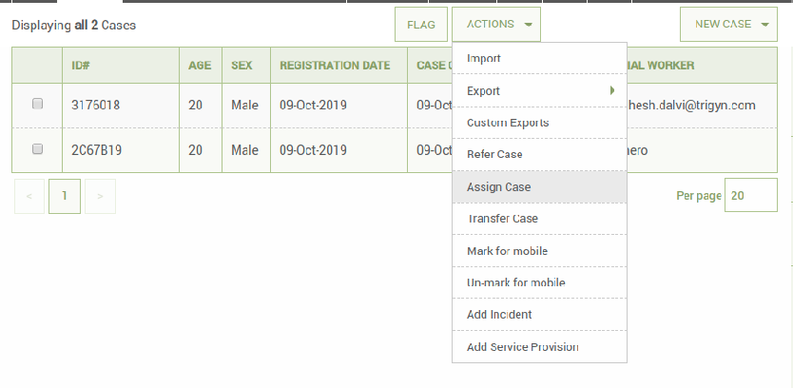

Case Closure
- Once the caseworker finds that the case can be closed, they will have to fill the case closure form and request for aprroval for case closure from the supervisor.

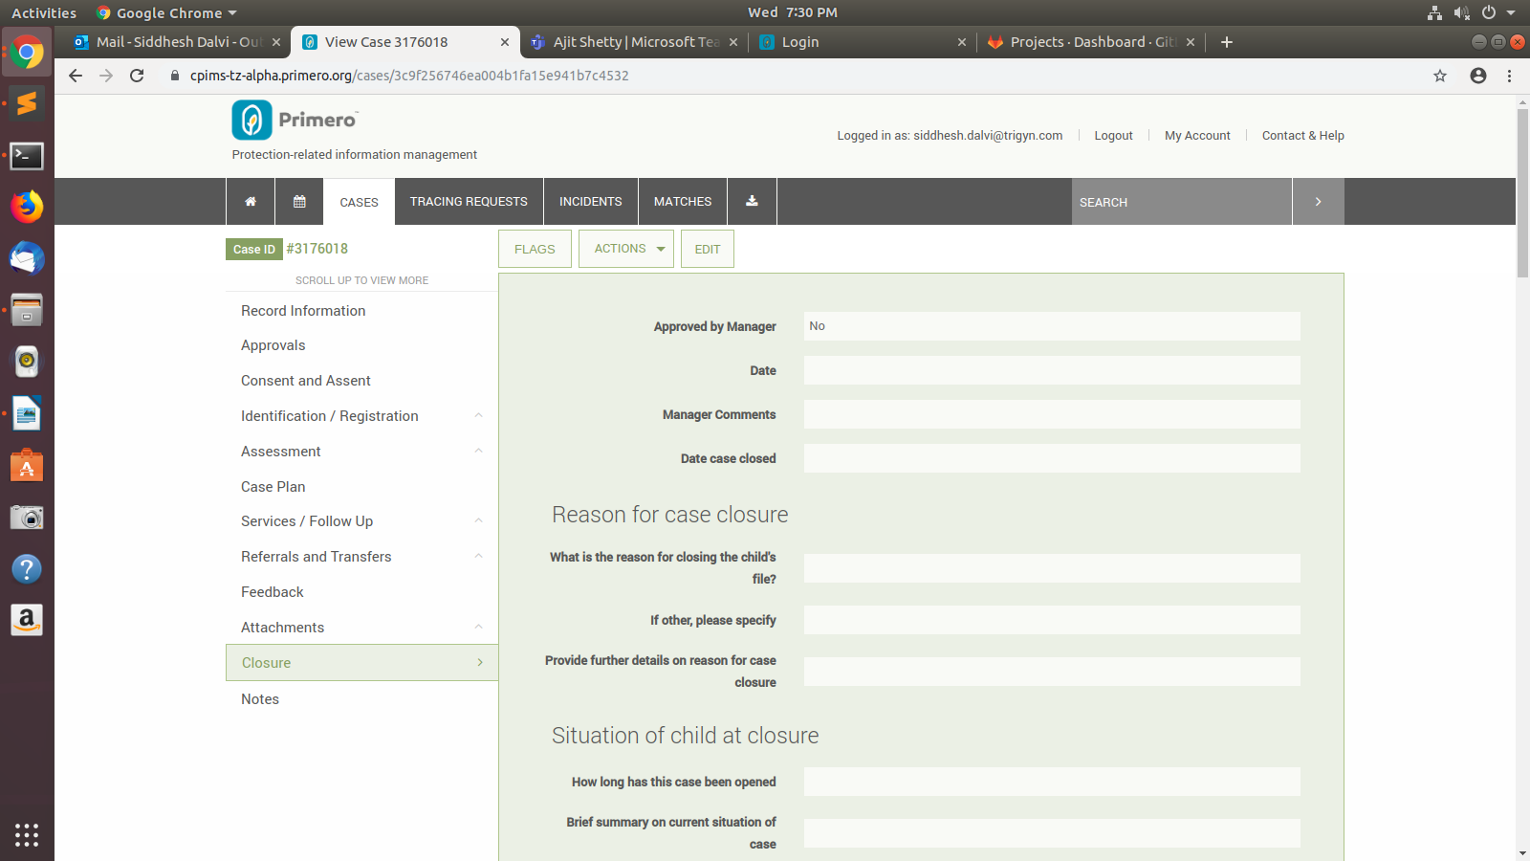
The Supervisor may accept/ reject the approval for case closure.If the supervisor approves the closure, caseworker can edit the case and change the status to closed and save the form.
- The status bar will change to closed and the case will be closed.
- Any further changes cannot be done to the case.

Case Reopen
- To reopen a case, the caseworker need to search the case and visit the case.
- Then they can reopen it from the actions tab.
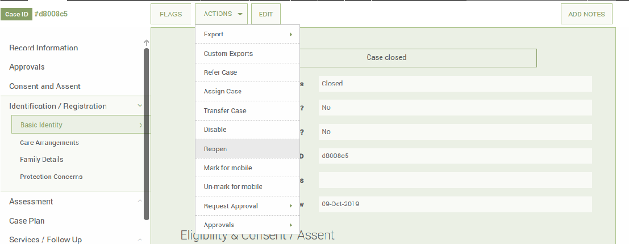

Reports
- Reports can be generated by CPIMS+ administrator only. However oversight and agency administrator can view the reports.

Exports
- A user can export a case or some part of case from the export tab.
- There is provision for exporting each forms.

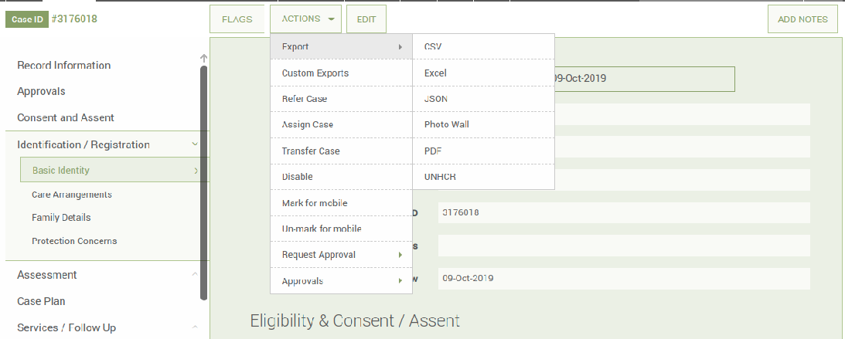
- Permissions A case can be viewed by a caseworker who owns it and by their supervisor
- A supervisor can access all the case in his group.
- An Agency administrator can access all the cases from all groups in his agency.

Other Aspects
- A user can search cases from dashboard.
- The Dashboard differs from each user to user depending on the roles.
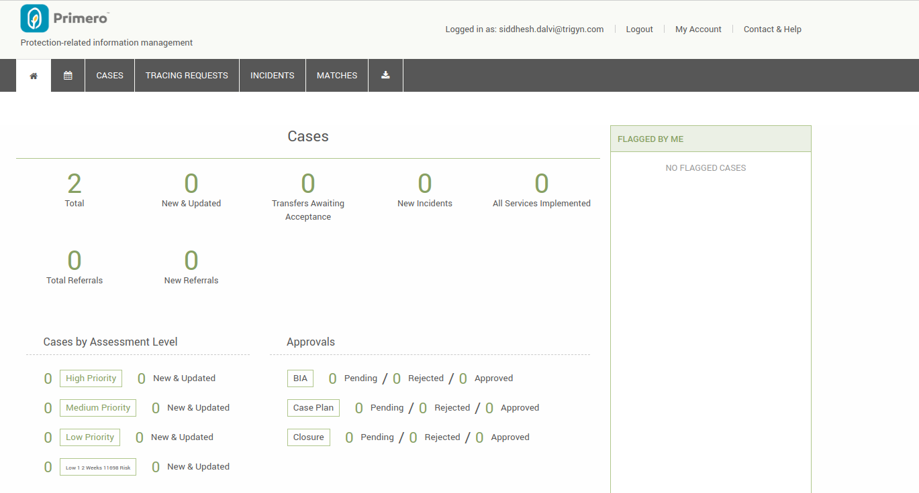

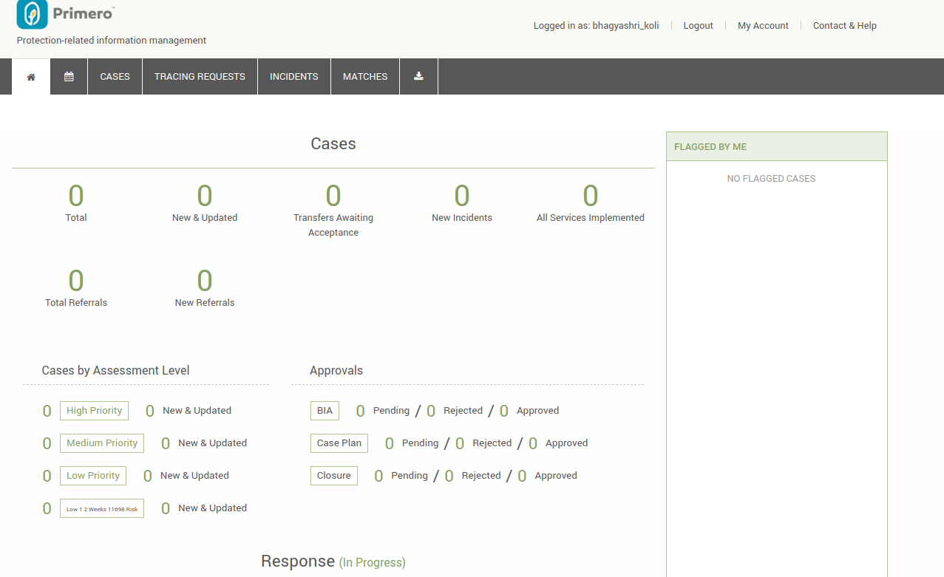
Feedback
- Any feedback about the configuration should be submitted in the feedback document.

