(Title of project)

Submitted in partial fulfillment of the requirements

of the

PYTHON LAB

by

(Name of the Students)

Supervisor:

Prof. Samira Nigrel

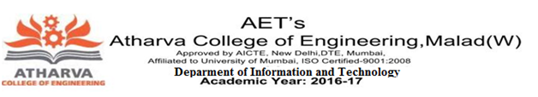

Department of Information Technology

Atharva College of Engineering

Year: 2017-18