# Does your program output any garbage? If yes, why?

Yes, we get garbage value in our program output. Following is the screen shot of the same:

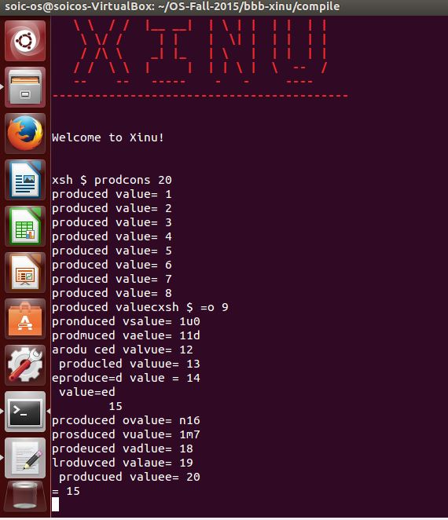

The reason we get garbage value is, because the producer and consumer are not synchronized.

# Are all the produced values getting consumed? Check your program for a small count like 20.

No, only values till 15 get consumed in our tests.

# Tasks

Siddharth:

* Created consumer.c, producer.c, tested on device

Prateek:

* Created xsh_prodcons.c, prodcons.h, tested on device