addendum
2nd OLS model-
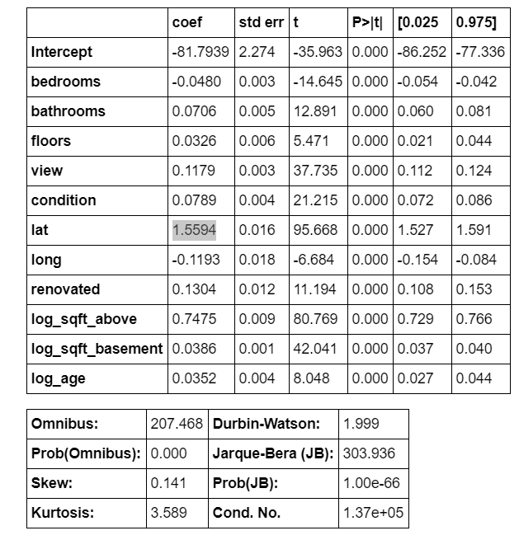
- 3rd highest coefficient: renovated (.1304). Which was a newly-engineered, booleon feature
- 2nd highest coef: log_sqft above (.7475). Make sense as available floor space ought to.
  - “sqft_above = square footage of house apart from basement”, but ofc no one cares about basements
- lat has highest coef (1.5594). Although this may be due to the caret shape of lat vs price
  - more investigation may decrease this coef’s value
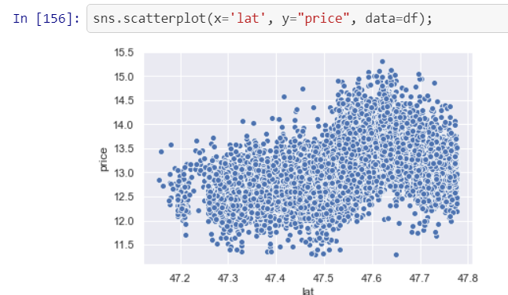
Recommendations-
- Honesty. Be honest about Floor Space when selling a house. Basement size does not impress buyers as much as actual above-ground area
- Upsell your home if it’s near Husky Stadium (free seats?)
