FSD Assignment 1

Exercise 1: Basic HTML5 Structure

Objective: Understand the basic structure of an HTML5 document.

Task:

Create a webpage with the following:

● A title “My First HTML Page”

● A heading (<h1>) with your name

● A paragraph (<p>) describing your hobbies

● A horizontal line and a line break

**Code**

<!DOCTYPE html>

<html lang="en">

<head>

<meta charset="UTF-8">

<meta name="viewport" content="width=device-width, initial-scale=1.0">

<title>My First HTML Page</title>

</head>

<body>

<h1>Darshan</h1>

<p>My hobbies are playing video games, games with my friends and single player games that focuses on story telling. I also watch movies and series in free time. I also keep up with computer hardware and love building conputers</p>

<hr><br>

<p>Line after, line break tag</p>

</body>

</html>

**Output**

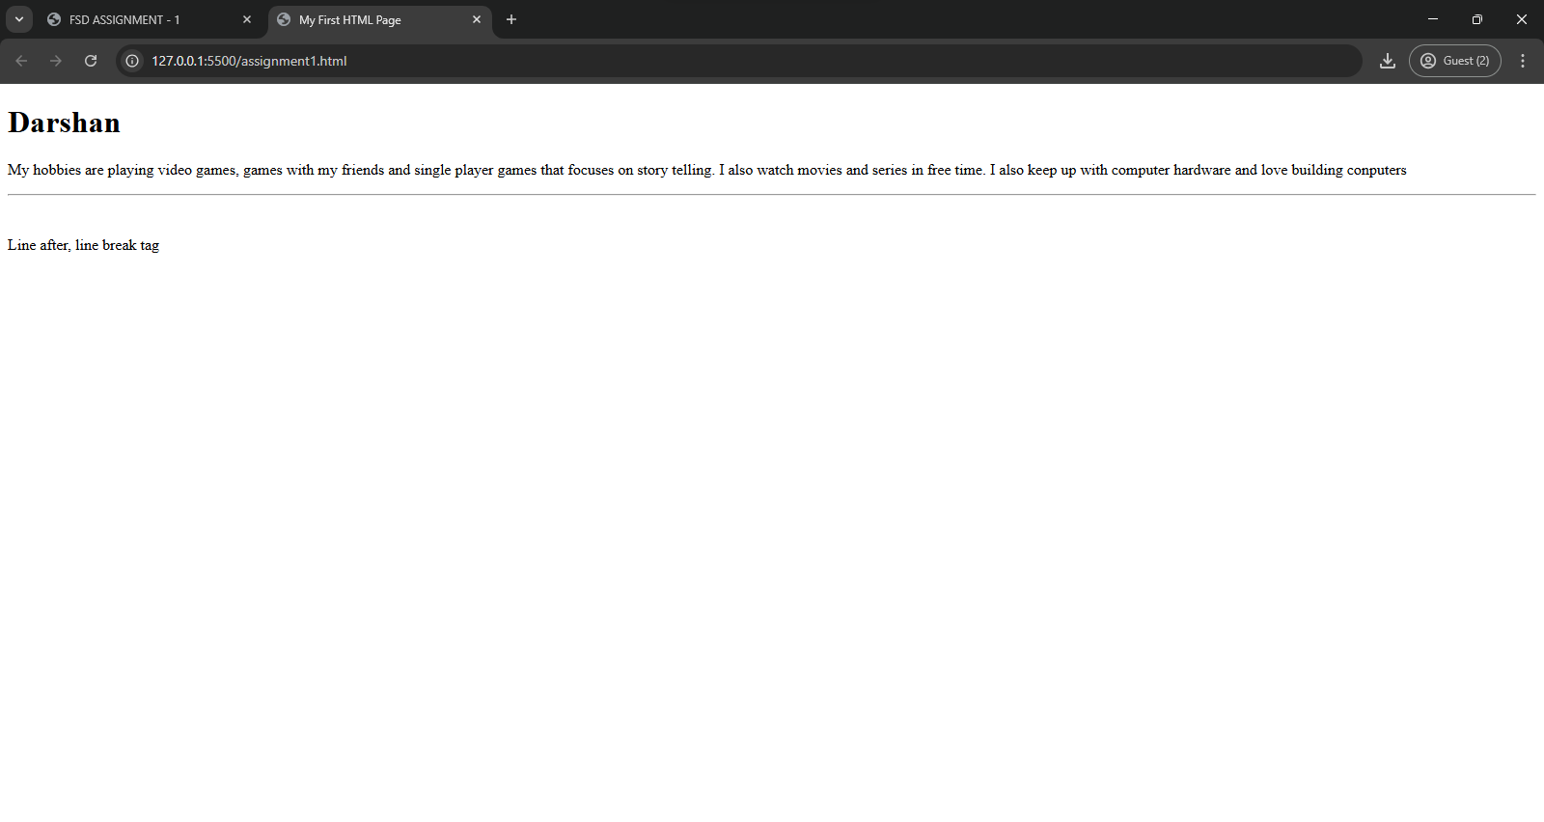

Exercise 2: Use of Lists and Links

Objective: Practice using different list types and hyperlinks.

Task:

Create a page that includes:

● An unordered list of your favorite fruits

● An ordered list of top 3 movies

● A hyperlink to your favorite website (open in a new tab)

**Code**

<!DOCTYPE html>

<html lang="en">

<head>

<meta charset="UTF-8">

<meta name="viewport" content="width=device-width, initial-scale=1.0">

<title>Assignment 2</title>

</head>

<body>

<h1>List and Links</h1>

<h2>my favorite fruits</h2>

<ul>

<li>Grapes</li>

<li>Pineapple</li>

<li>Mango</li>

</ul>

<h2>My favorite top 3 movies</h2>

<ol>

<li>Star Wars Episode 3: Revenge of the Sith</li>

<li>Spiderman 3</li>

<li>Spiderman No way home</li>

</ol>

<a href="https://www.ea.com/games/apex-legends/apex-legends" target="_blank">Link to Apex Web Site</a>

</body>

</html>

**Output**

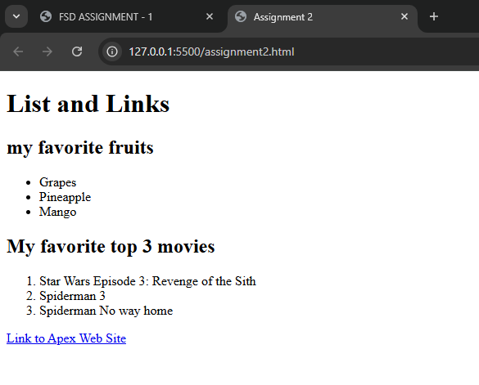

Exercise 3: Adding Images and Tables

Objective: Insert images and create tables using HTML.

Task:

● Insert an image using the <img> tag (use a placeholder URL or

local image)

● Create a table with 3 rows and 3 columns showing:

○ Student Name, Age, and Favorite Subject

**Code**

<!DOCTYPE html>

<html lang="en">

<head>

<meta charset="UTF-8">

<meta name="viewport" content="width=device-width, initial-scale=1.0">

<title>Assignment 3</title>

</head>

<body>

<h1>Image and table</h1>

<h2>Spiderman Image saved locally</h2>

<img src="spiderman.jpg" alt="Spiderman Image">

<br>

<h2>Table</h2>

<table border="2px">

<tr>

<th>Student Name</th>

<th>Age</th>

<th>Favorite Subject</th>

</tr>

<tr>

<td>Kenobi</td>

<td>18</td>

<td>Maths</td>

</tr>

<tr>

<td>Anakin</td>

<td>16</td>

<td>Geography</td>

</tr>

<tr>

<td>Maul</td>

<td>17</td>

<td>Science</td>

</tr>

</table>

</body>

</html>

**Output**

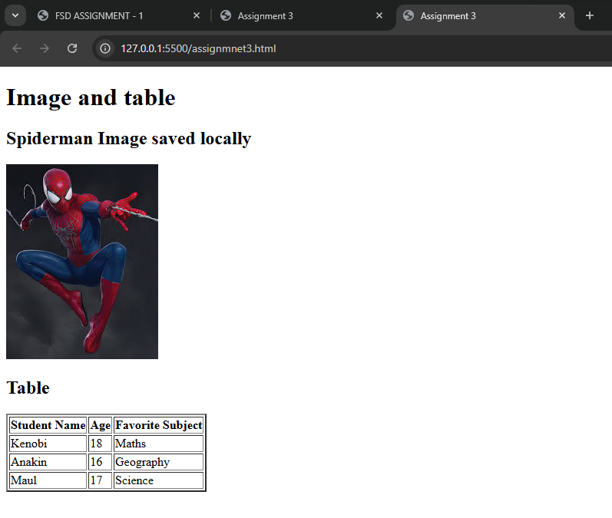

Exercise 4: Introduction to CSS (Internal CSS)

Objective: Apply basic styles to HTML using <style> tag.

Task:

● Create a heading styled with:

○ Background color: lightblue

○ Text color: darkblue

○ Font size: 30px

● Style a paragraph with:

○ Font family: Arial

○ Text alignment: justify

Code

<!DOCTYPE html>

<html lang="en">

<head>

<meta charset="UTF-8">

<meta name="viewport" content="width=device-width, initial-scale=1.0">

<title>Assignment 4</title>

<style>

h1{

background-color: lightblue;

color: darkblue;

font-size: 30px;

}

p{

font-family: Arial;

text-align: justify;

}

</style>

</head>

<body>

<h1>H1 styled using Internal CSS</h1>

<p>Paragraph with font Arial , and content justify</p>

</body>

</html>

Output

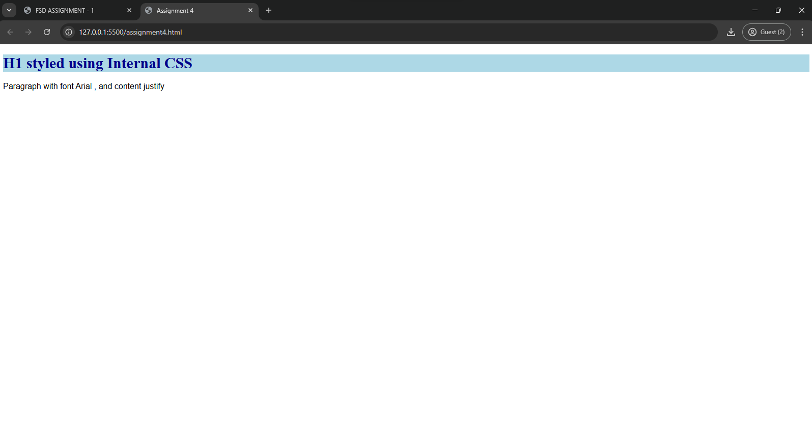

Exercise 5: CSS Classes and IDs

Objective: Learn to differentiate and apply CSS classes and IDs.

Task:

● Create two <div> blocks:

○ One with ID intro styled with a border and padding

○ One with class highlight styled with a yellow background

● Add text to both and observe the styles

**Code**

<!DOCTYPE html>

<html lang="en">

<head>

<meta charset="UTF-8">

<meta name="viewport" content="width=device-width, initial-scale=1.0">

<title>Assignment 5</title>

<style>

#intro{

border: 2px;

border-color: black;

border-style: solid;

padding: 50px;

}

.highlight{

background-color: yellow;

}

</style>

</head>

<body>

<h1>Div CSS</h1>

<div id="intro">Div with intro</div>

<div class="highlight">Div with yellow background</div>

</body>

</html>

**Output**

