Nmae:-Megh Joshi

Rollno:- 19

Expt no7

### DSF

Code:-

#include <stdio.h>

#include <stdlib.h>

#define MAX_VERTICES 20

int source, V, E, visited[MAX_VERTICES], G[MAX_VERTICES][MAX_VERTICES];

void DFS(int vertex) {

printf("%d -> ", vertex + 1);

visited[vertex] = 1;

for (int j = 0; j < V; j++) {

if (G[vertex][j] == 1 && !visited[j]) {

DFS(j);

}

}

}

int main() {

int v1, v2;

printf("\t\t\tGraphs\n");

printf("Enter the number of edges: ");

scanf("%d", &E);

printf("Enter the number of vertices: ");

scanf("%d", &V);

for (int i = 0; i < V; i++) {

for (int j = 0; j < V; j++) {

G[i][j] = 0;

}

}

for (int i = 0; i < E; i++) {

printf("Enter edge (format: V1 V2): ");

scanf("%d %d", &v1, &v2);

if (v1 >= 1 && v1 <= V && v2 >= 1 && v2 <= V) {

G[v1 - 1][v2 - 1] = 1;

G[v2 - 1][v1 - 1] = 1; // If your graph is undirected

} else {

printf("Invalid input. Please enter valid vertices.\n");

i--; // Decrement 'i' to re-enter the edge

}

}

printf("Adjacency Matrix:\n");

for (int i = 0; i < V; i++) {

for (int j = 0; j < V; j++) {

printf("%d ", G[i][j]);

}

printf("\n");

}

printf("Enter the source vertex: ");

scanf("%d", &source);

if (source >= 1 && source <= V) {

printf("DFS Traversal starting from vertex %d:\n", source);

DFS(source - 1);

} else {

printf("Invalid source vertex.\n");

}

return 0;

}

OUTPUT:-

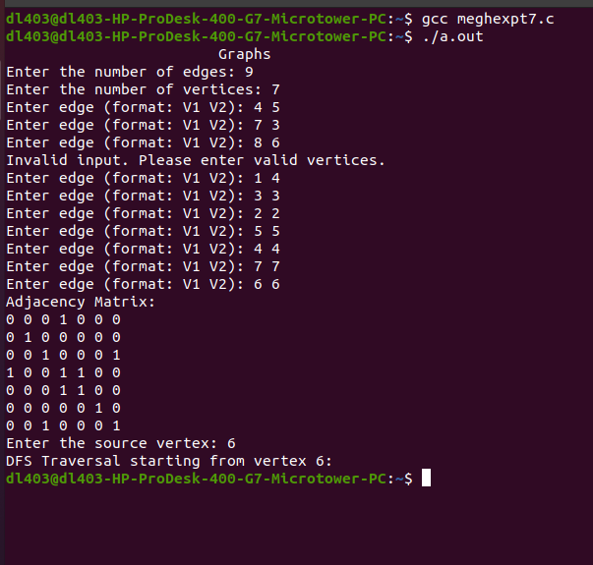

## BSF

CODE:-

#include <stdio.h>

#include <stdlib.h>

#define MAX_VERTICES 20

int a[MAX_VERTICES][MAX_VERTICES], q[MAX_VERTICES], visited[MAX_VERTICES], n, f = -1, r = -1;

void bfs(int v) {

int i;

for (i = 0; i < n; i++) {

if (a[v][i] != 0 && visited[i] == 0) {

r = r + 1;

q[r] = i;

visited[i] = 1;

printf("%d ", i);

}

}

f = f + 1;

if (f <= r) {

bfs(q[f]);

}

}

int main() {

int v, i, j;

printf("\n\t\t\tBreadth-First Search (BFS)\n");

printf("\nEnter the number of vertices: ");

scanf("%d", &n);

for (i = 0; i < n; i++) {

visited[i] = 0;

printf("\nEnter graph data in matrix form for vertex %d:\n", i);

for (j = 0; j < n; j++) {

scanf("%d", &a[i][j]);

}

}

printf("\nEnter the starting vertex: ");

scanf("%d", &v);

if (v >= 0 && v < n) {

f = r = 0;

q[r] = v;

visited[v] = 1;

printf("BFS Traversal starting from vertex %d:\n", v);

printf("%d ", v);

bfs(v);

if (r != n - 1) {

printf("\nBFS not possible\n");

}

} else {

printf("Invalid starting vertex.\n");

}

return 0;

}

OUTPUT:_

