## Megh Joshi

## Roll no:-19

## EXPT:-08

Code:-

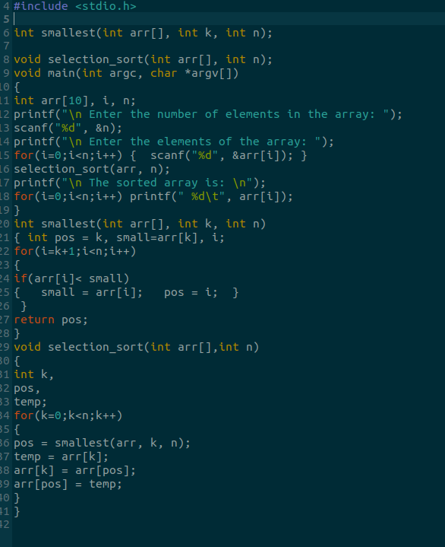

# Output:-

