

SCHOOL OF COMPUTER SCIENCE AND ENGINEERING

Modern Application Development

(Java Spring Boot)

WEEK-2 ASSIGNMENT

1. create ,update,delete commands in mysql

|  |
| --- |
| CREATE TABLE city (  city_no int NOT NULL PRIMARY KEY,  city_name varchar(20) NOT NULL,  state varchar(20) NOT NULL,  country varchar(20) NOT NULL,  population int NOT NULL,  famous_for varchar(20) NOT NULL,  mayor_id int NOT NULL  ); |
| CREATE TABLE mayor (  mayor_id int NOT NULL PRIMARY KEY,  mayor_name varchar(20) NOT NULL,  age int NOT NULL,  address varchar(25) NOT NULL,  phone varchar(12) NOT NULL,  mayor_start_date DATE NOT NULL,  mayor_end_date DATE NOT NULL  ); |
| INSERT INTO mayor values(101,'tom',45,'cp nagar',9608600000,'2000-08-08','2005-05-06');  INSERT INTO mayor values(102,'ravi',42,'rv nagar',9608687650,'2000-08-08','2005-05-06');  INSERT INTO mayor values(103,'sam',67,'nmj',960875400,'2000-08-08','2005-05-06');  INSERT INTO mayor values(105,'siva',65,'kk town',987345000,'2000-08-08','2005-05-06'); |
| INSERT INTO city values(1,'gct','mp','ind',600000,'tourism',101);  INSERT INTO city values(3,'tct','tp','uk',56000,'movie',103);  INSERT INTO city values(4,'gct','mp','uk',400000,'tourism',104);  INSERT INTO city values(5,'kct','tp','us',6540000,'forming',105); |

|  |
| --- |
| UPDATE mayor  SET mayor_name = 'Alfred Schmidt', age = 45  WHERE mayor_id = 103;  DELETE FROM mayor WHERE mayor_name='ravi';  select * FROM mayor; |

1. create tables and perform joins in mysql

SELECT city.city_name,city.state,mayor.mayor_name, mayor.address FROM city

INNER JOIN mayor ON city.mayor_id=mayor.mayor_id;

SELECT * FROM city LEFT JOIN mayor ON city.mayor_id=mayor.mayor_id

ORDER BY city.city_no;

SELECT * FROM city RIGHT JOIN mayor ON city.mayor_id=mayor.mayor_id

ORDER BY city.city_no;

1. create ,update,delete commands in mongo

**CREATE –**

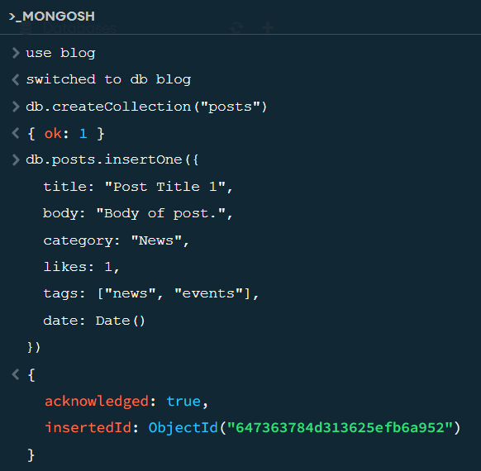

**UPDATE –**

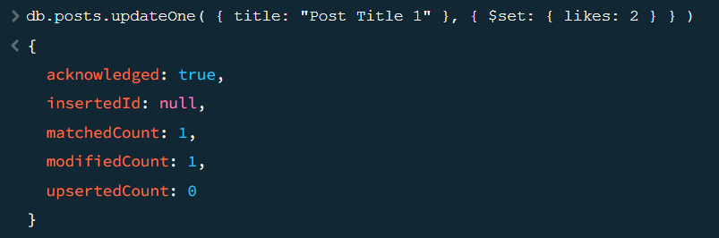

**DELETE –**

