**User Manual: To-Do List**

**Main Features:**

There are four main features of this application:

1. The tasks in the list box appear in sorted order i.e. the task to be completed in the near future is listed first in the list
2. Notifications – in every 15 minutes, the user is notified about the tasks to be completed in that hour, thus helping the user to be organised and punctual.
3. Priority – the user can set priority to a task, thus if user considers a task to be very important, he/she can set its priority to high.
4. Very user-friendly interface – the application comes with a very intuitive and easy to understand interface, thus the user can adapt to the application pretty easily

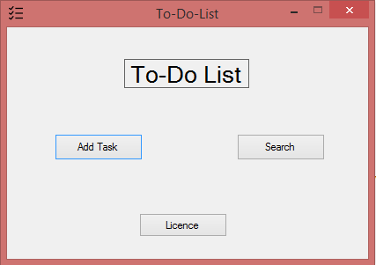

Figure 1 : Home window

**To add a task to your list-**

Click on the “Add Task” button on the home screen

Enter some description of the task, its completion date/time and its priority.

Then click on “Add Task” button to save the task.

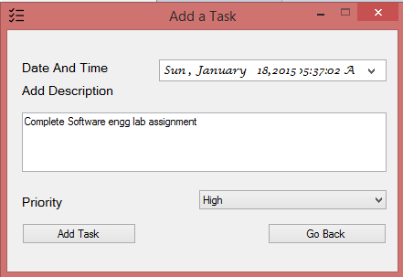

Figure 2 : Add Task window

**To search for tasks-**

Click on the “Search” button on the home screen

Enter the date/time to view the tasks to be completed before the date/time you specified

Then click on the “Search” button to get the tasks

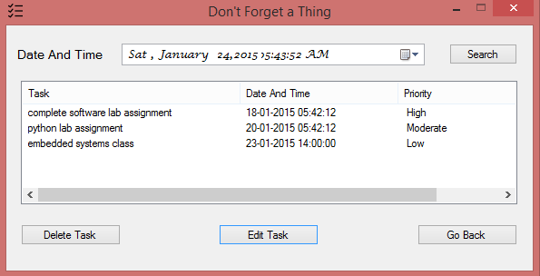

Figure 3 : Search Task window

**To delete a task-**

First, select the task to be deleted

Click on the delete button on the search window

**To edit a task-**

First, select the task to be edited

Click on the edit button on the search window

This should open a new window, now you may change any or all of the task’s description, date/time and priority

To save the changes made in the task list, click on “Done Editing” button

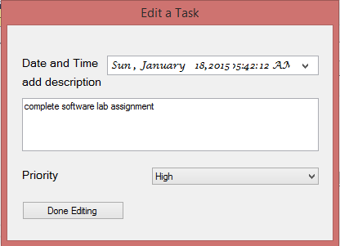

Figure 4 : Edit Task window

**To view the Licence-**

Click on the “Licence” button on the home screen.

If the software is Licenced, “Licenced” would be written in the window near the bottom left corner

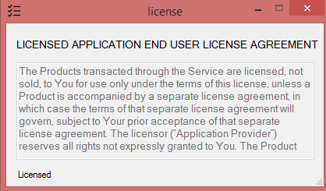

Figure 5 : Home window