ReadMe !!

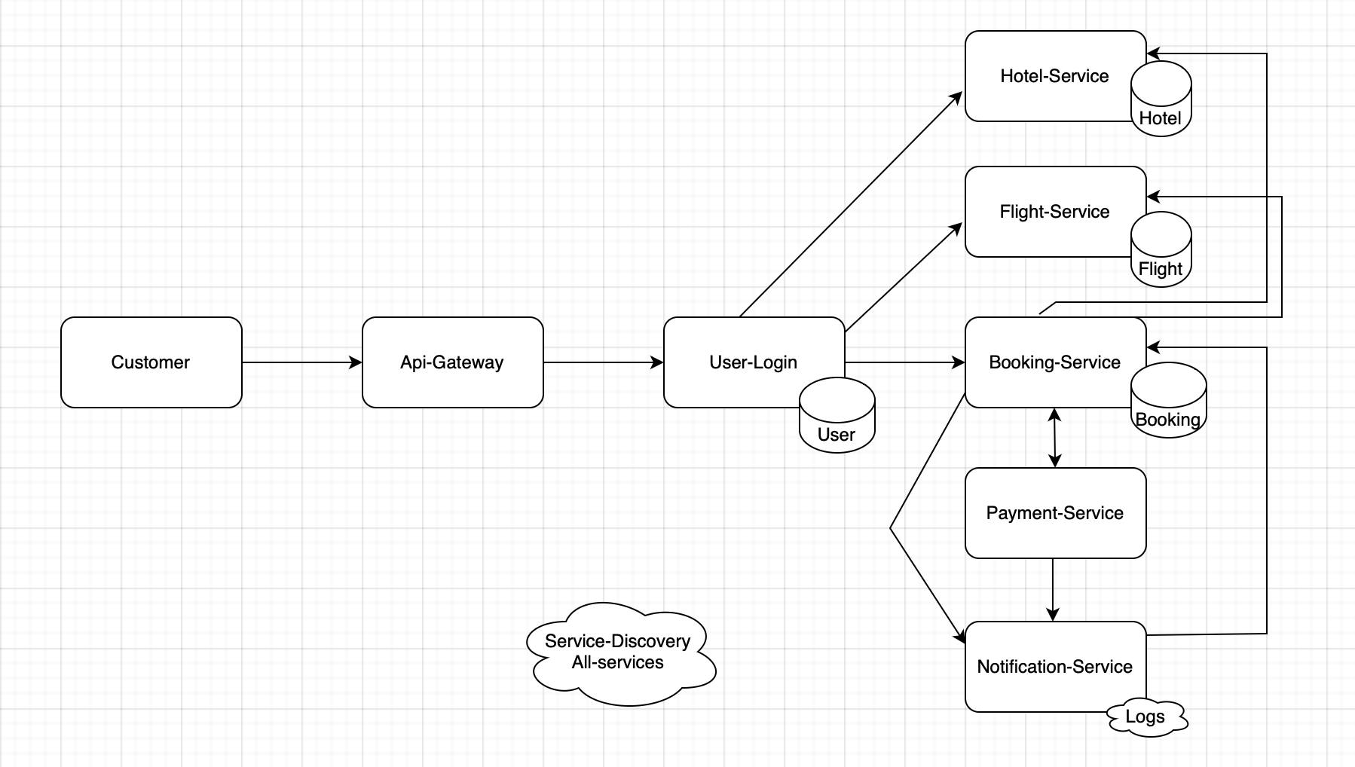

Services:

jet-set-stay-service-discovery

jet-set-stay-api-gateway

flight-service

hotel-service

booking-service

payment-service

notification-service

user-login-service(but not integrated)

jaegar included

sql scripts

h2 database

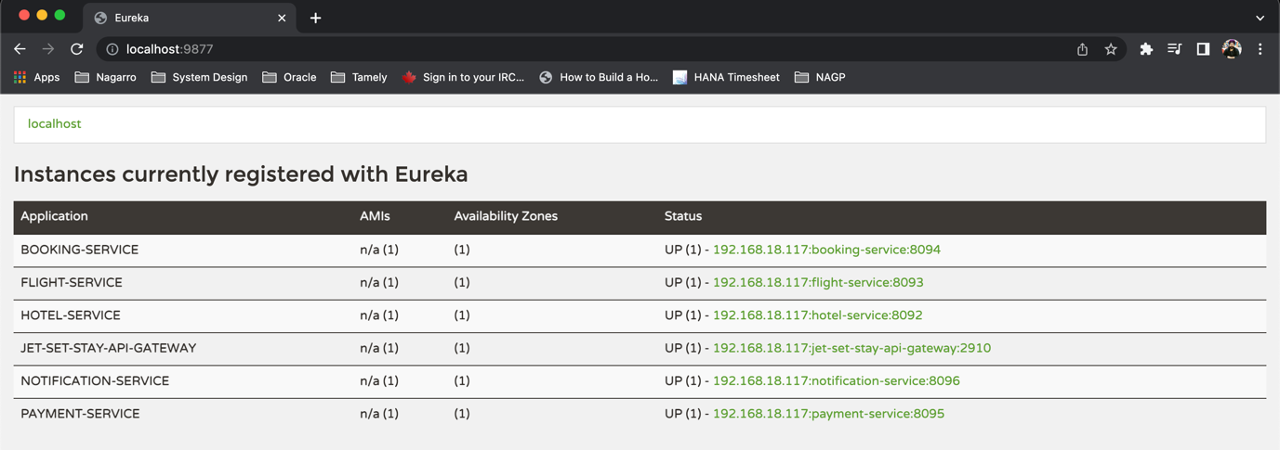

<http://localhost:9877/>

<http://localhost:2910/flight-service/flight/search?departure=Delhi&arrival=Pune&flightType=BUSINESS&flightDate=04-05-2023>

<http://localhost:2910/hotel-service/hotel/search?name=Hyatt&city=Delhi&checkIn=22-01-2023&checkOut=22-09-2023>

<http://localhost:2910/booking-service/booking/book>

<http://localhost:2910/payment-service/payment/pay?bookingAmount=2900.0&paid=false>

<http://localhost:2910/notification-service/notification/notify?message=SUCCESS>

java -jar jet-set-stay-service-discovery-1.0.0.jar

java -jar jet-set-stay-api-gateway-1.0.0.jar

java -jar booking-service-1.0.0.jar

java -jar flight-service-1.0.0.jar

java -jar hotel-service-1.0.0.jar

java -jar notification-service-1.0.0.jar

java -jar payment-service-1.0.0.jar