**Project 3**

**Sidharth Amarnath**

|  |
| --- |
| **INSTRUCTION:**   * Please use this template to provide your answers * You need to complete the questions independently * After you complete the questions, please print this Word document to PDF and name the PDF file to LASTNAME_FIRSTNAME_Project#.pdf (replace # by the project number). * Submit the PDF file to D2L. |

**Question 1**

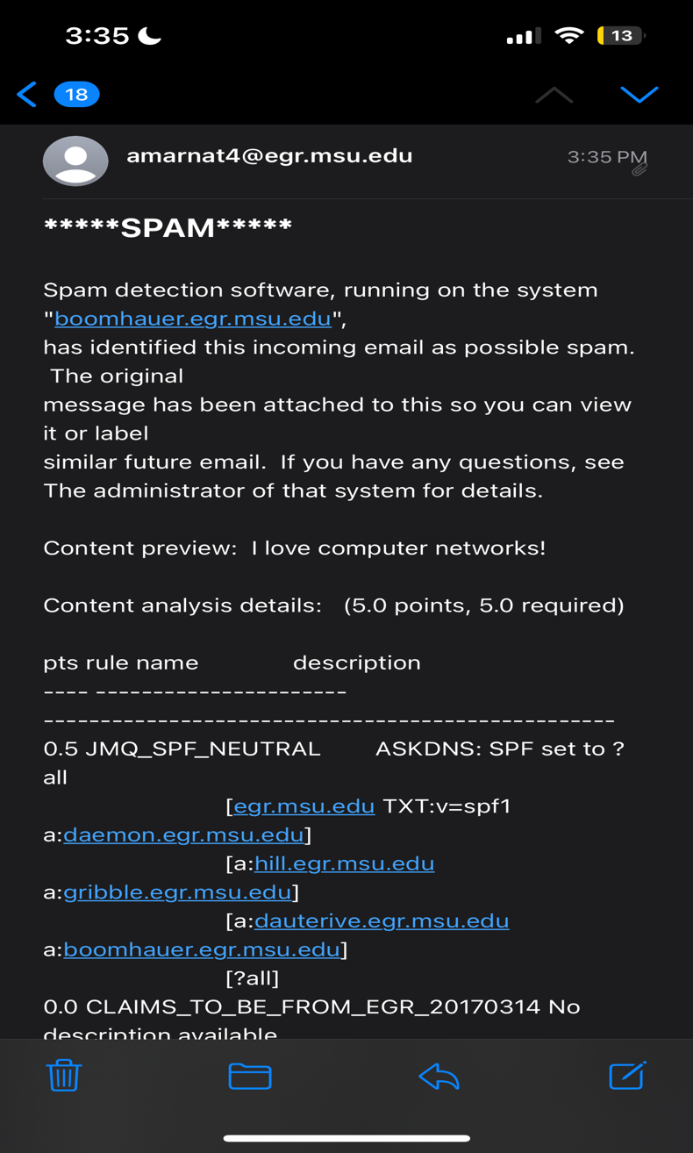

These are screenshots of the email sent to my egr email ([amarnat4@egr.msu.edu](mailto:amarnat4@egr.msu.edu)). The content preview displays: “I love computer networks!” which is the same as the message in the skeleton code. The email successfully sent to my engineering email, and the code works as it should.

**Question 2**

This is the email received to my personal email. The message states “I love computer networks!” which is the same as the msg in the code. The email successfully sent from my engineering email to my personal email, so the code seems to work properly.