**Project 4**

Sidharth Amarnath

|  |
| --- |
| **INSTRUCTION:**   * Please use this template to provide your answers * You need to complete the questions independently * After you complete the questions, please print this Word document to PDF and name the PDF file to LASTNAME_FIRSTNAME_Project#.pdf (replace # by the project number). * Submit the PDF file to D2L. |

**Question 1**

Below are screenshots of the website and my code terminal when I paste the URL. Unfortunately, I was unable to get any data when pasted the website into google. I was able to receive a connection as you can see in the last line of my code terminal screenshots, however I’m not exactly sure why the google page wasn’t working.

**Sohu.com**

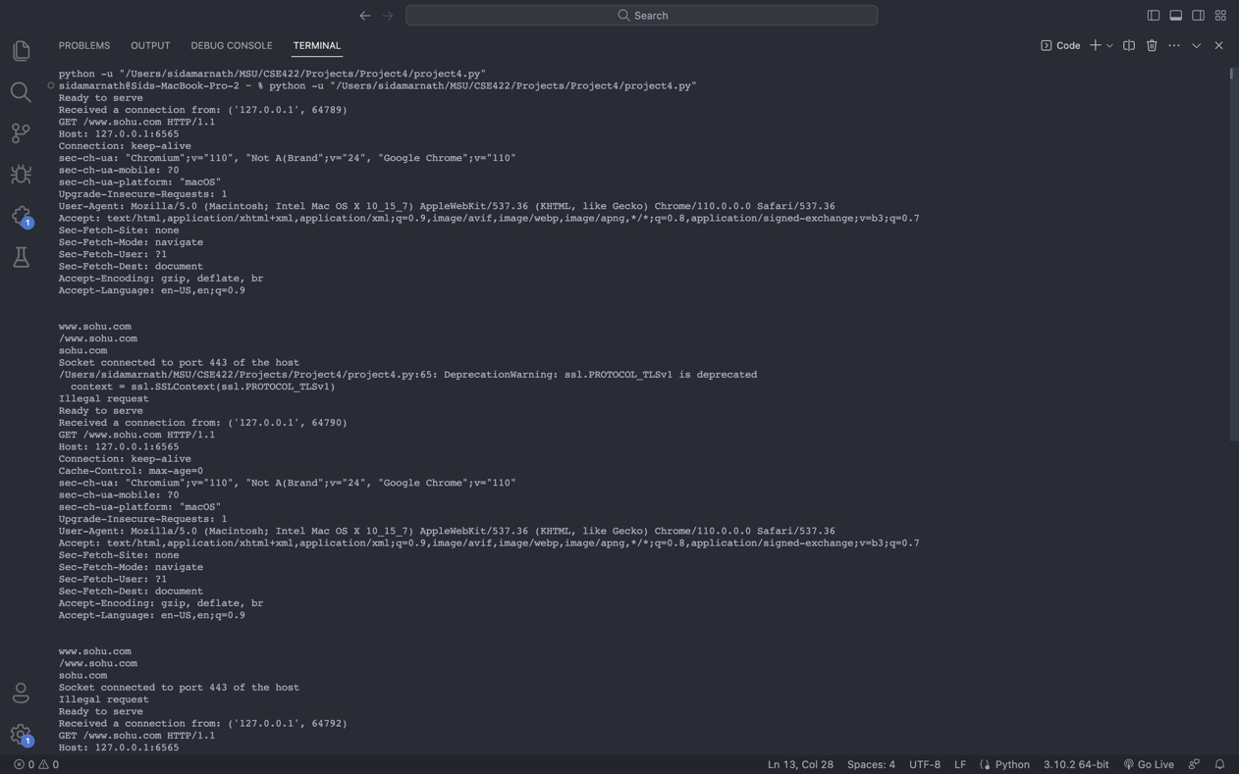

**Bbc.com**

