
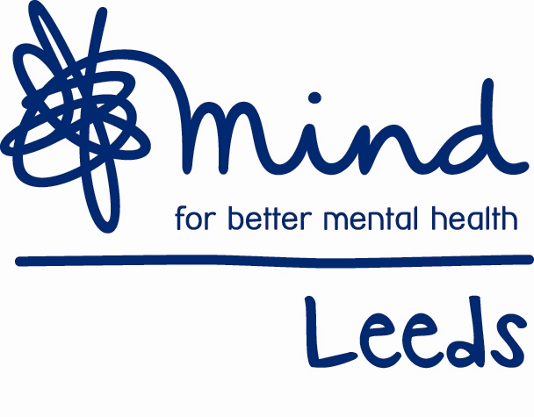
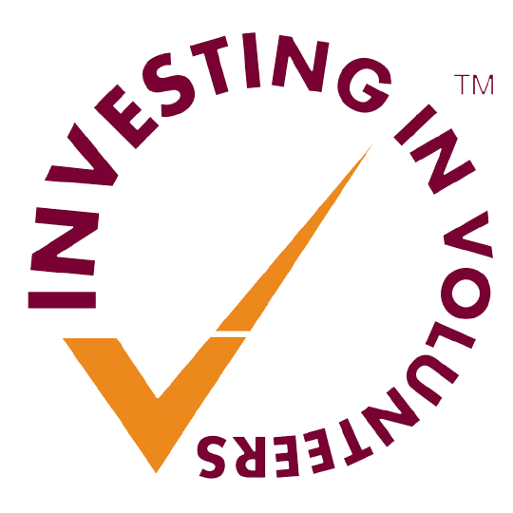

Leeds Mind Recruitment

Information Sheet- Key Terms and Conditions of Employment

Service: Business Development

Post: Business Development Assistant

Hours: Full Time (37 hours per week)

Salary Scale: NJC Scale 4 points 7-10

Salary: £19,554 - £20,751 per annum

Contract: Permanent

Location: Clarence House, Horsforth, Leeds, LS18 4LB with occasional travel across Leeds and surrounding areas

Annual leave: 28 days per annum + 8 Statutory holidays - rising to 31 days after 3 years

Pension: 3% employer contribution, 5% employee contribution, enhanced by salary exchange

Probationary Period: 6 months

Job Description
Business Development Assistant

Introduction
The post holder will join Leeds Mind with specific administrative duties for our Business Development Team which encompasses our Fundraising and commercial Training teams. The post will be based at Clarence House in Horsforth and is full time.

Leeds Mind is the city’s leading mental health charity with a turnover of approximately £3m each year. The Business Development team is at an exciting point in its growth and this new role will be pivotal in supporting the team, valuing our donors and clients and underpinning our income generation operation.

Purpose of the role
To be the first point of contact for new supporters, whether they be a donor, fundraiser or training client. Providing fantastic customer service for all who encounter the Leeds Mind Business Development Team and supporting the existing delivery team to provide a smooth service showing all our supporters they are both important and valued.

Main tasks and responsibilities:
- Management of the Business Development CRM Database
- Financial consolidation and issuing thank you letters
- Managing the fundraising and training inboxes and directing enquiries
- Taking initial calls and enquiries from clients and supporters
- General administration of Training events
- Administrative support for the Business Development Director
- General Fundraising administration
- Social media monitoring
- Supporting events as required (TOIL applies for out of hour work)
- Use Xero accounting system to raise Invoices as required for BD & Training team
- Use Xero to process purchase orders and bills as requested by BD & Training team, and to pay for BD & Training related service suppliers.
- Hold a company credit card and record credit card transactions in Xero for own card, and the BD & Training Team’s company credit cards.

Organisation
- Participate in 1:1s, performance and development, including Leeds Mind compulsory training programme
- Attend and participate in service/team meetings
- Work within the framework of Leeds Mind’s policies and procedures
- Promote the values, behaviours and ethos of Leeds Mind
- Promote the possibilities for empowerment of service users
- Demonstrate a commitment to personal development
- Be involved with wider organisation activities
- Occasional requirement to cover reception in the event of sickness or holiday. Cover is provided until 8pm (time off in lieu will be provided).
- Undertake any other reasonable duties as and when required

It is Leeds Mind’s policy to make reasonable adjustments to enable workers with a disability/ disabilities to undertake the above, including the interview process.
May 2019
Business Development Assistant

Person Specification

 | Essential | Desirable | Shown by
Qualifications | - GSCE English and Maths (or equivalent) at grade C/4 or above | A Levels  Degree  Administration Qualification | Application
Experience of | - Providing excellent office/admin support  - Working in an office environment  - Reception and telephone work  - Working as part of a team  - Data input on a variety of systems  - Utilising databases, collating, analysing & presenting data  - Developing, implementing and maintaining admin office systems.  - Managing multiple priorities | Supporting and supervising volunteers  Working in a charity business development role  Financial systems and processes  Liaising with a variety of stakeholders  Providing support at events (e.g. fundraising events, conferences or similar) | Application  Interview
Skills | - High level of IT skills, proficient with a wide range of Microsoft Office programmes (Word, Excel, Outlook, PowerPoint, CRM Database)  - Excellent administrative and organisational skills  - Excellent communication and customer care  - Good level of written and spoken English | Use of charity CRM  Background in charity events | Application  Test  Interview
Able to | - Take the initiative and problem-solve  - Manage, organise and prioritise own work  - Work on own and without direct supervision  - Work under pressure and able to meet deadlines  - Minute/take notes at meetings  - Analyse statistical data and develop reports  - Use social media (including Twitter and Facebook)  - Work outside of normal office hours as and when required (e.g. evenings or weekend events)  - Travel around Leeds and surrounding areas if required | Use WordPress | Application  Interview
Knowledge and understanding of | - The handling of confidential information in an admin setting  - Data protection & GDPR  - Your own support and development needs  - Anti-discriminatory practice, promoting diversity |  | Application  Interview
Attitude and Personal Attributes | - Solution-focused approach to work.  - Motivated, confident and resilient.  - Open to change and able to work flexibly in line with the needs of the service/organisation.  - Commitment to working in partnership with service users, management and staff.  - Interest in mental health | Lived experience of mental health difficulties. | Application  Interview

