./



|  |  |  |  |  |  |
| --- | --- | --- | --- | --- | --- |
| **Ver.Rel. No.** | **Release Date** | **Prepared. By** | **Reviewed By** | **Approved By** | **Remarks/Revision Details** |
| 1 | 20/02/2022 | SIDARAY TELI |  |  |  |
|  |  |  |  |  |  |
|  |  |  |  |  |  |
|  |  |  |  |  |  |
|  |  |  |  |  |  |

**Document History**

# 

# Embedded System :- Smart Irrigation System

* Smart Irrigation is an one of the Embedded system

* Irrigation is nothing but watering, It is a process of applying amount of water to land to help the production of crops.
* Earlier days Irrigation was too difficult because lack of technology. Nowadays it’s easy with technology and automation.
* Having less amount of water itself smart irrigation system helps to grow agricultural crops in dry areas or areas with less rainfall.
* It’s used for cooling livestock, Dust suppression, And protection of soil erosion and agricultural crops.
* This internet based embedded smart irrigation system can helps to prevent wastage of water, Where farmers can control irrigation and get the update of soil in home itself.

# Block Diagram:-

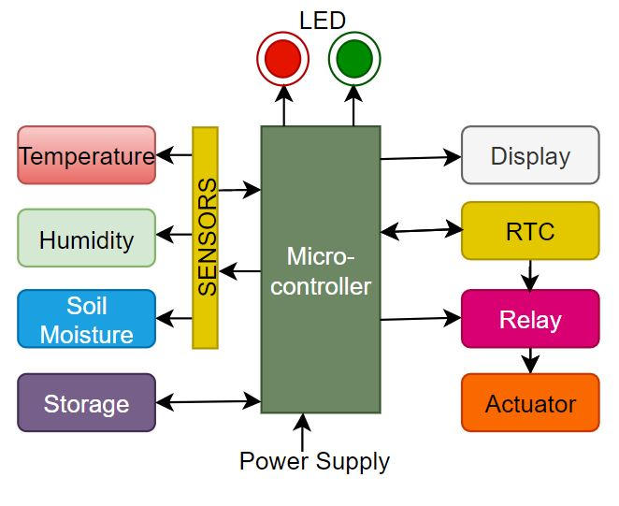

**Components:-**

**Microcontroller :** Used to control various sensors, Actuators and for sending and storing data’s ,etc.

**Temperature Sensor :** To measure environment temperature.

**Humidity Sensor :** To measure environment humidity.

**Soil Moisture Sensor :** To detect the moisture content in the soil.

**Display :** Helps to display various parameters like temperature, Humidity of environment and Moisture content of soil.

**RTC :** Real time clock is used to set irrigation time automatically.

**Relay :** It’s used to control the actuator.

**Actuator :** Used as motor pump to supply water to soil.

**Storage :** To record data’s for analysis.

* **Requirements:**
* **High Level Requirements:-**
* **HLR_01:** Should detect soil moisture.
* **HLR_02:** Need to detect environment temperature and humidity.
* **HLR_03:** Display all parameters.
* **HLR_04:** Should be automatic irrigation.
* **Low Level Requirements:-**
* **HLR_01**

**LLR_01.1:** If water content in soil is low, Watering should be done.

* **HLR_02**

**LLR_02.1:** Irrigation to be done based on environment parameters like temperature and humidity.

* **HLR_03**

**LLR_03.1:** Based on parameters user may interrupt purposely.

**LLR_03.2:** To show indication light whether the system is ON or OFF.

**LLR_03.3:** Recording of all data should be done for analysis.

* **HLR_04**

**LLR_04.1:** Irrigation should be vary automatically based on environment parameters. Example:- Rainfall and Increment in temperature etc.

**LLR_04.2:** Based on measured data, Itself RTC can sets the time for irrigation.

**LLR_04.3:** Controllable pressure and water flow.

* **Applications:-**
* Useful for farmers for irrigation
* Helps to protect agricultural crops
* Preventing wastage of water during irrigation
* Prevention of soil erosion
* As a Dust suppression
* **Major Features:-**
* Battery duration
* Storage media
* Data display
* Autocontrol irrigation