**PROJECT TITLE: SMART IRRIGATION SYSTEM USING SOIL MOISTURE AND DHT11 TEMPERATURE SENSOR**

By- SIDARAY TELI

**Table of contents**

**1 Abstract**

**1.1 Description**

**2 Requirements**

**2.1 High Level Requirement**

**2.2 Low Level Requirement**

**2.3 Swot analysis**

**2.4 5W 1H**

**3 Design and architecture**

**3.1 Use case diagram**

**3.2 Flowchart**

**3.3 Block diagram**

**4 Components used**

**5 Applications**

**6 Test plan and Result**

**6.1 High level requirement table**

**6.2 Low level requirement table**

**6.3 Simulide Implementation**

**6.4 Breadboard Implementation**

**6.5 Conclusion**

**7 References**

**8 Future scope**

**1. Abstract**

Smart Irrigation is an one of the Embedded system. The main goal of this work is to develop a prototype of the system that can collect the health of the soil by measuring parameters like environmental temperature and humidity, Moisture content of soil and can display all parameters. And automatically irrigation can be done using motor pumps and it is based on parameters measured from various sensors.

**Explanation**

In earlier days Irrigation was too difficult because lack of technology and lack of electricity. Nowadays it’s easy with technology and automation. "Irrigation is nothing but watering, It is a process of applying amount of water to land to help the production of crops". Having less amount of water itself smart irrigation system helps to grow agricultural crops in dry areas or areas with less rainfall, And it’s used for cooling livestock, Dust suppression, And protection of soil erosion and agricultural crops. This internet based embedded smart irrigation system can helps to prevent wastage of water, Where farmers can control irrigation and get the update.

**2. Requirements**

**2.1 High Level Requirements:**

* HLR_01: Shall detect soil moisture.
* HLR_02: Need to detect environment temperature and humidity.
* HLR_03: Shall Display all parameters.
* HLR_04: Shall be automatic irrigation.

**2.2 Low Level Requirements:**

**HLR_01**

* LLR_01.1: If water content in soil is low, Watering shall take place.

**HLR_02**

* LLR_02.1: Irrigation shall be done based on environment parameters like temperature and humidity.

**HLR_03**

* LLR_03.1: Based on parameters, User may interrupt purposely.
* LLR_03.2: Show indication light whether the system is ON or OFF.

**HLR_04**

* LLR_04.1: Irrigation can be automatically based on environment parameters. Example:- Rainfall and Increment in temperature etc.
* LLR_04.2: Based on measured data, Itself can sets the time for irrigation.
* LLR_04.3: Shall be Controllable pressure and water flow.

**SWOT Analysis**

**Strengths**

* Easy to use Applications
* Useful to all farmers
* Less energy consumption

**Weaknesses**

* Lack of graphical user interface
* App may be needed for easy usage

**Opportunities**

* GUI can be implemented

**Threats**

* Best applications are available
* May be majority of farmers will not use because of lack of guidance

**5W 1H**

**Who**

* The system can be used by farmer.

**What**

* It's a smart irrigation system that works automatically.

**When**

* It is available 24X7, 365 days for service.

**Where**

* It can be use in fields and farms etc.

**Why**

* Useful to all farmers to do irrigation without wasting of water and energy.

**How**

* To run this system, Programme is written in C to prevent complication and keep things simple to the user. Microcontroller is used here to control and collect data from various sensors like temperature, Humidity and soil moisture sensor. It works based on sensor parameters, For example if temperature parameters are higher than its threshold then irrigation is takes place with the help of motor. And all sensors parameters are being displayed using LCD.

**3. Design**

**3.1 Use case diagram**

[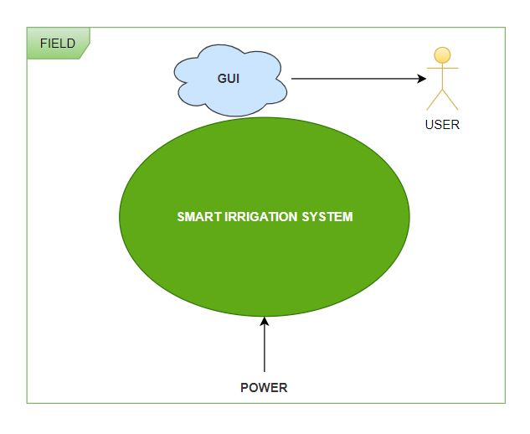](https://user-images.githubusercontent.com/46900710/155770366-ee2bdb72-2774-478f-9227-2937691a1a10.JPG)

**3.2 Flowchart**

[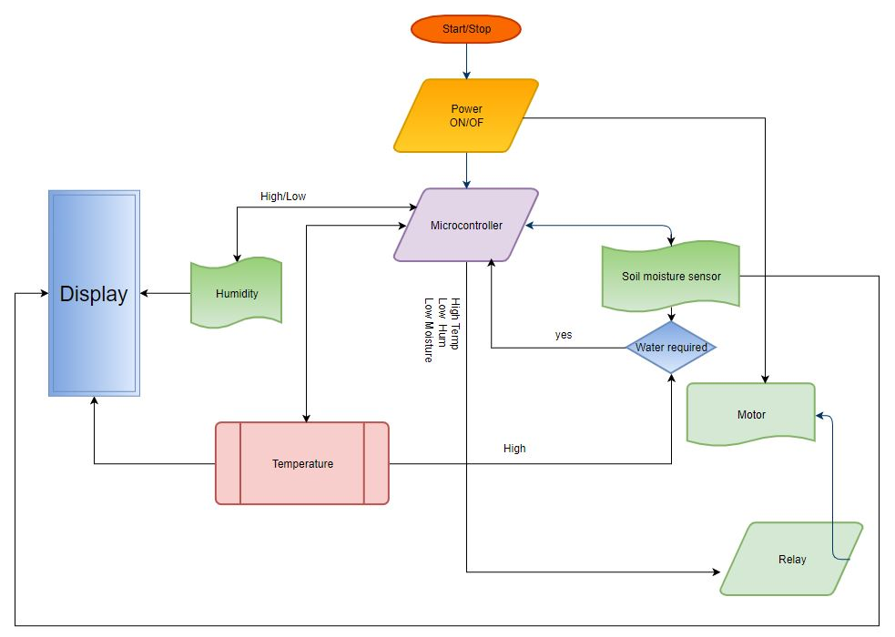](https://user-images.githubusercontent.com/46900710/155830718-fe4051ac-5f74-48bf-851c-76f6bd31e806.JPG)

**3.3 Block diagram**

[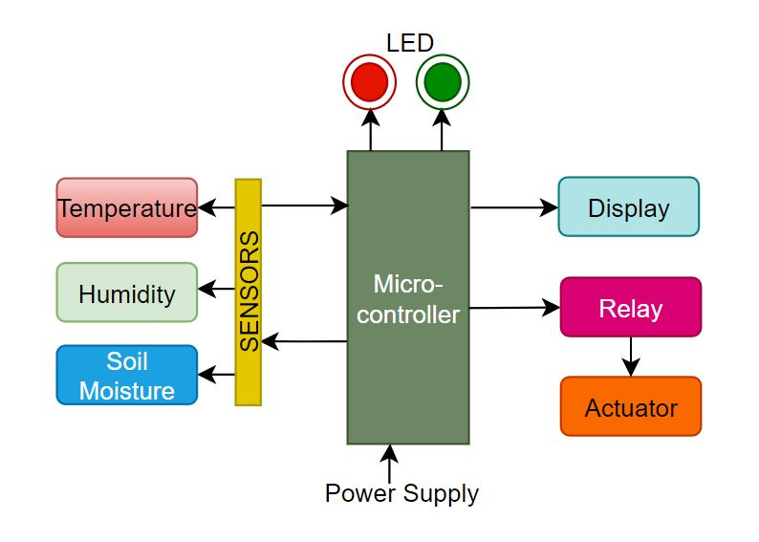](https://user-images.githubusercontent.com/46900710/156874998-70c45966-3866-49c0-a449-fcdbcafad91b.JPG)

**Block Diagram Explanation**

In the project smart irrigation system controller is used to control various sensors (Analog /digital) like temperature, Humidity sensor and soil moisture sensor. Where all parameters are collected by the controller with the help of sensors. If the temperature level is more than its threshold value then based on temperature reading the controller on the motor. Where motor is controlled by relay. Similarly if humidity level and moisture content in soil is very low or high then also controller takes respective actions like to on or of the motor which was set for irrigation. Also all parameters are displayed using LCD(Display). The power is provided to the system along with that on and off button is provided to the system for user control.

**4. Components Used**

**\* Microcontroller :**

Used to control various sensors, Actuators and for sending and storing data’s ,etc.

**\* Temperature Sensor :**

DHT11 used as temperature sensor to measure environmental temperature. It works under supply voltage of 3.3v to 5v and it can measure temperature in the range of 0ºC(degree celcius ) to 50ºC(degree celcius). It is commonly used to measure both temperature and humidity of environment. It gives digital output so dht11 is an digital sensor.

**\* Humidity Sensor :**

DHT11 used as humidity sensor to measure environmental humidity. It works under supply voltage of 3.3v to 5v and it can measure humidity in the range of 20% to 90%. It is commonly used to measure both temperature and humidity of environment. It gives digital output so dht11 is an digital sensor.

**\* Soil Moisture Sensor :**

Soil moisture sensor is used to measure the loss of moisture in the soil over a time due to evaporation and plant uptake(water used by plant). Used to control irrigation. It is having some specifications like works under supply voltage of 3.3 to 5v. The soil moisture sensor is having two legs which are used to measures the volumetric content of water. And it gives both digital as well as analog output.

**\* Display :**

Helps to display various parameters like temperature, Humidity of environment and moisture content of soil. Input voltage ranges 4.7v to 5.3v supply. It can displays alphabets as well as numbers. Interfacing is done with microcontrollers.

**\* Relay :**

Relay having switching voltages VAC is at 250V and 10A and VDC is at 30V and 10A. Its trigger voltage(VDC) is 12V and trigger current is 20mA Operates under temperature range from -40°C to 85°C and humidity range of 20% to 85% Standard interface that can be controlled by microcontroller. Here it’s used to control the actuator.

**\* Actuator :**

DC motor operates under voltage of 4.5V to 9V and load current is approximately 250mA. In DC motor there many types based on their torque value. Here it is used as motor pump to supply water to soil.

**5. Applications**

* Useful for farmers for irrigation
* Helps to protect agricultural crops
* Preventing wastage of water during irrigation
* Prevention of soil erosion
* As a Dust suppression

**6. Test plan and result**

**6.1 High Level Requirement Table**

[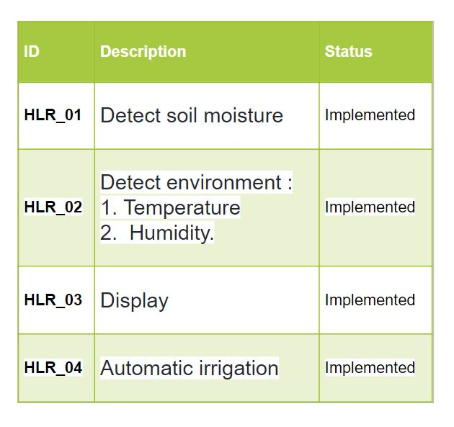](https://user-images.githubusercontent.com/46900710/156876684-4655870a-10fc-4cd5-ad06-cccc0cd543c8.JPG)

**6.2 Low Level Requirement Table**

[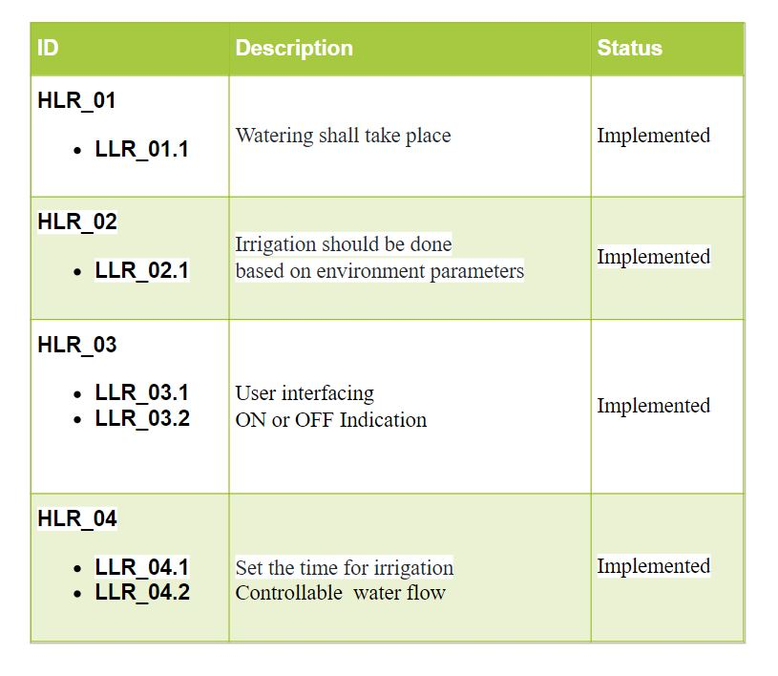](https://user-images.githubusercontent.com/46900710/156876804-e5214d86-9fb4-47b8-9412-b9daa5a2469b.JPG)

**6.3 Simulide Implementation**

[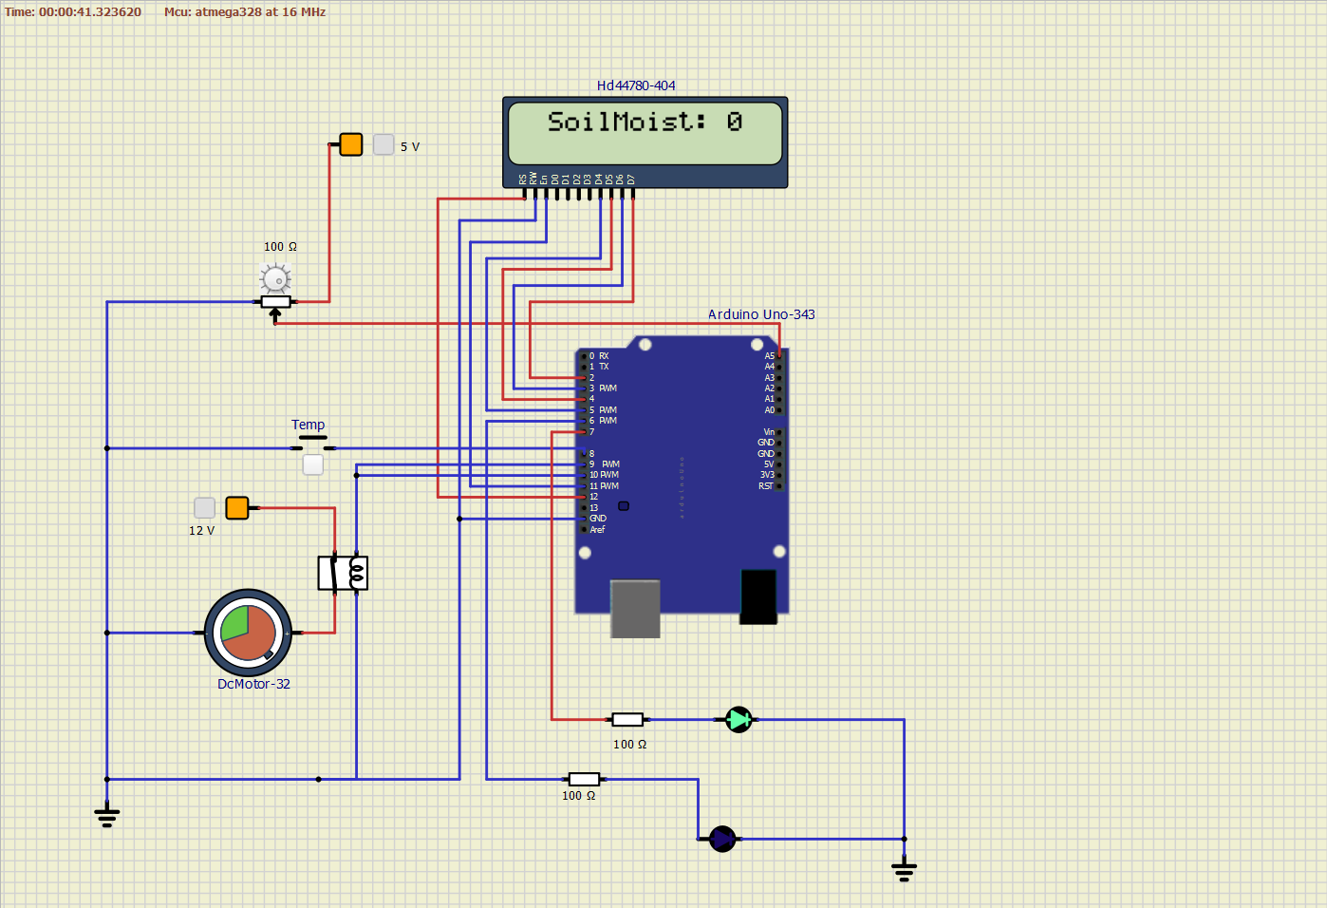](https://user-images.githubusercontent.com/46900710/157177912-b37ec328-bdee-4426-9e1e-a83fe4a6eeea.png) Figure a

**Explanation**

In the project smart irrigation system Arduino UNO is used as controlling unit. In above figure 'a': push button is used as temperature sensor instead of dht11 sensor and potentiometer is used as soil moisture sensor. LCD is used for displaying environment temperature, humidity and soil moisture data's. If temperature readings are greater than the threshold temperature value and soil moisture is lesser the threshold soil moisture value(where those threshold values are fixed in code) then motor gets ON with the help of relay.

**6.4 Breadboard Implementation**

[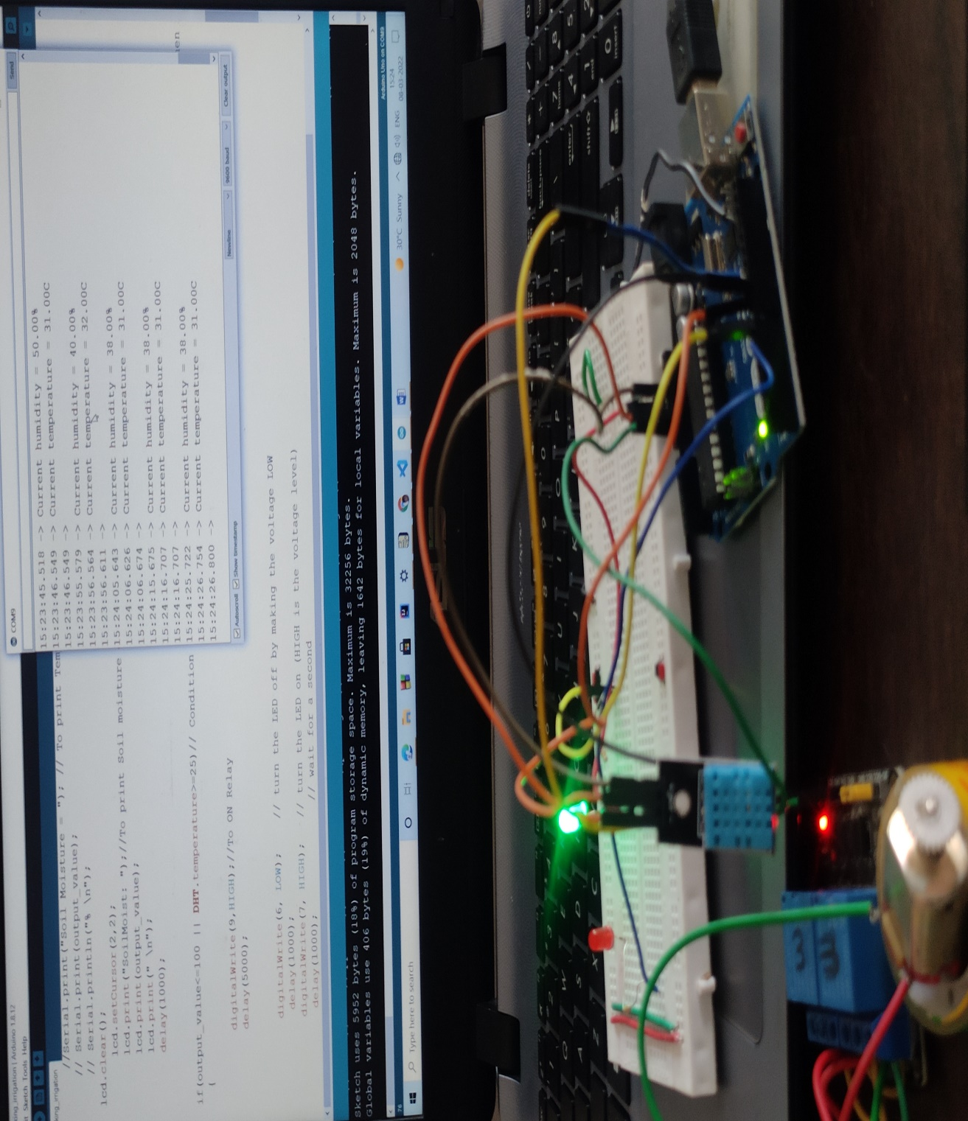](https://user-images.githubusercontent.com/46900710/157218337-969239da-2fc2-4fda-99b3-fc57a4c03425.jpg)

Figure b

**Explanation**

In the project smart irrigation system Arduino UNO is used as controlling unit. In above figure 'b': DHT11 is used to measure environment temperature and humidity. Here relay is used to control the dc motor. Green led gets on Whenever the system is on for irrigation and the red led is on whenever the system is off.

**6.5 Conclusion**

The smart irrigation system is ready. Where it can make automatic irrigation whenever environment temperature is higher than its threshold value and soil moisture level lower than its threshold value. For irrigation motor is used to supply water which is controlled by relay and arduino uno.

**7 Future scope**

* System should store all data’s for analysis
* App is needed for easy usage

**8 References**

**https://ieeexplore.ieee.org/document/9077924/**