EE545: Lab1 Submission
by
Team Dubs
Priyanka Patil
Sai Sidharth D
Shantanu Deshpande

4.1 Line Following with PID Control
1. Answer: What exactly was your error metric? How exactly did you choose which point the
robot should navigate towards?
Our error metric was sum of weighted translation error and weighted rotational error.
We have transformed plan array poses w.r.t car current pose. To find which point in array are behind and which points are ahead of the robot, we used following logic:
The transformed poses from the plan will have x-axis readings as positive for the points ahead of the robot. We pick the pose from the plan array which is the first one detected which is in front of the car and break out of the loop.

2. Answer: What are the 3 sets of PID parameters that you choose? Which set of PID
parameters performed best? Why do you think this is the case?
We chose following PID parameters:
KP: , KI: , KD: 1.0, 1.5, 0
KP: , KI: , KD: 1.7, 1.0, 0.3
KP: , KI: , KD: 1.0, 0.7, 0.5

Above mentioned, are the best PID parameters that we used. The first set of parameters performed the best. It is because, it is important to have a Ki, in your design, because if there is a constant offset of the robot from the line, for some reason then a positive Ki would help in the accumulation of the error, and change the steering angle accordingly. We had lesser oscillations of our robot, while not using a positive Kd. So, we have used a PI controller.

3. Answer: What is missing that is stopping us from implementing this on the real robot?
In this implementation, following things are stopping us from implementing this on real robot:
Localization: the robot won’t know where it is on the floor to follow the given pose array. I will not be possible to put it on the floor, on the exact same pose as that of the start pose of a given line.
At any point in the middle of the line, it won’t be able to know where it is positioned with respect to the next pose on the line.

4. The error plot described at the end of Section 2.1
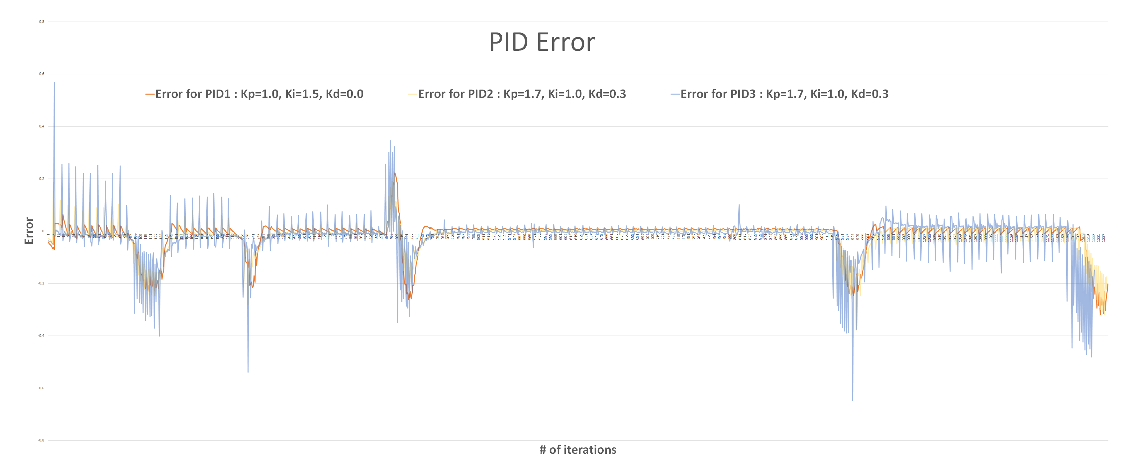

4.2. Wandering Around with MPC

1. Answer: Describe the parameter values that you chose (e.g. T, delta_incr, etc.). Describe
any other design choices that you made.
Ans: Parameter values that we chose have been given below:
speed = 1.0
min_delta = -0.34
max_delta = 0.341
delta_incr = 0.34
dt = 0.01
T = 300
compute_time = 0.09
laser_offset = 1.0
A) One design choice that we made is that, if the angle of the pose in the trajectory is outside the range of the laser angles, we have penalized with max_penalty.
B) We have calculated the angle of a pose in the trajectory with respect to the robot, and then found the laser ray corresponding to that angle, and then penalized the cost corresponding to that delta, if the (value of that range - the laser_offset) is lesser than the euclidean distance from the pose to robot.
C) We have also used isfinite in python, to find out if the laser_range values are not NaNs and also checked if they are nonzero, before it is further used in the computation.
D) We have found the minimum cost in the N*1 array of costs that have been calculated within the coumpute_time amount of time, and returned the delta corresponding to the minimum cost as the steering angle to the robot.
Changes made in the code so that it works on the robot:
We have taken into account the laser corresponding 90 degrees on either side, and penalized for obstructions, with more weightage than that other trajectories. We have also increased the offset so that the robot has more room to turn.

Links to simulation video:
https://drive.google.com/open?id=1E33glZs9Y3M8iOATvv7GmxDObbcfu0pD

