Email Agent
High-Level Architecture Design
LQABR — AI Lead Qualification & Outreach · Epic E4
Location: agents/email/
Last updated: 2026-07-28

1. Purpose & Scope
The Email Agent is the first automated outreach stage in the LQABR pipeline. It has two responsibilities: draft and send a personalized first-touch email to a qualified lead, and translate that lead's engagement (delivered, opened, clicked) into an updated score that determines whether the lead advances to the next stage.
This document is a high-level architectural view intended for stakeholders and engineering leads. It covers system context, component responsibilities, key design decisions, and data flow at a conceptual level. Implementation-level detail — exact endpoints, status codes, and field-level API contracts — is maintained separately in the engineering reference, docs/EMAIL_AGENT_ARCHITECTURE.md.

2. System Context
The Email Agent is one of six agents in the LQABR pipeline. A lead flows through the pipeline in a fixed order, with HubSpot acting as the single system of record at every stage:
Ingestion → Lead Profile → Email Agent → Text/Voice Agent → Scheduling Agent → Orchestrator (cross-cutting)
It integrates with three external systems:
- HubSpot — the CRM of record for lead profile data, engagement status, and probability score.
- Mailgun — transactional email delivery plus delivery/open/click tracking, delivered back via a signed webhook.
- An LLM provider (currently Anthropic's Claude, via Google's Agent Development Kit) — the reasoning engine that drafts outreach copy and decides which tool to call.

3. Architecture Overview
The architecture separates into two independent data flows sharing the same HubSpot record: an outbound flow (drafting and sending) driven by the LLM agent, and an inbound flow (engagement scoring) driven by a separate, passive webhook service that reacts to Mailgun's callbacks.
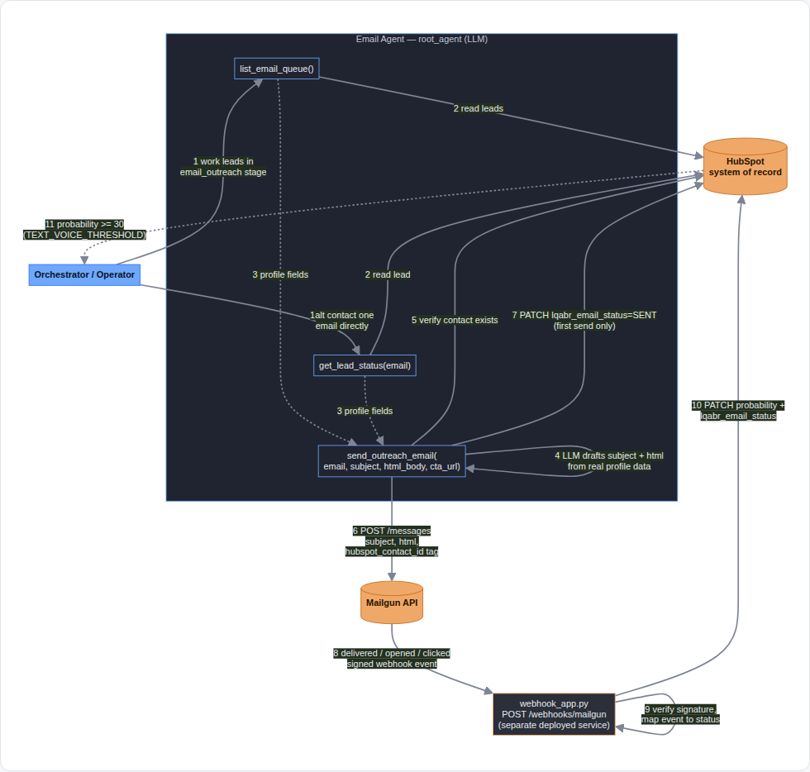
Figure 1 — Email Agent data flow: outbound draft & send (steps 1–7), inbound engagement scoring (steps 8–11).

4. Key Components
Component | Responsibility
Email Agent (LLM + tools) | Decides what to send and when. Reads lead data, drafts personalized copy, triggers the send.
HubSpot CRM Adapter | The only code path that talks to HubSpot. Owns retries and all property-level read/write logic.
Mailgun Client | The only code path that sends transactional email through Mailgun, with tracking enabled.
Mailgun Webhook Service | An independently deployed service that receives Mailgun's signed delivery/open/click events and scores them.
Probability Engine | Single source of truth for point values and promotion thresholds — shared by every agent, never duplicated.
Secrets Manager Integration | Resolves API credentials from Google Secret Manager rather than storing them in code.

5. Key Design Decisions

5.1 LLM-authored copy, grounded in real data
Outreach copy is drafted by the agent itself rather than filled into a single fixed template. This trades a small amount of predictability for meaningfully better personalization. The risk of fabricated claims is mitigated by an explicit grounding rule: the agent may only reference facts already present in the lead's HubSpot profile, and must write around any missing field rather than invent one. A static fallback template still exists purely as a safety net for the rare case where no draft is supplied.

5.2 Independent verification before every send
The send path re-verifies that the target is a real HubSpot contact at the moment of sending, independent of whatever list the agent used to decide who to contact. This closes a gap where a cached or partial view of leads could otherwise allow contacting an invalid address, and ensures the agent cannot invent a recipient.

5.3 Fail loud, never fail silent
Every external call — to HubSpot or to Mailgun — either succeeds or returns an explicit, surfaced error. Nothing is retried into invisibility beyond each client's own bounded retry/backoff policy, and a failed send is always reported rather than swallowed.

5.4 Signed, asynchronous engagement scoring
Engagement is only ever recorded from a cryptographically signed Mailgun event, verified via HMAC before anything is trusted. This is a deliberate security boundary: no other part of the system, including the LLM agent itself, can claim an email was opened or clicked without that signed evidence.

5.5 Probability as the single progression signal
There is one score, on one HubSpot record, that every consumer reads to decide whether a lead should progress. No agent maintains its own separate notion of pipeline stage — this avoids the class of bugs where two parts of the system disagree about where a lead actually is.

6. Data Flow Summary

6.1 Outbound — draft and send
The orchestrator (or an operator) asks the agent to work a lead. The agent reads that lead's real profile from HubSpot, drafts a personalized subject and body from it, and sends the message through Mailgun with tracking enabled. On the first send for a lead, HubSpot is updated to reflect that outreach has begun.

6.2 Inbound — engagement and scoring
When Mailgun reports that a message was delivered, opened, or clicked, it calls the webhook service directly — not the agent process. The webhook validates the event's signature, converts it into a score increment, and writes the lead's updated status and probability back to HubSpot in a single update. Once that score crosses a fixed threshold, the lead is considered ready for the next stage, and the orchestrator picks it up from there.

7. Non-Functional Considerations
Concern | Approach | Notes
Security | HMAC-signed webhook events; credentials in Secret Manager | No plaintext credentials in code; unsigned events rejected outright
Reliability | Bounded retry with backoff on every external call | A transient HubSpot outage triggers Mailgun's own retry rather than losing the event
Auditability | Every engagement ties back to one HubSpot contact via a correlation id | Set at send time, read back at webhook time
Extensibility | Model provider is swappable behind one wiring module | Currently Anthropic Claude; a Gemini model string routes natively instead

8. Current Limitations & Roadmap
- The webhook service is not yet deployed to a public endpoint, so live engagement scoring is not currently active — until it is deployed (Cloud Run) and registered with Mailgun, engagement is synced through a manual local utility instead.
- HubSpot does not yet have a dedicated property for cross-agent pipeline stage on the email channel; stage is inferred from the probability score by every consumer rather than stored directly.

9. References
- Full engineering reference: docs/EMAIL_AGENT_ARCHITECTURE.md
- Pipeline overview and epic map: docs/EPICS.md (Epic E4)
- Interactive data-flow diagram: docs/email_agent_data_flow.html

