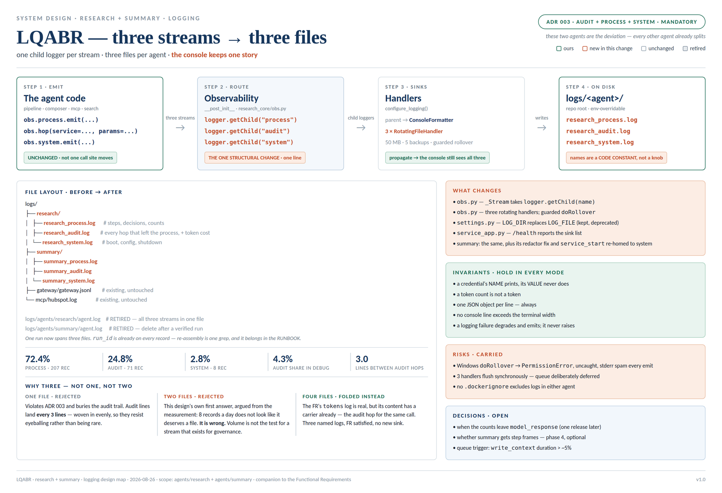

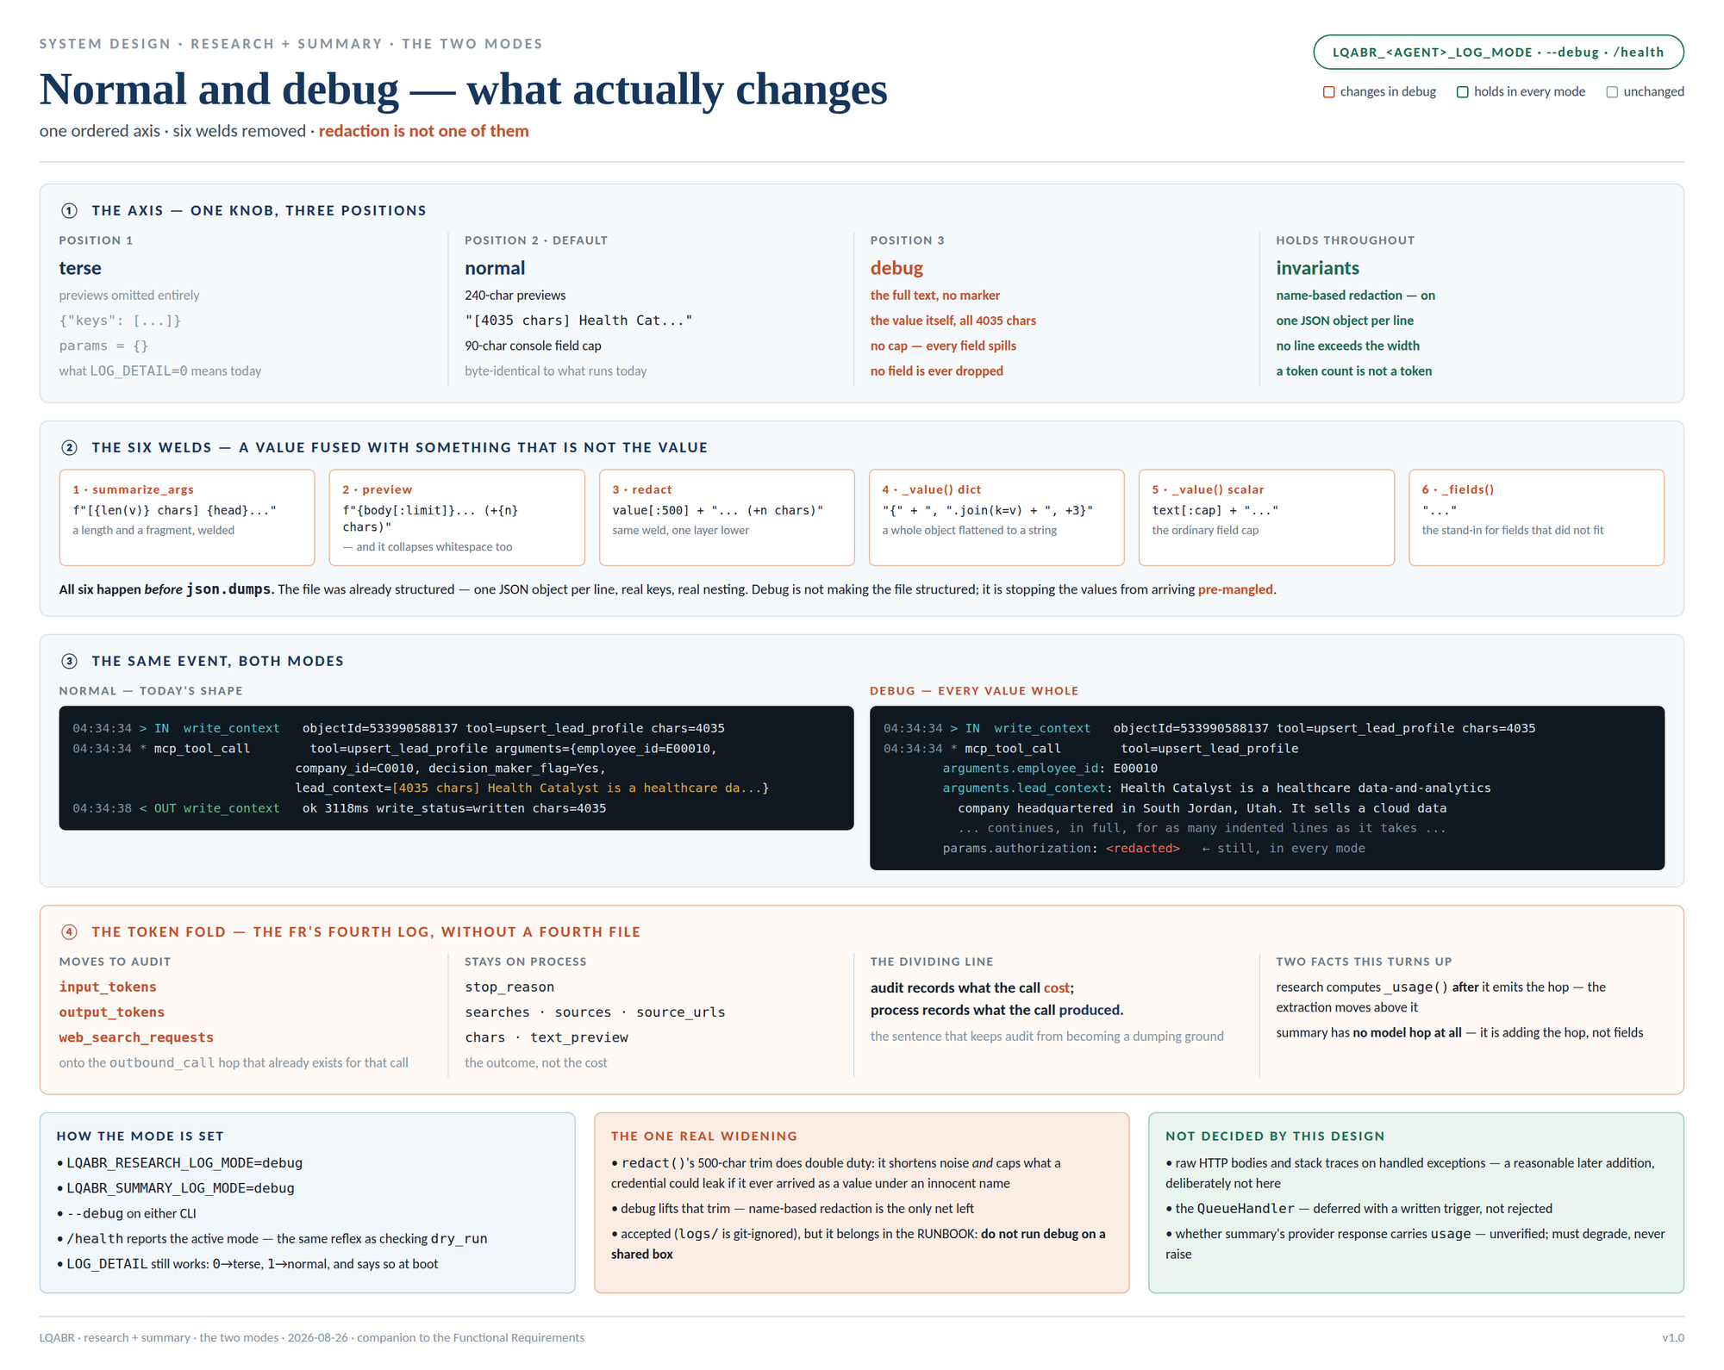

SYSTEM DESIGN · RESEARCH + SUMMARY · LOGGING
LQABR — logging on three streams
Logging Functional Requirements
For the log pipeline itself: what triggers each block, what inputs it needs, its end goal, and what it produces. Scoped to what happens between an emit() call and a line on disk; the agents' own behaviour — what they research, what they write to HubSpot — is unchanged and out of scope.
See the two design maps on the preceding pages (three streams → three files · normal and debug, side by side). Authority for the split is ADR 003; the fourth log the platform FR names is folded onto the audit hop rather than given a file — Functional Requirement 6.

Functional Requirements — the Log Pipeline

Functional Requirement 1 — Resolve the Sink · Open the Three Files
Trigger | The service starts (lifespan) or a CLI run begins, and configure_logging() is called with the settings resolved once by settings.py.
Process | 1. LOG_DIR resolves — env var, then config.yaml, then the code default logs/<agent>. A relative value resolves against the repo root; an absolute value is honoured; an empty value disables file logging entirely and the run continues on stdout alone.  2. The directory is created if it does not exist.  3. Three rotating handlers open <agent>_process.log, <agent>_audit.log and <agent>_system.log — 50 MB, 5 backups, the live file keeping the exact configured name.  4. Each handler is attached to its own child logger; the console handler stays on the parent, so nothing about the terminal changes.  5. If the directory cannot be written, log_sink_unavailable is emitted and the run proceeds — observability never kills a run.  6. A deprecated LOG_FILE, if a deployment still sets it, wins and sends all three streams to that one file, announcing itself with log_sink_legacy. Nothing is silently ignored.
Inputs required | LOG_DIR, LOG_MODE, LOG_LEVEL, LOG_FORMAT, LOG_MAX_BYTES, LOG_BACKUPS — all through settings.py, which is the only thing in either agent that reads os.environ. The repo root, for relative paths.
End goal | Three named files exist and are writable before the first record is emitted — or the failure is visible and the run still proceeds.
Produces | Three open handlers plus the console handler; a service_start record on the system stream carrying the full redacted config; logging: {mode, dir, sinks, degraded} on /health (Functional Requirement 7).

Functional Requirement 2 — Route Every Record to Its Own Stream
Trigger | Any call to obs.process.emit(), obs.audit.emit() / obs.hop(), or obs.system.emit() — anywhere in either agent.
Process | 1. Observability.__post_init__ built each _Stream on logger.getChild(<stream>) instead of on the parent logger. This is the one structural change in the whole design — a single line.  2. The field bag is redacted, serialised to one JSON object, and logged on that child.  3. The child's file handler writes the line to that stream's file and to no other.  4. The record then propagates to the parent, where the console formatter renders it — so the terminal keeps the single interleaved narrative it has today.  5. No call site moves. emit, hop, step, redact are all untouched.
Inputs required | The run's run_id; the caller's field bag; the active mode (Functional Requirements 4 and 5 decide the shape, not the destination).
End goal | One stream, one file, one destination — while a person watching a campaign still reads it as one run, top to bottom.
Produces | Exactly one line in exactly one file, plus one rendered console line. Every line carries run_id, so a run is re-assembled across the split with one command: grep -h '"run_id":"res-…"' logs/research/*.log | jq -s 'sort_by(.ts)'

Functional Requirement 3 — Rotate Without Becoming the Failure
Trigger | A stream file reaches LOG_MAX_BYTES and the handler attempts a rollover.
Process | 1. <name>.log rolls to <name>.log.1, shifting existing backups up to LOG_BACKUPS.  2. The live file keeps the exact configured name — never a dated or suffixed variant, because tooling and the runbook name it directly.  3. If the rollover raises OSError — on Windows a second handle on the file gives PermissionError [WinError 32] — it is caught, log_rotate_failed is emitted once per handler, and the handler keeps appending to the current file.  4. LOG_MAX_BYTES=0 disables rotation entirely.
Inputs required | LOG_MAX_BYTES, LOG_BACKUPS; the host OS's file-locking behaviour. These files sit on a Windows filesystem and the service and the CLI can both be live.
End goal | Bound disk use without letting the logger become the loudest failure in the run. An oversized log is a nuisance; a log that raises on every emit is an outage.
Produces | Rotated backups — or exactly one log_rotate_failed record and uninterrupted writing. At ~200 KB/day in normal mode and ~4 MB/day in debug, this path is expected to run rarely.

Functional Requirement 4 — Normal Mode
Trigger | LOG_MODE resolves to normal — the default — or the deprecated LOG_DETAIL=1 maps to it.
Process | 1. Payload text renders as a 240-character *_preview, marked when it is cut.  2. Call arguments render as [N chars] <head>….  3. redact() trims any value over 500 characters.  4. Console fields cap at 90 characters; fields that do not fit are dropped behind a single …, except a diagnosis or a payload preview, which continue on indented lines.  5. Everything else is exactly what runs today. Normal-mode output is byte-identical to current output — only re-routed.
Inputs required | The record's field bag; the real terminal width, measured rather than assumed; the active mode.
End goal | A run that is legible on screen at a glance, with no line ever wrapping over its neighbour.
Produces | Today's readable console and today's JSON records, now landing in three files instead of one.

Functional Requirement 5 — Debug Mode (no string concatenation)
Trigger | LOG_MODE=debug, or --debug on either agent's CLI.
Process | 1. preview() returns the full text — unmarked, with newlines and whitespace intact (it no longer collapses whitespace, which was itself a mutation of the value).  2. summarize_args() returns each argument's real value rather than [N chars] <head>….  3. redact() performs no length trim.  4. The hop's parameter bag is carried whole and nested.  5. On the console every field is promoted to the spill class: nothing is capped, nothing is dropped — a long value continues on indented lines.  6. Nested dicts render one key per line rather than flattened into {a=1, b=2, +3}.  7. Name-based redaction is unchanged — a credential is still <redacted>. <redacted> is a substitution, not a concatenation, so "no string concatenation" does not reach it.
Inputs required | The record's field bag; the active mode; the terminal width — used for wrapping, never for truncating.
End goal | Every logged fact reaches the file and the screen as the value it actually is. The file was already structured — one JSON object per line, real keys, real nesting; all six welds happen before json.dumps, so what debug fixes is that the values were arriving pre-mangled.
Produces | Records whose fields hold complete values; a console that continues rather than cuts; the same one-JSON-object-per-line file format, since json.dumps escapes the newlines a full value contains.

Functional Requirement 6 — Token Cost onto the Audit Hop
Trigger | A model call returns — client.messages.create in research, LiteLLM completion(...) in summary.
Process | 1. Usage is extracted before the hop is emitted. In research this means moving _usage(message) above the existing hop(...) call, where it currently runs several lines later.  2. The audit hop for that call carries input_tokens, output_tokens and web_search_requests alongside its endpoint, status, duration and attempt.  3. Summary has no model hop at all today — it emits model_call on process and nothing on audit. It gains the hop. Its retry loop emits one per attempt, distinguished by the hop's existing attempt field.  4. If the provider response carries no usage, the hop is emitted without counts — never a raise.  5. A call that raised emits an error hop with no token fields, because there was no usage. This is correct, not a gap, and is asserted so nobody later "fixes" it.  6. stop_reason, searches, sources and text_preview stay on the process stream. The counts also stay on model_response for one release, then leave.
Inputs required | The provider's response object and its usage; the model name and max_tokens, already on the hop.
End goal | Satisfy the platform FR's fourth log without a fourth file. The meter sits on the call that incurred it, so "what did this cost" needs no join. audit records what the call cost; process records what the call produced.
Produces | One audit record per model call carrying both the call and its cost; the tokens requirement met on the audit stream, in both agents.

Functional Requirement 7 — Report the Logging Configuration
Trigger | Service startup, and any request to /health.
Process | 1. service_start emits on the system stream with the full redacted config — the credential's NAME prints, its value does not.  2. /health gains logging: {mode, dir, sinks, degraded}.  3. degraded is true when any sink failed to open, so a silent no-file deployment is visible without reading the process.  4. Summary's service_start / service_stop move from the process stream to system, matching research. This changes an existing log line's stream and is flagged rather than shipped quietly.
Inputs required | The resolved settings; the state of the three handlers.
End goal | "Which mode is this running in, and where are its logs?" is answerable in one request — the same reflex as checking dry_run in /health before wondering why HubSpot is unchanged.
Produces | A system-stream boot record and a /health payload naming the active mode and the live sinks.

Edge Cases & Failure Handling
Beyond the happy paths above — how the pipeline must behave when things go wrong, and where each is visible. The rule underneath all of them: a logging failure degrades and emits; it never raises, and it never changes a lead's outcome.
Case | Expected behaviour | Where it's visible
Log directory cannot be created or written | log_sink_unavailable is emitted and the run continues on stdout alone. No raise, no failed lead. The console is unaffected, so a run watched live looks normal — which is exactly why /health must say so. | system stream (stdout) + /health degraded: true
Rollover fails — Windows, a second handle on the file | The OSError is caught, log_rotate_failed is emitted once per handler, and the handler keeps appending. Not once per emit: the reported failure in the wild is stderr spam on every record, which is worse than the oversized file. | system stream
LOG_DIR set empty | File logging is disabled entirely and deliberately. No directory is created, no handler opens, no error is raised; every stream still reaches stdout. | console only; /health reports an empty sink list
A deployment still sets the deprecated LOG_FILE | Honoured — all three streams go to that one file — and log_sink_legacy names it at boot. Nothing is silently ignored; a knob that no longer fits the design still says what it did. | system stream
A deployment still sets the deprecated LOG_DETAIL | Maps to a mode (0 → terse, 1 → normal) and log_detail_deprecated names the mode it resolved to. | system stream
A field value will not serialise | json.dumps(..., default=repr) already covers it: the record is written with the repr rather than dropped. A record that cannot be rendered is still a record. | the record's own stream
The provider response carries no usage (summary's LiteLLM path) | The audit hop is emitted without counts. Never a raise, never a skipped hop — the call happened and the audit trail must say so even when the meter is missing. | audit stream
A debug value contains newlines | json.dumps escapes them, so the file stays one JSON object per line and any parser downstream is unaffected. The console continues the value on indented lines. | all three streams
Service and CLI write the same files at once | Appends interleave safely; only rollover is at risk, and Functional Requirement 3 covers it. Each process stamps its own run_id, so the records stay separable. | system stream, on rollover failure only

The Three Logs — What Each Answers
Three distinct logs, split by layer — agent, network, container — each answering a different question. This is not a preference: ADR 003 records it as a leadership mandate enforced at PR review, and the platform's shared module already materialises the streams one file per type. One run_id correlates all three.
process_log | Agent activity — per run: which step ran, what it was handed, what it produced, and how long it took. The step_in / step_out frame is the narrative; the decisions between them (ok / failed / skipped / degraded) are why the run went the way it did. Answers "where did this run get stuck, and what did the agent decide?" — 72% of records.
audit_log | Network activity — every hop that left this process: the MCP calls, the direct HubSpot lead lookup, the model call, each with endpoint, status, attempt, duration, the parameters it was made with, and the credential's NAME. From Functional Requirement 6 it also carries the model call's token cost. Answers "did this request go out, what did it ask for, and what did it cost?" — 25% of records.
system_log | Container and configuration activity — service start and stop, the resolved config at boot, the MCP startup check. Small by design: 8 records a day, and that is the point. Answers "what was this process, and what was it configured with?" — independent of any single run.

Where each log is written
Startup (FR 1, FR 7) | system — the resolved config, the credential names, the MCP startup check. Written before any run exists.
A campaign or a single lead (FR 2) | process for every step frame and decision; audit for every MCP call, the direct HubSpot lookup, and the model call. Both correlated by one run_id, which the RUNBOOK's cross-file grep depends on.
The model call (FR 6) | audit — one hop carrying the call and its cost. The outcome of that call (stop_reason, sources, the note itself) stays on process, because it is what the call produced rather than what it cost.
A logging failure (FR 3) | system — log_sink_unavailable or log_rotate_failed, once. A failure in the observability layer is a system fact, not a step outcome, and must never be recorded as a failed lead.

Configuration Requirements
Every knob is env-driven and resolved once, so a change out there is a config change and never a code edit. Research shown; summary is identical with LQABR_SUMMARY_*. Precedence, highest first: environment variable → config.yaml → code default.
Location | LQABR_RESEARCH_LOG_DIR, default logs/research. A relative value resolves against the repo root; an absolute value is honoured; empty disables all file logging. Chosen to match the trees that already exist — logs/gateway/, logs/mcp/.
Naming | A code constant, {agent}_{stream}.log — deliberately not a knob. The "a rename outside is a config change" rule covers vocabulary owned by HubSpot and the MCP; these six names are ours, and making them configurable only invites two deployments that disagree about where the logs are.
Mode | LQABR_RESEARCH_LOG_MODE = terse | normal | debug, default normal. One ordered axis replacing two half-overlapping knobs. --debug on the CLI sets it for that run.
Rotation | LQABR_RESEARCH_LOG_MAX_BYTES (default 52 428 800 — 50 MB) and LQABR_RESEARCH_LOG_BACKUPS (default 5). 0 bytes disables rotation. The ceiling matters more than the cadence: at measured volumes this path rarely runs.
Unchanged | LQABR_RESEARCH_LOG_LEVEL stays a severity filter, and LQABR_RESEARCH_LOG_FORMAT (auto | text | json) stays console-shape only. Neither is the record's shape — that is what LOG_MODE is for, and conflating the two is why LOG_LEVEL=DEBUG was rejected as the switch.
Deprecated, still honoured | LQABR_RESEARCH_LOG_FILE → one file for all three streams, plus log_sink_legacy. LQABR_RESEARCH_LOG_DETAIL → 0 is terse, 1 is normal, plus log_detail_deprecated. Both keep working and both say so at boot.
Ignore policy | logs/ and *.log are already git-ignored (.gitignore:47-49, verified). They must also be added to agents/summary/.dockerignore, which has no log entry, and to agents/research/.dockerignore, which does not exist and must be created — debug files carry full prompts and full notes.

Verification — What Proves Each Requirement
Every change ships with a test. The suite is offline and needs no credentials: cd agents/research && PYTHONPATH=src:packages python3 -m pytest -q. Verify by running, not by reading — several real bugs in this repo were found only because a documented command was actually executed.
Requirement | What proves it
FR 1 · sink | three files under the configured dir with exactly the six names · every line parses as JSON  LOG_DIR="" → no files, no error, stdout unaffected · an unwritable dir → log_sink_unavailable and the run completes  legacy LOG_FILE set → one file and log_sink_legacy naming it
FR 2 · routing | a process record lands in research_process.log and not in the other two · an audit hop lands in research_audit.log only  the console still receives all three — propagation intact  the existing 87 tests still pass unchanged: test_obs_detail._obs() injects a parent logger, and getChild children propagate into its handler. Reasoned, not yet confirmed — run the suite before calling this done.
FR 3 · rotation | a small maxBytes → .1 appears and the live file keeps the exact name  a rollover that raises → log_rotate_failed once, and writing continues
FR 4 · normal | terse reproduces today's detail=False shape exactly · LOG_DETAIL=0 resolves to terse and emits log_detail_deprecated · no console line exceeds the width at 90 / 120 / 165
FR 5 · debug | summarize_args({"lead_context": "N"*4000})["lead_context"] == "N"*4000 · preview(long) returns the input unchanged, newlines intact · redact({"note": "N"*4000})["note"] is 4000 chars  `redact({"api_key": "sk-ant-x"})["api_key"] == "<redacted>"` — asserted in debug mode specifically, not only in normal  the full value is present across the continuation lines, uncut · no line exceeds the width · a record holding a newline still serialises to exactly one line
FR 6 · token fold | a successful model call puts all three counts on the audit hop · a call that raises emits an error hop with no token fields  stop_reason, sources, chars stay on process — the fold does not drag outcome fields with it  summary: one hop per retry attempt · usage absent degrades to a hop with no counts, never a raise  a token count still survives redaction — the existing rule, now on the audit stream too
FR 7 · reporting | /health reports the active mode and the sink list · service_start appears on the system stream in both agents · summary's redact({"secret_name": …}) returns the NAME, not <redacted>
End to end | start each service, hit /health, confirm logging.mode and the sinks  run one campaign in normal mode; diff the console against today's — it must be identical  run the same campaign in debug; confirm the full note is in research_process.log and no credential is, and that the token counts are in research_audit.log rather than process  run each CLI with --debug; confirm stdout is still a parseable result document

References: docs/adr/003-agentic-tooling-and-logging-standards.md (audit / process / system, mandatory) · packages/lqabr_core/lqabr_core/obs/loggers.py (the four-log FR and the one-file-per-type convention) · docs/AGENT.md (the tokens stream, "wherever a model runs") · PROJECT_CONTEXT.md · OWASP Logging Cheat Sheet · PCI-DSS Requirement 10 · NIST SP 800-92.

