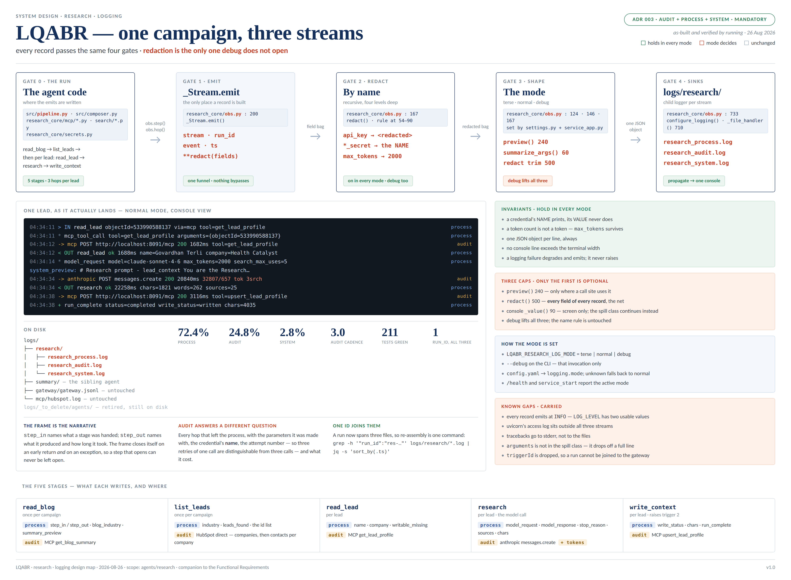

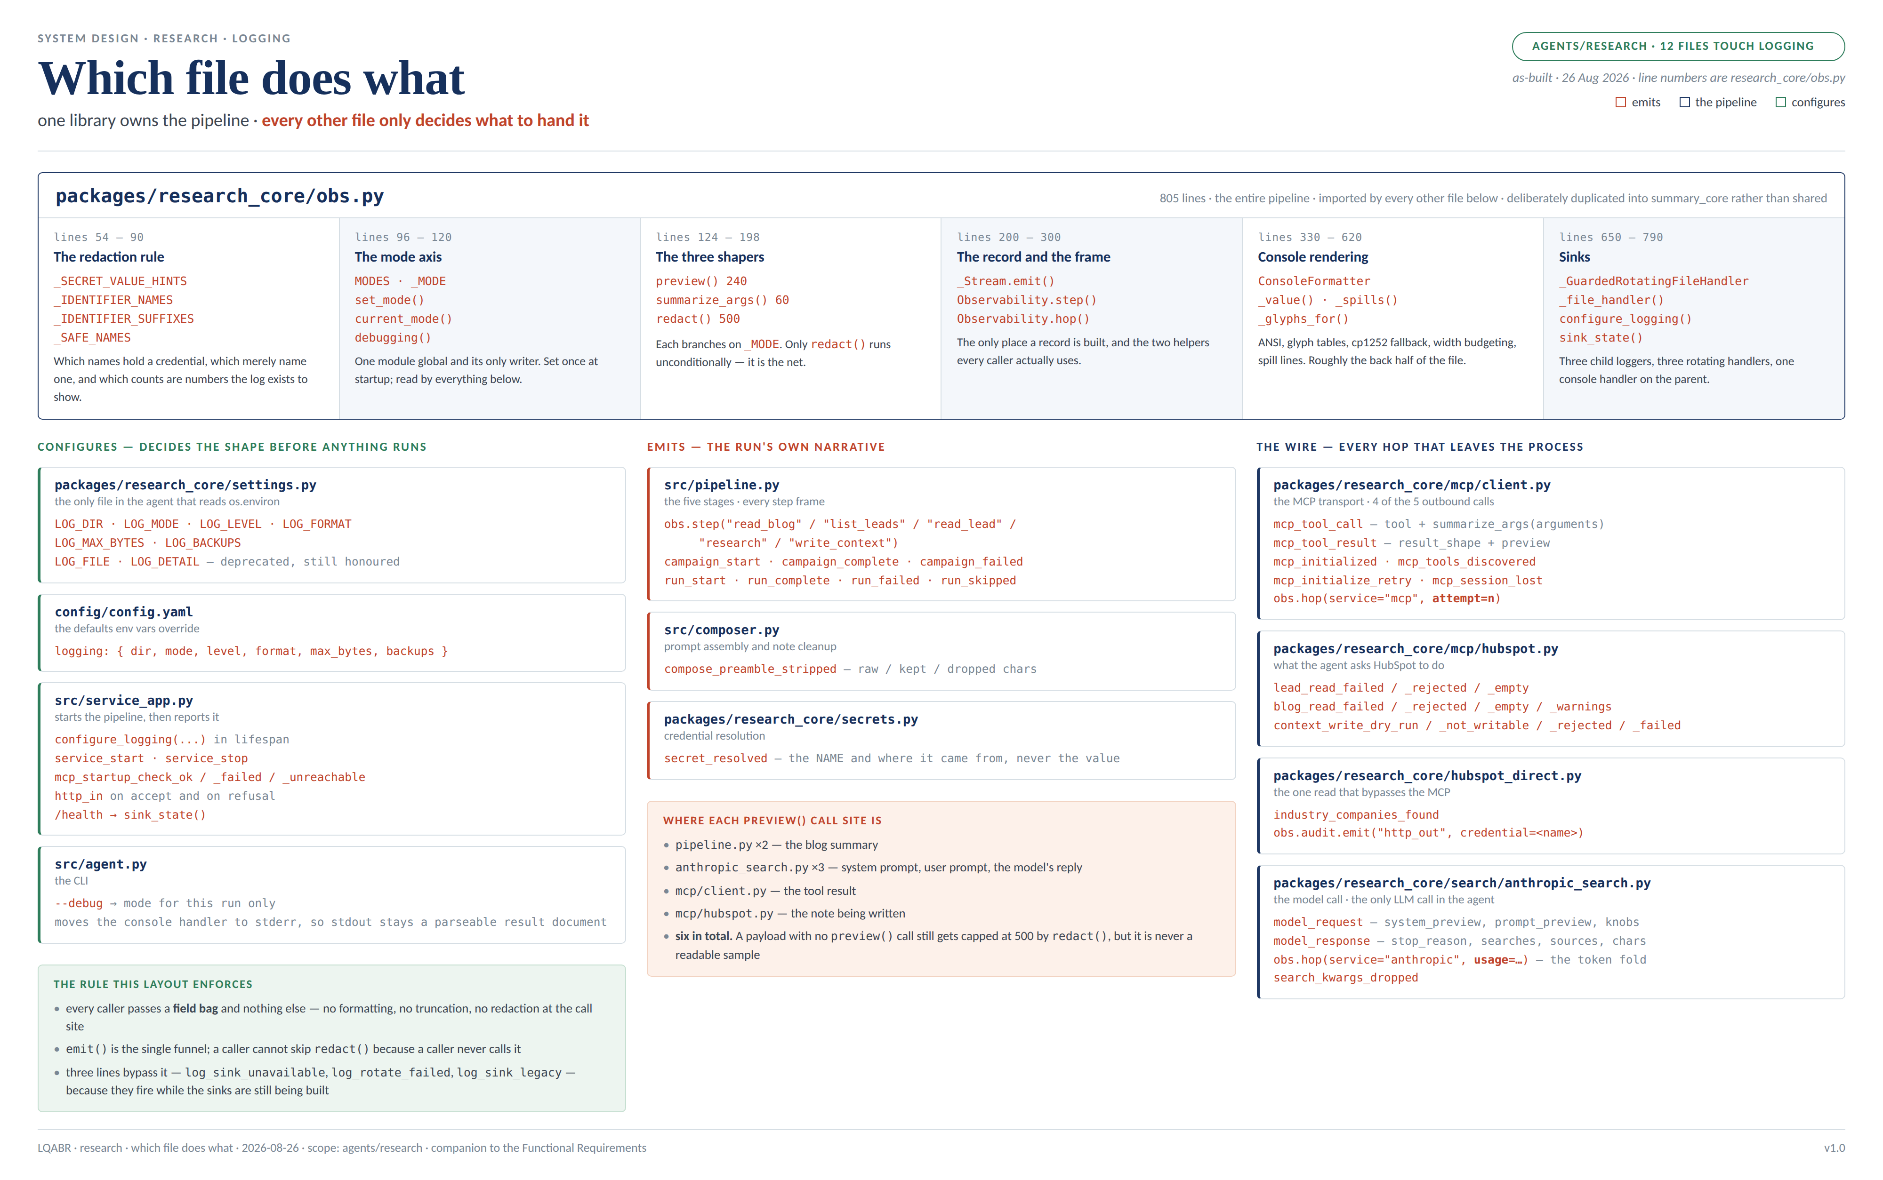

SYSTEM DESIGN · RESEARCH · LOGGING
LQABR — research agent logging
Logging Functional Requirements
For the log pipeline itself: what triggers each block, what inputs it needs, its end goal, and what it produces. Scoped to agents/research — what happens between an emit() call and a line on disk. The agent's own behaviour — what it researches and what it writes to HubSpot — is unchanged and out of scope. Summary carries a deliberate copy of the same obs.py and is documented separately.
See the two design maps on the preceding pages — the four gates every record passes with one lead as it actually lands, and which file owns which part of the pipeline. As-built and verified by running, 26 August 2026. Authority for the three-stream split is ADR 003; the fourth log the platform FR names is folded onto the audit hop rather than given a file — Functional Requirement 7. Deviations from the pre-build design are recorded in Known Gaps rather than quietly reconciled.

Functional Requirements — the Log Pipeline

Functional Requirement 1 — Resolve the Sink · Open the Three Files
Trigger | The service starts (FastAPI lifespan) or a CLI run begins, and configure_logging() is called with settings resolved once by settings.py.
Process | 1. LOG_DIR resolves — env var, then config.yaml, then the code default logs/research. Relative resolves against the repo root; absolute is honoured; empty disables file logging entirely and the run continues on stdout.  2. For each of the three streams a _GuardedRotatingFileHandler opens logs/research/research_<stream>.log, creating parent directories as needed.  3. A handler that cannot be opened emits log_sink_unavailable naming the path and the OSError, returns None, and that stream becomes console-only. The run is not affected.  4. The console handler is attached to the PARENT logger and log_format decides its shape: auto renders text when stdout is a terminal and JSON when it is not.  5. set_mode() records the active detail mode process-wide (Functional Requirements 5 and 6).
Inputs required | LOG_DIR, LOG_MODE, LOG_LEVEL, LOG_FORMAT, LOG_MAX_BYTES, LOG_BACKUPS — all through settings.py, the only thing in the agent that reads os.environ. The repo root, for relative paths.
End goal | Three named files exist and are writable before the first record is emitted — or the failure is visible and the run still proceeds.
Produces | Three open file handlers plus one console handler; a service_start record on the system stream carrying the full redacted config; logging: {mode, dir, files, degraded} on /health.

Functional Requirement 2 — Route Every Record to Its Own Stream
Trigger | Any call to obs.process.emit(), obs.audit.emit() / obs.hop(), or obs.system.emit() — anywhere in the agent.
Process | 1. Observability.__post_init__ builds each _Stream on logger.getChild(<stream>) rather than on the parent. That single line is the whole structural change.  2. _Stream.emit builds the record — stream, run_id, event, ts — then splats the redacted field bag over it.  3. The JSON string IS the log message, so the file handler needs no formatter beyond %(message)s. The record also rides on extra so the console formatter renders it without parsing its own output back.  4. The child writes to its own file; propagation carries the same record up to the parent's console handler.
Inputs required | The run's run_id, held on a ContextVar rather than a module global; the caller's field bag; the active mode, which decides shape but never destination.
End goal | One stream, one file — while a person watching a campaign still reads it as one run, top to bottom.
Produces | Exactly one line in exactly one file, plus one rendered console line. Every record carries run_id, so a run is re-assembled across the split with: grep -h '"run_id":"res-…"' logs/research/*.log | jq -s 'sort_by(.ts)'

Functional Requirement 3 — Frame Every Step · Record Every Hop
Trigger | A pipeline stage opens (with obs.step(...)) or an outbound call returns (obs.hop(...)).
Process | 1. obs.step emits step_in naming what the stage was handed, yields, then emits step_out with the outcome and duration_ms measured on time.monotonic().  2. The frame closes itself on the way out of the block, on an early return, and on an exception — which is recorded as the failure it is before it propagates. A step that opens can never be left open.  3. Each stage sets its own result: step.ok(...), step.failed(reason, ...) or step.skipped(reason, ...).  4. obs.hop writes one audit record per outbound call carrying service, endpoint, method, status, attempt, duration_ms and the parameters it was made with — never the raw payload and never a credential.
Inputs required | The five research stages — read_blog, list_leads, read_lead, research, write_context — and the three outbound services: mcp, hubspot (the one direct lead lookup), anthropic.
End goal | Read top to bottom, the log IS the run: what was asked, what came back, how long it took, and which decision followed.
Produces | A matched step_in / step_out pair per stage on process; one outbound_call per hop on audit, with attempt carrying the retry number so three retries of one call are distinguishable from three calls.

Functional Requirement 4 — Redact by Name, in Every Mode
Trigger | Every record, without exception — redact() runs inside _Stream.emit on the whole field bag.
Process | 1. A field whose NAME suggests it HOLDS a credential is blanked: token, secret, password, api_key, authorization, auth, bearer, credential.  2. A field whose name NAMES a credential rather than holding one is preserved: the suffixes _secret, _secret_name, _name, _source, _ref, and the names secret, credential, secrets_source.  3. A token COUNT is a number the log exists to show: max_tokens, input_tokens, output_tokens and their kin survive.  4. Recursive to four levels, because a credential nested inside a params or arguments bag must not escape the rule that blanks it at the top.  5. Outside debug, any string over 500 characters is trimmed. This is a length cap, not a security control — the name rule is the security control.
Inputs required | The field bag as the caller passed it. Nothing else: the rule is name-based on purpose, because a token cannot be recognised by looking at it but we always know what we called it.
End goal | Log the credential's NAME and never its value — the project non-negotiable — and hold that in debug, where the length cap is lifted and the name rule becomes the only net.
Produces | api_key → <redacted>. model_token_secret → lqabr-anthropic-api-key. secrets_source → env. max_tokens → 2000. Asserted in debug specifically, not only in normal.

Functional Requirement 5 — Normal Mode
Trigger | LOG_MODE resolves to normal — the default — or the deprecated LOG_DETAIL=1 maps to it.
Process | 1. Payload text renders as a 240-character *_preview, whitespace collapsed to one line and marked with (+N chars) when cut.  2. Call arguments render as [N chars] <head>… via summarize_args().  3. redact() trims any value over 500 characters.  4. Console fields cap at 90 characters and are dropped when the line fills — except the spill class (reason, error, detail, and anything ending _preview), which continues on indented lines rather than being cut.  5. No console line may exceed the terminal width, measured rather than assumed.
Inputs required | The record's field bag; the real terminal width; the active mode.
End goal | A run that is legible on screen at a glance, with no line ever wrapping over its neighbour.
Produces | The readable console narrative and JSON records small enough to scan — the shape a person watching a campaign needs.

Functional Requirement 6 — Debug Mode, No String Concatenation
Trigger | LOG_MODE=debug, or --debug on the CLI, which overrides the environment for that invocation only.
Process | 1. preview() returns the full text — unmarked, newlines intact. It no longer collapses whitespace, which was itself a mutation of the value.  2. summarize_args() returns each argument's real value rather than [N chars] <head>….  3. redact()'s 500-character trim is skipped; the name rule is untouched.  4. hop(params=…) carries the full nested bag.  5. The console drops no field and caps no value; every field joins the spill class and continues on indented lines.
Inputs required | The record's field bag; the active mode; the terminal width — used for wrapping, never for truncating.
End goal | Every logged fact reaches the file and the screen as the value it actually is. All five caps happen BEFORE json.dumps, so a structured file had been storing damaged strings in well-formed fields; debug stops the values arriving pre-mangled.
Produces | Records whose fields hold complete values; a console that continues rather than cuts; the same one-JSON-object-per-line format, because json.dumps escapes the newlines a full value contains. The tell: (+N chars) never appears.

Functional Requirement 7 — Token Cost onto the Audit Hop
Trigger | A model call returns — client.messages.create in AnthropicWebSearch.research().
Process | 1. usage = _usage(message) is extracted BEFORE the hop is emitted, so the meter rides the line for the call it measures. It previously ran several lines later, which is why answering "what did that call cost" meant joining audit to process on run_id and ordering.  2. The audit hop carries input_tokens, output_tokens and web_search_requests as top-level fields.  3. Counts that are absent are omitted rather than printed as empty columns.  4. A call that RAISED produced no usage, and its error hop carries none. That is correct rather than a gap, and is asserted so nobody later "fixes" it.  5. The three counts stay on model_response for one release alongside the new audit fields — migrate, do not yank.
Inputs required | The provider's response object and its usage; the model name and max_tokens, already on the hop.
End goal | Satisfy the platform FR's fourth log without a fourth file. Audit records what the call cost; process records what the call produced — so stop_reason, searches, sources and chars stay where they are.
Produces | One audit record per model call carrying both the call and its cost, rendered on the console as: → anthropic POST messages.create 200 20840ms 32807/657 tok 3srch

Functional Requirement 8 — Rotate, Degrade, and Report
Trigger | A stream file reaches LOG_MAX_BYTES; or a sink cannot be opened; or /health is requested.
Process | 1. <name>.log rolls to <name>.log.1, shifting existing backups up to LOG_BACKUPS. The live file keeps the exact configured name — never a dated variant, because tooling and the RUNBOOK name it directly.  2. If the rollover raises OSError — Windows PermissionError [WinError 32] when the service and the CLI both hold the file — _GuardedRotatingFileHandler catches it, emits log_rotate_failed ONCE per handler, and keeps appending. Not once per emit: the reported failure in the wild is stderr spam on every record, which is an outage rather than a nuisance.  3. sink_state() reports dir, files and degraded, and /health carries it beside the active mode.
Inputs required | LOG_MAX_BYTES, LOG_BACKUPS; the host OS's file-locking behaviour.
End goal | Bound disk use without letting the logger become the loudest failure in the run, and make a degraded sink visible without reading the boot log.
Produces | Rotated backups — or exactly one log_rotate_failed record and uninterrupted writing. "Which mode is this running in, and where are its logs?" answerable in one request.

Edge Cases & Failure Handling
Beyond the happy paths above — how the pipeline must behave when things go wrong, and where each is visible. The rule underneath all of them: a logging failure degrades and emits; it never raises, and it never changes a lead's outcome.
Case | Expected behaviour | Where it is visible
Log directory cannot be created or written | log_sink_unavailable is emitted naming the path, and the run continues on stdout alone. No raise, no failed lead. The console is unaffected, so a run watched live looks normal — which is exactly why /health must say so. | system stream; /health degraded
Rollover fails — Windows, a second handle on the file | The OSError is caught, log_rotate_failed is emitted once per handler, and the handler keeps appending to the file it has. | system stream, once
LOG_DIR set empty | File logging is disabled entirely and deliberately. No directory is created, no handler opens, no error is raised; every stream still reaches stdout. | console only; /health reports an empty sink list
A deployment still sets the deprecated LOG_FILE | Honoured — all three streams go to that one file — and log_sink_legacy names it at boot. A knob that no longer fits the design still says what it did. | system stream
A deployment still sets the deprecated LOG_DETAIL | Maps to a mode (0 → terse, 1 → normal) and log_detail_deprecated names the mode it resolved to. Consulted only when LOG_MODE is unset. | system stream
An unknown LOG_MODE value | Falls back to normal rather than raising. A logging setting must never stop a run. | the resolved mode on service_start
A field value will not serialise | json.dumps(..., default=repr) covers it: the record is written with the repr rather than dropped. A record that cannot be rendered is still a record. | the record's own stream
A debug value contains newlines | json.dumps escapes them, so the file stays one JSON object per line and any downstream parser is unaffected. The console continues the value on indented lines. | all three streams
Service and CLI write the same files at once | Appends interleave safely; only rollover is at risk, and Functional Requirement 8 covers it. Each process stamps its own run_id, so the records stay separable. | system stream, on rollover failure only
The MCP retries a call three times | Each attempt writes its own audit hop carrying attempt=1, 2, 3, so one retried operation is distinguishable from three separate operations. | audit stream

The Three Logs — What Each Answers
Three distinct logs, split by layer — agent, network, container — each answering a different question. ADR 003 records the split as a leadership mandate enforced at PR review, and the platform's shared module already materialises streams one file per type. One run_id correlates all three.
research_process.log | Agent activity — per run: which step ran, what it was handed, what it produced, and how long it took. The step_in / step_out frame is the narrative; the decisions between them (ok / failed / skipped / degraded) are why the run went the way it did. Roughly 72% of records.
research_audit.log | Network activity — every hop that left this process: the MCP calls, the one direct HubSpot lead lookup, and the model call, each with endpoint, status, attempt, duration, the parameters it was made with, the credential's NAME, and — from Functional Requirement 7 — what the call cost. Roughly 25% of records.
research_system.log | Container and configuration activity — service start and stop, the resolved config at boot, the MCP startup check, and any sink failure. Small by design: single figures per day, and that is the point. Answers "what was this process, and what was it configured with?"

Where each log is written
Startup (FR 1, FR 8) | system — the resolved config with credential NAMES, and the MCP startup check. Written before any run exists.
Receiving a hand-off | audit — http_in with the route, objectId, the HubSpot event fields and the run_id, including on a refusal so a rejected campaign is findable later.
read_blog · list_leads (FR 3) | process for the step frames; audit for the MCP get_blog_summary call and for the direct HubSpot company/contacts lookup — the one read that bypasses the MCP.
Per lead: read_lead · research · write_context | process for each step frame and its decision; audit for the two MCP hops and the model call. All correlated by the campaign's run_id, which the RUNBOOK's cross-file grep depends on.
The model call (FR 7) | audit — one hop carrying the call and its cost. The outcome of that call (stop_reason, searches, sources, the note itself) stays on process, because it is what the call produced rather than what it cost.
A logging failure (FR 8) | system — log_sink_unavailable or log_rotate_failed, once. A failure in the observability layer is a system fact, not a step outcome, and must never be recorded as a failed lead.

Configuration Requirements
Every knob is env-driven and resolved once, so a change out there is a config change and never a code edit. Precedence, highest first: environment variable → the deprecated alias, only when the primary is unset → config.yaml → code default. The prefix is LQABR_RESEARCH_; the summary agent owns LQABR_SUMMARY_ and reads none of these.
LOG_DIR | Default logs/research. Relative resolves against the repo root; absolute is honoured; empty disables all file logging. Chosen to match the trees that already exist — logs/gateway/, logs/mcp/.
Naming | A code constant, research_<stream>.log — deliberately not a knob. The "a rename outside is a config change" rule covers vocabulary owned by HubSpot and the MCP; these three names are ours, and making them configurable only invites two deployments that disagree about where the logs are.
LOG_MODE | terse | normal | debug, default normal. One ordered axis. An unknown value falls back to normal rather than raising. --debug on the CLI sets it for that invocation only, overriding both env and config.
LOG_LEVEL | Default INFO. A severity filter, not the record's shape — conflating the two is why LOG_LEVEL=DEBUG was rejected as the mode axis. See Known Gaps: every record is currently emitted at INFO, so this knob has two usable values.
LOG_FORMAT | auto | text | json, default auto. Console shape only — the FILES are always JSON. auto means readable text when stdout is a terminal and JSON when it is not, so Cloud Run keeps structured fields while a human gets something legible.
LOG_MAX_BYTES · LOG_BACKUPS | Default 52 428 800 (50 MB) and 5. 0 bytes disables rotation. At measured volumes this path runs rarely — see Known Gaps.
LOG_FILE (deprecated) | Sends all three streams to one file and emits log_sink_legacy naming it at boot. Off unless explicitly asked for: it used to default to logs/agents/research/agent.log, which would quietly keep every stream in one place after the split.
LOG_DETAIL (deprecated) | 0 → terse, 1 → normal, plus log_detail_deprecated naming the resolved mode. Consulted only when LOG_MODE is unset. Research only — summary never had the boolean and therefore has no alias.
Ignore policy | logs/ and *.log are git-ignored (.gitignore:48-49) and agents/research/.dockerignore now excludes them — debug files carry full prompts and full notes, and the alternative is a debug log baked into an image layer.

Verification — What Proves Each Requirement
Every change ships with a test. The suite is offline and needs no credentials: cd agents/research && PYTHONPATH=src:packages python3 -m pytest -q — 211 passing, 1 skipped. Verify by running, not by reading: several real bugs in this repo were found only because a documented command was actually executed.
FR 1 · sink | Three files under the configured dir with exactly the three names · every line parses as JSON · LOG_DIR="" → no files, no error, stdout unaffected · an unwritable dir → log_sink_unavailable and the run completes · legacy LOG_FILE → one file plus log_sink_legacy. tests/test_obs_sinks.py.
FR 2 · routing | A process record lands in research_process.log and NOT in the other two · an audit hop lands in research_audit.log only · the console still receives all three, so propagation is intact · the pre-existing obs tests pass unchanged, which is what proves getChild() did not change what any assertion sees.
FR 3 · frames and hops | A step left by an exception still closes and names the exception · three MCP retries produce three hops reading attempt=1, 2, 3 · driven end to end against a real MCPClient with a stubbed transport, not only in unit tests.
FR 4 · redaction | redact({"api_key": "sk-ant-x"})["api_key"] == "<redacted>" asserted IN DEBUG · model_token_secret returns the NAME · secrets_source survives · max_tokens survives · a credential nested in a params bag is blanked.
FR 5 · normal | terse reproduces the old detail=False shape exactly · LOG_DETAIL=0 resolves to terse and emits log_detail_deprecated · no console line exceeds the width at 90 / 120 / 165 columns.
FR 6 · debug | summarize_args({"lead_context": "N"*4000})["lead_context"] == "N"*4000 · preview(long) returns the input unchanged, newlines intact · redact({"note": "N"*4000})["note"] is 4000 chars · a record holding a newline still serialises to exactly one line · verified live: a 5,400-character note stored whole with zero (+N chars) markers.
FR 7 · token fold | A successful model call puts all three counts on the audit hop · a call that raises emits an error hop with NO token fields, asserted rather than left ambiguous · stop_reason, sources and chars stay on process, so the fold does not drag outcome fields with it. tests/test_obs_tokens.py.
FR 8 · rotate and report | A small maxBytes → .1 appears and the live file keeps the exact name · a rollover that raises → log_rotate_failed once, and writing continues · /health reports the active mode and the sink list.
End to end | Start the service, hit /health, confirm logging.mode and the sinks · run one campaign in normal mode and read the console: step frames, mcp_tool_call with arguments, the outbound hop with parameters, mcp_tool_result with shape and preview · run the same campaign in debug and confirm the full note is in research_process.log and no credential is.

Known Gaps — Open and Named
Recorded rather than rounded up. None of these prevents the requirements above from being met; each is a place where the system is weaker than it reads.
The level axis is near-dead | Every record is emitted at logger.info() — the agent uses no .debug(), .warning(), .error() or .exception() anywhere. Measured: LOG_LEVEL=DEBUG and INFO emit identically, and WARNING silences the agent entirely, failures included. So LOG_LEVEL has two usable values, and "failures only" cannot be expressed. Using severity properly would make the two axes genuinely orthogonal.
Uvicorn's access log is outside the system | Nothing configures uvicorn.access, uvicorn.error or the root logger, so request lines are plain text, in no file, and carry no run_id.
No HTTP middleware | A 422 from pydantic or a 404 never reaches a handler, so it produces no http_in record. Those requests are invisible to the three streams.
Tracebacks are not in the files | _guarded records "TypeError: …" on the process stream and re-raises; the stack goes to uvicorn's stderr. Two halves of one failure in two places.
arguments can be dropped from a full console line | arguments is not in the spill class, so the mcp_tool_call for the CRM write — the one line whose job is "what did we send" — loses its payload exactly when the payload is largest. Adding arguments and params to the spill set is a two-line fix.
Run correlation does not cross the gateway | The gateway sends triggerId on every hand-off and A2AEnvelope does not declare the field, so pydantic drops it. The agent returns run_id in the acknowledgement and the gateway captures it into A2AResponse.result, which nothing reads. A research run cannot currently be joined back to the dispatch that caused it.
Rotation effectively never fires | The ceiling is 50 MB and research_process.log is under 1 MB after a full day. The files grow slowly and never roll, so "give me yesterday's log" is not a question this setup can answer. TimedRotatingFileHandler(when="midnight") would fit actual usage; the guard subclass works unchanged against it.
obs.py is 805 lines | Roughly the back half is the console formatter, which shares nothing with the logging contract above it but a dict. The split is deferred deliberately: both agents carry deliberate copies, so the two halves must move in lockstep or test_standalone.py starts lying.
Blocking file I/O is unmeasured | Three handlers flush synchronously and debug multiplies bytes per record. A QueueHandler is deferred with a written trigger to revisit: write_context's duration_ms moving more than ~5% in a debug campaign.
References: docs/adr/003-agentic-tooling-and-logging-standards.md (audit / process / system, mandatory) · packages/lqabr_core/lqabr_core/obs/loggers.py (the four-log FR and the one-file-per-type convention) · docs/AGENT.md (the tokens stream, "wherever a model runs") · PROJECT_CONTEXT.md · docs/RUNBOOK.md · docs/ENV_VARS.md · OWASP Logging Cheat Sheet · PCI-DSS Requirement 10 · NIST SP 800-92.

