ChatDSI

Business Requirement Document

**Confidentiality Statement**

Information and data contained herein are proprietary and confidential.

This information should not be disclosed to any third party without the prior written consent of Daiichi Sankyo Incorporated.

**Table of Contents**

**1** **Feature Revision History** - 3 -

**2** **Overview** - 3 -

**2.1 Introduction** - 3 -

**2.2 In-scope** - 3 -

**2.3 Out of scope** - 4 -

**2.4 Acronyms and Abbreviations** - 5 -

**2.5 Assumptions and Risks** - 5 -

**2.5.1 Assumptions** - 5 -

**2.5.2 Risks** - 5 -

**3** **Business requirements** - 6 -

**3.1** **Application/User Interface** - 6 -

**3.2** **Current state and New state** - 7 -

**3.3** **Risk and Mitigation strategies** - 8 -

**3.4** **Business stakeholders** - 8 -

**4** **Procedural requirements** - 9 -

**4.1** **Training Procedures** - 9 -

# **Feature Revision History**

|  |  |  |  |
| --- | --- | --- | --- |
| **Version sharepoint** | **Date of revision** | **Date of Release** | **Description** |
| 1.0 |  | 15th Jan | Initial release |
| 2.0 |  | 6th May | Addition of File-Upload feature and Creativity feature |
| 3.0 |  | 3rd June | Addition of GPT 4 Turbo feature and functionality to Copy/Export chat response |
| 4.0 | 06/17 | 8th July | Switch to GPT 4o, major UI revamp with better user experience, including addition of prompt suggestions, chat edit and regenerate options |
| 5.0 | 06/18 | August | Single/multi-image upload; ability to read documents with images and scanned documents |
| 6.0 | 07/01 | August | Addition of translate option for responses and for documents that are uploaded. |
| 7.0 | 08/27 | September | Citations and Voice Interaction |
| 8.0 | 10/28 | Jan | Bulk Upload |
| 9.0 | 12/13 | April | SharePoint connection |
| 10.0 | 12/13 | April-May | Teams Integration |
| 11.0 | 04/15 | April | Production Issues resolved |

# **Overview**

## **2.1 Introduction**

ChatDSI uses GPT-4o model to provide accurate responses to user queries. It offers a user-friendly way for employees to access information quickly and improve productivity. The core functionality of our web application revolves around its ability to understand and respond to user queries, making it an indispensable tool for information retrieval and workflow optimization. By leveraging the power of Azure and GPT model, we offer a simplified yet powerful interface that facilitates efficient communication between users and the application.

The Upload feature enhances ChatDSI by allowing users to upload documents and images directly into conversations, eliminating the need for manual text input. It supports PDF, DOCX, PPTX, XLSX, CSV, TXT, PNG, JPG and JPEG formats, streamlining interactions and enabling efficient content analysis and summarization with the GPT-4o model. Integrated with Azure, this functionality bolsters ChatDSI's ability to simplify information access and improve communication efficiency.

## **2.2 In-scope**

* The application will implement Single Sign-On (SSO) functionality, integrating seamlessly with Azure Active Directory for user authentication and access management.
* The web application is designed to provide access to up to 2000 DSI users, ensuring efficient access to information.
* The web application employs the GPT-4o model to deliver precise responses to user inquiries, facilitating a user-friendly approach for employees to swiftly access information and enhance productivity
* Users can copy and export responses in PDF, TXT, or DOCX formats, enhancing documentation and sharing capabilities.
* Users can click on ‘Feedback’ button to access a Microsoft Form where they can submit their feedback. This feature ensures that user suggestions and concerns are directly communicated to the development team for continuous improvement.
* ‘Customize’ feature grants users the flexibility to tailor their chat experience according to their preferences or specific needs. It enables users to customize and fine-tune their interactions with the assistant. For instance, users can set the assistant to function as a ‘French translator’, aiding in the seamless translation of text or conversations.
* Clear Chat option allows users to clear all previous chat history from the current session, effectively creating a new session. It ensures privacy and a clean slate for users wanting to start fresh without previous conversation contexts influencing the current session.
* Help window is available for users needing assistance or guidance regarding the application's functionality. This feature aims to provide immediate support, helping users understand and navigate through the various functionalities the application offers.
* Users will have the ability to upload more than one file/ image (for file types: PDF, DOCX, PPTX, TXT, PNG, JPEG, JPG) at a time, facilitating a more efficient workflow where numerous documents need to be reviewed or processed in a single session.
* Once uploaded, the system can analyze the content within these files. It can summarize the text, extract pertinent information, and even answer questions related to the content, leveraging the GPT-4o model's understanding capabilities.
* Regenerate chat option will allow users to regenerate responses for the same prompt, which was used to generate the original response.
* Edit chat option will allow users to original prompt and generate a response for the changed prompt.
* A streaming-enabled OpenAI ChatCompletion call is initiated with appropriate parameters (model, temperature, max_tokens), enabling a real-time typing effect and faster perceived response time

## **2.3 Out of scope**

* The web application will not be fine-tuned to access or retrieve information from company-related databases or documents. It will operate independently from such data sources.
* While the application will provide intelligent responses, it will not replace the need for human oversight, especially in cases where accuracy and appropriateness are critical. Human intervention will be required to ensure quality and compliance in such situations.
* Integration with custom or proprietary data sources specific to the company's internal systems is not within the scope of this application.
* Extensive model training, or continuous model improvement for specific company-related knowledge domains is not included. This application will rely on the capabilities of the GPT model without custom domain training.
* The current version of the file upload feature does not support real-time editing or collaboration on documents. Users cannot modify uploaded files directly within ChatDSI.
* The system will not automatically translate the content of uploaded files into different languages. It processes and analyzes content in the language in which it is uploaded.
* There will be restrictions on the size of the files that can be uploaded. Large files exceeding the set size limit will not be supported to ensure optimal performance and responsiveness of the platform.
* The system restricts users to uploading only a single file at a time when dealing with CSV and Excel formats, as opposed to allowing multiple file uploads in these specific formats.

## **2.4 Acronyms and Abbreviations**

| Acronym | Definition |
| --- | --- |
| DSI | Daiichi Sankyo Inc. |

## **2.5 Assumptions and Risks**

### **2.5.1 Assumptions**

|  |  |
| --- | --- |
| **ID** | **DESCRIPTION** |
| *2.5.1.1* | The performance of the GPT model, including its accuracy and response quality, is assumed to be consistent with its documented capabilities. |

### **2.5.2 Risks**

|  |  |
| --- | --- |
| **ID** | **DESCRIPTION** |
| *2.5.2.1* | ChatDSI might generate responses that are factually incorrect or misleading. It may have biases that could result in incorrect or inappropriate responses, posing reputational and compliance risks. |
| *2.5.2.2* | An influx of large files or a high volume of uploads could potentially overload the system, leading to slower response times or disruptions in service. |
| *2.5.2.3* | Technical issues, such as bugs in the file upload process or compatibility problems with certain file types, could hinder the functionality and user experience, affecting the overall utility of the feature. |

# **Business requirements**

## **Application/User Interface**

| ID/ Number | Requirement text |
| --- | --- |
| **3.1.1** | To ensure user access and security, ChatDSI implements Single Sign-On (SSO) functionality, leveraging Microsoft Entra ID (previously known as Azure Active Directory) for user authentication and access management. |
| **3.1.2** | The central functionality of our web application revolves around users submitting text-based queries to engage with Chat. These queries can span from basic information requests to challenging problem-solving scenarios. |
| **3.1.3** | Users have the option to enhance their experience by adding context to their queries, providing additional information that helps the AI generate more accurate responses. |
| **3.1.4** | User can influence the depth of creativity by selecting Conversation style. |
| **3.1.5** | Users have option to upload file(s) to interact with from File Upload Button). |
| **3.1.6** | Users have the option to copy or export chat responses in PDF, TXT, or DOCX formats. |
| **3.1.7** | Major UI enhancements to improve user experience, which include consolidation of major options (settings, help, parameters, user profile) to a left navigation side bar. |
| **3.1.8** | Users can clear chat using the reset button added to the prompt query box. |
| **3.1.9** | Users can upload files through the upload button added to the prompt query box. |
| **3.1.10** | Users can use prompt suggestions provided on the main chat area. |
| **3.1.11** | Users can edit their prompts using an edit button on the prompt box after the prompts are sent. |
| **3.1.12** | Users can regenerate responses for the same prompt using the regenerate button provided on the prompt box after the prompts are sent. |

## **Risk and Mitigation strategies**

|  |  |  |  |  |
| --- | --- | --- | --- | --- |
| **Risk ID** | **Risk Desc** | **Risk – If Mitigated** | **Risk – If**  **Not Mitigated** | **Strategies** |
| R001 | Unauthorized access | Unauthorized access is prevented, ensuring the security of sensitive data and functionality. | Unauthorized users may gain access, potentially leading to misuse of application features. | Users are authenticated using Single Sign-On (SSO) and authorized to access the application through controlled Active Directory (AD) group memberships. This ensures that only authorized individuals can access the application, mitigating the risk of unauthorized access. |
| R002 | System Overload (File-Upload) | By setting file size limits and optimizing storage, the system can efficiently manage resources, significantly lowering the risk of downtime due to overload. | Without proper mitigation, the system may frequently crash or experience downtime during peak usage times, frustrating users and potentially causing loss of data. | Introduce file size limits and optimize file storage to handle high volumes of uploads. Implement scalable cloud infrastructure that can dynamically adjust resources based on demand. If any upload takes more than 4 mins, the system will run into a timeout error.  Current limit set for File Upload is **200 MB**, i.e. User cannot upload file greater than 200 MB. |

## **Business stakeholders**

|  |  |  |  |
| --- | --- | --- | --- |
| Stakeholders Name | Role | Department | Contact Info |
| Guneesh Bhatia | Director | Digital and Omnichannel Technology | [guneesh.bhatia@daiichisankyo.com](mailto:guneesh.bhatia@daiichisankyo.com) |
| Smrithi Nair | Associate Director | Data and Advanced Analytics Technology | [smrithi.nair@daiichisankyo.com](mailto:smrithi.nair@daiichisankyo.com) |
| Ramesh Natarajan | Associate Director | AI/ML Solutions | [ramesh.natarajan@daiichisankyo.com](mailto:ramesh.natarajan@daiichisankyo.com) |

# **Procedural requirements**

## **Training Procedures**

To ensure that first-time users from the company can effectively utilize our web application, the following training procedures will be implemented:

**4.1.1 User Manual**

We have developed a comprehensive user manual that provides step-by-step instructions on how to use the web application and interact with the AI assistant. The manual covers essential features, customization options, common user scenarios and how to upload/interact with documents.

**4.1.2 Collaborative Content Development**

Collaboration with DSI’s team will be done to create tailored teaching content that aligns with their specific needs and preferences. This may include video tutorials, FAQs, or additional documentation that complements our user manual.

**4.1.3 Documentation Update**

The user manual will be regularly updated to reflect any changes or enhancements to the web application, ensuring that users always have access to the most relevant information.

# **Enhancements based on releases**

## **July Release**

### **Changing the underlying GPT model from GPT 4 Turbo to GPT 4o**

* Perform analysis on GPT 4o and list down the pros and cons of the model
* Replace existing GPT model with 4o and conduct testing to ensure ChatDSI works as expected

### **UI enhancements**

* Current State:

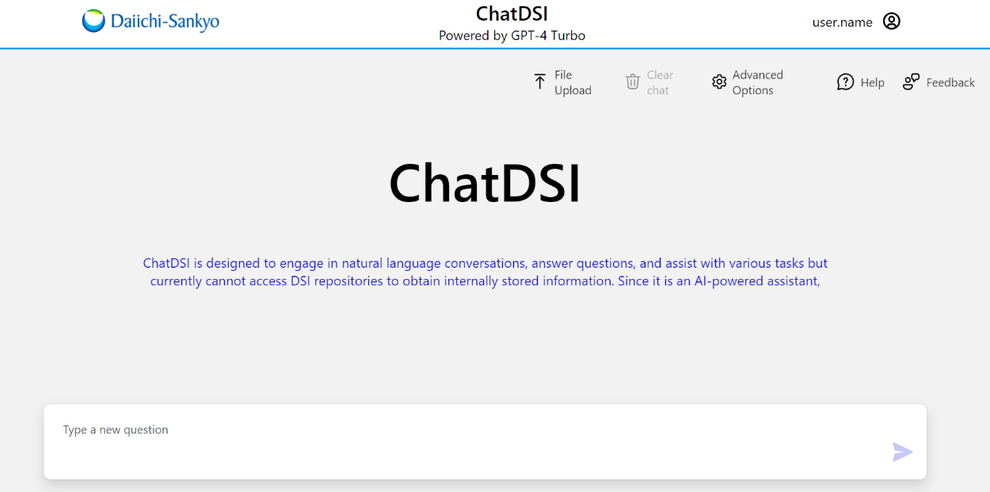

Figure 1 Current State UI

* New State:

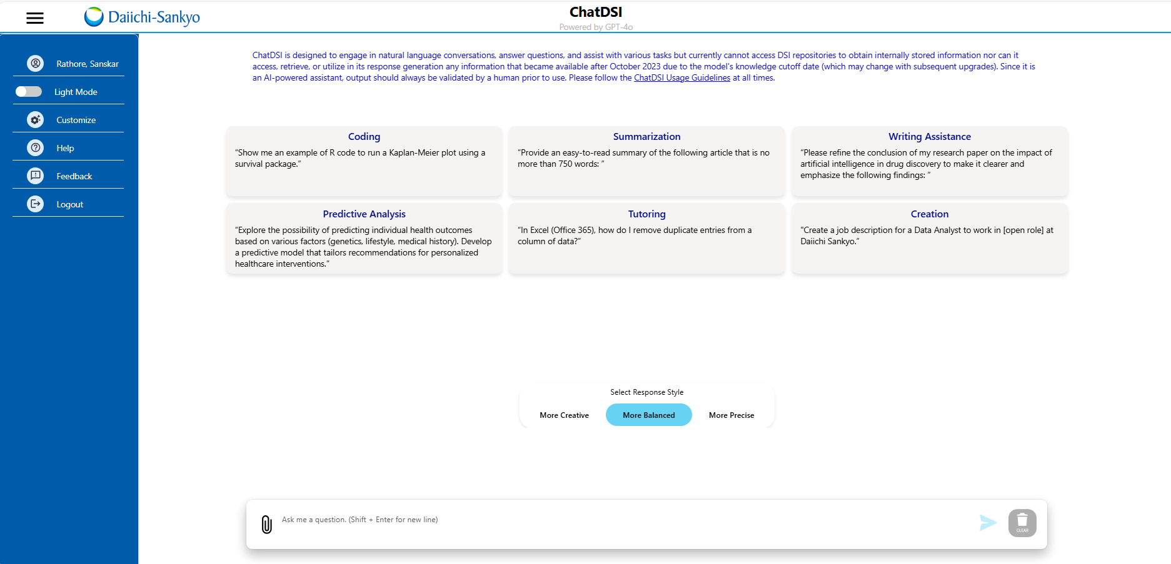

Figure 2.1 New state UI main window.

## **August Release**

### **Image Analysis**

* Ability to upload single image within the upload feature and ask questions about the same
* Ability to upload multiple images within the upload feature. User expected to specify the image they are asking about in their question.
* Ability to compare between multiple images that are uploaded
* When document containing images is uploaded, the response generated by the GPT should include information from the images and should not be restricted to the textual content in the document
* Ability to read scanned pdfs, icons, illustrations, diagrams, photographs, logos, tables and provide information as requested
* Supported image types are .jpeg, .jpg, .png, .webp, .gif, .tif.
* Create an icon for image upload and allow the user to upload images there

### **Translate Capability**

* Ability to translate responses to queries for any of the 13 languages
* Ability to select which language the response needs to be translated to in the input box.
* Ability to translate an uploaded document into 13 languages by selecting the language that the input file needs to be translated to and download the translated document.
* The translated document will be downloaded as << Original Filename >> _ << Translated language >> . << Original File Format - word, pdf etc,).
* A document can be translated to multiple languages and downloaded. Multi-select option to be made available. User can select maximum of 3 languages at a time.
* Bi-directional translation (from English to selected language and other language to English) for responses generated is in scope for both response and document translation.
* The languages that will be considered for translation are
  + Chinese Simplified
  + Czech
  + Danish
  + Dutch
  + English
  + French
  + German
  + Hindi
  + Italian
  + Japanese
  + Korean
  + Russian
  + Spanish
* Primary focus to be given to translating documents/ responses to Japanese, German and Spanish
* If the language selected for translation is the same as the response/document translated into, an alert message must be displayed notifying the user to select an alternate language for translation.

## **September Release**

### **Citations**

* Documents uploaded
  + PDF, txt, word docx: citation should include document name, page number and hyper link to the page for both single and multiple documents uploaded
  + PPT: citation should include file name, slide number and hyperlink to the slide of both single and multiple documents.
  + Ability of user to ask questions related to specific slide/ page number in a document to be based on key words like “summarize”, “explain briefly”
* Image Upload:
  + Citations to be included for single images that are uploaded
  + When multiple images are uploaded, citations to include the name of the image.
  + During image comparison, the images should be cited.

Out of scope:

* Citations on CSV/ XLSX files will not be there since only 1 file is accepted and user needs to input worksheet name to get answers
* Citations for images will not be hyperlinked
* No citations will be provided when user is using Translate functionality

### **Voice Interaction**

* User clicks on the mic, asks question, clicks on submit button and then the answer is generated.
* The speaker option is available after the response is generated and the user can click on it to have the answer read out aloud. By default the response will not be read out aloud.
* The user can click on the speaker again to stop the response from being read out aloud. When the icon is clicked again, it starts reading from the start of the response.
* User has the ability to use the mic to asks questions after file is uploaded (file content can be in English or other languages) or image is uploaded.
* User can ask questions in English or other languages.
* When user asks question in a different language, the response is generated in the same language.
* User can ask questions based on contents from all file formats and image formats that are allowed.

Out of scope:

* Ability to upload audio files and asking questions on it
* Ability to use the mic for instructing the system to perform some action like ‘upload file --’, ‘upload image---’, etc.

Risk: If the user uploads a file that has contents in a language other than English, it is recommended that the user asks question in the same language. While the functionality works even if the user speaks in a different language, the accuracy of the response generated might not be high.

Mock- up:

Addition of mic on the right side next to the submit button:

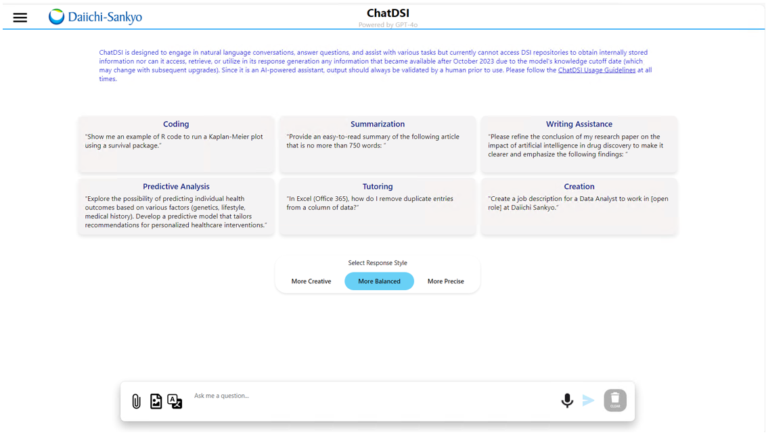

Addition of speaker option after the response is generated:

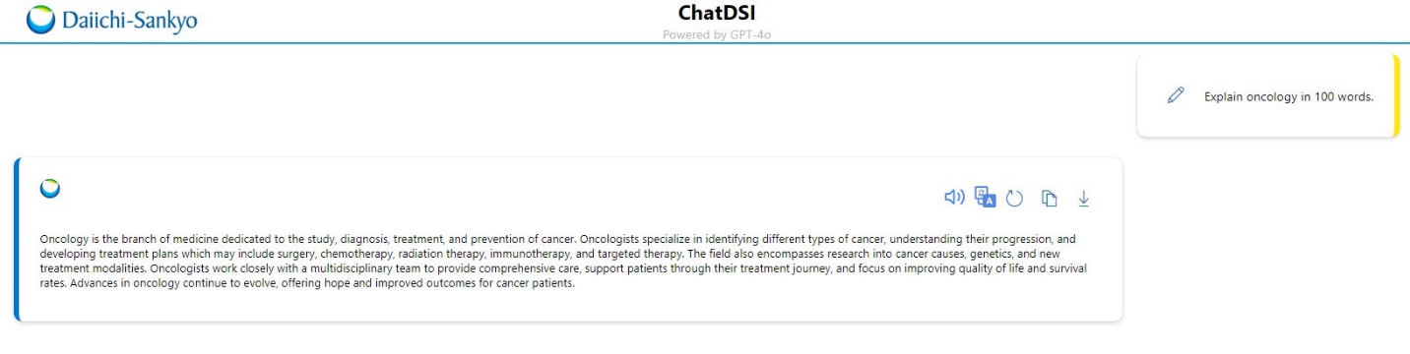

When we want the voice turned off:

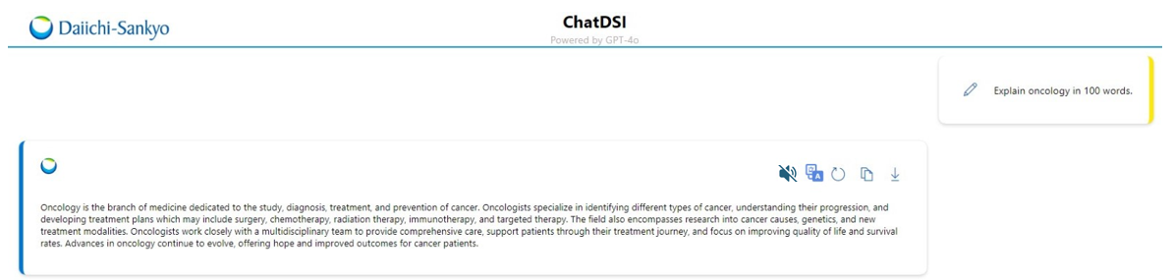

**5.4 Jan Release**

**5.4.1 Bulk Upload**

**In Scope**

* User has the ability to upload any number of documents (upto 200 MB) in pdf/pptx/txt/docx file formats and system timeout would happen if processing time takes beyond 4 mins.
* A pop-up appears on the screen with the range of time it is going to take for Upload. It will also ask the user if they want to continue uploading the files. [Continue/Continue without images/ Cancel] options are shown.
* If the user wants to proceed, they select “Continue”, and the system uploads all the documents and allows the user to query from any of the uploaded documents.
* If the user wants to proceed without images, they select “Continue without images”, and the system uploads all the documents bypassing images and allows the user to query from any of the uploaded documents.
* If the user selects “Cancel”, no operation takes place.
* After a successful upload, users are notified that it was successful or in case of a failure, an error message appears. This will continue to work as the current system is set up.
* A message “Responses are being queried from uploaded documents” above the prompt area in the home page.

**Out of Scope**

* CSV, Excel, and image file formats are not supported for bulk upload.

**Limitation:**

* Files with large number of images can take a long time to get processed even if the file size is very less. We are not determining the relevance of any images and removing any images from processing.

**5.4.2 UI change for Upload Functionality**

Currently there are 3 upload functionalities: file upload, image upload and translate. As part of this release, there will be 2 options– translate and upload.

* On clicking on upload functionality, a popup with 3 operations appear:
  + Image Upload
  + File Upload (supports bulk upload of pdf, txt, docx, pptx file formats)
  + CSV/ Excel Upload

**UI Design**

**Bulk Upload:**

On clicking on the upload feature -

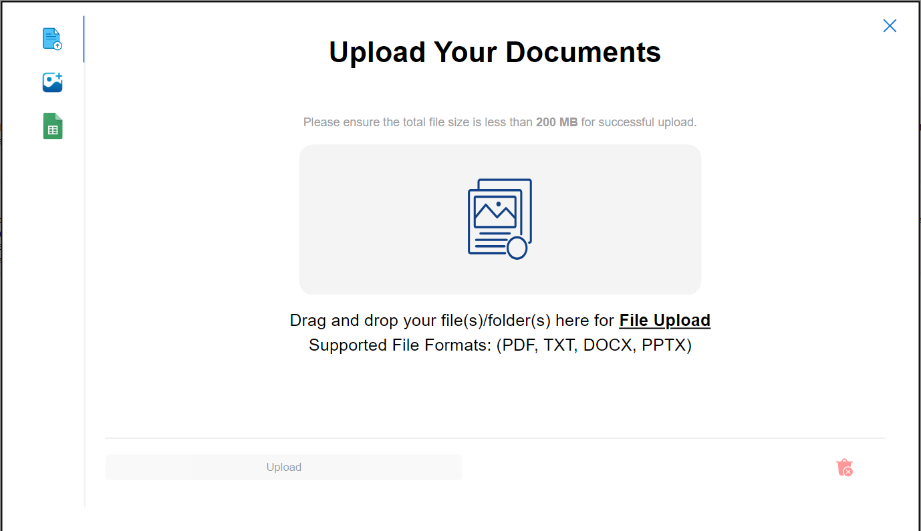

**5.5 Apr Release**

**5.5.1** **SharePoint Upload:**

* SharePoint button will be added to the upload functionality pop-up.
* On clicking on SharePoint Upload the screen will request the user to input the SharePoint URL. Authentication will be done in the backend to ensure that user has access to that SharePoint URL.
* Users can select the files and folders they want to get information from. A select all option will also be available so that users can select all files/ folders.
* Once we click on “Process selected files” message for processing time popup appears with options as "Continue", "Continue without images" and "Cancel".
* After selecting one option from above the files and folders are processed.
* The user can then ask questions related to files and folders on the SharePoint. A generic message will be shown saying that the responses being generated are from SharePoint.
* The other icons (file upload/ image upload/ Excel upload/Document Translation) will be disabled when users have uploaded files on SharePoint. User needs to clear the uploaded SharePoint url in case they want to use the other upload functionalities.
* The SharePoint URLs that users will fill in should be ones that will work on the global tenant and can be accessed using global credentials.
* The SharePoint URLs with nested sites or sub-sites can be accessed and parsed and processed.
* The SharePoint URL links copied from windows file explorer and from browser both will be processed and are accessible for our both "sites" (older format) and "teams'' (newer format). We have not restricted this for "sites" or "teams".
* Only allowed file types and count of allowed types are shown once the SharePoint link is processed. Sub folder count is not included in count as they are not processed.
* Currently the SharePoint URLs with domain name “dsg2ic.sharepoint.com” are only supported.

**Out of Scope:**

* The user is allowed to select at folder or file level. They will not be able to upload files/ folders at a sub folder level.
* Users cannot use other upload functionalities until the SharePoint url is cleared.
* The SharePoint URLs in the regional tenant will not work.
* Folder navigation within SharePoint isn’t supported.
* Current SharePoint functionality is like File Upload feature having supported formats as “PDF, TXT, DOCX, PPTX”. Any format outside of these are not processed.
* Currently the URLs having custom drives as well as nested sites are not accessible.
* Direct SharePoint URL of a file cannot be accessed.

**Limitations:**

* Limitations can be viewed here - [Limitations Document.docx](https://dsg2ic.sharepoint.com/teams/DSTeam_CoE_AIML/_layouts/15/Doc.aspx?sourcedoc=%7B167E74F8-8E09-4043-B40B-701505C8B98C%7D&file=Limitations%20Document.docx&action=default&mobileredirect=true)

**UI for SharePoint:**

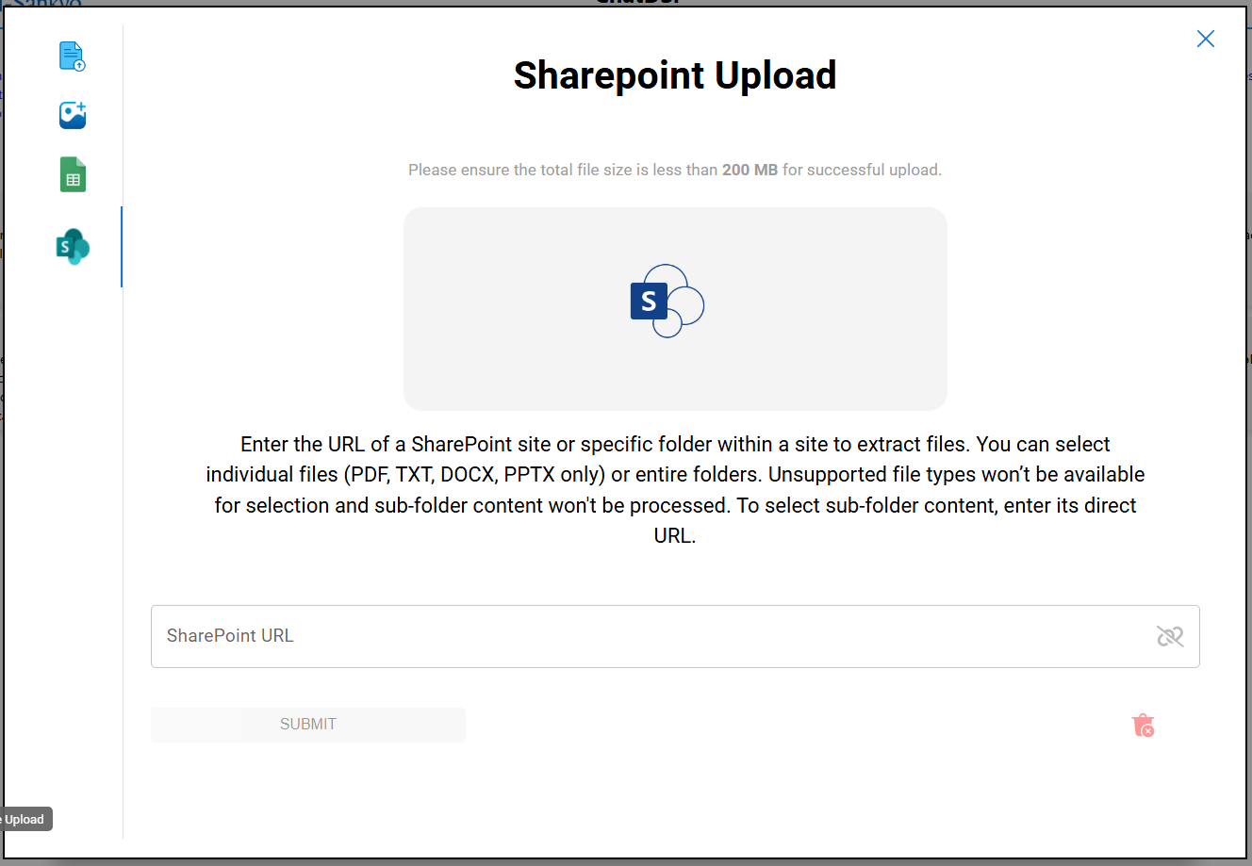

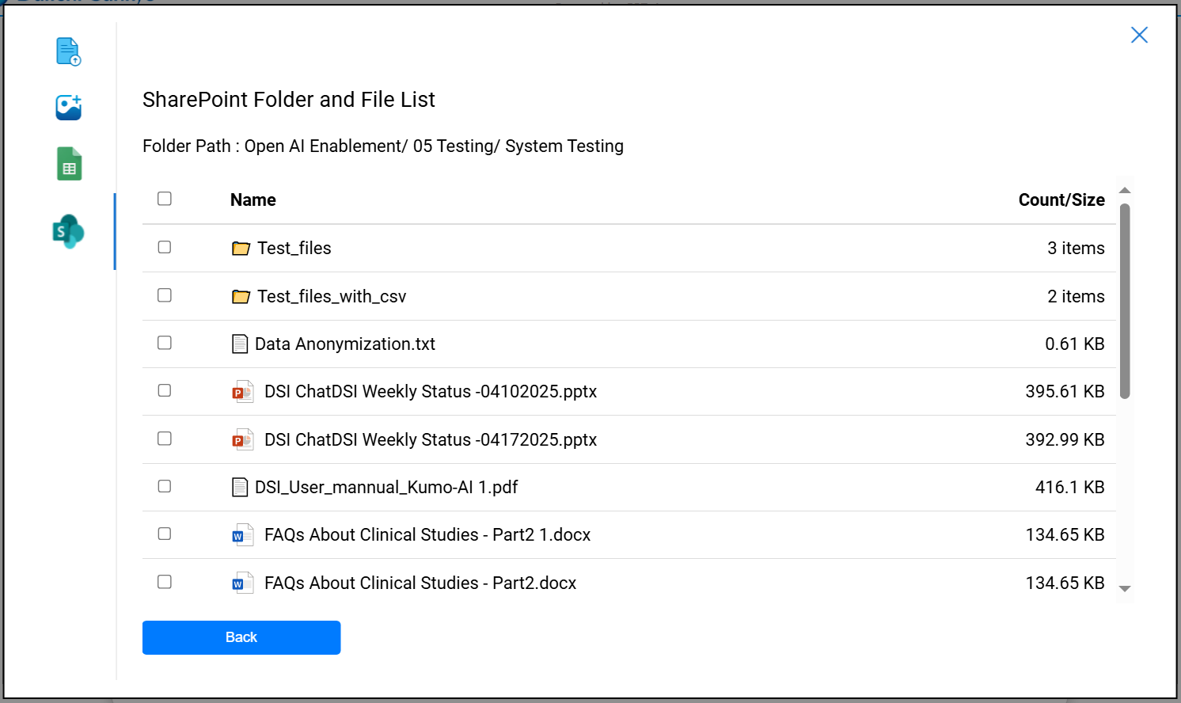

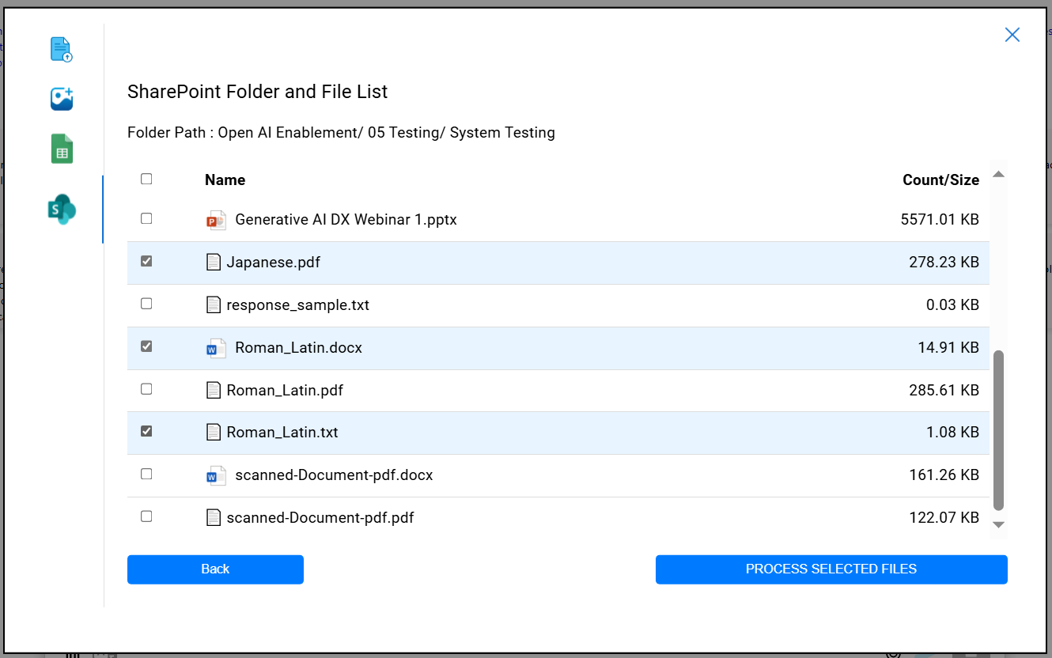

### **5.5.2 Teams Integration**

**Objective:**

Enable seamless integration of ChatDSI into Microsoft Teams, making it easily accessible to all global employees with a unified and consistent user experience.

**Integration Requirements:**

1. **App Availability in Teams App Store:**
   1. The ChatDSI application will be published and made available in the Microsoft Teams app store (tenant-wide catalog).
   2. Users can install the app directly from the "Apps" section within Teams.
2. **Access via Teams Side Panel:**
   1. Once installed, the ChatDSI app will be accessible from the Teams left-side rail (personal app section) for quick and persistent access.
   2. The app icon will be visible and can be pinned by default for all users (if configured by admin policy).
3. **Full Feature Access in Teams Tab:**
   1. All functionality currently available in the standalone ChatDSI web application will also be accessible via the Teams tab interface.
   2. No degradation of functionality will occur; the Teams version will maintain the same user experience and capabilities.
   3. The app will leverage Microsoft Entra ID (Azure AD) for authentication and support Single Sign-On (SSO), ensuring users are automatically logged in with their organizational credentials.
   4. Users without having proper access to the ChatDSI specific AD groups won't be able to access the application.
   5. The app will be configured and deployed under the global tenant, ensuring all employees across regions can access it using their global credentials.
   6. All backend infrastructure (API, authentication, etc.) must be configured and operational under the global tenant to support the Teams integration.
   7. IT admins will have the ability to deploy the app proactively to specific users or groups using Teams app setup policies.
   8. ChatDSI will be accessible via the Teams desktop client, web client ensuring consistent functionality across platforms.
   9. The application will adhere to organizational compliance and security policies.

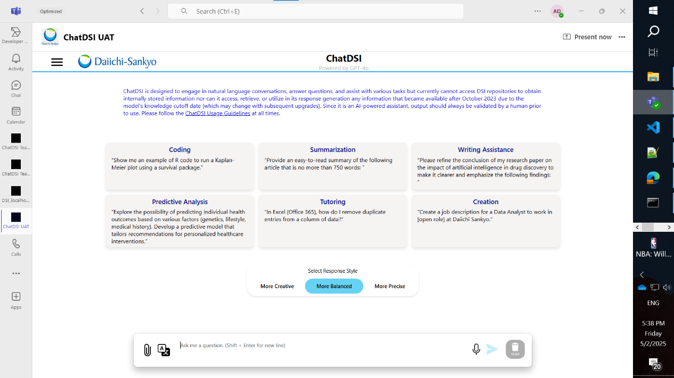

**5.6 Production Issues – Phase 1 and 2 requirements – April Release**

**5.6.1 Phase 1:**

* History retention capability to be improved from 4000 to 128000 tokens. Users should have the ability to chat for longer and have context of previous answers.
* Ability to translate CSV/Excel files using the File translate option.

**5.6.2 Phase2:** Improve Contextual and Non-contextual responses generated after document upload

* ChatDSI must only use the uploaded document to generate responses, and not information from the web when a file is uploaded. Once the document is cleared, responses must be based solely on web-sourced information, not the previously uploaded document.
* Summarization and listing of documents can be done by using certain key words listed in the limitations document
* After the document or chat is cleared, previous history of the chat should not be retained for the upcoming conversation.
* The upload button needs to be enabled only after files are selected for upload. At a given time either file upload or translate button is enabled. Additionally, if a file has been uploaded, image and excel upload is disabled and vice versa.
* Processing time popup should appear only for file upload and not for image or excel upload

**Limitations:**

* Limitations can be viewed here - [Limitations Document.docx](https://dsg2ic.sharepoint.com/teams/DSTeam_CoE_AIML/_layouts/15/Doc.aspx?sourcedoc=%7B167E74F8-8E09-4043-B40B-701505C8B98C%7D&file=Limitations%20Document.docx&action=default&mobileredirect=true)