GPT 4o vs Phi 3 Vision Comparison

Observations/ Takeaways:

|  |  |  |
| --- | --- | --- |
|  | GPT-4o | Phi3+Vision |
| Coverage | Comprehensively captures most part of the image | Provides a high-level concise summary for the image |
| Quality | Sometimes the outputs don’t accurately describe the image | Not a lot of information is shared as response and this doesn’t accurately describe the image |
| Model | Tested through Azure API | Tested through HuggingFace |
| Open-Source | No | Yes |
| Key-Value OCR | Able to capture more information but not able to match key with values | Unable to capture some information but key value pairs are identified |

Testing:

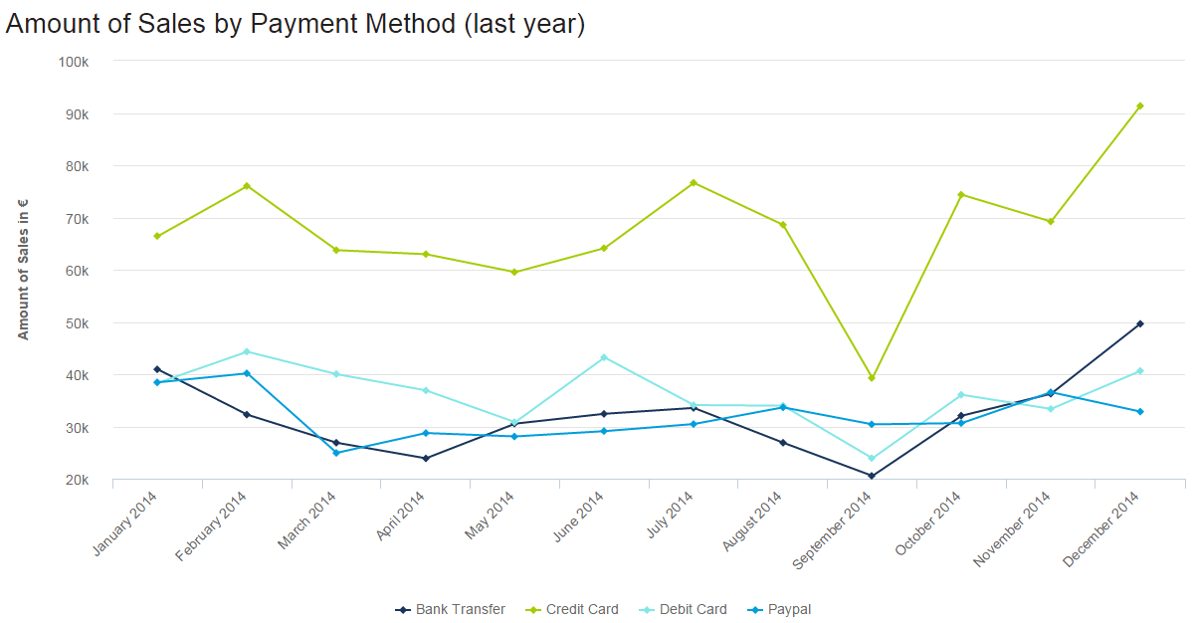

**GPT-4o Output: -**

The image shows a line graph depicting the amount of sales by different payment methods over the last year. Here are some business insights derived from the graph:

1. **Credit Card Dominance**: Credit card payments consistently show the highest sales amounts throughout the year, peaking in July and December. This indicates a strong preference for credit card payments among customers.

2. **Seasonal Trends**: There are noticeable peaks in sales for credit card payments in July and December, suggesting seasonal shopping trends, possibly related to summer sales and holiday shopping.

3. **Bank Transfer Growth**: Bank transfer sales show a significant increase towards the end of the year, particularly in December. This could indicate a growing trust or preference for bank transfers during this period.

4. **Stable but Lower Sales for Debit Card and PayPal**: Both debit card and PayPal sales remain relatively stable throughout the year but are consistently lower compared to credit card and bank transfer sales. This suggests that while these methods are used, they are not the primary choice for most customers.

5. **Mid-Year Dip**: There is a noticeable dip in sales for all payment methods around April and May, which could indicate a seasonal lull in purchasing activity.

6. **Recovery and Growth**: After the mid-year dip, there is a gradual recovery and growth in sales across all payment methods, with a significant spike in December, indicating a strong end-of-year performance.

7. **Strategic Focus**: Given the high sales volume through credit cards, businesses might consider focusing marketing and promotional efforts on credit card users. Additionally, the growth in bank transfer sales towards the end of the year suggests an opportunity to promote this payment method during peak seasons.

8. **Diversification**: While credit cards dominate, the presence of other payment methods like bank transfers, debit cards, and PayPal indicates the importance of offering multiple payment options to cater to different customer preferences.

In summary, the graph highlights the importance of credit card payments, seasonal shopping trends, and the need for a diverse range of payment options to maximize sales throughout the year.  
  
Time Taken: - ~ 45 Seconds.

**Phi3+Vision: -**

The chart is a line graph titled 'Amount of Sales by Payment Method (last year)' that displays the sales in euros for four different payment methods over the course of a year. The x-axis represents the months from January 2014 to December 2014, while the y-axis shows the amount of sales in euros, ranging from 0 to 100,000. There are four lines representing different payment methods: Bank Transfer (blue line), Credit Card (green line), Debit Card (cyan line), and Paypal (black line). The graph shows fluctuations in sales for each payment method throughout the year. For instance, Bank Transfer sales appear to have a significant increase in December, while Credit Card sales peak in February and then again in December. Debit Card sales show a steady increase over the year, and Paypal sales have a notable peak in December as well. The graph indicates that different payment methods have varying popularity and usage patterns throughout the year.  
  
Time Taken:- ~ 20 Seconds

2.

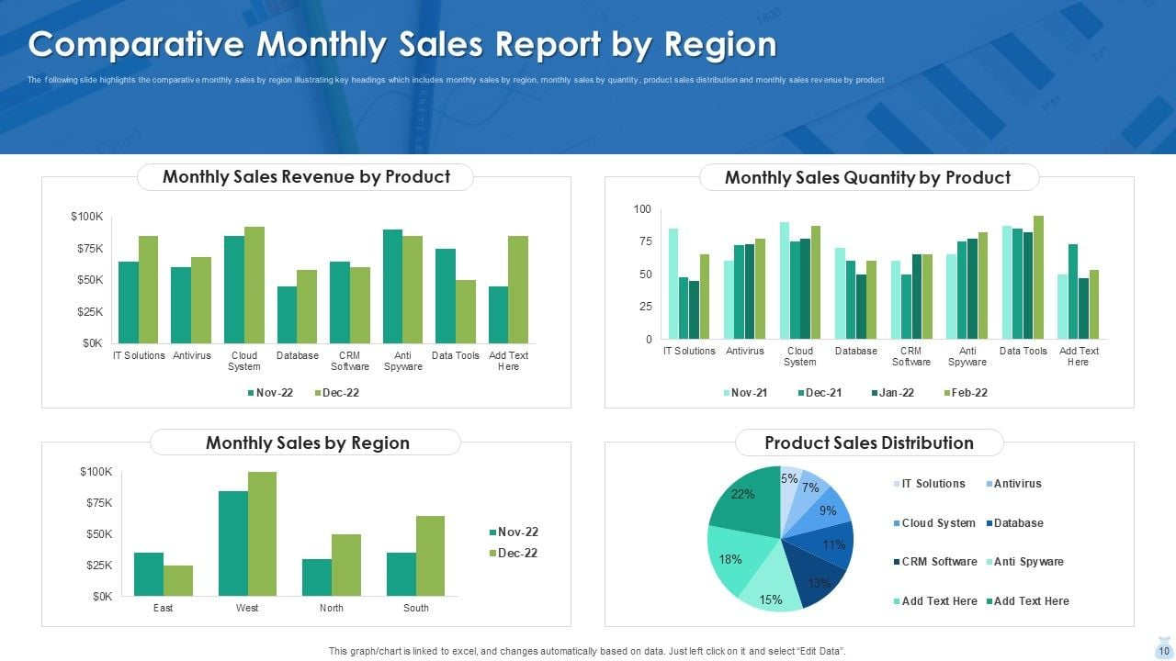

**GPT-4o Output: -**

The image presents a "Comparative Monthly Sales Report by Region," which includes various charts and graphs to illustrate sales performance. Here are some business insights derived from the image:

### Monthly Sales Revenue by Product

1. **Cloud System**: This product shows the highest revenue in both November 2022 and December 2022, indicating strong market demand.

2. **Antivirus and IT Solutions**: These products also show significant revenue, with Antivirus showing a slight increase from November to December.

3. **CRM Software and Data Tools**: These products have lower revenue compared to others, suggesting potential areas for improvement or increased marketing efforts.

### Monthly Sales Quantity by Product

1. **Cloud System and Anti Spyware**: These products have the highest sales quantities across the months, indicating high customer demand.

2. **IT Solutions and Antivirus**: These products also show consistent sales quantities, with a noticeable increase in December 2021 and January 2022.

3. **Data Tools**: This product shows a steady increase in sales quantity over the months, suggesting growing interest.

### Monthly Sales by Region

1. **West Region**: This region shows the highest sales revenue in both November and December 2022, making it the most lucrative market.

2. **South Region**: This region shows a significant increase in sales revenue from November to December 2022.

3. **East and North Regions**: These regions have lower sales revenue, indicating potential areas for market expansion or targeted sales strategies.

### Product Sales Distribution

1. **Anti Spyware**: This product holds the largest share of sales distribution at 22%, indicating it is the most popular product.

2. **Cloud System**: This product has an 18% share, reinforcing its strong performance in revenue and quantity.

3. **IT Solutions and Antivirus**: These products have 15% and 13% shares, respectively, showing they are also key contributors to overall sales.

### General Insights

1. **Product Focus**: The company should continue to focus on high-performing products like Cloud System and Anti Spyware while exploring ways to boost sales for lower-performing products like CRM Software and Data Tools.

2. **Regional Strategies**: The West region is a strong market, but there is potential for growth in the East and North regions. Tailored marketing and sales strategies could help increase revenue in these areas.

3. **Sales Trends**: Monitoring monthly sales trends can help identify seasonal patterns or market shifts, allowing for proactive adjustments in sales strategies.

These insights can help the company make informed decisions regarding product development, marketing strategies, and regional sales efforts.

Time Taken: - ~ 1 Minute 30 Seconds.

**Phi3+Vision: -**

The image presents a Comparative Monthly Sales Report by Region, featuring four key metrics: Monthly Sales Revenue by Product, Monthly Sales Quantity by Product, Monthly Sales by Region, and Product Sales Distribution. The Monthly Sales Revenue by Product shows a comparison of sales revenue for different products across four months, with IT Solutions, Cloud System, and Database being the top-selling products. The Monthly Sales Quantity by Product displays a similar trend, indicating the volume of sales for each product. The Monthly Sales by Region chart illustrates the sales distribution across four regions, with the East region leading in sales. Lastly, the Product Sales Distribution pie chart breaks down the percentage share of each product in the total sales. The data is dynamic and can be edited through an interactive feature on the graphic.

Time Taken:- 17 Seconds

3.

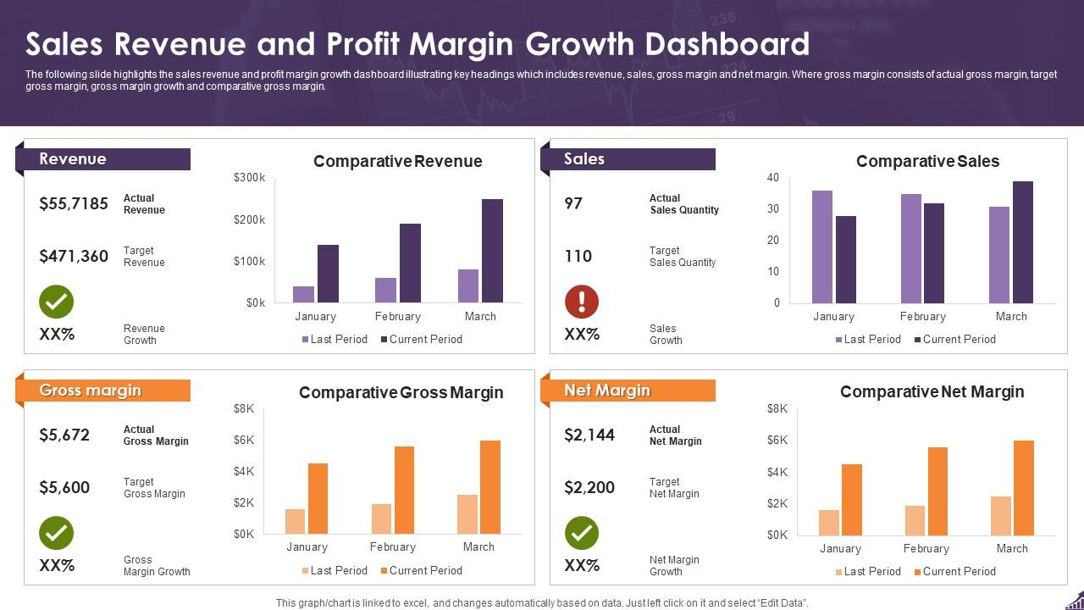

**GPT-4o Output: -**

The image is a Sales Revenue and Profit Margin Growth Dashboard, which provides a comprehensive overview of key business metrics. Here are the business insights derived from the dashboard:

### Revenue

- **Actual Revenue**: $55,7185

- **Target Revenue**: $471,360

- **Revenue Growth**: Not specified (XX%)

**Comparative Revenue**:

- January: Current period revenue is higher than the last period.

- February: Significant increase in current period revenue compared to the last period.

- March: Current period revenue is higher than the last period but shows a slight decrease compared to February.

### Sales

- **Actual Sales Quantity**: 97

- **Target Sales Quantity**: 110

- **Sales Growth**: Not specified (XX%)

**Comparative Sales**:

- January: Current period sales are higher than the last period.

- February: Current period sales show a significant increase compared to the last period.

- March: Current period sales are higher than the last period but show a slight decrease compared to February.

### Gross Margin

- **Actual Gross Margin**: $5,672

- **Target Gross Margin**: $5,600

- **Gross Margin Growth**: Not specified (XX%)

**Comparative Gross Margin**:

- January: Current period gross margin is higher than the last period.

- February: Significant increase in current period gross margin compared to the last period.

- March: Current period gross margin is higher than the last period but shows a slight decrease compared to February.

### Net Margin

- **Actual Net Margin**: $2,144

- **Target Net Margin**: $2,200

- **Net Margin Growth**: Not specified (XX%)

**Comparative Net Margin**:

- January: Current period net margin is higher than the last period.

- February: Significant increase in current period net margin compared to the last period.

- March: Current period net margin is higher than the last period but shows a slight decrease compared to February.

### Key Insights:

1. **Revenue and Sales**: Both revenue and sales quantities are below their respective targets. However, there is a positive trend in revenue and sales growth over the months, indicating potential for future improvement.

2. **Gross Margin**: The actual gross margin slightly exceeds the target, showing efficient cost management and profitability.

3. **Net Margin**: The actual net margin is slightly below the target, indicating room for improvement in cost control or revenue enhancement.

4. **Monthly Trends**: There is a consistent increase in revenue, sales, gross margin, and net margin from January to February, followed by a slight decrease in March. This suggests a need to investigate the factors causing the decline in March and address them to sustain growth.

### Recommendations:

1. **Sales Strategy**: Enhance sales strategies to meet or exceed the target sales quantity.

2. **Cost Management**: Focus on cost control measures to improve net margin and meet the target.

3. **Market Analysis**: Conduct a detailed analysis of the market conditions in March to understand the reasons for the decline and take corrective actions.

4. **Performance Monitoring**: Continuously monitor performance metrics to ensure alignment with business goals and make data-driven decisions.

Time Taken :- 1 Minute 10 Seconds

**Phi3+Vision: -**

The image displays a Sales Revenue and Profit Margin Growth Dashboard, which is a comprehensive visual representation of a company's financial performance over a three-month period. The dashboard is divided into six sections, each representing a different financial metric: Revenue, Comparative Revenue, Sales, Comparative Sales, Gross Margin, Comparative Gross Margin, and Net Margin.

1. Revenue: The actual revenue for the last period is $55,7185, with a target revenue of $471,360, indicating a positive growth of XX%.

2. Comparative Revenue: The comparative revenue shows a significant increase in the last period compared to the current period, with the last period at $200k and the current period at $100k.

3. Sales: The actual sales quantity for the last period is 97, with a target of 110, showing a negative growth of XX%.

4. Comparative Sales: The comparative sales quantity shows a decrease in the last period compared to the current period, with the last period at 30 and the current period at 20.

5. Gross Margin: The actual gross margin for the last period is $5,672, with a target of $5,600, indicating a positive growth of XX%.

6. Comparative Gross Margin: The comparative gross margin shows an increase in the last period compared to the current period, with the last period at $6K and the current period at $2K.

7. Net Margin: The actual net margin for the last period is $2,144, with a target of $2,200, indicating a positive growth of XX%.

8. Comparative Net Margin: The comparative net margin shows an increase in the last period compared to the current period, with the last period at $4K and the current period at $2K.

The dashboard also includes a note that the graph/chart is linked to Excel and changes automatically based on data. The dashboard is designed to provide a clear and concise overview of the company's financial performance, allowing for easy comparison between the last period and the current period.

Time Taken:- 39 Seconds

4.



**GPT 4-o Output:-**

MANUFACTURED BY:

FABRIQUE PAR

TEREX CRANES INC.

WAVERLY, IA 50677

MODEL T500

VIN/NIV

MFG DATE

TYPE TRU/CAM

GVWR/PNBV 89,000 LB / 40,370 KG

GAWR/PNBE FRONT 46,000 LB / 20,865 KG TIRES 425/65R22.5

RIMS 22.5 X 13.00 COLD TIRE INFL. 110 PSI (758 kPa) SINGLE

GAWR/PNBE REAR 43,000 LB / 19,505 KG TIRES 11R22.5

RIMS 22.5 X 8.25 COLD TIRE INFL. 105 PSI (724 kPa) SINGLE

THIS VEHICLE CONFORMS TO ALL APPLICABLE STANDARDS

PRESCRIBED UNDER THE CANADIAN MOTOR VEHICLE SAFETY

REGULATIONS IN EFFECT ON THE DATE OF MANUFACTURE

CE VEHICULE EST CONFORME A TOUTES LES NORMES QUI LUI SONT

APPLICABLES EN VERTU REGLEMENT SUR LA SECURITE DES VEHICULES

AUTOMOBILES DU CANADA EN VIGUEUR A LA DATE DE SA FABRICATION

12460-2012

**Phi3+Vision:-**

- Manufacturer: TEREX CRANES INC.

- Location: Waverly, IA 50677

- Model: T500

- Vin/Niv: (Not specified)

- MFG Date: (Not specified)

- Type: TRU/CAM

- GVWR/PNBV: 89,000 LB / 40,370 KG

- GAWR/PNBE FRONT: 46,000 LB / 20,865 KG

- Tires: 425/65R22.5

- Rims: 22.5 X 13.00

- Cold Tire Infl. PSI: 110

- Cold Tire Infl. PSI: (758 kPa)

- Rims: 22.5 X 8.25

- Tires: 11R22.5

- Cold Tire Infl. PSI: 105

- Cold Tire Infl. PSI: (724 kPa)

- This vehicle conforms to all applicable standards prescribed under the Canadian Motor Vehicle Safety Regulations in effect on the date of manufacture.

- The vehicle is conforming to all the standards that are currently in force on the date of manufacture.

- The vehicle is conforming to all the standards that are currently in force on the date of manufacture.

- The vehicle is conforming to all the standards that are currently in force on the date of manufacture.

- The vehicle is conforming to all the standards that are currently in force on the date of manufacture.

- The vehicle is conforming to all the standards that are currently in force on the date of manufacture.

- The vehicle is conforming to all the standards that are currently in force on the date of manufacture.

- The vehicle is conforming to all the standards that are currently in force on the date of manufacture.

- The vehicle is conforming to all the standards that are currently in force on the date of manufacture.