CS 247 - Midterm 2 Name: sida zhong _________________________________

Instructions: Type all your answers in this file. Do not be concerned with formatting (such as page breaks) which might shift as you insert your answers. Also, you do not need to make your answer "fit" in the empty space provided. The completeness and thoroughness of your responses will be part of the grading criteria for many of the questions on this exam, so use as much space as you feel is necessary in order to provide all relevant details in your answers to maximize credit.

Hint: Pace yourself. Skim the entire exam before starting, taking note of the points allocated for each question. Remember that you can answer the questions in any order.

1) The Failure Rate vs. Time of a system is plotted with certain time points labeled A to E in the diagram below. Discuss and describe all of the important distinct regions on the plot (for example, region AB). Explain why the curve is shaped the way it is in that region in the context of the system’s overall lifespan. [8 pts]

Failure
Rate
Time
A
B
C
D
E

A-B is called burn-in phase. In this area, although components are new, but there would be manufacturer defects, algorithm defects or any potential untested defects. The reliability is low.

B-D is called useful life period, in this area, component are stable, usually shows a high reliability.

D-E is call wear out phase, in this area, component are getting old. failure is increasing, and it is inevitable. Reliability decreased.

2) You are a reliability engineer working for an automobile manufacturer that currently offers a 5 year warranty on their cars sold. A marketing salesperson proposes the following:

“We currently offer a 5 year warranty just like our competitors. The 5 year warranty is costing us an average of $500/vehicle in warranty repair costs. I propose that we beat our competition by offering a 7 year warranty. The repair costs will now be $700/vehicle on average, but the resulting increased sales and profits will more than offset the extra $200 that we would need to spend per vehicle on warranty coverage”.

Explain the potential flaw with the salesperson’s argument. Use a worst case engineering scenario as seen from the manufacturer’s point of view. Clearly state your assumptions and contrast them against those assumptions of the salesperson. Use the diagram and labeled time points from problem 1 in the context of your explanation. [12 pts]

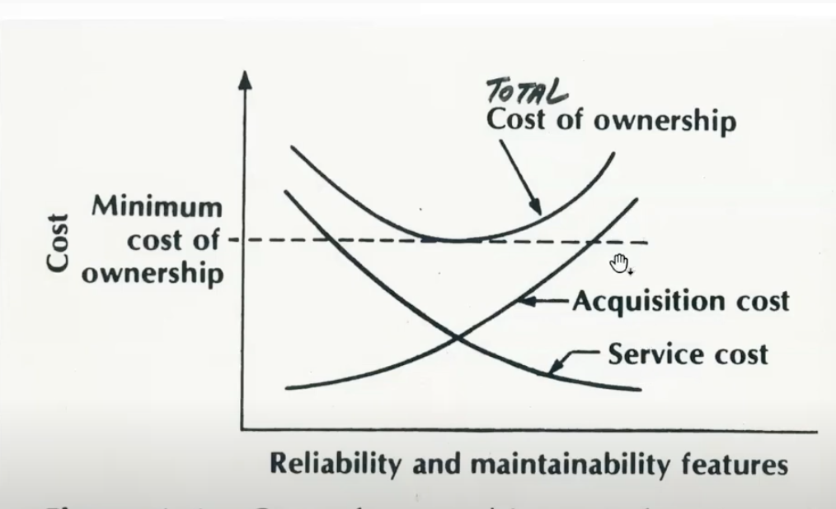

The picture shows that service cost and acquisition cost are inversely proportional. Increasing the warranty will reduce the user's service cost but the user’s acquisition cost of the car will increase. That means the cost of the car will increase, and the customer will not likely buy the car. The result of sales maybe decreased instead of increasing.

That would be like the second half of the picture.

3) You designed the computer for a space probe that was scheduled to reach its target in 5 years, take pictures of the target for 1 week, and then get essentially 'discarded' by continuing to fly past the target into the endless void of deep space. A year after the probe is launched, a new planet 8 years away from earth is discovered. In its excitement, NASA considers opportunistically redirecting the mission midstream from the original target to the newly discovered planet instead. This will require that your computer work reliably for 3 more years than originally planned. NASA has asked for your input regarding the proposed change in mission. Assuming that your computer design employed TMR, could any problems potentially arise with changing the mission and extending its duration by 3 years? Explain your answer as a response to NASA management. [12 pts]

In some situations, the reliability of TMR system decreases very quickly. The bath-tub diagram shows that if the component enters the ware-out period, reliability will inevitably decrease. Because TMR consists of multiple systems, the failure will accumulate faster than people expected. So the answer is No, TMR system does not recommend additional service life.

If it is a single system, it may extend service life. Although the single system is not stable than TMR during the official life period time. But it shows more reliability in the end of life period. So, single system, answer is yes, worth to try at least.

4) Voting techniques for improving reliability usually involve 2n+1 modules. That is, the number of modules participating in the vote is usually odd. Explain why. [4 pts]

2n+1 modules similar like TMR, The odd number systems can vote for fault tolerance. Majority votes win.

5) Describe the transition between CISC and RISC, at a minimum covering the issues in questions (a) to (e):

a) Describe the "Semantic Gap" which computer architects were trying to solve by developing CISC architectures. [4 pts]

human speak nature language. Computer can only read binary code.
The engineer needs to map the nature language and the binary code of the machine that can understand, that is called instructions.

b) What were the salient characteristics of CISC architectures and the rationale for each characteristic? [4 pts]

large instructions, a lot of optimize code, the reason is no compiler
variable length instructions, the reason is short memory.

c) Describe the problems that started to arise after several decades of CISC-type design. [4 pts]

accumulate too much instructions
a lot of time to design and test
variable length instructions not friendly to pipeline

d) What empirical evidence arose leading to doubts about the CISC design philosophy? [4 pts]

Although there are more than 200 instructions, only 30 are used regularly, more than 99% of the total.

e) What was the explanation for the empirical evidence? [4 pts]

engineers like simple and unified instructions.

6) The following 4 binary strings represent the only valid states possible in a code. What is the maximum number of random bit flips that can be tolerated (that is detected, but not necessarily corrected) within a single word at the receiver end of a transmission line without it accidentally being misinterpreted as another valid code word ? Explain your line of reasoning. [5 pts]

00000000
11110000
00001111
11111111

the distance of each binary strings is 4. distance 4 can tolerated 3 bits.

15 is 1111
7 is 111
so within 3 bits range. it still can find the closed binary code.

7) Compute the Parity bits associated with the following Hamming Encoding for 4 data bits. Use EVEN parity. [6 pts]

P1 P2 D1 P4 D2 D3 D4

0 0 1 1 0 0 1

8) During our discussion of Design Optimization, we covered some real-world aspects that can often be overlooked by Computer Architects in their quest to constantly increase the speed and performance of the hardware. Three of the pitfalls are listed below. Explain each one, and elaborate on why that aspect should not be ignored in holistic design.

a) Ignoring the Marketplace. What does the marketplace require ? [5 pts]

The product that takes the lead in the market has the initiative. Although product may not perfect, it accumulates more users and resources. Over perfect products will lose opportunities.

b) Ignoring Technology Trends. What is unique about Computer Technology Trends ? [5 pts]

The speed of technology update and iteration in the computer field is very fast. If the technology is too old, the product is hard to expanded to adapt to the new market in the future. Community support for every language and technology. If the community gives up, then the technology is also abandoned, and the product is also abandoned

c) Ignoring Design Complexity. What are some disadvantages of highly optimized, complex designs ? [5 pts]

Increase the work of development, not easy to test, not easy to expand. when old developers leave, newcomers can’t hand over work

9) In VHDL, two lines of code can have their order interchanged in the source code, yet this can have no effect on the outcome. When performed on ordinary procedural software, the same type of interchanging of order can result in completely different results. Why is this so ? What is the paradigm of operation in VHDL that makes it independent of its source code ordering ? [4 pts]

In computer hardware like VHDL, all signals are activated at the same time.

10) Explain the Inertial Delay Model in VHDL and describe its impact upon the maximum operating speed of a digital circuit being simulated. [6 pts]

If the signal changes during the Inertial delay time, it will be ignored. So the complicated circuit must wait for all inertial delays to complete, and then change its signal.

maximum operating speed > all Inertial delay

11) Assume you have 2 gate primitives already defined, XOR2 (a 2-input Exclusive OR function) and INV, an Inverter. Both have 0ns delays. The following VHDL code uses these two primitive gates in a design entity named unknown. Fill in the time table below based on the signal values as driven and received by the unknown_tester entity. [8 pts]

ENTITY unknown IS
PORT (a, b : IN BIT ; c : OUT BIT);
END unknown;

ARCHITECTURE structure OF unknown IS
SIGNAL tmp : BIT;
COMPONENT xor2 PORT (x, y: IN BIT; z: OUT BIT); END COMPONENT;
COMPONENT inv PORT (x: IN BIT; z: OUT BIT); END COMPONENT;
BEGIN
u1: inv PORT MAP (tmp, c);
u2: xor2 PORT MAP (a, b, tmp);
END structure;

ENTITY unknown_tester IS
PORT (a, b : OUT BIT ; c : IN BIT);
END unknown_tester;

ARCHITECTURE behavioral OF unknown_tester IS
BEGIN
a <= '0' AFTER 0 ns,
'0' AFTER 10 ns,
'1' AFTER 20 ns,
'1' AFTER 30 ns;
b <= '0' AFTER 0 ns,
'1' AFTER 10 ns,
'0' AFTER 20 ns,
'1' AFTER 30 ns;
END behavioral;

ENTITY testbench IS
END testbench;

ARCHITECTURE structure OF testbench IS
COMPONENT unknown_tester PORT(a, b: OUT BIT; c: IN BIT); END COMPONENT;
COMPONENT unknown PORT(a, b: IN BIT; c: OUT BIT); END COMPONENT;
SIGNAL a, b, c: BIT;
BEGIN
tester: unknown_tester PORT MAP (a, b, c);
UUT: unknown PORT MAP (a, b, c);
END structure;
Time | a | b | c
5 ns | 0 | 0 | 1
15 ns | 0 | 1 | 0
25 ns | 1 | 0 | 0
35 ns | 1 | 1 | 1

