I was NOT able to run ubuntu machine in mac so i did it in another windows pc. PLEASE provide ssh tool for mac as well in your next class

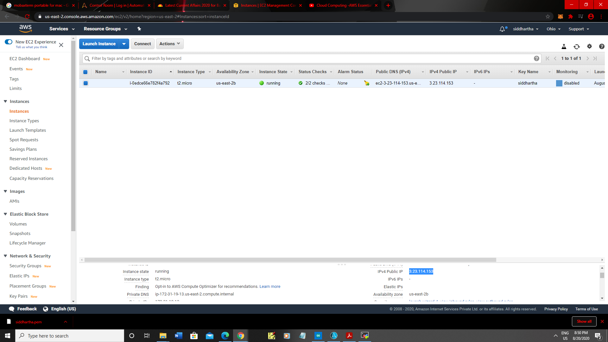

Created ubuntu instance

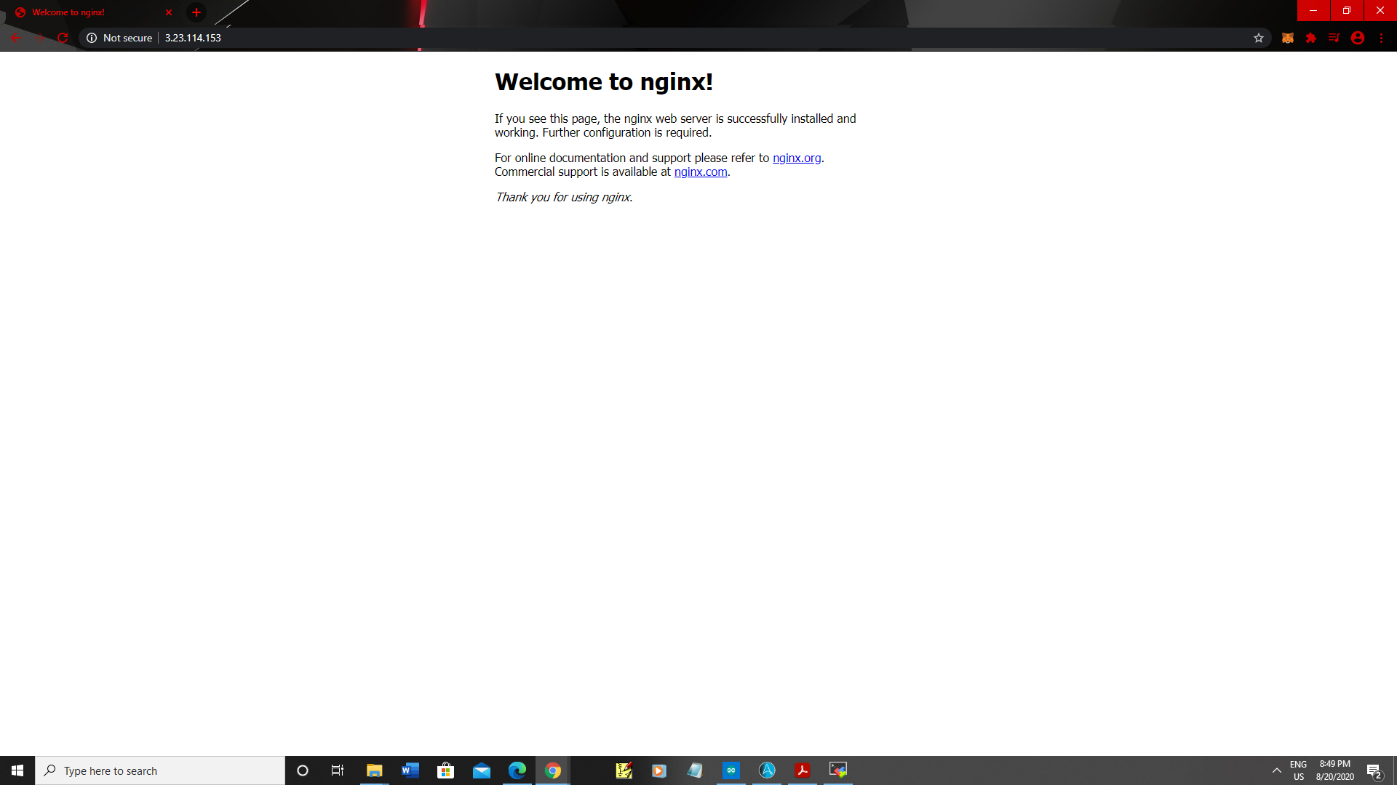

Copy and pasted the commands and installed nginx