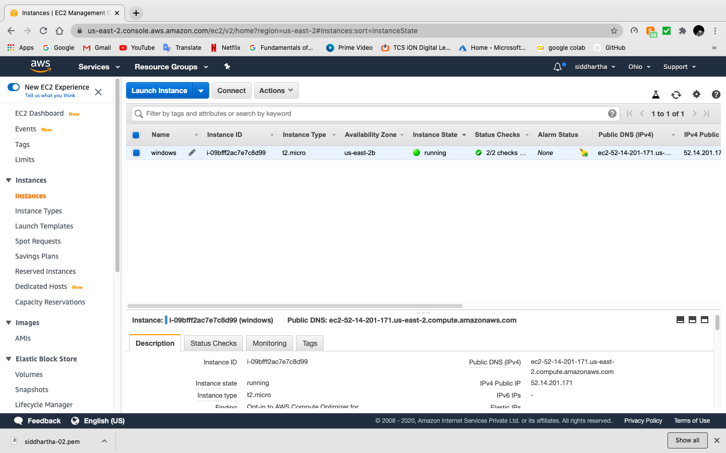

Created windows 2019 instance

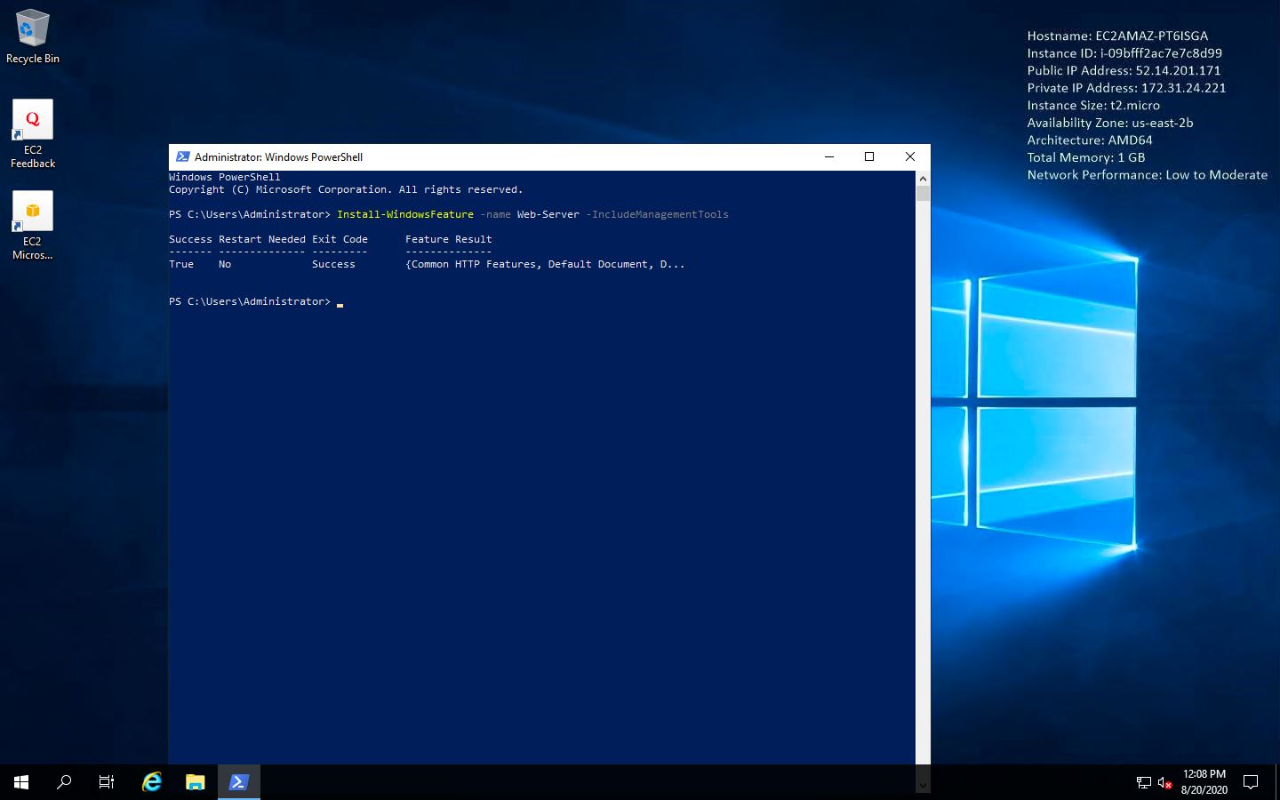

Copy-pasted the code in windows VM powershell to install IIS web sever

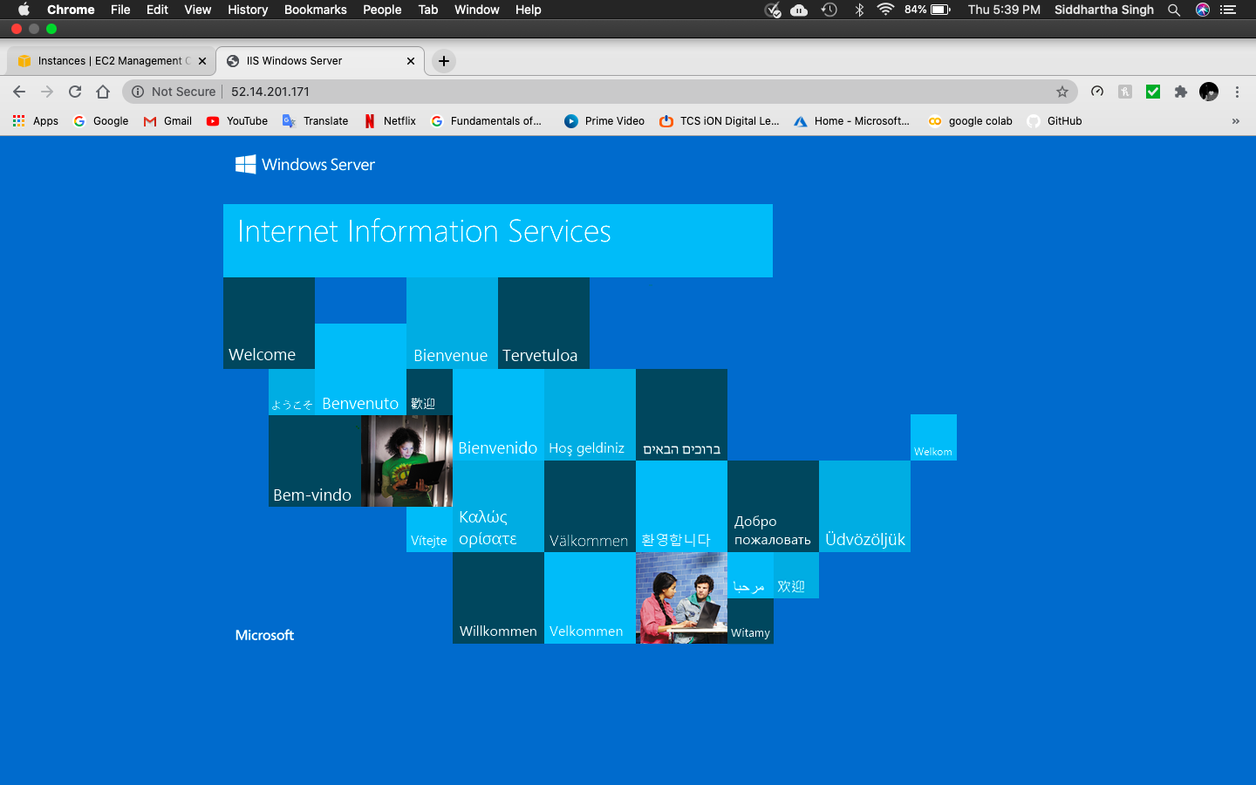

Copy and pasted public IP on browser for testing the connections