DRAM:
Dynamic random access memory is a type of memory that is typically used for data or program code that a computer processor needs to function. It's a common type of RAM used IN Pcs, workstations and servers. Although SRAM is faster DRAM is more preferred. Why? Because it is cheaper and DRAM is denser than SRAM and hence is more optimum in case of chip area. SRAM is only used where fast memory is used, like cache.
DRAM stores each bit of data in a storage cell consisting of a transistor and capacitor circuit. As there is the use of capacitor, to maintain data integrity the cells have to be periodically refreshed so that data bits don't change and charge leak from capacitor is compensated.
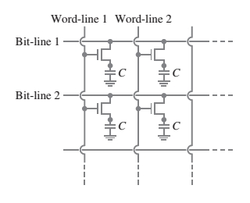

Fig1 : a group of DRAM cells

GPGPU(General-Purposecomputaion on Graphics Processing Units):

Modern OS allow programs to access the GPU alongside the CPU although GPU's main job is graphics rendering, speeding up the overall performance. GPGPU maximizes processing efficiency by releasing some operations from the CPU and instead carries those job by itself whilw sitting idle when not processing any grahics. Since GPUs are optimized for vectored calculations, they can process instructions faster than the CPU. GPGPU is a type of parallel processing, in which operations are processed between the CPU and GPU. When GPU finishes an operation it stores the result temporarily in a buffer and then passes it onto the CPU

