DIGITAL SIGNAGE CMS
Complete User Guide
Organisations · Roles · Plans · Screens · Media · Playlists · Layouts · Scheduling · Offline playback · Monitoring
Everything you need to run your screens: how to set up your organisation, connect screens, build and schedule content, and keep it all playing, explained step by step in plain English.
Who it is for | Everyone who uses the system: owners, administrators, content editors and the people who install screens. No technical background needed
What it covers | Organisations and how they stay separate, roles and permissions, plans and limits, screens, media, playlists, layouts, scheduling, offline playback, monitoring and alerts
Also inside | A chapter of hidden and advanced features, a troubleshooting chapter, and the complete journey from signing in to content playing
Based on | The software as it is actually built, checked against the running system
Version | 1.0
Date | September 2026
Prepared for developer hand-off. Diagrams are embedded as figures; cross-references and the table of contents are clickable.

Contents

Welcome 4
What this system does 4
Who this guide is for 4
How your account is organised 4
How to read this guide 4
Signing in for the first time 4
1. The short version 6
How the pieces fit together 7
The quickest way to see something on a screen 8
2. How your organisation stays separate 9
2.1 The idea 9
2.2 How the separation actually works 10
2.3 Things worth knowing 10
2.4 Joining two companies or splitting one 10
3. People, roles and permissions 11
3.1 The four ready-made roles 11
3.2 What each permission allows 11
3.3 Adding someone to your team 12
3.4 Making a custom role 12
3.5 Rules the system enforces 12
3.6 What people see when they lack a permission 12
4. Your plan and its limits 13
4.1 The three plans 13
4.2 How limits behave 14
4.3 Checking where you stand 15
4.4 Changing plan 15
4.5 About payment 15
5. Setting up your organisation 16
5.1 Creating the organisation 16
5.2 Organisation settings 16
5.3 Locations 16
5.4 Device groups 16
5.5 A good order for your first day 16
6. Connecting screens 17
6.1 What you need 17
6.2 On the screen 17
6.3 In the CMS 17
6.4 Screen states 19
6.5 Changing a screen later 19
6.6 Removing a screen 20
6.7 If pairing does not work 20
7. Media library 21
7.1 What you can upload 21
7.2 Uploading 21
7.3 Adding a web page 21
7.4 Finding things 21
7.5 Editing and deleting 21
7.6 Why your screens are safe from broken files 21
8. Playlists 22
8.1 Creating one 22
8.2 Using a playlist 23
8.3 Good habits 24
8.4 Deleting 24
9. Layout builder 25
9.1 Start from a template 25
9.2 Editing zones 26
9.3 Saving 27
9.4 Putting a layout on screens 27
9.5 Tips 27
10. Scheduling 28
10.1 Creating a schedule 28
10.2 How a screen picks what to play 29
10.3 An example week 30
10.4 Practical advice 30
10.5 Changing or removing 30
11. What happens without internet 31
11.1 Screens keep a copy 31
11.2 During an outage 32
11.3 When the internet returns 32
11.4 What does not work offline 32
11.5 Restarting a screen while offline 32
11.6 How updates reach screens normally 32
12. Watching your screens 33
12.1 The device wall 33
12.2 A single screen 33
12.3 Commands you can send 33
12.4 Alerts 34
12.5 The activity history 34
13. Hidden and advanced features 35
13.1 On the screen itself 35
13.2 In the media library 35
13.3 In playlists and layouts 35
13.4 In scheduling 36
13.5 Around the screens list 36
13.6 Account and organisation 36
13.7 For technical colleagues 37
14. When something is not right 38
14.1 Screens 38
14.2 Pairing 38
14.3 Signing in and permissions 38
14.4 Content 38
14.5 The CMS itself 39
14.6 Who to ask 39
15. The whole journey, start to finish 40
15.1 The path at a glance 40
15.2 Step by step 41
15.3 What made it safe 41
15.4 Five things to remember 41
List of figures 43

If the contents list is empty or out of date, right-click it in Word and choose Update Field → Update entire table.

Welcome

What this system does
Signage CMS lets you control the screens in your business from one website. You upload pictures and videos, decide the order they play in and when, and the screens follow along. A screen can be an Android TV, an Android tablet, or any computer or smart TV with a web browser.
Screens keep a copy of your content, so they keep playing even if the internet goes down.

Who this guide is for
Anyone who uses the system: owners, administrators, content editors and the people who install screens. You do not need any technical background. Where something technical matters, it is explained in plain words.

How your account is organised
When you sign up, you create an organisation. Everything you make afterwards belongs to it: your users, screens, pictures, playlists and schedules. Other companies using the same installation cannot see any of it, and you cannot see theirs. Chapter 2 explains how that separation works.
Word we use | What it means
Organisation | Your company's space in the system. Also called a "tenant"
User | A person who can sign in
Role | What a person is allowed to do (Owner, Admin, Editor, Viewer, or your own)
Location | A site, such as a shop or an office, with its own time zone
Device (screen) | A TV, tablet or browser connected to your organisation
Device group | A named set of screens, such as "All reception screens"
Media | One picture, video or web page
Playlist | Media in an order, each with a duration
Layout | A screen split into zones, each playing its own playlist
Schedule | A rule that says what plays, on which screens, on which days and at what times
Plan | Your subscription: how many screens, users and storage you can use

How to read this guide
- Steps are numbered in the order you do them.
- Bold words are buttons and menu names you will see on screen.
- Diagrams are pictures of the steps: rounded boxes are start and end points, diamonds are choices.
- Chapter 13 lists useful features that are easy to miss.
- Chapter 14 walks the whole journey once more, from signing in to content playing.

Signing in for the first time
- Open the web address your administrator gave you, for example https://signage.yourcompany.com.
- Enter your email and password and choose Sign in.
- If you do not have an account yet and you are starting fresh, choose Create an organisation instead (Chapter 4).
If you forget your password, ask an Owner or Admin in your organisation to set a new one for you under Users. There is no "forgot password" email yet.

1. The short version
Here is the whole system in nine steps. The rest of the guide explains each one.
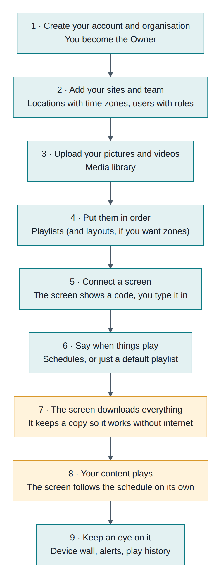
Figure 1-1 The nine steps, from creating your account to watching your screens
Blue steps are things you do in the website. Orange steps happen on the screen by itself.

How the pieces fit together
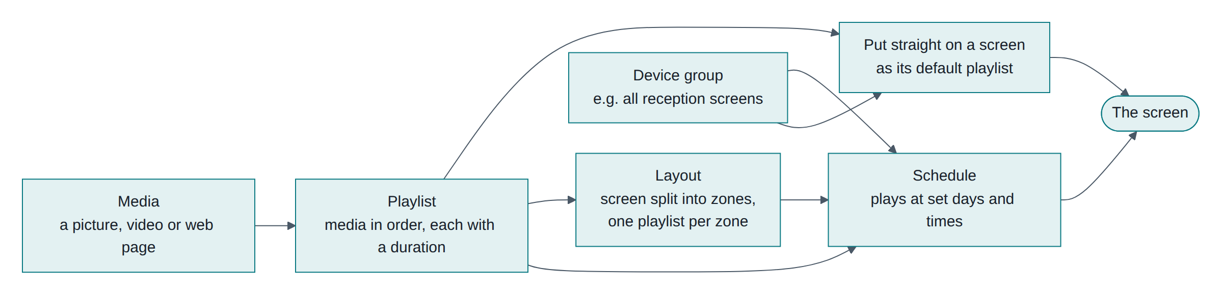
Figure 1-2 How media, playlists, layouts, schedules and screens relate

Read it like this: media goes into a playlist. A playlist can play on a screen on its own, or inside a layout that splits the screen into zones. A schedule decides when a playlist or layout plays, on chosen screens or groups.

The quickest way to see something on a screen
- Upload one picture (Media → Upload).
- Make a playlist with it (Playlists → New playlist, click the picture, Save).
- Open the player on your screen and note its code.
- Devices → Pair a screen, type the code, choose your playlist as the default playlist, then Pair screen.
Within a few seconds the picture appears. You can add schedules later; the default playlist covers everything not scheduled.

2. How your organisation stays separate

2.1 The idea
Several companies can use the same installation. Each one has its own organisation, and the system keeps them completely apart. You see only your own screens, media and users, and nobody outside your organisation can see yours.
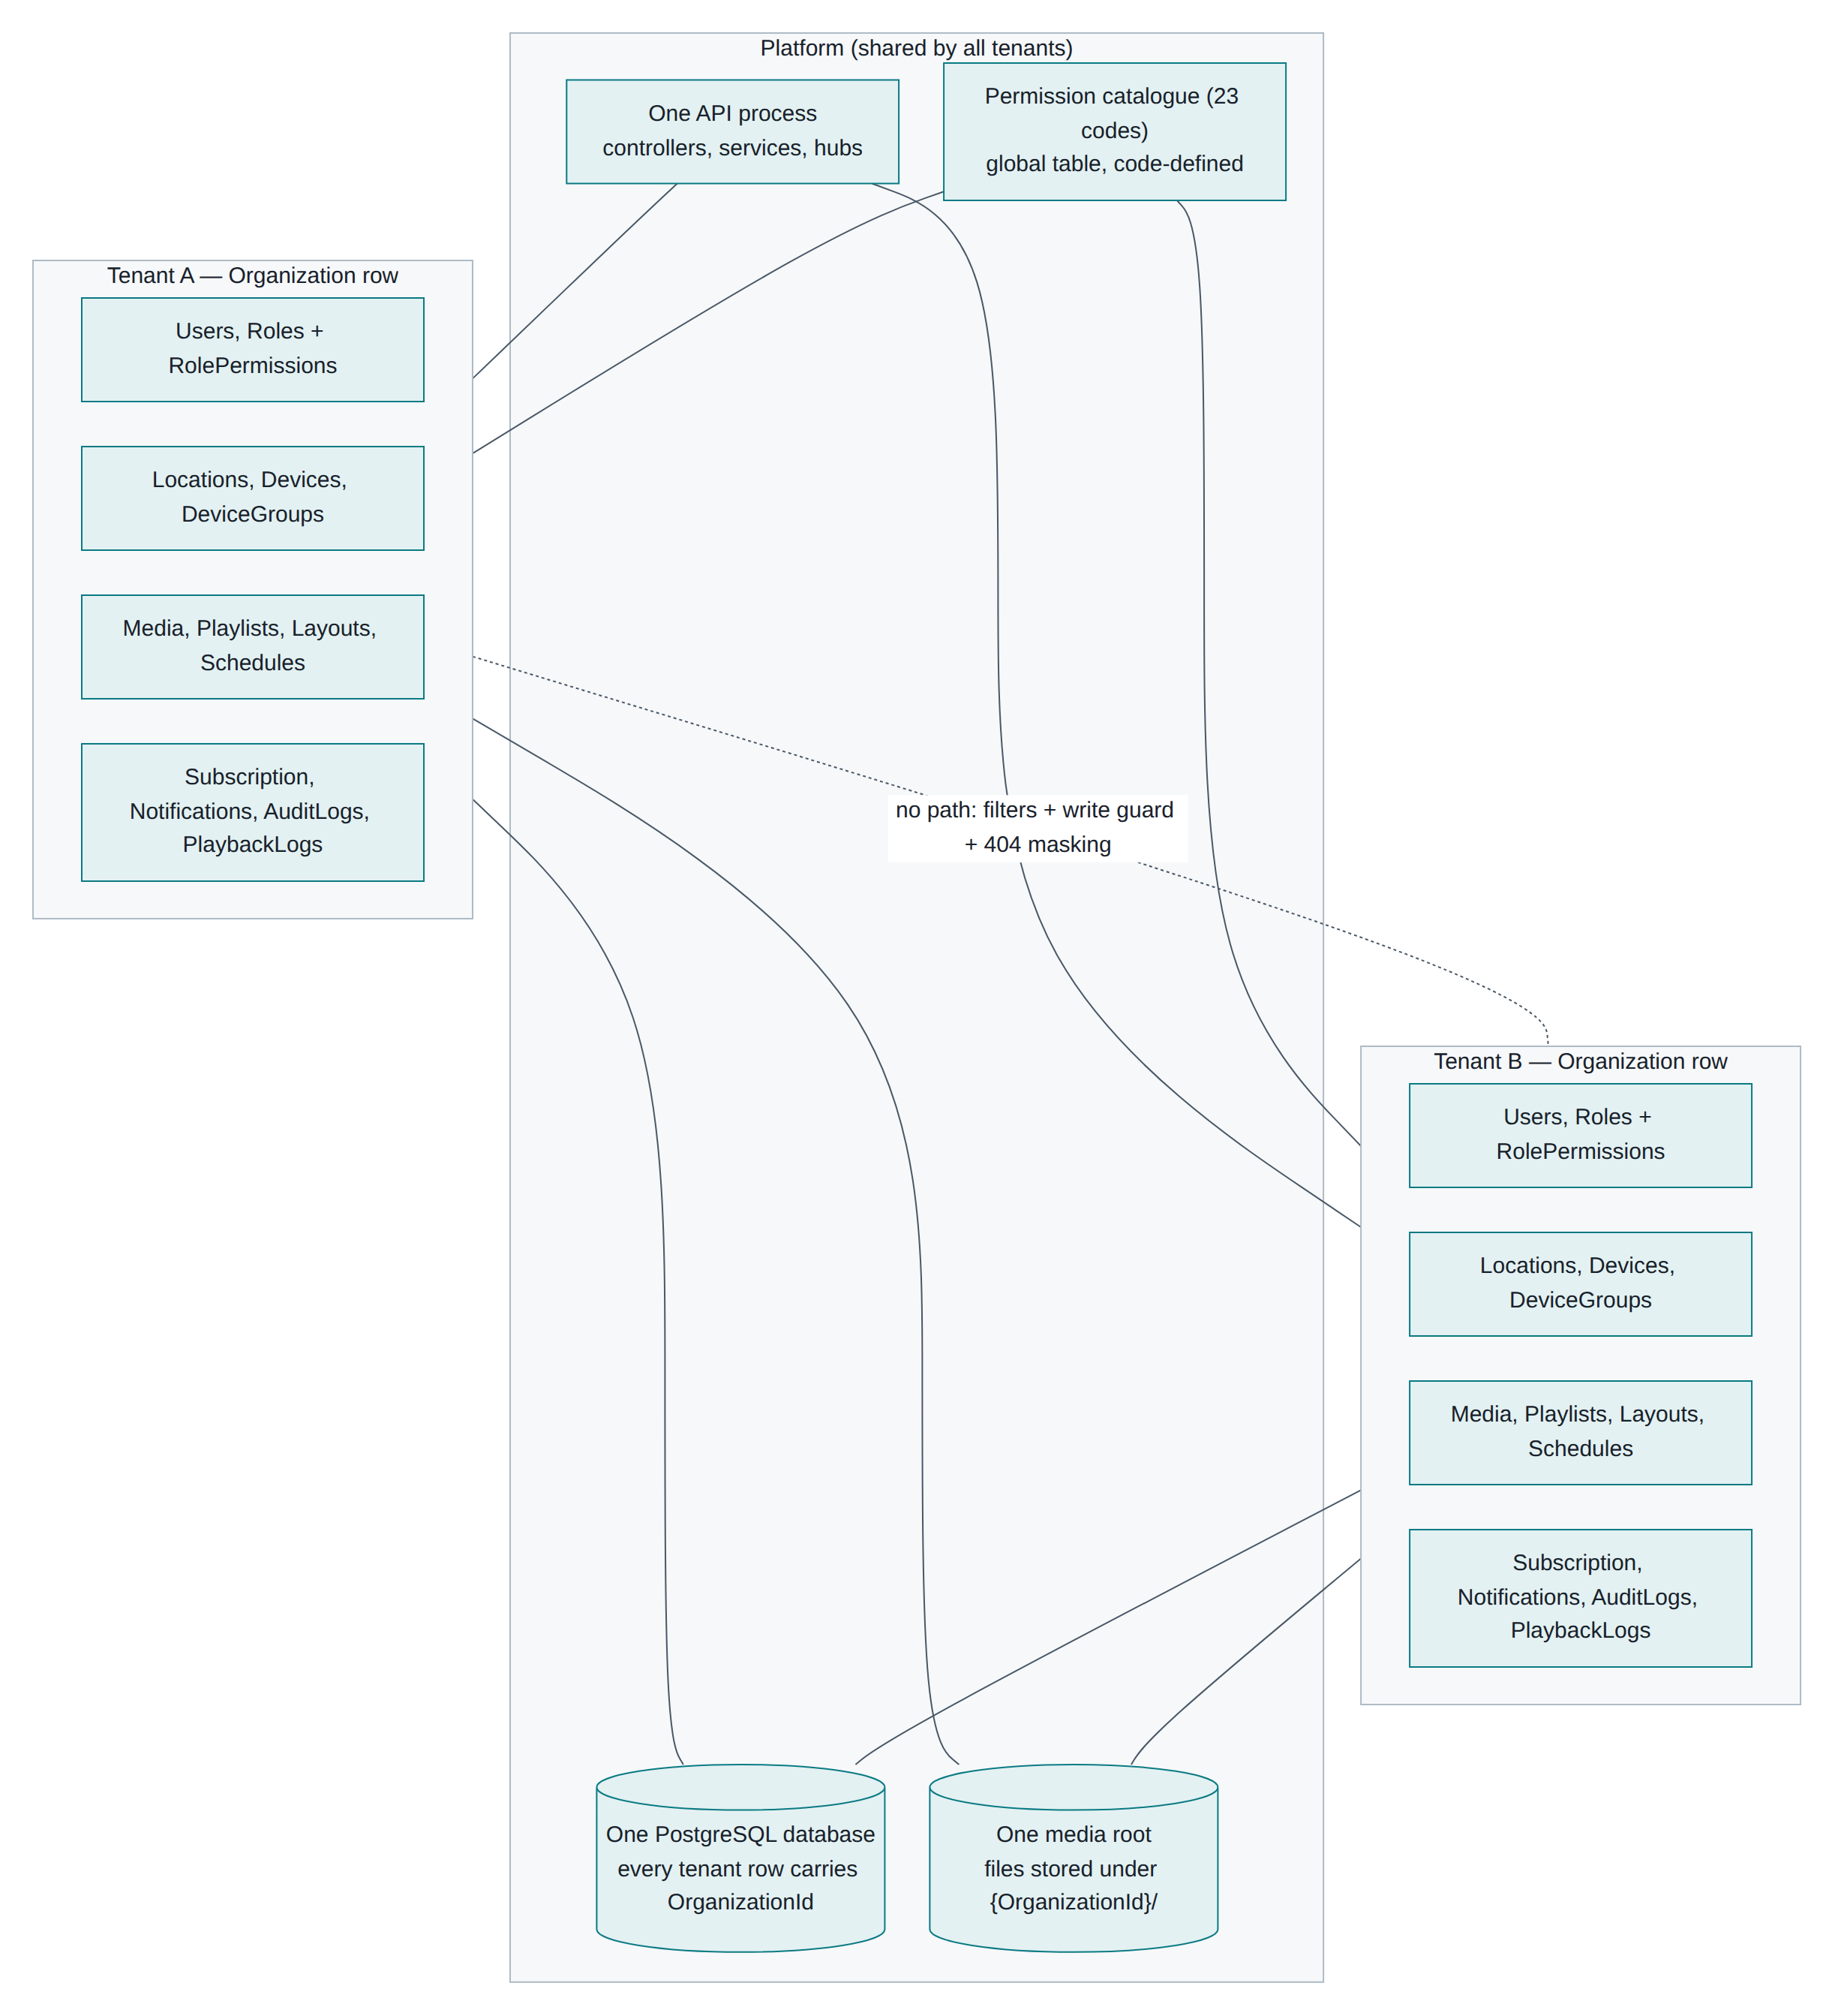
Figure 2-1 What belongs to your organisation, and what the platform shares
Yours alone: users, roles, locations, screens, groups, media files, playlists, layouts, schedules, alerts, activity history and your plan.
Shared by everyone, but harmless: the software itself, the database it runs on, the disk that stores files (your files sit in your own folder), and the fixed list of permissions.

2.2 How the separation actually works
You do not have to do anything to keep your data separate; the system does it on every single request.
What happens | What it means for you
Your organisation is recorded in your sign-in token | Every page you open, every search you run, is limited to your organisation automatically
Every record is stamped with your organisation when it is created | Nothing can be created "loose" or in someone else's space
Anything you try to save into another organisation is blocked | Even a fault in the software cannot mix two companies' data
Another company's item looks like it does not exist | You get "not found", not "not allowed", so nobody can discover what others have
Ids you send are checked against your own data | You cannot accidentally add someone else's video to your playlist
Files are served through short-lived private links | A link to a media file expires, and it only ever opens that one file

2.3 Things worth knowing
Point | Detail
One email, one organisation | An email address can belong to only one organisation. To work with a colleague, they must be a user in your organisation
Screens belong to the organisation that connects them | Whoever types the pairing code claims the screen. Nobody else can reach it afterwards
Live updates stay inside your organisation | When you change content, only your screens are told
Your plan counts only your things | Your screen, user and storage counts are yours alone
Support cannot look inside | Nobody has an "admin of everything" login. If you need help with your data, invite the helper as a user in your organisation

2.4 Joining two companies or splitting one
There is no built-in way to merge organisations, move a screen from one organisation to another, or export everything and delete an organisation yourself. To move a screen, remove it from the first organisation and pair it again in the second. For anything bigger, ask whoever runs the installation.

3. People, roles and permissions

3.1 The four ready-made roles
Every new organisation gets these four roles. You can also make your own.
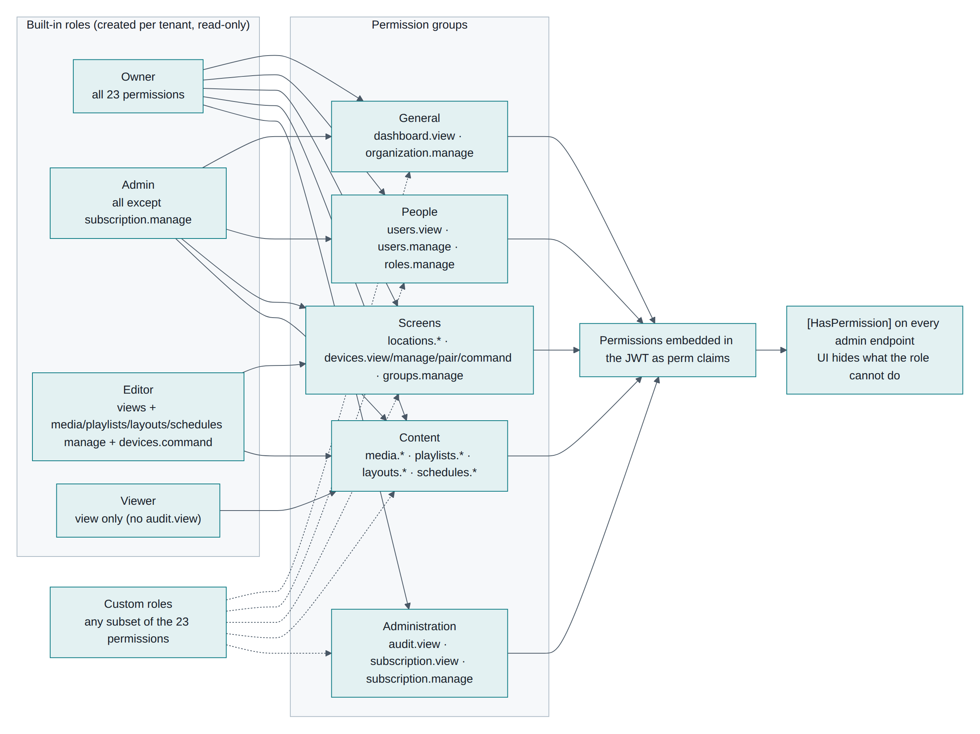
Figure 3-1 The built-in roles and the permissions behind them
Role | Best for | What they can do
Owner | The person responsible for the account | Everything, including changing the plan
Admin | Day-to-day manager | Everything except changing the plan
Editor | Marketing or content staff | Upload media, build playlists and layouts, make schedules, send commands to screens. Cannot manage users, roles or the plan
Viewer | Someone who only needs to look | See screens, media, playlists, layouts and schedules. Change nothing

The four ready-made roles cannot be edited or deleted. If you need something different, create a custom role.

3.2 What each permission allows
A role is simply a list of ticked permissions. There are 23.
Area | Permission | Lets the person…
General | See the dashboard | Open the home page with the screen wall
General | Edit organisation settings | Change the organisation name and default time zone
People | See users | View the user list and roles
People | Manage users | Add, edit, deactivate and remove users
People | Manage roles | Create and edit custom roles
Screens | See locations | View locations
Screens | Manage locations | Add, edit and delete locations
Screens | See devices | View screens, their status and play history
Screens | Manage devices | Rename screens, change their settings, remove them
Screens | Pair devices | Connect a new screen using its code
Screens | Command devices | Identify, sync now, restart, clear cache
Screens | Manage groups | Create and edit device groups
Content | See / manage media | View the library / upload, edit, delete
Content | See / manage playlists | View / create and edit
Content | See / manage layouts | View / create and edit
Content | See / manage schedules | View / create and edit
Administration | See the audit log | Read the history of changes
Administration | See the plan | View plan and usage
Administration | Manage the plan | Switch plan

3.3 Adding someone to your team
- Go to Users and choose Add user (you need "manage users").
- Fill in their email, name and a temporary password (at least 8 characters, with a letter and a number).
- Tick one or more roles. Most content staff need Editor.
- Choose Save, then pass the password to them securely. They can be given a new one at any time.

3.4 Making a custom role
Roles → New role, give it a name, and tick exactly what it should allow. A useful example is a "Screen installer" who can see locations and pair screens but cannot touch content.

3.5 Rules the system enforces
- Every user needs at least one role.
- Your organisation must always keep at least one active Owner.
- You cannot deactivate or delete your own account.
- Changing someone's password, or deactivating them, signs them out everywhere immediately.
- A role still assigned to someone cannot be deleted.
- After a permission change, the person may need up to 15 minutes, or a fresh sign-in, before it takes effect.

3.6 What people see when they lack a permission
Buttons and menu items they cannot use are hidden, so most people never meet an error. If they reach a page directly they get a short message saying which permission they need.

4. Your plan and its limits

4.1 The three plans
Plan | Screens | Users | Media storage
Free (where everyone starts) | 3 | 3 | 2 GB
Pro | 100 | 25 | 100 GB
Enterprise | 10,000 | 1,000 | 2,000 GB

4.2 How limits behave
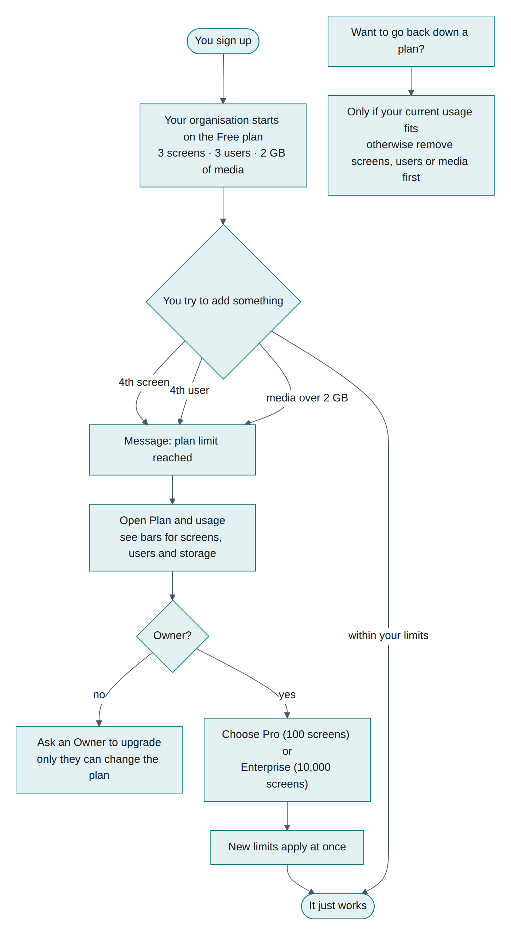
Figure 4-1 What happens when you reach a limit, and how to lift it
Limits are checked at the moment you act:
- Connecting a screen beyond your limit is refused, with a message naming the plan. The screen keeps showing its code, so you can upgrade and finish.
- Adding a user beyond your limit is refused in the same way.
- Uploading media that would push you over your storage is refused before the file is stored.

4.3 Checking where you stand
Open Plan and usage. Three bars show screens, users and storage. A bar turns amber near the limit and red when nearly full.

4.4 Changing plan
Only an Owner can switch plans. Open Plan and usage and choose the plan you want. New limits apply immediately.
To move to a smaller plan, your current usage must already fit inside it. Otherwise remove screens, users or media first.

4.5 About payment
This installation does not take payment. Switching plans changes your limits only. Whoever runs your installation decides how billing is handled.

5. Setting up your organisation

5.1 Creating the organisation
- Choose Create an organisation on the sign-in page.
- Enter your organisation name, your name, your work email and a password (at least 8 characters with a letter and a number).
- Choose Create organisation.
You are now signed in as the Owner. The system has already prepared, behind the scenes: your organisation, the Free plan, the four ready-made roles, six layout templates, and your own user account.

5.2 Organisation settings
Open Settings to set:
- Name — shown in the sidebar and on screens when you use Identify.
- Default time zone — used by any screen that has no location. Getting this right matters, because schedules run in local time.

5.3 Locations
A location is a site with its own time zone: "Chennai shop", "London office". Screens at that location follow that local time, which is what makes a "07:00 to 11:00" schedule correct in every city at once.
- Locations → Add location.
- Enter the name, address (optional) and choose the time zone.
- Choose Save.
Deleting a location does not delete its screens; they simply fall back to your organisation's default time zone.

5.4 Device groups
A group is a set of screens you treat together, such as "All menu boards". Schedules can target a group instead of listing screens one by one, and new screens added to the group pick up its schedules automatically.
- Device groups → New group.
- Name it, optionally choose a default playlist, tick the screens that belong to it.
- Choose Save.

5.5 A good order for your first day
- Settings — set your default time zone.
- Locations — add your sites.
- Device groups — create the groups you will schedule against.
- Users — invite colleagues with the smallest role that fits.
- Media and Playlists — upload a few files and build one loop.
- Devices — connect one screen and give it that playlist as its default.
- Schedules — add time-based rules once the basics work.

6. Connecting screens

6.1 What you need
A screen (Android TV, Android tablet, or any device with a modern browser) that can reach your CMS over the network, and a user account with the "pair devices" permission.

6.2 On the screen
Screen type | What to do
Android TV or tablet | Install the Signage Player app, open it, type your CMS address (for example 192.168.1.10:5080) and choose Connect
Browser, stick PC, smart TV | Open your-cms-address/player

The screen then shows a 6-character code in large letters. Codes never contain the confusing characters 0, O, 1 or I, and last 15 minutes. If nobody claims it, the screen quietly asks for a new one.

6.3 In the CMS
- Go to Devices and choose Pair a screen.
- Type the code exactly as shown.
- Give the screen a name you will recognise, such as "Lobby TV".
- Optionally choose its location, orientation, default playlist and groups.
- Choose Pair screen.
The screen picks it up within about three seconds, downloads its content and starts playing.
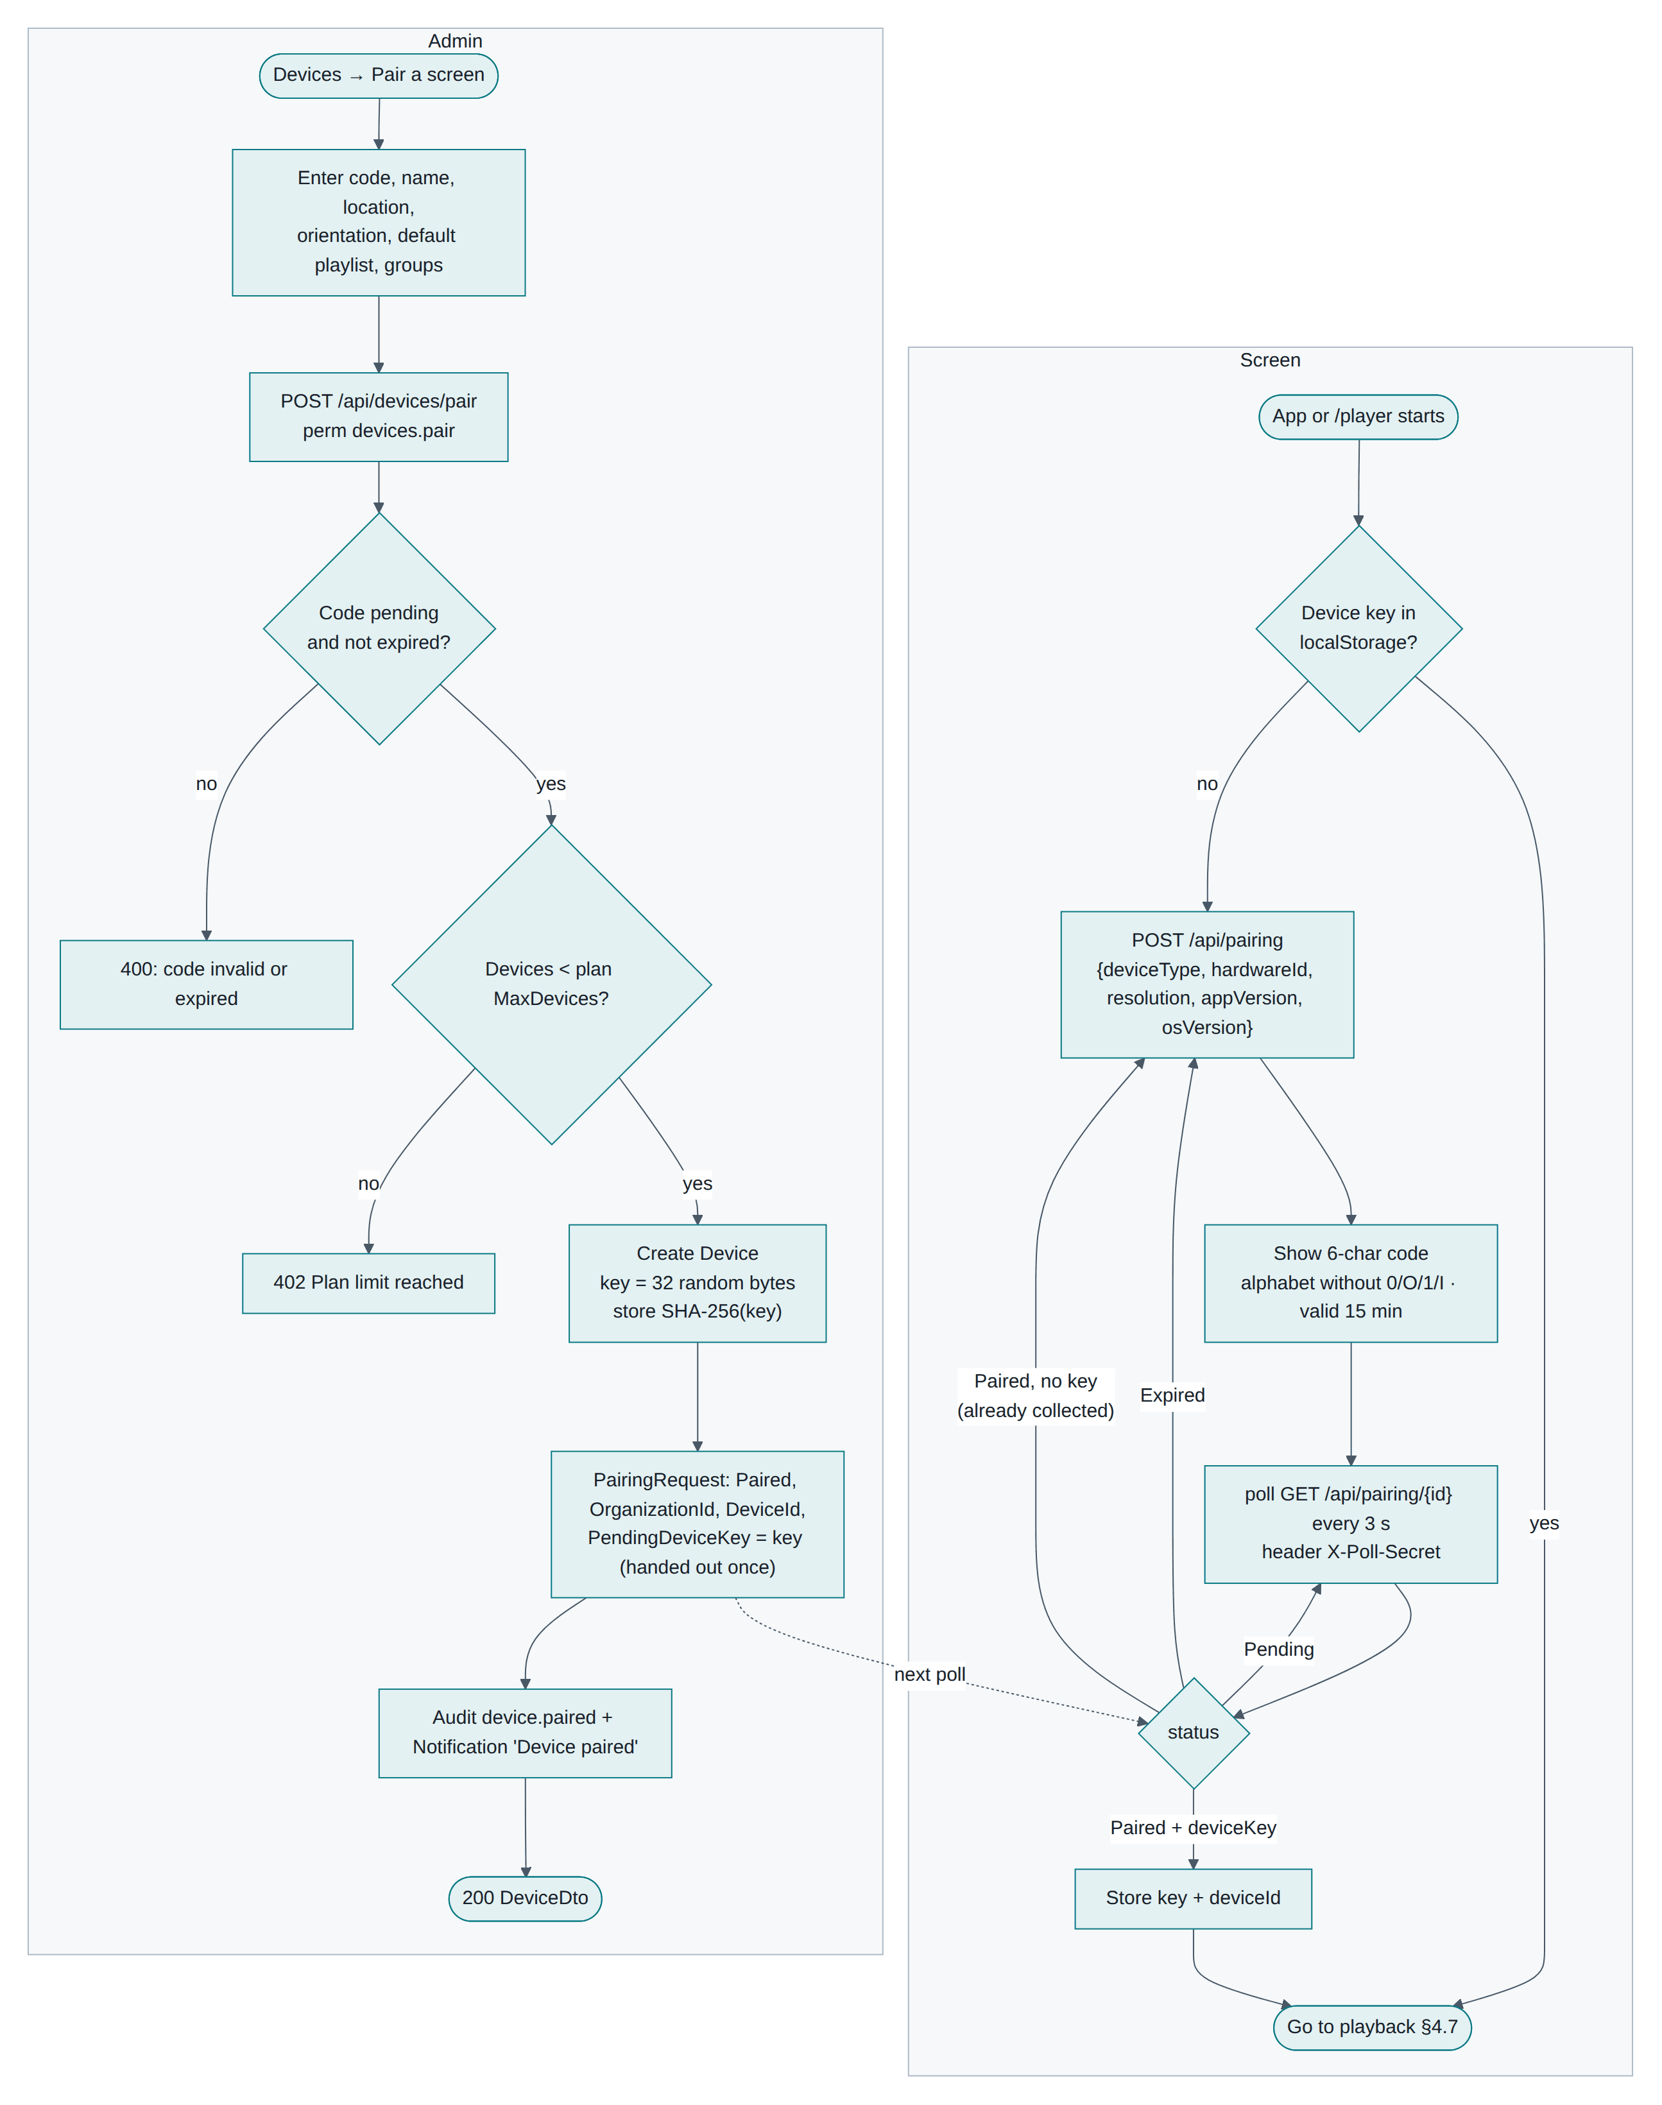
Figure 6-1 Connecting a screen: what happens on the screen and in the CMS

6.4 Screen states
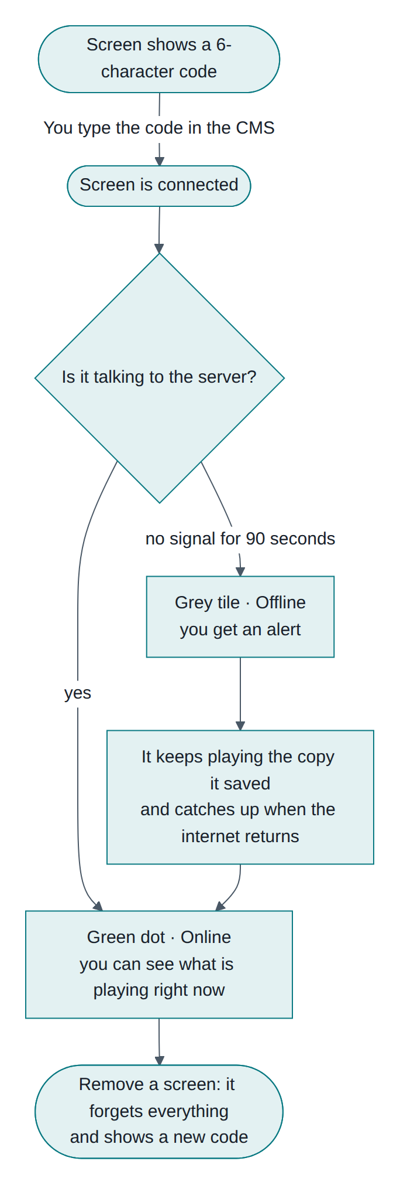
Figure 6-2 From pairing code to a running screen, and what happens when it drops offline

6.5 Changing a screen later
Open Devices and click the screen. You can change its name, location, orientation, default playlist and groups. Saving pushes the change out straight away.

6.6 Removing a screen
On the screen's page choose Unpair screen. The screen loses access immediately, deletes its saved copy of your content, and returns to showing a new pairing code. Use this whenever a screen is sold, moved to another organisation, or lost.

6.7 If pairing does not work
Problem | What to do
"That code is invalid or has expired" | Check for typos, then use the newest code on the screen
Screen still shows the code after you paired it | It cannot reach the server. Check the network
"Plan limit reached" | You are at your screen limit. Upgrade, or remove an unused screen
The app says it cannot reach the server | Check the address, that the screen is on the same network, and that the firewall allows the port

7. Media library

7.1 What you can upload
Type | Formats | Notes
Pictures | JPG, PNG, GIF, WEBP | Best at the screen's own resolution
Videos | MP4, WEBM, M4V | Use H.264 MP4 for the widest support on TVs
Web pages | any address | Added as a link, not a file. Needs internet at play time, and the page must allow being embedded

The largest single file is 1 GB. Total storage depends on your plan.

7.2 Uploading
- Go to Media.
- Either drag files onto the page or choose Upload and pick them.
- Each file shows a progress bar. They upload one after another.
The system reads each file's size and, for videos, its length, so your playlists show the right durations without you typing anything.

7.3 Adding a web page
Choose Add web page, give it a name, the full address (https://…) and how long it should stay on screen.

7.4 Finding things
Search by name or tag, and filter by type (picture, video, web page). Tags are free text you set when editing an item, such as summer, menu.

7.5 Editing and deleting
Click the pencil on any item to change its name, default duration and tags. The default duration is how long a picture stays on screen when a playlist does not override it.
Deleting is refused while the item is used in a playlist, and the message names the playlists. Remove it from those first.

7.6 Why your screens are safe from broken files
Every uploaded file gets a fingerprint. When a screen downloads it, it checks the fingerprint matches. If anything went wrong in transit, the screen keeps playing the content it already had rather than showing something broken.

8. Playlists
A playlist is your content in order. It loops: when it reaches the end, it starts again.

8.1 Creating one
- Playlists → New playlist. The editor opens straight away.
- Give it a name at the top.
- On the right, search your library and click items to add them.
- Set each item's options:
  - Duration — leave blank to use the item's own default, or type seconds to override it here. Videos play to the end.
  - Transition — Fade (default), Slide or Cut.
  - Order — the arrows move an item up or down; the ✕ removes it.
- Optionally turn on Shuffle to play items in random order.
- Choose Save changes.
The header shows how many items there are and how long one loop lasts.
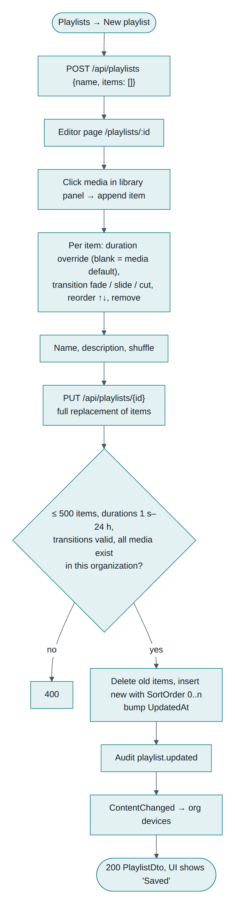
Figure 8-1 Building and saving a playlist

8.2 Using a playlist
Way to use it | Result
Default playlist on a screen | Plays whenever no schedule applies
Default playlist on a group | Same, for every screen in the group without its own default
Inside a layout zone | Loops in that part of the screen
In a schedule | Plays full screen during the chosen days and times

8.3 Good habits
- Keep a loop short enough that a passer-by sees it all, often 30 to 90 seconds.
- Give pictures 8 to 12 seconds; less looks rushed.
- Use one playlist per purpose ("Breakfast", "Promos"), rather than one giant one.

8.4 Deleting
Refused while a schedule uses the playlist. If a screen, group or layout zone simply has it as a default, deleting is allowed and that default becomes empty.

9. Layout builder
A layout divides one screen into rectangles called zones. Each zone plays its own playlist, so you can show a video with a sidebar of offers and a strip along the bottom.

9.1 Start from a template
Six templates come with every organisation:
Template | What it gives you
Full screen | One zone filling the screen
Main with sidebar | Large area plus a right-hand column
Main with ticker | Large area plus a bottom strip
L-shape | Main area, sidebar and bottom strip
Quad grid | Four equal quarters
Portrait split | Top and bottom, for upright screens

- Layouts → Templates.
- Choose Use on the one closest to what you want.
- Give your layout a name and choose Create and edit.
Templates themselves cannot be changed; you always work on your own copy.
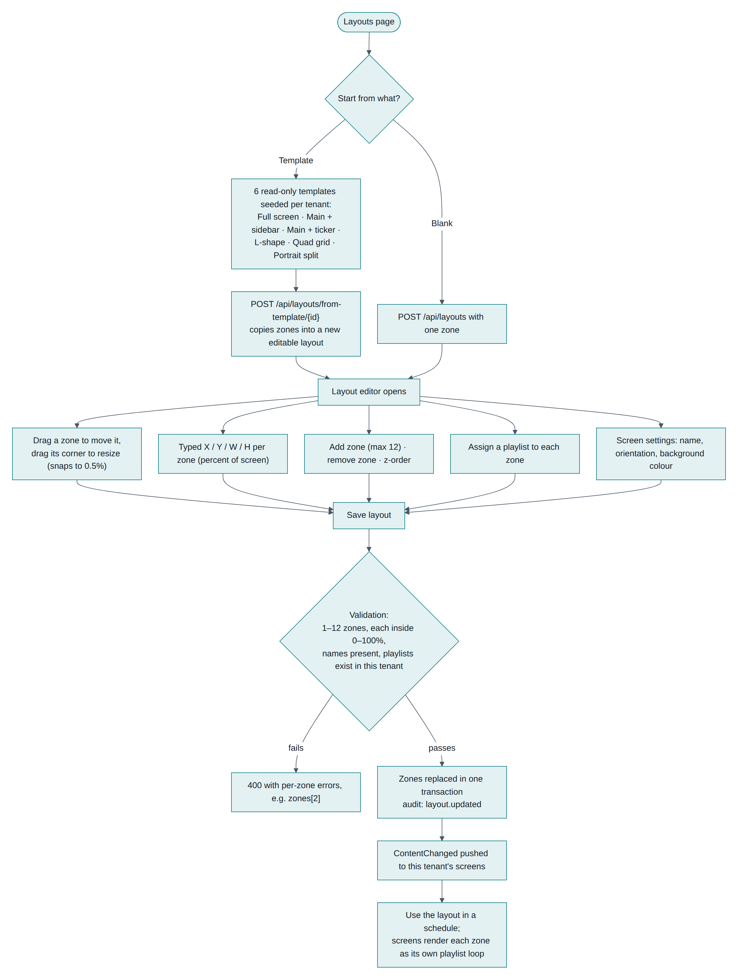
Figure 9-1 Building a layout, from template to something you can schedule

9.2 Editing zones
To do this | Do that
Move a zone | Drag it on the canvas
Resize | Drag the small square at its bottom-right corner
Position exactly | Type X, Y, W and H (percentages of the screen)
Choose what plays | Pick a playlist for the selected zone
Add or remove | Add (up to 12 zones); Remove zone
Change the screen | Name, orientation (landscape or portrait), background colour

Sizes are percentages, not pixels, so the same layout fits a small tablet and a 4K TV.

9.3 Saving
Choose Save layout. If a zone sticks out past the edge of the screen, or a zone has no name, you get a clear message naming the zone. Once saved, your screens are told immediately.

9.4 Putting a layout on screens
A layout reaches a screen through a schedule (see Chapter 10). A screen's default can only be a playlist, so a layout always needs a schedule, even an all-day one.

9.5 Tips
- Put moving video in the largest zone; use still pictures in small zones so text stays readable.
- Keep zones from overlapping unless you mean to. If they do overlap, the higher zone number sits on top.
- A zone with no playlist simply shows the background colour.

10. Scheduling
Schedules answer: what plays, on which screens, on which days, between which times?

10.1 Creating a schedule
- Schedules → New schedule.
- Name it something recognisable, such as "Breakfast menu".
- Priority (0–100): when two schedules overlap, the higher number wins.
- Plays: choose either a playlist or a layout.
- Starts / Ends: the date range. Leave the end empty to run indefinitely.
- Days: tap the day buttons.
- Time: leave All day on, or set From and Until. If "until" is earlier than "from", it runs past midnight (for example 22:00 to 02:00).
- Screens: tick device groups and individual screens.
- Leave Active on, and choose Save schedule.
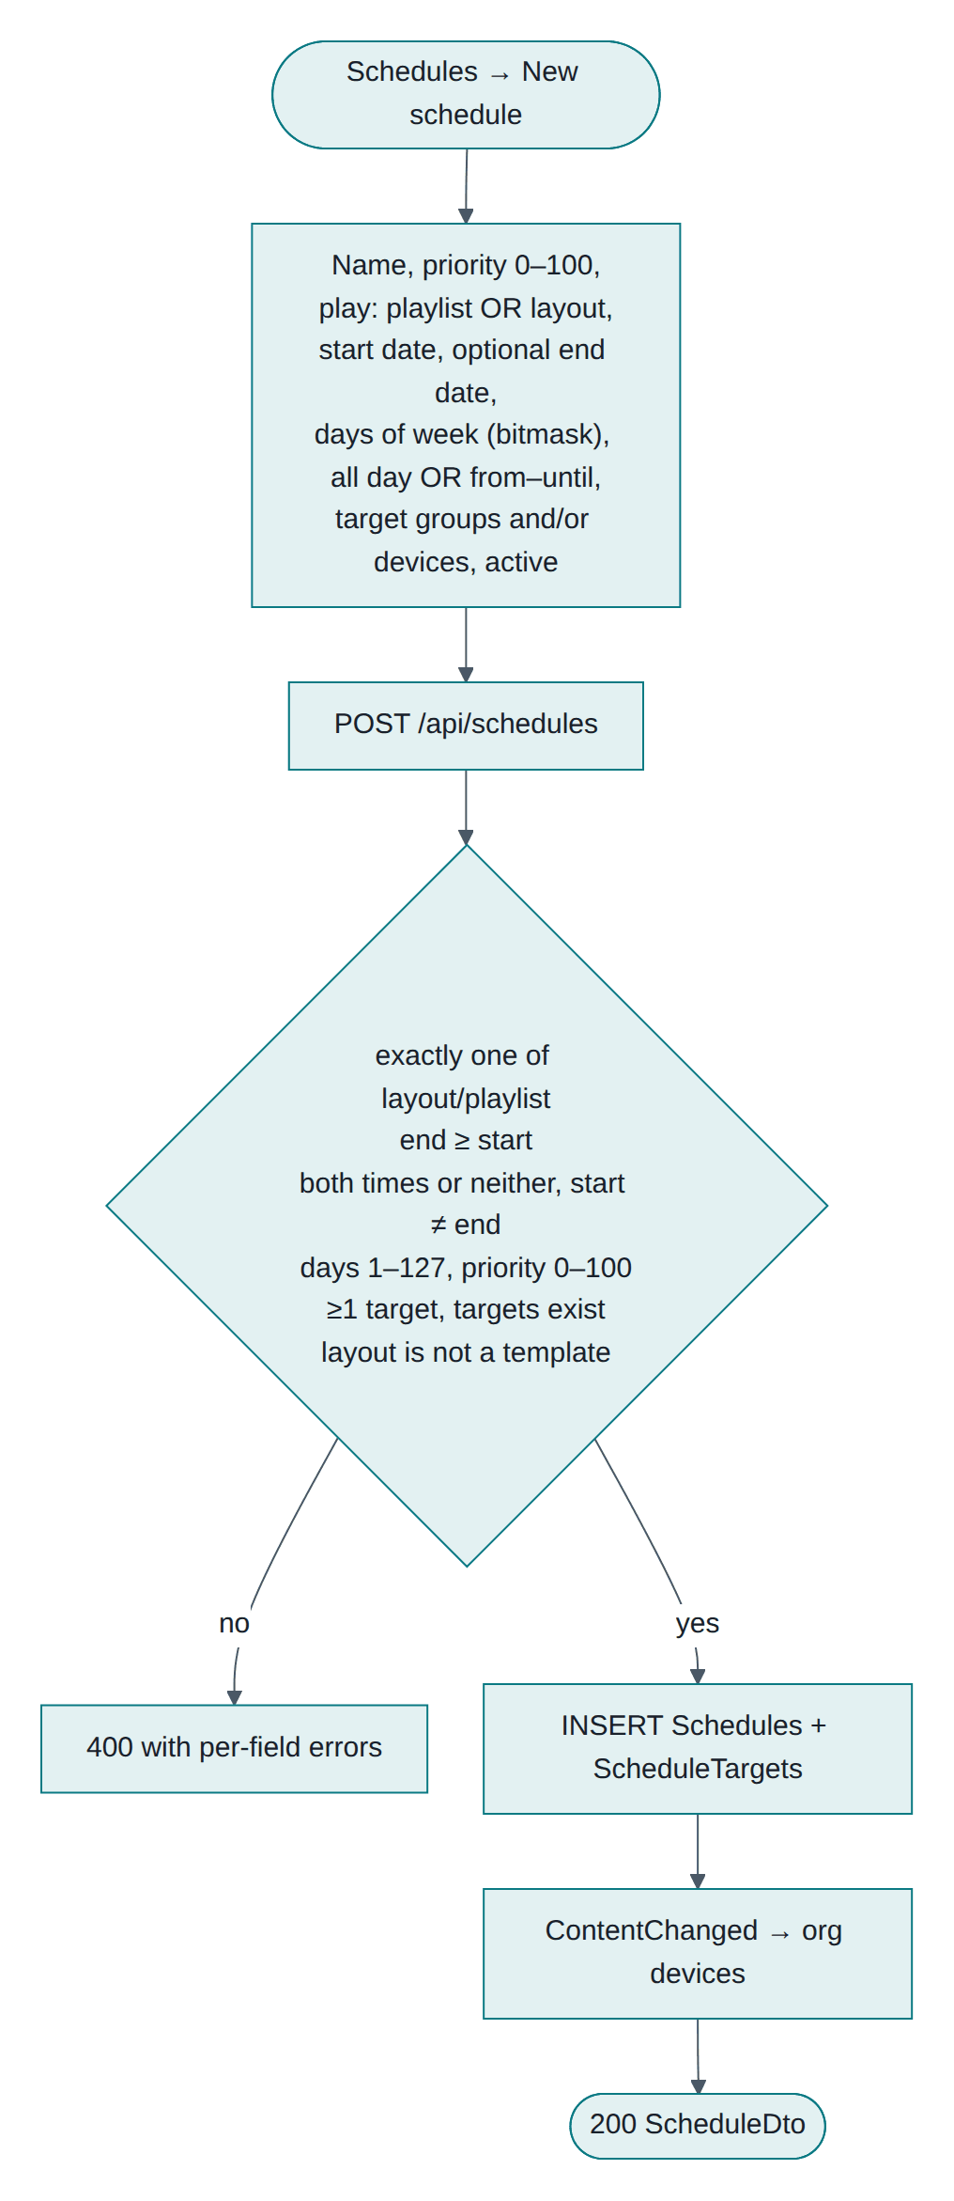
Figure 10-1 Creating a schedule

10.2 How a screen picks what to play
Screens decide for themselves, which is why they stay correct without internet. Every 15 seconds a screen checks, in its own local time:
- Which schedules apply today, on this weekday, at this time?
- Of those, which has the highest priority? That one plays.
- If none apply, play the screen's default playlist.
- If it has none, use its group's default.
- If there is still nothing, show a clock with the screen's name.

10.3 An example week
Schedule | Priority | Days | Time | Plays
Breakfast menu | 20 | Mon–Fri | 07:00–11:00 | Breakfast playlist
Lunch menu | 20 | Mon–Fri | 11:00–15:00 | Lunch layout
Weekend brunch | 30 | Sat–Sun | 08:00–14:00 | Brunch layout
Promo loop | 10 | Every day | All day | Promo playlist

Tuesday 09:00 shows Breakfast, because 20 beats the all-day Promo at 10. Tuesday 16:00 shows Promo. Saturday 09:00 shows Weekend brunch, because 30 beats everything.

10.4 Practical advice
- Give one all-day, low-priority schedule as your safety net, so a screen is never blank.
- Use priorities in steps of 10, leaving room to slot something between later.
- Check the screen's location is right: a schedule runs in the location's time zone.
- Use Active to pause a seasonal schedule instead of deleting it.

10.5 Changing or removing
Edit any schedule from the list; screens update within seconds. Deleting simply removes that rule, and screens fall back to the next match.

11. What happens without internet

11.1 Screens keep a copy
When a screen connects, it downloads everything it needs: your schedules, playlists, layouts and the actual picture and video files. It checks every file is complete, then saves it locally.
That is why a screen keeps working when the network drops. It is not streaming from the server; it plays from its own copy.
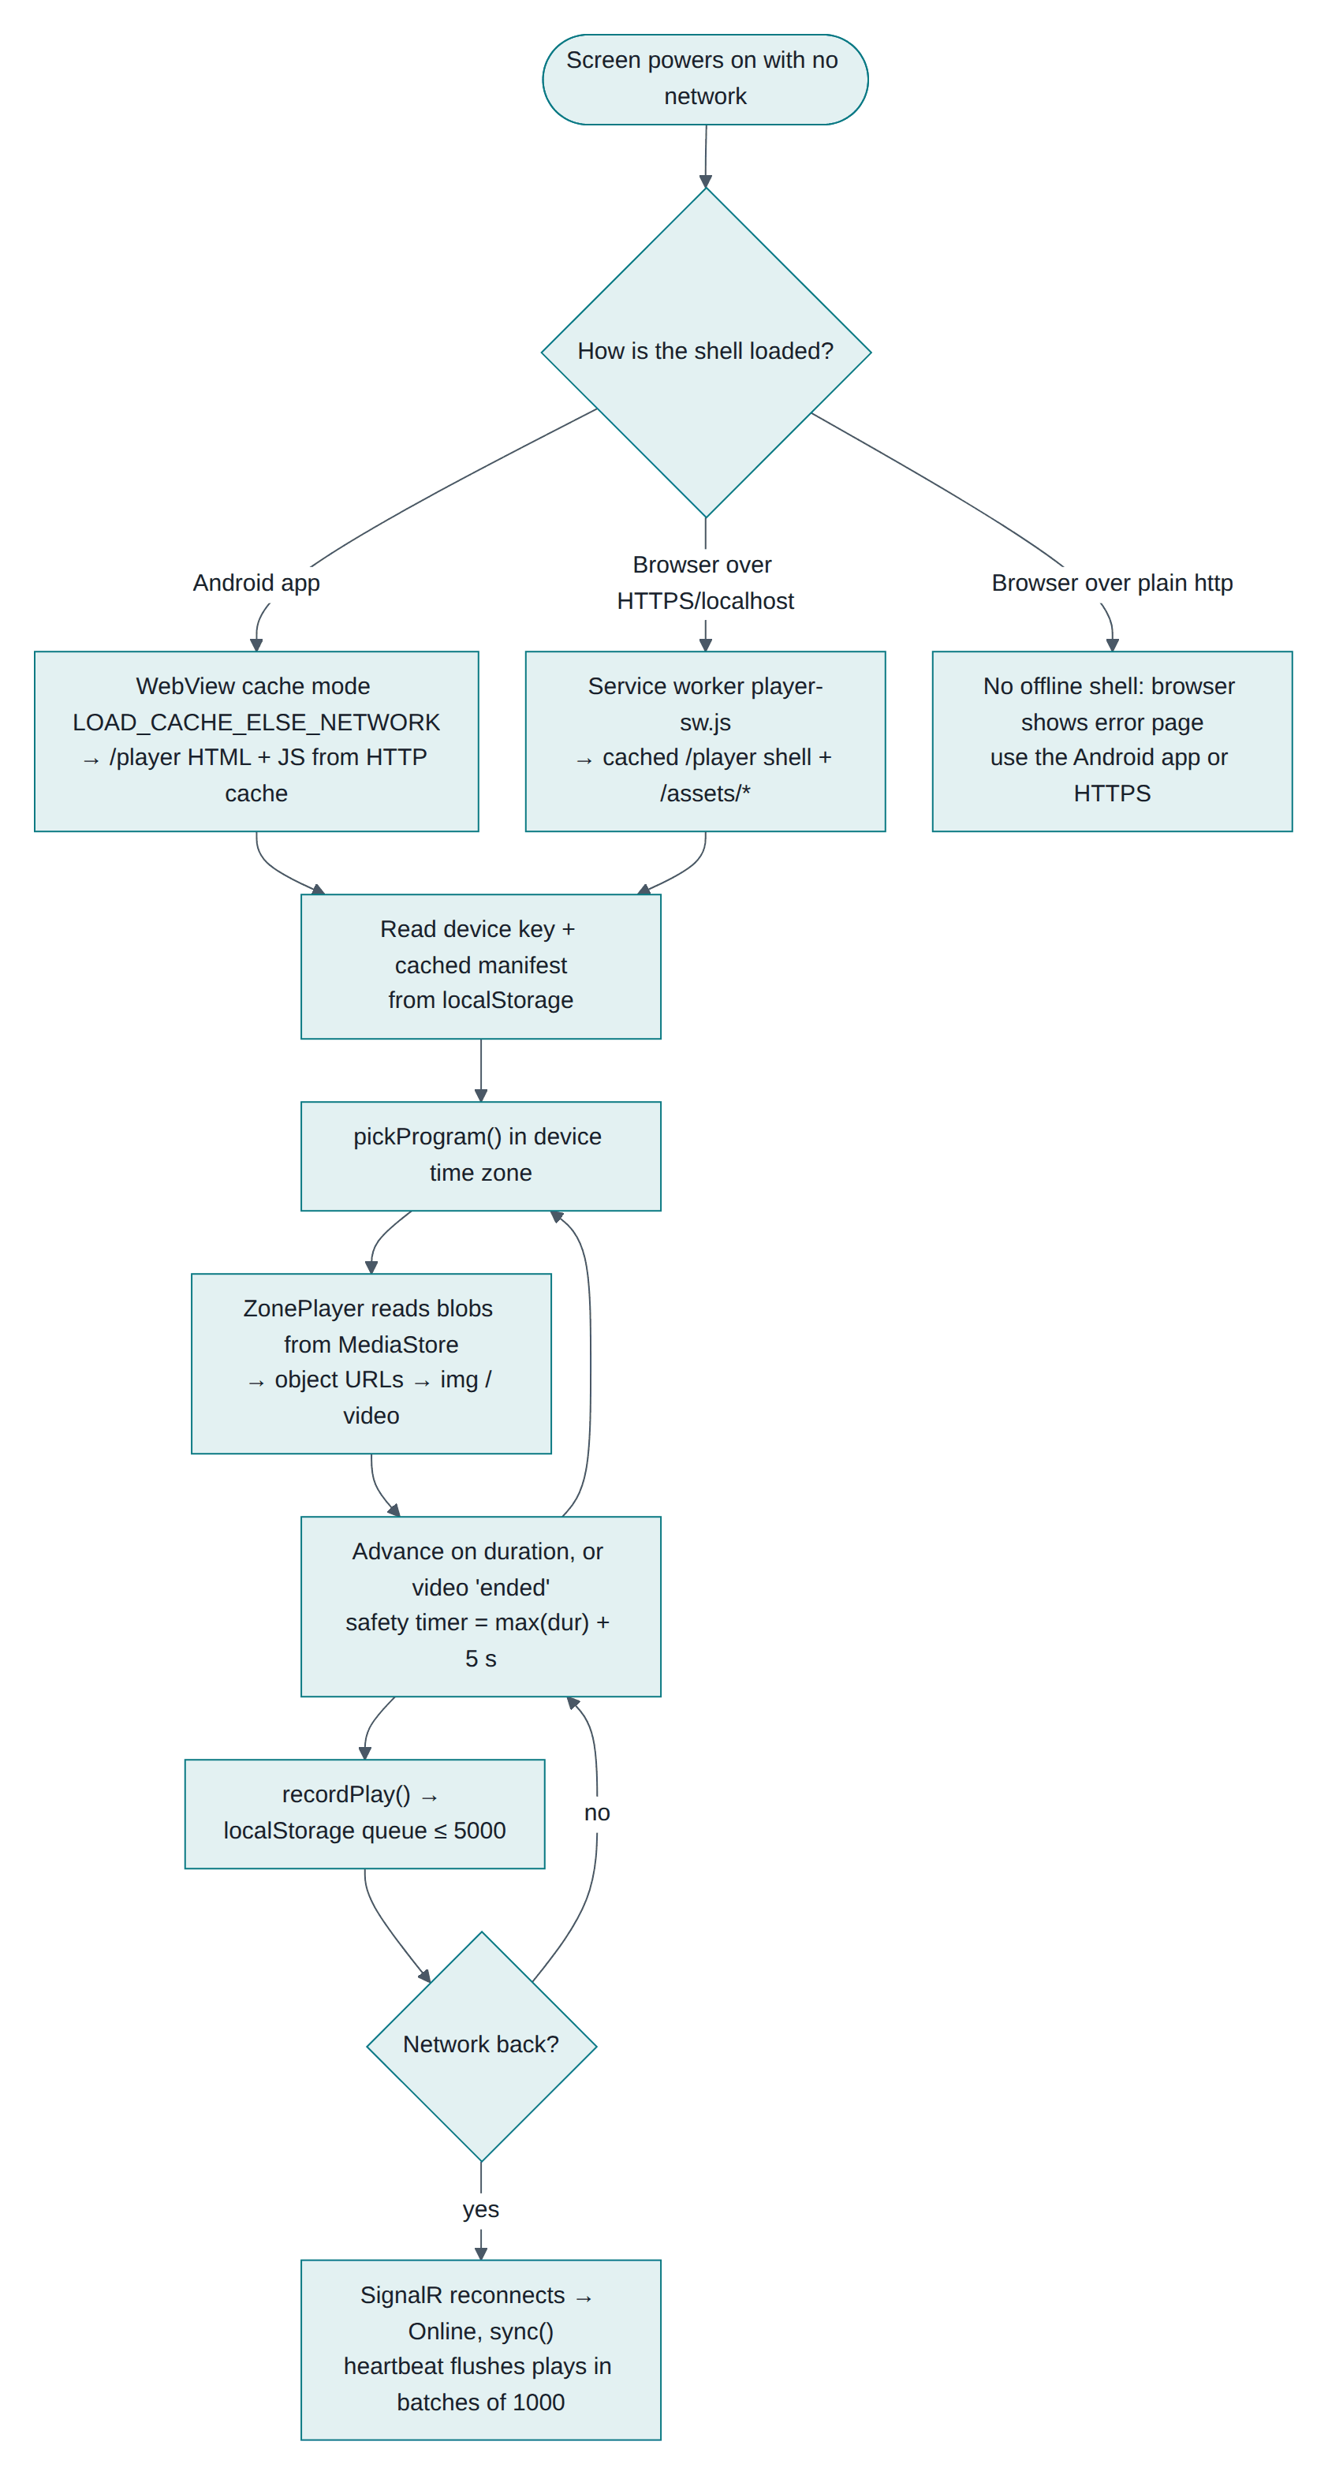
Figure 11-1 What a screen does while the internet is down, and when it returns

11.2 During an outage
- Content keeps playing.
- Schedules keep switching at the right times, because the screen tracks time itself.
- The screen quietly records what it played.
- In the CMS the screen shows as Offline after about 90 seconds, and you get an alert.

11.3 When the internet returns
The screen reconnects, shows Online again, checks whether anything changed, downloads only what is new, and uploads the play history it collected while away.

11.4 What does not work offline
- Web page media needs the internet, because it loads a live page.
- New content cannot arrive until the connection returns.
- Commands such as Identify or Sync now only reach a connected screen.

11.5 Restarting a screen while offline
Screen type | Result
Android app | Starts up and plays its saved copy
Browser on a secure (https) address | Starts up and plays its saved copy
Browser on a plain http address | Cannot start without the network. Use the Android app, or ask for https

For screens left unattended, the Android app is the safer choice.

11.6 How updates reach screens normally
When you save a change, connected screens are told at once and update within seconds. As a backstop, every screen also checks for changes every 5 minutes, so nothing is ever missed. You can force it with Sync now on the screen's page.

12. Watching your screens

12.1 The device wall
The dashboard shows every screen as a small picture of a display, in its real orientation. A screen that is playing glows; one that is not is grey and says "No signal". Underneath you see its name, location and what it is playing.
Counters at the top show screens online, media and storage used, playlists and active schedules.
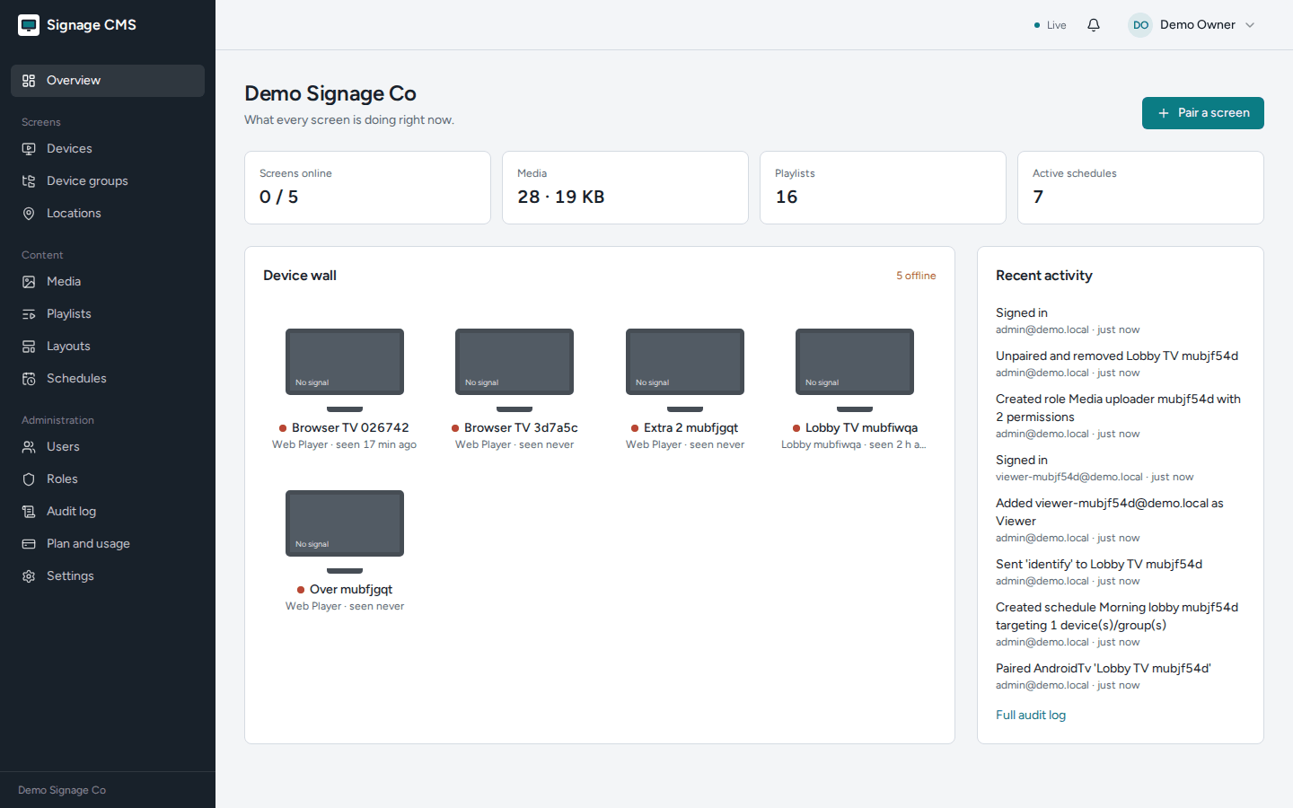
Figure 12-1 The dashboard: counts, device wall and recent activity

12.2 A single screen
Click any screen to see:
Section | What it tells you
Status | Online or Offline, and when it was last seen
Settings | Name, orientation, location, default playlist, groups
Device | Type, resolution, app and system version, network address, when it was connected, when it last synced, which content version it has, what is playing, free storage
Proof of play | What actually played over the last 7 days, how many times and for how long

12.3 Commands you can send
Button | What the screen does
Identify | Shows its name in big letters for 10 seconds. Useful for finding which physical screen you are looking at
Sync now | Checks for new content immediately
Restart player | Restarts the player software

Commands reach connected screens only. An offline screen does not receive them later.

12.4 Alerts
The bell in the top bar shows unread alerts. You get one when a screen is connected, goes offline, or comes back.
- A pop-up appears if you have the CMS open at that moment.
- Everything is kept in Notifications, where you can open the screen concerned or mark items read.
- Note that read or unread is shared across your team, so if a colleague clears an alert, it clears for you too.

12.5 The activity history
Audit log records every change: who did it, what changed, when and from which address. Search by wording, person or action, and filter by the kind of item. Useful for "who deleted that playlist?" questions. It requires the audit permission, which Owners and Admins have.

13. Hidden and advanced features
These all exist in the software but are easy to miss. They are grouped by where you find them.

13.1 On the screen itself
Feature | How to use it
Hidden menu on Android | Press Back three times quickly (or the Menu key) on the remote. You get Reload player, Change server, turn start-on-boot on or off, and Exit. This is the only way out of the app, which is deliberate
Starts by itself after a power cut | The Android app reopens when the device powers on. On Android 10 and newer, tap Allow start on boot during setup, otherwise the system blocks it
Keeps the screen awake | The player prevents the screen saver and sleep while it is running
Full screen in a browser | Double-click (or double-tap) the player page to go full screen
Quiet offline marker | A small amber dot at the bottom-left means "playing from my saved copy". A small note at the bottom-right appears while new content downloads
Identify overlay | Shows the screen's name, your organisation name and its content version, useful when several screens hang side by side
Device details are reported automatically | Model, system version, resolution and free storage appear on the screen's page without any setup

13.2 In the media library
Feature | How to use it
Drag and drop, many files at once | Drop a selection onto the Media page; each gets its own progress bar
Tags | Add words like summer, menu when editing an item, then search by them
Video length detected for you | Durations are read from the file, so playlist timings are right immediately
Usage count | Each item shows how many playlists use it, so you can spot unused files
Safe deletion | The system refuses to delete something a playlist still uses, and names the playlists
Web pages as content | Any web address can be shown for a set time, handy for dashboards (it needs internet)

13.3 In playlists and layouts
Feature | How to use it
Per-item duration | Leave the duration blank to use the item's default, or set a different time just for this playlist
Transitions | Fade, Slide or Cut per item
Shuffle | Plays a loop in random order
Live loop length | The header adds up your playlist as you build it
Snap-to-grid dragging | Zones snap to half-percent steps, so edges line up neatly
Flip orientation | Switching a layout between landscape and portrait swaps its dimensions for you
Zone stacking | Zones have an order, so a small zone can sit on top of a big one
Empty zones are allowed | A zone with no playlist shows the background colour, useful for spacing

13.4 In scheduling
Feature | How to use it
Overnight windows | Set "until" earlier than "from" (22:00 to 02:00) and it correctly runs through midnight
Priority | Overlapping schedules are resolved by the highest number, so you can drop a one-day promotion over a standing schedule
Pause instead of delete | Turn Active off to keep a seasonal schedule for next year
Target groups, not screens | Schedule to a group, then any screen you later add to the group picks it up automatically
Per-location time zones | The same schedule plays at 07:00 local time in every city
End date optional | Leave it empty for an evergreen rule

13.5 Around the screens list
Feature | How to use it
Filters | Filter by status (Online/Offline) and location, and search by name
Group defaults | Give a group a default playlist, and every screen in it without its own default uses it
Live updates without refreshing | Status changes arrive by themselves. The header shows Live, Connecting or Updates paused
Proof of play | The last 7 days per screen, including anything played while offline
Clear cache | An advanced command that makes a screen throw away its saved copy and download everything again; useful if a screen ever looks stuck

13.6 Account and organisation
Feature | How to use it
Custom roles | Build a role from the exact permissions you want
Sessions end on password change | Changing someone's password or deactivating them signs them out everywhere at once
Audit search | Search the change history by wording, person or action, and filter by item type
Notification badge | The bell count refreshes on its own
Download the Android app from your own CMS | Settings → Connect a screen has a download button, and the address to type into a TV downloader app
Open the web player quickly | The user menu has Open web player, which opens a player in a new tab, handy for testing without hardware
Time zone list | The time zone pickers list proper zone names so daylight saving is handled for you

13.7 For technical colleagues
Feature | Detail
API documentation | If enabled on your installation, /swagger lists every endpoint and lets you try it
Any browser can be a screen | /player works on smart TV browsers, stick PCs and kiosk browsers, not just the Android app
Media links expire | Files are served through private links that stop working after a while, so a copied link cannot be shared permanently
Bandwidth-friendly updates | A screen asks "has anything changed?" and gets a tiny answer when nothing has
Video seeking supported | Media is served in a way that allows partial downloads and resuming
Other device types can be added | Anything that can follow the player's simple connect-and-sync steps can act as a screen

14. When something is not right

14.1 Screens
What you see | Most likely cause | What to do
Screen shows a clock and its name | No schedule applies and there is no default playlist | Give the screen or its group a default playlist, or check your schedule's days, times and location
Content changes at the wrong time | Wrong time zone on the location, or no location set | Fix the location's time zone in Locations
Still showing yesterday's content | The screen cannot reach the server, or is still downloading | Look for the amber dot; use Sync now; check the network
"Preparing content…" for a long time | A large video is downloading, or the device is short of space | Check Free storage on the screen's page
Video is skipped or black | The device cannot play that video format | Re-save the video as MP4 (H.264)
Screen is blank after a power cut | A browser on a plain http address cannot start offline | Use the Android app, or ask for an https address
Screen shows Offline but is clearly playing | It is playing its saved copy but cannot reach the server | Check the network; content updates will resume automatically

14.2 Pairing
What you see | What to do
"That code is invalid or has expired" | Use the code currently on the screen. Codes last 15 minutes and never contain 0, O, 1 or I
Screen keeps showing the code after you paired | It cannot reach the server; check the network
"Plan limit reached" | Upgrade the plan or remove an unused screen, then pair again

14.3 Signing in and permissions
What you see | What to do
"Email or password is incorrect" | Ask an Owner or Admin to set a new password under Users
"This account is disabled" | An administrator deactivated it; ask them to reactivate
Signed out unexpectedly | Your password was changed, your account was deactivated, or you were signed in twice in an unusual way. Sign in again
A button you expected is missing | Your role does not include that permission; ask an Owner or Admin
Too many sign-in attempts | Wait a minute and try again

14.4 Content
What you see | What to do
Upload refused | Check the format (JPG, PNG, GIF, WEBP, MP4, WEBM) and that it is under 1 GB
"Plan limit reached" on upload | Delete unused media or upgrade
Cannot delete media | It is used in a playlist; the message names them
Cannot delete a playlist or layout | A schedule uses it; change or delete that schedule first
Web page shows blank on screens | That site does not allow being embedded, or the screen has no internet
Layout save refused | A zone is outside the screen or unnamed; the message names the zone

14.5 The CMS itself
What you see | What to do
Header says "Updates paused" | Live updates are blocked on your network. Everything still works; screens update within 5 minutes
Something looks stale | Refresh the page. Lists refresh automatically, but a refresh never hurts
"Not found" for something a colleague sees | You are probably in a different organisation. One email belongs to one organisation

14.6 Who to ask
For anything about the address, network, https, backups or upgrades, ask whoever runs your installation. For roles, plans and content, ask an Owner or Admin in your organisation.

15. The whole journey, start to finish
This chapter follows one complete example: an admin signs in and, a few minutes later, a breakfast menu is playing on a new TV in a café.

15.1 The path at a glance
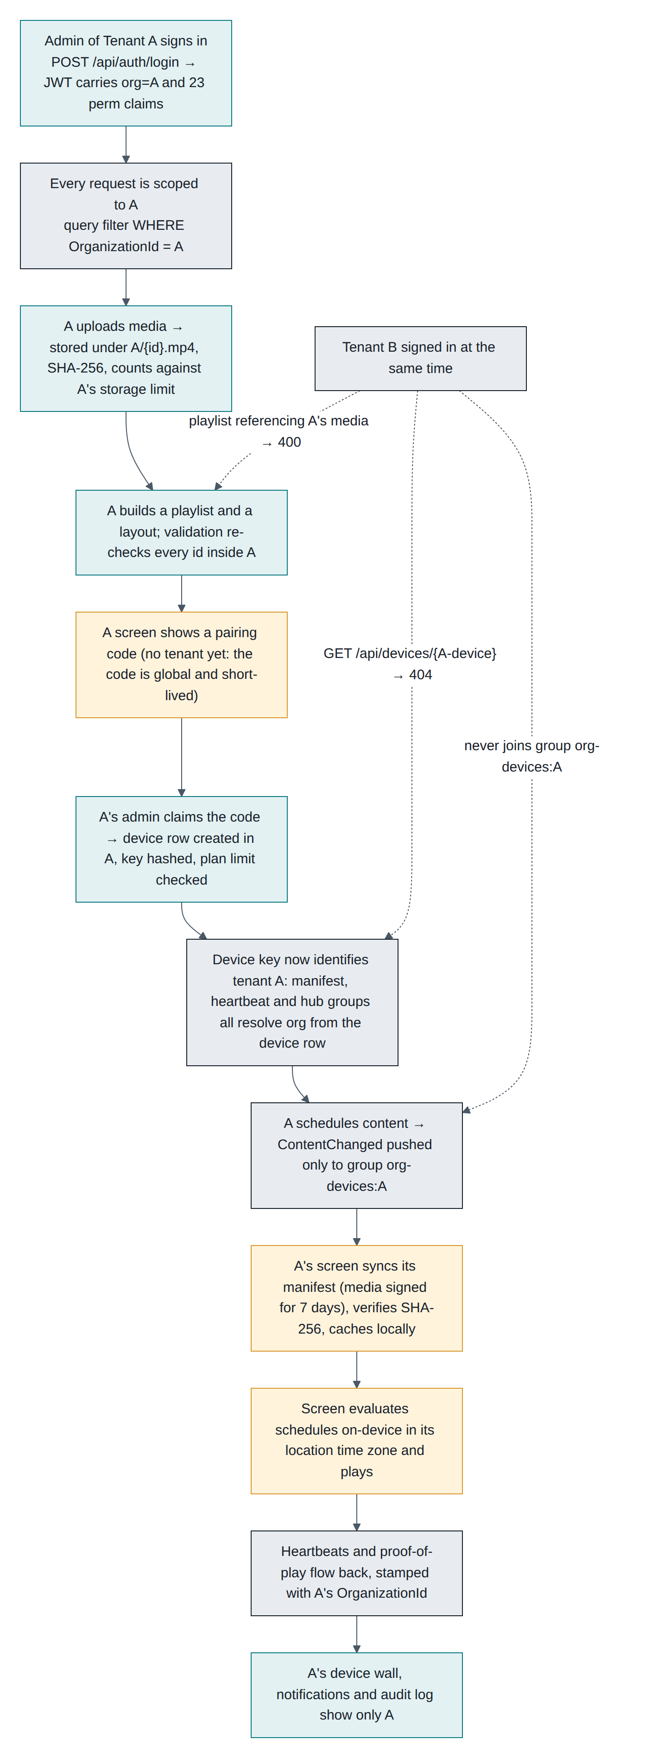
Figure 15-1 From signing in to content playing, with your organisation's boundary marked at each step
The dotted lines show what another company using the same installation experiences at the same moment: they cannot open your screen, cannot use your media, and never receive your updates.

15.2 Step by step
# | What you do | What the system does
1 | Sign in | Confirms your password and remembers which organisation you belong to and what you may do
2 | Upload breakfast.mp4 | Stores it in your organisation's own folder, records its size and fingerprint, checks your storage limit
3 | Create the "Breakfast" playlist | Saves the order and durations, and checks every item is yours
4 | Open the player on the TV | The TV asks for a code and shows it
5 | Devices → Pair a screen, type the code | Creates the screen inside your organisation, checks your plan, and hands the TV a private key once
6 | (nothing) | The TV downloads its content, checks each file, saves a copy, and starts playing your default playlist
7 | Create the "Breakfast menu" schedule, 07:00–11:00, Mon–Fri | Saves the rule and tells your screens something changed
8 | (nothing) | The TV asks what changed, gets the new schedule, and downloads nothing extra because it already has the video
9 | (nothing) | From 07:00 local time the TV plays the breakfast playlist, and returns to the default at 11:00
10 | Watch the dashboard | The TV reports in every 30 seconds; you see it online with what is playing now
11 | Someone unplugs the network | The TV keeps playing, saves its play history, and after 90 seconds you get an offline alert
12 | The network returns | The TV comes back online, uploads what it played, and checks for changes

15.3 What made it safe
Moment | Protection
Signing in | Your organisation is attached to your session; everything you see is filtered to it
Uploading | The file goes into your organisation's folder and counts against your storage only
Pairing | Whoever types the code claims the screen, and it stays in that organisation for life
The screen asking for content | Its private key identifies both the screen and your organisation
Content updates | Only your screens are told
Media links | Time-limited private links, never a public folder

15.4 Five things to remember
- Your organisation is your world. Everything you create lives inside it, and nobody outside can see it.
- A screen is claimed by whoever types its code. Keep codes to yourself, and unpair screens you no longer control.
- Screens think for themselves. They keep a copy and follow schedules in their own local time, so they survive outages.
- Priority settles overlaps. Highest number wins, and a default playlist is your safety net.
- Roles keep things tidy. Give people the smallest role that lets them do their job; Owners keep control of the plan.

List of figures
Figure 1-1 The nine steps, from creating your account to watching your screens
Figure 1-2 How media, playlists, layouts, schedules and screens relate
Figure 2-1 What belongs to your organisation, and what the platform shares
Figure 3-1 The built-in roles and the permissions behind them
Figure 4-1 What happens when you reach a limit, and how to lift it
Figure 6-1 Connecting a screen: what happens on the screen and in the CMS
Figure 6-2 From pairing code to a running screen, and what happens when it drops offline
Figure 8-1 Building and saving a playlist
Figure 9-1 Building a layout, from template to something you can schedule
Figure 10-1 Creating a schedule
Figure 11-1 What a screen does while the internet is down, and when it returns
Figure 12-1 The dashboard: counts, device wall and recent activity
Figure 15-1 From signing in to content playing, with your organisation's boundary marked at each step

