PROPOSAL
ERP Modernization: A Decoupled, Event-Driven Architecture for SRD Logistics
Rebuilding the platform around CDC, event streaming, an analytics store and a caching layer — with the existing ERP backend as the system of record, not a casualty of the rebuild.

PREPARED FOR
SRD Logistics
PREPARED BY
FleetSense Engineering — Ideassion Technology Solutions
DATE
September 2026

1. Executive Summary
SRD Logistics' ERP today runs as a single, tightly-coupled system: one backend, one database, and a growing list of applications and external services calling it directly. That worked when the number of integrations was small. It doesn't scale — every new integration (the mobile app, FleetSense, WhatsApp messaging, live tracking) adds another direct dependency on the backend's internal APIs, and every change to those APIs now risks breaking something downstream, silently.
This proposal is for a rebuild of the platform around the architecture in Figure 1: the existing ERP backend remains the system of record, but is surrounded by an event-streaming backbone (Kafka, fed by Debezium change-data-capture), a dedicated analytics store (ClickHouse), an in-memory caching layer (Redis), and a modern React frontend — with every downstream consumer moved off direct, tightly-coupled API calls.
The outcome: a backend that can change without breaking every application connected to it, reporting and analytics that no longer compete with live transactions for database resources, and a real-time data backbone that positions SRD to add AI-driven reporting and live tracking features on solid ground rather than on top of today's fragile integration pattern.

2. Where the Current Architecture Is Limiting the Business

2.1 Every integration is a direct, tightly-coupled dependency
As shown in the diagram, the Mobile Application and FleetSense both call the ERP Backend's APIs directly. There is no contract layer between them and the backend's internal implementation. The practical effect: any change to the backend — a renamed field, a modified endpoint, a schema adjustment — has a direct chance of breaking the mobile app or FleetSense without warning. This is flagged explicitly on the architecture diagram as the single largest source of fragility in the current system.

2.2 One database serves two very different workloads
The existing ERP database has to serve live transactional traffic (bookings, billing, trip updates) and reporting/analytics queries from the same tables at the same time. Heavy reports slow down live operations; live operations mean reports run against a constantly-changing, lock-contended dataset. Neither workload is well served by sharing infrastructure with the other.

2.3 No caching layer
Every read — including ones that repeat constantly, like rate lookups or party details — goes straight to the database. There's no fast path for the queries the system already knows are hot.

2.4 No structured event stream
Downstream systems and integrations (payments, GST, SMS, WhatsApp, live tracking) currently have no reliable way to react to changes in the ERP in near real time. Anything event-driven — live status updates, instant notifications, real-time dashboards — is either bolted on with polling or not possible today.

3. Proposed Architecture
The diagram below is the target state this proposal delivers. It keeps the ERP Backend as the single source of truth for business logic and data, while adding the infrastructure needed to decouple, cache, stream, and analyze around it.
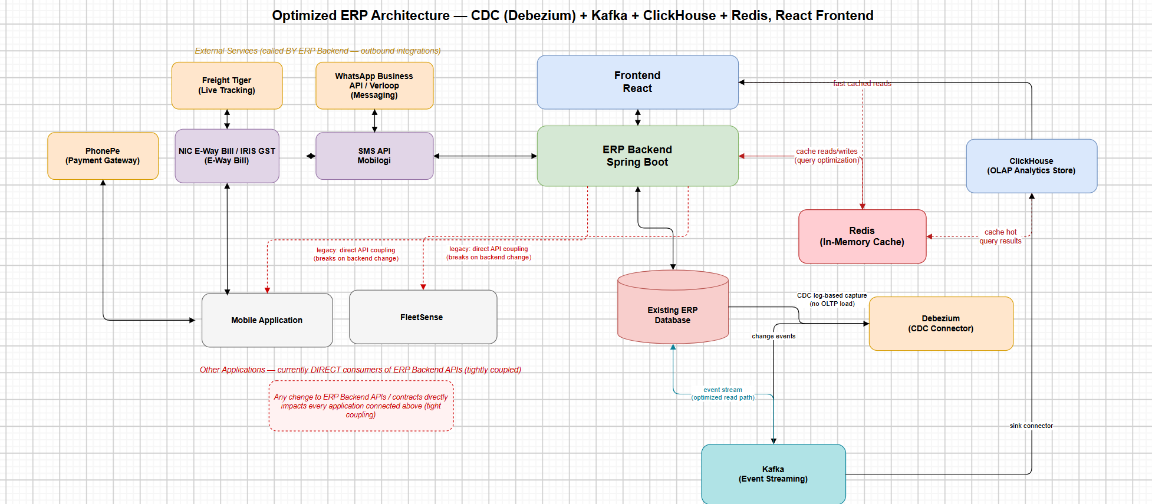
Figure 1 — Optimized ERP architecture: CDC (Debezium) + Kafka + ClickHouse + Redis, React frontend

3.1 React frontend
A modern, responsive interface replacing the current UI, talking to the ERP Backend through its own governed API — and, for read-heavy views, benefiting directly from the Redis cache layer for fast, low-latency screens.

3.2 ERP Backend (Spring Boot) — the system of record
The backend keeps ownership of core business logic and the existing ERP database. Every other component in this architecture is built around it, not as a replacement for it — this is a deliberate choice to reduce risk: the business rules SRD depends on today keep running, while everything that currently couples to them directly gets a safer path in.

3.3 Redis — in-memory cache
Sits between the backend and its most frequent, most expensive queries. Hot data (rate lookups, party/station lookups, session data) is served from memory instead of hitting the database on every request — this is what gives the React frontend “fast cached reads” and takes repeated load off the ERP database.

3.4 Debezium + Kafka — the event backbone
Debezium reads the existing ERP database's transaction log directly (change-data-capture) and publishes every insert/update/delete as an event onto Kafka — without adding any extra query load to the live database. This event stream becomes the single reliable feed that every downstream system — analytics, notifications, future integrations — can subscribe to, instead of each one polling or querying the ERP database independently.

3.5 ClickHouse — analytics store
A dedicated analytics database, kept in sync via a Kafka sink connector fed by the CDC stream. Every heavy reporting or dashboard query runs here — against a store built for exactly that kind of workload — instead of against the live ERP database. This is what removes the current conflict between “keep bookings fast” and “run the monthly report.”

3.6 External integrations, called by the backend
PhonePe (payments), NIC E-Way Bill / IRIS GST (compliance), SMS API (Mobilogi) and WhatsApp Business API (Verloop) for messaging, and Freight Tiger for live tracking all remain outbound integrations the backend calls out to — governed centrally, rather than called ad hoc from multiple places in the system.

3.7 Mobile Application and FleetSense — decoupled
The core of this rebuild: both applications move off direct, tightly-coupled calls into the ERP backend's internals and onto a stable, versioned API contract. A backend change no longer means a guaranteed break downstream — it means a contract that's tested and versioned before anything on the other side has to change.

4. Why This Needs to Be a Rebuild, Not a Patch
It's fair to ask whether this can be added incrementally on top of the current system rather than rebuilt. In practice, three things make a coordinated rebuild the sounder path:
- Decoupling can't be bolted on. Removing tight coupling means introducing a real contract layer between the backend and every consumer — that's a structural change to how the backend exposes itself, not a configuration change.
- An analytics pipeline is only as good as what feeds it. Standing up Kafka, Debezium and ClickHouse on top of an inconsistent data layer just moves today's data-quality problems into tomorrow's dashboards, faster. The value of this architecture depends on the data it streams being trustworthy.
- Doing it once, coordinated, is cheaper than doing it twice. Adding caching, streaming and analytics as separate follow-on projects means each one re-discovers the same integration points and re-touches the same code paths. Planned together, they share the same foundation work.
Rebuilding does not mean discarding what works. The ERP Backend and the existing database remain the system of record throughout — this proposal is about what surrounds them, and about how everything else is allowed to depend on them.

5. What This Delivers for SRD
Benefit | What changes
Reliability | Mobile app and FleetSense stop breaking when the backend changes — they consume a stable, versioned contract instead of internal APIs.
Performance | Redis serves hot reads from memory; the React frontend gets consistently fast screens instead of a database round-trip on every load.
Scalability | Reporting and analytics run against ClickHouse, not the live database — booking and billing performance stop degrading as reporting usage grows.
Real-time capability | The Kafka event stream is the foundation for live tracking, instant notifications, and dashboards that update as things happen, not on a batch schedule.
AI readiness | A clean, structured event stream and a purpose-built analytics store are the prerequisite for natural-language / AI-driven reporting on top of ClickHouse.
Governed integrations | Payments, GST/e-way bill, SMS and WhatsApp all route through one backend-owned integration layer instead of scattered direct calls.

6. Managing the Risk
A platform rebuild on a live, revenue-critical system carries real risk, and we've planned around it rather than around it away:
- Phased delivery, not a big-bang cutover. Each component (Redis, then the CDC/Kafka pipeline, then ClickHouse, then the decoupled API contract) goes live and proves itself before the next phase begins.
- The ERP backend and database are never replaced mid-project — they stay the system of record throughout, so the business keeps running on a stable core while everything around it is built.
- CDC is log-based and read-only against the existing database — it adds no additional query load or write risk to live operations.
- Mobile app and FleetSense migrate to the new API contract only after it's tested against their existing usage patterns, with the old direct-coupling path kept available until cutover is confirmed stable.
- Financial and compliance flows (PhonePe, e-way bill/GST) are validated in parallel-run before anything switches over.

7. Delivery Approach
Delivered in five phases, each building on a proven previous phase rather than all at once:
Phase | Focus | Delivers
1 | Caching foundation | Redis layer live in front of the ERP backend's highest-traffic reads.
2 | Event backbone | Debezium + Kafka streaming every change out of the existing ERP database.
3 | Analytics store | ClickHouse live via the Kafka sink connector; first reporting dashboards move off the live database.
4 | Decoupling | Versioned API contract published; Mobile Application and FleetSense migrated off direct coupling.
5 | Frontend & stabilization | React frontend live against the new, cached, decoupled backend; parallel-run and sign-off.

Indicative timeline: approximately 7–9 months with a dedicated team, running phases 2 and 3 in parallel with phase 1 once the caching foundation is stable. A detailed, resourced schedule will follow discovery.

8. Next Steps
- Approve scope and proceed to a short discovery phase to confirm integration points and data volumes for Debezium/Kafka sizing.
- Agree the phased delivery plan and resourcing above.
- Kick off Phase 1 (Redis caching layer) as the lowest-risk, fastest-to-value starting point.
We're glad to walk through any part of this in more detail and adjust the phasing to fit SRD's priorities.

