SIGNAGE CMS
Application Walkthrough
Platform to playback · Multi-tenancy · Roles · Subscriptions · Devices · Content · Scheduling · Offline · Operations
A guided, end-to-end tour of the Signage CMS as it is actually built: from deploying the platform and creating an organization to content playing on a paired screen, with the tenant boundary explained at every step.
Scope | End-to-end application walkthrough: platform setup, tenant creation, roles, subscriptions, devices, content, scheduling, playback and operations
Focus | Multi-tenancy as implemented: tenant boundaries, tenant identity creation, and the six layers of data isolation
Codebase snapshot | .NET 8 + PostgreSQL + React; 23 tables, 70 REST endpoints, 2 SignalR hubs, 23 permissions, 4 built-in roles, 3 plans
Verification | Checked against the running system: live database catalogue, controllers, and 108 passing automated checks
Version | 1.0 — developer hand-off
Date | September 2026
Status | Released for hand-off
Prepared for developer hand-off. Diagrams are embedded as figures; cross-references and the table of contents are clickable.

Contents

About this walkthrough 5
What this document is 5
One thing to know before you start 5
How to read it 5
Chapter map 6
1. The journey: platform to playback 7
1.1 Ten steps 7
1.2 What each step produces 8
1.3 The shortest possible path 8
2. Multi-tenancy in this implementation 9
2.1 The tenant boundary 9
2.2 How a tenant identity is created 11
2.3 How data is isolated, layer by layer 12
2.4 Tenant data in the schema 15
2.5 Real-time is tenant-scoped too 16
2.6 What the tests prove 16
2.7 Limits of the current model 16
3. Roles and permissions 17
3.1 The model 17
3.2 The 23 permissions 17
3.3 The four built-in roles 18
3.4 Rules the services enforce 18
3.5 Walkthrough: add an editor 18
3.6 Permission timing 19
4. Subscription setup and limits 20
4.1 Plans 20
4.2 Where limits are enforced 20
4.3 Viewing and changing the plan 21
4.4 Walkthrough: hitting and lifting a limit 21
4.5 Before charging money 21
5. Organization creation and first-day setup 22
5.1 Creating the organization 22
5.2 Organization settings 24
5.3 Locations 24
5.4 Device groups 25
5.5 A sensible first day 25
6. Device registration and pairing 26
6.1 Why pairing works this way 26
6.2 Step by step 28
6.3 What the device key is 28
6.4 Failure cases worth knowing 28
6.5 Editing and unpairing 28
7. Media upload 29
7.1 The flow 29
7.2 What happens in the browser first 31
7.3 What the server does 31
7.4 Web pages as media 31
7.5 Serving files 31
7.6 Editing and deleting 31
8. Playlist creation 32
8.1 The flow 32
8.2 Using the editor 34
8.3 Validation 34
8.4 After saving 34
8.5 Where playlists are used 34
9. Layout builder 35
9.1 The flow 35
9.2 Templates 36
9.3 The editor 36
9.4 Validation on save 36
9.5 How a layout reaches a screen 36
9.6 Deleting 37
10. Scheduling 38
10.1 Creating a schedule 38
10.2 How a screen decides what to play 39
10.3 Worked example 40
10.4 Publishing a change 41
11. Synchronization and real-time updates 42
11.1 The manifest 42
11.2 The sync cycle 43
11.3 Real-time channels 45
11.4 If real-time is blocked 45
12. Offline playback 46
12.1 What the screen keeps locally 46
12.2 Behaviour during an outage 47
12.3 Rebooting while offline 48
12.4 What cannot work offline 48
12.5 Catching up 48
13. Device monitoring and notifications 49
13.1 Device states 49
13.2 Heartbeats 50
13.3 Going offline 51
13.4 What an operator sees 51
13.5 Notifications 52
13.6 Remote commands 53
13.7 Proof-of-play 53
14. Troubleshooting 54
14.1 Where to start 54
14.2 Platform and start-up 55
14.3 Tenancy-specific confusion 55
14.4 Sign-in and permissions 55
14.5 Screens 55
14.6 Real-time 56
14.7 Useful commands 56
15. Deployment, environment setup and Docker 57
15.1 Paths to production 57
15.2 Local development 58
15.3 Configuration 58
15.4 Docker 58
15.5 Reverse proxy and HTTPS 59
15.6 Database schema 59
15.7 Operating 59
15.8 Production checklist 60
16. Testing 61
16.1 What exists 61
16.2 Running them 62
16.3 The tenancy tests specifically 62
16.4 Hardware acceptance (manual) 62
16.5 Recommended additions 63
17. End-to-end flow with multi-tenant considerations 64
17.1 The whole path on one page 64
17.2 Where the tenant is decided, step by step 65
17.3 The same flow as a sequence, phase by phase 66
17.4 Timing 74
17.5 The five things to remember 74
List of figures 75

If the contents list is out of date, right-click it in Word and choose Update Field → Update entire table.

About this walkthrough

What this document is
This is an end-to-end walkthrough of the Signage CMS as it is actually built. It follows the system in the order you meet it: deploy the platform, create an organization, invite people, pair screens, build and schedule content, and watch it play — with the multi-tenant behaviour explained at every step.
It complements the reference documentation (architecture, database, API). Where the reference answers "what is this endpoint?", this walkthrough answers "what happens, in order, and what does the tenant boundary do here?".
Everything was checked against the running code: the database facts come from the live PostgreSQL catalogue, the endpoint and permission facts from the controllers, and the behaviour from the automated test suites (81 API checks, 19 browser checks, 8 LAN-player checks) that pass against this build.

One thing to know before you start
There is no platform super-admin in this implementation. No account can see across organizations, and no screen or API can list tenants. The platform level is operational only: whoever deploys the system configures it, holds the signing key and the database, and can create the first owner account through seed settings. Everything else happens inside a tenant.
So "from platform admin to organization playback" reads like this: an operator deploys and configures the platform; a person signs up (or is seeded), which creates an organization and makes them its Owner; from there all work is tenant-scoped.
Level | Who | What they can do
Platform | operator / DevOps | Deploy, configure Jwt__SigningKey, database and storage, TLS, backups, plan limits in code, optional first-owner seed. Has database access, not an application login
Tenant (organization) | Owner | Everything inside their organization, including plan changes
Tenant | Admin, Editor, Viewer, custom roles | A subset of the 23 permissions, always inside their own organization
Screen | paired device | Only its own manifest, heartbeat and playback endpoints, inside its organization

How to read it
- Figures are numbered by chapter (Figure 6-2 is the second figure in Chapter 6) and embedded as images. Rounded boxes are start and end points, diamonds are decisions, rectangles are actions. Sequence diagrams number each interaction.
- Monospace marks endpoints, configuration keys, permission codes such as devices.pair, and database identifiers.
- Status codes are the ones the API really returns: 402 means a plan limit, 404 often means "belongs to another tenant".
- Cross-references and the contents list are clickable.

Chapter map
Chapter | What it covers
1 | The high-level journey, platform to playback
2 | Multi-tenancy: boundaries, tenant identity creation, data isolation
3 | Roles and permissions
4 | Subscription setup and limits
5 | Organization creation and first-day setup
6 | Device registration and pairing
7 | Media upload
8 | Playlist creation
9 | Layout builder
10 | Scheduling
11 | Synchronization and real-time updates
12 | Offline playback
13 | Device monitoring and notifications
14 | Troubleshooting
15 | Deployment, environment setup and Docker
16 | Testing
17 | End-to-end flow with multi-tenant considerations

1. The journey: platform to playback

1.1 Ten steps
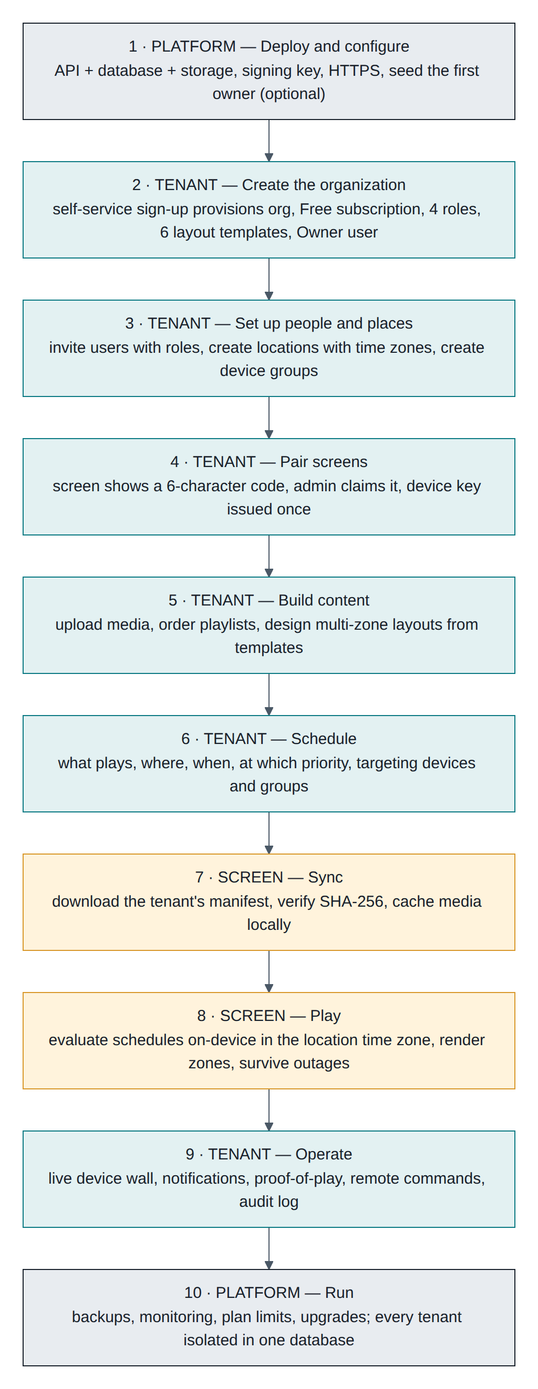
Figure 1-1 The end-to-end journey, from deploying the platform to content on screen
Grey steps are platform work (once per installation), teal steps are done by people inside a tenant, amber steps happen on the screen itself.

1.2 What each step produces
Step | Actor | Output | Tenant effect
1 Deploy | operator | Running API, database, media volume, TLS | None yet: no organizations exist
2 Create the organization | visitor → Owner | Organizations row + Subscriptions (Free) + 4 roles + 6 layout templates + Owner user, in one transaction | The tenant is born. Its id becomes the org claim in every token
3 People and places | Owner / Admin | Users with roles, locations with time zones, device groups | All rows stamped with this OrganizationId
4 Pair screens | Admin + screen | Devices row with a hashed device key | The key binds that screen to this tenant for life
5 Build content | Editor | Media files, playlists, layouts | Files stored under {OrganizationId}/, rows tenant-stamped
6 Schedule | Editor | Schedules targeting devices and groups | Only this tenant's devices can be targeted
7 Sync | screen | Manifest + verified local media cache | Manifest is built from the device's own organization only
8 Play | screen | Pixels on the display | Schedules evaluated on-device in the location's time zone
9 Operate | any role | Device wall, notifications, proof-of-play, audit log | Every view filtered to the tenant
10 Run the platform | operator | Backups, monitoring, upgrades | Shared infrastructure, isolated data

1.3 The shortest possible path
For a first demonstration on one machine:

cd frontend && npm install && npm run build:api # admin UI served by the API
# open http://localhost:5080 → sign in admin@demo.local / Admin@12345
# open http://localhost:5080/player in a second window → pair the code it shows
That covers steps 1, 2, 4, 7 and 8. Everything after this chapter is the long version.

2. Multi-tenancy in this implementation
Signage CMS is single database, shared schema, row-level isolation by OrganizationId, enforced below the business logic so that new code is isolated by default.

2.1 The tenant boundary
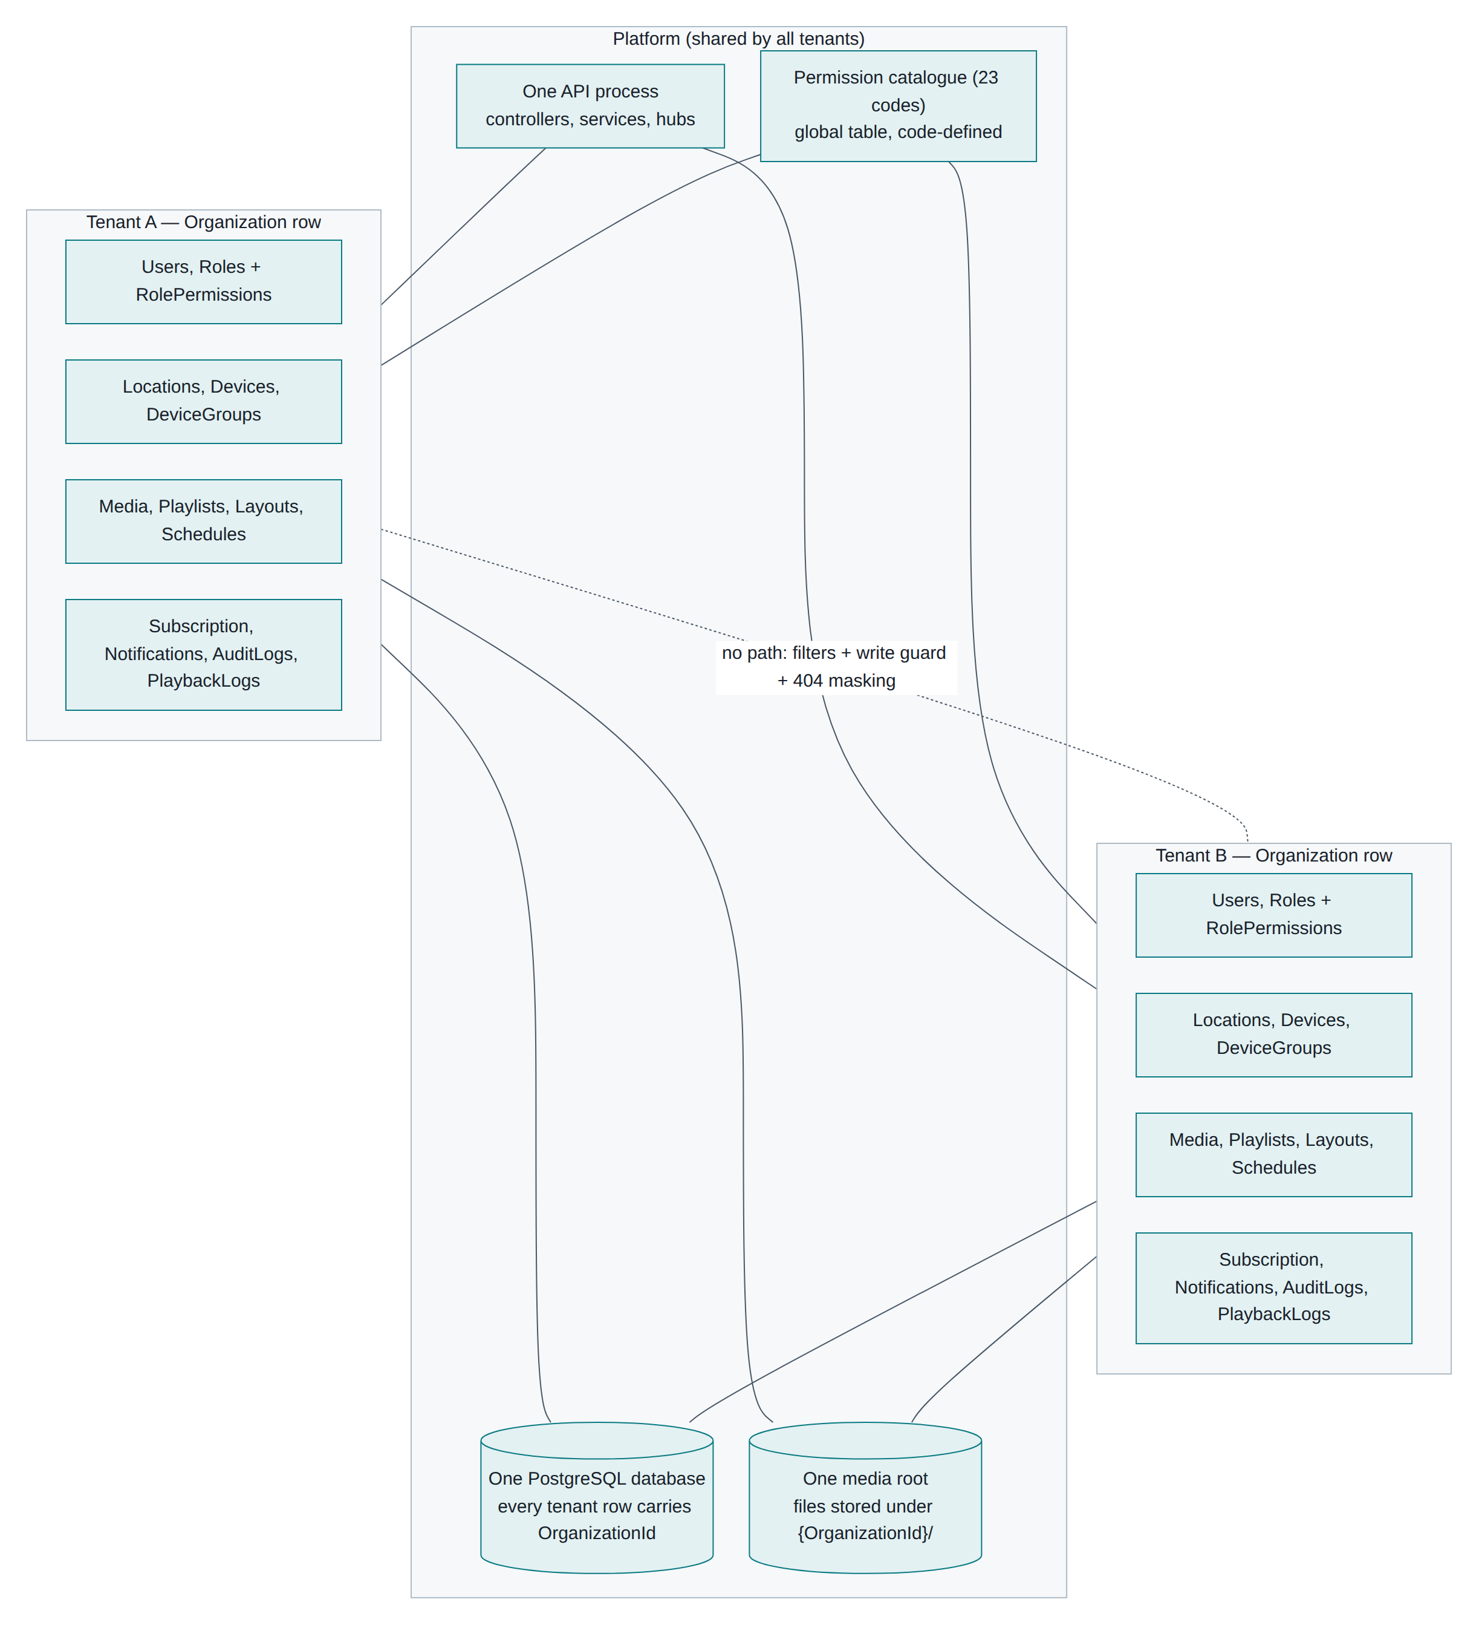
Figure 2-1 What is shared by all tenants and what belongs to one tenant
Inside the boundary (per tenant): users, roles and their permission grants, locations, devices, device groups, media, playlists, layouts, schedules, notifications, audit logs, playback logs, and the subscription with its limits.
Outside the boundary (shared platform): the API process, the database, the media root directory, the permission catalogue (23 fixed codes), plan definitions in code, the JWT signing key, and the background device monitor that sweeps every tenant.
Deliberately global, and worth knowing:
Thing | Why it is global | Consequence
Users.Email unique index | One email = one account, so sign-in needs no tenant selector | A person cannot belong to two organizations with the same address
Pairing codes | A screen has no tenant before it is claimed | Codes are short (15 min), single-use, and claiming one is what assigns the tenant
Permissions table | Codes are defined in code and synced at startup | Roles are per tenant, the catalogue is not
Media root path | One volume, files namespaced {OrganizationId}/{mediaId}.ext | Isolation comes from the path plus signed URLs, not from separate volumes

2.2 How a tenant identity is created
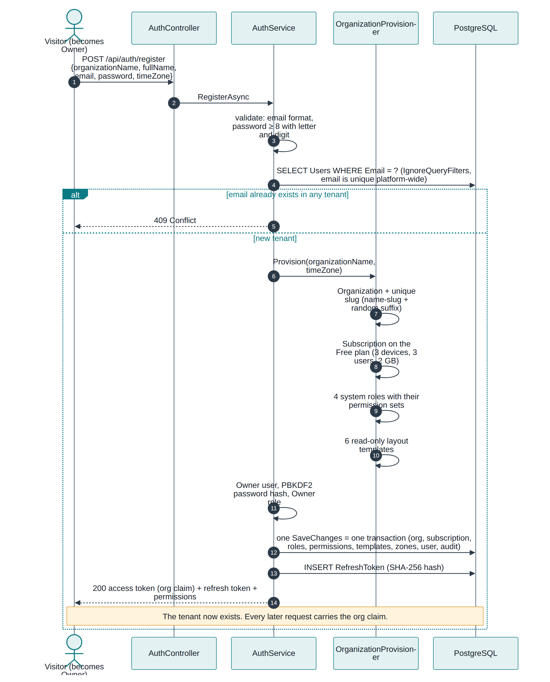
Figure 2-2 Tenant identity creation: one request, one transaction
Notice four things:
- The email check is the only deliberately cross-tenant query in registration. It uses IgnoreQueryFilters() because at that moment there is no tenant context.
- OrganizationProvisioner.Provision builds the whole starter set — organization (with a slug made from the name plus a random suffix), Free subscription, the four system roles with their permission rows, and six read-only layout templates.
- It is one SaveChanges, so one transaction. A tenant is never half-created: either everything exists or nothing does.
- The tenant id then travels in the token. The access token carries org, org_name, one role claim per role and one perm claim per permission. Tokens last 15 minutes, so a permission change takes effect at the next refresh.
Seeded tenants (Seed__AdminEmail, Seed__AdminPassword, Seed__OrganizationName) go through the same provisioner at startup, so a seeded organization is identical to a self-registered one.

2.3 How data is isolated, layer by layer
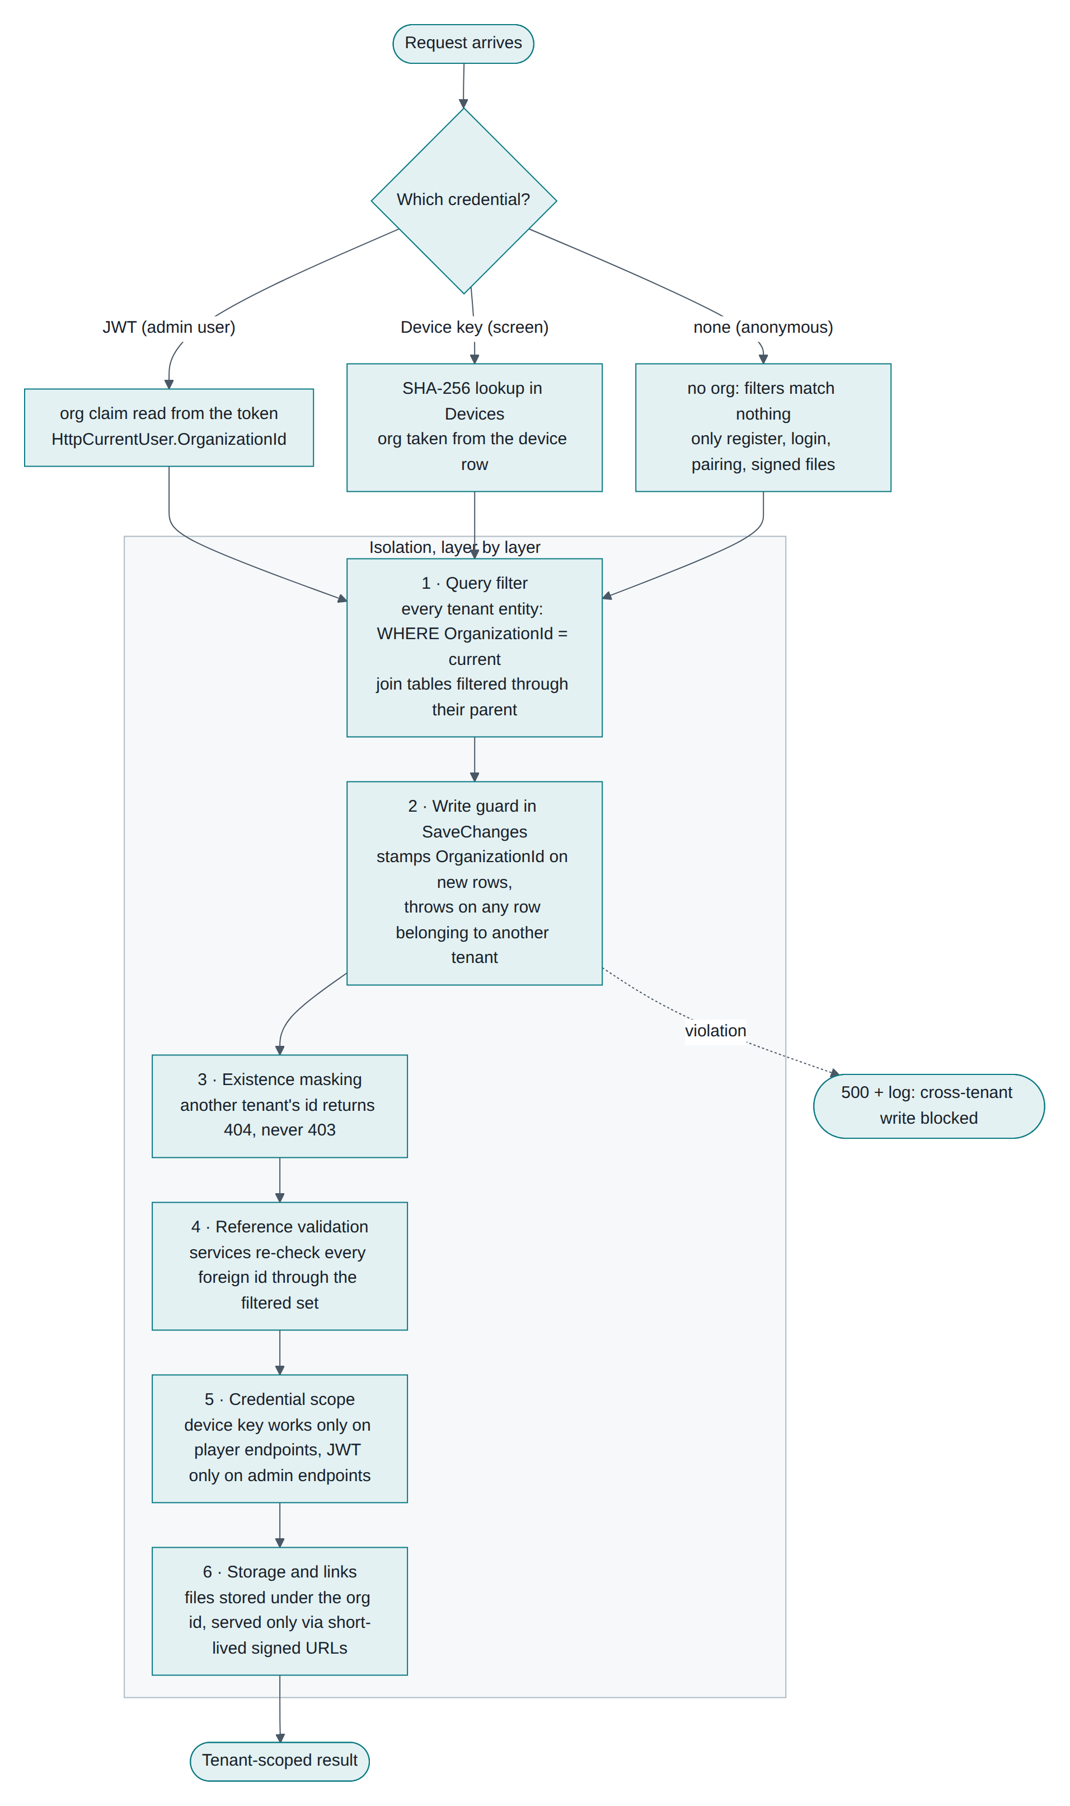
Figure 2-3 Six layers of tenant isolation on every request

Layer 1 — Global query filters
Every entity that implements ITenantEntity gets a filter built with an expression tree:

b.Entity(clr).HasQueryFilter(e => e.OrganizationId == CurrentOrganizationId);

// Children without their own OrganizationId inherit isolation through their parent
b.Entity<PlaylistItem>().HasQueryFilter(x => x.Playlist!.OrganizationId == CurrentOrganizationId);
b.Entity<UserRole>().HasQueryFilter(x => x.User!.OrganizationId == CurrentOrganizationId);
CurrentOrganizationId is a property on the context, read from ICurrentUser on every query. When it is null, nothing matches — an unauthenticated request sees an empty database rather than everything. That is the safe default, and it is why anonymous endpoints (registration, login, pairing, signed file download) each fetch what they need explicitly.

Layer 2 — Write guard in SaveChangesAsync

te.OrganizationId = org ?? throw new InvalidOperationException("Cannot create ... without an organization context.");
if (org != null && te.OrganizationId != org)
throw new InvalidOperationException($"Cross-tenant write blocked on {e.Entity.GetType().Name}.");
New rows are stamped automatically, so a service that forgets to set OrganizationId still produces correct data. Any attempt to modify another tenant's row throws before it reaches the database.

Layer 3 — Existence masking
Services fetch through the filtered set and throw NotFoundException when nothing comes back, so another tenant's identifier returns 404, never 403. A tenant cannot even learn that an id exists.

Layer 4 — Reference validation
Every id inside a request body is re-checked through the filtered set before use: playlist items verify their media, schedules verify layouts, playlists, devices and groups, device updates verify locations, playlists and groups. Passing a foreign id returns 400, not a silent link.

Layer 5 — Credential scope
Two authentication schemes exist and never overlap. Admin endpoints require the JWT scheme with a perm claim; player endpoints require the Device scheme. A device key gets 401 on admin endpoints, and an admin token gets 401 on player endpoints. Both directions are covered by tests.

Layer 6 — Storage and links
Uploads are written to {OrganizationId}/{mediaId}{ext}, with the storage key generated server-side and the resolved path checked to stay under the root (no traversal). Files are served only through /api/files/{id}?exp&sig, an HMAC-signed, expiring URL. That endpoint is anonymous by design — the signature is the authorization — so a signed link is a capability for exactly one file until it expires.

The deliberate exceptions
Only these paths bypass the filters, each for a reason:
Where | Why
AuthService register / login / refresh / logout / me | Find an account before any tenant context exists
DeviceAuthenticationHandler | Resolve a device key to its device, which is what supplies the tenant
MediaService.ResolveSignedAsync | Serve a signed file; the HMAC is the authorization
DeviceSyncService.SweepStaleDevicesAsync | Background monitor must sweep every tenant
DbSeeder | Startup seeding before any request exists

2.4 Tenant data in the schema
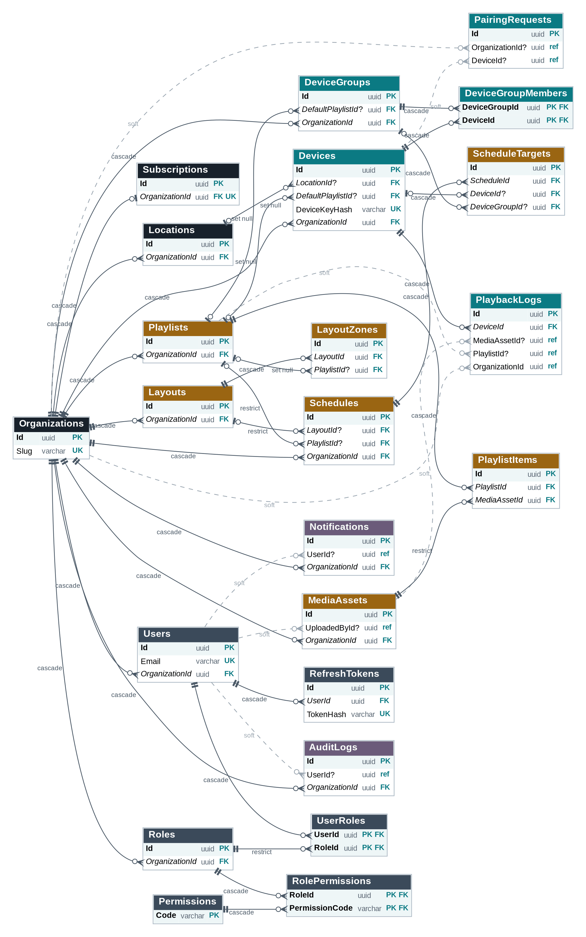
Figure 2-4 Every tenant-owned table carries OrganizationId (key columns shown)
OrganizationId is indexed on every tenant table and cascades from Organizations, so deleting an organization removes its entire world in one statement. Join tables (PlaylistItems, LayoutZones, UserRoles, RolePermissions, DeviceGroupMembers, ScheduleTargets) have no OrganizationId of their own and are isolated through their parent.

2.5 Real-time is tenant-scoped too
Channel | Group | Who joins
/hubs/admin | org:{organizationId} | Admin browser tabs, from the org claim in the token
/hubs/device | device:{deviceId} and org-devices:{organizationId} | Paired screens, from their device row

Content changes are broadcast to org-devices:{id} only, device commands to a single device group, and status and notification events to org:{id}. No message can reach another tenant because the group name is derived from the credential, never from the request body.

2.6 What the tests prove
The API suite includes a tenancy section that registers a second organization and checks that it cannot read a device, media item or playlist of the first (404), sees empty lists, cannot reference foreign media when creating a playlist (400), and gets its own six layout templates.

2.7 Limits of the current model
Point | Detail
No per-tenant database or schema | Noisy-neighbour risk is managed by plan limits and indexes, not by physical separation. Moving a large tenant to its own database would need a connection-per-tenant strategy
No cross-tenant administration | Deliberate. Support work happens in the database or by being invited into the organization
One media volume | Per-tenant quotas are enforced in the application (MaxStorageBytes), not by the filesystem
Pairing codes are global | A brute-force gap exists here: the claim endpoint is not rate-limited (finding S1 in the security review). Fix before production
Tenant deletion | Cascade deletes exist, but no self-service "delete my organization" flow or export

3. Roles and permissions

3.1 The model
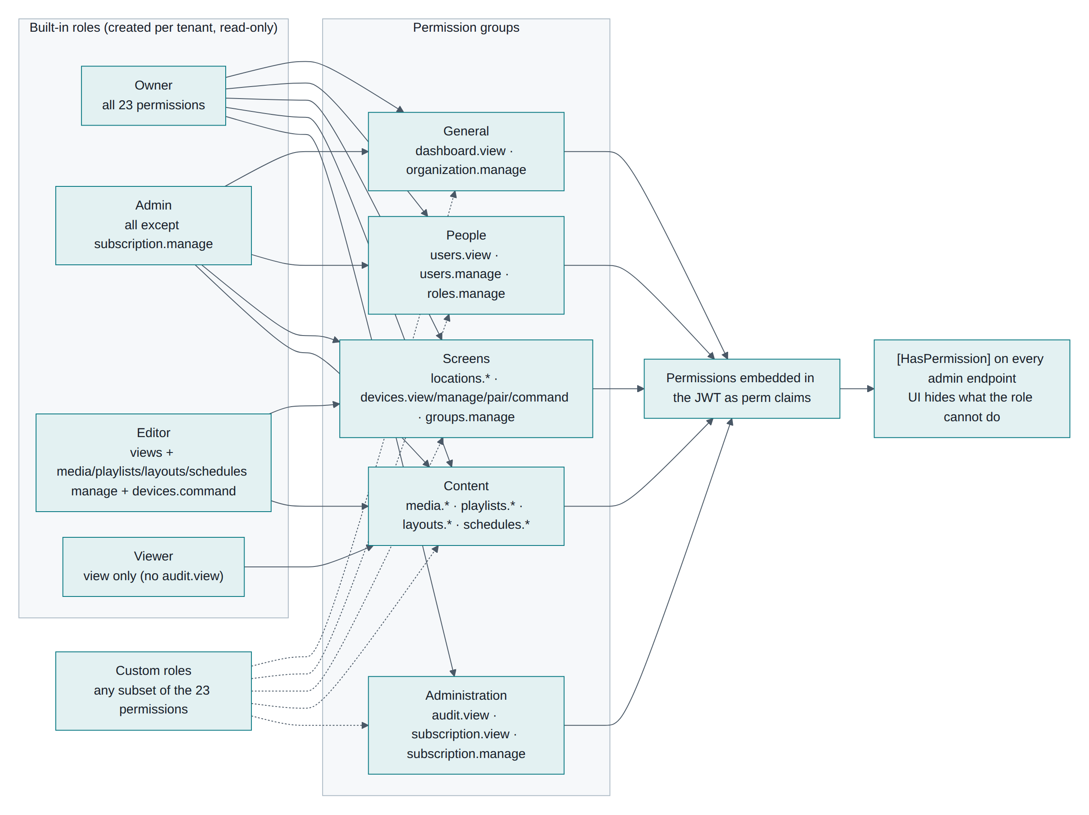
Figure 3-1 Roles, permission groups and how they are enforced
Three facts define the model:
- Permissions are fixed in code — 23 codes in Permissions.All, synced into the Permissions table at every startup. Adding one is a code change, not a data change.
- Roles are per tenant. Four system roles are created for each new organization and marked IsSystem (read-only). Any number of custom roles can be added from the same 23 codes.
- Enforcement is in the token. Permissions ride in the JWT as perm claims; [HasPermission("media.manage")] builds a policy on demand and checks the claim. The UI hides what a role cannot do, but the API is the real gate.

3.2 The 23 permissions
Group | Code | Allows
General | dashboard.view | See the dashboard
General | organization.manage | Edit organization name and default time zone
People | users.view | See users and roles
People | users.manage | Add, edit, deactivate and remove users
People | roles.manage | Create and edit custom roles
Screens | locations.view | See locations
Screens | locations.manage | Create, edit and delete locations
Screens | devices.view | See devices, their status and proof-of-play
Screens | devices.manage | Edit devices, unpair them
Screens | devices.pair | Claim a pairing code
Screens | devices.command | Send identify, sync, restart, clear-cache
Screens | groups.manage | Create and edit device groups
Content | media.view | See the media library
Content | media.manage | Upload, edit and delete media
Content | playlists.view / playlists.manage | See / edit playlists
Content | layouts.view / layouts.manage | See / edit layouts
Content | schedules.view / schedules.manage | See / edit schedules
Administration | audit.view | Read the audit log
Administration | subscription.view | See plan and usage
Administration | subscription.manage | Change the plan

3.3 The four built-in roles
Role | Permissions | Typical holder
Owner | All 23 | The person who created the organization; billing decisions
Admin | All except subscription.manage | Day-to-day administrator
Editor | All *.view except audit.view, plus media.manage, playlists.manage, layouts.manage, schedules.manage, devices.command | Marketing or content staff
Viewer | All *.view except audit.view | Store manager who only checks screens

Built-in roles cannot be edited or deleted (403). Create a custom role instead — for example "Screen installer" with devices.view, devices.pair and locations.view.

3.4 Rules the services enforce
Rule | Behaviour
Every user has at least one role | Creating or updating with an empty role list returns 400
An organization keeps at least one active Owner | Removing the last Owner, or deactivating them, returns 400
You cannot lock yourself out | You cannot deactivate or delete your own account
Password change or deactivation ends sessions | All refresh tokens for that user are revoked immediately
Roles in use cannot be deleted | 409 naming the number of users
A role's name is unique per tenant | 409 on duplicates

3.5 Walkthrough: add an editor
- Sign in as Owner or Admin (needs users.manage).
- Users → Add user: email, full name, temporary password (at least 8 characters with a letter and a digit), tick Editor.
- POST /api/users checks the plan's user limit first (402 if full), then that the email is unused platform-wide (409), then creates the user with a PBKDF2 hash and the role link.
- Share the password out of band. The new user signs in and receives a token carrying the Editor permissions.
- They now see Media, Playlists, Layouts and Schedules in the sidebar, but not Users, Roles, Audit log or Plan. If they call POST /api/media anyway they get 200; if they call DELETE /api/schedules/{id} they get 403 — the tests cover exactly this.

3.6 Permission timing
Because permissions live in the access token, a change takes effect when that token is next refreshed — within 15 minutes, or immediately if the user signs out and in. Deactivation is instant, since it revokes refresh tokens.

4. Subscription setup and limits

4.1 Plans
Every organization gets a Subscriptions row at creation, on the Free plan. The three plans are defined in code (Plans.All) and copied onto the row, so a tenant's limits are data and can be adjusted per tenant in the database if needed.
Plan | Devices | Users | Storage | Price used in the UI
Free | 3 | 3 | 2 GB | 0
Pro | 100 | 25 | 100 GB | $12 per screen / month
Enterprise | 10,000 | 1,000 | 2,000 GB | $20 per screen / month

Subscriptions also carries Status (Active, PastDue, Cancelled), StartsAt and EndsAt. Status is set to Active on a plan change and is otherwise unused: no payment provider is connected.

4.2 Where limits are enforced
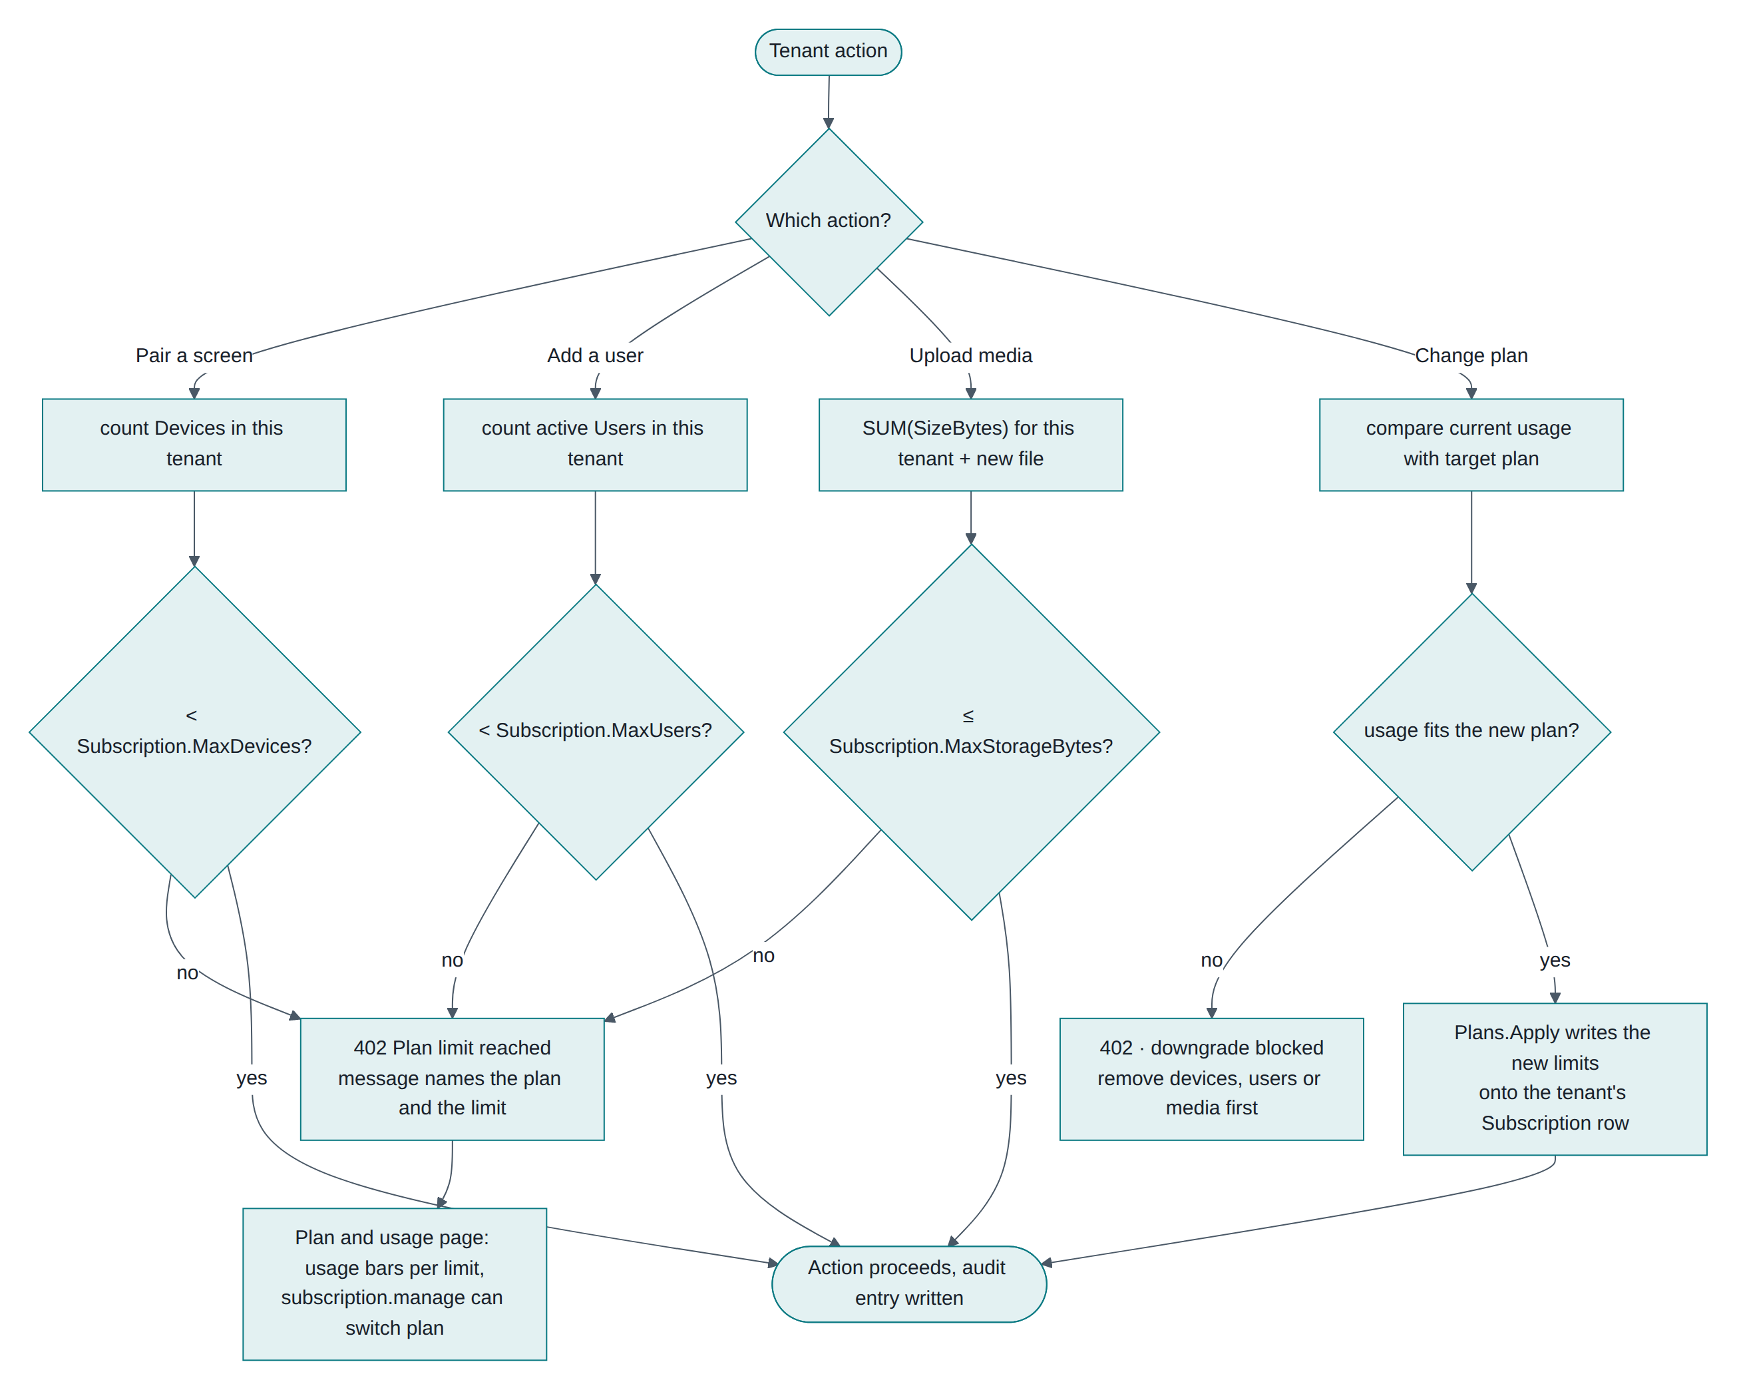
Figure 4-1 Plan limit checks, and what a tenant sees when one is reached
Limit | Checked in | Response when exceeded
MaxDevices | DeviceService.PairAsync, before creating the device | 402 "Your Free plan allows 3 devices. Upgrade the plan to pair more screens."
MaxUsers | UserService.CreateAsync, counting active users | 402 naming the plan and limit
MaxStorageBytes | MediaService.UploadAsync, summing existing media plus the new file | 402 "This upload would exceed your Free plan storage…"
Downgrade | OrganizationService.ChangePlanAsync | 402 "Current usage is above the … plan limits. Remove devices, users or media first."

All four counts are tenant-scoped by the query filter, so one organization's usage never affects another's.

4.3 Viewing and changing the plan
Plan and usage (subscription.view) shows three usage bars — screens, users, storage — that turn amber at 70% and red at 90%, and the three plan cards. Switching plans requires subscription.manage, which only Owner holds by default.
PUT /api/subscription {"plan":"Pro"} validates the plan name, compares current usage against the target, applies the new limits, writes an audit entry (subscription.changed) and returns the refreshed usage.

4.4 Walkthrough: hitting and lifting a limit
- A Free tenant pairs its third screen. Fine.
- A fourth pairing attempt returns 402 and the pairing code stays valid (the screen keeps polling).
- The Owner opens Plan and usage, sees 3 of 3 screens in red, and switches to Pro.
- The same pairing code, if still inside its 15-minute window, can now be claimed successfully. This exact sequence is part of the automated suite.

4.5 Before charging money
- Connect a billing provider and drive PUT /api/subscription from its webhook rather than from the UI button.
- Decide what PastDue should do. Today nothing reads it; a natural behaviour is to keep screens playing but block new uploads and pairings.
- Add invoicing data (billing contact, VAT/GST number, address). None of it exists in the schema yet.

5. Organization creation and first-day setup

5.1 Creating the organization
Two ways in, both through the same provisioner:
Route | When | How
Self-service | Normal | /register in the UI → POST /api/auth/register
Seeded | First install, demos | Seed__AdminEmail, Seed__AdminPassword, Seed__OrganizationName, Seed__TimeZone at startup

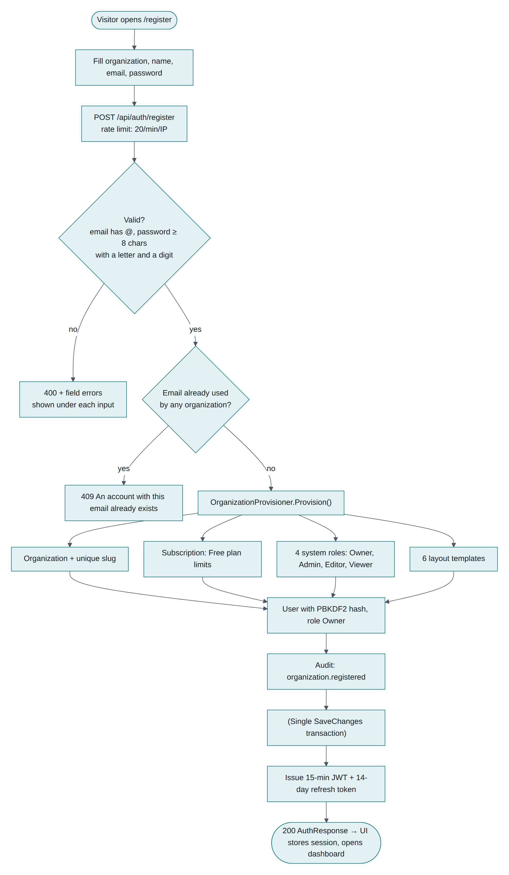
Figure 5-1 Registration: validation, provisioning and first tokens
What you get immediately: the organization with a unique slug, a Free subscription, the Owner user, four system roles, six layout templates, and an audit entry organization.registered. The browser stores the tokens and opens the dashboard, already connected to /hubs/admin.

5.2 Organization settings
Settings (organization.manage) holds the name and the default time zone. That time zone matters: any screen without a location uses it to evaluate schedules. Changing it pushes ContentChanged to every screen in the tenant so they re-evaluate in the new zone.

5.3 Locations
A location is a site with an IANA time zone (Asia/Kolkata, Europe/London). Time zones are validated against the server's database, so a typo returns 400 with a field error.
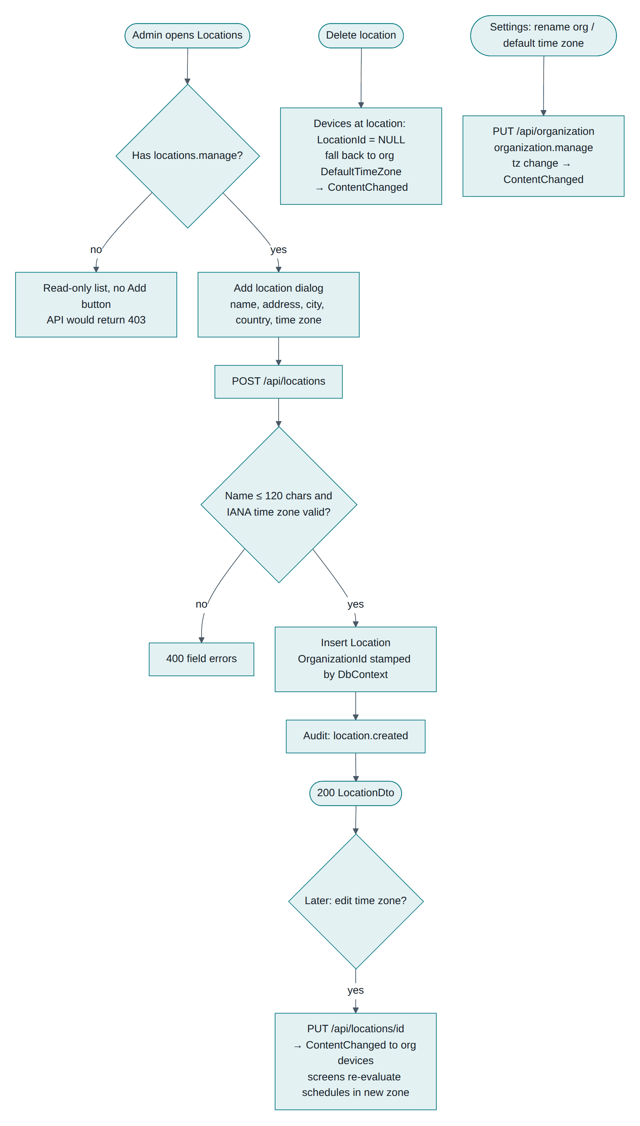
Figure 5-2 Locations: creation, time-zone changes and deletion
Deleting a location does not delete its screens: they lose the link and fall back to the organization default, and a content push tells them to re-evaluate.

5.4 Device groups
A group is a named set of screens with an optional default playlist. Groups are the unit most schedules target — "all reception screens" rather than eleven devices. A screen can be in several groups; membership is diffed on save. If a screen has no default playlist of its own, it inherits the default of its first group by name.

5.5 A sensible first day
- Settings — set the organization's default time zone.
- Locations — add each site with its real time zone.
- Device groups — create the groups you will schedule against.
- Users — invite colleagues with the narrowest role that fits.
- Media → Playlists — upload a few files and build one loop.
- Devices → Pair a screen — pair one screen with that playlist as its default, so it plays immediately.
- Schedules — add the first time-based rule once the default is working.
Everything you create in these steps is stamped with your OrganizationId automatically.

6. Device registration and pairing

6.1 Why pairing works this way
A TV has a remote control, not a keyboard. No credential is ever typed on the screen: the screen asks the server for a short code, an admin claims that code inside their authenticated session, and the server hands the screen a long random key exactly once.
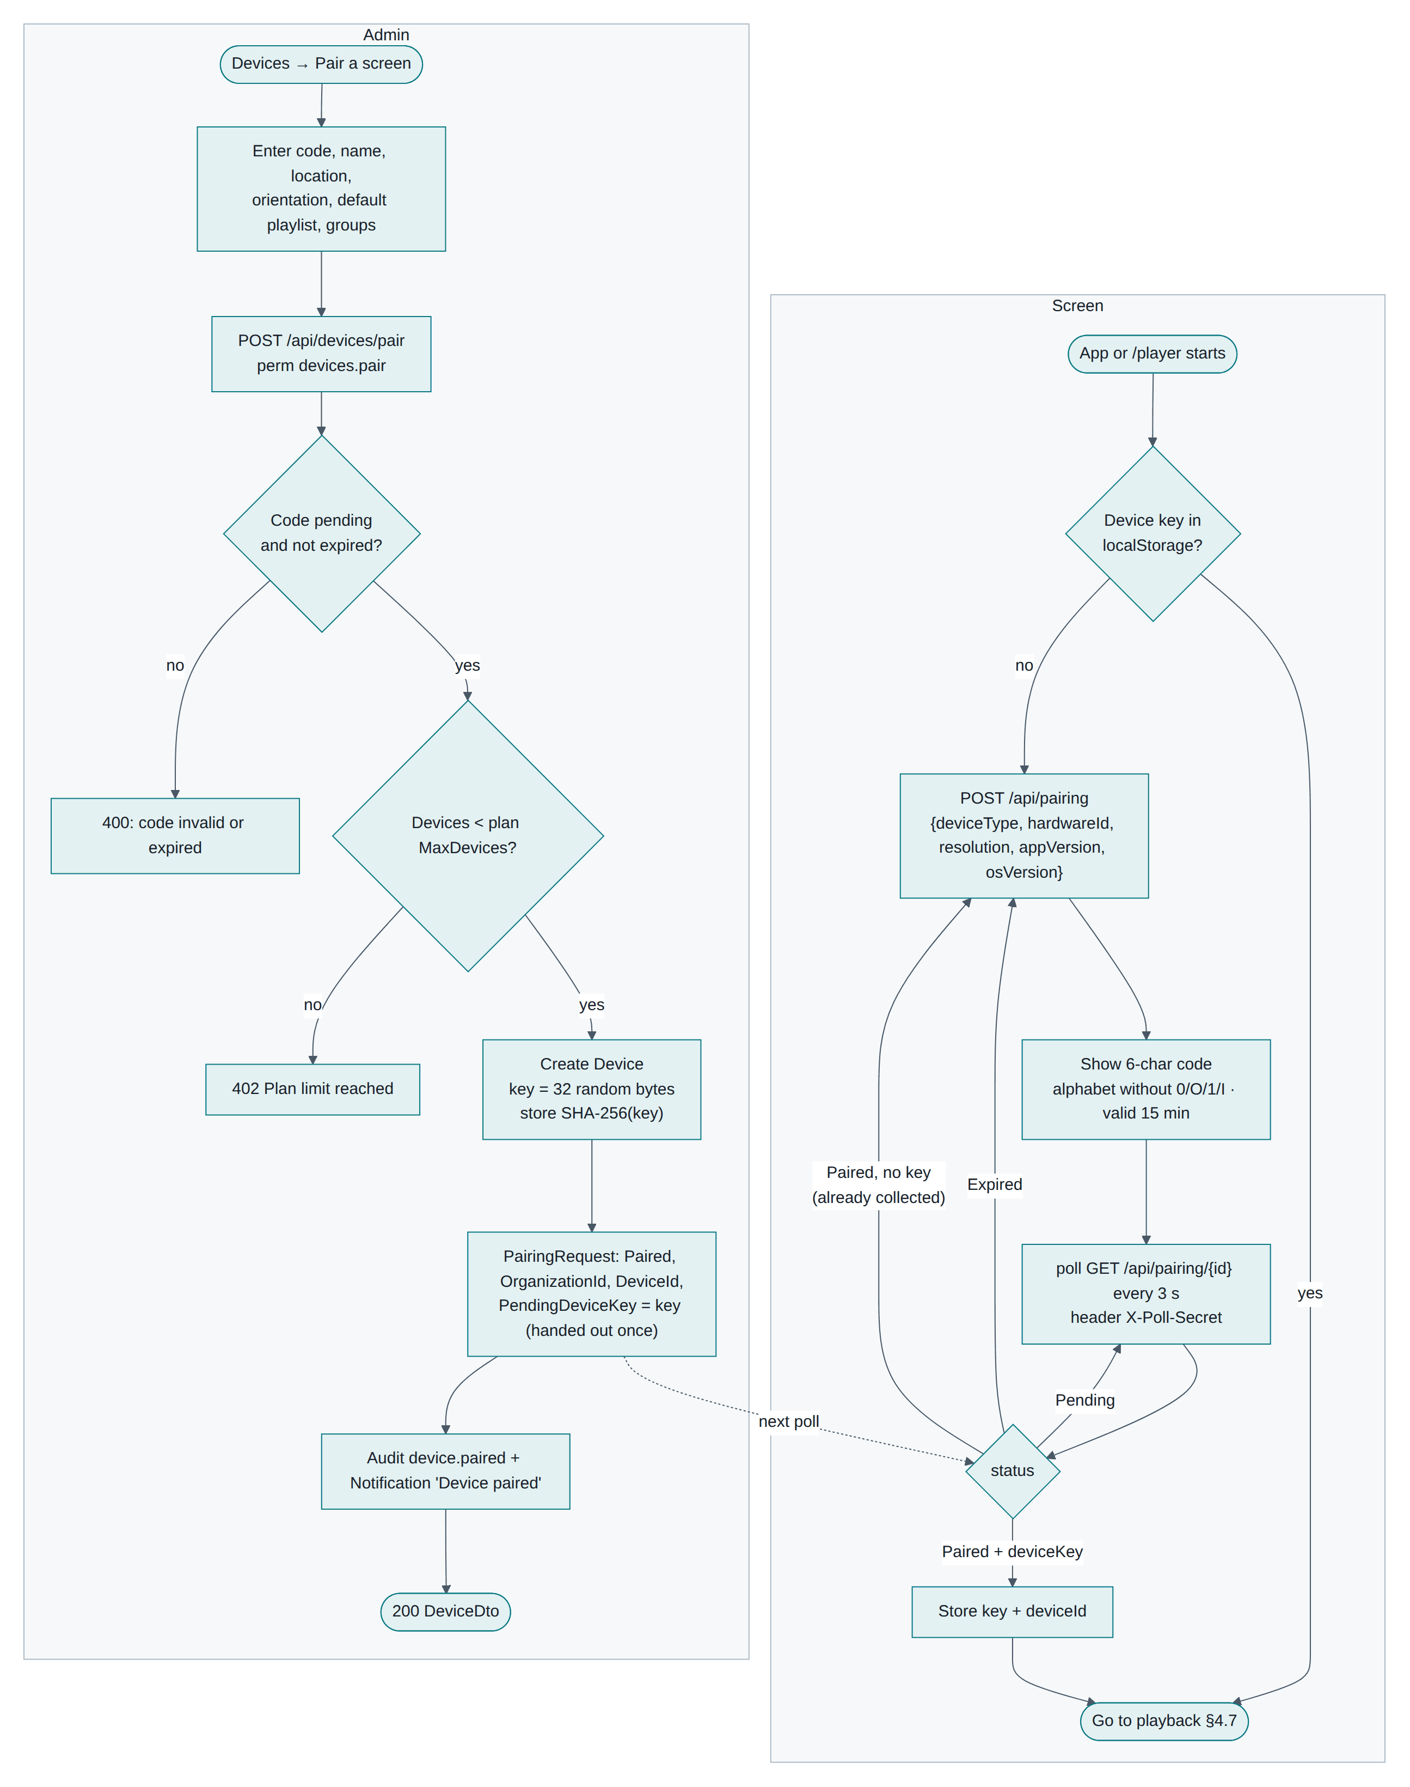
Figure 6-1 Device pairing: the screen side and the admin side

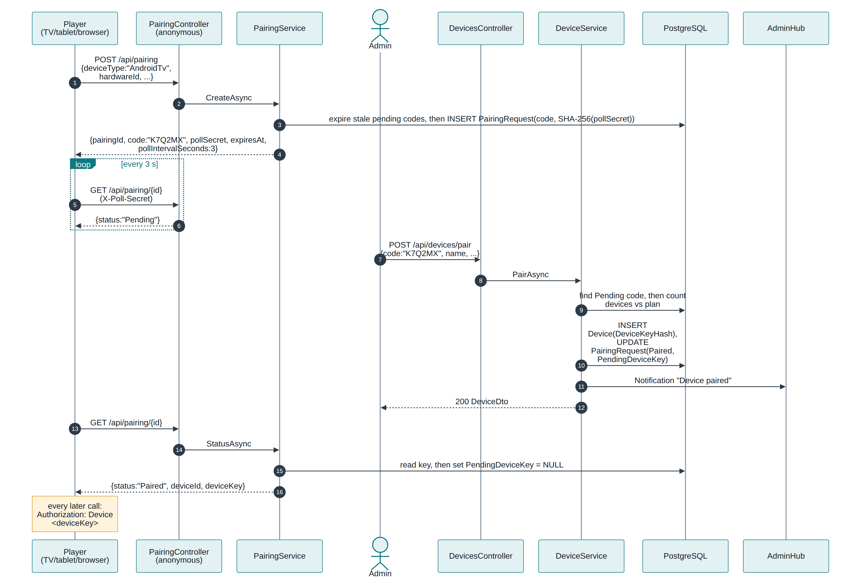
Figure 6-2 Pairing sequence, from code request to device key

6.2 Step by step
# | Step | Detail
1 | Screen requests a code | POST /api/pairing with device type, hardware id, resolution, app and OS version. Anonymous, rate-limited 60/min/IP
2 | Server creates the request | 6 characters from ABCDEFGHJKLMNPQRSTUVWXYZ23456789 (no 0/O/1/I), unique among pending, valid 15 minutes, plus a 256-bit poll secret stored as a SHA-256 hash
3 | Screen displays and polls | Big code on screen; GET /api/pairing/{id} every 3 seconds with the X-Poll-Secret header. A wrong secret returns 404
4 | Admin claims it | Devices → Pair a screen (devices.pair): code, name, location, orientation, default playlist, groups
5 | Server binds the tenant | Finds the pending code, checks the plan device limit, creates the Devices row in the admin's organization, generates a 256-bit key, stores only its SHA-256, marks the request Paired and parks the key for one-time collection
6 | Screen collects the key | Next poll returns deviceKey; the server clears it, so a second poll never returns it again
7 | Screen goes live | Connects /hubs/device, fetches its manifest, starts playing

The pairing record is kept as history. PairingRequests is the one table where OrganizationId is nullable: a code exists before it belongs to anyone.

6.3 What the device key is
- 32 random bytes, base64url, shown once and never stored in plain text on the server.
- Sent as Authorization: Device <key> (and as the SignalR access token on /hubs/device).
- Resolves to the device row, which supplies both device identity and tenant identity.
- Revoked instantly when the device is unpaired — the row is deleted, so the hash no longer matches.

6.4 Failure cases worth knowing
Situation | Result
Wrong or expired code | 400 "That code is invalid or has expired". The screen refreshes its own code after 15 minutes
Code claimed twice | 400 the second time
Plan device limit reached | 402; the screen keeps showing its code, so an upgrade lets you finish
Screen cannot reach the server | It keeps polling and retries the whole request after errors
Admin of another tenant guesses the code | It would succeed — codes are global. Rate-limit this endpoint (finding S1) before production

6.5 Editing and unpairing
PUT /api/devices/{id} (devices.manage) changes name, location, orientation, default playlist and groups, then pushes ContentChanged so the screen re-syncs.
DELETE /api/devices/{id} deletes the row, which immediately invalidates the key (401 on any call), and pushes Revoked over SignalR. The player wipes its key, manifest, media cache and play queue and returns to a fresh pairing code — verified in the browser tests.

7. Media upload

7.1 The flow
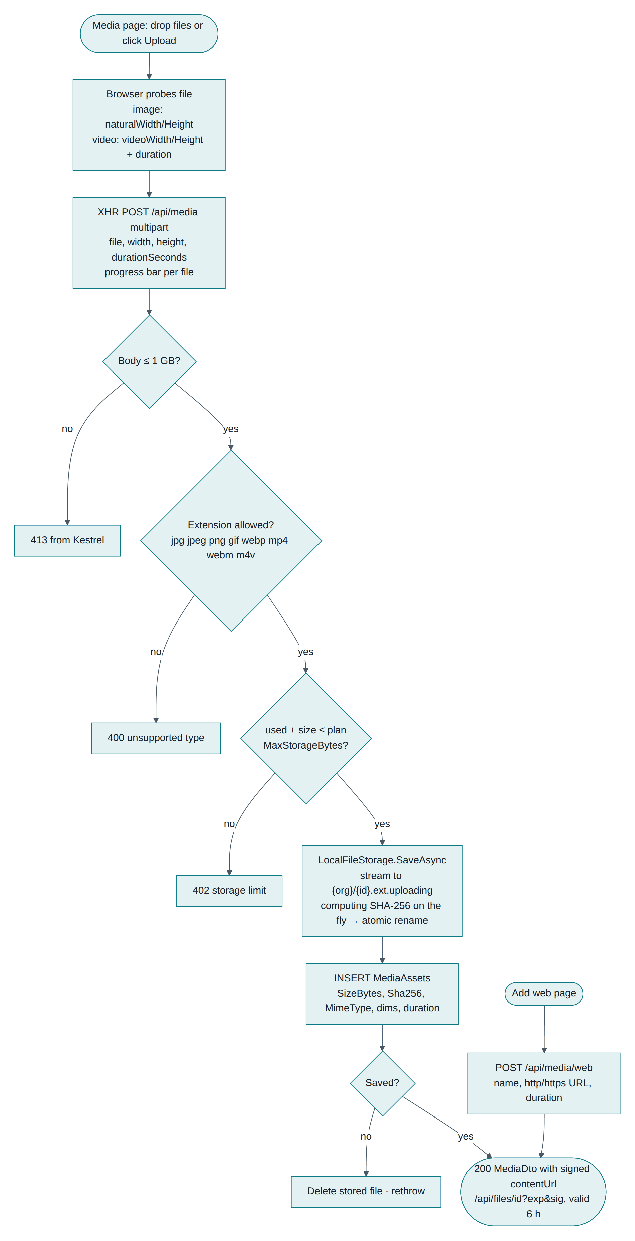
Figure 7-1 Media upload: validation, quota, streaming write and checksum

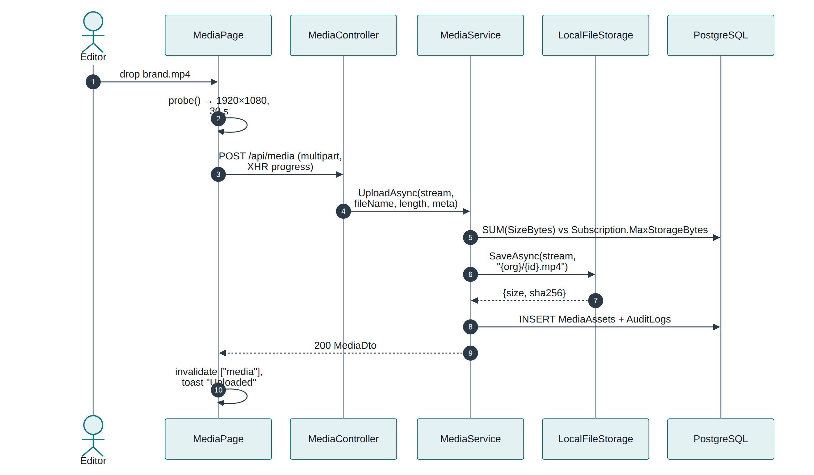
Figure 7-2 Upload sequence, browser to disk

7.2 What happens in the browser first
Before sending, the page reads the file locally: image dimensions from an Image, video dimensions and duration from a video element. Those become width, height and durationSeconds in the multipart body, so the library shows accurate metadata without the server decoding anything. Upload uses XMLHttpRequest for a real progress bar; several files upload one after another, each with its own row.

7.3 What the server does
Check or step | Detail
Permission | media.manage
Size | Kestrel and the controller cap the body at 1 GB (413 above that)
Type | Extension allow-list: jpg, jpeg, png, gif, webp, mp4, webm, m4v. No SVG or HTML (they would execute in the player)
Quota | Sum of this tenant's SizeBytes plus the new file against MaxStorageBytes → 402
Write | Streamed to {OrganizationId}/{mediaId}{ext}.uploading, computing SHA-256 as it goes, then atomically renamed
Row | MediaAssets with size, checksum, MIME type, dimensions, duration, uploader, tenant stamp
Rollback | If the database write fails, the file is deleted

The checksum is the foundation of offline sync: screens verify every downloaded file against it (Chapter 11).

7.4 Web pages as media
POST /api/media/web adds a URL with a duration instead of a file. It renders in an iframe on the player, so the page must allow framing, and it needs the network at play time — it cannot be cached offline.

7.5 Serving files
Files are never served by path. Each response includes a signed URL — /api/files/{id}?exp=…&sig=… — valid 6 hours for the admin UI and 7 days inside a device manifest. The endpoint is anonymous because the HMAC signature is the authorization, supports HTTP range requests (video seeking, resumable downloads), and returns 403 for a tampered or expired signature.

7.6 Editing and deleting
Editing changes name, default duration and tags (and the URL for web media), then pushes ContentChanged. Deleting is blocked with 409 while any playlist uses the item, and the message names the playlists. When deletion succeeds, the row goes first and the file afterwards.

8. Playlist creation

8.1 The flow
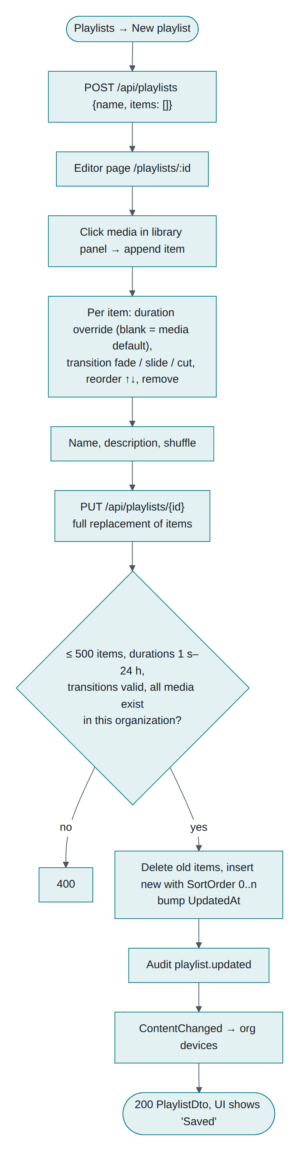
Figure 8-1 Playlist creation and saving

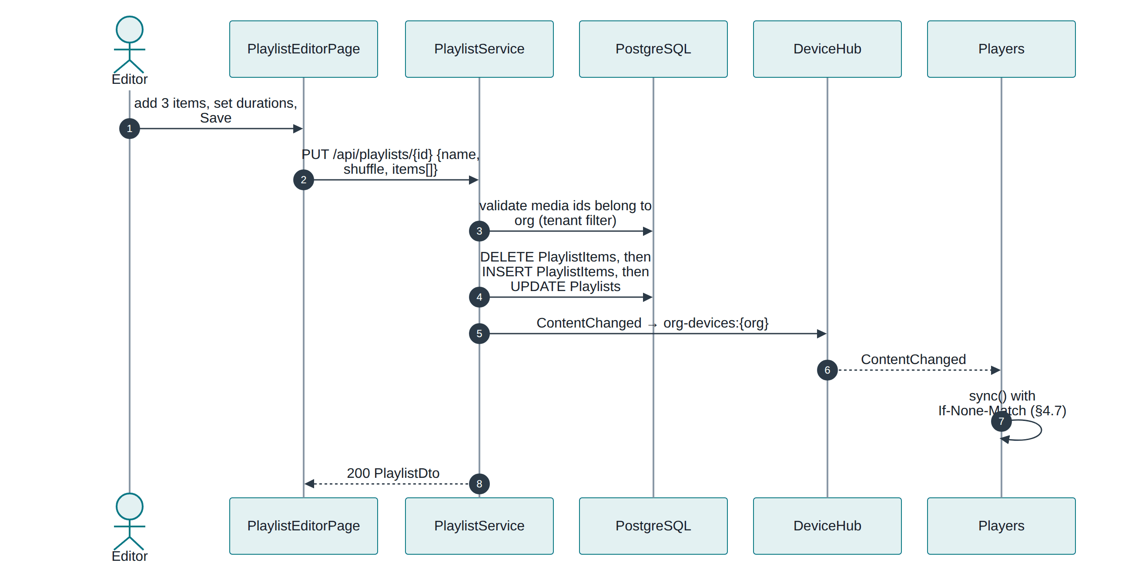
Figure 8-2 Playlist save sequence, including the push to screens

8.2 Using the editor
Playlists → New playlist creates an empty playlist and opens the editor straight away, so there is no naming dialog before you can work.
Control | Behaviour
Library panel | Search the tenant's media; click an item to append it
Duration | Blank uses the media's own default; a number overrides it for this playlist only (1 s to 24 h)
Transition | fade (default), slide or none
Order | Move up and down; SortOrder is rewritten 0..n on save
Shuffle | Plays items in random order on the device
Header | Live item count and total loop length

Saving sends the whole item list. The server deletes the old rows and writes the new ones in one transaction, so there is no partially-saved playlist.

8.3 Validation
- At most 500 items; durations between 1 second and 24 hours; transition must be one of the three.
- Every media id is re-checked through the tenant filter. An id from another organization returns 400 — a tenancy test covers exactly this.

8.4 After saving
ContentChanged goes to org-devices:{tenant}. Screens fetch their manifest conditionally; those whose content actually changed get a new version and download only files they do not already have.

8.5 Where playlists are used
Use | Effect
Device default playlist | Plays whenever no schedule matches
Group default playlist | Same, inherited by member screens without their own default
Layout zone | The playlist loops inside that rectangle
Schedule target | Plays full-screen during the schedule's window

Deleting a playlist is blocked (409) while a schedule uses it. Device, group and zone defaults simply become empty.

9. Layout builder
A layout splits one screen into rectangles ("zones"), each running its own playlist — a main video with a sidebar of offers and a ticker along the bottom, for example.

9.1 The flow
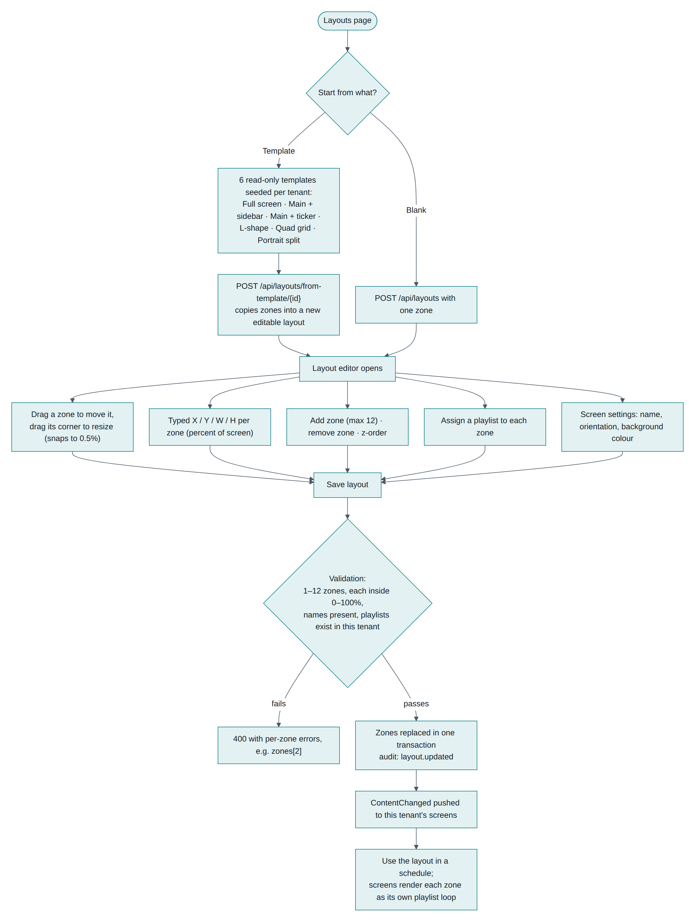
Figure 9-1 Layout builder: from template to a saved, scheduled layout

9.2 Templates
Six read-only templates are created for every new organization, so each tenant owns its own copies:
Template | Zones | Orientation
Full screen | Main (100%) | Landscape
Main with sidebar | Main 70% + Sidebar 30% | Landscape
Main with ticker | Main 85% + Ticker 15% (bottom strip) | Landscape
L-shape | Main 75×80 + Sidebar 25×80 + Bottom 100×20 | Landscape
Quad grid | Four equal quarters | Landscape
Portrait split | Top 60% + Bottom 40% | Portrait

Templates cannot be edited or deleted (403). Use copies one into a new editable layout via POST /api/layouts/from-template/{id}, with zone geometry preserved and playlists left empty.

9.3 The editor
The canvas shows the screen at its real aspect ratio, with zones as coloured rectangles in z-order.
Action | How
Move a zone | Drag it; position snaps to 0.5% steps and is clamped inside the screen
Resize | Drag the corner handle (minimum 5% in each direction)
Precise placement | Type X, Y, W, H as percentages
Add or remove | Up to 12 zones; the last zone cannot be removed
Assign content | Pick a playlist per zone, or leave it empty
Screen settings | Name, orientation (swapping it swaps width and height), background colour

Geometry is stored in percentages, not pixels, so one layout fits a 1080p tablet and a 4K TV.

9.4 Validation on save
Rule | Message
1–12 zones | "A layout needs between 1 and 12 zones."
Zone fits the screen | "Zone 'Sidebar' must fit inside the screen (0–100%)", keyed as zones[2] so the editor highlights it
Every zone named | Per-zone field error
Resolution 320×240 to 7680×7680 | Field error
Background colour is #rrggbb | Field error
Playlists exist in this tenant | "A zone refers to a playlist that no longer exists."

Zones are replaced in one transaction, an audit entry is written, and ContentChanged goes out to the tenant's screens.

9.5 How a layout reaches a screen
A layout plays only through a schedule (a device's default is a playlist, not a layout). The manifest carries the layout with all its zones and every playlist any zone references. The player positions each zone by percentage and runs an independent playlist loop inside it — so a 30-second video in the main zone and a 5-second image rotation in the sidebar run side by side, each on its own timer.

9.6 Deleting
Blocked with 409 while any schedule uses the layout. Templates always return 403.

10. Scheduling

10.1 Creating a schedule
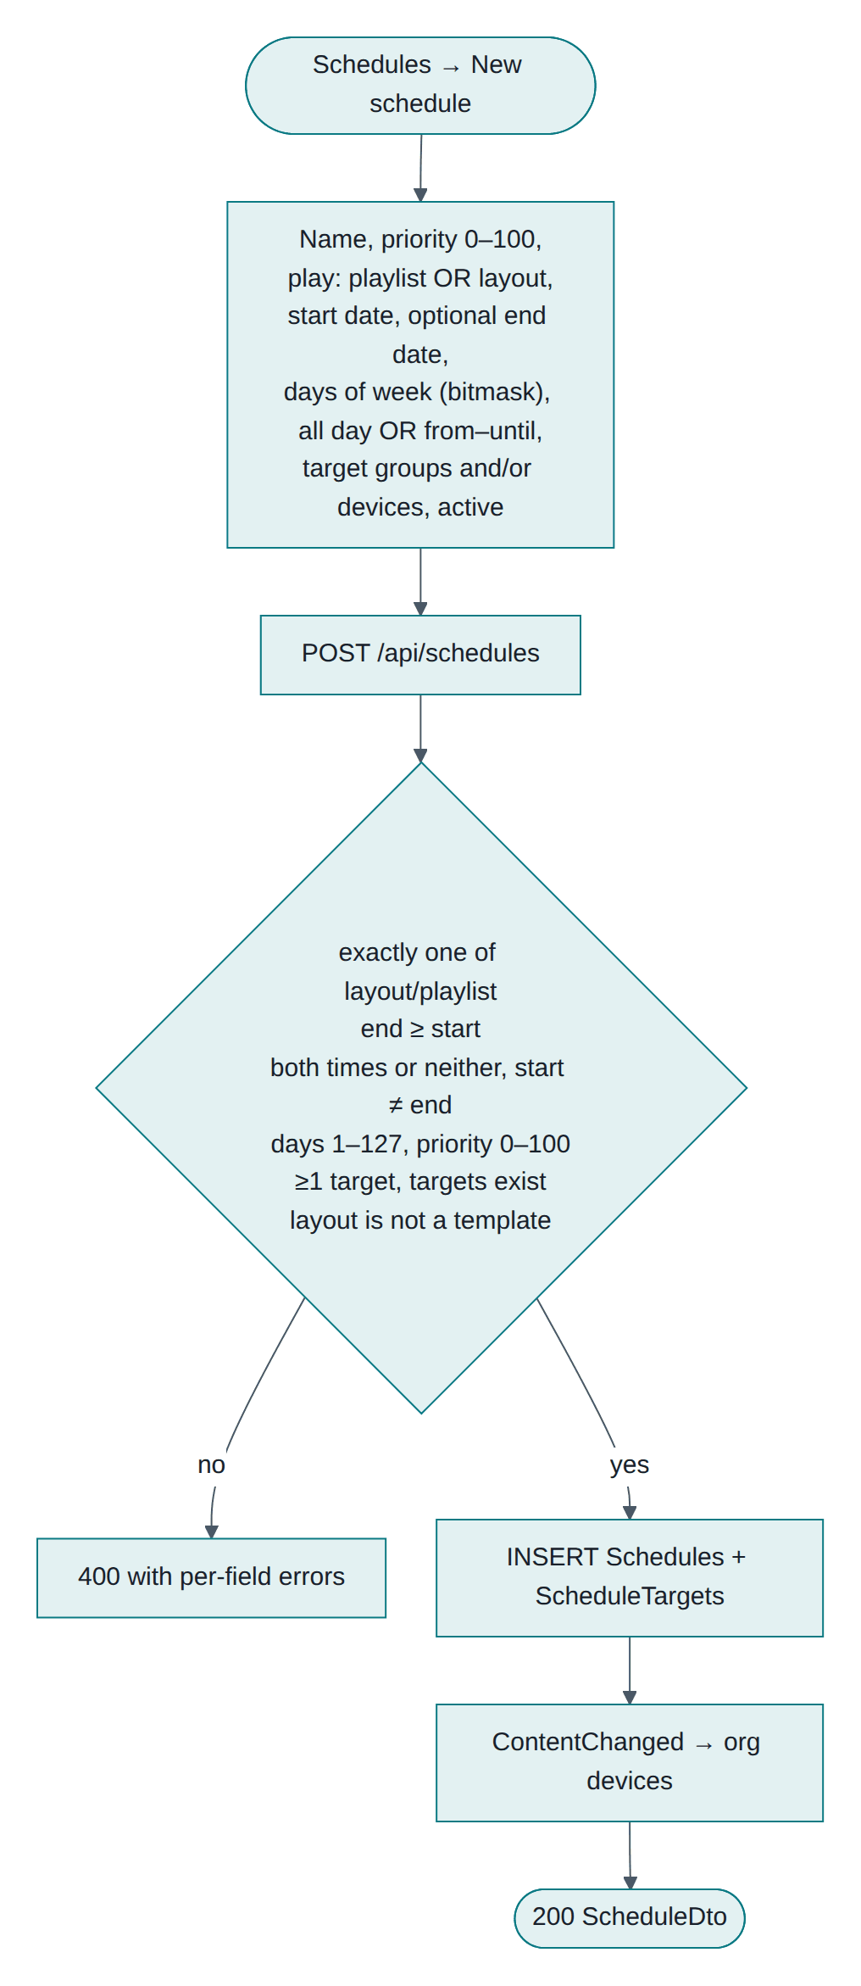
Figure 10-1 Creating a schedule
Field | Meaning
Plays | Exactly one of a playlist or a layout (enforced in the service and by a database check constraint)
Priority | 0–100. The highest active schedule wins
Start / end date | End is optional: leave it empty to run indefinitely
Days | Bitmask, bit 0 = Sunday. 127 every day, 62 weekdays, 65 weekends
Time window | All day, or from–until. If "until" is earlier than "from", the window runs past midnight
Targets | Any mix of devices and device groups, at least one, all inside your tenant
Active | A pause switch that keeps the schedule for later

10.2 How a screen decides what to play
Scheduling decisions are made on the device, not on the server. That is what keeps content correct during an outage.
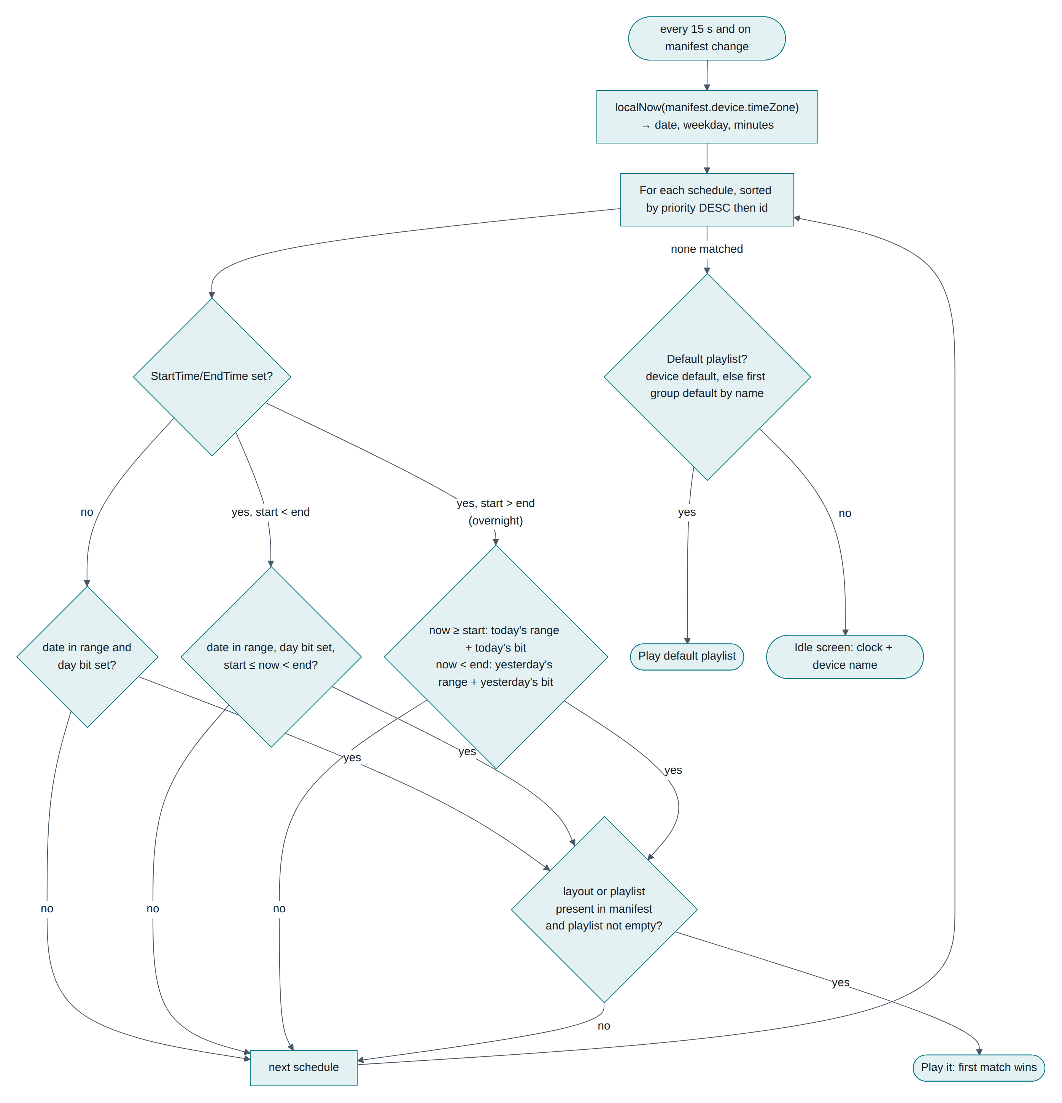
Figure 10-2 Schedule evaluation on the screen, every 15 seconds
The device evaluates, in its own time zone (its location's, or the organization default):
- Walk schedules in priority order (the manifest is pre-sorted).
- Skip any whose date range or weekday bit does not match today.
- For a timed schedule, match the window; for an overnight window, the after-midnight part belongs to the previous day's occurrence, so a Friday 22:00–02:00 rule still plays at 01:00 on Saturday.
- First match wins; its layout or playlist must exist in the manifest and not be empty.
- If nothing matches, fall back to the device default playlist, then the first group default, then an idle clock screen.

10.3 Worked example
A café with Asia/Kolkata on its location:
Schedule | Priority | Days | Window | Plays
Breakfast menu | 20 | Mon–Fri | 07:00–11:00 | Breakfast playlist
Lunch menu | 20 | Mon–Fri | 11:00–15:00 | Lunch layout
Weekend brunch | 30 | Sat–Sun | 08:00–14:00 | Brunch layout
Promo loop | 10 | Every day | all day | Promo playlist

At 09:00 on Tuesday, Breakfast (20) beats Promo (10). At 16:00 on Tuesday only Promo matches. At 09:00 on Saturday, Weekend brunch (30) wins. Outside all of them, the device default plays.

10.4 Publishing a change
Saving a schedule pushes ContentChanged to the tenant's screens; they re-sync within seconds and pick the new rule up at the next 15-second evaluation. Nothing is pushed per-device: the server tells the tenant's screens that something changed, and each screen decides what that means for it.

11. Synchronization and real-time updates

11.1 The manifest
Each screen downloads one document describing everything it may need: its own identity and time zone, its default playlist, every active schedule targeting it (directly or through its groups), the layouts and playlists those reference, and the media behind them with checksums and signed URLs.
The version is a SHA-256 of the manifest's content with the signed URLs excluded, so a version changes only when content really changes, not because the URLs were re-signed. It is returned as an ETag.

11.2 The sync cycle
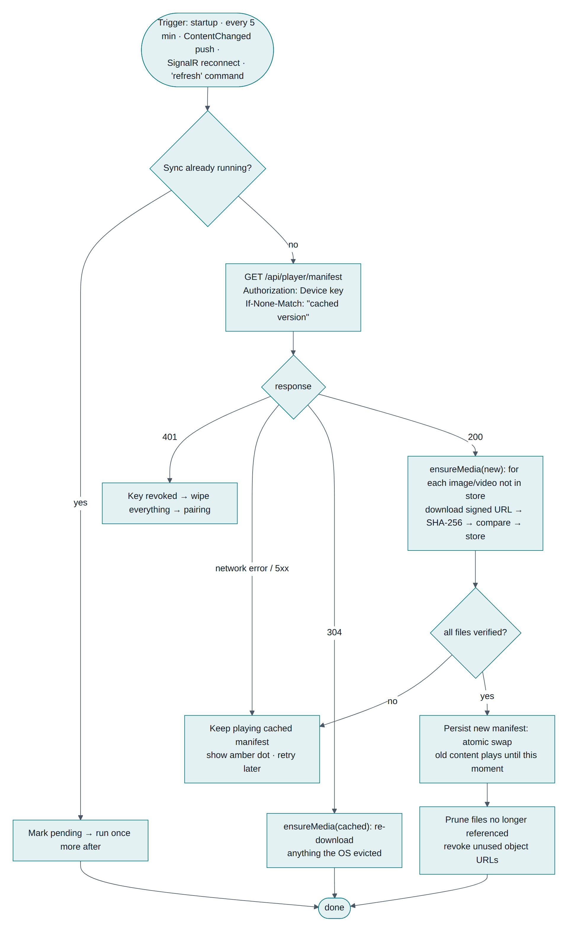
Figure 11-1 Synchronization: triggers, conditional fetch, verified download, atomic swap

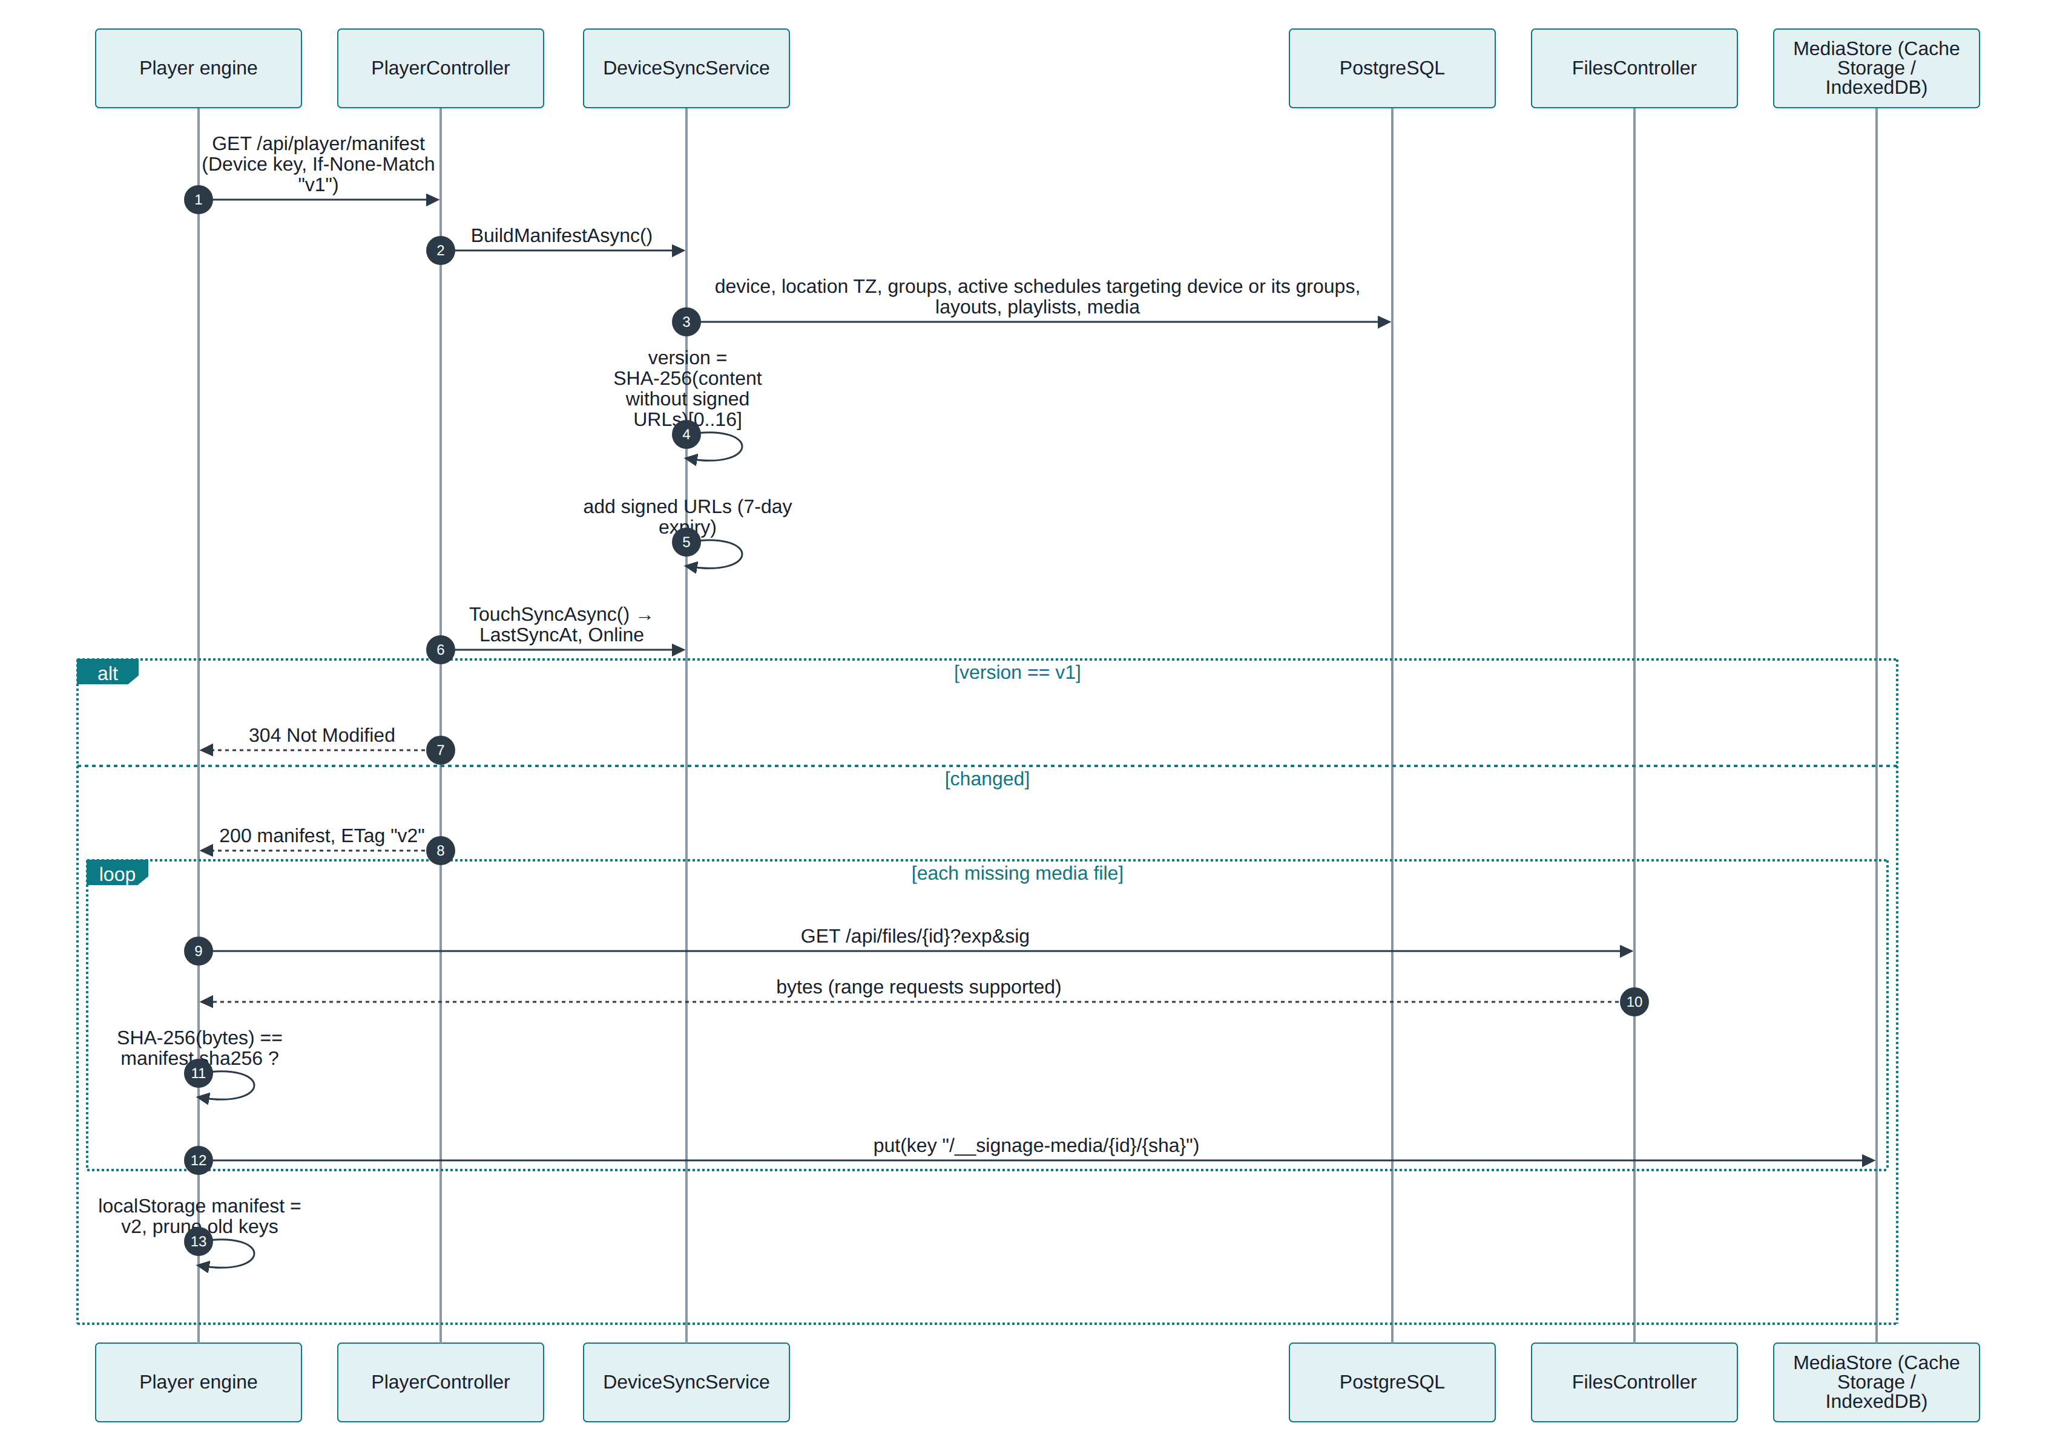
Figure 11-2 Sync sequence: manifest, files, checksum, local store

Trigger | When
Startup | Every time the player loads
Timer | Every 5 minutes (the safety net)
Push | ContentChanged over SignalR (the fast path)
Reconnect | After the hub reconnects
Command | An admin presses Sync now

Three properties matter:
- Conditional. If-None-Match means an unchanged manifest costs a 304 and a few hundred bytes.
- Verified. Every downloaded file is hashed and compared with the manifest's sha256; a mismatch aborts the sync and the old content keeps playing.
- Atomic. The new manifest is stored only after every file is present, so a half-finished download never interrupts playback. Files no longer referenced are then pruned.

11.3 Real-time channels
Hub | Who connects | Server → client | Client → server
/hubs/admin | Admin browser tabs (JWT) | DeviceStatus, Notification | —
/hubs/device | Paired screens (device key) | ContentChanged, Command, Revoked | Heartbeat

In the admin UI the connection state shows as Live / Connecting / Updates paused in the header. Incoming DeviceStatus events are patched straight into the cached device list, so the wall updates without refetching.
Which admin actions push ContentChanged: playlist save or delete, layout save, schedule create, update or delete, device update, group create, update or delete, media edit, location time-zone change or delete, and organization time-zone change.

11.4 If real-time is blocked
Everything still works, just slower: screens fall back to the 5-minute sync timer and REST heartbeats, and the admin UI polls. The usual cause is a proxy without WebSocket upgrade headers (Chapter 14).

12. Offline playback

12.1 What the screen keeps locally
Item | Where
Device key and id | localStorage
Manifest (schedules, layouts, playlists, media metadata) | localStorage
Media files | Cache Storage over HTTPS, or IndexedDB on plain HTTP
Proof-of-play queue | localStorage, up to 5,000 entries
App shell (HTML/JS) | Service worker over HTTPS; the Android app uses the WebView cache

12.2 Behaviour during an outage
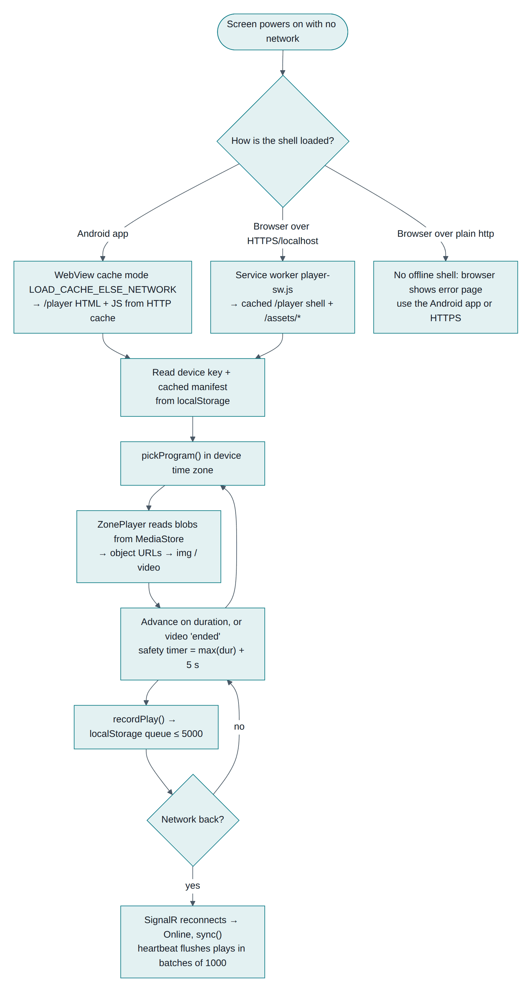
Figure 12-1 Offline playback: booting, playing and catching up
- Playback continues from the local store; nothing streams from the server at play time.
- Schedules keep switching at the right local times, because evaluation is on-device.
- Plays are queued and uploaded when the network returns.
- A small amber dot in the corner marks "offline, playing cached content".
- After 90 seconds of silence the admin side marks the screen Offline and raises a warning notification.

12.3 Rebooting while offline
Shell | Result
Android app | Works. The WebView switches to cache-first when it detects no network, so the player loads and plays cached media
Browser over HTTPS (or localhost) | Works. The service worker serves the cached shell
Browser over plain http://<LAN IP> | Does not work. Browsers disable service workers on insecure origins, so a cold start needs the network

That last row is the practical reason to run HTTPS or use the Android app for unattended screens. A running player over plain HTTP still survives outages — it just cannot cold-start during one.

12.4 What cannot work offline
Web-page media (iframes need the network), new content, and remote commands. Everything else — images, videos, layouts, transitions, shuffle, scheduling — is local.

12.5 Catching up
On reconnect the player re-registers on the hub (Online), fetches its manifest conditionally (usually 304), and flushes queued plays in batches of up to 1,000. Proof-of-play for the offline period therefore appears on the device page afterwards, which the browser tests verify.

13. Device monitoring and notifications

13.1 Device states
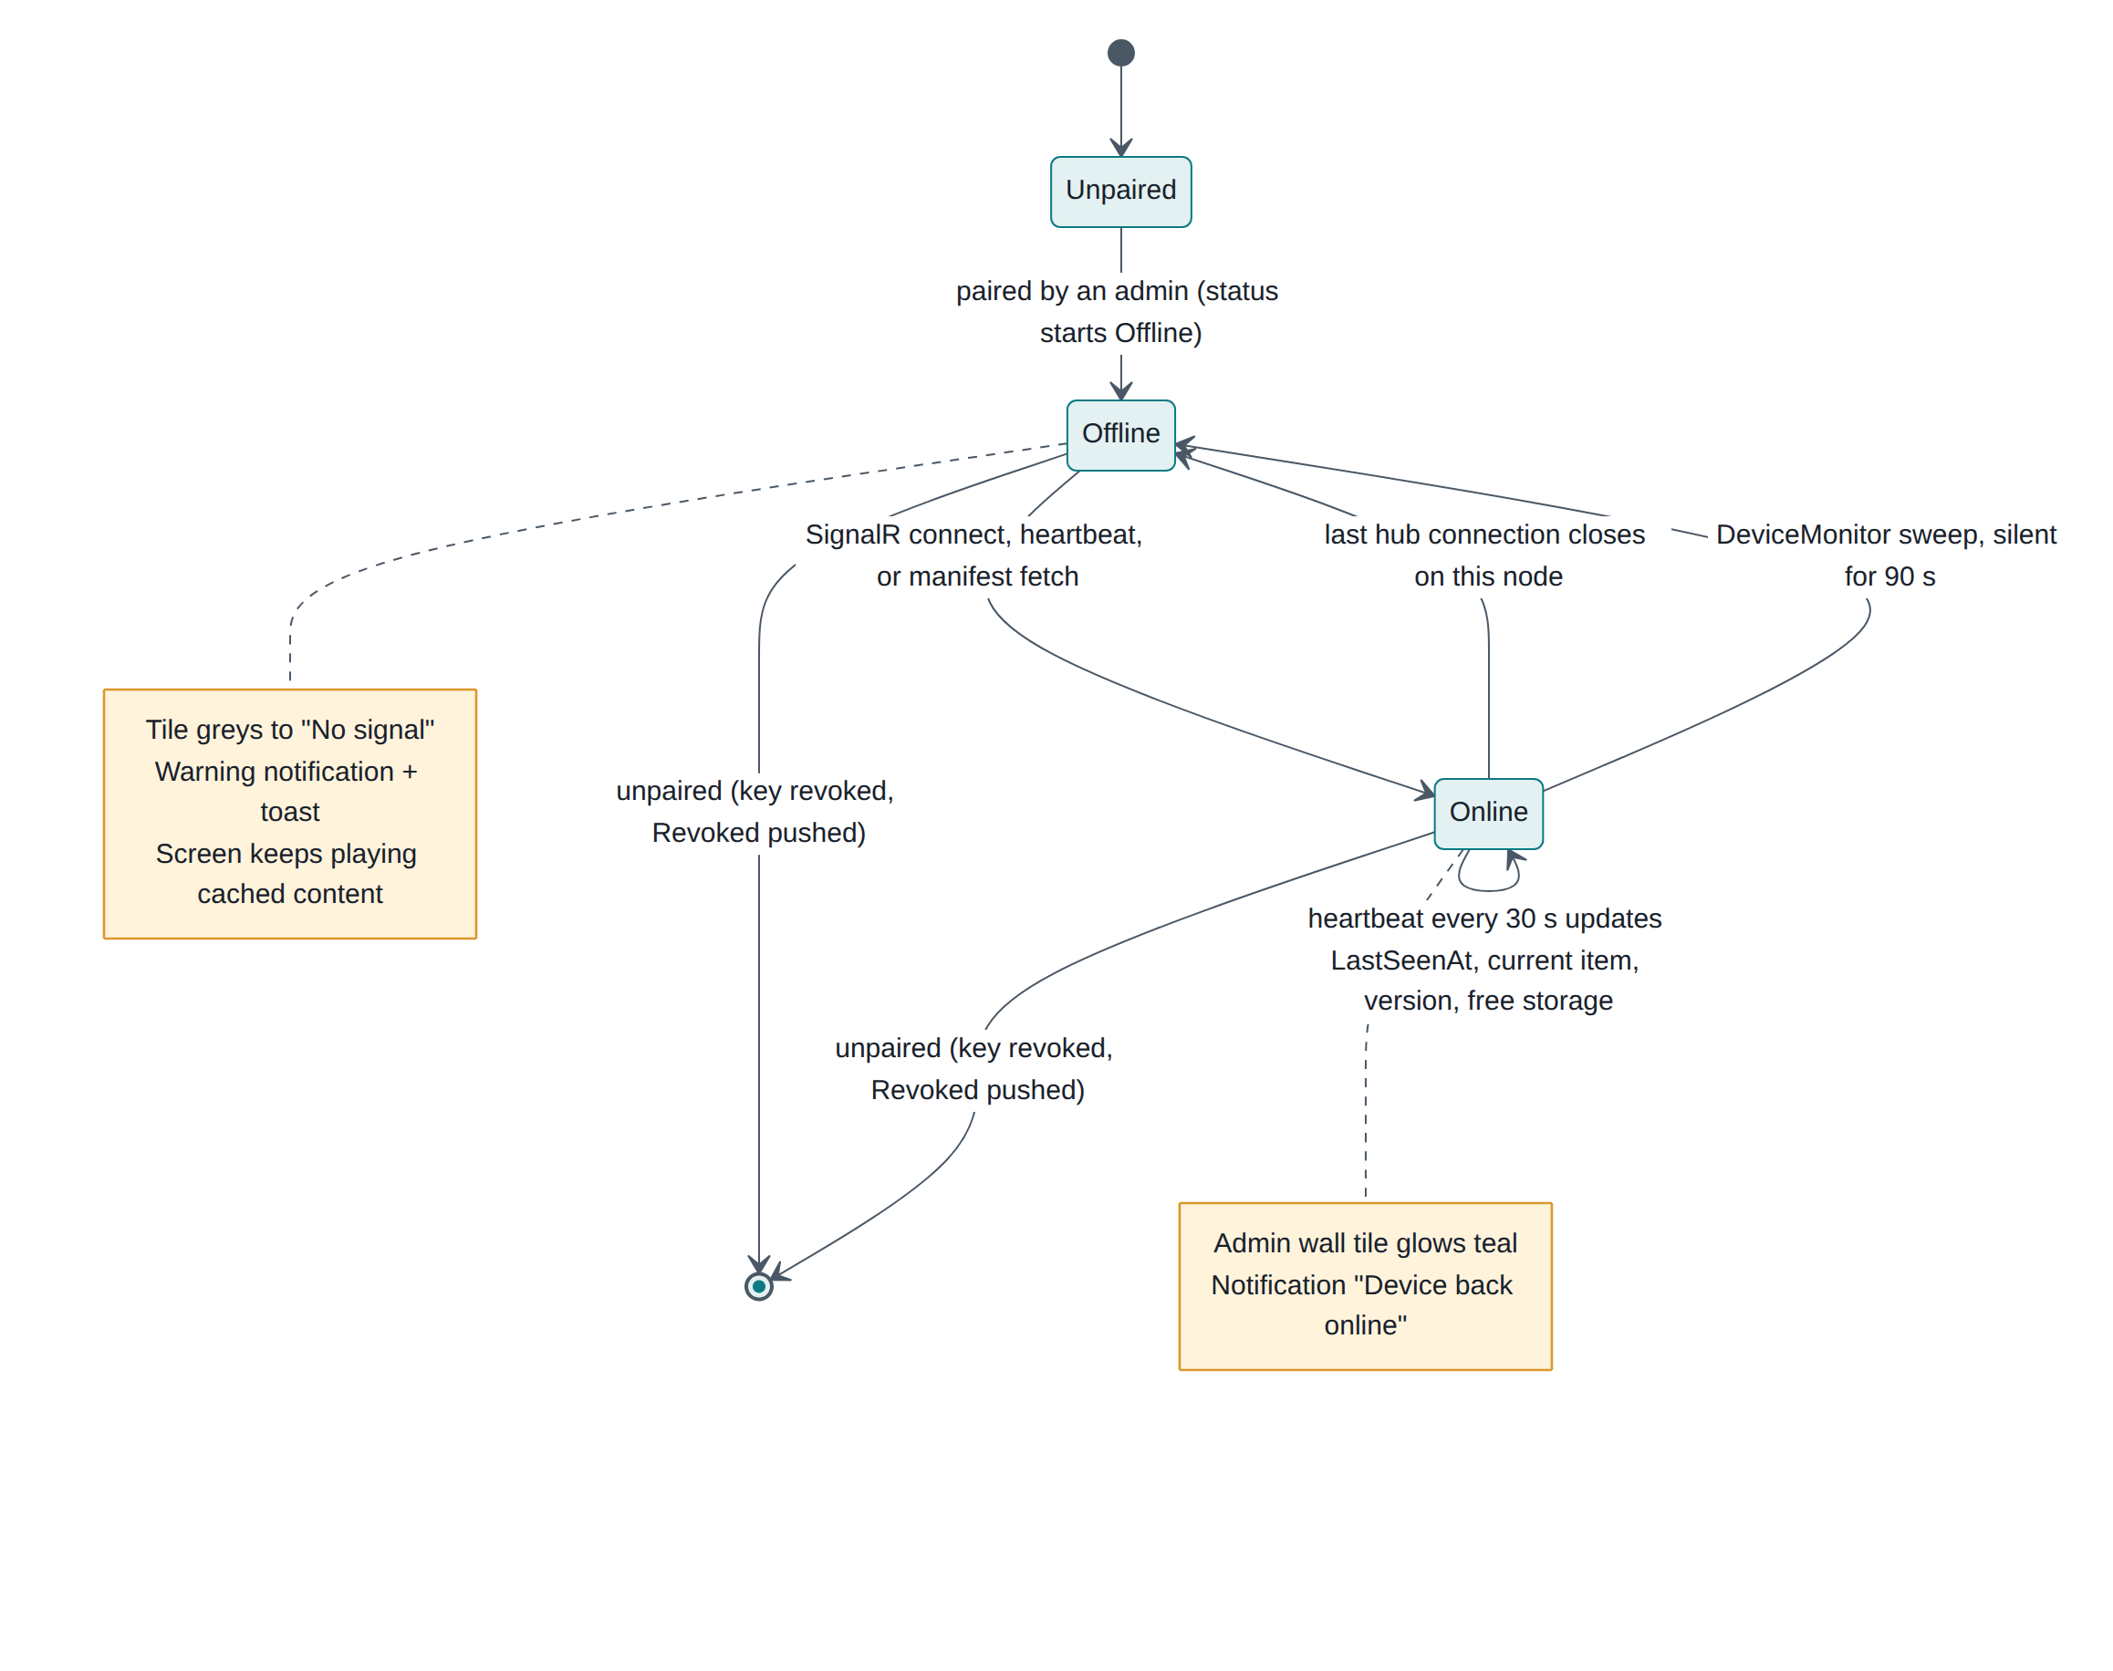
Figure 13-1 Device status: what moves a screen between Online and Offline

13.2 Heartbeats
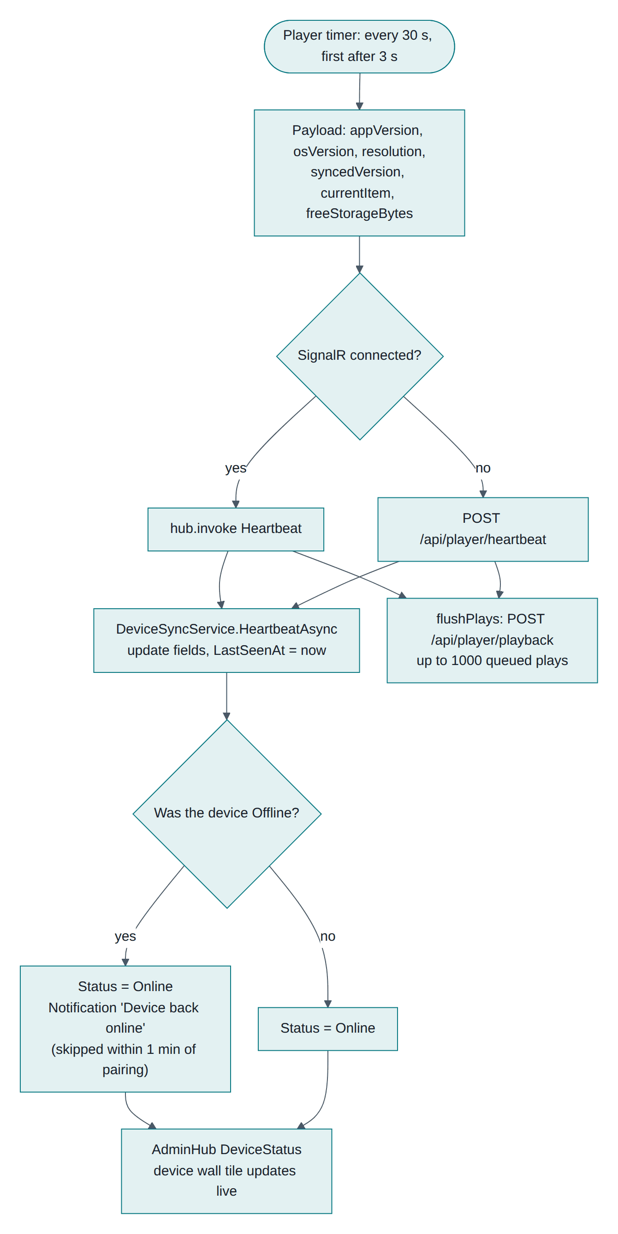
Figure 13-2 Heartbeat handling, from the player's timer to the admin wall
Every 30 seconds (first beat after 3 seconds) each screen reports app version, OS and model, resolution, the manifest version it is running, the item playing right now, and free storage. It uses the SignalR hub when connected and falls back to POST /api/player/heartbeat otherwise. The same tick flushes queued proof-of-play.

13.3 Going offline
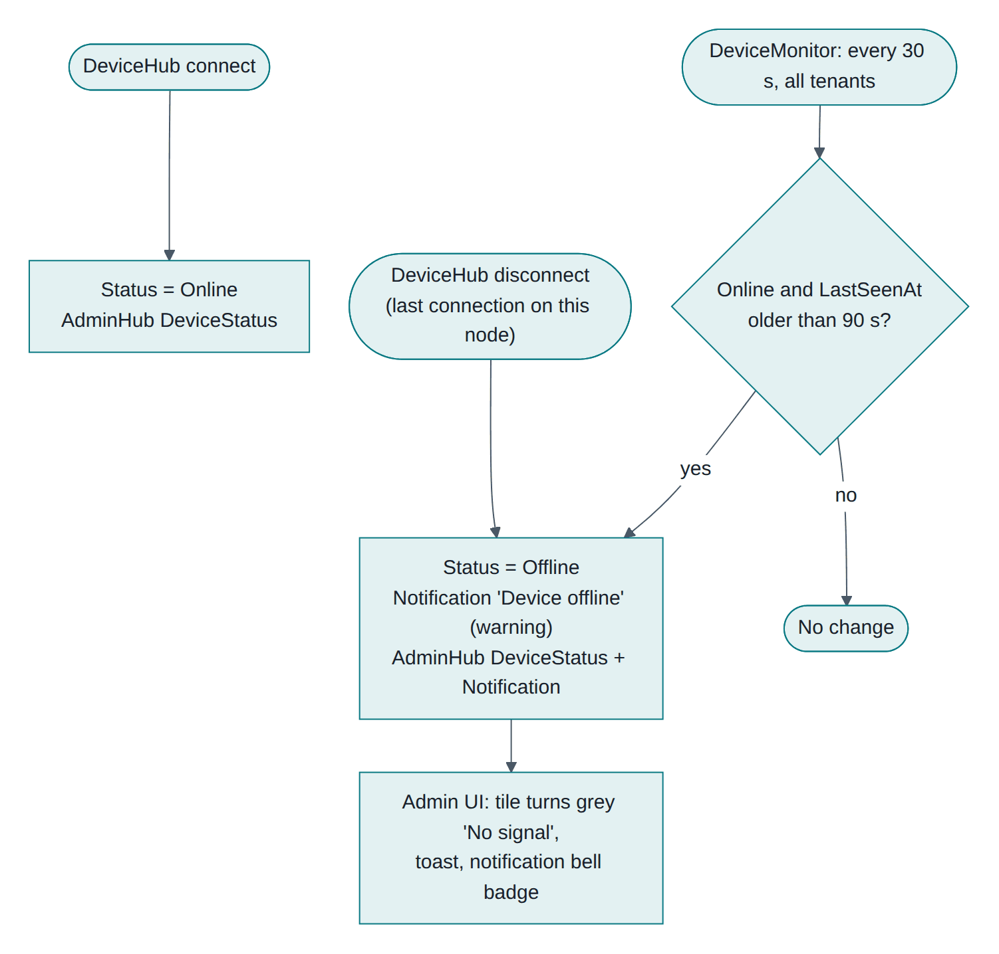
Figure 13-3 Presence and offline detection
Two mechanisms: a clean hub disconnect (marked offline when the last connection for that device on the node closes, so a page reload does not flap the status), and DeviceMonitor, a background service that sweeps all tenants every 30 seconds and marks anything silent for 90 seconds as Offline — the case that catches power cuts.

13.4 What an operator sees
Surface | Shows
Dashboard device wall | Each screen drawn in its real orientation; teal glow when live, "No signal" when not, with the current item
Device page | Status, last seen, last sync, content version, app and OS, IP, free storage, proof-of-play for 7 days
Header indicator | Whether this browser's live connection is up
Bell | Unread notification count

13.5 Notifications
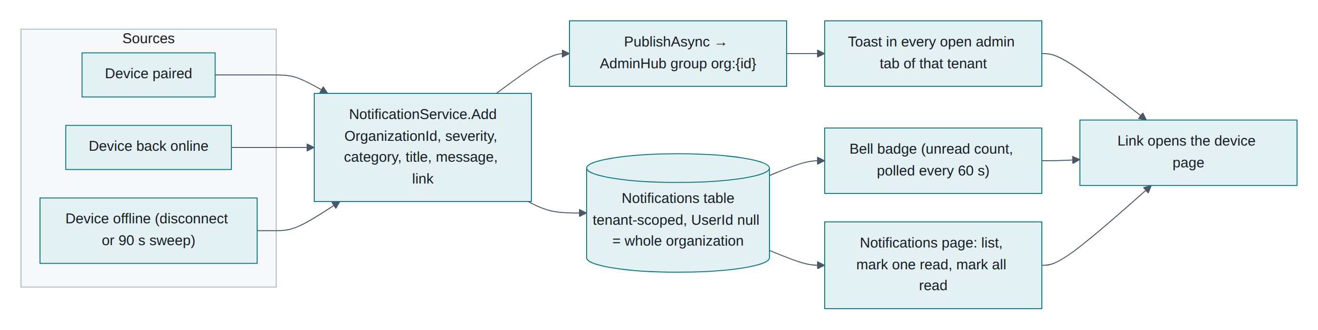
Figure 13-4 Notification sources, storage and delivery

Notifications are tenant-wide (UserId is null) and are both stored and pushed, so a tab open at the time gets a toast and a tab opened later still sees the item. Sources today: device paired, device back online, device offline. Read state is shared across the tenant's users — a known simplification.

13.6 Remote commands
Command | Effect on the screen
Identify | 10-second overlay with the device name, organization and content version
Sync now | Immediate manifest sync
Restart player | Reloads the player
Clear cache | Drops cached media and manifest, then re-syncs from scratch

Commands need devices.command, return 202 Accepted and are fire-and-forget: a screen that is offline at that moment does not receive them later.

13.7 Proof-of-play
Screens report what actually played. The device page aggregates the last 7 days by media item (plays, screen time, last played). Entries survive media deletion and show as "(deleted)", because the link is soft by design.

14. Troubleshooting

14.1 Where to start
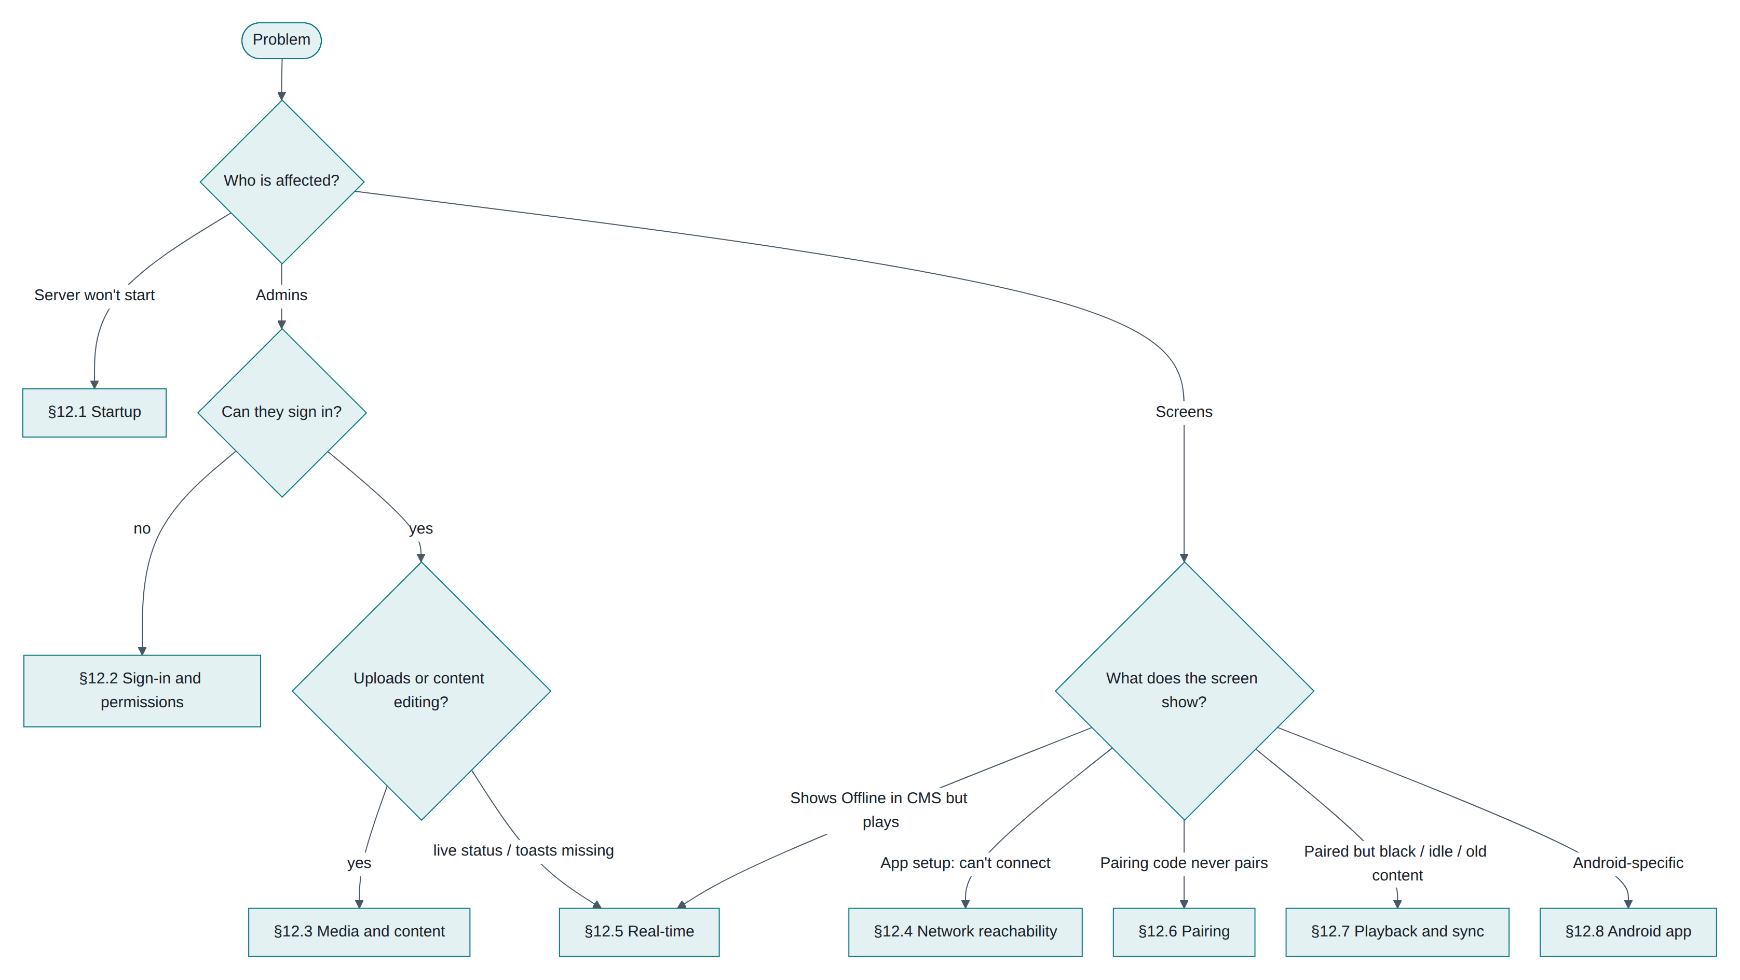
Figure 14-1 Triage: start from who is affected and what they see

Every API error carries a traceId; search the server log for it. Only genuine 5xx errors are logged at error level, so a fail: line always means a real fault.

14.2 Platform and start-up
Symptom | Cause | Fix
Jwt:SigningKey must be at least 32 bytes | No signing key configured | export Jwt__SigningKey=$(openssl rand -hex 32)
Database not reachable (attempt n/10) | PostgreSQL down or wrong credentials | Check ConnectionStrings__Default; the API retries for 30 seconds
Placeholder page instead of the UI | Frontend not built into wwwroot | cd frontend && npm run build:api
column … does not exist after an update | EnsureCreated() cannot evolve a schema | Adopt migrations (Chapter 15); in development, drop and recreate

14.3 Tenancy-specific confusion
Symptom | Explanation
"The item exists but I get 404" | It belongs to another organization. Existence is masked deliberately
"My colleague cannot see the screens I paired" | They are in a different organization. One email belongs to one organization; invite them under Users instead
400 "A selected device no longer exists" | The id in the request is not in your tenant (or was deleted)
Cross-tenant write blocked (500 in the log) | A bug: code tried to write another tenant's row. The guard stopped it; check the stack trace
A seeded organization reappears | Seed__AdminEmail/Password still set in the environment. Remove them after first boot

14.4 Sign-in and permissions
Symptom | Cause | Fix
Repeated sign-outs | An old refresh token was reused (two tabs), which revokes the session family, or the signing key changed | Sign in again
403 on an action the UI offered | Role lacks the permission | Add it to a custom role; effective at the next token refresh (≤ 15 min)
429 on login | 20 auth requests/min/IP | Behind a proxy all users can share one IP: configure KnownNetworks
Cannot demote the last Owner | Guard rule | Promote someone else first

14.5 Screens
Symptom | Cause | Fix
Code never pairs | Screen cannot reach /api/pairing/{id}, or 429 from many screens behind one NAT | Check connectivity; stagger first boots
"That code is invalid or has expired" | Typo (codes never contain 0/O/1/I), expired, or already claimed | The screen refreshes its code automatically
Screen shows the clock | No schedule matches and no default playlist | Set a device or group default, or check days, times and time zone
Content changes at the wrong hour | Wrong location time zone, or no location (uses the organization default) | Fix the location
"Preparing content…" forever | A download or checksum failed; storage may be full | Sync now; check free storage on the device page
Old content persists | Sync failing (amber dot) or files still downloading | Check connectivity; Sync now
Video skipped or black | Codec unsupported on that device | Re-encode to H.264/AAC MP4
Blank after reboot with no network | Plain HTTP origin has no service worker | Use HTTPS or the Android app
Status flaps Online/Offline | Heartbeats not arriving (proxy) or a badly wrong device clock | Check /api/player/heartbeat in proxy logs

14.6 Real-time
Symptom | Fix
Header shows "Updates paused" | Proxy is missing WebSocket upgrade headers (Upgrade, Connection, HTTP/1.1)
Screens update only every 5 minutes | Same cause on /hubs/device; they are falling back to the timer
Some admins miss status changes on a multi-node deployment | Add the Redis backplane

14.7 Useful commands

curl -s -D- http://server:5080/api/player/manifest \
-H "Authorization: Device <key>" -o /dev/null # 200 + ETag, or 401 if revoked
psql -c 'SELECT "Name","Status","LastSeenAt","SyncedVersion","CurrentItem" FROM "Devices" ORDER BY "LastSeenAt" DESC NULLS LAST;'
psql -c 'SELECT "CreatedAt","UserEmail","Action","Summary" FROM "AuditLogs" ORDER BY "CreatedAt" DESC LIMIT 20;'
grep -E 'fail:|traceId' /tmp/api.log
On the screen itself: browser DevTools → Application shows signage.player.* in Local Storage and the media cache; on Android, adb logcat | grep -i chromium.

15. Deployment, environment setup and Docker

15.1 Paths to production
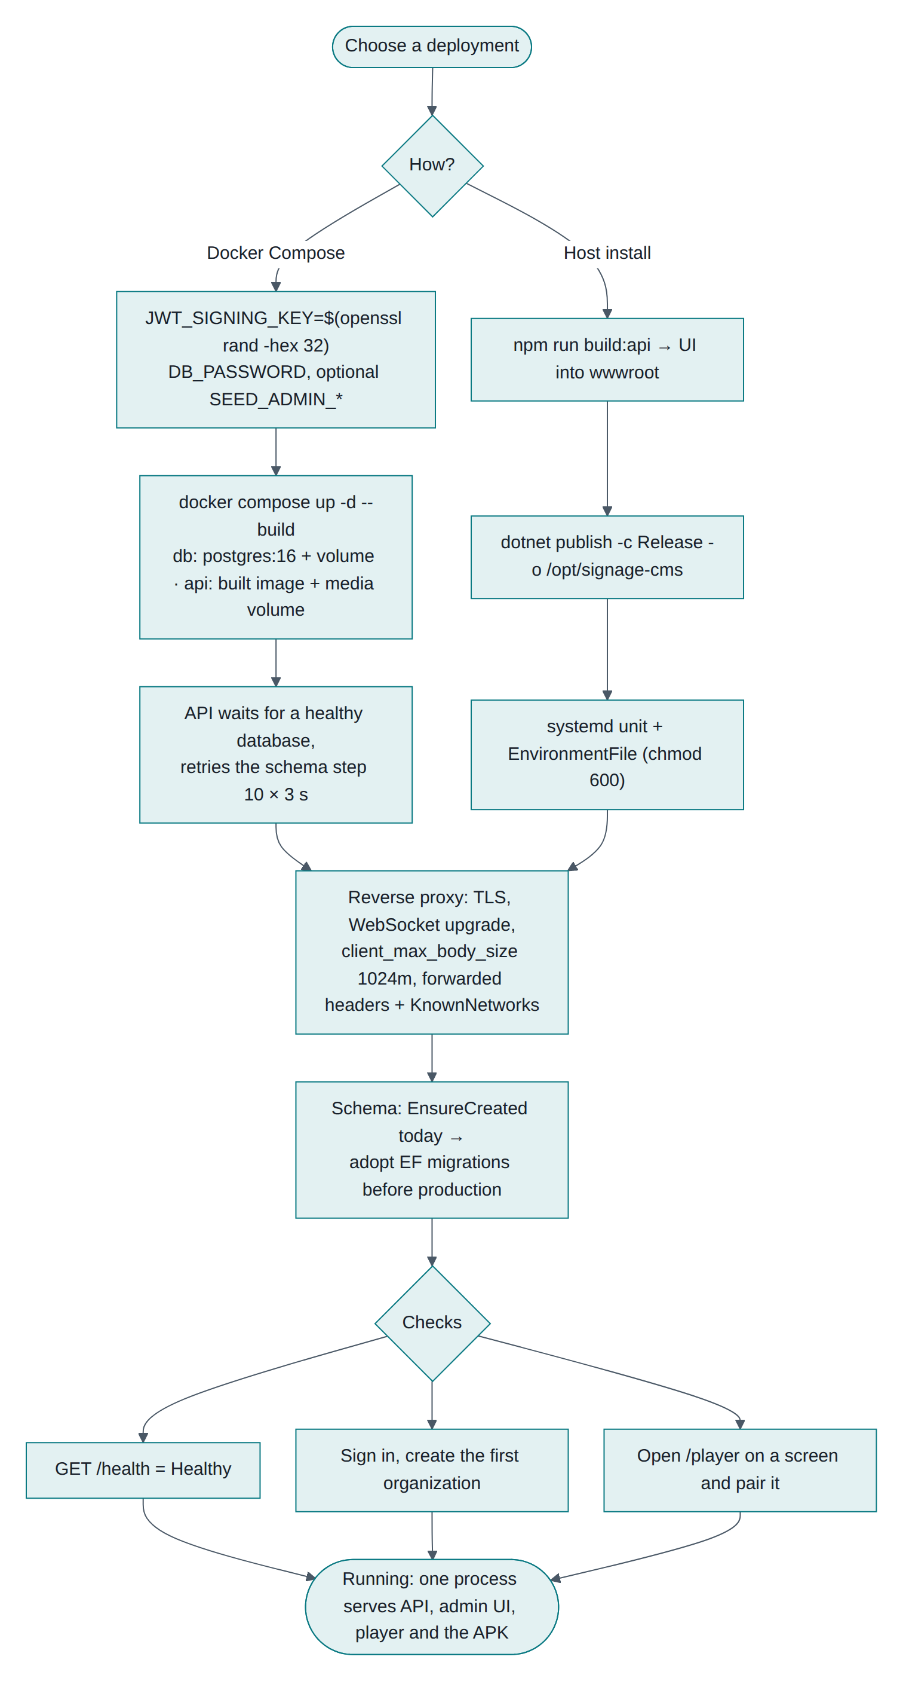
Figure 15-1 Deployment: Docker Compose or a host install, then the checks that prove it works

15.2 Local development
Prerequisites: .NET 8 SDK, Node 20+, PostgreSQL 14+ (16 recommended).

sudo -u postgres psql -c "CREATE DATABASE signage OWNER signage;"

cd backend/src/SignageCms.Api && dotnet run # http://0.0.0.0:5080, Swagger at /swagger
cd frontend && npm install && npm run dev # http://localhost:5173, proxies /api and /hubs
# or: npm run build:api → one process serves everything on :5080
scripts/dev-api.sh restarts the API in the background (PID in /tmp/api.pid, log in /tmp/api.log) and waits for /health.

15.3 Configuration
Settings come from appsettings.json, then the environment file, then environment variables (__ separates levels).
Key | Required | Notes
ConnectionStrings__Default | yes | Npgsql connection string; add SSL Mode=Require for managed databases
Jwt__SigningKey | yes | ≥ 32 random bytes. Signs tokens and media URLs. The API refuses to start without it. Rotating it signs everyone out
Jwt__AccessTokenMinutes | no | Default 15; refresh tokens last 14 days and rotate
Storage__RootPath | no | Media directory (/data/media in Docker). Must be persistent and backed up
Cors__AllowedOrigins__0 | no | Only if the UI is on another origin
Swagger__Enabled | no | Off outside Development
Seed__AdminEmail / Seed__AdminPassword / Seed__OrganizationName / Seed__TimeZone | no | Creates the first organization. Remove after first boot
ASPNETCORE_ENVIRONMENT | no | Production hides exception detail

15.4 Docker
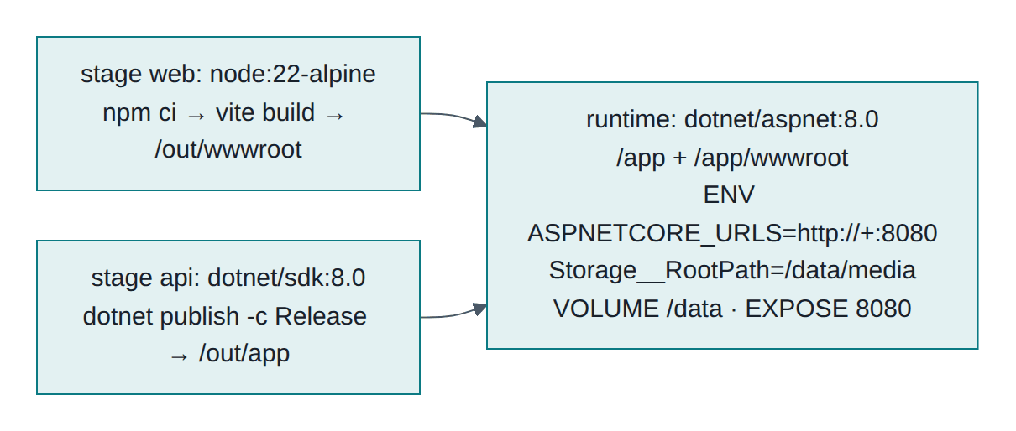
Figure 15-2 The multi-stage image: UI build, publish, slim runtime

export DB_PASSWORD=$(openssl rand -hex 16)
export SEED_ADMIN_EMAIL=you@example.com SEED_ADMIN_PASSWORD='ChangeMe123' SEED_ORG_NAME='Acme'
docker compose up -d --build
docker compose logs -f api # wait for "Now listening on: http://[::]:8080"
curl http://localhost:8080/health # Healthy
docker-compose.yml runs db (postgres:16 with a health check and the pgdata volume) and api (the built image, port 8080, media volume at /data). The API waits for a healthy database and retries the schema step ten times.
These Docker files were written against the same configuration verified locally but could not be executed in the build environment, which has no Docker. Run docker compose up --build once in staging before relying on them.

15.5 Reverse proxy and HTTPS
Screens and admins should use HTTPS; it also gives browser players offline cold-start. The proxy needs: TLS, WebSocket upgrade for /hubs/*, client_max_body_size 1024m for uploads, generous read timeouts, and forwarded headers.

server {
listen 443 ssl http2;
server_name signage.example.com;
client_max_body_size 1024m;
proxy_request_buffering off;
location / {
proxy_pass http://127.0.0.1:8080;
proxy_http_version 1.1;
proxy_set_header Host $host;
proxy_set_header X-Forwarded-For $proxy_add_x_forwarded_for;
proxy_set_header X-Forwarded-Proto $scheme;
proxy_set_header Upgrade $http_upgrade;
proxy_set_header Connection $connection_upgrade;
proxy_read_timeout 120s;
}
}
Required when the proxy is not on loopback. ASP.NET Core ignores X-Forwarded-* from unknown proxies, so every request would appear to come from the proxy: per-IP rate limits become one shared bucket and audit logs record the wrong address. Configure ForwardedHeadersOptions.KnownNetworks with your proxy subnet.

15.6 Database schema
The schema is created at startup with EnsureCreated(), which cannot evolve an existing database. Before the first production release:

dotnet add src/SignageCms.Api package Microsoft.EntityFrameworkCore.Design --version 8.0.11
dotnet ef migrations add InitialCreate --project src/SignageCms.Infrastructure --startup-project src/SignageCms.Api -o Persistence/Migrations
# then replace EnsureCreatedAsync with MigrateAsync in DbSeeder
For a database already created by EnsureCreated, insert the baseline row into __EFMigrationsHistory once so the first migration is treated as applied.

15.7 Operating
- Back up both the database and the media directory; one without the other is useless.
- Retention: no jobs run automatically. Schedule deletes for expired refresh tokens, old pairing requests, read notifications and playback logs beyond 90 days.
- Monitor: /health, fail: lines in the log, offline device counts, disk on both volumes.
- Upgrades: back up, apply migrations, deploy, restart. Screens reconnect by themselves and keep playing meanwhile. Only an Android shell change needs a new APK.

15.8 Production checklist
- Random Jwt__SigningKey from a secret store
- ASPNETCORE_ENVIRONMENT=Production, Swagger off
- Seed variables removed after the first owner exists
- HTTPS with WebSockets, upload limit and KnownNetworks configured
- Database not reachable from the internet; strong password
- Media volume persistent and backed up; restore tested
- EF migrations adopted
- Security findings S1–S3 fixed (rate-limit device claiming, forwarded headers, HTTPS)
- Monitoring and retention jobs scheduled

16. Testing

16.1 What exists
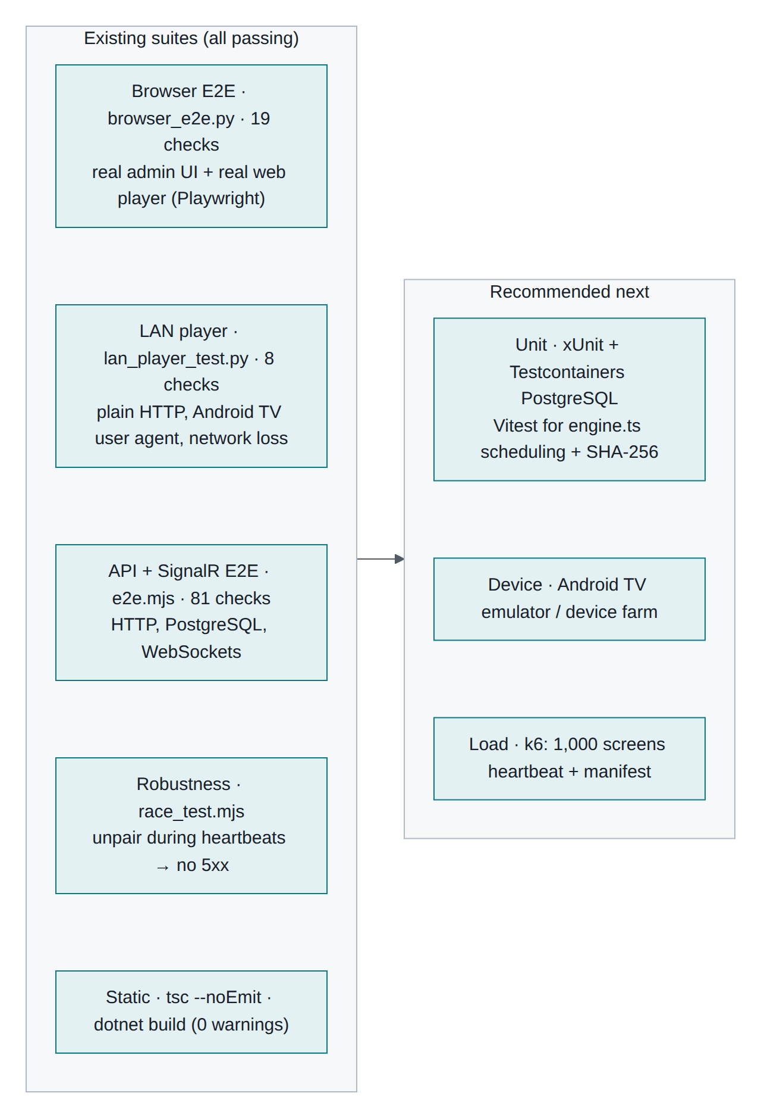
Figure 16-1 Existing suites and the recommended next layers
The riskiest behaviour in this system is integration behaviour: tenant isolation through EF filters, the two credential schemes, real-time presence, manifest caching and offline playback. The suites therefore drive a real API, a real PostgreSQL, real WebSockets and a real browser.
Suite | Checks | Covers
tests/e2e.mjs | 81 | Auth and token rotation, organization structure, media, playlists and layouts, pairing, sync and manifest, real-time, multi-tenant isolation, RBAC, plan limits, offline detection, audit and notifications
tests/browser_e2e.py | 19 | The real admin UI and a real player: upload, playlist, pairing, cached playback, identify, live status, offline reboot, layout editor, unpair
tests/lan_player_test.py | 8 | A player on plain HTTP at a LAN IP with an Android TV user agent, including network loss
tests/race_test.mjs | — | Unpairing a device while heartbeats are in flight produces no 5xx

16.2 Running them

pip install playwright && python3 -m playwright install chromium

# with the API running (scripts/dev-api.sh)
node e2e.mjs # → 81 passed, 0 failed
python3 browser_e2e.py # → 19 passed, 0 failed (screenshots in tests/shots/)
python3 lan_player_test.py # → 8 passed, 0 failed (API must listen on 0.0.0.0)
node race_test.mjs # → no HTTP 5xx during unpair-while-heartbeating races
grep -c 'fail:' /tmp/api.log # → 0

cd frontend && npm run typecheck # TypeScript
cd backend && dotnet build # 0 warnings
The suites create uniquely named data, so they can run repeatedly against the same database.

16.3 The tenancy tests specifically
The isolation section registers a second organization and asserts that it:
- gets 404 for the first tenant's device, media item and playlist;
- sees empty device and media lists;
- cannot create a playlist that references the other tenant's media (400);
- receives its own six layout templates, not the other tenant's.
If you change anything in AppDbContext, ICurrentUser or a service's reference validation, run this suite first.

16.4 Hardware acceptance (manual)
Automation cannot cover real screens. Before a rollout, on one Android TV and one tablet:
- APK installs and appears in the TV launcher
- Pairing code readable from 3 m; pairing completes in under 10 seconds
- 1080p H.264 video loops smoothly; images transition
- Multi-zone layout renders proportionally
- Unplug the network: content continues; admin shows Offline within ~90 s
- Power-cycle with the network down: the app restarts and plays cached content
- Reconnect: Online returns and offline proof-of-play appears
- A schedule starting two minutes from now switches at the right local time
- Identify, Sync now, Restart player work; Back ×3 opens the hidden menu
- Unpair returns the screen to a new code
- 24-hour soak with no black screens

16.5 Recommended additions
Layer | Tooling | First targets
Backend unit | xUnit + Testcontainers PostgreSQL | Tenant write guard, schedule validation, refresh-token reuse, manifest version stability, plan limits
Player unit | Vitest | Overnight and DST schedule windows, priority selection, the JavaScript SHA-256
Contract | OpenAPI snapshot in CI | Fail the build if a player-facing field disappears
Load | k6 | 1,000 screens heartbeating and syncing, one content-change fan-out

17. End-to-end flow with multi-tenant considerations

17.1 The whole path on one page
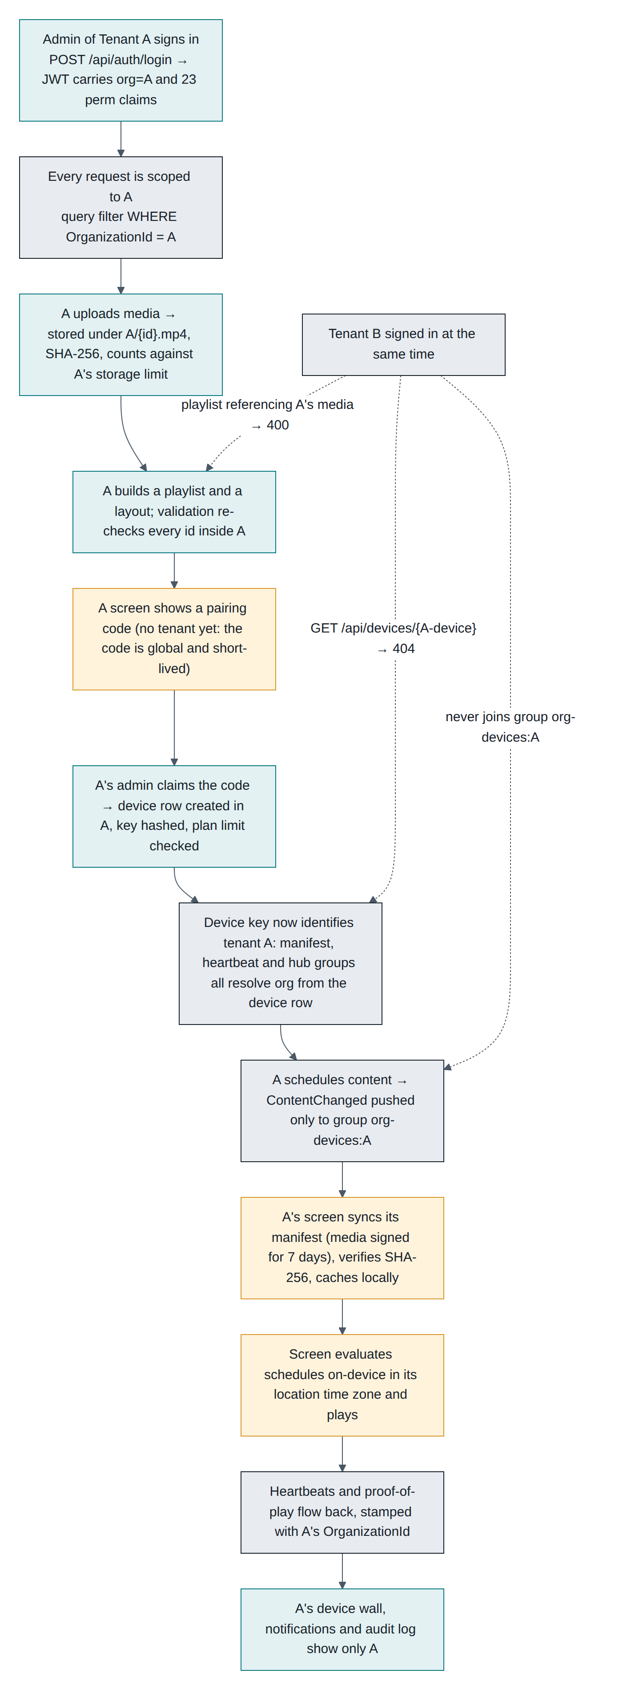
Figure 17-1 Admin login to playback, with the tenant boundary marked at every step
Dotted lines show what a second tenant, signed in at the same moment, experiences: 404 on the first tenant's device, 400 when referencing its media, and no membership of its real-time group.

17.2 Where the tenant is decided, step by step
Step | What identifies the tenant | If it were missing
Admin signs in | org claim written into the JWT from the user's row | No claim → filters match nothing → empty lists
Any admin request | ICurrentUser.OrganizationId → EF query filter | Unfiltered reads across tenants
Creating anything | SaveChanges stamps OrganizationId | Orphan rows; the guard throws instead
Uploading | Storage key {OrganizationId}/{mediaId} | Filename collisions across tenants
Pairing | The admin's organization is written onto the new device row | A screen with no owner
Screen requests | Device key → device row → its organization | A screen could read another tenant's manifest
Real-time | Group names derived from the credential (org:{id}, org-devices:{id}) | Cross-tenant broadcast
Serving a file | HMAC signature over the media id and expiry | Any file readable by id

17.3 The same flow as a sequence, phase by phase
The eight diagrams below are one continuous sequence of numbered interactions, from sign-in to an outage and recovery. Everything shown happens inside one organization.
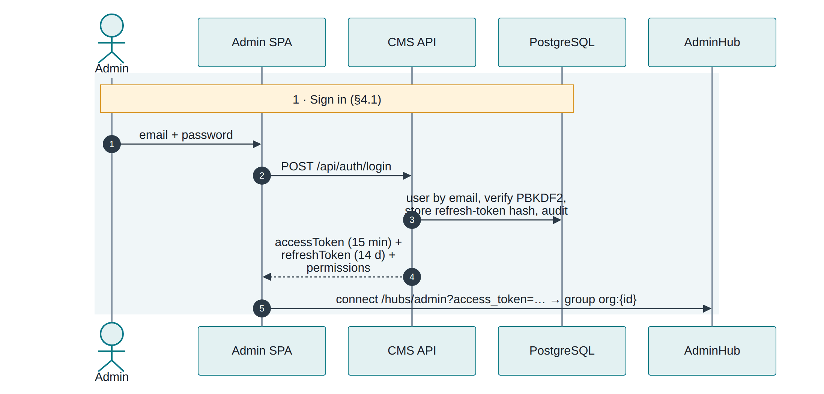
Figure 17-2 Phase 1: admin sign-in and the org claim

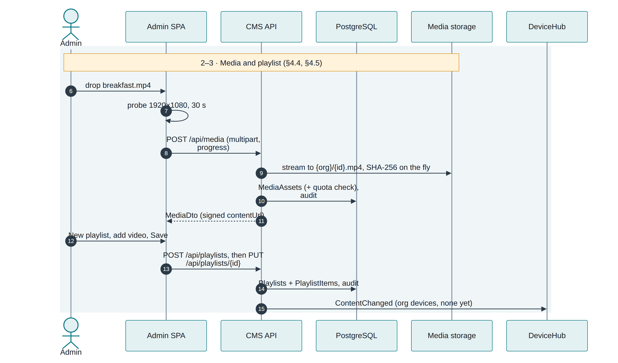
Figure 17-3 Phase 2–3: media upload and playlist creation

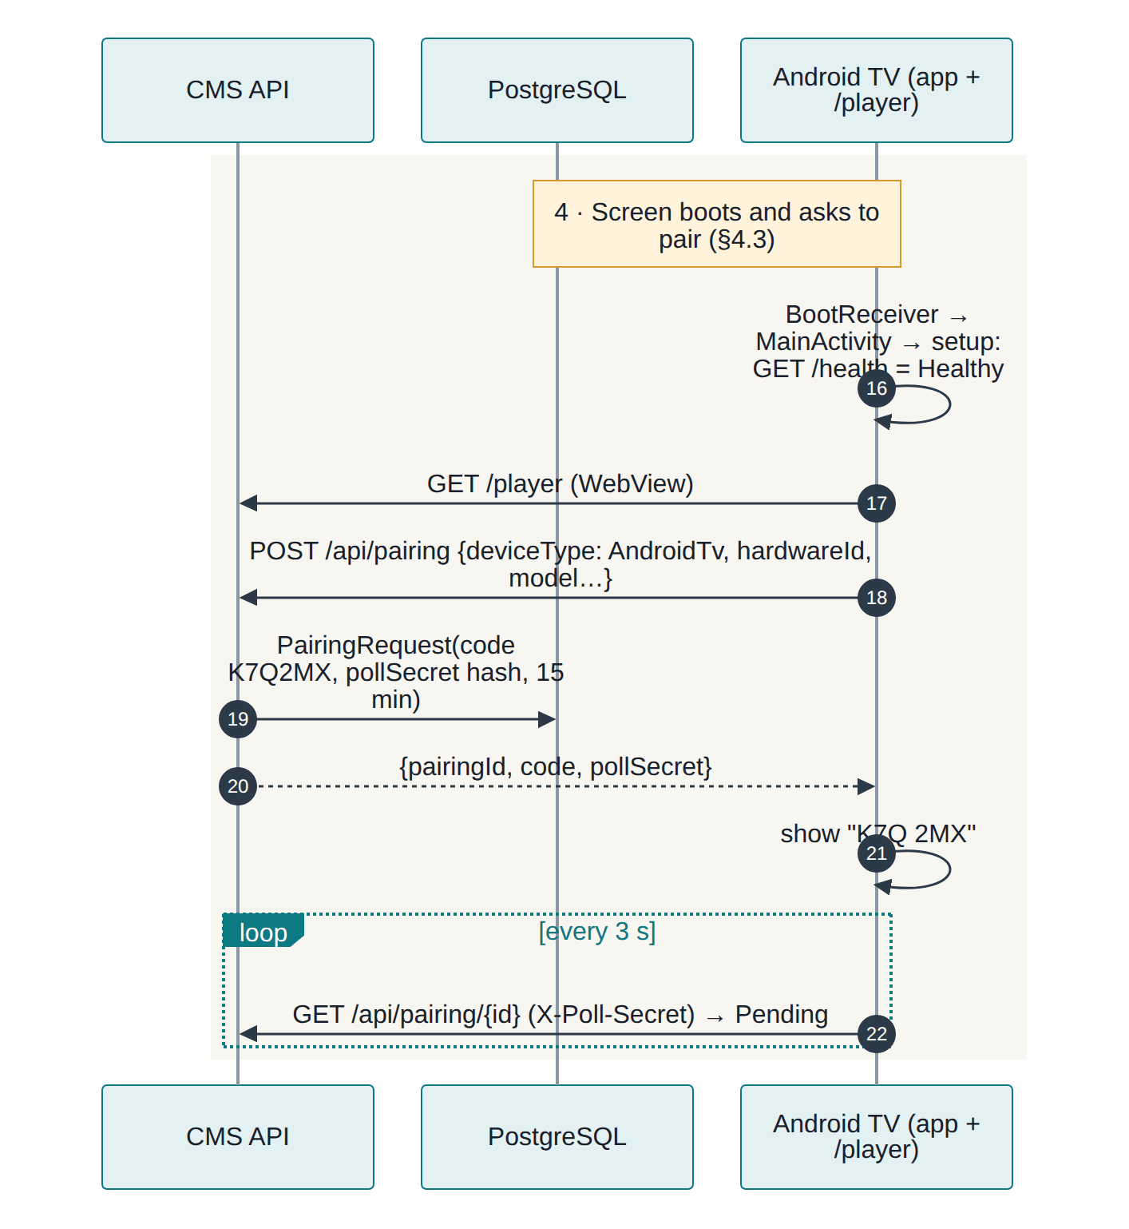
Figure 17-4 Phase 4: the screen boots and asks to pair

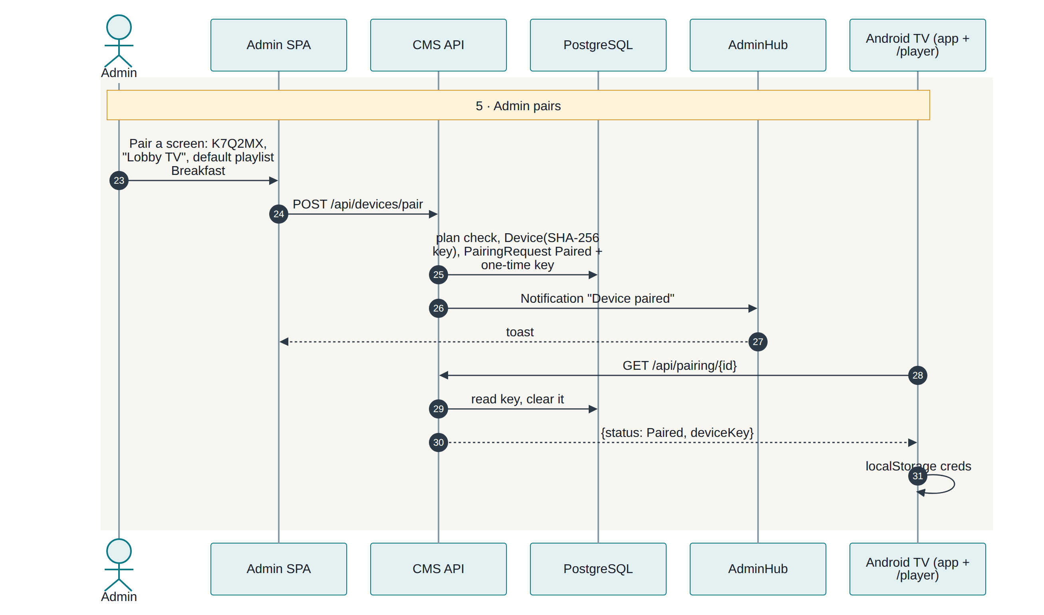
Figure 17-5 Phase 5: the admin claims the code and the tenant is bound to the device

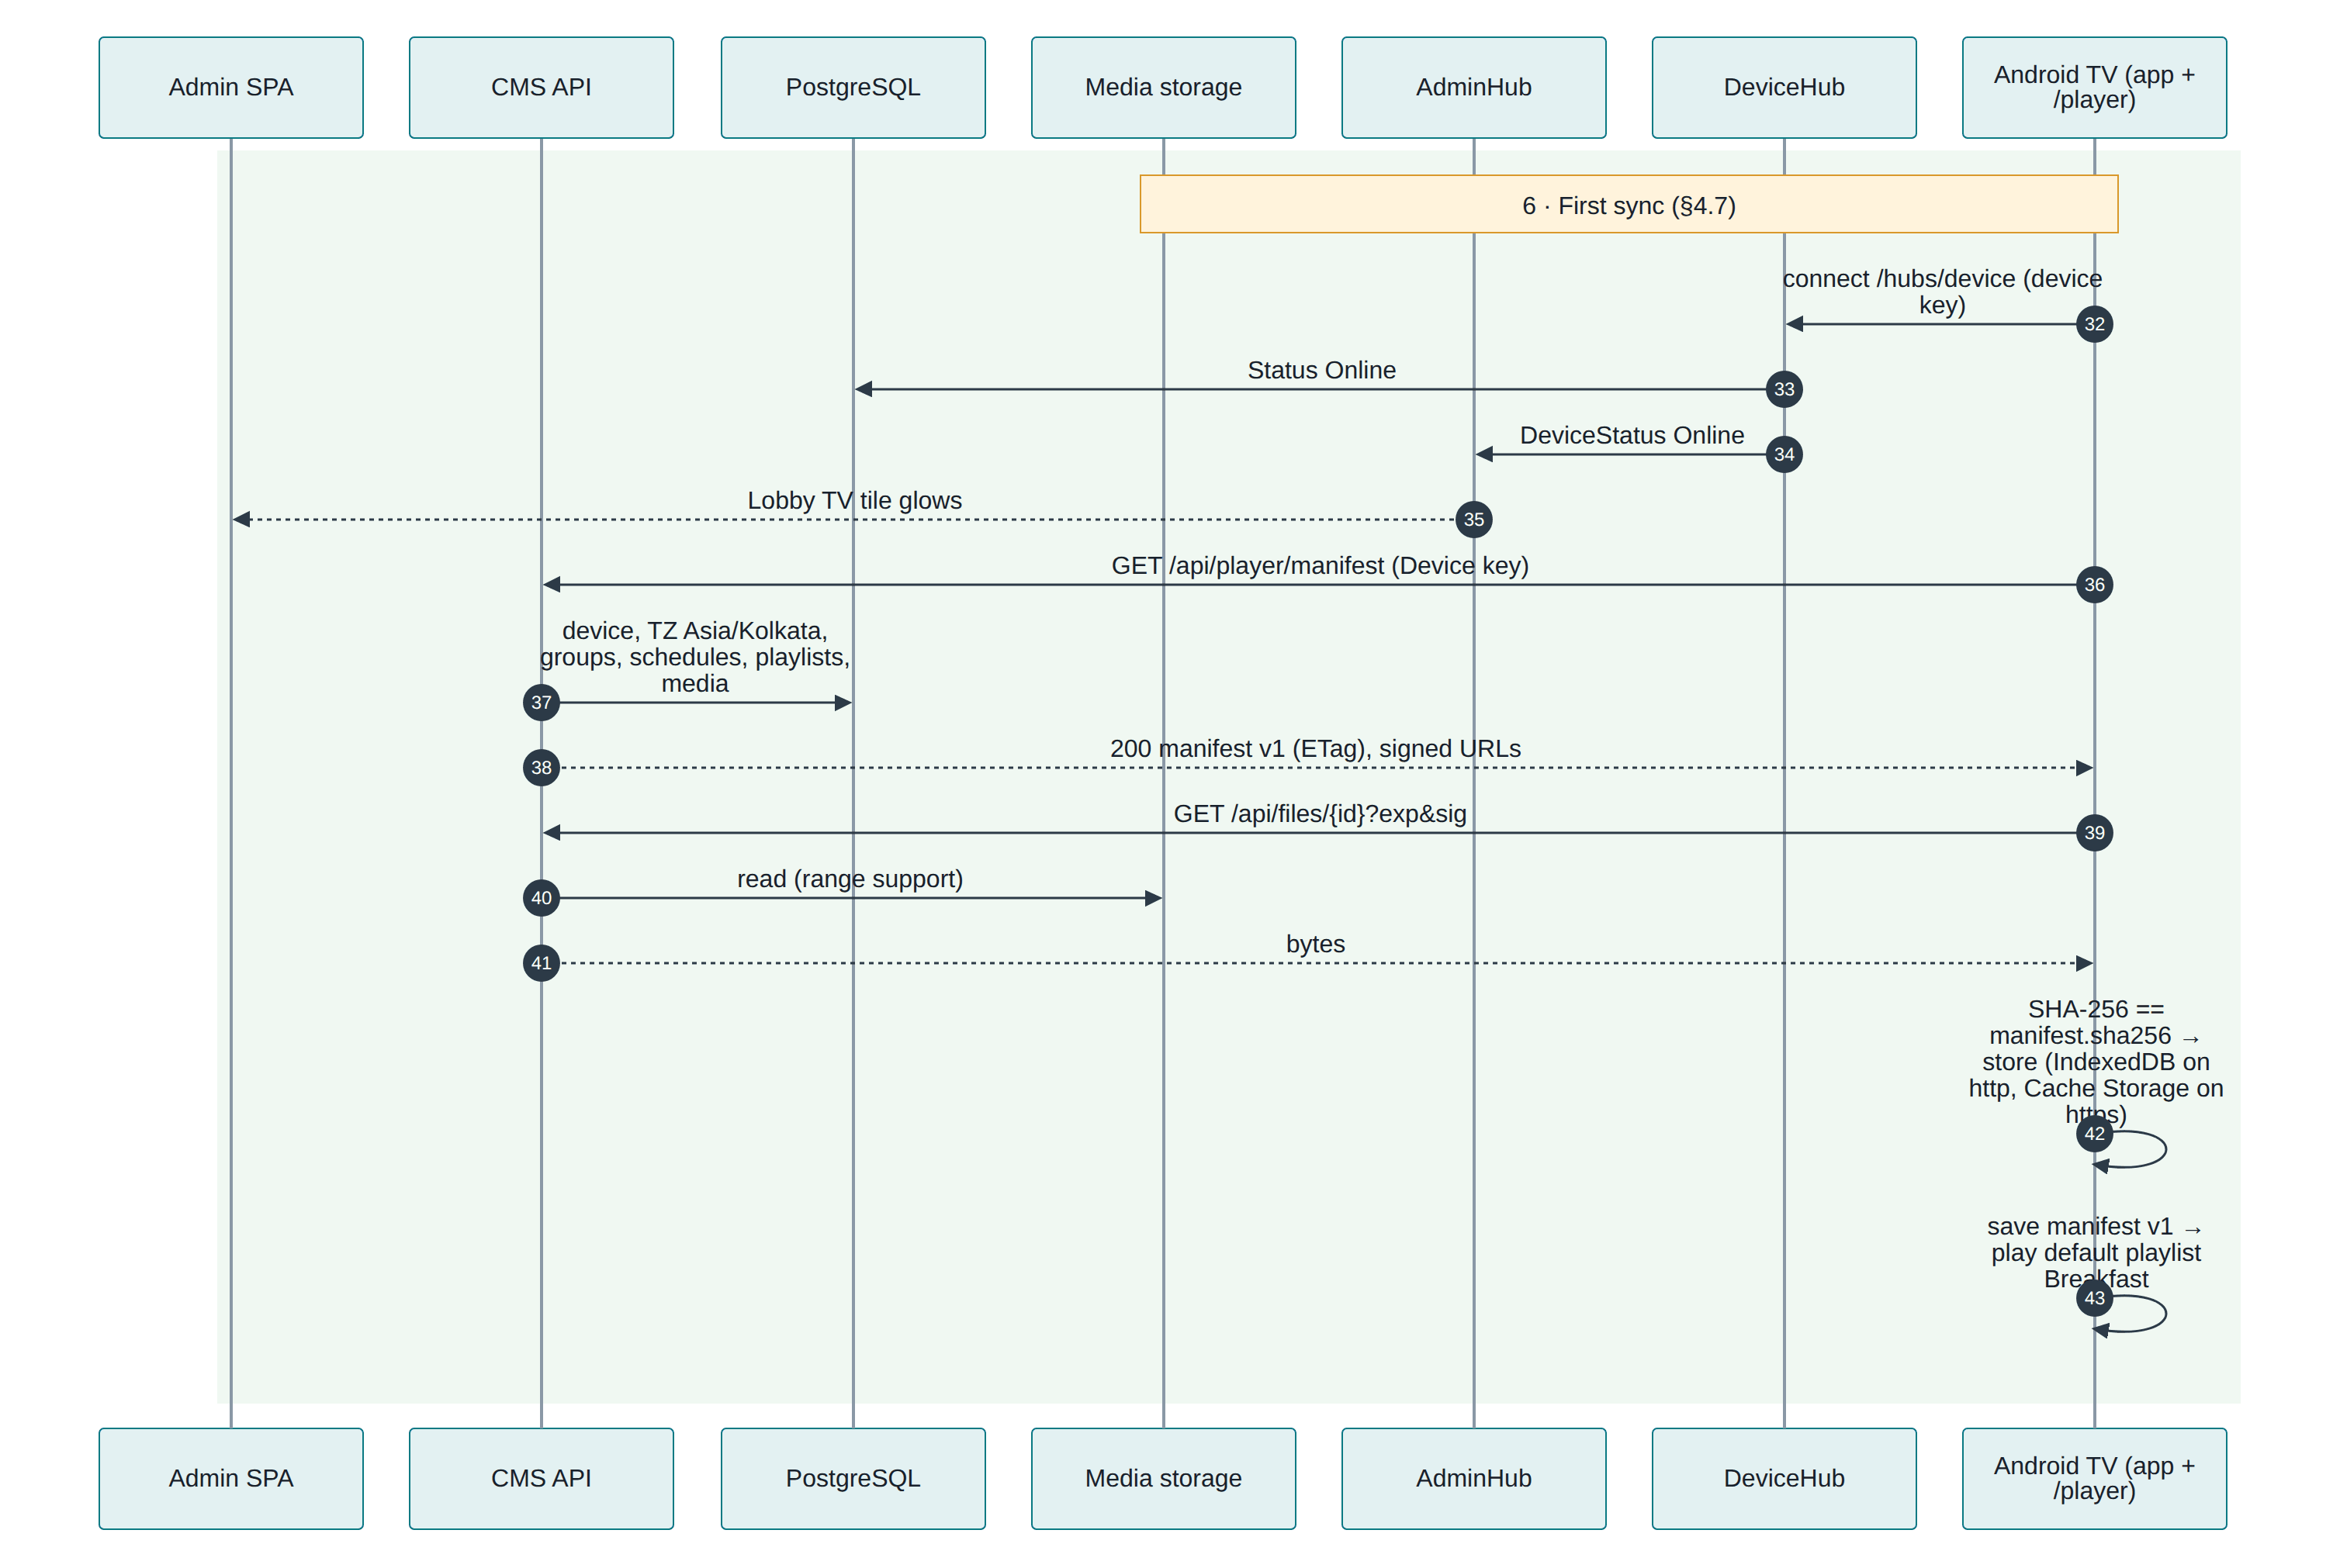
Figure 17-6 Phase 6: first sync, verified download and local cache

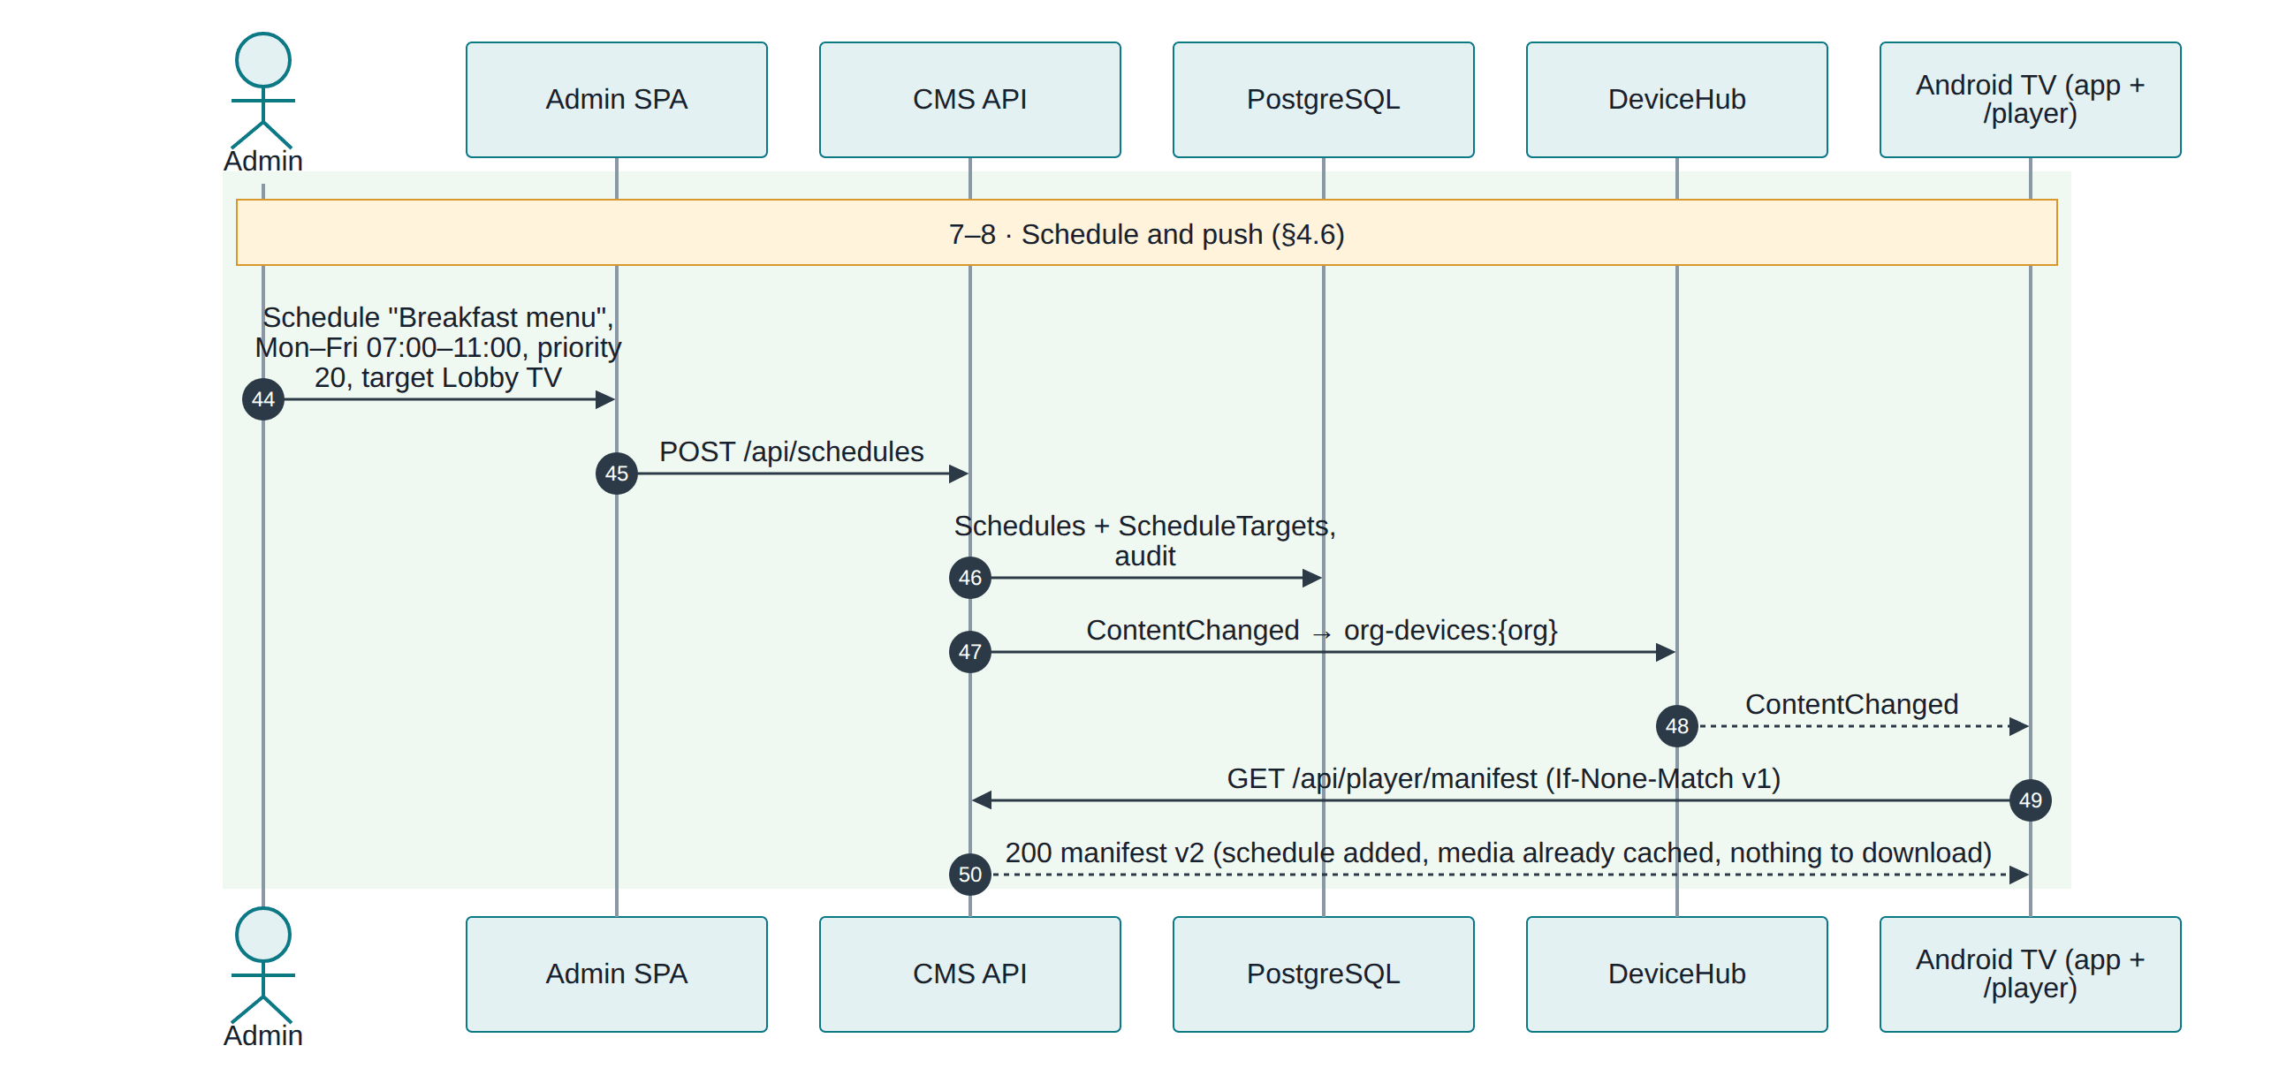
Figure 17-7 Phase 7–8: scheduling and the content push

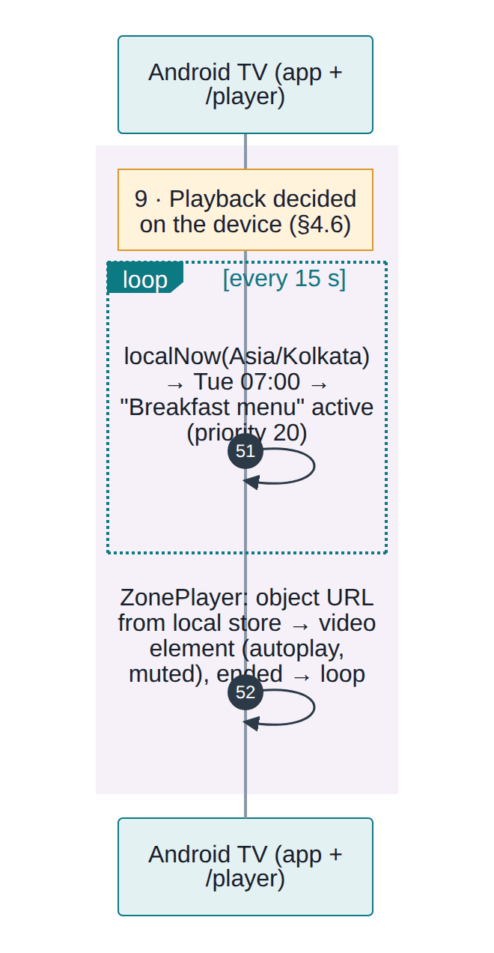
Figure 17-8 Phase 9: the screen decides what to play, on its own

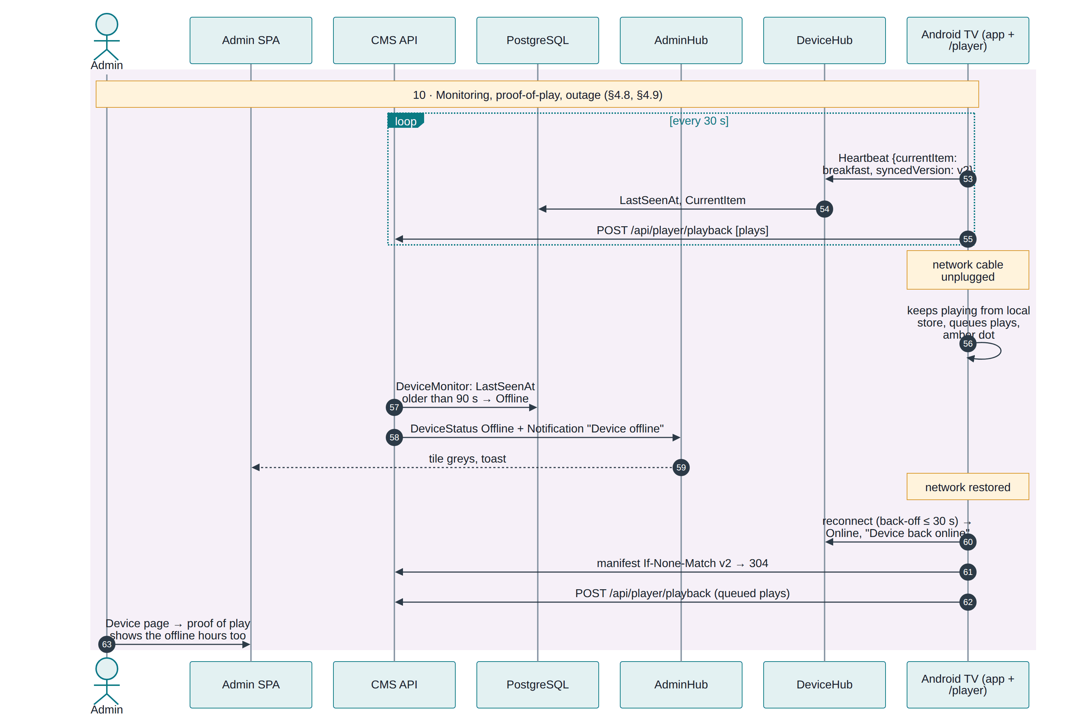
Figure 17-9 Phase 10: monitoring, proof-of-play, outage and recovery

17.4 Timing
Step | Typical time | Governed by
Code appears on a new screen | < 2 s | POST /api/pairing
Screen reacts after the admin pairs | ≤ 3 s | Pairing poll interval
First content visible | download time + ~1 s | Network and file sizes
An edit reaches screens | < 1 s push, then a conditional fetch | SignalR ContentChanged
Schedule boundary to switch | ≤ 15 s | On-device evaluation interval
Offline shown after a power cut | 90–120 s | 90 s threshold + 30 s sweep
Online again after recovery | ≤ 30 s | Reconnect back-off

17.5 The five things to remember
- A tenant is one Organizations row, created in a single transaction with its subscription, roles, templates and Owner.
- Isolation is below the business logic — query filters, a write guard, 404 masking — so new code is isolated by default.
- A device key is a tenant credential. It names the device, and through it the organization; unpairing revokes it instantly.
- Screens decide what to play, using a verified local copy of their tenant's content, which is why they survive outages.
- Real-time is scoped by credential, never by request body, so no message can cross the boundary.

List of figures
Figure 1-1 The end-to-end journey, from deploying the platform to content on screen
Figure 2-1 What is shared by all tenants and what belongs to one tenant
Figure 2-2 Tenant identity creation: one request, one transaction
Figure 2-3 Six layers of tenant isolation on every request
Figure 2-4 Every tenant-owned table carries OrganizationId (key columns shown)
Figure 3-1 Roles, permission groups and how they are enforced
Figure 4-1 Plan limit checks, and what a tenant sees when one is reached
Figure 5-1 Registration: validation, provisioning and first tokens
Figure 5-2 Locations: creation, time-zone changes and deletion
Figure 6-1 Device pairing: the screen side and the admin side
Figure 6-2 Pairing sequence, from code request to device key
Figure 7-1 Media upload: validation, quota, streaming write and checksum
Figure 7-2 Upload sequence, browser to disk
Figure 8-1 Playlist creation and saving
Figure 8-2 Playlist save sequence, including the push to screens
Figure 9-1 Layout builder: from template to a saved, scheduled layout
Figure 10-1 Creating a schedule
Figure 10-2 Schedule evaluation on the screen, every 15 seconds
Figure 11-1 Synchronization: triggers, conditional fetch, verified download, atomic swap
Figure 11-2 Sync sequence: manifest, files, checksum, local store
Figure 12-1 Offline playback: booting, playing and catching up
Figure 13-1 Device status: what moves a screen between Online and Offline
Figure 13-2 Heartbeat handling, from the player's timer to the admin wall
Figure 13-3 Presence and offline detection
Figure 13-4 Notification sources, storage and delivery
Figure 14-1 Triage: start from who is affected and what they see
Figure 15-1 Deployment: Docker Compose or a host install, then the checks that prove it works
Figure 15-2 The multi-stage image: UI build, publish, slim runtime
Figure 16-1 Existing suites and the recommended next layers
Figure 17-1 Admin login to playback, with the tenant boundary marked at every step
Figure 17-2 Phase 1: admin sign-in and the org claim
Figure 17-3 Phase 2–3: media upload and playlist creation
Figure 17-4 Phase 4: the screen boots and asks to pair
Figure 17-5 Phase 5: the admin claims the code and the tenant is bound to the device
Figure 17-6 Phase 6: first sync, verified download and local cache
Figure 17-7 Phase 7–8: scheduling and the content push
Figure 17-8 Phase 9: the screen decides what to play, on its own
Figure 17-9 Phase 10: monitoring, proof-of-play, outage and recovery

