SIGNAGE CMS
Setup, Build and Deployment Guide
Android Studio · JDK · SDK · Gradle · .NET 8 · PostgreSQL · migrations · Node · Vite · Docker · ADB · pairing · updates
Everything needed to build, deploy and maintain the whole stack: the .NET 8 API and PostgreSQL, the React and Vite frontend, and the Android TV and tablet player, from a clean machine to content playing on a paired screen.
Covers | Android Studio, JDK, SDK and Gradle setup; the backend (.NET 8, PostgreSQL, migrations, seed data); the frontend (Node, Vite, API URL); Docker and production deployment
Also inside | Building and signing the APK, installing on physical TVs and tablets, ADB, device pairing, how updates reach devices, and a troubleshooting chapter covering ten error families
Versions | .NET SDK 8.0 · Node 20/22 · PostgreSQL 14+ (16 recommended) · JDK 17 · Android SDK 23 (repo build) or 35 (Android Studio) · AGP 8.7 / Gradle 8.9
Verified | Backend, frontend and the Gradle-free APK build were executed in this environment. Docker and the Android Studio project files are provided but were not executed
Version | 1.0
Date | September 2026
Prepared for developer hand-off. Diagrams are embedded as figures; cross-references and the table of contents are clickable.

Contents

1. Overview and prerequisites 4
1.1 What you are building 4
1.2 The complete workflow 5
1.3 Versions you need 5
1.4 Repository layout 6
1.5 Build order 6
2. Backend setup (.NET 8) 7
2.1 Install the SDK 7
2.2 PostgreSQL configuration 7
2.3 Environment variables 7
2.4 Database schema and migrations 8
2.5 Seed data 8
2.6 Running locally 9
2.7 Production build 9
2.8 Docker 9
3. Frontend setup (React + Vite) 10
3.1 Node and install 10
3.2 Configuring the backend API URL 10
3.3 Running and building 10
3.4 What the build produces 11
3.5 Serving the frontend separately (optional) 11
4. Android toolchain setup 12
4.1 Two ways to build the APK 12
4.2 JDK 13
4.3 Android Studio and the SDK 13
4.4 The Gradle-free toolchain (what this repository actually uses) 13
4.5 Gradle 14
5. Building and configuring the Android app 15
5.1 How the app finds your server 15
5.2 Building with the repository script 15
5.3 Building with Android Studio 15
5.4 Signing keys 15
5.5 Publishing the APK through your own CMS 16
5.6 Version numbers 16
6. Installing on physical devices and pairing 17
6.1 Android tablet 17
6.2 Android TV / Google TV 17
6.3 ADB: connecting to devices 17
6.4 Device registration and pairing 18
6.5 Verifying a screen is working 19
6.6 Bulk rollout 19
7. How devices receive updates, and updating in production 20
7.1 Three kinds of update 20
7.2 Content updates in detail 21
7.3 Updating the server in production 21
7.4 Updating the Android app in production 21
7.5 Rollback 22
7.6 Keeping a fleet healthy 22
8. From the CMS to content on a screen 23
8.1 The flow 23
8.2 What the device actually downloads 24
8.3 Why playback survives outages 24
8.4 Timings to expect 24
8.5 End-to-end smoke test after a deployment 24
9. Common errors and their solutions 26
9.1 Android Studio and Gradle build failures 26
9.2 Gradle-free build (android/build.sh) failures 26
9.3 APK installation failures 27
9.4 ADB connection issues 27
9.5 API connection and CORS issues 27
9.6 Database connection and migration errors 28
9.7 SignalR (real-time) connection issues 28
9.8 Device pairing failures 29
9.9 Media synchronisation problems 29
9.10 Offline playback issues 29
9.11 Collecting evidence for a bug report 30
List of figures 31

If the contents list is empty or out of date, right-click it in Word and choose Update Field → Update entire table.

1. Overview and prerequisites

1.1 What you are building
Three deliverables come out of this repository:
Deliverable | Technology | Output
Backend API | .NET 8, ASP.NET Core, EF Core, PostgreSQL, SignalR | SignageCms.Api.dll, or a Docker image
Frontend (admin console + web player) | React 18, Vite 5, TypeScript 5.6, Tailwind 3 | Static files, normally built straight into the API's wwwroot
Android player | Java 8 sources, Android SDK, no third-party libraries | signage-player.apk, signed, one APK for TVs and tablets

In the normal deployment the frontend is served by the backend, so one process serves the API, the admin console, the web player and the APK download.

1.2 The complete workflow
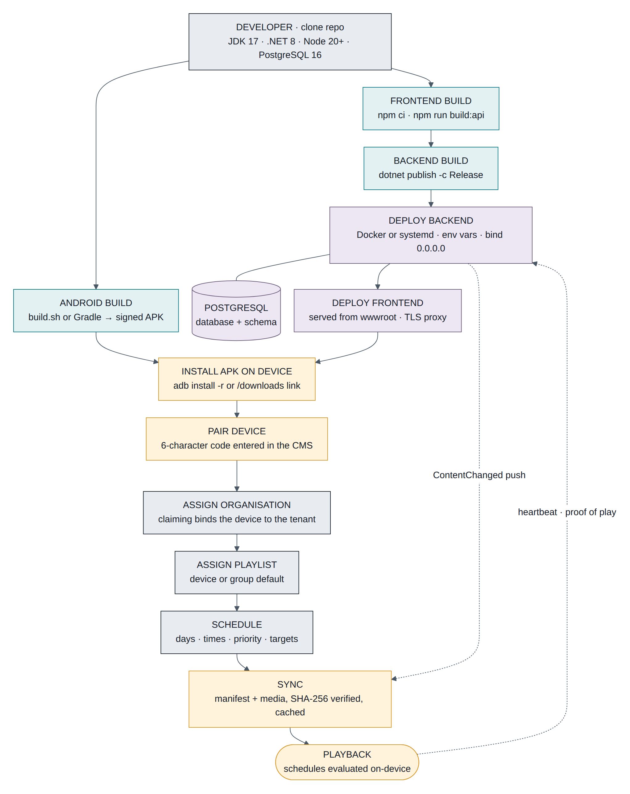
Figure 0-1 The full path: developer, builds, database, deployment, device install, pairing, content, playback

1.3 Versions you need
Tool | Version | Check | Notes
.NET SDK | 8.0.x (built with 8.0.131) | dotnet --version | .NET 9 can build it, but keep the target at net8.0
Node.js | 20 LTS or 22 (built with 22.22) | node -v | Node 18 is below Vite 5's supported range
npm | 10+ | npm -v | Ships with Node
PostgreSQL | 14+, 16 recommended | psql --version | 16 used in development and in Docker
JDK | 17 (LTS) | java -version | Required by Android Gradle Plugin 8.x; also fine for the Gradle-free build
Android SDK | Platform 23 for the repository build; Platform 35 + Build-Tools 35 for Android Studio | sdkmanager --list_installed
Android Studio | Ladybug 2024.2 or newer | Help → About | Only needed if you use the Gradle project
Gradle | 8.9+ (wrapper) | ./gradlew -v | Supplied by the wrapper, do not install separately
Docker (optional) | 24+ with Compose v2 | docker --version | For container deployment
Git | any recent | git --version

1.4 Repository layout
signage-cms/
├── backend/ .NET 8 solution (Domain, Application, Infrastructure, Api) + Dockerfile
├── frontend/ React admin console and web player (Vite)
├── android/ Player app: build.sh (no Gradle) + gradle-project/ (Android Studio)
├── tests/ End-to-end suites
├── scripts/ dev-api.sh
└── docker-compose.yml

1.5 Build order
- Database first: the API needs it at startup.
- Frontend next, because npm run build:api writes into the backend's wwwroot.
- Backend publish, which picks up that wwwroot.
- Android APK any time; copy it into frontend/public/downloads/ so the CMS can serve it.

2. Backend setup (.NET 8)

2.1 Install the SDK
Download .NET SDK 8.0 from Microsoft, or on Ubuntu:

dotnet --version # 8.0.x
dotnet --list-sdks
The solution pins net8.0 in backend/Directory.Build.props, with nullable reference types and implicit usings enabled and warnings not treated as errors.

2.2 PostgreSQL configuration

sudo -u postgres psql -c "CREATE USER signage WITH PASSWORD 'signage_dev_pw';"
sudo -u postgres psql -c "CREATE DATABASE signage OWNER signage;"
psql -h localhost -U signage -d signage -c '\conninfo'
The connection string format is Npgsql's:
Host=localhost;Port=5432;Database=signage;Username=signage;Password=signage_dev_pw
For managed databases add SSL Mode=Require;Trust Server Certificate=false. The application user only needs ownership of this one database; it creates its own tables.
Server settings that matter: allow connections from the API host (listen_addresses, pg_hba.conf), and size max_connections for your instances. EF Core is configured with EnableRetryOnFailure(3), so brief blips recover on their own.

2.3 Environment variables
Configuration order: appsettings.json → appsettings.{Environment}.json → environment variables → command line. Nested keys use a double underscore.
Variable | Required | Example | Purpose
ConnectionStrings__Default | yes in production | Host=db;Database=signage;Username=signage;Password=… | PostgreSQL
Jwt__SigningKey | yes | openssl rand -hex 32 | Signs access tokens and media URLs. The API refuses to start if it is shorter than 32 bytes
Jwt__Issuer, Jwt__Audience | no | signage-cms | Token issuer/audience
Jwt__AccessTokenMinutes | no | 15 | Access-token lifetime
Storage__RootPath | no | /data/media | Where uploads are written. Must be persistent
Cors__AllowedOrigins__0 | only if split hosting | https://admin.example.com | Extra browser origins
Swagger__Enabled | no | false | API explorer
Seed__AdminEmail, Seed__AdminPassword, Seed__OrganizationName, Seed__TimeZone | no |  | Creates the first organisation at startup
ASPNETCORE_URLS | no | http://0.0.0.0:5080 | Bind address. Must not be localhost if screens are remote
ASPNETCORE_ENVIRONMENT | no | Production | Development exposes exception detail and the demo seed

Example environment file:

ASPNETCORE_ENVIRONMENT=Production
ASPNETCORE_URLS=http://0.0.0.0:8080
ConnectionStrings__Default=Host=db;Port=5432;Database=signage;Username=signage;Password=CHANGE_ME
Jwt__SigningKey=2b7e151628aed2a6abf7158809cf4f3c762e7160f38b4da56a784d9045190cfe
Storage__RootPath=/var/lib/signage/media
Swagger__Enabled=false

2.4 Database schema and migrations
How it works today: at startup DbSeeder calls Database.EnsureCreatedAsync(), which creates the schema if the database is empty. It cannot change an existing schema, so a code change that alters the model will not reach a database that already exists.
Adopt EF Core migrations before your first production release:

cd backend
dotnet add src/SignageCms.Api package Microsoft.EntityFrameworkCore.Design --version 8.0.11

dotnet ef migrations add InitialCreate \
--project src/SignageCms.Infrastructure --startup-project src/SignageCms.Api \
--output-dir Persistence/Migrations
Then change one line in src/SignageCms.Infrastructure/Persistence/DbSeeder.cs:

await _db.Database.MigrateAsync(ct);
If a database already exists from EnsureCreated, mark the baseline as applied once, before deploying the migration-enabled build:

"MigrationId" varchar(150) PRIMARY KEY, "ProductVersion" varchar(32) NOT NULL);
INSERT INTO "__EFMigrationsHistory" VALUES ('20260101000000_InitialCreate', '8.0.11');
Everyday commands:

dotnet ef migrations script --idempotent -o migrate.sql --project src/SignageCms.Infrastructure --startup-project src/SignageCms.Api
dotnet ef database update --project src/SignageCms.Infrastructure --startup-project src/SignageCms.Api
On multi-instance deployments run migrations once from a deploy job, not from every starting instance.

2.5 Seed data
Two seeding behaviours, both in DbSeeder:
- Permission catalogue — the 23 permission codes are written and refreshed at every startup. Always happens.
- First organisation — if Seed__AdminEmail and Seed__AdminPassword are set and that email does not exist, it provisions an organisation (name from Seed__OrganizationName, time zone from Seed__TimeZone), the Free subscription, the four system roles, six layout templates, the owner user and one location.
In Development, appsettings.Development.json seeds a demo organisation: admin@demo.local / Admin@12345, "Demo Signage Co", Asia/Kolkata. Never ship those values to production, and remove the seed variables once the first owner exists.

2.6 Running locally

dotnet run # http://0.0.0.0:5080, Swagger at /swagger
dotnet watch run # with hot reload
Helper: scripts/dev-api.sh starts PostgreSQL if needed, rebuilds, restarts the API in the background (PID /tmp/api.pid, log /tmp/api.log) and waits for /health.
Verify:

curl -s -X POST localhost:5080/api/auth/login -H 'Content-Type: application/json' \
-d '{"email":"admin@demo.local","password":"Admin@12345"}' | head -c 120

2.7 Production build

cd ../backend
dotnet publish src/SignageCms.Api -c Release -o /opt/signage-cms
Useful variants:

dotnet publish src/SignageCms.Api -c Release -r linux-x64 --self-contained true -o out/linux
# trimmed framework-dependent build for Windows
dotnet publish src/SignageCms.Api -c Release -r win-x64 --self-contained false -o out/win
systemd unit:

Description=Signage CMS
After=network-online.target postgresql.service
[Service]
User=signage
WorkingDirectory=/opt/signage-cms
ExecStart=/usr/bin/dotnet /opt/signage-cms/SignageCms.Api.dll
EnvironmentFile=/etc/signage-cms.env
Restart=always
RestartSec=5
[Install]
WantedBy=multi-user.target

2.8 Docker

export DB_PASSWORD=$(openssl rand -hex 16)
docker compose up -d --build
docker compose logs -f api
curl http://localhost:8080/health
backend/Dockerfile is multi-stage: node:22-alpine builds the frontend, dotnet/sdk:8.0 publishes the API, and dotnet/aspnet:8.0 runs it with ASPNETCORE_URLS=http://+:8080 and Storage__RootPath=/data/media, exposing a /data volume.
The Docker files were written against the verified local configuration but were not executed in the environment that produced this repository. Run docker compose up --build once in staging before relying on them.

3. Frontend setup (React + Vite)

3.1 Node and install

cd frontend
npm ci # reproducible install from package-lock.json (use npm install only to change deps)
Stack: React 18.3, Vite 5, TypeScript 5.6, Tailwind 3, shadcn/ui (Radix), TanStack Query 5, React Router 6, @microsoft/signalr 8, and @fontsource-variable/figtree so the font is bundled rather than fetched from a CDN.

3.2 Configuring the backend API URL
There are two different situations.
Same origin (the normal case). The API serves the built frontend, so the browser calls /api/... on the origin it was loaded from. Nothing to configure: API_BASE is an empty string.
Development with hot reload. npm run dev serves on port 5173 and proxies to the API, configured in vite.config.ts:

port: 5173,
proxy: {
"/api": { target: process.env.VITE_API_PROXY ?? "http://localhost:5080", changeOrigin: true },
"/hubs": { target: process.env.VITE_API_PROXY ?? "http://localhost:5080", changeOrigin: true, ws: true },
},
}
Point it elsewhere with an environment variable:

Frontend hosted separately (its own domain or CDN). Set the API origin at build time, and allow that origin on the backend:

VITE_API_URL=https://api.example.com

Cors__AllowedOrigins__0=https://admin.example.com
VITE_API_URL is read once in src/lib/api.ts and also used by the player engine. Vite only exposes variables prefixed VITE_, and they are baked in at build time, so changing the API URL means rebuilding.
Variable | Default | Effect
VITE_API_URL | "" (same origin) | API and hub base URL compiled into the bundle
VITE_API_PROXY | http://localhost:5080 | Dev-server proxy target only
OUT_DIR | dist | Build output directory

3.3 Running and building

npm run typecheck # tsc -b --noEmit (run before every commit)
npm run lint
npm run build # → frontend/dist
npm run build:api # → backend/src/SignageCms.Api/wwwroot (single-process deployment)
build:api is simply tsc -b && OUT_DIR=../backend/src/SignageCms.Api/wwwroot vite build. Vite empties the output directory, which is why the Android APK lives in frontend/public/downloads/ — everything in public/ is copied into the build.

3.4 What the build produces
- index.html plus hashed assets in assets/.
- The web player as a separate lazy-loaded chunk, so screens never download the admin console.
- player-sw.js, the player's offline service worker (active on HTTPS or localhost).
- downloads/signage-player.apk if you copied the APK in.

3.5 Serving the frontend separately (optional)
Any static host works, with two requirements:
- SPA fallback: unknown paths must return index.html, otherwise deep links such as /devices/{id} break on refresh.
- CORS and WebSockets: the API must list the origin in Cors__AllowedOrigins, and /hubs/* must allow WebSocket upgrades through whatever sits in front.
The single-origin deployment avoids both problems, which is why it is the default.

4. Android toolchain setup

4.1 Two ways to build the APK
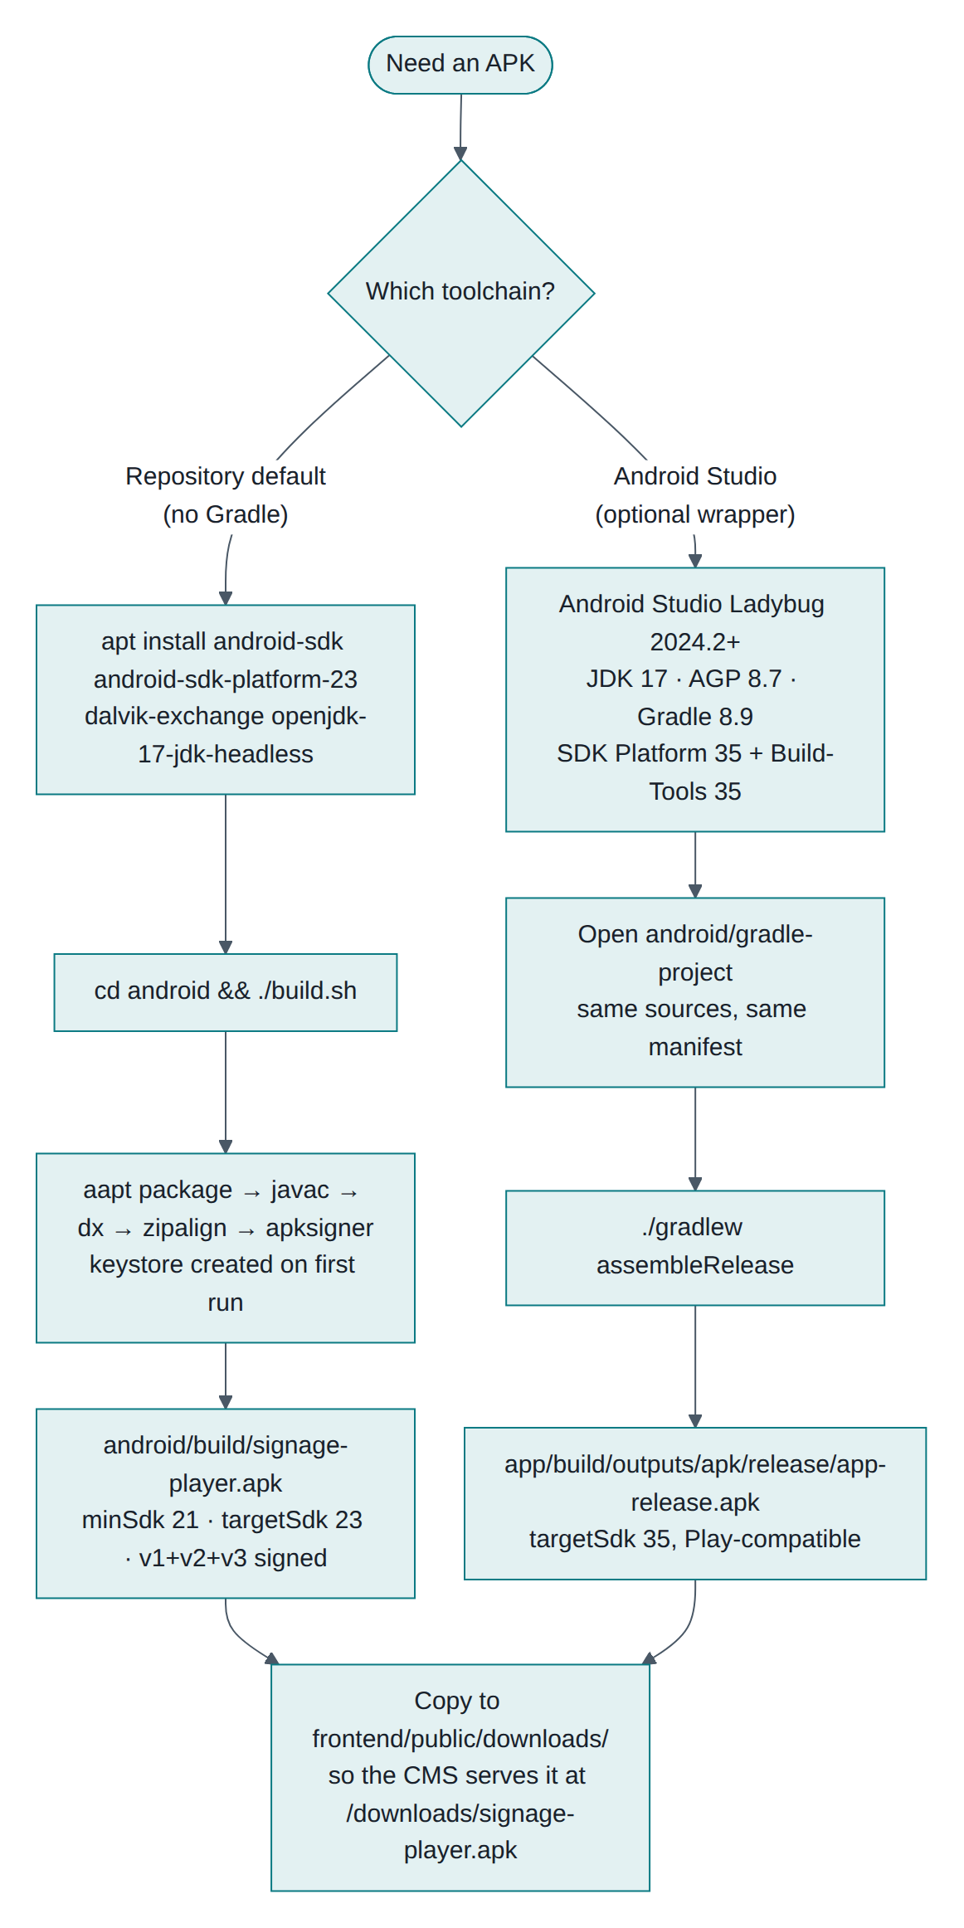
Figure 3-1 Two supported toolchains for the same sources
 | Repository default (android/build.sh) | Android Studio (android/gradle-project)
Needs Gradle | No | Yes (wrapper)
Needs Android Studio | No | Yes
Tools | aapt, javac, dx, zipalign, apksigner | Android Gradle Plugin
targetSdk | 23 (from the manifest) | 35 (set in Gradle)
Good for | CI, servers, reproducible sideload builds | Editing, debugging, Google Play
Verified in this repository | Yes, produced the shipped APK | No, files provided but never executed here

Both compile the same sources: android/AndroidManifest.xml, android/src, android/res.

4.2 JDK
Install JDK 17 (LTS). It is required by Android Gradle Plugin 8.x and works for the Gradle-free build too.

brew install openjdk@17 # macOS
java -version # openjdk version "17.x"
Environment variables (add to ~/.bashrc, ~/.zshrc, or Windows System Properties → Environment Variables):

export PATH="$JAVA_HOME/bin:$PATH"
In Android Studio, set Settings → Build, Execution, Deployment → Build Tools → Gradle → Gradle JDK to 17.

4.3 Android Studio and the SDK
- Install Android Studio Ladybug (2024.2) or newer.
- Settings → Languages & Frameworks → Android SDK → SDK Platforms: tick Android 15 (API 35) — the compile target — and optionally Android 6.0 (API 23).
- SDK Tools tab: tick Android SDK Build-Tools 35, Android SDK Platform-Tools (this is where adb comes from), and Android SDK Command-line Tools.
- For an emulator, add an Android TV (1080p) system image.
Environment variables:

# Windows: %LOCALAPPDATA%\Android\Sdk
export PATH="$ANDROID_HOME/platform-tools:$ANDROID_HOME/cmdline-tools/latest/bin:$PATH"
adb version
ANDROID_SDK_ROOT is the older name for the same thing; setting both does no harm.

4.4 The Gradle-free toolchain (what this repository actually uses)

export ANDROID_SDK=/usr/lib/android-sdk # only if yours is elsewhere
This gives aapt, zipalign, apksigner, the android-23 platform jar and the dx dexer, which is everything build.sh needs. No Google Maven access is required, which is why it works on locked-down build servers.

4.5 Gradle
Do not install Gradle by hand. The project uses the wrapper; generate it once inside the Gradle project if it is missing:

gradle wrapper --gradle-version 8.9 # only needed once, if gradlew is absent
./gradlew -v # Gradle 8.9, JVM 17, AGP 8.7.2
Version pairing matters: AGP 8.7 → Gradle 8.9+ → JDK 17. Mixing versions is the most common source of build failures (Chapter 9).

5. Building and configuring the Android app

5.1 How the app finds your server
The APK contains no hard-coded server address. On first launch the app shows a setup screen where the installer types the CMS address, for example 192.168.1.10:5080 or https://signage.example.com. The app:
- Accepts the address with or without http://, and strips a trailing /player.
- Calls GET {address}/health and expects Healthy before saving it.
- Stores it in the app's private preferences, so it survives reboots and updates.
- Loads {address}/player in a full-screen WebView.
To change it later: Back three times quickly (or the Menu key) → Change server.
To pre-set the address for a fleet, either use an MDM that seeds shared preferences, or change the default in Prefs.java and rebuild.

5.2 Building with the repository script

./build.sh
# → android/build/signage-player.apk
Steps performed: aapt package (manifest + resources) → javac --release 8 against android-23.jar → dx --min-sdk-version=21 → aapt add classes.dex → zipalign 4 → apksigner sign (v1+v2+v3) → apksigner verify.
Variable | Default | Purpose
ANDROID_SDK | /usr/lib/android-sdk | SDK root
KEYSTORE | keystore/signage-player.jks | Created on first run if missing
KEYSTORE_PASS | signage-player | Change for production

5.3 Building with Android Studio

./gradlew assembleRelease # app/build/outputs/apk/release/app-release.apk
./gradlew assembleDebug # debuggable, installs alongside as .debug
./gradlew installRelease # build and push to the connected device
Put signing credentials in ~/.gradle/gradle.properties, never in the repository:

SIGNAGE_KEYSTORE_PASSWORD=…
SIGNAGE_KEY_ALIAS=signage
SIGNAGE_KEY_PASSWORD=…

5.4 Signing keys
The signing key is your app's identity. Android refuses an update signed with a different key.
- Back up the keystore and its password somewhere safe and separate.
- Change the default password before your first real release.
- Use one key for the whole fleet; a second key means uninstalling and re-pairing every screen.

-validity 10000 -dname "CN=Signage Player, O=Your Company"
apksigner verify -v --print-certs android/build/signage-player.apk
aapt dump badging android/build/signage-player.apk | head -5

5.5 Publishing the APK through your own CMS

cd frontend && npm run build:api
It is then downloadable at https://your-cms/downloads/signage-player.apk, and linked from Settings → Connect a screen. The API serves .apk with the correct content type.

5.6 Version numbers
Before each release, raise both in android/AndroidManifest.xml (and versionName in MainActivity.java, which is reported to the CMS):

android:versionName="1.1.0" <!-- shown to people -->
In the Gradle project the same values live in app/build.gradle.kts and override the manifest.

6. Installing on physical devices and pairing

6.1 Android tablet
- On the tablet, open https://your-cms/downloads/signage-player.apk in Chrome.
- Allow Install unknown apps for Chrome when prompted, then install.
- Open Signage Player, type the CMS address, choose Connect.
- On Android 10+, tap Allow start on boot and grant Display over other apps.
- For a locked-down kiosk: Settings → Security → App pinning, or an MDM in single-app mode. Set screen timeout to maximum and keep it on a charger.

6.2 Android TV / Google TV
- Settings → Device Preferences → About, click Build seven times to enable developer options.
- Security & restrictions → Unknown sources: allow your installer app.
- Install the free Downloader app from the Play Store, open it and enter
https://your-cms/downloads/signage-player.apk.
- Or install from a computer over ADB (next section).
- Open Signage Player from the TV home row, enter the address, allow start on boot.
Menu wording differs by manufacturer (Sony, TCL, Xiaomi, Chromecast with Google TV); search Settings for "unknown sources".

6.3 ADB: connecting to devices
ADB comes from Android SDK Platform-Tools.
Over USB (tablets):

adb install -r signage-player.apk
Over the network (most TVs have no usable USB port):

adb connect 192.168.1.50:5555 # accept the prompt on the TV
adb devices # 192.168.1.50:5555 device
adb install -r signage-player.apk
adb disconnect 192.168.1.50:5555
Android 11+ devices may use wireless debugging with pairing:

adb connect 192.168.1.50:5555
Useful commands:

adb shell appops set com.signagecms.player SYSTEM_ALERT_WINDOW allow # boot start on Android 10+
adb shell pm list packages | grep signagecms # confirm installation
adb uninstall com.signagecms.player # remove (also clears pairing)
adb logcat | grep -i -E "signage|chromium" # player logs
adb shell dumpsys meminfo com.signagecms.player # memory during a soak test
ADB does not register a device with the CMS. ADB only installs software. A screen becomes a device in your CMS through pairing, next.

6.4 Device registration and pairing
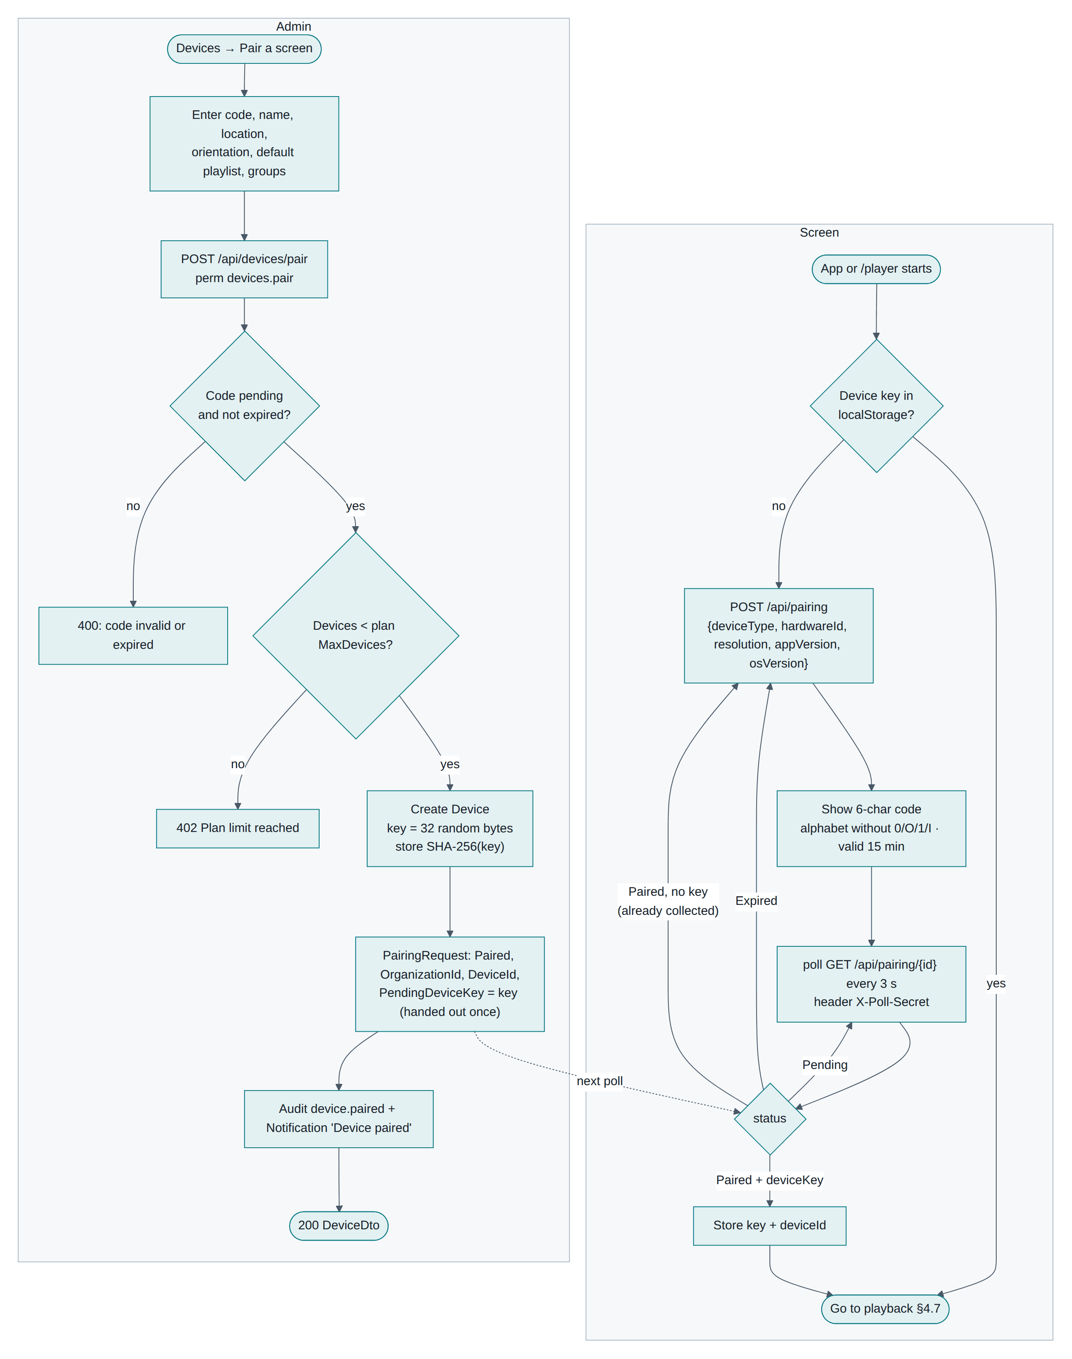
Figure 5-1 Pairing: the screen side and the admin side
- The app (or /player in a browser) requests a 6-character code, valid 15 minutes, and displays it. Codes never contain 0, O, 1 or I.
- In the CMS: Devices → Pair a screen (needs the devices.pair permission).
- Enter the code, a name, and optionally the location, orientation, default playlist and groups.
- The server checks the code and your plan's device limit, creates the device in your organisation, and issues a 256-bit device key, stored only as a hash.
- The screen collects that key on its next poll — once only — and starts syncing.
Assigning the organisation happens here: whoever claims the code binds that screen to their organisation permanently. To move a screen to another organisation, unpair it and pair it again there.

6.5 Verifying a screen is working
Check | Where
Device appears Online | Dashboard device wall, within seconds
It is playing | Device page → "Now playing"
Content version matches | Device page → "Content version"
Identify | Device page → Identify shows its name on the screen for 10 seconds
Free storage is sensible | Device page → "Free storage"

6.6 Bulk rollout

adb connect $ip:5555 && adb -s $ip:5555 install -r signage-player.apk \
&& adb -s $ip:5555 shell appops set com.signagecms.player SYSTEM_ALERT_WINDOW allow \
&& adb -s $ip:5555 shell am start -n com.signagecms.player/.MainActivity
adb disconnect $ip:5555
done
Each screen still needs its address typed once and its code claimed, unless your MDM seeds the address for you.

7. How devices receive updates, and updating in production

7.1 Three kinds of update
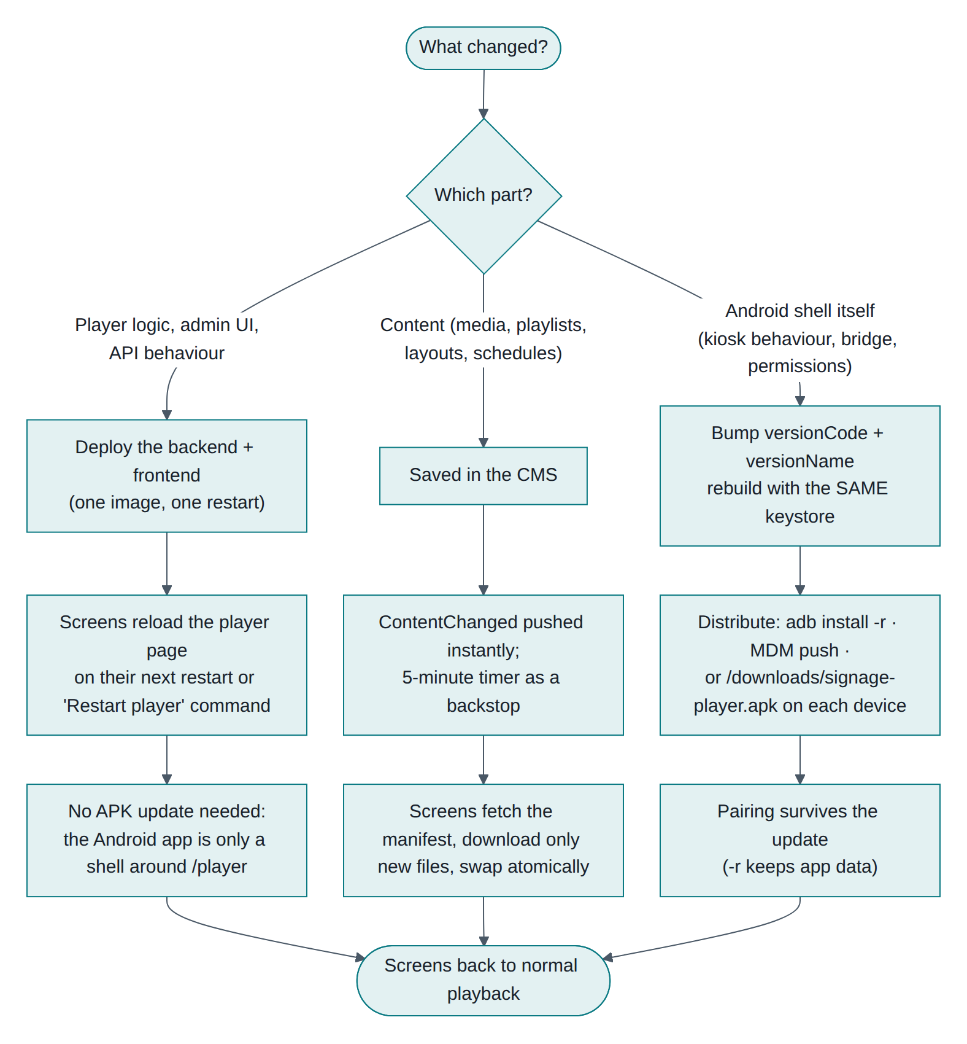
Figure 6-1 What to do for each kind of change
What changed | How it reaches screens | Needs a new APK?
Content (media, playlists, layouts, schedules) | Push over SignalR within a second, plus a 5-minute safety check | No
Player or admin software (the web app) | On the screen's next page load; force it with Restart player | No
API behaviour | On deployment | No
Android shell (kiosk behaviour, permissions, the native bridge) | You must install a new APK | Yes

The important consequence: most improvements ship without touching the devices, because the Android app is a thin shell around the web player.

7.2 Content updates in detail
When you save content, connected screens receive ContentChanged, ask the server whether their manifest changed, and if so download only the files they do not already have, verify each one, then switch over atomically. Unchanged screens get a tiny "nothing changed" response. Anything missed is caught by the 5-minute timer.

7.3 Updating the server in production

pg_dump -Fc -h db -U signage signage > signage-$(date +%F).dump
tar czf media-$(date +%F).tgz -C /var/lib/signage media

# 2. Build
cd frontend && npm ci && npm run build:api
cd ../backend && dotnet publish src/SignageCms.Api -c Release -o /opt/signage-cms-new

# 3. Apply migrations (once migrations are adopted)
dotnet ef database update --project src/SignageCms.Infrastructure --startup-project src/SignageCms.Api

# 4. Swap and restart
sudo systemctl stop signage-cms
sudo rsync -a --delete /opt/signage-cms-new/ /opt/signage-cms/
sudo systemctl start signage-cms
curl -s https://your-cms/health
With Docker: docker compose pull && docker compose up -d --build.
Screens keep playing throughout a restart, because they run from their local copy. They reconnect on their own, with a back-off up to 30 seconds.

7.4 Updating the Android app in production
- Raise versionCode and versionName.
- Build with the same keystore.
- Publish the new APK to frontend/public/downloads/ and rebuild the frontend.
- Distribute:
Method | Command or action | Pairing kept?
ADB | adb install -r signage-player.apk | Yes (-r keeps app data)
MDM | Push the new version | Yes
Manual | Download the link on the device and install over the top | Yes

Never uninstall to update: that clears the device key and the screen has to be paired again.

7.5 Rollback
Layer | How
Backend | Redeploy the previous published folder or image tag. Reversing a migration needs a --idempotent down script prepared in advance
Frontend | It is part of the backend deployment; the same rollback covers it
Android | Install the previous APK with adb install -r -d (the -d allows a downgrade), or restore from your MDM

7.6 Keeping a fleet healthy
- Roll out to one pilot screen first, watch it for a day, then the rest.
- Watch Plan and usage for storage creep and delete unused media.
- Check the dashboard after every deployment: every screen should return to Online within a minute.
- Keep versionName meaningful; it is reported on each screen's page, so you can see what is actually installed.

8. From the CMS to content on a screen
This chapter joins the two halves: what you configure in the CMS, and what the device does with it.

8.1 The flow
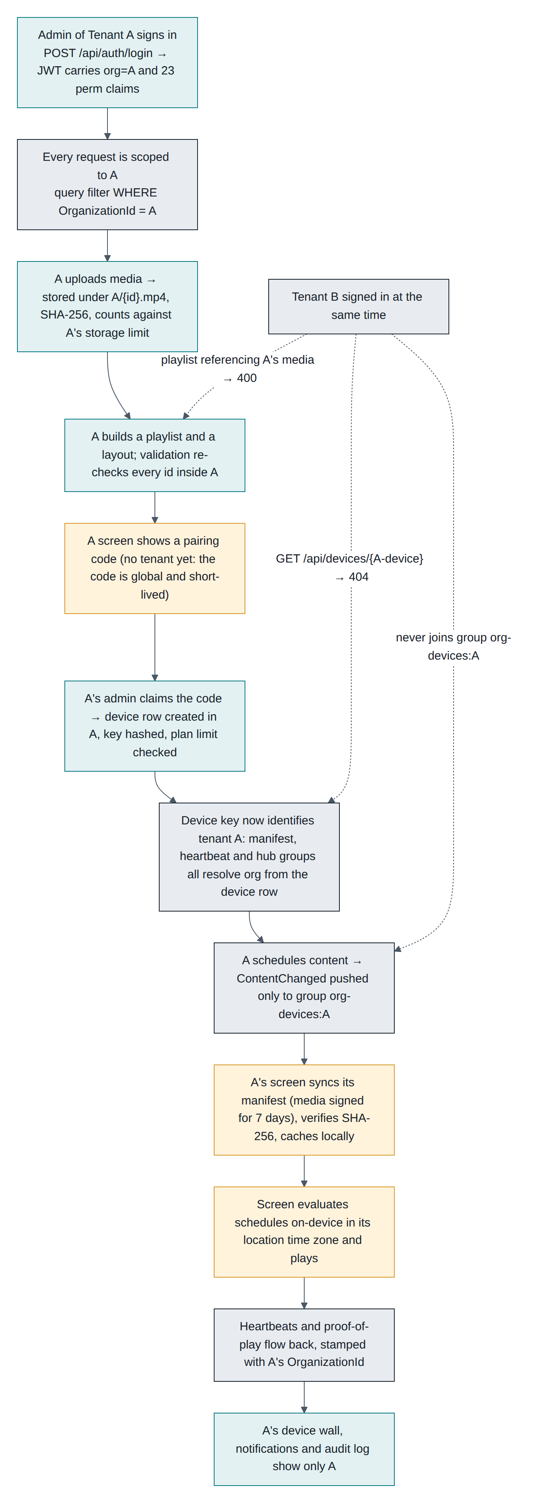
Figure 7-1 From admin sign-in to playback, with the organisation boundary at each step
Stage | In the CMS | On the device
Sign in | Your organisation and permissions are attached to your session | —
Upload media | File stored under your organisation's folder, with a checksum | —
Build a playlist | Order and durations saved | —
Pair a screen | Device created in your organisation, key issued once | Key stored, sync begins
Assign a playlist | Set as the device's or group's default | Appears in the next manifest
Schedule | Rule saved, screens told immediately | Manifest updated
Sync | Manifest built for that one device | Files downloaded, checksummed, cached
Playback | — | Schedules evaluated every 15 s in the location's time zone
Monitor | Device wall, alerts, proof of play | Heartbeat every 30 s

8.2 What the device actually downloads
One JSON manifest containing: the device's own name, orientation and time zone; its default playlist; every active schedule aimed at it or its groups; the layouts and playlists those use; and the media behind them, each with a checksum and a temporary signed link.
The manifest has a version derived from its content, returned as an ETag. On each check the device sends the version it has; if nothing changed the server replies "not modified" and the exchange costs a few hundred bytes.

8.3 Why playback survives outages
The device never streams at play time. It plays from its verified local copy and evaluates schedules itself, so a network failure changes nothing visible. Plays are queued locally and uploaded when the connection returns. After 90 seconds of silence the CMS marks the screen Offline and raises an alert.

8.4 Timings to expect
Step | Typical
Code appears on a new screen | under 2 seconds
Screen reacts after you pair it | about 3 seconds
First content visible | download time plus about a second
A content edit reaches screens | under a second, then any new downloads
Schedule boundary to switch | up to 15 seconds
Offline shown after a power cut | 90 to 120 seconds
Online again after recovery | up to 30 seconds

8.5 End-to-end smoke test after a deployment

curl -s -o /dev/null -w '%{http_code}\n' https://your-cms/player # 200
- Sign in to the CMS; the header should show Live.
- Open /player in another browser tab; note the code.
- Pair it, with a default playlist attached.
- Confirm playback starts and the dashboard shows the screen Online with the item name.
- Unpair the test screen.
If all five pass, the full chain works: database, API, real-time, media delivery, player and sync.

9. Common errors and their solutions

9.1 Android Studio and Gradle build failures
Error | Cause | Fix
Unsupported class file major version 65/66 | Gradle running on a newer JDK than it supports | Set Gradle JDK to 17 (Settings → Build Tools → Gradle) and JAVA_HOME to JDK 17
Android Gradle plugin requires Java 17 to run. You are currently using Java 11 | Old JDK | Install JDK 17 and point Gradle at it
Minimum supported Gradle version is 8.9. Current version is … | AGP/Gradle mismatch | ./gradlew wrapper --gradle-version 8.9, or lower the AGP version
Could not find com.android.tools.build:gradle:8.7.2 | No access to Google's Maven, or missing google() repository | Check network/proxy; confirm settings.gradle.kts lists google(); configure the proxy in gradle.properties
SDK location not found | ANDROID_HOME unset and no local.properties | Export ANDROID_HOME, or create local.properties with sdk.dir=/path/to/Sdk
Failed to install the following SDK components: platforms;android-35 | Licences not accepted | sdkmanager --licenses and accept, or install via Studio's SDK Manager
Execution failed … :app:processReleaseResources | Malformed XML in android/res | Read the file and line in the message; validate the XML
Cannot resolve symbol 'R' after moving files | Studio indexed the shared source folders oddly | Build → Clean Project, then File → Invalidate Caches / Restart
Daemon will be stopped … JVM heap | Not enough memory | Raise org.gradle.jvmargs=-Xmx2048m in gradle.properties
Build succeeds but targetSdk differs from the manifest | Gradle overrides manifest values | Expected: Gradle uses app/build.gradle.kts, build.sh uses the manifest

9.2 Gradle-free build (android/build.sh) failures
Error | Cause | Fix
aapt: command not found | SDK packages missing | sudo apt install android-sdk android-sdk-platform-23
dalvik-exchange: command not found | Dexer missing | sudo apt install dalvik-exchange
error: invalid source release: 8 | Wrong JDK | Install JDK 17; the script passes --release 8
javac failed with cannot find symbol for framework classes | Wrong platform jar path | Check $ANDROID_SDK/platforms/android-23/android.jar exists; export ANDROID_SDK
Invalid or corrupt jarfile apksigner.jar | Broken build-tools install | Reinstall android-sdk, or use the Studio-provided apksigner
keytool: command not found | JDK not on PATH | Add $JAVA_HOME/bin to PATH

9.3 APK installation failures
Message | Cause | Fix
INSTALL_FAILED_UPDATE_INCOMPATIBLE / "App not installed" | An existing app signed with a different key | Uninstall the old app (pairing is lost), then install. Always build with the same keystore
INSTALL_FAILED_VERSION_DOWNGRADE | Installing an older versionCode | Raise versionCode, or force with adb install -r -d
INSTALL_FAILED_INSUFFICIENT_STORAGE | Device full | Free space; check Free storage on the device page
INSTALL_FAILED_NO_MATCHING_ABIS | Not applicable here (no native code) | Confirm you are installing the right file
INSTALL_FAILED_TEST_ONLY | Built as a test-only debug artefact | Build assembleRelease, or adb install -t
"Blocked by Play Protect" | Sideloaded app | Choose "Install anyway", or distribute via MDM
Install blocked entirely on a TV | Unknown sources disabled | Enable developer options and unknown sources for the installer app

9.4 ADB connection issues
Symptom | Cause | Fix
adb: command not found | Platform-tools not on PATH | Add $ANDROID_HOME/platform-tools
Device shows as unauthorized | Prompt not accepted | Accept "Allow USB debugging" on the device; adb kill-server && adb start-server
adb: device offline | Stale session | adb disconnect, then reconnect; reboot the TV if it persists
failed to connect to 192.168.1.50:5555 | Network debugging off, wrong IP, different subnet, or firewall | Re-check the IP in Settings → About → Status; ensure both are on the same network
Connection drops every few minutes | TV sleeps or reassigns its IP over DHCP | Give screens static or reserved IP addresses
more than one device/emulator | Several targets attached | Use adb -s <serial>
Wireless pairing fails on Android 11+ | Used connect instead of pair | adb pair <ip>:<pairing-port> with the 6-digit code first

9.5 API connection and CORS issues
Symptom | Cause | Fix
App: "Can't reach the server" | API bound to localhost, firewall, or different subnet | Run with ASPNETCORE_URLS=http://0.0.0.0:8080; open the port; test /health from the device's browser
Browser console: blocked by CORS policy | Frontend on another origin not in the allow-list | Add Cors__AllowedOrigins__0=https://your-frontend; restart. Best avoided by serving both from one origin
net::ERR_CERT_AUTHORITY_INVALID | Self-signed certificate | Install the CA on the device, or use a publicly trusted certificate
Mixed-content warnings | HTTPS page calling an HTTP API | Serve both over HTTPS
401 on every call after a while | Access token expired and refresh failed | Sign in again; check the server clock, since tokens are time-based
413 on upload | Proxy body limit | client_max_body_size 1024m in nginx
429 responses | Rate limits (20/min auth, 60/min pairing per IP) | Expected under NAT; configure KnownNetworks so real client IPs are used
Works on the LAN, fails remotely | Proxy or DNS | Verify the public address resolves and forwards to the API

9.6 Database connection and migration errors
Error | Cause | Fix
Npgsql.NpgsqlException: Failed to connect at startup | Database down, wrong host or port | The API retries ten times over 30 s; check ConnectionStrings__Default and pg_isready
28P01: password authentication failed | Wrong password, or pg_hba.conf method | Reset the password; check pg_hba.conf uses scram-sha-256 or md5 for that host
3D000: database "signage" does not exist | Database never created | CREATE DATABASE signage OWNER signage;
42501: permission denied for schema public | User does not own the database | ALTER DATABASE signage OWNER TO signage; and grant on schema public
column … does not exist after an update | EnsureCreated() cannot evolve a schema | Adopt migrations (§2.4); in development, drop and recreate
Unable to create a 'DbContext' of type … when running dotnet ef | Missing design package or wrong startup project | Add Microsoft.EntityFrameworkCore.Design; pass both --project and --startup-project
The migration '…' has already been applied | History row present | Check __EFMigrationsHistory; do not re-apply the baseline
relation "__EFMigrationsHistory" does not exist on an existing database | Migrating a database created by EnsureCreated | Insert the baseline row once (§2.4)
SSL connection required | Managed database enforces TLS | Add SSL Mode=Require to the connection string
too many clients already | Connection pool exhausted | Raise max_connections, or lower pool size in the connection string

9.7 SignalR (real-time) connection issues
Symptom | Cause | Fix
Header shows "Updates paused" | WebSocket upgrade blocked | In nginx set proxy_http_version 1.1, Upgrade, Connection $connection_upgrade; raise proxy_read_timeout
Screens only update every 5 minutes | /hubs/device unreachable; they are on the timer fallback | Same proxy fix; check the path is not blocked
Failed to complete negotiation with the server: Error: Unauthorized | Token or device key not accepted | Admin hub needs a valid JWT (sent as access_token); device hub needs the device key
WebSocket closes after ~60 seconds | Idle timeout too low at the proxy or load balancer | Set the idle timeout above 2 minutes
Works on one node, not on several | No backplane | Add the Redis backplane for multi-instance deployments
Corporate network blocks WebSockets | Policy | SignalR falls back automatically, but confirm long polling is not blocked either

9.8 Device pairing failures
Symptom | Cause | Fix
"That code is invalid or has expired" | Typo, expired (15 min), or already claimed | Use the current code; codes never contain 0, O, 1, I
Screen keeps showing the code after pairing | It cannot reach /api/pairing/{id} | Check connectivity and proxy rules
"Too many attempts. Retrying shortly." | 60 pairing requests/min from one IP | Stagger first boots; behind NAT, configure KnownNetworks
402 "Plan limit reached" | Device limit hit | Upgrade the plan or remove an unused screen, then claim the same code
Paired but immediately Offline | Hub blocked, or the device clock is badly wrong | Check WebSockets; set the device's time zone and clock to automatic
Screen returns to a pairing code unexpectedly | It was unpaired in the CMS, or its key was revoked | Pair again; check the audit log for who removed it
Device type shows as WebPlayer on a TV | Browser used rather than the app | Expected; use the Android app for accurate reporting

9.9 Media synchronisation problems
Symptom | Cause | Fix
"Preparing content…" never finishes | A file fails to download or checksum | Check Free storage; use Sync now; look for Checksum mismatch in the player console
Stuck on an old content version | Sync failing; the amber dot is showing | Check connectivity and that /api/files is reachable through the proxy
Media plays from the network instead of cache | Storage was evicted, or Cache Storage unavailable on plain HTTP | Normal fallback; serve over HTTPS or use the app for reliable caching
403 when fetching a file | Signed link expired or altered | Screens re-sync automatically; never hand-edit media URLs
Video downloads but will not play | Codec unsupported on that device | Re-encode to H.264/AAC MP4
Web-page media blank | Site forbids embedding, or no internet | Use a page that allows framing
Sync loops repeatedly | Media changed on disk so the checksum no longer matches | Re-upload the file

9.10 Offline playback issues
Symptom | Cause | Fix
Blank screen after rebooting without a network | Browser on plain HTTP cannot start offline | Use the Android app, or serve the CMS over HTTPS
Content stops during an outage | The playlist referenced web-page media, which needs the internet | Use images and videos for anything that must survive outages
Schedules do not switch while offline | The device's clock or time zone is wrong | Set date and time to automatic; set the location's time zone in the CMS
Proof of play missing for the outage | Queue full (5,000 entries) or cleared | Expected on very long outages; shorter gaps upload in full
App does not restart after a power cut | Start-on-boot not granted on Android 10+ | adb shell appops set com.signagecms.player SYSTEM_ALERT_WINDOW allow, or use the setup screen button
TV switches itself off overnight | TV power-saving or eco timer | Disable auto power-off in the TV's own settings
Player exits to the launcher | Someone pressed Back three times and chose Exit | Use app pinning or MDM kiosk mode

9.11 Collecting evidence for a bug report

journalctl -u signage-cms -n 200 # or: docker compose logs --tail=200 api
grep -E 'fail:|traceId' /tmp/api.log

# database
psql -c 'SELECT "Name","Status","LastSeenAt","SyncedVersion" FROM "Devices";'

# device
adb logcat -d | grep -i -E "signage|chromium" > device.log
Include: what you did, what you expected, the traceId from the error, the CMS version, the APK versionName, and the device model and Android version.

List of figures
Figure 0-1 The full path: developer, builds, database, deployment, device install, pairing, content, playback
Figure 3-1 Two supported toolchains for the same sources
Figure 5-1 Pairing: the screen side and the admin side
Figure 6-1 What to do for each kind of change
Figure 7-1 From admin sign-in to playback, with the organisation boundary at each step

