ASSIGNMENT 4

Siddhartha Bhaumik

2022-04-23

# Markdown Basics

## Favorite Foods

1. Chicken Biryani
2. Fried Fish
3. Chicken Shawarma

## Images

{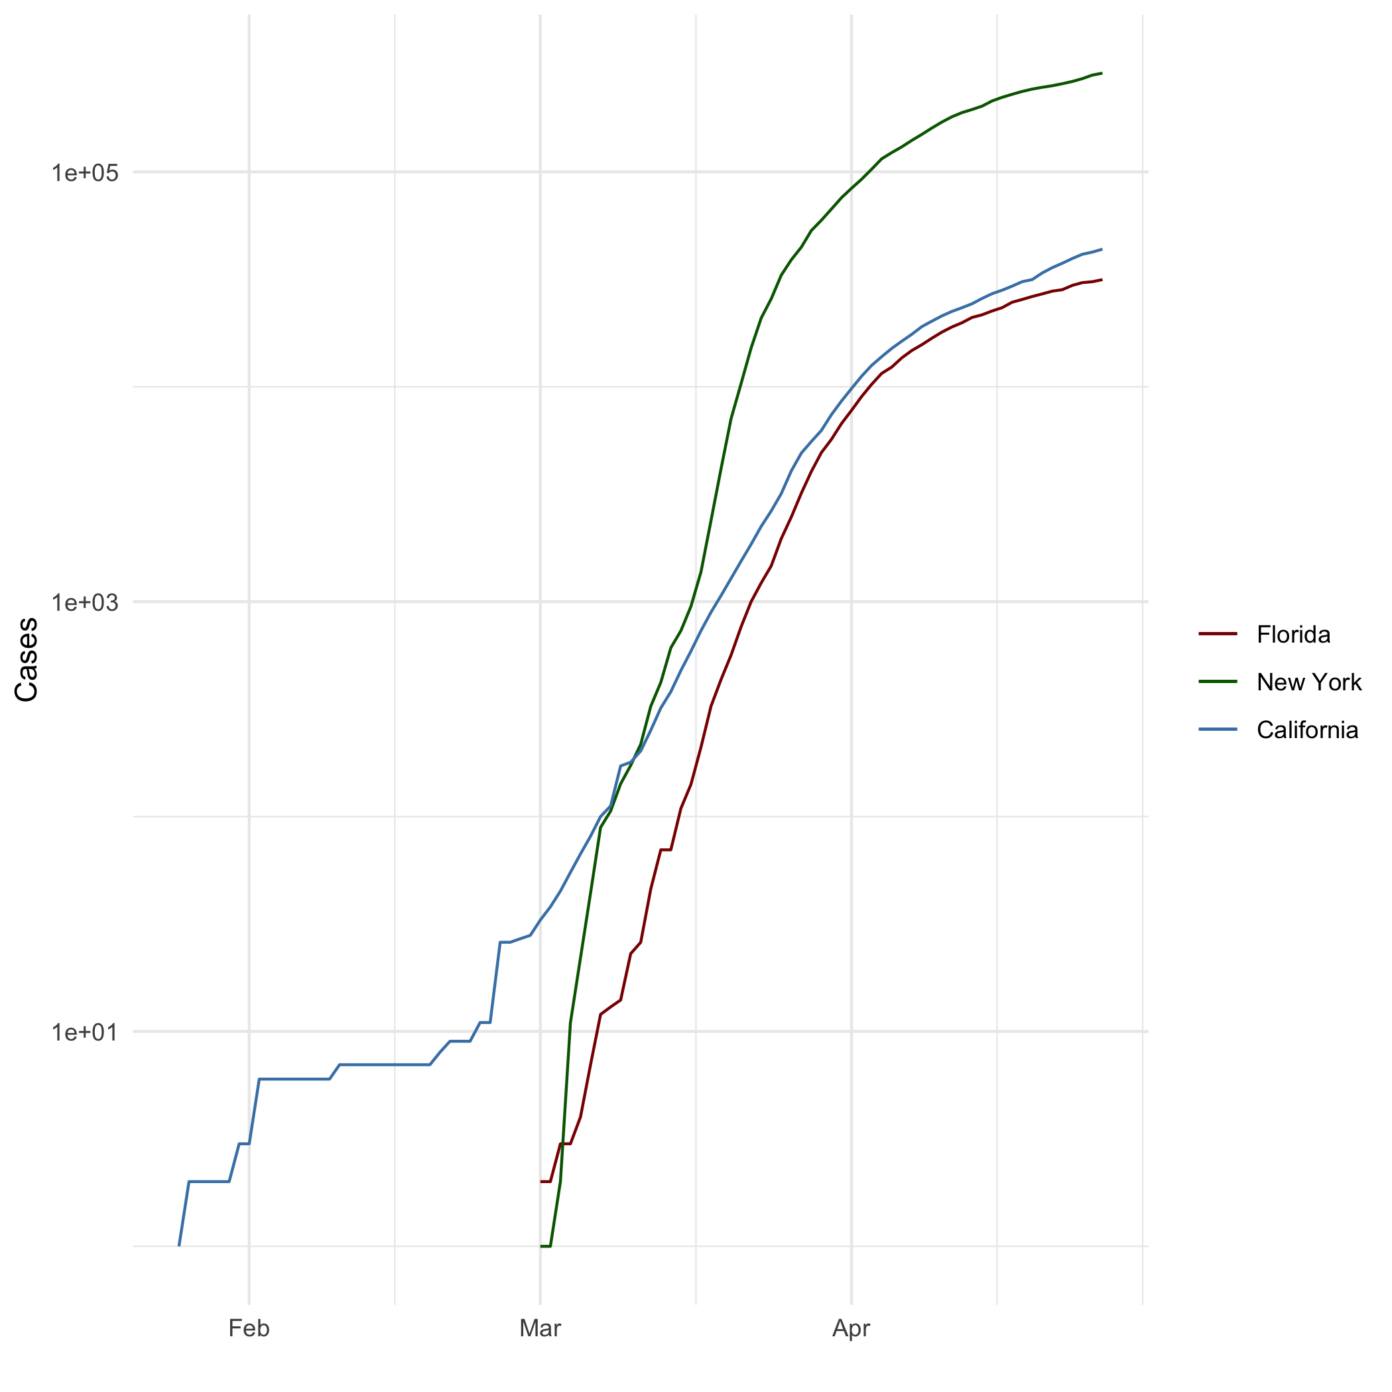}

## Add a Quote

“You are what you believe in. You become that which you believe you can become” ― Bhagavad Gita

## Add an Equation

$$f\left(x\right)=β_{0}+β_{1}x+β_{2}x^{2}+β_{3}x^{3}+β_{4}{\left(x−ξ\right)}_{+}^{3}$$

$${\left(x−ξ\right)}_{+}^{3}=\left\{\begin{matrix}{\left(x−ξ\right)}^{3} , & x>ξ \\ 0, & x≤ξ\end{matrix}\right.$$

$$\begin{matrix}\left(x≤ξ\right)⇒f\left(x\right) & =β_{0}+β_{1}x+β_{2}x^{2}+β_{3}x^{3} \\ \left(x>ξ\right)⇒f\left(x\right) & =β_{0}+β_{1}x+β_{2}x^{2}+β_{3}x^{3}+β_{4}\left(x^{3}−3x^{2}ξ+3xξ^{2}−ξ^{3}\right) \\ & =\left(β_{0}+β_{4}ξ^{3}\right)+\left(β_{1}+3β_{4}ξ^{2}\right)x+\left(β_{2}−3β_{4}\right)\end{matrix}$$

## Add a Footnote

Learning R Markdown

## Add Citations

* R for Everyone
* Discovering Statistics Using R

# Inline Code

## NY Times COVID-19 Data

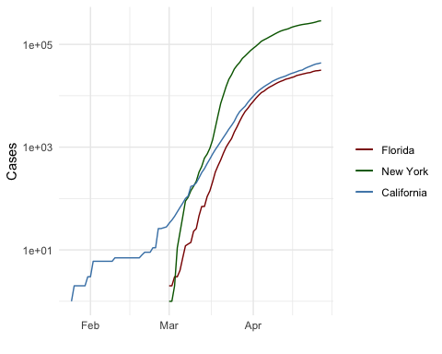

## R4DS Height vs Earnings

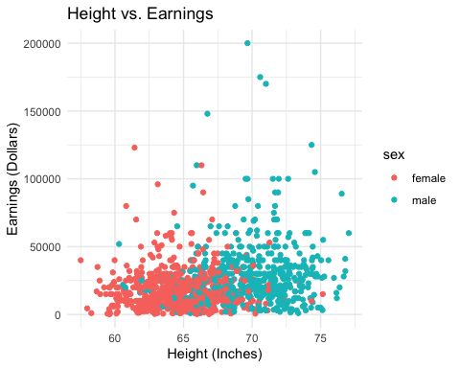

# Tables

## Knitr Table with Kable

One Ring to Rule Them All

| name | race | in_fellowship | ring_bearer | age |
| --- | --- | --- | --- | --- |
| Aragon | Men | TRUE | FALSE | 88 |
| Bilbo | Hobbit | FALSE | TRUE | 129 |
| Frodo | Hobbit | TRUE | TRUE | 51 |
| Galadriel | Elf | FALSE | FALSE | 7000 |
| Sam | Hobbit | TRUE | TRUE | 36 |
| Gandalf | Maia | TRUE | TRUE | 2019 |
| Legolas | Elf | TRUE | FALSE | 2931 |
| Sauron | Maia | FALSE | TRUE | 7052 |
| Gollum | Hobbit | FALSE | TRUE | 589 |

## Pandoc Table

##   
## ---------------------------------------------------------  
## name race in_fellowship ring_bearer age   
## ----------- -------- --------------- ------------- ------  
## Aragon Men TRUE FALSE 88   
##   
## Bilbo Hobbit FALSE TRUE 129   
##   
## Frodo Hobbit TRUE TRUE 51   
##   
## Galadriel Elf FALSE FALSE 7000   
##   
## Sam Hobbit TRUE TRUE 36   
##   
## Gandalf Maia TRUE TRUE 2019   
##   
## Legolas Elf TRUE FALSE 2931   
##   
## Sauron Maia FALSE TRUE 7052   
##   
## Gollum Hobbit FALSE TRUE 589   
## ---------------------------------------------------------

# References