**GRAPHIC ERA DEEMED TO BE**

**UNIVERSITY**



**MINI PROJECT**

**Evaluation Of Academic Performance System**

Name : Siddhant Bohra

Section : A

Class Roll No. : 56

Univ Roll No. : 2014881

**ACKNOWLEDGEMENT**

I am extremely thankful to our Honorable Chairman Sir Prof. Kamal Ghanshala of GRAPHIC ERA DEEMED TO BE UNIVERSITY, DEHRADUN for providing all kind of educational and infrastructural support to the students.

I would also like to thank our head of the department, Dr D P Singh, and all other faculties of computer science engineering, head of the department and faculties of other departments and all other teaching and non-teaching staff of our collage for the most effective and most valuable guidance.

I hereby like to express my sincere gratitude and respect to my project mentor Mr. Pankaj Kumar for his stimulating guidance and continuous supervision, monitoring and constant encouragement throughout the project completion.

I am obliged to my classmates for the valuable help and feedback provided by them in the completion of this course. I am grateful for everyone’s cooperation during the period of my mini project completion.

**ABSTRACT**

The aim of this project is to demonstrate an android application which can be accessed by both teachers and students to view their academic evaluation like in context of how much did they score in their respective subjects and what is their performance in comparison with students of same section and year. Also it informs the students about in which subjects they are scoring less and need to focus more on that subject, in which subjects are they scoring well and need to keep up there studies in those subjects. It also assigns grades attained each student with respect to their marks attained, and also tells about the overall grades and percentages.

**INTRODUCTION**

In today’s world, which is full of competitions and hard work, it is very important for students to keep a track of there academic performance and see where they stand as compared to the students in his/her competition. Also it is very essential for teachers to keep a record of their students’ performances as which student is performing well and which student is not. Also it is very essential for teachers to have contact with their students and their parents so that they can guide their students on how to perform well and how to prepare for future and can also guide the parents on how they can help their child so that he/she can attain greater success in life.

This project, **Evaluation of Academic Performance System** focuses on the above mentioned context. This project is an android application which can be used by students to know about their academic performance in their given academic year and which are their weak and strong subjects and also where their performance lies as compared to students of their section and year. This application can also be used by teachers to see the records of each and every student and if needed they can contact their students and also if needed their parents also via call or email as required.

This project is made by using ANDROID STUDIO in JAVA language, SQL queries also many JAVA libraries were used too. It comprises of login page which can be used to access the details of students and teachers respectively by providing username and password.

Students need to provide their university roll no and password and teachers need to provide their teacher id and password to access the data. The teacher can view data of students by choosing section and year, or they can also view data of all students if required. It also has the feature to call or email the student or their parents as per required.

**ADVANTAGES OF EVALUATION OF ACADEMIC PERFORMANCE SYSTEM**

1. Accessibility for each and every student as everyone has mobile phones.
2. Parents can also view their student’s record via the access of such mobile apps.
3. Teachers can view performance of each and every student.
4. Teacher can also contact the students or their parents if required.
5. Students can know where their performance stands as compared to other students of same section and year.

**MOTIVATION**

For the motivation, there is no specific motivation for me to choose this topic, but since we are going to deal with databases and application development in our future semesters so I thought learning and to get an experience of working with database will be a good option.

Also during pandemic lockdown, I have been learning a bit of beginners level android app development too, also we had Database Management System in our course so this reason also pushed me a little bit to work on this project.

**SOME DETAILS REGARDING THE TERMINOLOGIES IN THE PROJECT**

**Ques : What is Android App Development?**

Android software development is the process by which applications are created for devices running the Android operating system. Google states that "Android apps can be written using Kotlin, Java, and C++ languages" using the Android software development kit.

**Ques : What is the importance of evaluation of academic performance?**

Academic achievement is important for the successful development of young people in society. Students who do well in school are better able to make the transition into adulthood and to achieve occupational and economic success.

**Ques : Which languages is/are used in this project?**

JAVA : For building the back-end of the project and providing the functionality to all the objects in the project’s front- end.

SQL : For accessing and managing the database using query language.

XML : For designing the UI of the application.

**Ques : Why SQL is better to use for database management?**

SQL allows us to interact with relational databases through queries. These queries can allow you to perform a number of actions such as: insert, select, update and delete information in a database.

**Ques : What is an Activity in Android Studio?**

An activity provides the window in which the app draws its UI. This window typically fills the screen, but may be smaller than the screen and float on top of other windows. ... Typically, one activity in an app is specified as the main activity, which is the first screen to appear when the user launches the app.

**Ques : What is Intent in Android Studio?**

An Intent is a messaging object you can use to request an action from another app component. Android supports two types of intents: explicit and implicit. When an application defines its target component in an intent, that it is an explicit intent. When the application does not name a target component, that it is an implicit intent.

**Ques : How to use Query Language in Android Studio?**

SQLite is a open-source SQL database that stores data to a text file on a device. Android comes in with built in SQLite database implementation.

**Ques : What is Cursor?**

A SQL Server cursor is a set of T-SQL logic to loop over a predetermined number of rows one at a time. The purpose for the cursor may be to update one row at a time or perform an administrative process such as SQL Server database backups in a sequential manner.

**METHODOLOGY**

In this project I have used Java language as it is one of the most common language to perform android apps, also SQL languages is used to access the database efficiently by using SQLite library.

Initially we have a database named students.csv which I have imported in this project and has details of 500 students like university roll no, name, year, section, class roll no, father’s name, contact details and subject score. This project works only in online mode as it has a login feature which requires internet connectivity as I have connected my project with **Google Console** using Firebase service provided by android studio, which stores the username and password of both students and teachers. This login feature helps students so that no other person can see their data except teachers without their concern.

The initial page is the Login Page which shows us two options for login where the user is given options to login either as teacher or student. Student has access to only his data, whereas teacher can access data of all the students. Next choosing one of the options sends us to the login page of either student or teacher. The student login is constrained to have the username between 1901001 and 1901500, and the password is constrained to have at least 6 characters else suitable error will be shown as toast to the user. For teacher login is constrained to have teacher id to be greater than 2001000 and password to be having at least 6 characters. Both login pages also have an option to create new account, where new account can be created using university roll no or teacher id. After login :

**For Student :** The university roll no. is passed to the query handler class (SQLConvert), here first the imported CSV file is converted to SQL table using Cursor and InputStream, and later the data regarding the inputted university roll number is fetched and the user is taken to the next page where the fetched data is displayed. The data contains, student’s photo, student’s personal details, student’s marks, overall percentage and grades and also his/her performance as compared to the students of same section and year. Also marks are shown in different colors signifying the level of performance in that particular subject. The notes regarding the significance of coloured marks is given at the end and tells the student that in which subject he needs to practice better and which are his strong subject.

**For Teachers :** The teacher id and password is processed via Google Console and the teacher is logged in to a page where he is given an option to filter the student database by selecting specific year and section. Or else he can opt to see the details of all the students of all years and sections in a single list. On choosing one of the options the teacher is next taken to the next page which has the list of all the students where university roll number is the primary key. The teacher has the privilege to access data of each student by clicking on his/her university roll number. The same data which is displayed to the student is shown and in addition to it the teacher has option to contact student or their parent via call or mail with just one click.

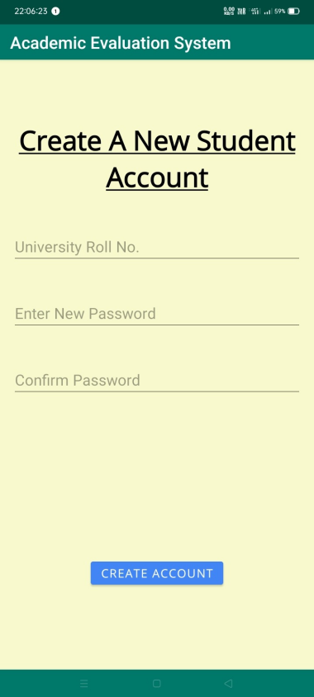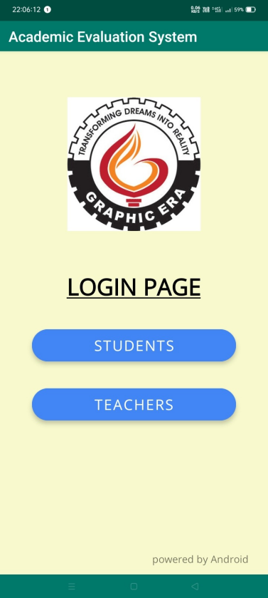 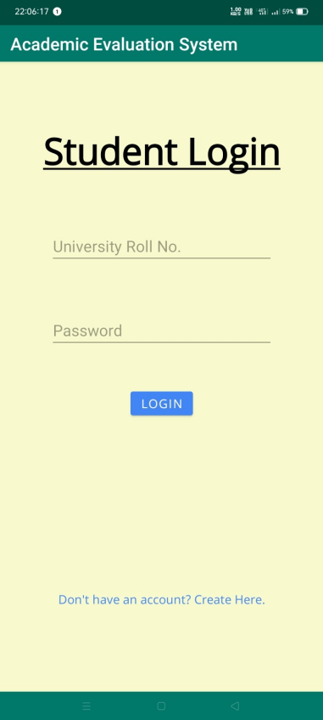

Login Select Student Login Page Create Account Page

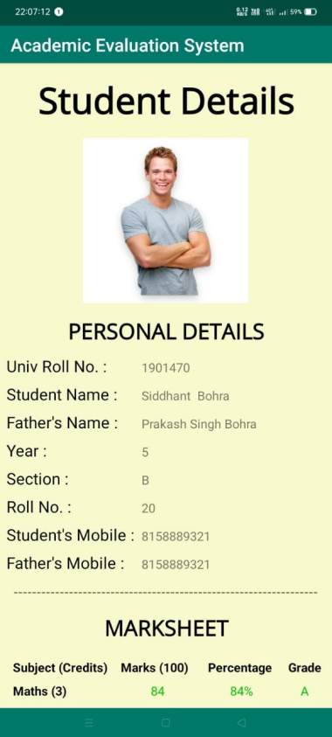 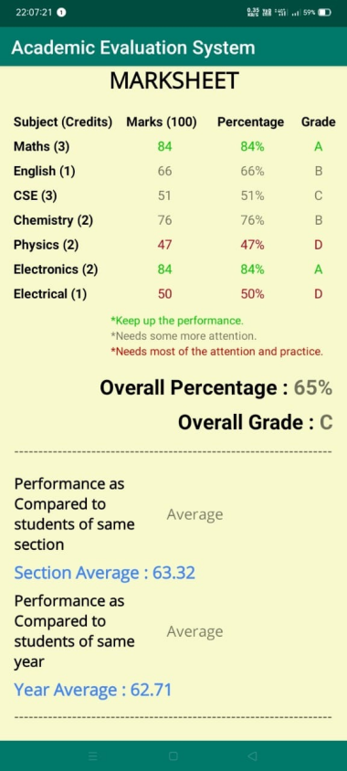 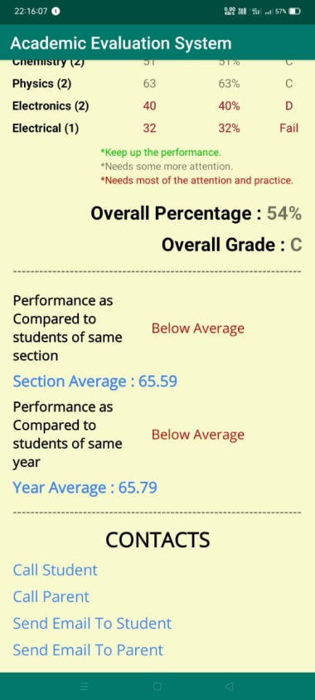

Student Details Mark Sheet Contact Options

Page Section

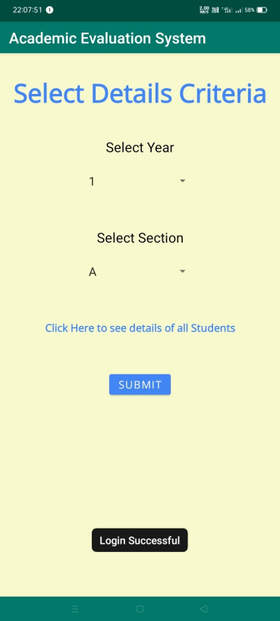 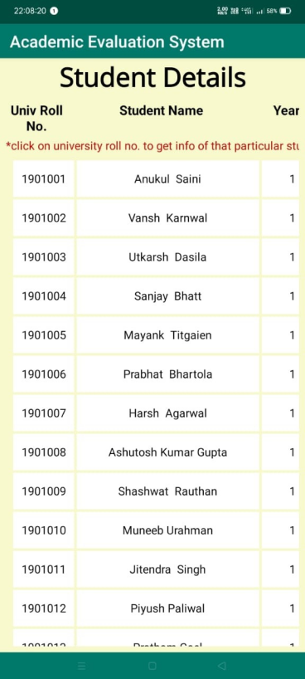

Filter Data Option Students List

**Fig. : Application Images.**

**REFERENCES**

1. **Code With Harry**  (<https://www.youtube.com/c/CodeWithHarry>) : For getting to know about the basic android app development concept.
2. **Android Studio Developer Site**  (<https://developer.android.com/>) : For getting to know about the SQL related help in Android Studio.

**PROJECT LINKS**

Link to my Project On GitHub :

<https://github.com/sidbohra2001/Evaluation-Of-Academic-Performance-System.git>

Link to my Project On Google Drive :

<https://drive.google.com/drive/folders/1uB_CwMv4qD7oCyRzYWLcwVMIYZ-GYlOs?usp=sharing>