

Project Preparation Report

Title of the MSc Project
Author’s Name

Date

Introduction
Supercomputers have had a major effect on everyone’s lives over the years. There are countless uses such as weather prediction, molecular dynamics, automobile engineering, astronomy (Tynan, 2020) and many more that have made us reliant on supercomputing. Naturally, since there are so many benefits, there has been a constant demand for faster computing.
The Top500 list from just 10 years ago in November 2010 shows the fastest supercomputer, Tianhe 1-A, to have a peak at 4,701 TFlops/ and a power consumption of 4,040 kW (T500, 2010) , in November 2020 Fugaku is the fastest supercomputer with a peak of 537,212 TFlops/s and power consumption at 29,899 kW (Top500, 2020). The energy effieciency of these machines is better due to the effiency improvements in CPUs over this period of time. In November 2010, the supercomputer that consumed the most power in the top 10 was IBM’s Summit at 6,950 kW, in Novermber 2020, out of the 8 power readings provided, 4 are above 10,000 kW. This mean that although the power effiency of hardware is improving, supercomputers still use more chips and more power to hit higher performance numbers.
This has two important consequences; the cost of running supercomputers is increasing and the environmental impact of these supercomputers in worsening. In the case of Fugaku, we can find that the price per kWh in Japan for a household is $0.29 (Sönnichsen, 2020), the annual cost in power alone is approximately $75,000,000. When we look at the environmental impact, supercomputers have been scrutinized for their carbon emissions in the past. In 2009, the Met supercomputer in London came under scrutiny for being a massive cause of carbon emission while modelling climate change (Johnson, 2009). In the case of Fugaku, if we take an estimate of amount of CO2 produced per kWh from US energy Information Administration of 0.417 kg/kWh (U.S. Energy Information Administration, 2020), the Carbon emissions per year over 100,000 tonnes.
There is an environmental and monetary benefit to working on reducing the power consumption of supercomputers. This proposition is for an investigation into some methods of reducing the power consumption of these machines while they are working on intense workloads. The possible methods proposed include examining the impact on power consumption by using MPI, openMP or hybrid MPI/openMP, using the matrix free method for matrix multiplication and adjusting the data storage formats.

2. Previous Dissertation Review
The dissertation I reviewed was about Profiling and Optimisation of Meshing in the OpenFOAM for the Renault F1 Team by Daniel Hews written 2020.
Project Summary
The dissertation discusses the use of Computational Fluid Dynamic (CFD), its importance to an F1 team when designing components and how speeding up a component of this process, the meshing, by optimising the snappyHexMesh utility helps the F1 team. CFD is done by Renault using OpenFOAM CFD software, the most expensive part of this computation is the snappyHexMesh utility which is why it is the focus of the project. The primary objective is to reduce the runtime of the process. Optimising parallel efficiency is not essential.
Initially, the code was tested, and it was discovered that the current software scaled poorly to multiple cores. The time taken reduced dramatically till 48 processes, but after 144-192 processes, the program took longer to complete. This was identified, with profiling, to be caused by the decomposition taking too long on the main thread.
The decomposition default method used by Renault was using the Scotch decomposition library. Experiments were conducted to try and improve the Scotch decomposition library and explore other decomposition methods, Hierarchical and the use of the KaHIP library.
Hierarchical requires some user input to decide how the decomposition should take place (deciding which axis to decompose) and the actual decomposition takes significantly less time than the Scotch method. On the other hand, the load balance was worse and inconsistent.
The second approach was to improve the current Scotch library. Although the decomposition quality is high, the process takes a long time. The author identifies that Renault uses a very low maxLoadUnbalance value (0.1), this makes the process repeat until the parameter is met. The author conducted experiments to find the optimal value, and this did show significant improvement in the overall runtime.
The final method explored was the KaHIP(Karlsruhe High Quality Partitioning) library, this library (along with the scotch) were built into OpenFOAM. This method was to be more configurable and could improve performance. The author found the optimal experimented with various parameters including the maxLoadUnbalanced value. This method was, again, far better than the baseline.
The author found that KaHIP scaled the best with increased processors, followed by the hierarchical and then the improved Scotch. The author concluded to allow the F1 team to choose between KaHIP and Scotch, despite KaHIP performing the best and Scotch performing the worse, since there was more risk to switch to KaHIP and the Scotch times were improved over the baseline.
The author goes on to try and use vectorization to optimise the code more. This showed minimal improvement, upon further testing with wide vector units the author concluded that to benefit from vectorization the codebase would need changes beyond the scope of the project. The author then attempted to optimise the codebase in places they had identified earlier. They looked to switch from a standard parallel sorting algorithm to a parallel replacement and switched the communication from blocking to non-blocking. Unfortunately, both changes had negligible effects on performance.
Does the dissertation adequately explain the context in which the problem is set?
This dissertation explains the context of the problem very well. It describes why CFD is important and time sensitive for F1 teams (Chapter 1). It mentions that there are restrictions on CFDs to ensure even competition in F1. This restriction only applied to some uses of CFDs though and it restricts the amount of performance per core and by clock speed of each core and luckily this project does not fall under that restriction (2.1, 2.1.1). This project does, however, restrict the time available to run those programs as well. So, the author explains how performance improvement is necessary in terms of a reduction in time taken, but the performance improvement per core is optional. (2.1.2)

Has the student adequately explained the scope of the problem, the approach that they would take, how success would be measured and reflected on the outcomes?
In sections 2.2 and 2.3 the author explains the structure of OpenFOAM and explains that the snappyHexMesh utility is the only one that has not been optimised, referencing to past literature, and that is why they are choosing to work on this. Furthermore, they explain that the primary goal of this project is to reduce the time taken by the program overall. Any efficiency goals are secondary, and they should not increase the time taken.
In Chapter 3 they explain how they hardware they are required to use as well as the profiling tools they will use to analyse the current codebase and the checkMesh utility they are using to find compare the current program with any modifications to ensure that the program still functions correctly overall.
In Chapters 4 the author explains their findings from profiling and what they identified as the primary bottleneck in snappyHexMesh and then they go on to explain their approaches to improve this in chapters 5, 6 and 7. Each experiment they conduct is first justified with theory and is every variable is explained including the number of times the tests are conducted. Every decision is also justified, and any changed due to experiment results is explained in the analysis. This makes the experiments very reproducible.
Quality of presentation.
The structure of the dissertation was of high quality, although the chapters are a little confusing at the beginning, each section explains what the information presented means for the entire project as well as the next steps that need to be taken and therefore what the next chapter will focus on. This made the reading of the dissertation much easier since it was less jarring moving from one section to the next and from one chapter to the next.
The sections are also very consistent in how they present experiments, there is always a section to explain the theory to justify the experiment that will be conducted. This is then followed by what the experimental conditions are, how many times the experiments are conducted and if there are any parameters being left unchanged as well as justification for this. The next section discusses the results and explains what this means for the project as well as any anomalies, any changes from the initial plan.
The language used overall was very formal but also the verbs used in a consistent. In experiment plans the author always used active verbs to describe how things will be conducted (despite the experiments possibly taking place in the past) and in the analysis the verbs were in the past tense.
Presentation of additional information.
The references and citations in the text were always used to backup certain theory or about some sort of hardware specification. Furthermore, the author also mentioned when the experiments would go against some references and explain why this could be the case. The references themselves were in a standard format.
The tables and figures in the dissertation were listed along with the contents page, meaning there was a list of tables and figures and the pages they were on along with the list of chapters. This seemed odd at first but in the paper, it became clear that this was because all the figures and tables were not always in the places they were referenced. This is understandable in a long paper as there are references to figures in different chapters, however all the figures were always on the top of a page and would be oddly placed. For example, in section 6.1 the table for the results of a vectorisation experiment is placed in the middle of the description of the experiment itself. The analysis is in the next section, on the same page. This would be an area for improvement.

3. Background and Literature Review
When it comes to reducing power consumption there are several actors that have control over the methods that can be used to reduce power consumption, the programmer, the library developers, and the centre that runs the supercomputer.
The most straightforward method of reducing power usage, is to limit the power provided to the CPUs at the cost of speed. Centres have the option to cap power and there have been various approaches to try and adjust power usages to lower power consumption. Borghes et al. proposed using machine learning to predict the power consumption of HPC machines as well as a batch system which could schedule based with some bounds on power consumption (Andrea Borghes, 2015). Power management systems have been proposed as well. The propisiton by Cao et al (Thang Cao, 2016) which monitors the power usage of a system and adjusts power consumption according to a system budget to meet the requirements of the jobs that are being scheduled as best as possible.
When it comes to library makers and programmers, one of the most comprehensive sources is the Addressing Energy in Parallel Technologies (Adept) report on Power Usage of Parallel Algorithms and Parallel Programming Models (N. Johnson (UEDIN), 2016). This explores various parallel technologies and its impact on power consumption. One of their comparisons looks at the affect on power consumption based on matrix format, testing three types of matrix storage formats: co-ordinate format, compressed sparse row format and the sparse skyline format. The results suggest that having a different storage format has an affect on performance as well as power consumption, this would be a possible change from a library developer.
Another method to consider in the same vein is the matrix-free method for matrix multiplciation, this method is known to reduce the memory usage (N. G. Burago, 2018) and provide better performance by evaluating the matrix-vector product instead of storing the matrix itself. This is especialy useful for very large matrices that a difficult to store. The possible power save here comes from being able to use less storage and therefore requiring less writing of data from memory to cache, which consumes energy.
The Adept report also looks at the comparison between MPI and openMP suggests that in the majority of cases, for programs that are as similar as possible in implementation in the MPI and openMP, MPI uses more energy, this would be a change decided by the programmer. We can also find that the programming languages themselves require different amounts of energy. In experiments conducted by (Rui Pereira, 2017) on 27 different well known languages, the energy usage, performance and memory usage were vastly different. C stood out as the best in terms of energy usage and performance and was third best in memory usage. Whereas even a language as popular as python was second worst in both performance and energy usage. It should be noted that performance and energy usage are tied since a program that takes longer to run also uses more energy. Nevertheless, this is an important factor to consider that is controlled by the programmer

4. Preliminary Investigation
Two sets of experiments were conducted on the Fulhame machine for preliminary investigation using the High-Performance Conjugate Gradients (HPCG) benchmarking tool. The first experiment was conducted to find what problem size exceded the cache memory levels and began using RAM, by increasing the problem size and comparing the system’s speed during benchmarking. The second experiment was to measure the power consumption of the system during the benchmark with increasing problem sizes.
The purpose of these experiments is to find at what problem size the system is forced to use RAM, causing more data to be transmitted during the benchmark. This allows us to measure the impact this has on the power consumption of the system.

Cache Levels Experiment
The experiment was conducted on the Fulhame machine to identify the problem size at which RAM is used along with the cache levels. A single process is used to run the HPCG benchmark with a 3D problem of size starting at 16 (this means 16,16,16), which is the minimum allowed by default, and incrementing this by 8 until the memory usage exceeds the available cache memory.
Each test is conducted three times and then averaged to account for anomalies and to account for the system being under different loads at different times.
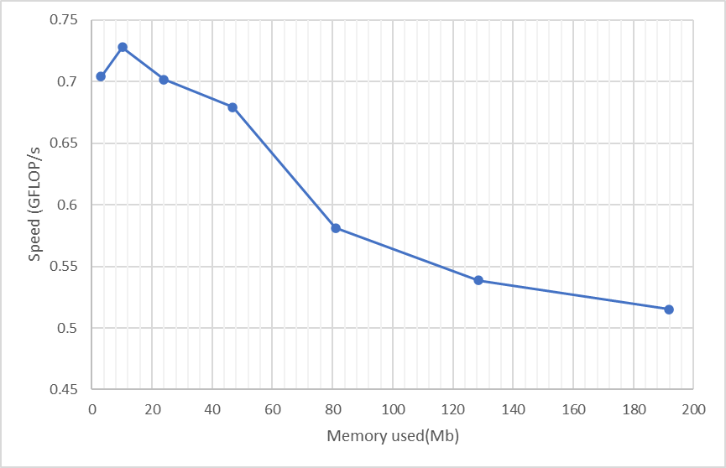
Figure 1 : Impact of speed as prolem size is increased

Cache Levels Analysis
Ideally, the experiment would allow us to find the point of every cache level, but even at the minimum problem size of 16, this was using L3 cache. The point where we see the performance drop was for problem of size 48 or when the memory usage is about 80 Mb. When the problem size is 40, the majority of the 46Mb of RAM usage fits in the 40Mb of cache available with very few cache misses. At this point, the memory requirement is double that of the cache memory available and so the reading and writing from RAM to cache happens more frequen. This is the threshold for further experiments using HPCG on Fulhame for testing whether an improvement has been made on the power consumption

Memory Power Consumption Experiments
The next experiment was to try and find what the impact of the system needing to use more memory to story the data. To test this, experiments were conducted on Fulhame with increasing problem sizes, again, and the tx2mon package was used to retrieve the power consumption during an experiment.
The tests were conducted with 1 process and 64 processes and in each experiment the problem size was doubled in one of the dimensions. The codebase was adjusted to allow for smaller problem sizes as well, the smallest problem is of size 4x4x4 then 8x4x4, then 8x8x4 and so on until 64x64x64. Each set of tests is conducted three times to account for anomalies and volatile system loads.
The problem is set to run for 60s with a 10s wait on either side. This is so that it is clear in the results when the system has started running the benchmark as the CPU power usage will increase. The benchmark is such that it will keep running for 60s and then output the average speeds during that time.
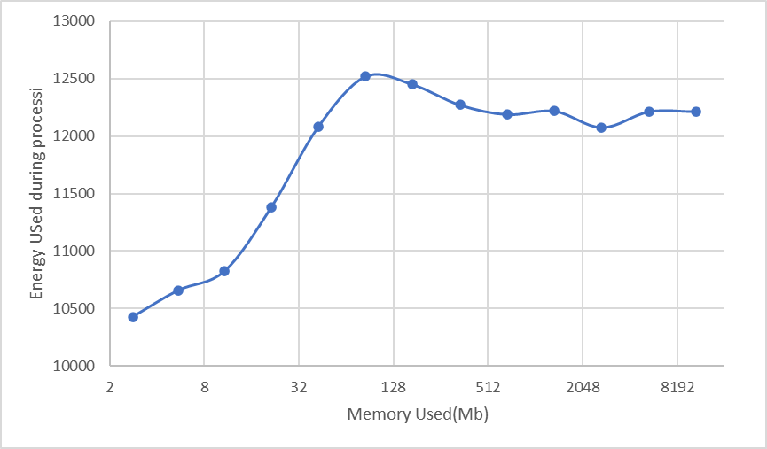
Figure 2: Energy Consumption as memory usage is increases

Power Usage Analysis
The results above are consistent with what is expected from the cache level experiment. The energy usage increases as the memory usage increases, we can see that at the beginning of the graph, the energy usage is rising rapidly. At 80Mb, the system reaches its peak energy consumed, then the energy usage reduced very slightly but remains close to the same amount throughout.
This is because at this point the problem is far larger than the cache storage available on these chips and has mostly being stored in RAM, the CPU is running at its peak clock speed and the volatility is caused by the changes in DRAM power consumption.

5. Final Project Proposal

Proposal
When in comes to super computers, most of the focus is on improving speed, but the electrical costs of running these machines is enormous as well. This report aims to find possible methods of making these systems more power efficient without acquiring better hardware and how much this would affect the performance of the system.
There are a few methods that could help reduce the power usage, the most obvious is to reduce the clock speeds of processors, this uses less power at the expense of performance. Another approach is to try test different implementations of common methods (in our case the conjugate gradient method) to see if any of them are more power efficient and what the performance cost is, if any. The primary focus of this project will be to look at data layout; transferring data uses power. Limiting the transfer of data between RAM and the various cache levels is likely to create a more power efficient implementation.

Hardware Requirements (or similar)
The main hardware requirement for this project is a machine that can measure the power usage during benchmarks. There are two machines available for this purpose, Fulhame and NextgenIO.
At this stage access to both machines has been acquired and some tests have been run on Fulhame already. Furthermore, access to the Tx2Mon package within Fulhame has been acquired, this is the package needed for power measurements. There is limited storage needed, just enough to store the benchmarks (in order of megabytes).
- Hardware resources needed: computer which provides capability of measuring power. Fulhame does it and we have access.
- Additional costs inferred? – run tests and judge how long the tests will take and how many need to be conducted
- Any challenges to get access, sufficient storage, large enough budget to this hardware?
Access to everything acquired, access to fulhame and required package (Tx2Mon)

6. Workplan

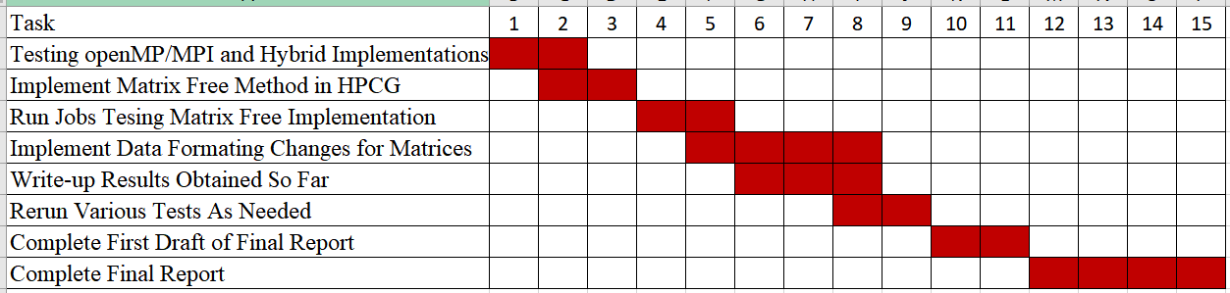
Begin running data format tests:
Rerun tests/try different power settings/different compilers:
Week 10, aim for first draft ish

7. Risk Analysis

7. 1 Success Criteria
The aim of this project is to reduce the power consumption of the system during computation. The current focus is on adjusting how data is stored in memory and trying to reduce the cache misses and transferring data from memory to cache. Preliminary investigation has helped find the threshold at which RAM is used during computation for the HPCG benchmark as well as the increase in power when this happens. This will only really impact the implementation of the conjugate gradient method, but it is commonly used in HPC systems (hence why it is used for benchmarking) and will still be highly beneficial.
Although the focus is on power consumption, ideally there would be no impact on the computation speed but there is also a possible increase in speed if more information can be stored in cache. It is unlikely that the final product will provide a performance benefit, but it could make it possible that it could counteract any performance impact. Overall, the goal is to reduce the power consumption; if there is a small performance impact then this is still a viable method for non-urgent problems if the speeds are not significantly slower.

Possible fallbacks
In the case that the restricting of data is already optimised or the impact on performance is beyond acceptable then project can take two other approaches. The first is to compare different implementations of the conjugate gradient method and inspect their performance and power consumption to find which one is best for which scenario. Then perhaps some could be improved by inspecting other to form a combined, optimal method. The second is to try and reduce the voltage on the chips themselves, this will have an impact on performance, but experiments can be conducted to find a balance that provides more efficiency, again as a non-urgent method. This method is less likely to be possible since it is unclear whether the necessary permissions can be acquired to test this.

Extensions
The fallbacks for this project are also possible extensions, currently the experiments suggests that there could be better power efficiency if the data is restructured and that is why it has been chosen as the primary focus. It may not be possible to test lower voltages on the chips since it is unclear whether access to this is possible and testing multiple implementations of the conjugate gradient method may not lead to any improvement overall, but these are still worth experimenting on if there is enough time available.

Reflect on
- What will define the success of the project.
- What are your fallbacks? What is the “minimum viable product”?
- What could you do if you achieve the goals early, what are possible extensions?
You will have to refer back to these in your dissertation!

7.2 Risks and Mitigations
Consider the success criteria, the minimum viable product and resource requirements outlined earlier. What are bare necessities for you to carry out the work? Which of these resources and inputs might fail or become unavailable, and what would you do in such a situation? What if the work does not progress as planned?
The resource that is essential for this project is a system which can provide power readings. Currently, experiments have been run on one such machine, Fulhame. A second machine, NextgenIO is also being used to compare two different chips results. In the case that one of these fails, the experiments will only be conducted on once of the machines. If both machines fail or become unavailable, then the project will have to pivot to purely improve performance of the conjugate gradient method, the data restructuring and investigation of multiple implementations could still help improve the performance.

8. Outline of the Dissertation Report
Planned dissertation chapters.

References
Andrea Borghes, A. B. (2015). Scheduling-based power capping in high performance computing systems. Principles and Practice of Constraint Programming, 524-540.
Johnson, B. (2009, 08 29). Supercomputer in the firing line over carbon footprint. (The Gaurdian) Retrieved 03 12, 2021, from https://www.theguardian.com/technology/blog/2009/aug/28/met-office-supercomputer
N. G. Burago, I. S. (2018). Matrix-Free Conjugate Gradient Implementation of Implicit Schemes 58. Computational Mathematics and Mathematical Physics, 1247-1258.
N. Johnson (UEDIN), M. W. (2016). Addressing Energy in Parallel Technologies.
Rui Pereira, M. C. (2017). Energy efficiency across programming languages: how do energy, time, and memory relate? the 10th ACM SIGPLAN International Conference.
Sönnichsen, N. (2020, 11 11). Statista. Retrieved 02 12, 2021, from https://www.statista.com/statistics/263492/electricity-prices-in-selected-countries/
T500. (2010, 11). NOVEMBER 2010. Retrieved 03 18, 2021, from https://www.top500.org/lists/top500/2010/11/
Thang Cao, Y. H. (2016). Demand-Aware Power Management for Power-Constrained HPC Systems. 16th IEEE/ACM International Symposium on Cluster, Cloud and Grid Computing (CCGrid), 21-31.
Top500. (2020, November). November 2020. Retrieved from Top500: https://www.top500.org/lists/top500/2010/11/
Tynan, D. (2020, November 16). Six ways the world's fastest computers have changed your life. (Hewlett Packard Enterprice) Retrieved 03 10, 2021, from https://www.hpe.com/us/en/insights/articles/supercomputers-in-everyday-life-2011.html
U.S. Energy Information Administration. (2020, 12 15). How much carbon dioxide is produced per kilowatthour of U.S. electricity generation? Retrieved 03 15, 2021, from https://www.eia.gov/tools/faqs/faq.php?id=74&t=11#:~:text=In%202019%2C%20total%20U.S.%20electricity,of%20CO2%20emissions%20per%20kWh.

