**WIRELESS & MOBILE COMMUNICATION**

(Unit-1)

**Introduction to Wireless Communication:**

Before talking about wireless medium, we need to talk about the wired medium. Wired network is a bounded medium where data travels over a path that a wire or cable takes. In modern era of advanced and enormous no of devices, wired medium of communication imposes a restriction on fluent communication. There are various problems with wired networks. Consider a situation, you want to connect to 10 or more devices around you. You need exact same no of ports to be able to connect to devices, but large no of ports seems to be impractical but with wireless network, it can be easily done.

As the name suggests, wireless network eliminates needs to be tethered with wire or cable. Convenience and Mobility becomes its main characteristics. Many different wireless devices can connect to network easily and seamlessly. As wireless data travel through air, there must be some constraints within which wireless communication takes place.

These are:

•All wireless devices must follow a common standard i.e., IEEE 802.11 •Wireless coverage must be there where devices are expected to use.

•Wired network comes under IEEE standard 802.3 •Wireless network comes under IEEE standard 802.11

IEEE stands for “Institute of Electrical and Electronics Engineers”, is an organization composed of engineers that issues and manages standards for electrical and electronic devices.

Basics of Wireless Communication:

Wireless communication takes places over free space through RF (radio frequency), one device, a Transmitter, sends signal to another device, a Receiver. Two devices (transmitter and receiver) must use same frequency (or channel) to be able to communicate with each other. If a large number of wireless devices communicate at same time, radio frequency can cause interference with each other. Interference increases as no of devices increases.

Wireless devices share airtime just like wired devices connect to shared media and share common bandwidth. For effective use of media, all wireless devices operate in half duplex mode to avoid collision or interference. Before the transmission begins, devices following IEEE 802.11 standard must check whether channel is available and clear. Wireless communication is always half duplex as transmission uses same frequency or channel. To achieve full duplex mode, devices use different frequency or channel of transmission and receiving of signals. You can say that wireless communication is Full duplex but technically it is not.

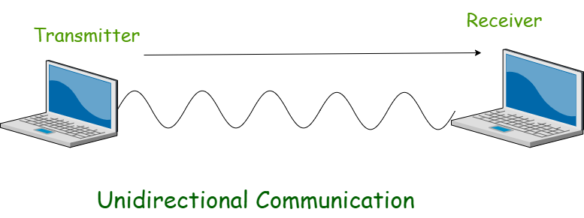

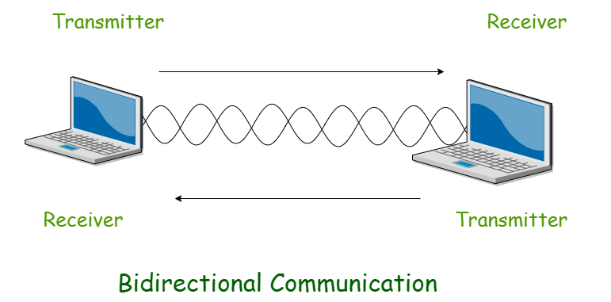

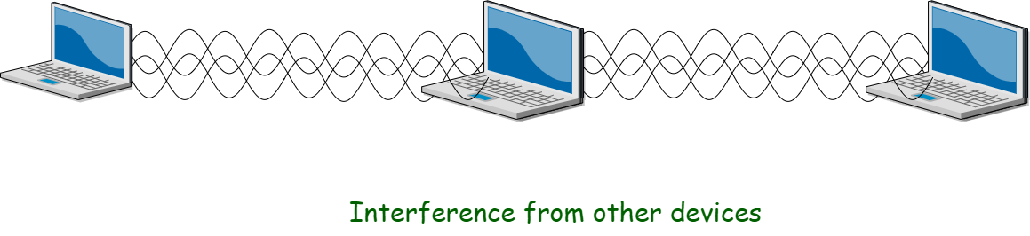

Radio Frequency:   
In free space, the sender (transmitter) sends an alternating current into a section of wire (an antenna). This sets up a moving electric and magnetic fields that travel as travelling waves. The electric and magnetic field moves along each other at a right angle to each other as shown. The signal must keep changing or alternating by cycle up and down to keep electric and magnetic field cyclic and pushing forward. The no of cycles a wave taking in a second is called Frequency of the wave. So, frequency = no of cycles per second

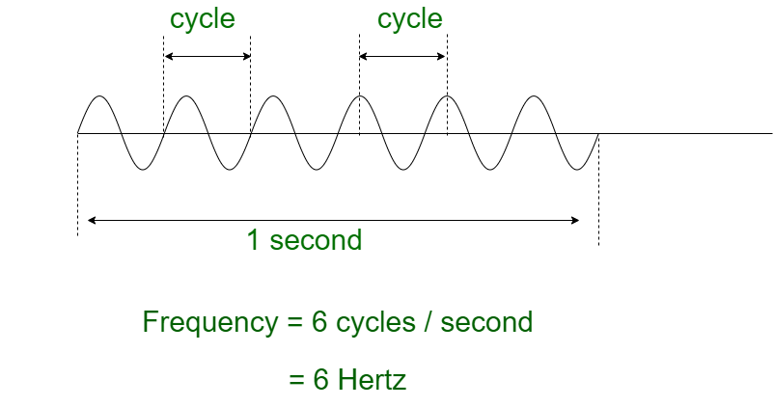

Antennas in our daily lives send out Electromagnetic waves in all directions, like the waves travelling in water when a stone is dropped in a water body.

Frequency Unit Names:

|  |  |  |
| --- | --- | --- |
| Unit | Abbreviation | Meaning |
| Hertz | Hz | Cycles per second |
| Kilohertz | kHz | 1000 Hz |
| Megahertz | MHz | 1, 000, 000 Hz |
| Gigahertz | GHz | 1, 000, 000, 000 Hz |

Features of Wireless Communication:

The evolution of wireless technology has brought many advancements with its effective features.

• The transmitted distance can be anywhere between a few meters (for example, a television's remote control) and thousands of kilometres (for example, radio communication).

• Wireless communication can be used for cellular telephony, wireless access to the internet, wireless home networking, and so on.

Other examples of applications of radio wireless technology include GPS units, •  
garage door openers, wireless computer mice, keyboards and headsets, headphones, radio receivers, satellite television, broadcast television and cordless telephones.

Wireless communication involves transfer of information without any physical connection between two or more points. Because of this absence of any 'physical infrastructure', wireless communication has certain advantages. This would often include collapsing distance or space.

Wireless communication has several advantages; the most important ones are discussed below.

Cost effectiveness

Wired communication entails the use of connection wires. In wireless networks, communication does not require elaborate physical infrastructure or maintenance practices. Hence the cost is reduced.

Example − Any company providing wireless communication services does not incur a lot of costs, and as a result, it is able to charge cheaply with regard to its customer fees.

Flexibility

Wireless communication enables people to communicate regardless of their location. It is not necessary to be in an office or some telephone booth in order to pass and receive messages.

Miners in the outback can rely on satellite phones to call their loved ones, and thus, help improve their general welfare by keeping them in touch with the people who mean the most to them.

Convenience

Wireless communication devices like mobile phones are quite simple and therefore allow anyone to use them, wherever they may be. There is no need to physically connect anything in order to receive or pass messages.

Example − Wireless communications services can also be seen in Internet technologies such as Wi-Fi. With no network cables hampering movement, we can now connect with almost anyone, anywhere, anytime.

Speed

Improvements can also be seen in speed. The network connectivity or the accessibility were much improved in accuracy and speed.

Example − A wireless remote can operate a system faster than a wired one. The wireless control of a machine can easily stop its working if something goes wrong, whereas direct operation can’t act so fast.

Accessibility

The wireless technology helps easy accessibility as the remote areas where ground lines can’t be properly laid, are being easily connected to the network.

Example − In rural regions, online education is now possible. Educators no longer need to travel to far-flung areas to teach their lessons. Thanks to live streaming of their educational modules.

Constant connectivity

Constant connectivity also ensures that people can respond to emergencies relatively quickly.

Example − A wireless mobile can ensure you a constant connectivity though you move from place to place or while you travel, whereas a wired land line can’t.

Wireless Communication is the fastest growing and most vibrant technological areas in the communication field. Wireless Communication is a method of transmitting information from one point to other, without using any connection like wires, cables or any physical medium. Generally, in a communication system, information is transmitted from transmitter to receiver that are placed over a limited distance. With the help of Wireless Communication, the transmitter and receiver can be placed anywhere between few meters (like a T.V. Remote Control) to few thousand kilometres (Satellite Communication).

We live in a World of communication and Wireless Communication, in particular, is a key part of our lives. Some of the commonly used Wireless Communication Systems in our day to day life are: Mobile Phones, GPS Receivers, Remote Controls, Bluetooth Audio and Wi-Fi etc.

What is Wireless Communication?

Communication Systems can be Wired or Wireless and the medium used for communication can be Guided or Unguided. In Wired Communication, the medium is a physical path like Co-axial Cables, Twisted Pair Cables and Optical Fibre Links etc. which guides the signal to propagate from one point to other. Such type of medium is called Guided Medium. On the other hand, Wireless Communication doesn’t require any physical medium but propagates the signal through space. Since, space only allows for signal transmission without any guidance, the medium used in Wireless Communication is called Unguided Medium.

If there is no physical medium, then how does wireless communication transmit signals? Even though there are no cables used in wireless communication, the transmission and reception of signals is accomplished with Antennas. Antennas are electrical devices that transform the electrical signals to radio signals in the form of Electromagnetic (EM) Waves and vice versa. These Electromagnetic Waves propagates through space. Hence, both transmitter and receiver consists of an antenna.

What is Electromagnetic Wave?

Electromagnetic Waves carry the electromagnetic energy of electromagnetic field through space. Electromagnetic Waves include Gamma Rays (γ – Rays), X – Rays, Ultraviolet Rays, Visible Light, Infrared Rays, Microwave Rays and Radio Waves. Electromagnetic Waves (usually Radio Waves) are used in wireless communication to carry the signals.

An Electromagnetic Wave consists of both electric and magnetic fields in the form of time varying sinusoidal waves. Both these fields are oscillating perpendicular to each other and the direction of propagation of the Electromagnetic Wave is again perpendicular to both these fields. Mathematically, an Electromagnetic Wave can be described using Maxwell’s equations. Pictorial representation of an Electromagnetic Wave is shown below, where the [Electric](https://www.electronicshub.org/basics-of-electric-field/)

[Field](https://www.electronicshub.org/basics-of-electric-field/) is acting in the Y – axis, magnetic field is acting in the Z – axis and the Electromagnetic Wave propagates in X – axis.

A Brief History of Wireless Communication:

Since the use of smoke signals, flags and flashing mirrors in the pre – historic period, Wireless communication has been a part of human life and it is continuously evolving. Modern Wireless Communication i.e., using electrical signals and radio waves for communication has been around us for more than 100 years. In the year 1897, Guglielmo Marconi successfully demonstrated the Wireless Telegraphy by sending EM Waves for a short distance of 100 meters. This demonstration paved way for Radio Communication and the term Radio is derived from Radiant Energy. By early 1900’s, Trans – Atlantic radio transmission had been established, where Marconi successfully transmitted messages in the form of Morse code. Since then, the technology related to wireless communication and wireless system has advanced rapidly and thus enabling transmissions over longer distances at low cost with cheaper devices.

Throughout the development of wireless communication, there are many wireless systems and methods that flourished and many got disappeared. The best example for this is Telephone Communication and Television Transmission. Initially, all telephone related communication was carried out (and still is) using wired network, which we call it as Landline Telephone. But the rapid growth of Mobile Communication started to replace the complex wired telephone system. In this scenario, the wired technology became outdated and got replaced by wireless communication. Another scenario where wireless communication got replaced by wired communication is Television broadcasting. In the early days, television signals were broadcasted using wireless radio transmitters. But this setup got replaced by cable television. These two examples point out that with the development of technology, we always have to choose what’s best for the situation i.e., in some areas we have to use wired communication whereas in the other, going for wireless may be a better option.

Why Wireless Communication?

When wired communication can do most of the tasks that a wireless communication can, why do we need Wireless Communication? The primary and important benefit of wireless communication is mobility. Apart from mobility, wireless communication also offers flexibility and ease of use, which makes it increasingly popular day – by – day. Wireless Communication like mobile telephony can be made anywhere and anytime with a considerably high throughput performance. Another important point is infrastructure. The setup and installation of infrastructure for wired communication systems is an expensive and time consuming job. The infrastructure for wireless communication can be installed easily and low cost. In emergency situations and remote locations, where the setup of wired communication is difficult, wireless communication is a viable option.

Advantages of Wireless Communication:

There are numerous advantage of Wireless Communication Technology, Wireless Networking and Wireless Systems over Wired Communication like Cost, Mobility, Ease of Installation, and Reliability etc.

Cost

The cost of installing wires, cables and other infrastructure is eliminated in wireless communication and hence lowering the overall cost of the system compared to wired communication system. Installing wired network in building, digging up the Earth to lay the cables and running those wires across the streets is extremely difficult, costly and time consuming job.

In historical buildings, drilling holes for cables is not a best idea as it destroys the integrity and importance of the building. Also, in older buildings with no dedicated lines for communication, wireless communication like Wi-Fi or Wireless LAN is the only option.

Mobility

As mentioned earlier, mobility is the main advantage of wireless communication system. It offers the freedom to move around while still connected to network.

Ease of Installation

The setup and installation of wireless communication network’s equipment and infrastructure is very easy as we need not worry about the hassle of cables. Also, the time required to setup a wireless system like a Wi-Fi network for example, is very less when compared to setting up a full cabled network.

Reliability

Since there are no cables and wires involved in wireless communication, there is no chance of communication failure due to damage of these cables, which may be caused by environmental conditions, cable splice and natural diminution of metallic conductors.

Disaster Recovery

In case of accidents due to fire, floods or other disasters, the loss of communication infrastructure in wireless communication system can be minimal.

Disadvantages of Wireless Communication:

Even though wireless communication has a number of advantages over wired communication, there are a few disadvantages as well. The most concerning disadvantages are Interference, Security and Health.

Interference

Wireless Communication systems use open space as the medium for transmitting signals. As a result, there is a huge chance that radio signals from one wireless communication system or network might interfere with other signals.

The best example is Bluetooth and Wi-Fi (WLAN). Both these technologies use the 2.4GHz frequency for communication and when both of these devices are active at the same time, there is a chance of interference.

Security

One of the main concerns of wireless communication is Security of the data. Since the signals are transmitted in open space, it is possible that an intruder can intercept the signals and copy sensitive information.

Health Concerns

Continuous exposure to any type of radiation can be hazardous. Even though the levels of RF energy that can cause the damage are not accurately established, it is advised to avoid RF radiation to the maximum.

**Basic Elements of a Wireless Communication System:**

A typical Wireless Communication System can be divided into three elements: the Transmitter, the Channel and the Receiver. The following image shows the block diagram of wireless communication system.

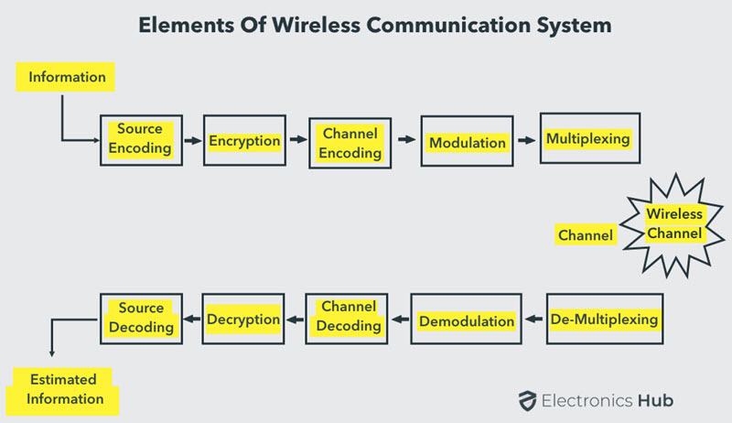

The Transmission Path

A typical transmission path of a Wireless Communication System consists of Encoder, Encryption, Modulation and Multiplexing. The signal from the source is passed through a Source Encoder, which converts the signal in to a suitable form for applying signal processing techniques.

The redundant information from signal is removed in this process in order to maximize the utilization of resources. This signal is then encrypted using an Encryption Standard so that the signal and the information is secured and doesn’t allow any unauthorized access.

Channel Encoding is a technique that is applied to the signal to reduce the impairments like noise, interference, etc. During this process, a small amount of redundancy is introduced to the

signal so that it becomes robust against noise. Then the signal is modulated using a suitable Modulation Technique (like PSK, FSK and QPSK etc.) , so that the signal can be easily transmitted using antenna.

The modulated signal is then multiplexed with other signals using different Multiplexing Techniques like Time Division Multiplexing (TDM) or Frequency Division Multiplexing (FDM) to share the valuable bandwidth.

The Channel

The channel in Wireless Communication indicates the medium of transmission of the signal i.e. open space. A wireless channel is unpredictable and also highly variable and random in nature. A channel maybe subject to interference, distortion, noise, scattering etc. and the result is that the received signal may be filled with errors.

The Reception Path

The job of the Receiver is to collect the signal from the channel and reproduce it as the source signal. The reception path of a Wireless Communication System comprises of Demultiplexing, Demodulation, Channel Decoding, Decryption and Source Decoding. From the components of the reception path it is clear that the task of the receiver is just the inverse to that of transmitter.

The signal from the channel is received by the Demultiplexer and is separated from other signals. The individual signals are demodulated using appropriate Demodulation Techniques and the original message signal is recovered. The redundant bits from the message are removed using the Channel Decoder.

Since the message is encrypted, Decryption of the signal removes the security and turns it into simple sequence of bits. Finally, this signal is given to the Source Decoder to get back the original transmitted message or signal.

Types of Wireless Communication Systems

Today, people need Mobile Phones for many things like talking, internet, multimedia etc. All these services must be made available to the user on the go i.e. while the user is mobile. With the help of these wireless communication services, we can transfer voice, data, videos, images etc.

Wireless Communication Systems also provide different services like video conferencing, cellular telephone, paging, TV, Radio etc. Due to the need for variety of communication services, different types of Wireless Communication Systems are developed. Some of the important Wireless Communication Systems available today are:

• Television and Radio Broadcasting   
• Satellite Communication   
• Radar   
• Mobile Telephone System (Cellular Communication) • Global Positioning System (GPS)   
• Infrared Communication

• WLAN (Wi-Fi)   
• Bluetooth   
• ZigBee   
• Paging   
• Cordless Phones   
• Radio Frequency Identification (RFID)

There are many other system with each being useful for different applications. Wireless Communication systems can be again classified as Simplex, Half Duplex and Full Duplex. Simplex communication is one way communication. An example is Radio broadcast system.

Half Duplex is two way communication but not simultaneous one. An example is walkie – talkie (civilian band radio). Full Duplex is also two way communication and it is a simultaneous one. Best example for full duplex is mobile phones. The devices used for Wireless Communication may vary from one service to other and they may have different size, shape, data throughput and cost. The area covered by a Wireless Communication system is also an important factor. The wireless networks may be limited to a building, an office campus, a city, a small regional area (greater than a city) or might have global coverage.

Television and Radio Broadcasting

Radio is considered to be the first wireless service to be broadcast. It is an example of a Simplex Communication System where the information is transmitted only in one direction and all the users receiving the same data.

Satellite Communication

Satellite Communication System is an important type of Wireless Communication. Satellite Communication Networks provide worldwide coverage independent to population density.

Satellite Communication Systems offer telecommunication (Satellite Phones), positioning and navigation (GPS), broadcasting, internet, etc. Other wireless services like mobile, television broadcasting and other radio systems are dependent of Satellite Communication Systems.

Mobile Telephone Communication System

Perhaps, the most commonly used wireless communication system is the Mobile Phone Technology. The development of mobile cellular device changed the World like no other technology. Today’s mobile phones are not limited to just making calls but are integrated with numerous other features like Bluetooth, Wi-Fi, GPS, and FM Radio.

The latest generation of Mobile Communication Technology is 5G (which is indeed successor to the widely adapted 4G). Apart from increased data transfer rates (technologists claim data rates in the order of Gbps), 5G Networks are also aimed at Internet of Things (IoT) related applications and future automobiles.

Global Positioning System (GPS)

GPS is solely a subcategory of satellite communication. GPS provides different wireless services like navigation, positioning, location, speed etc. with the help of dedicated GPS receivers and satellites.

Bluetooth

Bluetooth is another important low range wireless communication system. It provides data, voice and audio transmission with a transmission range of 10 meters. Almost all mobile phones, tablets and laptops are equipped with Bluetooth devices. They can be connected to wireless Bluetooth receivers, audio equipment, cameras etc.

Paging

Although it is considered an obsolete technology, paging was a major success before the wide spread use of mobile phones. Paging provides information in the form of messages and it is a simplex system i.e. the user can only receive the messages.

Wireless Local Area Network (WLAN)

Wireless Local Area Network or WLAN (Wi-Fi) is an internet related wireless service. Using WLAN, different devices like laptops and mobile phones can connect to an access point (like a Wi-Fi Router) and access internet.

Wi-Fi is one of the widely used wireless network, usually for internet access (but sometimes for data transfer within the Local Area Network). It is very difficult to imagine the modern World without Wi-Fi.

Infrared Communication

Infrared Communication is another commonly used wireless communication in our daily lives. It uses the infrared waves of the Electromagnetic (EM) spectrum. Infrared (IR) Communication is used in remote controls of Televisions, cars, audio equipment etc.

Cellular System Infrastructure

Early wireless systems had a high-power transmitter, covering the entire service area. This required a very huge amount of power and was not suitable for many practical reasons.

The cellular system replaced a large zone with a number of smaller hexagonal cells with a single BS (base station) covering a fraction of the area. Evolution of such a cellular system is shown in the given figures, with all wireless receivers located in a cell being served by a BS.

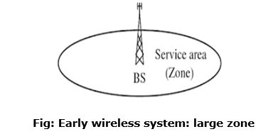

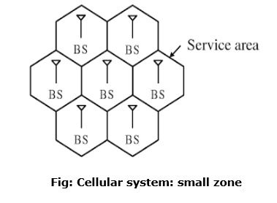

Wireless devices need to be supported for different types of services, the wireless device could be a wireless telephone laptop with wireless card, personal digital assistant (PDA), or web enabled phone. For simplicity, it could be called an MS.

In a cellular structure, a MS (mobile station) needs to communicate with the BS of the cell where the MS is currently located and the BS acts as a gateway to the rest of the world. Therefore, to provide a link, the MS needs to be in the area of one of the cells (and hence a BS) so that mobility of the MS can be supported. Several base stations are connected through hard-wires and are controlled by a BS controller (BSC), which in turn is connected to a mobile switching center (MSC). Several mobile switching centers are interconnected to a PSTN (public switched telephone network) and the ATM (asynchronous transfer mode) backbone. To provide a better perspective of wireless communication technology, simplified system infrastructure for cellular system is shown in the figure:

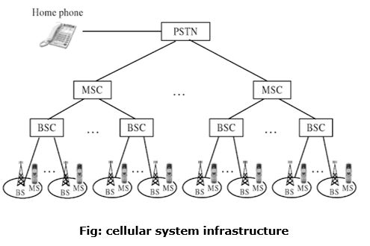

A cellular system requires a fairly complex infrastructure. A generic block diagram in shown in the figure:

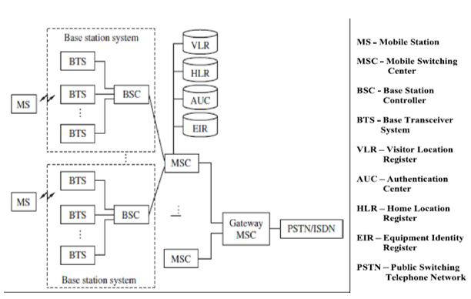

A BS consists of a base transceiver system (BTS) and a BSC. Both tower and antenna are a part of the BTS, while all associated electronics are contained in the BSC. The HLR (home location register) and VLR (visitor location register) are two sets of pointers that support mobility and enable the use of the same telephone numbers worldwide.

The AUC (authentication center) unit provides authentication and encryption parameters that verify the user's identity and ensure the confidentiality of each cell. The EIR (equipment identity register) is a database that information about identity of mobile equipment. Both AUC and EIR can be implemented as individual stand-alone units or as a combined AUC/EIR unit. The HLR is located at the MSC where MS is initially registered and is the initial home location for billing and access information.

In simple words, any incoming call, based on the calling number, is directed to the HLR of the home MS where the MS is registered. The HLR then points to the VLR of the MSC where the MS is currently located. Bidirectional HLR-VLR pointers help in carrying out various functionalities, as illustrated in the figure:

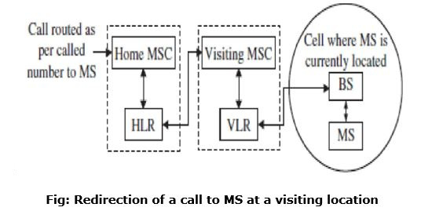

The VLR contains information about all MS visiting that particular MSC and hence points to the HLR of the visiting MSs for exchanging related information about the MS. Such a pointer allows calls to be routed or rerouted to the MS, wherever it is located. In cellular systems, a reverse direction pointer is needed that allows traversal of many control signals back and forth between the HLR and VLR such bidirectional HLR-VLR pointers help in carrying out various functionalities.

**Frequencies for Radio Communication:**

Radio frequency (RF) is a measurement representing the oscillation rate of electromagnetic radiation spectrum, or electromagnetic radio waves, from frequencies ranging from 300 gigahertz (GHz) to as low as 9 kilohertz (kHz). With the use of antennas and transmitters, an RF field can be used for various types of [wireless](https://www.techtarget.com/searchmobilecomputing/definition/wireless) broadcasting and communications.

How radio frequency works?

Radio frequency is measured in units called hertz [(Hz)](https://www.techtarget.com/searchmobilecomputing/definition/hertz), which represent the number of cycles per second when a radio wave is transmitted. One hertz equals one cycle per second; radio waves range from thousands (kilohertz) to millions (megahertz) to billions (gigahertz) of cycles per second. In a radio wave, the [wavelength](https://www.techtarget.com/searchnetworking/definition/wavelength) is inversely proportional to the [frequency.](https://www.techtarget.com/whatis/definition/frequency) Radio frequencies are not visible to the human eye. As the frequency is increased beyond that of the

RF spectrum, electromagnetic energy takes the form of microwaves, infrared radiation [(IR)](https://www.techtarget.com/searchnetworking/definition/infrared-radiation), visible, ultraviolet, X-rays and gamma rays.

RF technology

Many types of wireless devices make use of RF fields. Cordless and cell phones, radio and television broadcast stations, Wi-Fi and Bluetooth, satellite communications systems and two-way radios all operate in the RF spectrum. In addition, other appliances outside of communications, including microwave ovens and garage door openers, operate at radio frequencies. Some wireless devices, like TV remote controls, computer keyboards and computer mice, operate at IR frequencies, which have shorter electromagnetic wavelengths.

How the radio frequency spectrum is used?

The radio frequency spectrum includes the set of frequencies of the electromagnetic framework ranging from 30 Hz to 300 GHz. It is divided into several ranges, or bands, and given labels, such as low frequency (LF), medium frequency (MF) and high frequency (HF), for easier identification.

With the exception of the lowest-frequency segment, each band represents an increase of frequency corresponding to an order of magnitude (power of 10). The following table depicts the eight bands in the RF spectrum, showing frequency and bandwidth ranges. The super high frequency (SHF) and extremely high frequency (EHF) bands are often referred to as the microwave spectrum.

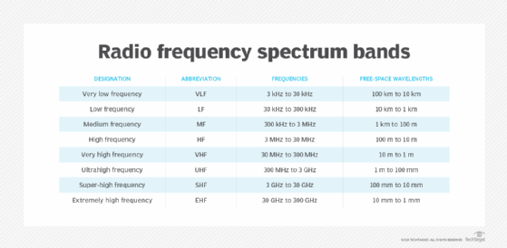

**Signals and Noise in Communication System:**

A signal is an electromagnetic or electrical current that carries data from one system or network to another. In electronics, a signal is often a time-varying voltage that is also an electromagnetic wave carrying information, though it can take on other forms, such as current. There are two main types of signals used in electronics: analog and digital signals. This article discusses the corresponding characteristics, uses, advantages and disadvantages, and typical applications of analog vs. digital signals.

Signal Strength:

Signal strength in mobile communication refers to the measurement of the power level of the radio signal received by a mobile device from a cellular network. It indicates the quality and reliability of the wireless connection between the mobile device and the network. Signal strength is typically measured in decibel milliwatts (dBm) or signal bars on the mobile device's display. The dBm scale represents the power level of the received signal relative to a reference level. A higher positive dBm value indicates a stronger signal, while a lower negative dBm value indicates a weaker signal. In most cases, a signal strength of around -50 dBm to -70 dBm is considered excellent, providing a strong and reliable connection. As the signal strength decreases, the quality of the connection may deteriorate, leading to dropped calls, slower data speeds, or difficulty establishing a connection. Signal strengths below -100 dBm may result in a complete loss of connectivity.

Several factors can affect signal strength, including:

Distance from the cellular tower: The farther away you are from a cellular tower, the weaker the signal is likely to be.

Obstructions: Buildings, trees, and other obstacles can attenuate or block the signal, reducing its strength.

Interference: Other electronic devices, physical obstructions, or nearby networks operating on the same frequency can cause signal interference.

Network congestion: High network usage or heavy traffic in a specific area can impact signal strength.

Weather conditions: Extreme weather conditions like storms or heavy rainfall can temporarily affect signal strength.

To improve signal strength, you can try the following:

Move closer to a window or go to an open area: This can reduce obstructions and improve the signal reception.

Avoid physical obstructions: Position yourself away from objects that may block the signal, such as large buildings or dense vegetation.

Restart your device: Sometimes, restarting your mobile device can help it reconnect to the network and improve signal strength.

Use Wi-Fi calling: If available, using a Wi-Fi network for calling can provide a more stable and reliable connection.

Consider using a signal booster: Signal boosters or repeaters can amplify the signal strength in areas with weak reception.

It's important to note that signal strength can vary depending on the cellular network, the technology used (2G, 3G, 4G, 5G), and the specific location you are in.

Analog Signal

An analog signal is time-varying and generally bound to a range (e.g. +12V to -12V), but there is an infinite number of values within that continuous range. An analog signal uses a given property of the medium to convey the signal’s information, such as electricity moving through a wire. In an electrical signal, the voltage, current, or frequency of the signal may be varied to represent the information. Analog signals are often calculated responses to changes in light, sound, temperature, position, pressure, or other physical phenomena.

Digital Signal

A digital signal is a signal that represents data as a sequence of discrete values. A digital signal can only take on one value from a finite set of possible values at a given time. With digital signals, the physical quantity representing the information can be many things:

|  |  |
| --- | --- |
| • • • • | Variable electric current or voltage  Phase or polarization of an electromagnetic field Acoustic pressure  The magnetization of a magnetic storage media |

Digital signals are used in all digital electronics, including computing equipment and data transmission devices. When plotted on a voltage vs. time graph, digital signals are one of two values, and are usually between 0V and VCC (usually 1.8V, 3.3V, or 5V)

In any communication system, during the transmission of the signal, or while receiving the signal, some unwanted signal gets introduced into the communication, making it unpleasant for the receiver, questioning the quality of the communication. Such a disturbance is called as Noise.

What is Noise?

Noise is an unwanted signal which interferes with the original message signal and corrupts the parameters of the message signal. This alteration in the communication process, leads to the message getting altered. It is most likely to be entered at the channel or the receiver.

The noise signal can be understood by taking a look at the following example.

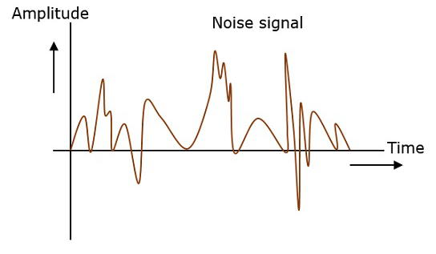

Hence, it is understood that noise is some signal which has no pattern and no constant frequency or amplitude. It is quite random and unpredictable. Measures are usually taken to reduce it, though it can’t be completely eliminated.

Most common examples of noise are −

• Hiss sound in radio receivers   
• Buzz sound amidst of telephone conversations   
• Flicker in television receivers, etc.

Effects of Noise

Noise is an inconvenient feature which affects the system performance. Following are the effects of noise.

Noise limits the operating range of the systems

Noise indirectly places a limit on the weakest signal that can be amplified by an amplifier. The oscillator in the mixer circuit may limit its frequency because of noise. A system’s operation depends on the operation of its circuits. Noise limits the smallest signal that a receiver is capable of processing.

Noise affects the sensitivity of receivers

Sensitivity is the minimum amount of input signal necessary to obtain the specified quality output. Noise affects the sensitivity of a receiver system, which eventually affects the output.

Types of Noise:

The classification of noise is done depending on the type of the source, the effect it shows or the relation it has with the receiver, etc.

There are two main ways in which noise is produced. One is through some external source while the other is created by an internal source, within the receiver section.

External Source

This noise is produced by the external sources which may occur in the medium or channel of communication, usually. This noise cannot be completely eliminated. The best way is to avoid the noise from affecting the signal.

Examples

Most common examples of this type of noise are −

• Atmospheric noise (due to irregularities in the atmosphere). • Extra-terrestrial noise, such as solar noise and cosmic noise. • Industrial noise.

Internal Source

This noise is produced by the receiver components while functioning. The components in the circuits, due to continuous functioning, may produce few types of noise. This noise is quantifiable. A proper receiver design may lower the effect of this internal noise.

Examples

Most common examples of this type of noise are –

• Thermal agitation noise (Johnson noise or Electrical noise).

• Shot noise (due to the random movement of electrons and holes).

• Transit-time noise (during transition).

• Miscellaneous noise is another type of noise which includes flicker, resistance effect and mixer generated noise, etc.

**Modulation and Demodulation:**

Modulation is the process of encoding information in a transmitted signal, while demodulation is the process of extracting information from the transmitted signal. Many factors influence

|  |  |  |  |  |  |  |  |  |
| --- | --- | --- | --- | --- | --- | --- | --- | --- |
| how | faithfully | the | extracted | information | replicates | the | original | input |

information. [Electromagnetic interference](https://www.techtarget.com/searchmobilecomputing/definition/electromagnetic-interference) can degrade signals and make the original signal impossible to extract. Demodulators typically include multiple stages of amplification and filtering in order to eliminate interference. A device that performs both modulation and demodulation is called a [modem](https://www.techtarget.com/searchmobilecomputing/definition/modem) -- a name created by combining the first letters of Modulator and Demodulator. A computer audio modem allows a computer to connect to another computer or to a data network over a regular analog phone line by using the data signal to modulate an

analog audio tone. A modem at the far end demodulates the audio signal to recover the data stream. A cable modem uses network data to modulate the cable service carrier signal.

**Amplitude Modulation and Frequency Modulation:**

Amplitude modulation and frequency modulation are used to transmit data using the method of modifying a carrier signal. The main difference between both modulations is that in frequency modulation, the carrier wave frequency is modified as per the transmit data. In contrast, in amplitude modulation, the carrier wave is modified according to the data.

For instance, if several sets of data are required to be transmitted using the same medium, then each set off is sent using different frequency waves. This is the process of how radio broadcasts are done.

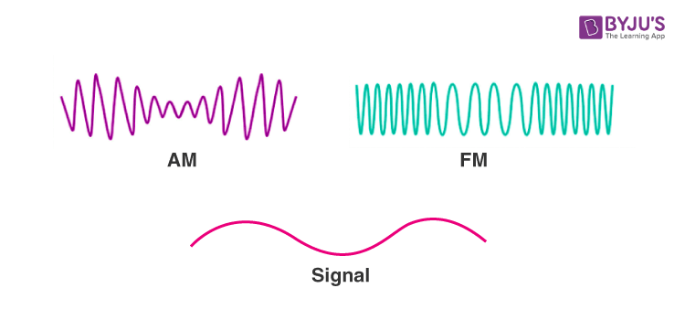

Amplitude Modulation

Amplitude modulation is a modulation technique where the amplitude of a carrier varies depending on the information signal. AM radio broadcast signals use lower carrier frequencies, which helps them travel long distances. Sometimes AM signals can be able to bounce off the ionosphere. The distance travelled by the AM is much larger than the FM.

Frequency Modulation

In this module, the carrier wave frequency is modified according to the signal that carries information. The radio signals have large bandwidth than AM radio signals, which helps to offer much better sound quality. Frequency modulation also enables to transmit stereo signals.

|  |  |  |  |  |  |  |  |  |  |  |
| --- | --- | --- | --- | --- | --- | --- | --- | --- | --- | --- |
| |  | | --- | | **Difference Between AM and FM** |  |  |  |  |  |  |  |  |  | | --- | --- | --- | --- | --- | --- | --- | --- | | |  | | --- | | Amplitude Modulation (AM) |  |  | | --- | | The first successful audio transmission was carried out in the mid-1870s |  |  | | --- | | The radio wave is called a carrier wave, and the frequency and phase remain the same | | |  | | --- | | Frequency Modulation (FM) |  |  | | --- | | Developed in 1930 by Edwin Armstrong, in the United States |  |  | | --- | | The radio wave is called a carrier wave, but the amplitude and phase remain the same | | | |
| Has poor sound quality, but can transmit longer distance | Has higher bandwidth with better sound quality |
| The frequency range of AM radio varies from 535 to 1705 kHz | The frequency range of FM is 88 to 108 MHz in the higher spectrum |
| More susceptible to noise | Less susceptible to noise |

**Digital Modulation Techniques:**

Digital Modulation provides more information capacity, high data security, quicker system availability with great quality communication. Hence, digital modulation techniques have a greater demand, for their capacity to convey larger amounts of data than analog ones.

There are many types of digital modulation techniques and we can even use a combination of these techniques as well. In this chapter, we will be discussing the most prominent digital modulation techniques.

**Amplitude Shift Keying:**

The amplitude of the resultant output depends upon the input data whether it should be a zero level or a variation of positive and negative, depending upon the carrier frequency.

Amplitude Shift Keying (ASK) is a type of Amplitude Modulation which represents the binary data in the form of variations in the amplitude of a signal.

Any modulated signal has a high frequency carrier. The binary signal when ASK is modulated, gives a zero value for LOW input and gives the carrier output for HIGH input.

Following is the diagram for ASK modulated waveform along with its input.

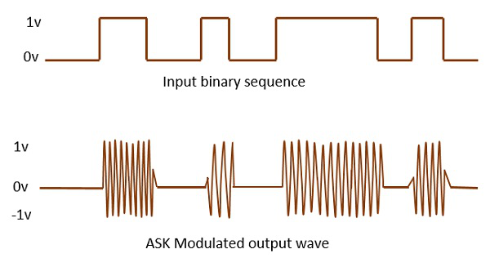

**Frequency Shift Keying:**

The frequency of the output signal will be either high or low, depending upon the input data applied.

Frequency Shift Keying (FSK) is the digital modulation technique in which the frequency of the carrier signal varies according to the discrete digital changes. FSK is a scheme of frequency modulation.

Following is the diagram for FSK modulated waveform along with its input.

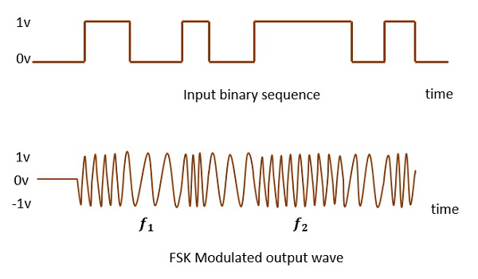

The output of a FSK modulated wave is high in frequency for a binary HIGH input and is low in frequency for a binary LOW input. The binary 1s and 0s are called Mark and Space frequencies.

**Phase Shift Keying:**

The phase of the output signal gets shifted depending upon the input. These are mainly of two types, namely BPSK and QPSK, according to the number of phase shifts. The other one is DPSK which changes the phase according to the previous value.

Phase Shift Keying (PSK) is the digital modulation technique in which the phase of the carrier signal is changed by varying the sine and cosine inputs at a particular time. PSK technique is widely used for wireless LANs, bio-metric, contactless operations, along with RFID and Bluetooth communications.

PSK is of two types, depending upon the phases the signal gets shifted. They are −

Binary Phase Shift Keying (BPSK)

This is also called as 2-phase PSK (or) Phase Reversal Keying. In this technique, the sine wave carrier takes two phase reversals such as 0° and 180°.

BPSK is basically a DSB-SC (Double Sideband Suppressed Carrier) modulation scheme, for message being the digital information.

Following is the image of BPSK Modulated output wave along with its input.

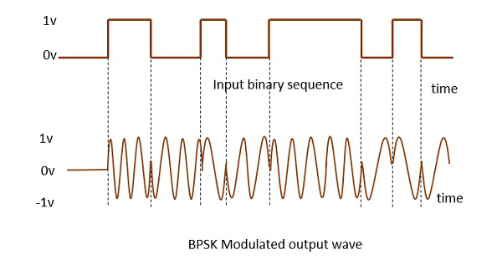

Quadrature Phase Shift Keying (QPSK)

This is the phase shift keying technique, in which the sine wave carrier takes four phase reversals such as 0°, 90°, 180°, and 270°.

If this kind of techniques are further extended, PSK can be done by eight or sixteen values also, depending upon the requirement. The following figure represents the QPSK waveform for two bits input, which shows the modulated result for different instances of binary inputs.

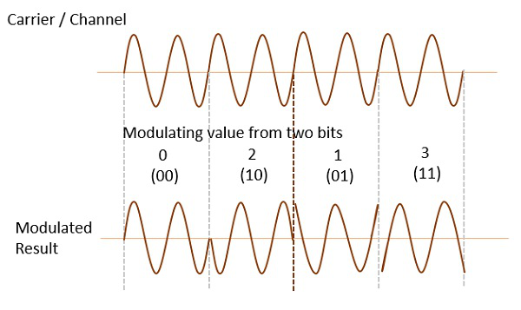

QPSK is a variation of BPSK, and it is also a DSB-SC (Double Sideband Suppressed Carrier) modulation scheme, which send two bits of digital information at a time, called as bigits.

Instead of the conversion of digital bits into a series of digital stream, it converts them into bit-pairs. This decreases the data bit rate to half, which allows space for the other users.

Differential Phase Shift Keying (DPSK)

In DPSK (Differential Phase Shift Keying) the phase of the modulated signal is shifted relative to the previous signal element. No reference signal is considered here. The signal phase follows the high or low state of the previous element. This DPSK technique doesn’t need a reference oscillator.

The following figure represents the model waveform of DPSK.

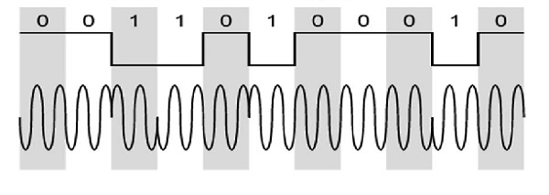

It is seen from the above figure that, if the data bit is LOW i.e., 0, then the phase of the signal is not reversed, but is continued as it was. If the data is HIGH i.e., 1, then the phase of the signal is reversed, as with NRZI, invert on 1 (a form of differential encoding).

If we observe the above waveform, we can say that the HIGH state represents an M in the modulating signal and the LOW state represents a W in the modulating signal.

**Multiple Access & It’s Techniques:**   
Sometimes a satellite’s service is present at a particular location on the earth station and sometimes it is not present. That means, a satellite may have different service stations of its own located at different places on the earth. They send carrier signal for the satellite. In this situation, we do multiple access to enable satellite to take or give signals from different stations at time without any interference between them. Following are the three types of multiple access techniques.

FDMA (Frequency Division Multiple Access) •  
 • TDMA (Time Division Multiple Access) • CDMA (Code Division Multiple Access) Now, let us discuss each technique one by one.

**FDMA**   
In this type of multiple access, we assign each signal a different type of frequency band (range). So, any two signals should not have same type of frequency range. Hence, there won’t be any interference between them, even if we send those signals in one channel.

One perfect example of this type of access is our radio channels. We can see that each station has been given a different frequency band in order to operate.

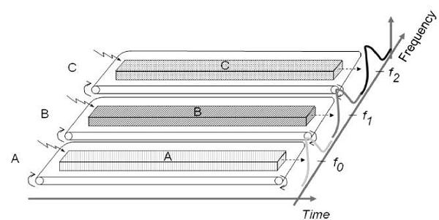

Let’s take three stations A, B and C. We want to access them through FDMA technique. So we assigned them different frequency bands.

As shown in the figure, satellite station A has been kept under the frequency range of 0 to 20 HZ. Similarly, stations B and C have been assigned the frequency range of 30-60 Hz and 70-90 Hz respectively. There is no interference between them.

The main disadvantage of this type of system is that it is very burst. This type of multiple access is not recommended for the channels, which are of dynamic and uneven. Because, it will make their data as inflexible and inefficient.

**TDMA**

As the name suggests, TDMA is a time based access. Here, we give certain time frame to each channel. Within that time frame, the channel can access the entire spectrum bandwidth

Each station got a fixed length or slot. The slots, which are unused will remain in idle stage.

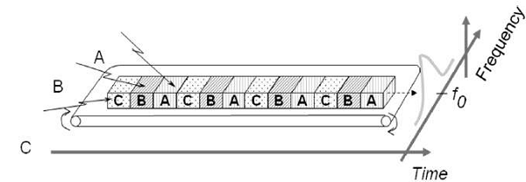

Suppose, we want to send five packets of data to a particular channel in TDMA technique. So, we should assign them certain time slots or time frame within which it can access the entire bandwidth.

In above figure, packets 1, 3 and 4 are active, which transmits data. Whereas, packets 2 and 5 are idle because of their non-participation. This format gets repeated every time we assign bandwidth to that particular channel.

Although, we have assigned certain time slots to a particular channel but it can also be changed depending upon the load bearing capacity. That means, if a channel is transmitting heavier loads, then it can be assigned a bigger time slot than the channel which is transmitting lighter loads. This is the biggest advantage of TDMA over FDMA. Another advantage of TDMA is that the power consumption will be very low.

Note − In some applications, we use the combination of both TDMA and FDMA techniques. In this case, each channel will be operated in a particular frequency band for a particular time frame. In this case, the frequency selection is more robust and it has greater capacity over time compression.

**CDMA**

In CDMA technique, a unique code has been assigned to each channel to distinguish from each other. A perfect example of this type of multiple access is our cellular system. We can see that no two persons’ mobile number match with each other although they are same X or Y mobile service providing company’s customers using the same bandwidth.

The basic advantage of this type of multiple access is that it allows all users to coexist and use the entire bandwidth at the same time. Since each user has different code, there won’t be any interference.

In this technique, a number of stations can have number of channels unlike FDMA and TDMA. The best part of this technique is that each station can use the entire spectrum at all time.

1. Frequency Division Multiple Access (FDMA) : FDMA is a type of channelization protocol. In this bandwidth is divided into various frequency bands. Each station is allocated with band to send data and that band is reserved for particular station for all the time which is as follows :

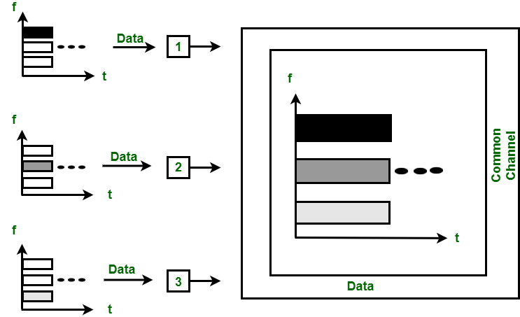

Figure – FDMA

The frequency bands of different stations are separated by small band of unused frequency and that unused frequency bands are called as guard bands that prevents the interference of stations. It is like access method in data link layer in which [data link layer](https://www.geeksforgeeks.org/design-issues-in-data-link-layer/) at each station tells its physical layer to make a band pass signal from the data passed to it. The signal is created in the allocated band and there is no physical multiplexer at the physical layer.

2. Time Division Multiple Access (TDMA) : TDMA is the channelization protocol in which bandwidth of channel is divided into various stations on the time basis. There is a time slot given to each station, the station can transmit data during that time slot only which is as follows :

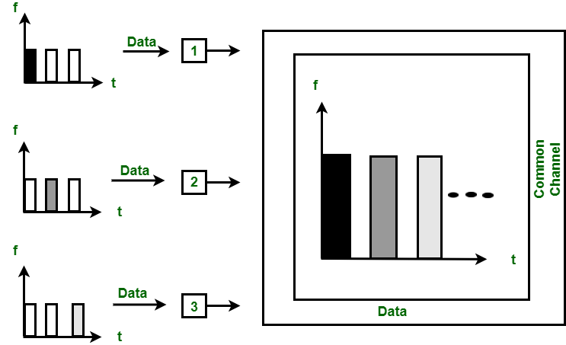

Figure – TDMA   
Each station must aware of its beginning of time slot and the location of the time slot. TDMA requires synchronization between different stations. It is type of access method in the data link layer. At each station data link layer tells the station to use the allocated time slot. 3. Code Division Multiple Access (CDMA) : In CDMA, all the stations can transmit data simultaneously. It allows each station to transmit data over the entire frequency all the time. Multiple simultaneous transmissions are separated by unique code sequence. Each user is assigned with a unique code sequence.

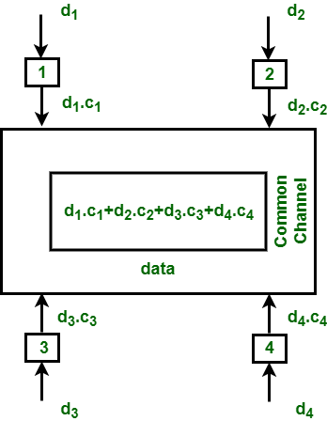

Figure – CDMA

In the above figure, there are 4 stations marked as 1, 2, 3 and 4. Data assigned with respective stations as d1, d2, d3 and d4 and the code assigned with respective stations as c1, c2, c3 and c4.

**Spread Spectrum Modulation:**

The increasing demand for wireless communications has problems due to limited spectrum efficiency and multipath propagation. The use of spread spectrum communication has simplified these problems. In the spread spectrum, signals from different sources are combined to fit into larger bandwidth.

Most stations use air as the medium for communication, stations must be able to share the medium without an interception and without being subject to jamming from a malicious intruder. To achieve this, spread-spectrum techniques add redundancy means it uses extended bandwidth to accommodate signals in a protective envelope so that more secure transmission is possible. The spread code is a series of numbers that looks random but are actually a pattern. The original bandwidth of the signal gets enlarged (spread) through the spread code as shown in the figure.

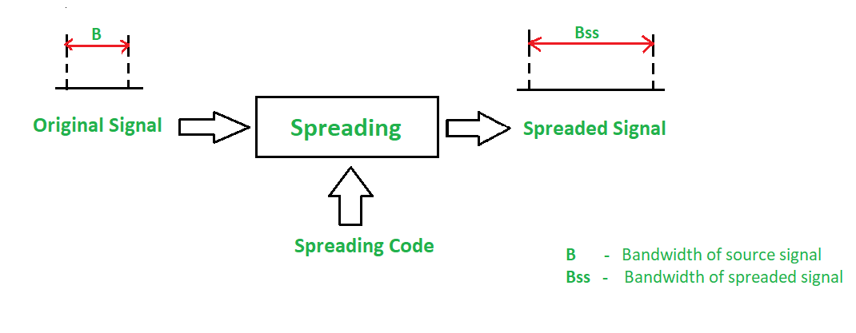

Spread Spectrum

Principles of Spread Spectrum process:

1.To allow redundancy, it is necessary that the bandwidth allocated to each station should be much larger than needed.

2.The spreading process occurs after the signal is created by the source.

Conditions of Spread Spectrum are:

1.The spread spectrum is a type of modulation where modulated signal BW is much larger than the baseband signal BW i.e. spread spectrum is a wide band scheme. 2.A special code (pseudo noise) is used for spectrum spreading and the same code is to be used to despread the signal at the receiver.

Characteristics of the Spread Spectrum are:

1.Higher channel capacity.

2.Ability to resist multipath propagation.

3.They cannot easily intercept any unauthorized person.

4.They are resistant to jamming.

5.The spread spectrum provides immunity to distortion due to multipath propagation.

6.The spread spectrum offers multiple access capabilities.

Two types of techniques for Spread Spectrum are:

1.Frequency Hopping Spread Spectrum (FHSS) 2.Direct Sequence Spread Spectrum (DSSS)

**Frequency Hopping Spread Spectrum (FHSS):**

In Frequency Hopping Spread Spectrum (FHSS), different carrier frequencies are modulated by the source signal i.e. M carrier frequencies are modulated by the signal. At one moment signal modulates one carrier frequency and at the subsequent moments, it modulates other carrier frequencies. The general block diagram of FHSS is shown in the below figure.

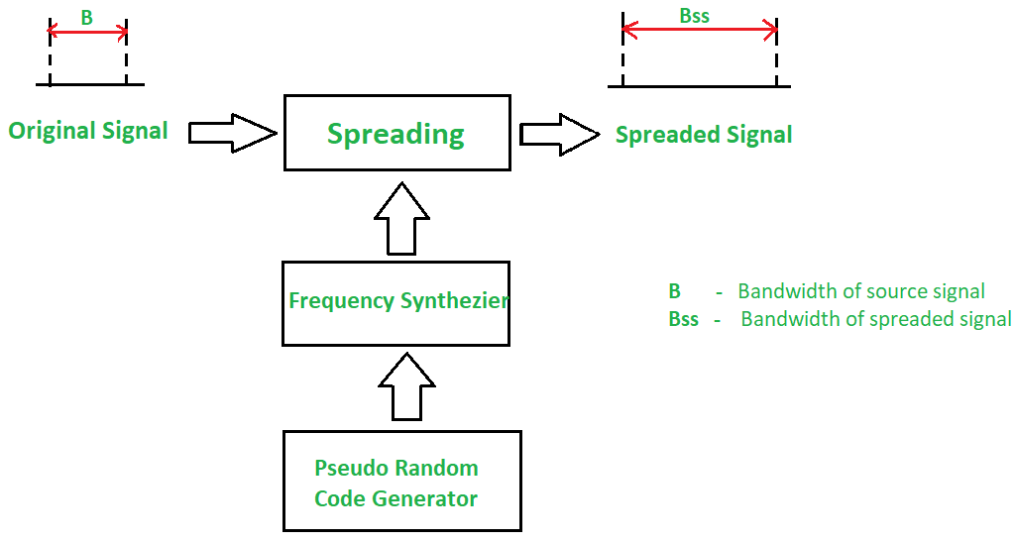

Frequency Hopping Spread Spectrum

A pseudorandom code generator generates Pseudo-random Noise of some pattern for each hopping period Th. The frequency corresponding to the pattern is used for the hopping period and is passed to the frequency synthesizer. The synthesizer generates a carrier signal of that frequency. The figure above shows the spread signal via FHSS.

Advantages of FHSS:

|  |  |
| --- | --- |
| • • | Synchronization is not greatly dependent on distance. Processing Gain is higher than DSSS. |

Disadvantages of FHSS:

|  |  |
| --- | --- |
| • • | The bandwidth of the FHSS system is too large (in GHz).  Complex and expensive Digital frequency synthesizers are required. |

**Direct Sequence Spread Spectrum (DSSS):**

In DSSS, the bandwidth of the original signal is also expanded by a different technique. Here, each data bit is replaced with n bits using a spreading code called chips, and the bit rate of the chip is called as chip-rate. The chip rate is n times the bit rate of the original signal. The below Figure shows the DSSS block diagram.

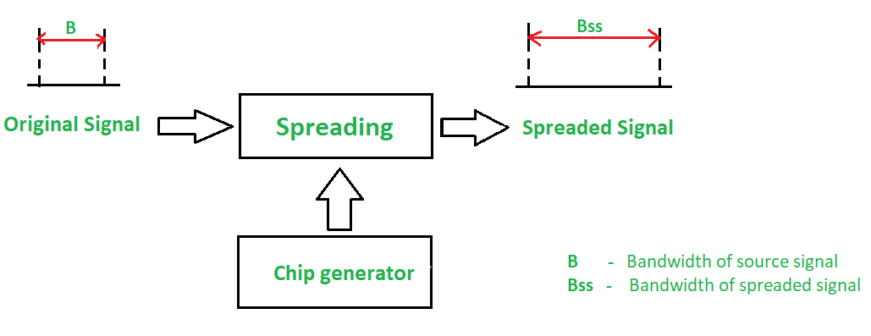

Direct Sequence Spread Spectrum

In wireless LAN, the sequence with n = 11 is used. The original data is multiplied by chips (spreading code) to get the spread signal. The required bandwidth of the spread signal is 11 times larger than the bandwidth of the original signal.

Advantages of DSSS:

|  |  |
| --- | --- |
| • • • | The DSSS System combats the jamming most effectively.  The performance of DSSS in presence of noise is superior to FHSS. Interference is minimized against the signals. |

Disadvantages of DSSS:

|  |  |
| --- | --- |
| • • • | Processing Gain is lower than DSSS.  Channel Bandwidth is less than FHSS.  Synchronization is affected by the variable distance between the transmitter and |

receiver.

**Prepared by Dr. Chiranjit Dutta**