Lab 3: Component Modelling & Architectural Pattern Selection
EV Charging Station Reservation System — Smart Cities, Transport & Logistics

1. Component Diagram
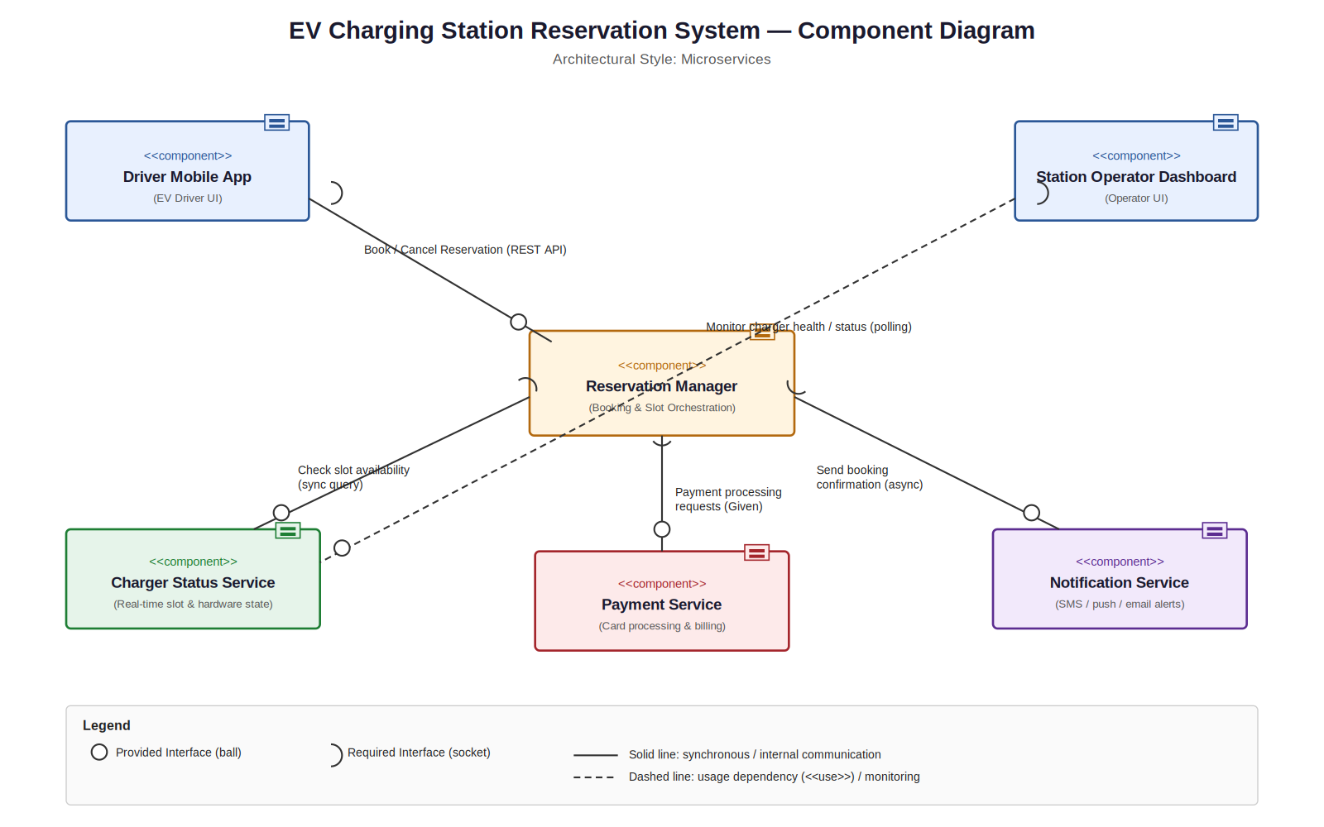

2. Written Justification
Architecture Selection: We chose Microservices Architecture for the EV Charging Station Reservation System.
Reason 1 — Independent Scaling: Reservation demand spikes sharply during peak commute hours across many city locations, while operator dashboards and notification traffic follow a much steadier load. Microservices let the Reservation Manager and Charger Status Service scale independently based on real-time demand, without over-provisioning the entire system.
Reason 2 — Fault Isolation Across a Distributed City-Wide Network: Charging stations are physically distributed across the city and connect over unreliable networks. If the Charger Status Service for one cluster of stations goes offline, microservices isolate the failure so that the Payment Service and Reservation Manager continue operating for stations that remain reachable — a single monolithic layer would risk a citywide outage.
Security Advantage: Isolating the Payment Service as its own microservice restricts card-handling logic and credentials to a single, independently secured boundary. The Driver Mobile App and other services never touch payment data directly — they only invoke a well-defined API — which shrinks the PCI-DSS compliance surface and limits the blast radius of any breach elsewhere in the system.
Performance Benefit: Because the Charger Status Service is decoupled from the Reservation Manager, real-time slot-availability queries are served by a lightweight, purpose-built service that can be cached and horizontally scaled, keeping booking response times low even as the number of connected charging stations grows across the city.

3. Components & Interfaces Summary
Components (6): Driver Mobile App, Station Operator Dashboard, Reservation Manager, Charger Status Service, Payment Service, Notification Service.
Interfaces (5): Driver App ↔ Reservation Manager (book/cancel), Reservation Manager ↔ Payment Service (payment processing — given), Reservation Manager ↔ Charger Status Service (slot availability), Reservation Manager ↔ Notification Service (booking confirmation), Station Operator Dashboard ↔ Charger Status Service (monitor charger health).

