**Omicron, a variant of concern**

**Origin of Omicron**

Researchers all over the world are hard at work determining the particular traits and origins of coronavirus omicron variants, the virus's ancestors. It may appear scholarly. However, knowing about it aids scientists in determining when the pandemic will finish and the best method to defend themselves from subsequent virus versions. Although there isn't much information (at the time of writing), Omicron is known to be harmful. The mutants have over 50 alterations, the majority of which are identified in viral spike proteins that infect human cells. Existing vaccinations against omicron are less effective. It is possible to become infected even if you have been vaccinated. It can "evade" or avoid our immunological reaction. The variant appears to be more contagious or transmissible than other variants, and some experts are concerned that many more infections in a short space of time may push health systems beyond their limits.

**Three theories on omicron's origin**

1. **Theory one: It evolved undetected in an isolated population**

Omicron may have evolved in a living human population in which the virus has been circulating for some time. These individuals may have been infected and recovered without recognition or diagnosis and without testing or sequencing the infected viral strain.

Christian Drosten, a virologist at Charité in Berlin, told Science that Omicron "did not evolve in South Africa, where there are many sequences, but evolved somewhere in southern Africa during the winter waves. ". It is a long-lasting number of infectious diseases and requires truly tremendous evolutionary pressure for this type of virus to evolve. "

1. **Theory two: It evolved in a person with weak immunity**

Omicron may occur in people with suppressed innate immunity, such as those who are chronically ill or whose immune system is weakened by drugs.

It may be someone who has some form of cancer or HIV. With weakened immunity, it takes longer to fight a viral infection. This allows the virus to give more time to develop and mutate to circumvent a person's immune response and defense.

Richard Lessells, an infectious disease researcher at KwaZulu-Natal University, supports this theory.

1. **Theory three**: **It evolved in an animal host and jumped back**

It is possible that the virus hid in an animal host, evolved into Omicron, and then returned to a human host. Kristian Andersen, an infectious disease researcher at

Scripps Research, and Mike Worobey, an evolutionary biologist at the University of Arizona at Tucson, support this theory.

**Statics on Omicron and COVID-19**

In the United States, weekly cases of the COVID 19 Omicron variant have increased significantly. Currently, 95.4% of COVID cases tested are due to the Omicron mutation and 4.6% are due to the Delta. The country's Omicron number has increased to 5,488, with Maharashtra (1,367) and Rajasthan (792) contributing to most cases of the new subspecies.

There are currently 549 cases in Delhi, Kerala 486, Karnataka 479, West Bengal 294, and UP 275. As of January 7, 2022, the global cumulative number of COVID 19 is 300,451,850.

The total number of deaths from COVID 19 worldwide is 5,474,348. Weekly increases in 19 cases of COVID were reported in all regions. From December 27, 2021, to January 2, 2022, the number of new deaths decreased by 10% compared to the previous week.

According to data from Johns Hopkins University, the U.S. has reported a record single-day number of new daily COVID cases on Monday, January 3, 2022, with a total of 1,082,549 new infections.

Based on data coming in from South Africa, COVID-19 deaths attributed to the Omicron variant are low.

The Americas region has the most significant increase in new COVID-19 cases (100%). The percent increase for the other regions are:

South-East Asia – 78%, The European region – 65%, Eastern Mediterranean – 40%, Western Pacific – 38%, African region – 7%

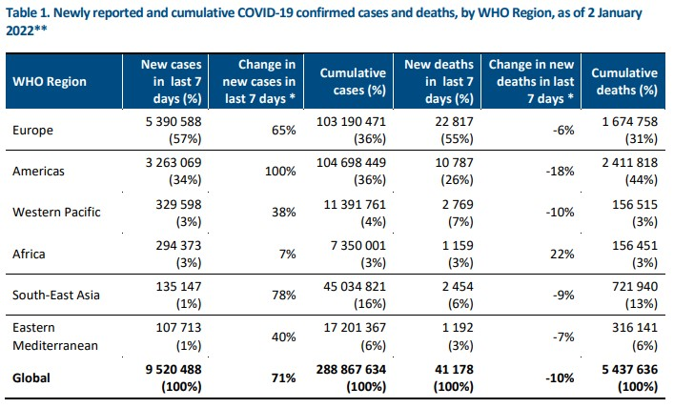

**What is a Variant of Concern (VOC)?**

As the virus propagates, all types of viruses, including SARSCoV2, acquire genetic material or genomic mutations. The virus mutated into several variants during a pandemic. Scientists are constantly collecting data on various mutations around the world by examining gene sequences in the laboratory to detect the transmission and severity of the diseases caused by these mutations. Therefore, although these variants share a common ancestor or lineage that initiated a pandemic in Wuhan, the virus's characteristics have changed over the past two years, especially invariants that are too mutated. Greek letters were used to identify variants. These affect diagnostic, therapeutic, vaccination, and management strategies.

**The SARS-CoV-2 variants are classified as :**

**Variants Being Monitored (VBM) (eg. Alpha, Beta, Gamma)-**not a significant threat to the public at present and are circulating at low levels.

**Variant Of Interest (VOI)(no variant at present)-**has specific attributes including changes in the receptor binding, transmission, potential pf increase in clusters of cases.

**Variant Of Concern (VOC)(eg. Delta, Omicron)-**increased transmission or more severe disease

**Variant Of High Consequence (VOHC) (no variant at present)-**failure to be detected by current diagnostic tests and significantly reduced susceptibility to treatment and vaccines, more severe disease.

The status of a variant can be escalated or deescalated by WHO based on the data collected about the behavior of the variant. Alpha, Beta, and Gamma were VOCs in December 2020 but were changed to VBMs in September 2021. The delta variant was first identified in India. Omicrons are known as VOCs because they have multiple mutations and substitutions in the spike protein and have replaced the South African delta mutant. It is also found in patients who have never traveled to some countries of the world. It may be less susceptible to vaccine protection and treatment, including currently available monoclonal antibodies. Scientists are still collecting evidence of the contagiousness of the disease and the severity of Omicron.

**Symptoms and precaution**

The top symptoms in both periods were:

* runny nose
* headache
* fatigue (mild or severe)
* sneezing
* sore throat

According to reliable sources, many symptoms of infections caused by the Omicron variant of COVID 19 are similar to those of the common cold. In patients infected with the COVID19Omicron variant, a runny nose, slight body temperature, headache, and sore throat, which usually occur with the common cold, were also predominantly observed.

According to the National Center for Disease Control and Prevention (CDC), cough, shortness of breath or dyspnea, fatigue, muscle or body pain, headache, newly developed loss of taste or odor, sore throat, congestion, or nasal nose, nausea, or vomiting. , And diarrhea are the most common symptoms of Omicron-related COVID19 infections. Elderly people and people with serious underlying illnesses such as heart and lung disease and diabetes appear to be at increased risk of developing more serious complications from COVID19 disease.

The UK`s National Health Service (NHS) says the primary signs and symptoms of COVID-19 are excessive temperatures, a brand new or non-stop cough, and loss or alternate to feel of scent or taste.

With this and as consistent with the information to be had from different legit sources, it could be visible that the signs and symptoms advanced because of contamination from the Omicron version of COVID-19 is a good deal just like the signs and symptoms standardized earlier.

Once someone receives the Omicron contamination signs and symptoms, she or he must move into self-isolation. Quarantine, even though sounds harrowing majorly because of the stressful surroundings we're in proper now, is one of the best methods to reduce the chain of transmission of COVID-19. One must additionally take clinical help frequently from the onset of the contamination until it subsides.

The best way to stay safe currently is by following all WHO and Government-mandated safety measures for Omicron –

* Get vaccinated if you haven’t
* Maintain physical distancing,
* Limit your travel outside as much as possible and avoid crowding at all costs.
* Wear a mask when stepping out or meeting any outsider
* Follow hand hygiene and respiratory etiquettes
* Do not ignore any signs of illness (fever, weakness, sore throat) and consult your doctor immediately