

**Farmer's Pal**

**CBS3012 - IT Project Management**

**B.Tech (Computer Science specialization in Business System)**

*By*

Siddhartha Purwar [19BBS0072]

Tanishq Mehta [19BBS0178]

Shivangi Sharma [19BBS0114]

Vinesh [19BBS0059]

Nishil Madhani [19BBS0065]

Abhiram B [19BBS0042]

*To*

Professor Senthilnathan – SCOPE

***On***

***31-January 2022***

**Winter Semester 2021-22**

**Gantt Chart**

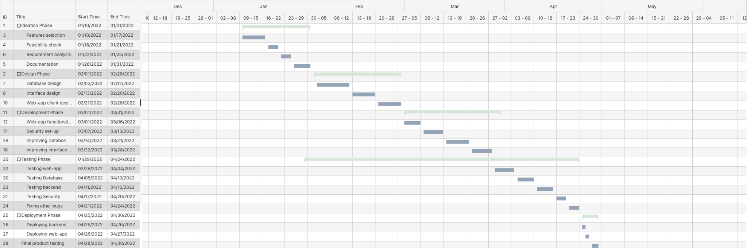

**TimeLine Chart**

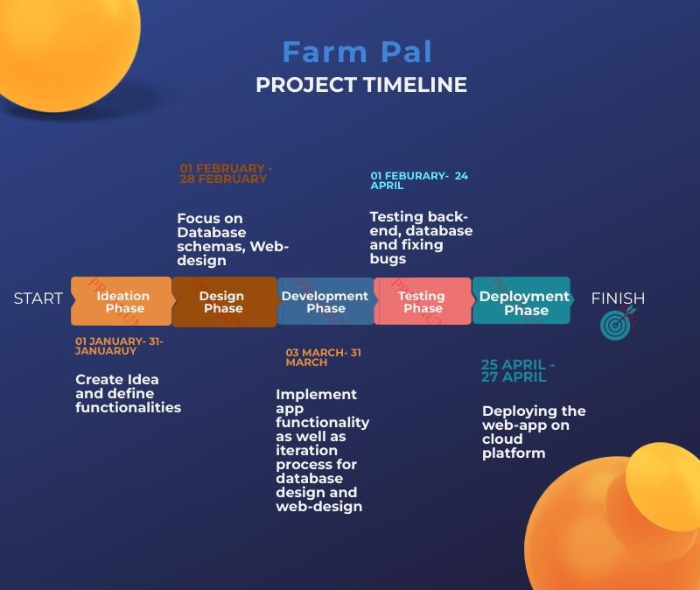

**PERT CHART**

