  CBS1006 Principles of Operating Systems  DA-I | Siddhartha Purwar  19BBS0072

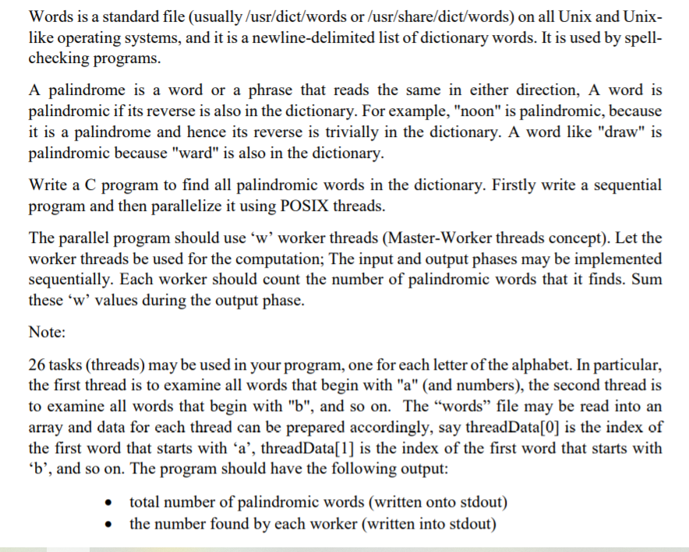

Version 1 (able to handle all characters and only one thread )
#include <stdio.h>
#include <pthread.h>
#include <ctype.h>
#include <string.h>
#include <math.h>
#include <stdlib.h>

#define MAXWORD 1000000
#define MAXLETTER 30
#define READLIMIT 50000

void read_data();
void process_data();
void display_data();
int check_for_palindrome_word(char, int);
int check_for_palindrome_word_default(int);
long long int index_global = 0;
long long int per_letter[26];
int total_palindorme = 0;
int data[MAXWORD][MAXLETTER];
long long int c = 0, j = 0, i = 0, length = 0, index_i = 0, o = 0;
char *strrev(char *str)
{
char *p1, *p2;

if (! str || ! *str)
return str;
for (p1 = str, p2 = str + strlen(str) - 1; p2 > p1; ++p1, --p2)
{
*p1 ^= *p2;
*p2 ^= *p1;
*p1 ^= *p2;
}
return str;
}

void * function_0(void * index_temp){
int *index_inside_temp = (int *)index_temp;
int index_inside = (*index_inside_temp);
char a[MAXLETTER];
char b[MAXLETTER];
int num = 0, i = 0, j = 0;
for(i = 0; data[index_inside][i] != '\0' ;i++){
a[i] = data[index_inside][i];
}
a[i] = '\0';
for(index_inside; index_inside < o; index_inside++){
for(j = 0; data[index_inside][j] != '\0'; j++){
b[j] = data[index_inside][j];
}
b[j] = '\0';
strrev(b);
if(strcmp(a, b)){
num++;
if(('a' <= a[0]) && (a[0] <= 'z')){
per_letter[a[0] - 97] += num;
}
else{
per_letter[26] += num;
}
}
}
pthread_exit(NULL);
}

int main(){

read_data();
//display_data();//uncomment this for display all data....ALERT set MAXREAD before uncommenting this otherwise it will print more than 400000 words
process_data();
printf("\ndata word in each letter class\n");
for(int h = 0; h < 27; h++){
per_letter[h] = (-1 + (pow(1 + (8 * per_letter[h]), 0.5)))/2;
printf("%c\t%lld\n",h+97, per_letter[h]);
}

return 0;
}

void read_data(){
FILE *filePointer;
j = 0;
length = 0;
c = 0;
filePointer = fopen("test.txt", "r");
if(filePointer == NULL){
perror("File not opened");
}
while(!feof(filePointer) && (o <= READLIMIT)){
c = getc(filePointer);
if(c == '\n'){
data[length++][j] = '\0';
o++;
j = 0;

}
else{
if(('a' <= c) && (c <= 'z')){
data[length][j++] = c;
}
else{
c = tolower(c);
data[length][j++] = c;
}
}
}
printf("total number of word is %lld\n", o);
}

void display_data(){
int k = 0, l = 0, i;
printf("Printing data\n");
for(k; k <= length; k++){
for(l = 0; data[k][l] != '\0';l++){
printf("%c", data[k][l]);
}
printf("\n");
}
}

void process_data(){
pthread_t tpid[28];
int *ptr;
char c;
index_global = 0;
for(index_global; index_global <= o; index_global++){

pthread_create(&tpid[26], NULL, function_0, &index_global);
pthread_join(tpid[26], NULL);

}
}

OUTPUT (word limit set to 5000 and display function is commented):
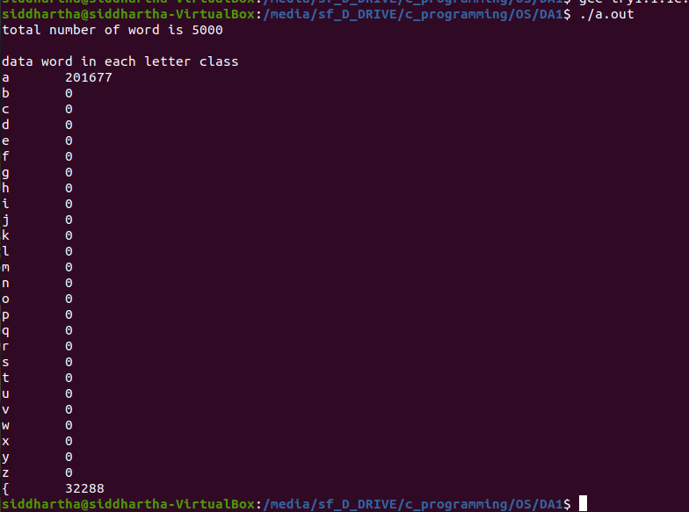
Issue: function_0 is not giving expected output, function_0 is responsible for checking the palindrome word.
OUTPUT (word limit set to 15 and display function is un-commented):

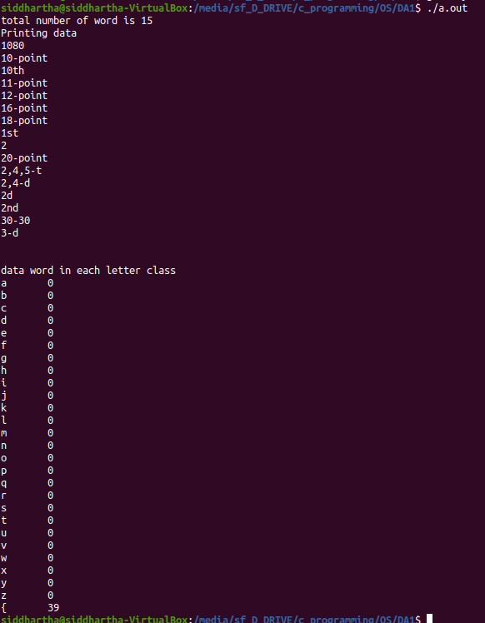
Issue: function_0 is not giving expected output, function_0 is responsible for checking the palindrome word.

VERSION 2(able to handle only english alphabet and having 26 threads):

#include <stdio.h>
#include <pthread.h>
#include <ctype.h>
#include <string.h>
#include <math.h>
#include <stdlib.h>

#define MAXWORD 1000000
#define MAXLETTER 30
#define MAXREAD 50

void read_data();
void process_data();
void display_data();
int check_for_palindrome_word(char, int);
int index_global = 0;
int per_letter[26];

void * function_a(void * index_temp){
int *index_inside = (int *)index_temp;
index_global = check_for_palindrome_word('a', (*index_inside));
pthread_exit(&index_global);
}
void * function_b(void * index_temp){
int *index_inside = (int *)index_temp;
index_global = check_for_palindrome_word('b', (*index_inside));
pthread_exit(&index_global);
}
void * function_c(void * index_temp){
int *index_inside = (int *)index_temp;
index_global = check_for_palindrome_word('c', (*index_inside));
pthread_exit(&index_global);

}
void * function_d(void * index_temp){
int *index_inside = (int *)index_temp;
index_global = check_for_palindrome_word('d', (*index_inside));
pthread_exit(&index_global);

}
void * function_e(void * index_temp){
int *index_inside = (int *)index_temp;
index_global = check_for_palindrome_word('e', (*index_inside));
pthread_exit(&index_global);

}
void * function_f(void * index_temp){
int *index_inside = (int *)index_temp;
index_global = check_for_palindrome_word('f', (*index_inside));
pthread_exit(&index_global);

}
void * function_g(void * index_temp){
int *index_inside = (int *)index_temp;
index_global = check_for_palindrome_word('g', (*index_inside));
pthread_exit(&index_global);

}
void * function_h(void * index_temp){
int *index_inside = (int *)index_temp;
index_global = check_for_palindrome_word('h', (*index_inside));
pthread_exit(&index_global);

}
void * function_i(void * index_temp){
int *index_inside = (int *)index_temp;
index_global = check_for_palindrome_word('i', (*index_inside));
pthread_exit(&index_global);

}
void * function_j(void * index_temp){
int *index_inside = (int *)index_temp;
index_global = check_for_palindrome_word('j', (*index_inside));
pthread_exit(&index_global);
}
void * function_k(void * index_temp){
int *index_inside = (int *)index_temp;
index_global = check_for_palindrome_word('k', (*index_inside));
pthread_exit(&index_global);

}
void * function_l(void * index_temp){
int *index_inside = (int *)index_temp;
index_global = check_for_palindrome_word('l', (*index_inside));
pthread_exit(&index_global);

}
void * function_m(void * index_temp){
int *index_inside = (int *)index_temp;
index_global = check_for_palindrome_word('m', (*index_inside));
pthread_exit(&index_global);

}
void * function_n(void * index_temp){
int *index_inside = (int *)index_temp;
index_global = check_for_palindrome_word('n', (*index_inside));
pthread_exit(&index_global);

}
void * function_o(void * index_temp){
int *index_inside = (int *)index_temp;
index_global = check_for_palindrome_word('o', (*index_inside));
pthread_exit(&index_global);

}
void * function_p(void * index_temp){
int *index_inside = (int *)index_temp;
index_global = check_for_palindrome_word('p', (*index_inside));
pthread_exit(&index_global);

}
void * function_q(void * index_temp){
int *index_inside = (int *)index_temp;
index_global = check_for_palindrome_word('q', (*index_inside));
pthread_exit(&index_global);

}
void * function_r(void * index_temp){
int *index_inside = (int *)index_temp;
index_global = check_for_palindrome_word('r', (*index_inside));
pthread_exit(&index_global);

}
void * function_s(void * index_temp){
int *index_inside = (int *)index_temp;
index_global = check_for_palindrome_word('s', (*index_inside));
pthread_exit(&index_global);

}
void * function_t(void * index_temp){
int *index_inside = (int *)index_temp;
index_global = check_for_palindrome_word('t', (*index_inside));
pthread_exit(&index_global);

}
void * function_u(void * index_temp){
int *index_inside = (int *)index_temp;
index_global = check_for_palindrome_word('u', (*index_inside));
pthread_exit(&index_global);

}
void * function_v(void * index_temp){
int *index_inside = (int *)index_temp;
index_global = check_for_palindrome_word('v', (*index_inside));
pthread_exit(&index_global);

}
void * function_w(void * index_temp){
int *index_inside = (int *)index_temp;
index_global = check_for_palindrome_word('w', (*index_inside));
pthread_exit(&index_global);

}
void * function_x(void * index_temp){
int *index_inside = (int *)index_temp;
index_global = check_for_palindrome_word('x', (*index_inside));
pthread_exit(&index_global);

}
void * function_y(void * index_temp){
int *index_inside = (int *)index_temp;
index_global = check_for_palindrome_word('y', (*index_inside));
pthread_exit(&index_global);

}
void * function_z(void * index_temp){
int *index_inside = (int *)index_temp;
index_global = check_for_palindrome_word('z', (*index_inside));
pthread_exit(&index_global);
}

int total_palindorme = 0;
int data[MAXWORD][MAXLETTER];
long long int c = 0, j = 0, i = 0, length = 0, index_i = 0, o = 0;

int main(){
for(int h = 0; h < 26; h++){
per_letter[h] = 0;
}
read_data();
// display_data();//uncomment this for display all data....ALERT set MAXREAD before uncommenting this otherwise it will print more than 400000 words

process_data();
printf("\ndata word in each letter class\n");
for(int h = 0; h < 27; h++){
per_letter[h] = (-1 + (pow(1 + (8 * per_letter[h]), 0.5)))/2;
printf("%c\t%d\n",h + 97, per_letter[h]);
}
return 0;
}

int check_for_palindrome_word(char ch, int ind){
long long int length;
long long int num, i, j, temp_count;
int word[30];
i = j = num = temp_count = 0;
int q = 0;
printf("\n");

for(ind; data[ind][0] - ch == 0; ind++){

for(length = 0; data[ind][length] != '\0'; length++){
word[length] = data[ind][length];
}
q = 0;
for(i = ind; i < o; i++){
for(j = 0; (word[j] - data[i][length - j - 1]) == 0; j++){
;
}
if(j == (length - 1)){
num++;
}
}
}
per_letter[ch - 97] += num;
return ind;
}

void read_data(){
FILE *filePointer;
j = 0;
length = 0;
c = 0;
filePointer = fopen("test.txt", "r");
if(filePointer == NULL){
perror("File not opened");
}
while(!feof(filePointer) && (o < MAXREAD)){
c = getc(filePointer);
if(c == '\n'){
data[length++][j] = '\0';
o++;
j = 0;

}
else{
c = tolower(c);
data[length][j++] = c;
}
}
printf("total number of word is %lld", o);
}

void display_data(){
int k = 0, l = 0;
printf("Printing data\n");
for(k; k <= length; k++){
for(l = 0; data[k][l] != '\0';l++){
printf("%c", data[k][l]);
}
printf("\n");
}
}

void process_data(){
pthread_t tpid[28];
int *ptr;
index_global = 0;
for(index_global; index_global <= o;index_global++){
switch(data[index_global][0]){
case 'a':
pthread_create(&tpid[0], NULL, function_a, &index_global);
pthread_join(tpid[0], (void**)&ptr);
index_global = (*ptr) - 1;
break;
case 'b':
pthread_create(&tpid[1], NULL, function_b, &index_global);
pthread_join(tpid[1], (void**)&ptr);
index_global = (*ptr) - 1;
break;

case 'c':
pthread_create(&tpid[2], NULL, function_c, &index_global);
pthread_join(tpid[2], (void**)&ptr);
index_global = (*ptr) - 1;
break;
case 'd':
pthread_create(&tpid[3], NULL, function_d, &index_global);
pthread_join(tpid[3], (void**)&ptr);
index_global = (*ptr) - 1;
break;
case 'e':
pthread_create(&tpid[4], NULL, function_e, &index_global);
pthread_join(tpid[4], (void**)&ptr);
index_global = (*ptr) - 1;
break;
case 'f':
pthread_create(&tpid[5], NULL, function_f, &index_global);
pthread_join(tpid[5], (void**)&ptr);
index_global = (*ptr) - 1;
break;
case 'g':
pthread_create(&tpid[6], NULL, function_g, &index_global);
pthread_join(tpid[6], (void**)&ptr);
index_global = (*ptr) - 1;
break;
case 'h':
pthread_create(&tpid[7], NULL, function_h, &index_global);
pthread_join(tpid[7], (void**)&ptr);
index_global = (*ptr) - 1;
break;
case 'i':
pthread_create(&tpid[8], NULL, function_i, &index_global);
pthread_join(tpid[8], (void**)&ptr);
index_global = (*ptr) - 1;
break;
case 'j':
pthread_create(&tpid[9], NULL, function_j, &index_global);
pthread_join(tpid[9], (void**)&ptr);
index_global = (*ptr) - 1;
break;
case 'k':
pthread_create(&tpid[10], NULL, function_k, &index_global);
pthread_join(tpid[10], (void**)&ptr);
index_global = (*ptr) - 1;
break;
case 'l':
pthread_create(&tpid[11], NULL, function_l, &index_global);
pthread_join(tpid[11], (void**)&ptr);
index_global = (*ptr) - 1;
break;
case 'm':
pthread_create(&tpid[12], NULL, function_m, &index_global);
pthread_join(tpid[12], (void**)&ptr);
index_global = (*ptr) - 1;
break;
case 'n':
pthread_create(&tpid[13], NULL, function_n, &index_global);
pthread_join(tpid[13], (void**)&ptr);
index_global = (*ptr) - 1;
break;
case 'o':
pthread_create(&tpid[14], NULL, function_o, &index_global);
pthread_join(tpid[14], (void**)&ptr);
index_global = (*ptr) - 1;
break;
case 'p':
pthread_create(&tpid[15], NULL, function_p, &index_global);
pthread_join(tpid[15], (void**)&ptr);
index_global = (*ptr) - 1;
break;
case 'q':
pthread_create(&tpid[16], NULL, function_q, &index_global);
pthread_join(tpid[16], (void**)&ptr);
index_global = (*ptr) - 1;
break;
case 'r':
pthread_create(&tpid[17], NULL, function_r, &index_global);
pthread_join(tpid[17], (void**)&ptr);
index_global = (*ptr) - 1;
break;
case 's':
pthread_create(&tpid[18], NULL, function_s, &index_global);
pthread_join(tpid[18], (void**)&ptr);
index_global = (*ptr) - 1;
break;
case 't':
pthread_create(&tpid[19], NULL, function_t, &index_global);
pthread_join(tpid[19], (void**)&ptr);
index_global = (*ptr) - 1;
break;
case 'u':
pthread_create(&tpid[20], NULL, function_u, &index_global);
pthread_join(tpid[20], (void**)&ptr);
index_global = (*ptr) - 1;
break;
case 'v':
pthread_create(&tpid[21], NULL, function_v, &index_global);
pthread_join(tpid[21], (void**)&ptr);
index_global = (*ptr) - 1;
break;
case 'w':
pthread_create(&tpid[22], NULL, function_w, &index_global);
pthread_join(tpid[22], (void**)&ptr);
index_global = (*ptr) - 1;
break;
case 'x':
pthread_create(&tpid[23], NULL, function_x, &index_global);
pthread_join(tpid[23], (void**)&ptr);
index_global = (*ptr) - 1;
break;
case 'y':
pthread_create(&tpid[24], NULL, function_y, &index_global);
pthread_join(tpid[24], (void**)&ptr);
index_global = (*ptr) - 1;
break;
case 'z':
pthread_create(&tpid[25], NULL, function_z, &index_global);
pthread_join(tpid[25], (void**)&ptr);
index_global = (*ptr) - 1;
break;
default:
break;
}

}
}

OUTPUT (word limit set to 1000 and display function is un-commented):

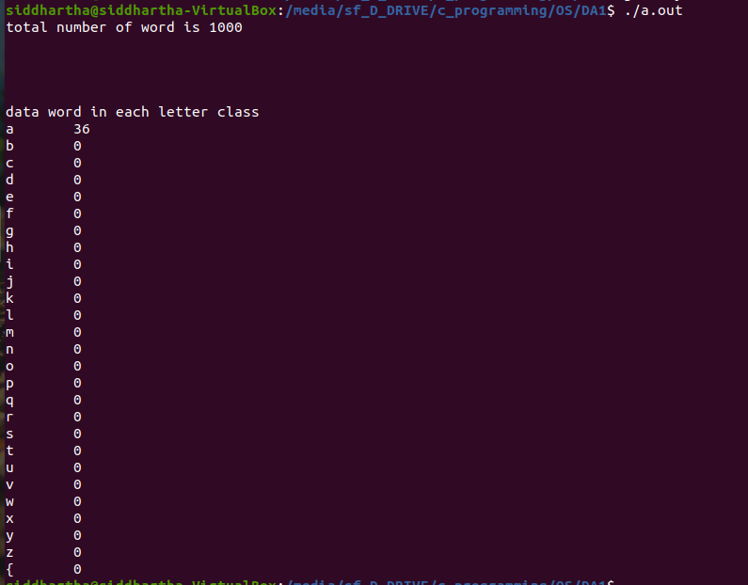

Issue: palindrome word is not correct.

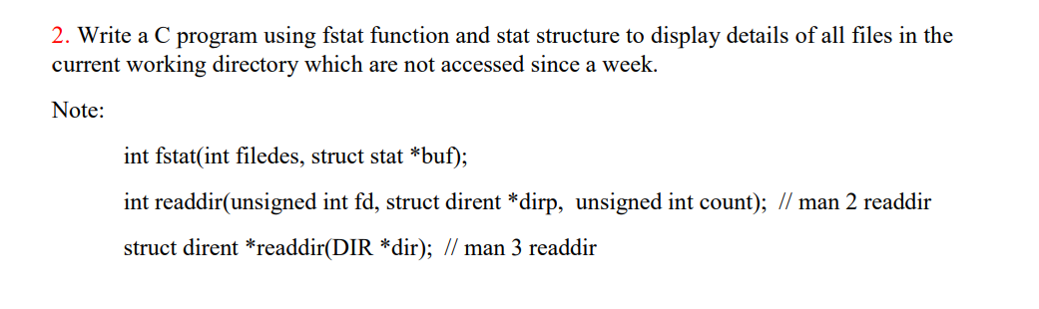
CODE:
#include <dirent.h>
#include <errno.h>
#include <fcntl.h>
#include <sys/types.h>
#include <stdio.h>
#include <sys/stat.h>
#include <time.h>
#include <stdlib.h>

char* formatdate(char* str, time_t val);//for converting dates in readable format.
int main(){

DIR *dir;
struct stat info;
struct dirent *entry;

int file=0;
char date[36];
time_t second;
second = time(NULL);

system("ls -la");

printf("\n\nfiles not accessed since last week are:\n\n");
if((dir = opendir(".")) == NULL){
perror("Opendir() error");
}
else{

while((entry = readdir(dir)) != NULL){
if((file=open(entry->d_name,O_RDONLY)) < -1){
perror("file discriptor");
}
else{
if(fstat(file, &info) < 0){
perror("fstat error");
}
else{

if((second - info.st_atime) > 604800){//604800 is the number of seconds in a week.
printf("%ld\t%d\t%ld\t%d\t%d\t%s\t%s\n", info.st_ino, info.st_mode, info.st_size, info.st_uid, info.st_gid,formatdate(date, info.st_atime), entry->d_name);
}
}
}

}
closedir(dir);
}
printf("\n\nfiles not modified since last week are:\n\n");
if((dir = opendir(".")) == NULL){
perror("Opendir() error");
}
else{

while((entry = readdir(dir)) != NULL){
if((file=open(entry->d_name,O_RDONLY)) < -1){
perror("file discriptor");
}
else{
if(fstat(file, &info) < 0){
perror("fstat error");
}
else{

if((second - info.st_mtime) > 604800){
printf("%ld\t%d\t%ld\t%d\t%d\t%s\t%s\n", info.st_ino, info.st_mode, info.st_size, info.st_uid, info.st_gid,formatdate(date, info.st_mtime), entry->d_name);
}
}
}

}
closedir(dir);
}
return 0;
}
char* formatdate(char* str, time_t val){
strftime(str, 36, "%d.%m.%Y", localtime(&val));
return str;
}

OUTPUT:
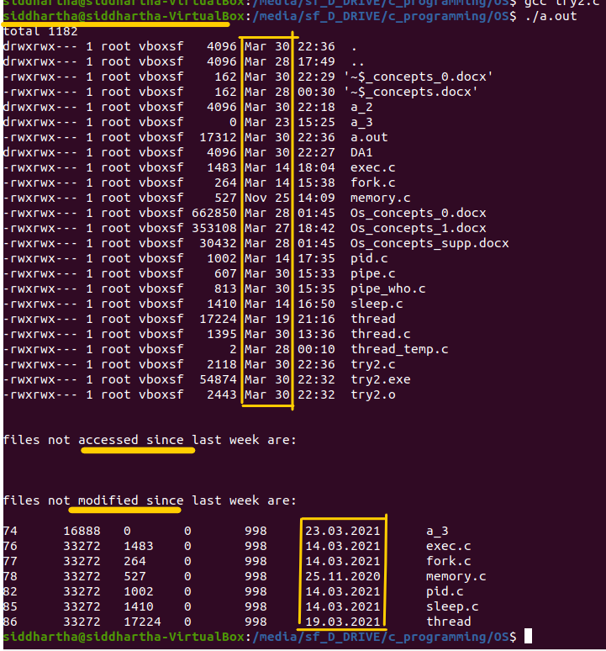
Note: While checking the file for their last access…we are actually accessing the file…so there is no file which is not accessed since last week.

