

Principles of Operating System [CBS1006]
  - Assessment - 4[lab]

SIDDHARTHA PURWAR| 19BBS0072
06-April-2021
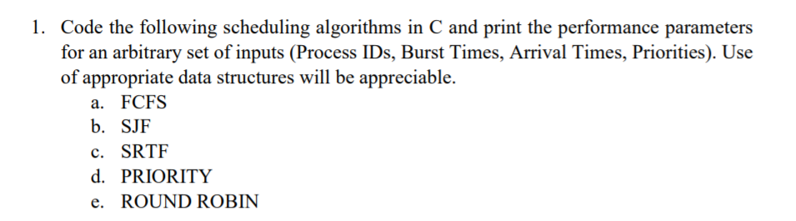

a) FCFS CODE:
#include <stdio.h>

struct inputs{
int arrival_time;
int waiting_time;
int turn_arround_time;
int brust_time;
};

int i = 0, j = 0, n = 0, t, total_waiting_time = 0, total_turn_arround_time = 0, pre_brust = 0;
float average_waiting_time = 0.0, average_turn_around_time = 0.0;

void fcfs(struct inputs *process){
process[0].waiting_time = 0;
int j, i;
for (j = 0; j < n; ){
for(i = 0; i < n ;i++){
if((process[i].arrival_time <= total_turn_arround_time) && (process[i].turn_arround_time == 0)){
process[i].waiting_time = pre_brust - process[i].arrival_time;
process[i].waiting_time = (process[i].waiting_time > 0) ? process[i].waiting_time : 0;
process[i].turn_arround_time = process[i].waiting_time + process[i].brust_time;
total_turn_arround_time = total_turn_arround_time + process[i].turn_arround_time;
total_waiting_time = total_waiting_time + process[i].waiting_time;
pre_brust += process[i].brust_time;
j++;
}
}

}
}
int main()
{

printf("total number of process\n");
scanf("%d",&n);
struct inputs process[n];

for(i=0;i<n;i++)
{
printf("\n\nBurst Time for process %d===>", i+ 1);
scanf("\t %d",&process[i].brust_time);
printf("\nArrival Time for process %d===>", i + 1);
scanf("\t%d",&process[i].arrival_time);
process[i].turn_arround_time = process[i].waiting_time = 0;
}

process[0].waiting_time = 0;
struct inputs t;

fcfs(process);

printf("Pid\tBurst time\t Arrival time\t WaitingTime\t Turn Arround Time\n");
for(i=0;i<n;i++){
printf("\n%d\t\t%d\t\t%d\t\t%d",process[i].brust_time, process[i].arrival_time, process[i].waiting_time,process[i].turn_arround_time);
}

average_waiting_time = (float)total_waiting_time / n;
average_turn_around_time = (float)total_turn_arround_time / n;
printf("\n\nAvg.Waiting Time: %f\nAvg.Turn Around Time: %f\n",average_waiting_time,average_turn_around_time);
return 0;
}
FCFS OUTPUT:
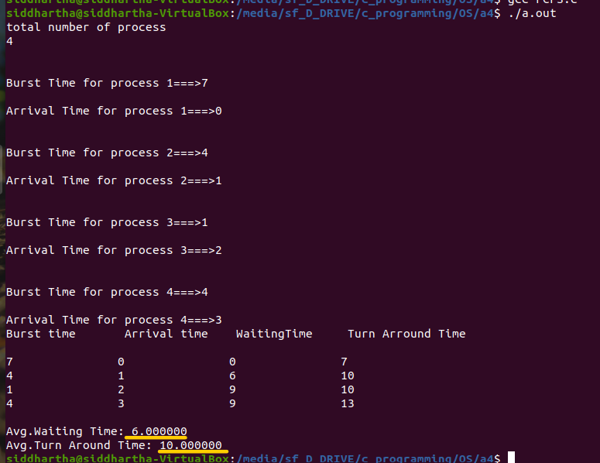
b) SJF CODE:
#include <stdio.h>

struct inputs{
int arrival_time;
int waiting_time;
int turn_arround_time;
int brust_time;
int id;
};
int i = 0, j = 0, n = 0, t, total_waiting_time = 0, total_turn_arround_time = 0, pre_brust = 0;
float average_waiting_time = 0.0, average_turn_around_time = 0.0;

void fcfs(struct inputs *process){
process[0].waiting_time = 0;
int j, i;
for (j = 0; j < n; ){
for(i = 0; i < n ;i++){
if((process[i].arrival_time <= total_turn_arround_time) && (process[i].turn_arround_time == 0)){
process[i].waiting_time = pre_brust - process[i].arrival_time;
process[i].waiting_time = (process[i].waiting_time > 0) ? process[i].waiting_time : 0;
process[i].turn_arround_time = process[i].waiting_time + process[i].brust_time;
total_turn_arround_time = total_turn_arround_time + process[i].turn_arround_time;
total_waiting_time = total_waiting_time + process[i].waiting_time;
pre_brust += process[i].brust_time;
j++;
}
}

}
}
int main()
{
printf("total number of process\n");
scanf("%d",&n);
struct inputs process[n];
for(i=0;i<n;i++)
{
printf("\n\nBurst Time for process %d===>", i+ 1);
scanf("\t %d",&process[i].brust_time);
printf("\nArrival Time for process %d===>", i + 1);
scanf("\t%d",&process[i].arrival_time);
process[i].id = i;
process[i].turn_arround_time = process[i].waiting_time = 0;
}
process[0].waiting_time = 0;
struct inputs t;
//sorting according to Brust_time
for (i=0;i<n;i++){
for(j=i+1;j<n;j++){
if (process[i].brust_time > process[j].brust_time){
t = process[j];
process[j] = process[i];
process[i] = t;
}
}
}
//after sorting SJF scheduling is like FCFS scheduling
fcfs(process);

printf("\n\nPid\tBurst time\t Arrival time\t WaitingTime\t Turn Arround Time\n");
for(i=0;i<n;i++){
printf("\n%d\t\t%d\t\t%d\t\t%d\t\t%d",process[i].id ,process[i].brust_time, process[i].arrival_time, process[i].waiting_time,process[i].turn_arround_time);
}
average_waiting_time = (float)total_waiting_time / n;
average_turn_around_time = (float)total_turn_arround_time / n;
printf("\n\nAvg.Waiting Time: %f\nAvg.Turn Around Time: %f\n",average_waiting_time,average_turn_around_time);
return 0;
}
SJF OUTPUT:
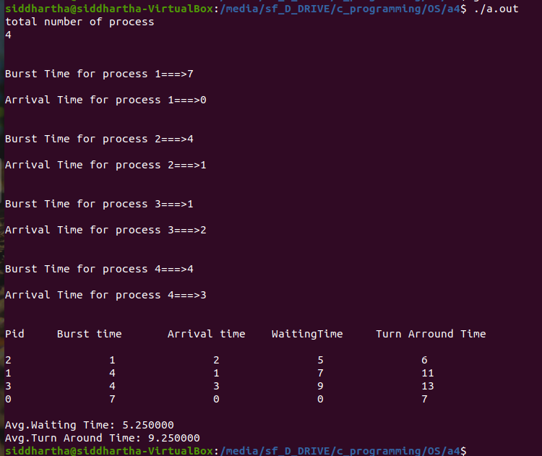
c) SRTF CODE:

#include <stdio.h>

struct inputs{
int arrival_time;
int waiting_time;
int turn_arround_time;
int burst_time;
int temp_burst_time;
int id;
};

int i = 0, j = 0, n = 0, t, total_waiting_time = 0, total_turn_arround_time = 0, pre_brust = 0, time = 0, count = 0, smallest = 0, end = 0;
float average_waiting_time = 0.0, average_turn_around_time = 0.0;

int main()
{
printf("total number of process\n");
scanf("%d",&n);
struct inputs process[n];

for(i=0;i<n;i++)
{
printf("\n\nBurst Time for process %d===>", i+ 1);
scanf("\t %d",&process[i].burst_time);
process[i].temp_burst_time = process[i].burst_time;
printf("\nArrival Time for process %d===>", i + 1);
scanf("\t%d",&process[i].arrival_time);
process[i].id = i;
process[i].turn_arround_time = process[i].waiting_time = 0;
process[i].id = i + 1;
}
process[i].burst_time = 1000;
for(time = 0; count != n; time++)
{
smallest = i;
for(i = 0; i < n; i++)
{
if(process[i].arrival_time <= time && process[i].burst_time < process[smallest].burst_time && process[i].burst_time > 0)
{
smallest = i;
}
}
process[smallest].burst_time--;
if(process[smallest].burst_time == 0)
{
count++;
end = time + 1;
process[smallest].waiting_time = end - process[smallest].arrival_time- process[smallest].temp_burst_time;
total_waiting_time += process[smallest].waiting_time;
process[smallest].turn_arround_time = end - process[smallest].arrival_time;
total_turn_arround_time += process[smallest].turn_arround_time;
}
}
printf("PID\t Burst time\t Arrival time\t WaitingTime\t Turn Arround Time\n");
for(i=0;i<n;i++){
printf("\n%d\t\t%d\t\t%d\t\t%d\t\t%d",process[i].id, process[i].temp_burst_time, process[i].arrival_time, process[i].waiting_time,process[i].turn_arround_time);
}

average_waiting_time = (float)total_waiting_time / n;
average_turn_around_time = (float)total_turn_arround_time / n;
printf("\n\nAvg.Waiting Time: %f\nAvg.Turn Around Time: %f\n",average_waiting_time,average_turn_around_time);
return 0;
}

SRTF OUTPUT:
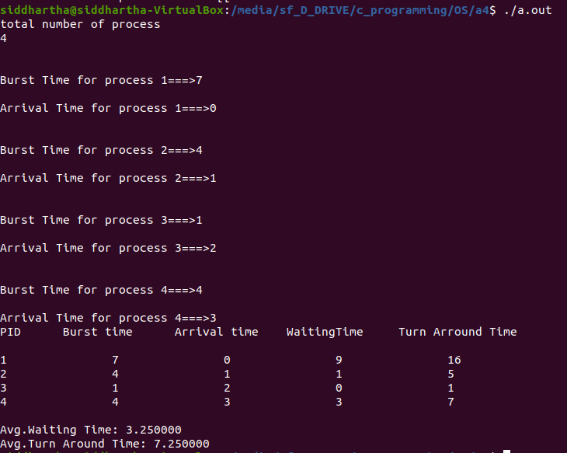

d) PRIORITY CODE:
#include <stdio.h>

struct inputs{
int arrival_time;
int waiting_time;
int turn_arround_time;
int brust_time;
int priority;
int id;
};
int i = 0, j = 0, n = 0, t, total_waiting_time = 0, total_turn_arround_time = 0, pre_brust = 0;
float average_waiting_time = 0.0, average_turn_around_time = 0.0;

void fcfs(struct inputs *process){
process[0].waiting_time = 0;
int j, i;
for (j = 0; j < n; ){
for(i = 0; i < n ;i++){
if((process[i].arrival_time <= total_turn_arround_time) && (process[i].turn_arround_time == 0)){
process[i].waiting_time = pre_brust - process[i].arrival_time;
process[i].waiting_time = (process[i].waiting_time > 0) ? process[i].waiting_time : 0;
process[i].turn_arround_time = process[i].waiting_time + process[i].brust_time;
total_turn_arround_time = total_turn_arround_time + process[i].turn_arround_time;
total_waiting_time = total_waiting_time + process[i].waiting_time;
pre_brust += process[i].brust_time;
j++;
}
}
}
}
int main(){
printf("total number of process\n");
scanf("%d",&n);
struct inputs process[n];
for(i=0;i<n;i++){
printf("\n\nBurst Time for process %d===>", i+ 1);
scanf("\t %d",&process[i].brust_time);
printf("\nArrival Time for process %d===>", i + 1);
scanf("\t%d",&process[i].arrival_time);
printf("\nPriority for process %d===>", i + 1);
scanf("\t%d",&process[i].priority);
process[i].id = i;
process[i].turn_arround_time = process[i].waiting_time = 0;
}
process[0].waiting_time = 0;
struct inputs t;
//sorting according to priority
for (i=0;i<n;i++){
for(j=i+1;j<n;j++){
if (process[i].priority > process[j].priority ){
t = process[j];
process[j] = process[i];
process[i] = t;
}
}
}
//after sorting priority scheduling is like FCFS scheduling
fcfs(process);

printf("Process_ID\tBurst time\t Arrival time\t WaitingTime\t Turn Arround Time\n");
for(i=0;i<n;i++){
printf("\n%d\t\t%d\t\t%d\t\t%d\t\t%d",process[i].id, process[i].brust_time, process[i].arrival_time, process[i].waiting_time,process[i].turn_arround_time);
}
average_waiting_time = (float)total_waiting_time / n;
average_turn_around_time = (float)total_turn_arround_time / n;
printf("\n\nAvg.Waiting Time: %f\nAvg.Turn Around Time: %f\n",average_waiting_time,average_turn_around_time);
}
PRIORITY OUTPUT: (Not getting expected Output)
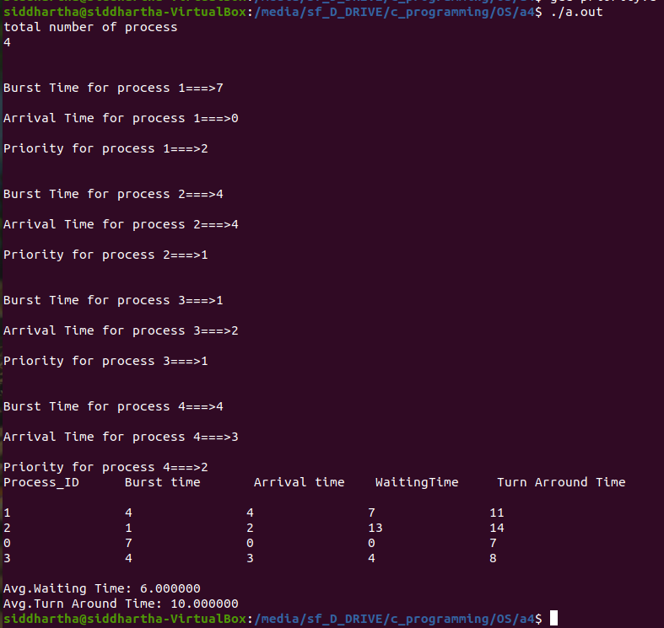

e) ROUND ROBIN CODE:

#include <stdio.h>

struct inputs{
int arrival_time;
int waiting_time;
int turn_arround_time;
int brust_time;
int temp_brust_time;
int id;
};
int time , i = 0, j = 0, n = 0, t, total_waiting_time = 0, total_turn_arround_time = 0, pre_brust = 0;
float average_waiting_time = 0.0, average_turn_around_time = 0.0;

void round_robin(struct inputs *process){
process[0].waiting_time = 0;
int j, i;
for (j = 0; j < n; ){
for(i = 0; i < n ;i++){
if((process[i].arrival_time <= total_turn_arround_time) && (process[i].brust_time != -1)){
process[i].waiting_time = pre_brust - process[i].arrival_time;
process[i].waiting_time = (process[i].waiting_time > 0) ? process[i].waiting_time : 0;
process[i].turn_arround_time = process[i].waiting_time + process[i].brust_time;
total_turn_arround_time = total_turn_arround_time + process[i].turn_arround_time;
total_waiting_time = total_waiting_time + process[i].waiting_time;
process[i].waiting_time = (process[i].waiting_time > 0) ? process[i].waiting_time : 0;
pre_brust += process[i].brust_time;
process[i].brust_time = process[i].brust_time - time;
}
if(process[i].brust_time <= 0){
j++;
process[i].brust_time = -1;
}
}
}
}
int main(){
printf("total number of process\n");
scanf("%d",&n);
printf("Enter timegap\n");
scanf("%d", &time);
struct inputs process[n];

for(i=0;i<n;i++)
{
printf("\nBurst Time");
scanf("\n %d",&process[i].brust_time);
printf("\nArrival Time");
process[i].temp_brust_time = process[i].brust_time;
scanf("\n %d",&process[i].arrival_time);
process[i].id = i;
process[i].turn_arround_time = process[i].waiting_time = 0;
}
process[0].waiting_time = 0;
struct inputs t;

round_robin(process);

printf("Pid\tBurst time\t Arrival time\t WaitingTime\t Turn Arround Time\n");
for(i=0;i<n;i++){
printf("\n%d\t\t%d\t\t%d\t\t%d\t\t%d",process[i].id ,process[i].temp_brust_time, process[i].arrival_time, process[i].waiting_time,process[i].turn_arround_time);
}

average_waiting_time = (float)total_waiting_time / n;
average_turn_around_time = (float)total_turn_arround_time / n;
printf("\n\nAvg.Waiting Time: %f\nAvg.Turn Around Time: %f\n",average_waiting_time,average_turn_around_time);
return 0;
}
ROUND ROBIN OUTPUT (Not giving expected output)
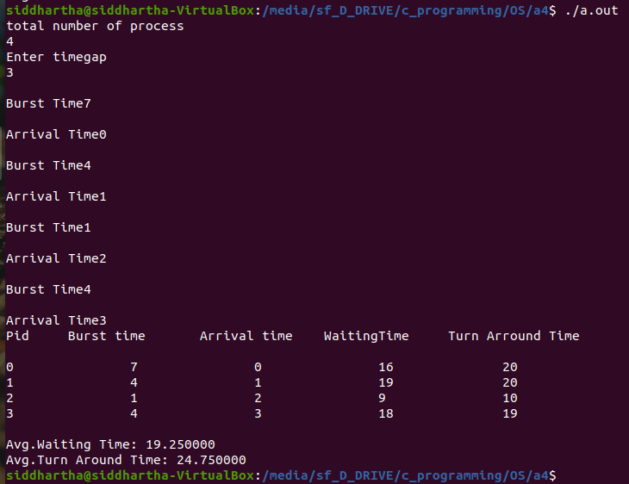
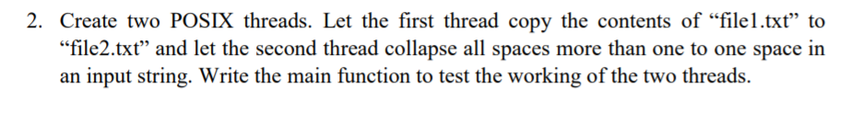

CODE:
#include<stdio.h>
#include<pthread.h>
#include<stdlib.h>
#include<string.h>
#include<unistd.h>
#define MAXNAME 50
#define MAXLENGTH 5000

char file1[MAXNAME];
char file2[MAXNAME];
char output_string[MAXLENGTH];

void* copy_file(void * arg){ //for thread_1
FILE *fp1, *fp2;
int c = 0;
if(!(fp1 = fopen(file1, "r"))){
perror("File 1 cannot be opened");
}
if(!(fp2 = fopen(file2, "w"))){
perror("File 2 cannot be opened");
}
while((c = fgetc(fp1)) != EOF){
fputc(c,fp2);
}
fclose(fp1);
fclose(fp2);
pthread_exit(NULL);
}

void * space_operation(void * arg){ //for thread_2
FILE *fp0, *fp3;
char d[1];
int flag = -1;
if(!(fp0 = fopen(file2, "r"))){
perror("File 2 cannot be opened");
}
while((d[0] = fgetc(fp0)) != EOF){
if((d[0] == ' ') && (flag == -1)){
flag = 1;
strcat(output_string, d);
}
if((d[0] == ' ') && (flag == 1)){
}
else{
strcat(output_string, d);
flag = -1;
}
}
fclose(fp0);
pthread_exit(NULL);
}

//DRIVER CODE
int main(){
pthread_t t1, t2;

printf("Enter name of file 1\n");
scanf("%s",file1);
printf("Enter name of file 2\n");
scanf("%s",file2);

if((pthread_create(&t1, NULL, copy_file, NULL))){
perror("Thread t1 cannot be created");
}
pthread_join(t1, NULL);

if((pthread_create(&t2, NULL, space_operation, NULL))){
perror("Thread t2 cannot be created");
}
pthread_join(t2, NULL);

printf("\nString is \n%s", output_string);
return 0;
}

OUTPUT:

Before executing program:
Content of test_1.txt: “hello i am siddhartha purwar 19BBS0072.”
Content of test_2.txt: “ “

After executing program:
Content of test_1.txt: “hello i am siddhartha purwar 19BBS0072.”
Content of test_2.txt: “hello i am siddhartha purwar 19BBS0072.”

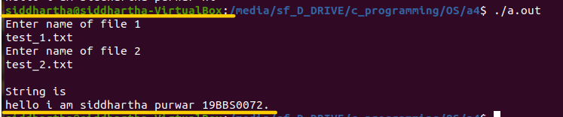

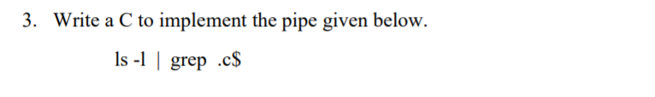

CODE:
#include<stdio.h>
#include<stdlib.h>
#include<unistd.h>
int main() {
int pid;
int fd[2]; //one for read end and one for write end
pipe(fd);
pid=fork();

if( pid < 0 ) {
perror( "fork");
exit( -1 );
}

if( pid==0) {

close(1); //no need to write to stdout
dup (fd[1]);
close(fd[0]);
close(fd[1]);
execl("/usr/bin/ls","ls", "-l",NULL);

}
else {
close(0); //no need to read from stdin
dup (fd[0]);
close(fd[0]);
close(fd[1]);
execl("/usr/bin/grep","grep", ".c$" ,NULL);
}
}

