Thread process
- When a program is started, the resulting process consists of a single thread, called
the initial or main thread
- All of these threads are independently executing the same program, and they all share the same global memory, including the initialized data, uninitialized data, and heap segments
- A single process can contain multiple threads
- If one thread is blocked on I/O, other threads are still eligible to execute.
- On a multiprocessor system, multiple threads can execute parallel
- Sharing information between threads is easy and fast. It is just a matter of copying
data into shared (global or heap) variables
- On Linux, threads are implemented using the clone() system call

Attribute shared between threads
Besides global memory, threads also share a number of other attributes (i.e., these
attributes are global to a process, rather than specific to a thread). These attributes
include the following:
- process ID and parent process ID;
- process group ID and session ID;
- controlling terminal;
- process credentials (user and group IDs);
- open file descriptors;
- record locks created using fcntl();
- signal dispositions;
- file system–related information: umask, current working directory, and root
- directory;
- interval timers (setitimer()) and POSIX timers (timer_create());
- System V semaphore undo (semadj) values (Section 47.8);
- resource limits;
- CPU time consumed (as returned by times());
- resources consumed (as returned by getrusage()); and
- nice value (set by setpriority() and nice()).620 Chapter 29
Attribute not shared between thread
- thread ID (Section 29.5);
- signal mask;
- thread-specific data (Section 31.3);
- alternate signal stack (sigaltstack());
- the errno variable;
- floating-point environment (see fenv(3));
- realtime scheduling policy and priority (Sections 35.2 and 35.3);
- CPU affinity (Linux-specific, described in Section 35.4);
- capabilities (Linux-specific, described in Chapter 39); and
- stack (local variables and function call linkage information)

POSIX
The Portable Operating System Interface (POSIX) is a family of standards specified by the IEEE Computer Society for maintaining compatibility between operating systems.

Pthread
- Pthread refers to the POSIX standard (IEEE 1003.lc) defining an API for thread creation and synchronization. This is a specification for thread behaviour not an implementation
- The Pthreads API defines a number of data types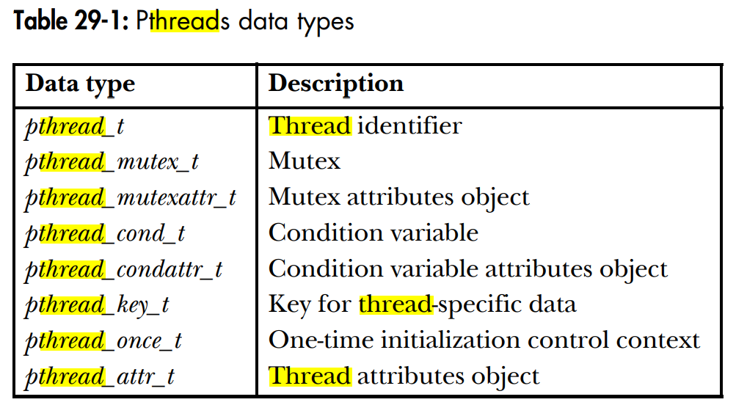
- https://www.quora.com/Why-do-we-need-to-give-a-lpthread-option-with-GCC-while-executing-a-threads-related-C-program
- https://stackoverflow.com/questions/23250863/difference-between-pthread-and-lpthread-while-compiling

pthread_create
- #include <pthread.h>
pthread_t *thread;//return thread Id, an unsigned integer
int s;
s = pthread_create(&thread, NULL, func, &arg);
if (s != 0)
errExitEN(s, "pthread_create");
- The first argument is a pointer to thread_id which is set by this function.
- The second argument specifies attributes. If the value is NULL, then default attributes shall be used.
- The third argument is name of function to be executed for the thread to be created. The return type and parameter type of the subroutine must be of type void *. The function has a single attribute but if multiple values need to be passed to the function, a struct must be used.
- The fourth argument is used to pass arguments to the function, myThreadFun.
- Pthread return 0 on successful creation of thread and positive value on failure.
- o execute the c file, we have to use the -pthread or -lpthread in the command line while compiling the file.
cc -pthread file.c or
cc -lpthread file.c
- pthread_t *thread or pthread_t thread
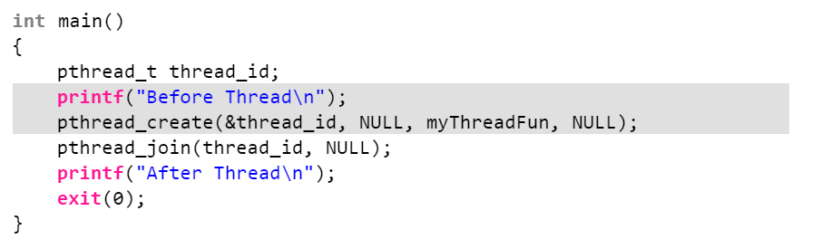
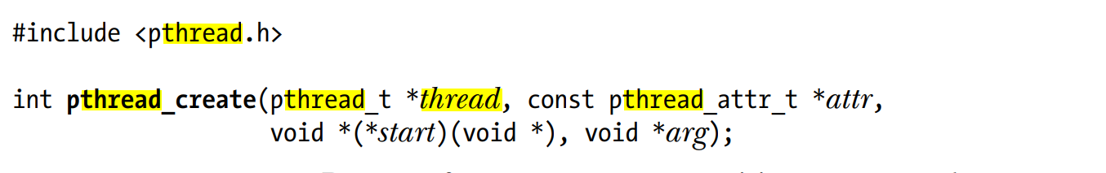
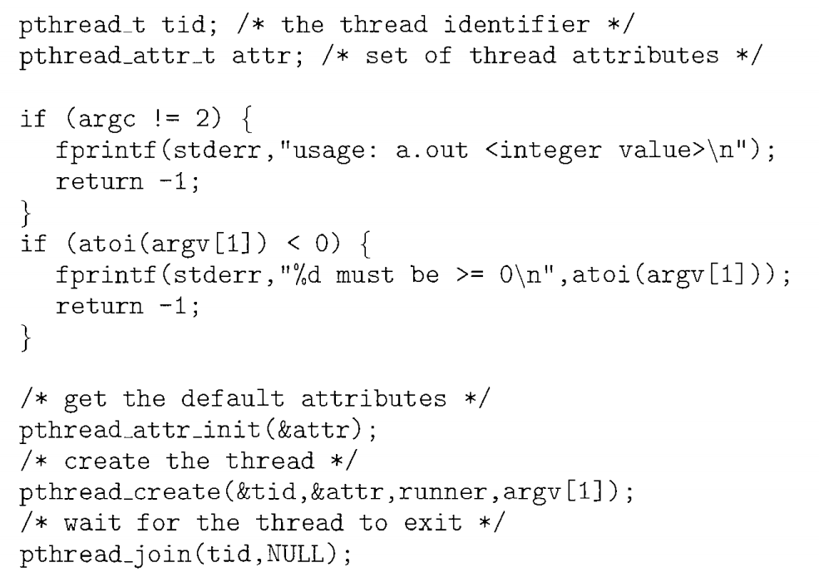
- https://stackoverflow.com/questions/17147646/invalid-conversion-from-void-to-void-void-c

pthread_exit: used to terminate a thread
- Syntax: void pthread_exit(void *retval);
- Parameters: This method accepts a mandatory parameter retval which is the pointer to an integer that stores the return status of the thread terminated. The scope of this variable must be global so that any thread waiting to join this thread may read the return status.
- If we use exit() instead of pthread_exit() to end a thread, the whole process with all associated threads will be terminated even if some of the threads may still be running

pthread_join: used to wait for the termination of a thread.
- Syntax: int pthread_join(pthread_t th, void **thread_return);
- Parameter: This method accepts following parameters:
- th: thread id of the thread for which the current thread waits.
- thread_return: pointer to the location where the exit status of the thread mentioned in th is stored.
pthread_self: used to get the thread id of the current thread.
- Syntax: pthread_t pthread_self(void);

pthread_equal: compares whether two threads are the same or not.
- If the two threads are equal, the function returns a non-zero value otherwise zero.
- Syntax: int pthread_equal(pthread_t t1, pthread_t t2);
- Parameters: This method accepts following parameters:
- t1: the thread id of the first thread
- t2: the thread id of the second thread

pthread_cancel: used to send a cancellation request to a thread
- Syntax: int pthread_cancel(pthread_t thread);
- Parameter: This method accepts a mandatory parameter thread which is the thread id of the thread to which cancel request is sent.

pthread_detach: used to detach a thread.
- A detached thread does not require a thread to join on terminating. The resources of the thread are automatically released after terminating if the thread is detached.
- Syntax: int pthread_detach(pthread_t thread);
- Parameter: This method accepts a mandatory parameter thread which is the thread id of the thread that must be detached.

https://www.geeksforgeeks.org/thread-functions-in-c-c/
http://gauss.ececs.uc.edu/Courses/c694/lectures/ForksThreads/forks.html
https://www.geeksforgeeks.org/multithreading-c-2/
http://www.csc.villanova.edu/~mdamian/threads/posixthreads.html

