pthread_t * thread,const pthread_attr_t * attr, void * (*start_routine)(void *),void *arg
text file and .txt file
errno
Gcc and cc
Fork() and clone()
Killing a process
https://www.linux.com/training-tutorials/how-kill-process-command-line/
https://phoenixnap.com/kb/how-to-kill-a-process-in-linux

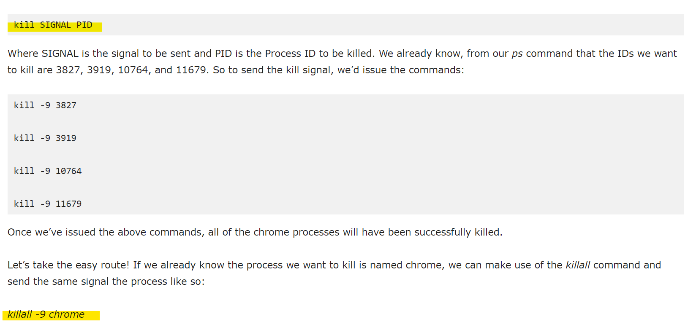
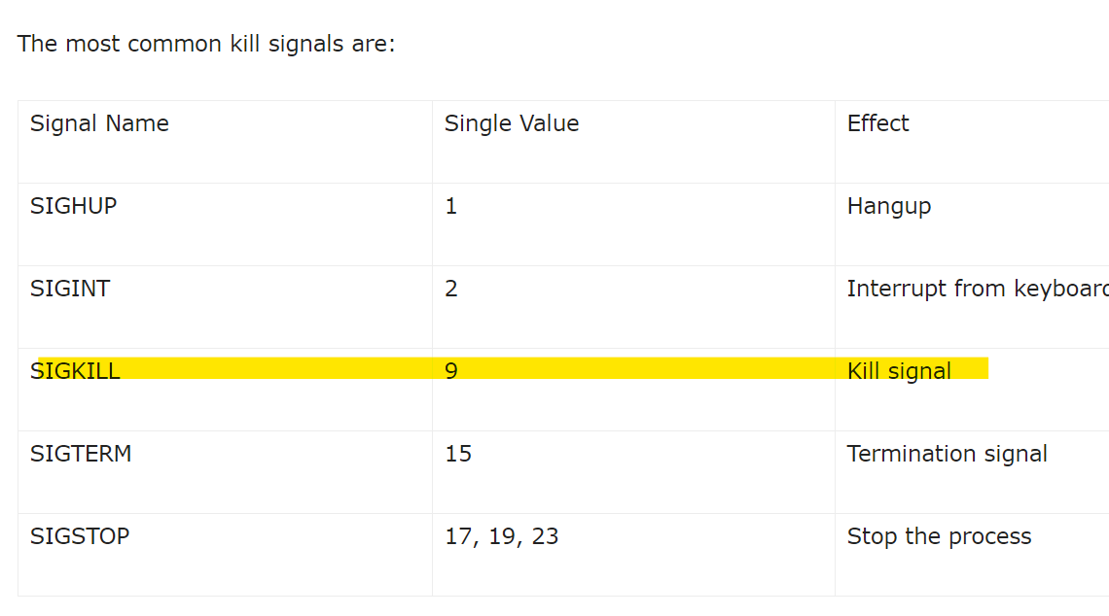
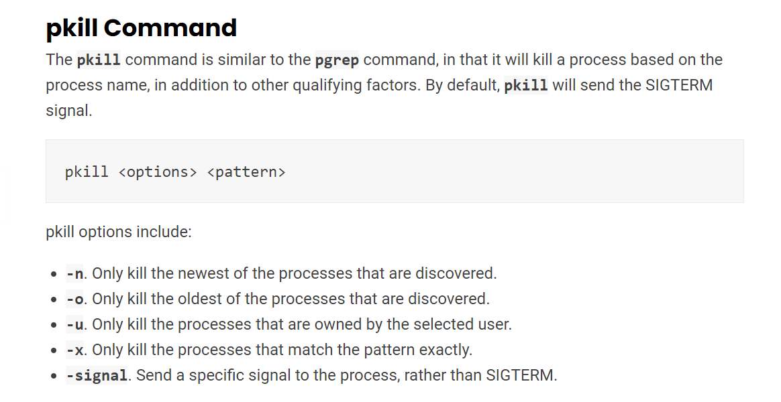
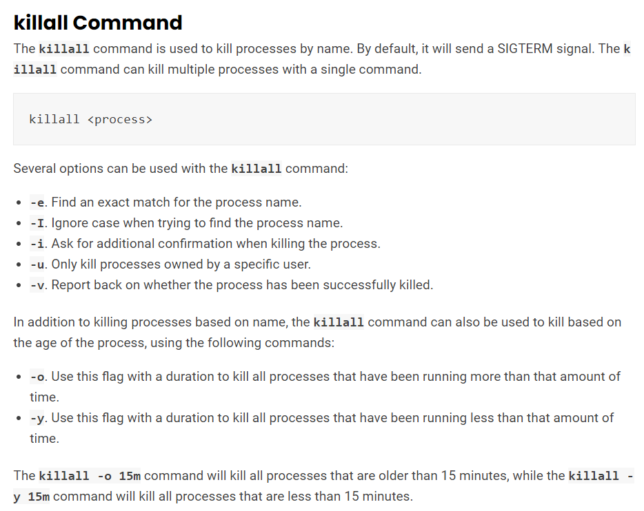
int main()
{
char process_name[100];
char kill_command[] = "pkill ";
int status = 868;
printf("Enter the process name to kill\n");
scanf("%s", process_name);
strcat(kill_command, process_name);
status = system(kill_command);
if(!status){
printf("Process killed successfully\n");
}
else{
printf("Process killing unsuccessfully\n");
}
return 0;
}

Inode
An inode is a data structure that stores various information about a file in Linux, such as the access mode (read, write, execute permissions), ownership, file type, file size, group, number of links, etc. Each inode is identified by an integer number
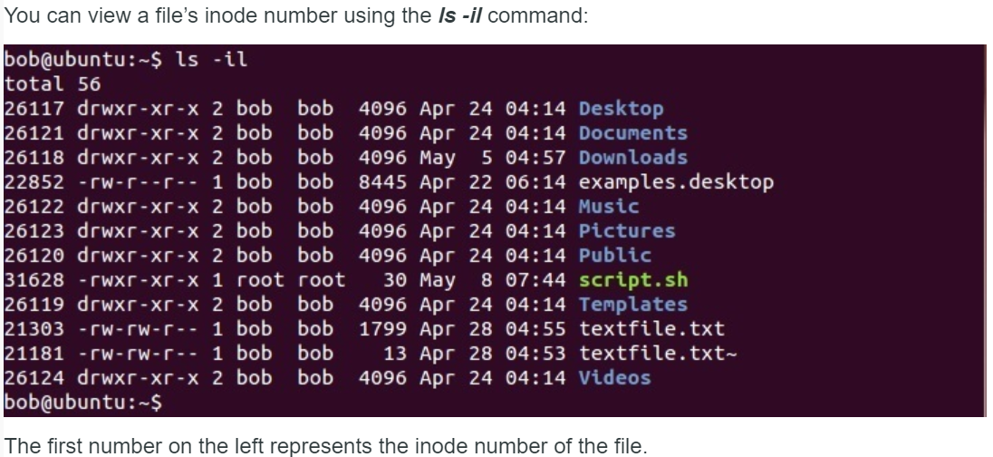

File descriptor
- In simple words, when you open a file, the operating system creates an entry to represent that file and store the information about that opened file. So if there are 100 files opened in your OS then there will be 100 entries in OS (somewhere in kernel). These entries are represented by integers like (...100, 101, 102....). This entry number is the file descriptor. So it is just an integer number that uniquely represents an opened file in operating system. If your process opens 10 files then your Process table will have 10 entries for file descriptors.
- https://www.geeksforgeeks.org/input-output-system-calls-c-create-open-close-read-write/
- https://www.computerhope.com/jargon/f/file-descriptor.htm
- https://users.cs.jmu.edu/bernstdh/web/common/lectures/summary_unix_file-descriptors.php

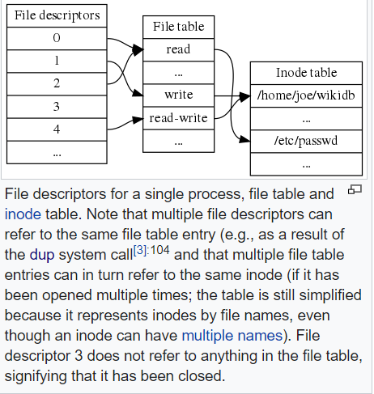
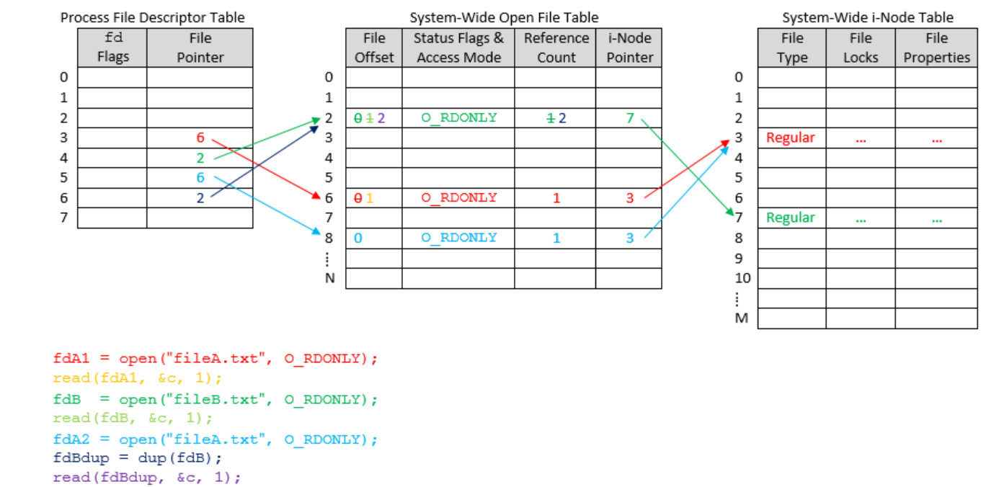
Standard File Descriptors
- When any process starts, then that process file descriptors table’s fd(file descriptor) 0, 1, 2 open automatically, (By default) each of these 3 fd references file table entry for a file named /dev/tty
- /dev/tty: In-memory surrogate for the terminal
- Terminal: Combination keyboard/video screen
- Read from stdin => read from fd 0 : Whenever we write any character from keyboard, it read from stdin through fd 0 and save to file named /dev/tty.
- Write to stdout => write to fd 1 : Whenever we see any output to the video screen, it’s from the file named /dev/tty and written to stdout in screen through fd 1.
- Write to stderr => write to fd 2 : We see any error to the video screen, it is also from that file write to stderr in screen through fd 2.
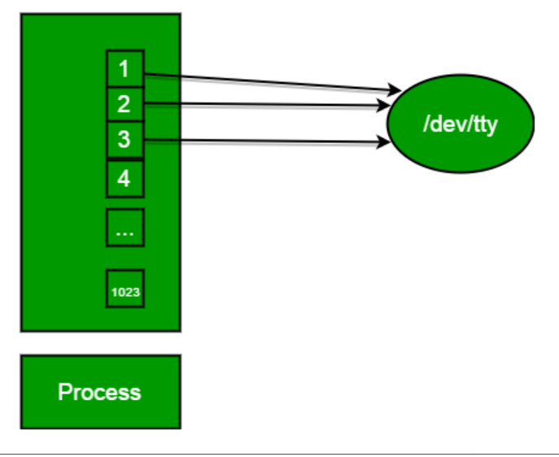

Size_t
- The size_t type is used to represent the size of objects in memory. As examples, it is the type of the return value of the sizeof operator, and of the strlen function.
- This means that it is an unsigned integral type. Its specific size is platform-dependent; the size is chosen to be large enough to represent all sizes on that platform.

OPEN() and CLOSE() system call
- #include <fcntl.h>
int close(int fd);
- Parameter
- fd :file descriptor
- Return
- 0 on success.
- -1 on error.
- Destroy file table entry referenced by element fd of file descriptor table
  - As long as no other process is pointing to it!
- Set element fd of file descriptor table to NULL
- #include<sys/types.h>
#include<sys/stat.h>
#include <fcntl.h>
int open (const char* Path, int flags [, int mode ]);
- Parameters
- Path : path to file which you want to use
- use absolute path begin with “/”, when you are not work in same directory of file.
- Use relative path which is only file name with extension, when you are work in same directory of file.
- flags : How you like to use
- O_RDONLY: read only, O_WRONLY: write only, O_RDWR: read and write, O_CREAT: create file if it doesn’t exist, O_EXCL: prevent creation if it already exists
- https://www.geeksforgeeks.org/input-output-system-calls-c-create-open-close-read-write/

WRITE() SYSTEM CALL
- #include<unistd.h>
ssize_t write(int fd, const void *buf, size_t count);
- The first parameter (fd) is the file descriptor where you want to write. The data that is to be written is specified in the second parameter. Finally, the third parameter is the total bytes that are to be written.
- If first and second parameter is missing then parameter given in last write() call will be taken.
- On success, the write() system call returns the ‘number of bytes written’ i.e. the count of how many bytes it could write. This you can save in an integer variable and checked. The write() system call on failure returns -1.
- https://dextutor.com/write-read-system-call/
- #include<stdio.h>
int main(){
int size_1;
size_t size_2, size_3, size_4, size_5, size_6;

size_1 = write(1, "Hello", 5); //Hello
printf("\t%d\n", size_1); //size_1 will be 5

size_2 = write(1, "how.....", 5); //how..
printf("\t%d\n", size_2); //size_2 will be 5

size_3 = write(1, "are", 50); //are#%#$#@#$^$$^....
printf("\t%d\n", size_3); //size_3 will be 50

size_4 = write(4, "you", 5); //write() will return error.
printf("\t%d\n", size_4); //size_4 will be -1

size_5 = write(1, "?", 50); //?$%^%^$^##@$%$^#$....
printf("\t%d\n", size_5); //size_5 will be 50

//size_6 = write(0, "Bye", 5); // undefined nature
//printf("%d", size_6); // garbage value

size_7 = write("This will get print"); // count will be of last
write() call by default it is 0
printf("%d", size_7); // size_7 will be 50, same as size_5

return 0;
}

READ() SYSTEM CALL
- #include<unistd.h>
ssize_t read(int fd, const void *buf, size_t count);
- The first parameter is the file descriptor. The second parameter is the buffer where the read data will be saved. Lastly, the third parameter is the number of bytes that you want to read.
- The read() system call returns -1 on failure and “the count of bytes read” on success.
- Return 0 on EOF
- #include<stdio.h>
#include<unistd.h>
int main(){
size_t size_8, size_9, size_10, size_11, size_12, size_13;
char buff[20];
int count_1;

write(1, "\nREAD() SYSTEM CALL", 20);

size_8 = read(0, buff, 10);
printf("%d", size_8);

size_9 = read(0, buff, count_1);
printf("%d", size_9);
size_10 = write(1, buff, size_9);

return 0;
}

Buffer
- A temporary storage area is called buffer.
- All standard input and output devices contain an input and output buffer. In standard C/C++, streams are buffered, for example in the case of standard input, when we press the key on keyboard, it isn’t sent to your program, rather it is buffered by operating system till the time is allotted to that program.
Context switching
- Context Switching involves storing the context or state of a process so that it can be reloaded when required and execution can be resumed from the same point as earlier. This is a feature of a multitasking operating system and allows a single CPU to be shared by multiple processes.
- https://www.javatpoint.com/what-is-the-context-switching-in-the-operating-system
- The steps involved in context switching are as follows −
- Save the context of the process that is currently running on the CPU. Update the process control block and other important fields.
- Move the process control block of the above process into the relevant queue such as the ready queue, I/O queue etc.
- Select a new process for execution.
- Update the process control block of the selected process. This includes updating the process state to running.
- Update the memory management data structures as required.
- Restore the context of the process that was previously running when it is loaded again on the processor. This is done by loading the previous values of the process control block and registers.

Zombie state
- When a process is created in UNIX using fork() system call, the address space of the Parent process is replicated. If the parent process calls wait() system call, then the execution of parent is suspended until the child is terminated.
- At the termination of the child, a ‘SIGCHLD’ signal is generated which is delivered to the parent by the kernel. Parent, on receipt of ‘SIGCHLD’ reaps the status of the child from the process table. Even though, the child is terminated, there is an entry in the process table corresponding to the child where the status is stored. When parent collects the status, this entry is deleted. Thus, all the traces of the child process are removed from the system.
- If the parent decides not to wait for the child’s termination and it executes its subsequent task, then at the termination of the child, the exit status is not read. Hence, there remains an entry in the process table even after the termination of the child. This state of the child process is known as the Zombie state.

./ and ../ directory
- Every directory on a Unix system (and probably every other system too) contains at least two directory entries. These are . (current directory) and .. (parent directory).
- In the case of the root directory, these point to the same place, but with any other directory, they are different.

Symbolic link
- A symbolic link is a file that points to another file, a kind of alias for a filepath
- https://askubuntu.com/questions/214562/cannot-transfer-file-due-to-filesystem-does-not-support-symbolic-links-error

sys/types.h
- The sys/types.h header file defines a collection of typedef symbols and structures.
- sys/types.h has pid_t

unistd.h
- The <unistd.h> header defines miscellaneous symbolic constants and types, and declares miscellaneous functions.
- unistd.h contain flush()
- unistd.h contain sleep()
- unistd.h conatin getpid() and getppid()
- unistd.h contain exec
- unistd.h - standard symbolic constants and types

pid_t
- Whenever, we want to declare a variable that is going to be deal with the process ids we can use pid_t data type.
- The type of pid_t data is a signed integer type (signed int or we can say int).

Fork()
- Upon successful completion, fork() returns 0 to the child process and returns the process ID of the child process to the parent process.
- Otherwise, -1 is returned to the parent process, no child process is created, and errno is set to indicate the error.

Perror()
- void perror(const char *str)
- Parameters: str − This is the C string containing a custom message to be printed before the error message itself.
- Return Value: This function does not return any value
- The perror() function produces a message on standard error describing the last error encountered during a call to a system or library function.
- First (if s is not NULL and *s is not a null byte ('\0')), the argument string s is printed, followed by a colon and a blank. Then an error message corresponding to the current value of errno and a new-line.
Fork() and exec()
- The exec call is a way to basically replace the entire current process with a new program. It loads the program into the current process space and runs it from the entry point.
- https://stackoverflow.com/questions/1653340/differences-between-fork-and-exec
- https://www.geeksforgeeks.org/fork-system-call/
- https://www.bottomupcs.com/fork_and_exec.xhtml
fflush(FILE *ostream)
- fflush() is typically used for output stream only. Its purpose is to clear (or flush) the output buffer and move the buffered data to console (in case of stdout) or disk (in case of file output stream)
- ostream points to an output stream or an update stream in which the most recent operation was not input, the fflush function causes any unwritten data for that stream to be delivered to the host environment to be written to the file; otherwise, the behavior is undefined.

File descriptor
https://www.geeksforgeeks.org/input-output-system-calls-c-create-open-close-read-write/
https://www.mkssoftware.com/docs/man5/stdio.5.asp

fprint()
- fprintf is used to print content in file instead of stdout console.
- int fprintf(FILE *fptr, const char *str, ...);
- https://www.tutorialspoint.com/c_standard_library/c_function_fprintf.html

sleep()
- C programming language provides sleep() function in order to wait for a current thread for a specified time.
- sleep() function will sleep given thread specified time for the current executable
- Windows.h contain sleep()
- We can also use usleep() function which will sleep given value in a microsecond
- The sleep() function will return void which means it will not return anything.

Sleep and wait
- C programming language provides sleep() function in order to wait for a current thread for a specified time. slepp() function will sleep given thread specified time for the current executable. Of course, the CPU and other processes will run without a problem.

getpid() and getppid()
- unistd.h contain both of these
- getppid() : returns the process ID of the parent of the calling process. If the calling process was created by the fork() function and the parent process still exists at the time of the getppid function call, this function returns the process ID of the parent process. Otherwise, this function returns a value of 1 which is the process id for init process.
- Syntax: pid_t getppid(void);
- Return type: getppid() returns the process ID of the parent of the current process. It never throws any error therefore is always successful.
- getpid() : returns the process ID of the calling process. This is often used by routines that generate unique temporary filenames.
- Syntax: pid_t getpid(void);
- Return type: getpid() returns the process ID of the current process. It never throws any error therefore is always successful.

Exec() and execlp
- The exec family of functions replaces the current running process with a new process.
- It can be used to run a C program by using another C program.
- This function is declared in <process.h>, which <unistd.h> includes
- https://www.qnx.com/developers/docs/6.5.0SP1.update/com.qnx.doc.neutrino_lib_ref/e/execlp.html
- https://www.geeksforgeeks.org/exec-family-of-functions-in-c/
- https://linuxhint.com/exec_linux_system_call_c/
- https://stackoverflow.com/questions/21558937/i-do-not-understand-how-execlp-works-in-linux
- int execlp(const char *file, const char *arg, ...);
- Say you run this from a commandline/shell:
$ ls
That'd be execlp("ls", "ls", (char *)NULL); Or if you run
- $ ls -l /
That'd be execlp("ls", "ls", "-l", "/", (char *)NULL);
- The exec call is a way to basically replace the entire current process with a new program. It loads the program into the current process space and runs it from the entry point.

system()
- system() is used to invoke an operating system command from a C/C++ program.
- int system(const char *command)
- Using system(), we can execute any command that can run on terminal if operating system allows.
- stdlib.h or cstdlib needs to be included to call system.
- https://www.geeksforgeeks.org/system-call-in-c/

SYSTEM() | EXECL()
NAME  system - execute a shell command | NAME  execl - execute a file
SYNOPSIS  #include <stdlib.h>  int system(const char *command); | SYNOPSIS  #include <unistd.h>  int execl(const char *pathname, const char *arg, /* (char *) NULL */);
RETURN VALUE  The return value of system() is one of the following:  - If command is NULL, then a nonzero value if a shell is available.  - 0 if no shell is available.  - If a child process could not be created the return value is -1  - If all system calls succeed, then the return value is the termination status of the child shell used to execute command. (The termination status of a shell is the termination status of the last com mand it executes.) | RETURN VALUE  The execl() functions return only if an error has occurred. The return value is -1
DESCRIPTION  - system() is used to invoke an operating system command from a C/C++ program.  - The system() library function uses fork() to create a child process that executes the shell command specified in command using execl() as follows:  execl("/bin/sh", "sh", "-c", command, (char *) NULL);  - system() returns after the command has been completed. | DESCRIPTION  - The execl() is a function of exec() family whose functions to replaces the current process image with a new process image.  - The const char *arg and subsequent ellipses can be thought of as arg0, arg1, ..., argn.  - Together they describe a list of one or more pointers to null-terminated strings that represent the argument list available to the executed program. The first argument, by convention, should point to the filename associated with the file being executed.  - The list of arguments must be terminated by a null pointer
System() will return to the program after executing its command.  It is like creating child process with parent as the calling program. | It will not execute any line of code after execl() call.  Execl() will overwritten the program with the command given it as argument and stop after executinf it.
EXAMPLE  #include <sys/types.h>  #include <stdio.h>  #include <unistd.h>  #include <stdlib.h>  int main()  {  int i = 0;  printf("Example to show system() call\n");  system("ls -l");  printf("This line will get execute, even it is after system() call\n");  return 0;  } | EXAMPLE  #include <sys/types.h>  #include <stdio.h>  #include <unistd.h>  #include <stdlib.h>  int main()  {  int i = 0;  printf("Example to show execl() call\n");  execlp("/bin/ls", "ls","-l", NULL);  printf("This line will not get execute, as it is after execl()\n");  return 0;  }

a.out and cc and .c and .o and ./
- .c are source file
- .o are object file
- Executables generally have no extension on UNIX, and .exe on Windows, though there is a default of a.out for linked C and C++ programs that haven't specified an output name
- cc command is stands for C Compiler, usually an alias command to gcc or clang.
- As the name suggests, executing the cc command will usually call the gcc on Linux systems. It is used to compile the C language codes and create executables.
- The number of options available for the cc command is very high. The most important options are explained below with examples.
- cc command with -o option: This command will compile the source_file.c file, and create a executable output file with the specified name. cc example.c -o examp_out
- https://stackoverflow.com/questions/58245469/o-vs-out-in-c/58249793
- https://www.geeksforgeeks.org/cc-command-in-linux-with-examples/

wait()
- <sys/types.h> and <sys/wait.h> include wait()
- A call to wait() blocks the calling process until one of its child processes exits or a signal is received. After child process terminates, parent continues its execution after wait system call instruction.
- A state change is considered to be: the child terminated; the child was stopped by a signal; or the child was resumed by a signal. In the case of a terminated child, performing a wait allows the system to release the resources associated with the child; if a wait is not performed, then the terminated child remains in a "zombie" state

Stderr

Running shell script from c
#include <stdio.h>
#include <stdlib.h>

#define SHELLSCRIPT "\
#/bin/bash \n\
echo \"hello\" \n\
echo \"how are you\" \n\
echo \"today\" \n\
"
/*Also you can write using char array without using MACRO*/
/*You can do split it with many strings finally concatenate
and send to the system(concatenated_string); */

int main()
{
puts("Will execute sh with the following script :");
puts(SHELLSCRIPT);
puts("Starting now:");
system(SHELLSCRIPT); //it will run the script inside the c code.
return 0;
}

Scanf(“%[^\n]s”, str) vs gets(str)
https://www.geeksforgeeks.org/use-fflushstdin-c/
buffer issue in c and c++
https://www.geeksforgeeks.org/clearing-the-input-buffer-in-cc/
https://www.educative.io/edpresso/what-is-a-buffer-in-c
https://www.geeksforgeeks.org/use-fflushstdin-c/
https://www.geeksforgeeks.org/fork-system-call/
https://stackoverflow.com/questions/18671525/how-does-fork-work-with-buffered-streams-like-stdout
https://pubs.opengroup.org/onlinepubs/7908799/xsh/fork.html
https://man7.org/linux/man-pages/man2/getpid.2.html#:~:text=getpid()%20returns%20the%20process,parent%20of%20the%20calling%20process
https://www.geeksforgeeks.org/use-fflushstdin-c/
https://www.geeksforgeeks.org/clearing-the-input-buffer-in-cc/
https://www.educative.io/edpresso/what-is-a-buffer-in-c
https://man7.org/tlpi/
https://www.geeksforgeeks.org/clearing-the-input-buffer-in-cc/

- The <unistd.h> header defines miscellaneous symbolic constants and types, and declares miscellaneous functions.
- fflush(): Is is typically used for output stream only. its purpose is to clear (or flush) the output buffer and move the buffered data to console (in case of stdout) or disk (in case of file output stream).

