Pipe
- Acts as a conduit allowing two processes to communicate
- two processes are unaware of the existence of the pipe; they just read from and write to the standard file descriptors.
- Pipes behave FIFO(First in First out), Pipe behave like a queue data structure. the data passes through the pipe sequentially—bytes are read from a pipe in exactly the order they were written.
- When we say that a pipe is a byte stream, we mean that there is no concept of messages or message boundaries when using a pipe. The process reading from a pipe can read blocks of data of any size, regardless of the size of blocks written by wthe writing process. Size of read and write don’t have to match here. We can write 512 bytes at a time but we can read only 1 byte at a time in a pipe
- pipe is a byte stream
- Once written to the write end of a pipe, data is immediately available to be read from the read end
- However, if we require bidirectional communication, there is a simpler way: just create two pipes, one for sending data in each direction between the two processes
- here is an exception to the statement that pipes can be used to communicate only between related processes. Passing a file descriptor over a UNIX domain socket makes it possible to pass a file descriptor for a pipe to an unrelated process.
- If the write end of a pipe is closed, then a process reading from the pipe will see end-of-file (i.e., read() returns 0) once it has read all remaining data in the pipe. That is why we must close all the un-used descriptor.
- When a pipe is created, the file descriptors used for the two ends of the pipe are the next lowest-numbered descriptors available
- Issues:
  - Is communication unidirectional or bidirectional?
  - In the case of two-way communication, is it half or full-duplex?
  - Must there exist a relationship (i.e., parent-child) between the communicating processes?
  - Can the pipes be used over a network?
- Ordinary pipes – cannot be accessed from outside the process that created it. Typically, a parent process creates a pipe and uses it to communicate with a child process that it created.
- Named pipes – can be accessed without a parent-child relationship.

Ordinary Pipe
- Ordinary Pipes allow communication in standard producer-consumer style
- Producer writes to one end (the write-end of the pipe)
- Consumer reads from the other end (the read-end of the pipe)
- Ordinary pipes are therefore unidirectional
- Require parent-child relationship between communicating processes
- Windows calls these anonymous pipes
- Unix and Windows code samples are available in textbook
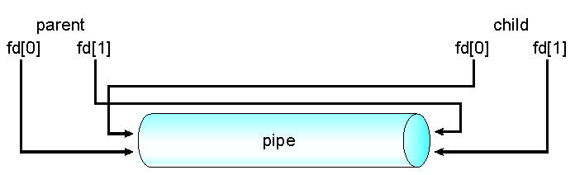

Named Pipes
- Named Pipes are more powerful than ordinary pipes
- Communication is bidirectional
- No parent-child relationship is necessary between the communicating processes
- Several processes can use the named pipe for communication
- Provided on both UNIX and Windows systems
Creating and Using Pipes
- include <unistd.h>
int pipe(int filedes[2]);
- Returns : 0 on Success. -1 on error.
- If pipe is empty and we call read system call then Reads on the pipe will return EOF (return value 0) if no process has the write end open.

Parent and child sharing a pipe
- When we use fork in any process, file descriptors remain open across child process and also parent process.
- If we call fork after creating a pipe, then the parent and child can communicate via the pipe.
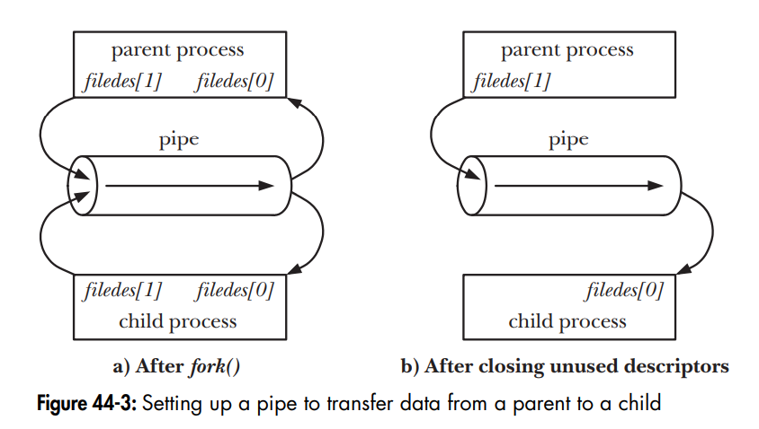
int filedes[2];
if (pipe(filedes) == -1) /* Create the pipe */
errExit("pipe");
switch (fork()) { /* Create a child process */
case -1:
errExit("fork");
case 0: /* Child */
if (close(filedes[1]) == -1) /* Close unused write end */
errExit("close");
/* Child now reads from pipe */
break;
default: /* Parent */
if (close(filedes[0]) == -1) /* Close unused read end */
errExit("close");
/* Parent now writes to pipe */
break;
}
Dup() and dup2()
dup()
- The dup() system call creates a copy of a file descriptor.
- It uses the lowest-numbered unused descriptor for the new descriptor.
- If the copy is successfully created, then the original and copy file descriptors may be used interchangeably.
- They both refer to the same open file description and thus share file offset and file status flags.
- Syntax:
int dup(int oldfd);
oldfd: old file descriptor whose copy is to be created.
dup2()
- The dup2() system call is similar to dup() but the basic difference between them is that instead of using the lowest-numbered unused file descriptor, it uses the descriptor number specified by the user.
- Syntax:
int dup2(int oldfd, int newfd);
oldfd: old file descriptor
newfd new file descriptor which is used by dup2() to create a copy.
Important points:
- Include the header file unistd.h for using dup() and dup2() system call.
- If the descriptor newfd was previously open, it is silently closed before being reused.
- If oldfd is not a valid file descriptor, then the call fails, and newfd is not closed.
- If oldfd is a valid file descriptor, and newfd has the same value as oldfd, then dup2() does
- nothing, and returns newfd.
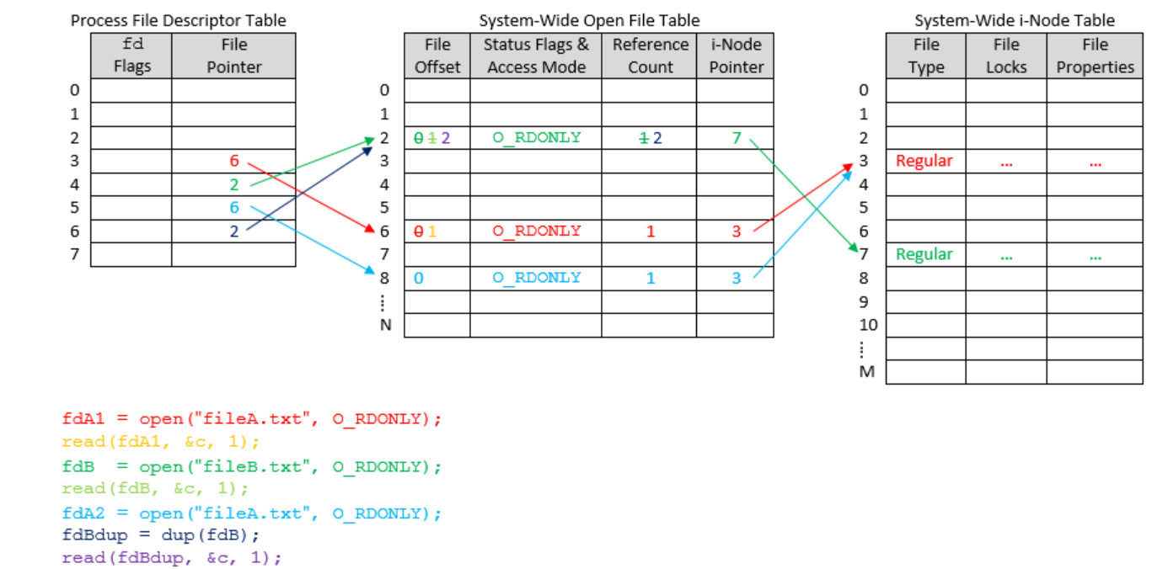
- https://users.cs.jmu.edu/bernstdh/web/common/lectures/summary_unix_file-descriptors.php
- #include<stdlib.h>
#include<unistd.h>
#include<stdio.h>
#include<fcntl.h>

int main()
{
int file_desc = open("tricky.txt",O_WRONLY | O_APPEND);

// here the newfd is the file descriptor of stdout (i.e. 1)
dup2(file_desc, 1) ;

// All the printf statements will be written in the file
// "tricky.txt"
printf("I will be printed in the file tricky.txt\n");

return 0;
}

Examples
// Parent sends a message to child using a pipe
#include<sys/types.h>
#include<stdio.h>
#include<unistd.h>
#include<string.h>
int main( ){
char msg1[100], msg2[100];
pid_t pid;
int pipeDesc[2];
strcpy(msg1, "Hello Child");

if( pipe( pipeDesc ) < 0 ) {
perror("pipe");
return 1;
}
pid = fork() ;
if (pid < 0 ) {
perror("fork");
return 1;
}
if ( pid > 0 ) {
close( pipeDesc [0 ] );
printf("Parent writes: %s\n", msg1);
write ( pipeDesc[1], msg1, strlen(msg1)+1);
}
else {
close( pipeDesc [1] );
read ( pipeDesc[0], msg2, sizeof( msg2 ) );
printf("\nChild read: %s\n", msg2);
}
return 0;
}

//……………………………………………………………………………………………………………..
// Parent sends a message to child using a pipe
#include<sys/types.h>
#include<stdio.h>
#include<unistd.h>
#include<string.h>
int main( ){
char msg1[100], msg2[100];
pid_t pid;
int pipeDesc[2];

if( pipe( pipeDesc ) < 0 ) {
perror("pipe");
return 1;
}
pid = fork() ;
if (pid < 0 ) {
perror("fork");
return 1;
}
if ( pid > 0 ) {
close( pipeDesc [0 ] );
printf("Input a line of text...\n");
scanf("%[^\n]", msg1);
printf("Parent writes: %s\n", msg1);
write ( pipeDesc[1], msg1, strlen(msg1)+1);
}
else {
close( pipeDesc [1] );
read ( pipeDesc[0], msg2, sizeof( msg2 ) );
printf("\nChild read: %s\n", msg2);
}
return 0;
}

//……………………………………………………………………………………………………………………………………..
// Implementation of the command “ ls - s | sort “ using pipe
#include<stdio.h>
#include<stdlib.h>
#include<unistd.h>
int main() {
int pid;
int fd[2];

pipe(fd);

pid=fork();
if( pid < 0 ) {
perror( "fork");
exit( -1 );
}

if( pid==0) {

close(1);
dup (fd[1]);

close(fd[0]);
close(fd[1]);
execl("/usr/bin/who","who",(char *) 0);
// execl("/bin/ls", "ls", "-s", (char *) 0);

}
else {
close(0);
dup (fd[0]);
close(fd[0]);
close(fd[1]);
execl("/usr/bin/sort","sort",(char *) 0);
}
}

