Introduction
POSIX.4 Message Queues (pja.edu.pl)
POSIX message queues in Linux | SoftPrayog
POSIX message queues allow for an efficient, priority-driven IPC mechanism with multiple readers and writers. For the experienced POSIX programmer, this description invokes an image of named pipes. However, there are some fundamental differences between pipes and message queues:
- Message queues have internal structure. With a named pipe, a writer is just pumping bits. For a reader, there's no distinction between different calls to write() from different writers. It's left up to the programmer to make sure that the correct number of bits are put into or taken out of the pipe. This makes variable-sized messages a hassle.
- Message queues are priority-driven. Whenever a writer sends a message to a queue, a priority is specified for that message. The queue will remain sorted such that the oldest message of the highest priority will always be at the front.
- The programmer has control over the geometry of a message queue. When a message queue is created, the programmer may set ceilings on the number of messages that can be on the queue, and the size of each message.
- A process can determine the status of a message queue. One major drawback of pipes is that their state is unknown. With message queues, a process can determine how many messages on the queue, the various maximums and flags that have been set, and the number of processes that are blocking to either send or receive.
Of course, message queues in the QNX implementation still have all of the advantages of named pipes (FIFOs in QNX):
- They exist in the pathname space.
- They can have POSIX permissions.
- They can be accessed using the traditional I/O routines (such as open(), read(), write(), select() and so on).
For more information, see "POSIX.4 Message Queues" in the Better Coordination: Messages, Shared Memory, and Synchronization chapter of Programming for the Real World - POSIX.4 by Bill O. Gallmeister (O'Reilly & Associates, Inc. ISBN: 1-56592-074-0).

Message-queue structures
POSIX.4 Message Queues (pja.edu.pl)
The message-queue structures are found in the <mqueue.h> header file.
mqd_t
Like pipes and FIFOs, all message queue operations are performed based on message queue descriptors (an mqd_t). In the QNX implementation, an mqd_t is a file descriptor. Thus, in addition to the POSIX message queue API, the programmer may call almost any I/O routine that takes a file descriptor.
mq_attr
Every message queue has an attribute structure associated with it. This structure includes:
long mq_flags
The options set for this queue. This field may have been changed since queue creation with a call to mq_setattr() (see below for a description of each bit).
long mq_maxmsg
The maximum number of messages that can be stored on the queue. In the QNX implementation, an mq_maxmsg of 0 means that there is no maximum. This value was set when the queue was created.
long mq_msgsize
The maximum size of each message on the given message queue. This value was also set when the queue was created.
long mq_curmsgs
This field represents the number of messages currently on the given queue.
long mq_sendwait
The number of processes currently waiting to send a message. This field was eliminated from the POSIX standard after draft 9, but has been resurrected for the QNX implementation. A nonzero value in this field implies that the queue is full.
long mq_recvwait
The number of processes currently waiting to receive a message. Like mq_sendwait, this field was resurrected for the QNX implementation. A nonzero value in this field implies that the queue is empty.

Flags
The mq_flags field is the bitwise OR of zero or more of the constants described below.
The following constant is specified by POSIX 1003.4:
MQ_NONBLOCK
No mq_receive() or mq_send() will ever block on this queue. If the queue is in such a condition that the given operation cannot be performed without blocking, then an error is returned, and errno is set to EAGAIN.
The following constants are unique to the QNX implementation:
MQ_MULT_NOTIFY
When this flag is set, more than one process may be registered for notification; a call to mq_notify() never returns an EBUSY error. If multiple processes are registered for notification, then they are notified on a first come, first served basis. This flag may only be set on; it may never be set off. Any attempt to set this flag off once it is on causes errno to be set to EINVAL.
MQ_NOTIFY_ALWAYS
When this flag is set, the mq_notify() call causes the process to be notified, even if the queue currently contains messages.
MQ_PRIO_RESTRICT
The POSIX 1003.4 standard allows any process to send a message of arbitrary priority. This may allow low-priority processes to wield excessive power. If this flag is set, then no process may use mq_send() to send a message with a priority higher than its own. An attempt to do so causes errno to be set to EINVAL.
MQ_PRIO_BOOST
By default, any write() to a message queue sends a message with priority 0. If this option is in effect, then any time a zero-priority message is written, its priority is boosted to that of the calling process. This option only affects messages with a priority of 0.
MQ_READBUF_DYNAMIC
POSIX mandates that an mq_receive() performed on a queue with a buffer size less than that queues maximum message size must fail. However, it is very possible that a process could have a receive buffer of significantly smaller size than the maximum, and still never miss data. If this flag is set, processes may make calls to mq_receive() with arbitrary buffer sizes. The call only fails if a message that has a size larger than the buffer allotted is about to be received. In this case, an error is returned, and errno is set to EINVAL.
Functions for message queues
The POSIX message queue API is as follows:
Function | Summary
mq_close() | close a message queue
mq_getattr() | get the current attributes of a message queue
mq_notify() | notify the calling process when the queue becomes nonempty
mq_open() | open or create a message queue
mq_receive() | receive a message from a queue
mq_send() | put a message into a message queue
mq_setattr() | set the flags for a message queue
mq_unlink() | unlink (i.e. delete) a message queue
In addition, the QNX implementation allows for the following standard I/O and file manipulation calls to be used on message queues:
Function | Summary
access() | check to see if the given queue exists and can be accessed
chmod() | change the permissions for a message queue
chown() | change the owner user ID and group ID of the specified message queue
close() | close a message queue
creat() | create a message queue
dup() | duplicate a file descriptor, getting an unused descriptor number
dup2() | duplicate a file descriptor, supplying a new descriptor number
fchmod() | change the permissions for a message queue
fchown() | change the user ID and group ID of a message queue
fstat() | get message queue status
lstat() | get message queue status
open() | open a message queue
read() | read (receive) from the given message queue
readv() | read several messages and places them into several buffers
select() | allow for synchronous multiplexing with standard I/O
stat() | get status for a message queue - see below
unlink() | remove the given message queue
utime() | set the modification time for a message queue
write() | write (send) to the given queue

For stat(), most fields in the stat structure are filled in as would be expected, with a few exceptions:
- The st_size field contains the number of messages currently on the queue.
- The st_ino field contains the capacity of the message queue.

<fcntl.h>
fcntl.h File - IBM Documentation
fcntl.h(0p) - Linux manual page (man7.org)
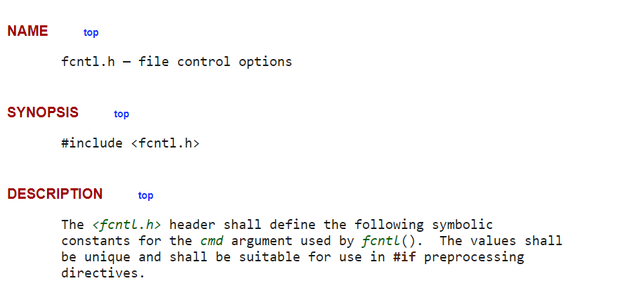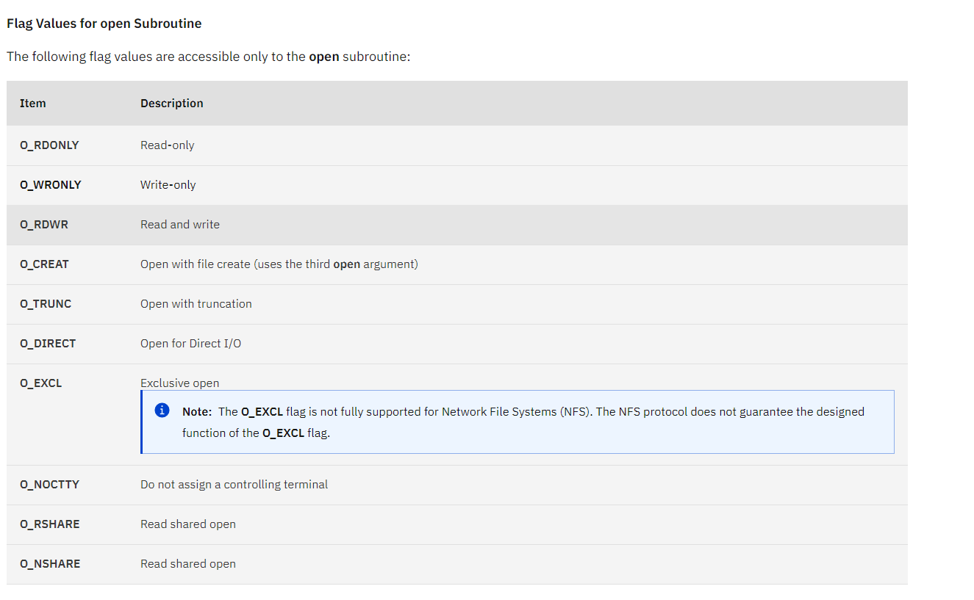

<mqueue.h>
mqueue.h(0p) - Linux manual page (man7.org)
mqueue.h - man pages section 3: Library Interfaces and Headers (oracle.com)
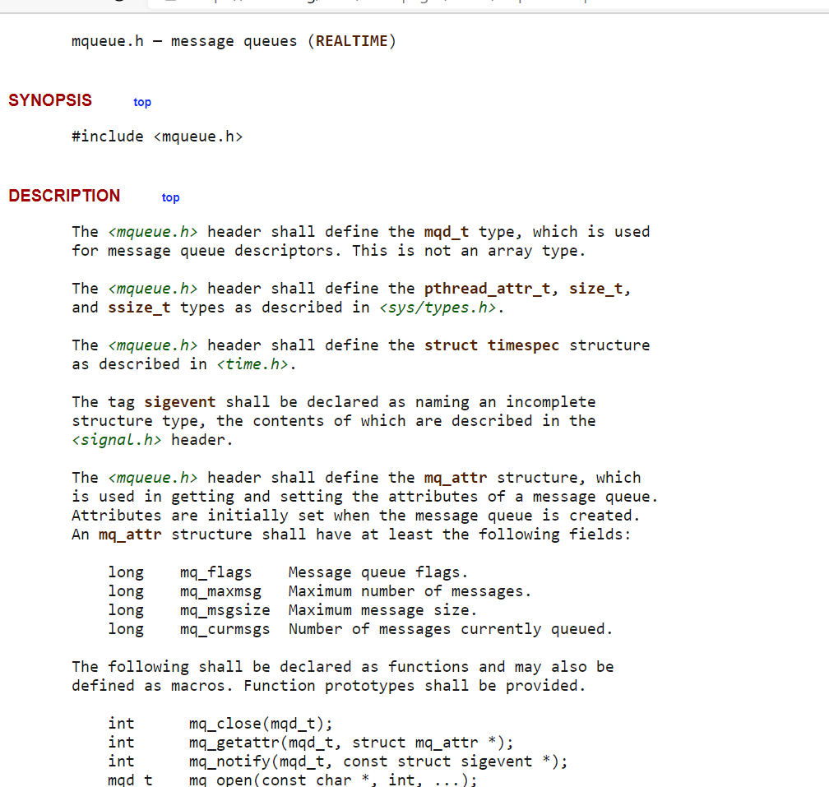
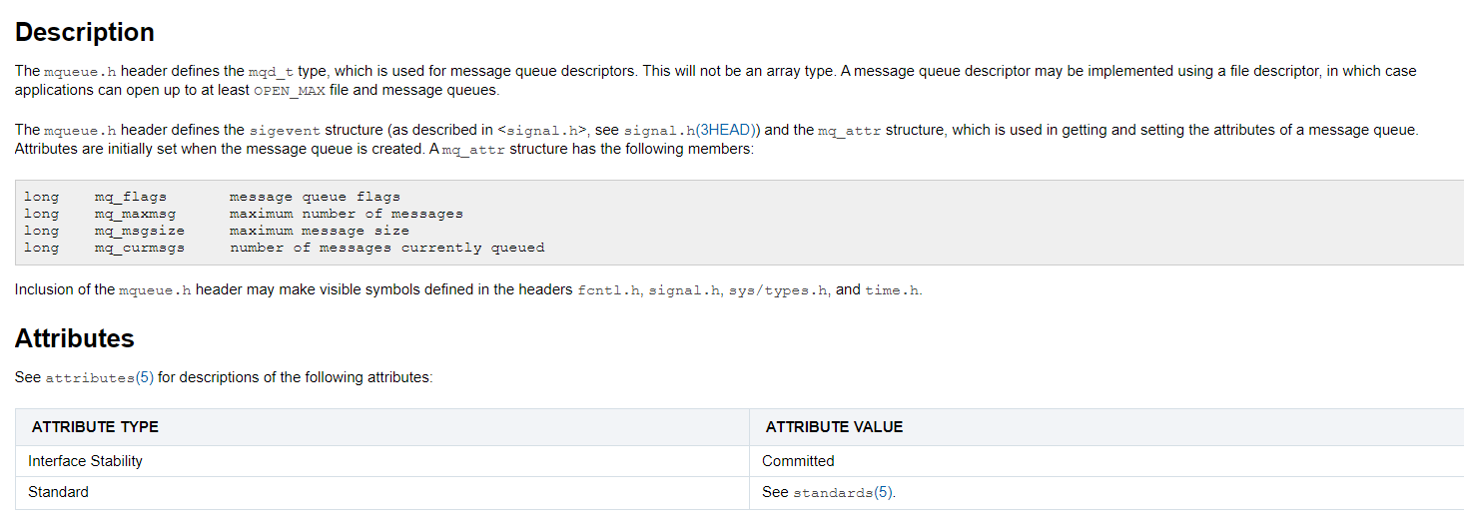

mq_open()
mq_open(3) - Linux manual page (man7.org)
mq_open (pja.edu.pl)

SYNOPSIS top
#include <fcntl.h> /* For O_* constants */
#include <sys/stat.h> /* For mode constants */
#include <mqueue.h>

mqd_t mq_open(const char *name, int oflag);
mqd_t mq_open(const char *name, int oflag, mode_t mode,
struct mq_attr *attr);

Link with -lrt.

DESCRIPTION top
mq_open() creates a new POSIX message queue or opens an existing
queue. The queue is identified by name. For details of the
construction of name, see mq_overview(7).

The oflag argument specifies flags that control the operation of
the call. (Definitions of the flags values can be obtained by
including <fcntl.h>.) Exactly one of the following must be
specified in oflag:
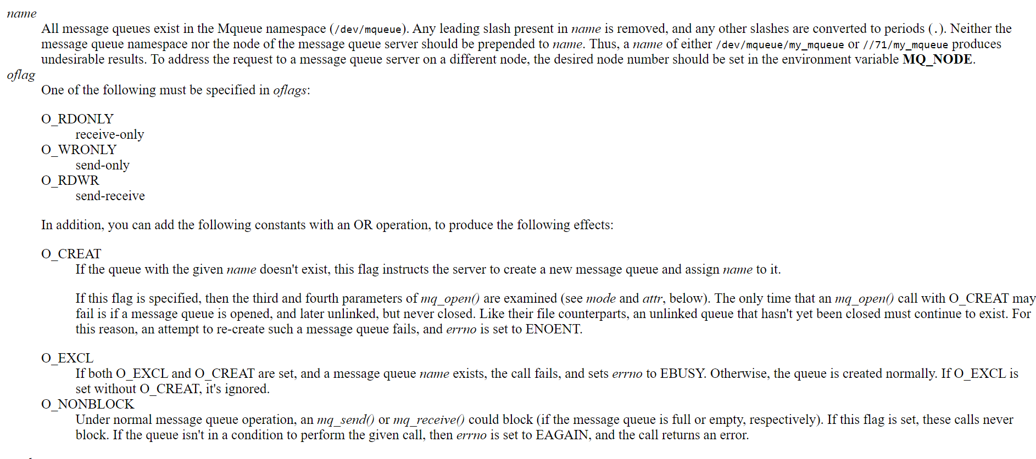

O_CREAT
Create the message queue if it does not exist. The owner
(user ID) of the message queue is set to the effective
user ID of the calling process. The group ownership
(group ID) is set to the effective group ID of the calling
process.

If O_CREAT is specified in oflag, then two additional arguments
must be supplied. The mode argument specifies the permissions to
be placed on the new queue, as for open(2). (Symbolic
definitions for the permissions bits can be obtained by including
<sys/stat.h>.) The permissions settings are masked against the
process umask.

The fields of the struct mq_attr pointed to attr specify the
maximum number of messages and the maximum size of messages that
the queue will allow. This structure is defined as follows:

struct mq_attr {
long mq_flags; /* Flags (ignored for mq_open()) */
long mq_maxmsg; /* Max. # of messages on queue */
long mq_msgsize; /* Max. message size (bytes) */
long mq_curmsgs; /* # of messages currently in queue
(ignored for mq_open()) */
};

Only the mq_maxmsg and mq_msgsize fields are employed when
calling mq_open(); the values in the remaining fields are
ignored.

If attr is NULL, then the queue is created with implementation-
defined default attributes. Since Linux 3.5, two /proc files can
be used to control these defaults; see mq_overview(7) for
details.

RETURN VALUE top
On success, mq_open() returns a message queue descriptor for use
by other message queue functions. On error, mq_open() returns
(mqd_t) -1, with errno set to indicate the error.

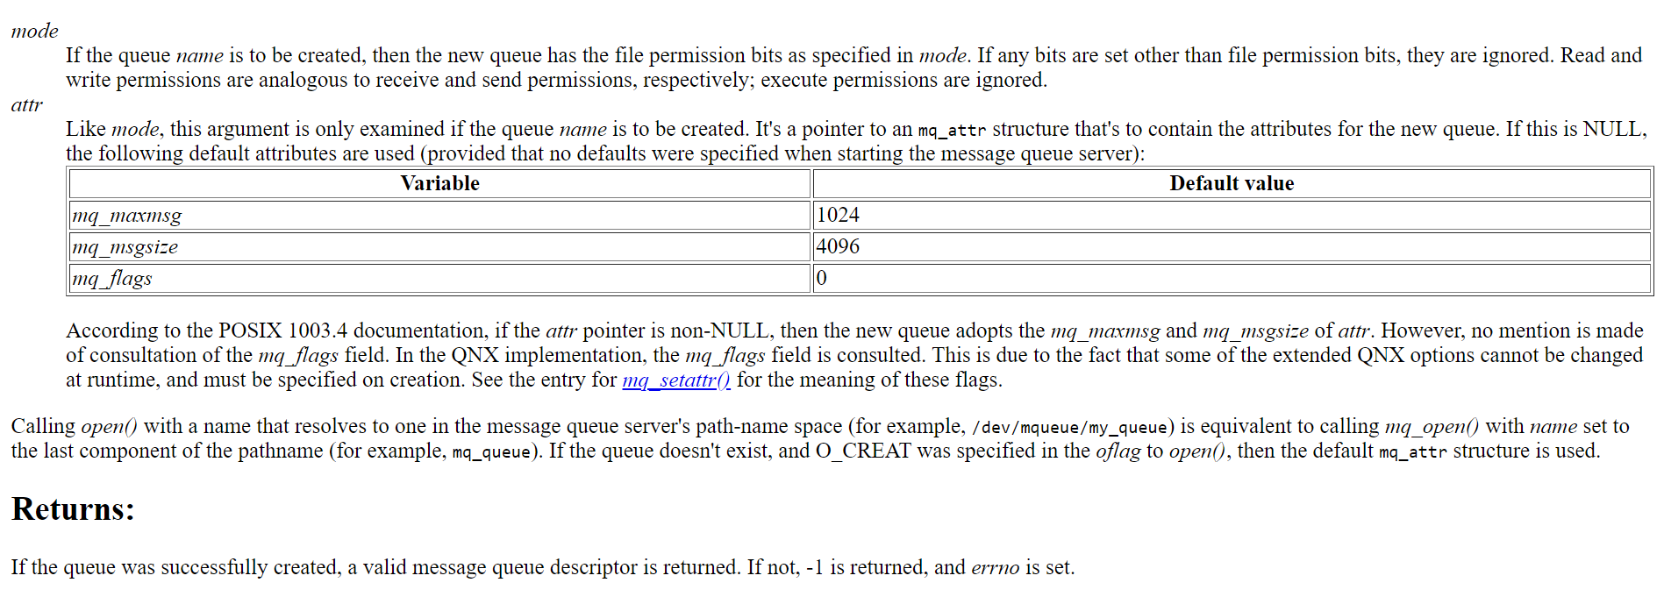

mq_send()
mq_send(3) - Linux manual page (man7.org)
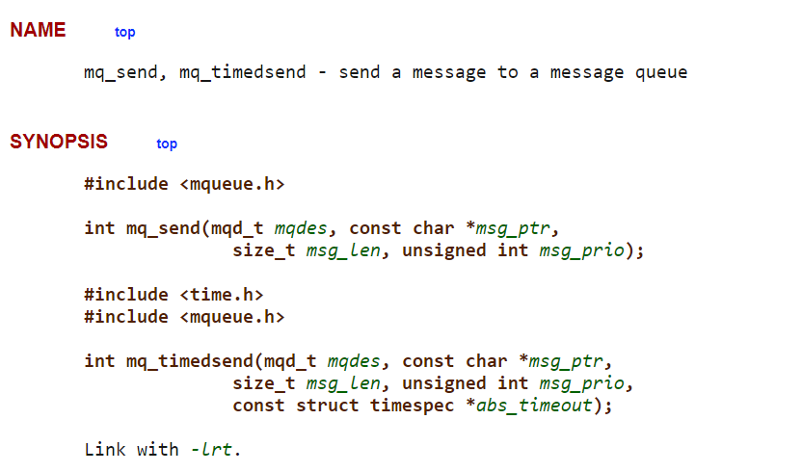
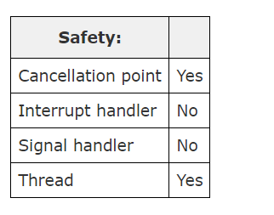
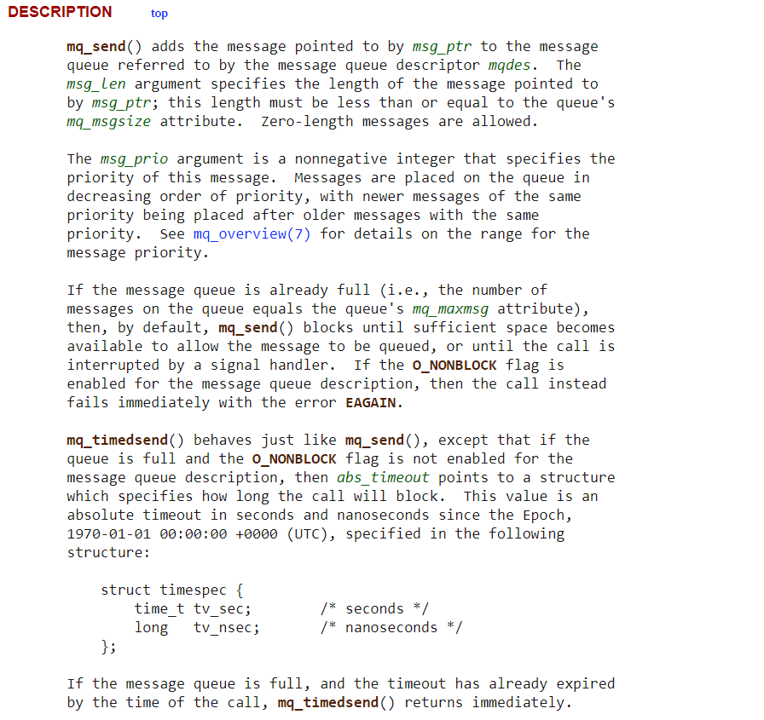RETURN VALUE
On success, mq_send() and mq_timedsend() return zero; on error, -1 is returned, with errno set to indicate the error.

mq_receive
mq_receive(3) - Linux manual page (man7.org)
