C strncmp() Function with example (beginnersbook.com)
C Language: strcmp function (String Compare) (techonthenet.com)
Use the bzero Function in C | Delft Stack
Unix Socket - Structures - Tutorialspoint
The BSD UNIX Socket Library : Header Files (sas.com)
Ubuntu Manpage: sys/socket.h - main sockets header
IBM Docs
Ubuntu Manpage: netinet/in.h - Internet address family
Socket Programming in C/C++ - GeeksforGeeks
Host and Network Byte Ordering, Little and Big Endian Ordering (techaccessinfo.com)
bind() — Bind a name to a socket - IBM Documentation
listen() -- mark a socket as accepting connections (mkssoftware.com)
Socket programming in C on Linux – The Ultimate Guide for Beginners – BinaryTides
PowerPoint Presentation (uoc.gr)
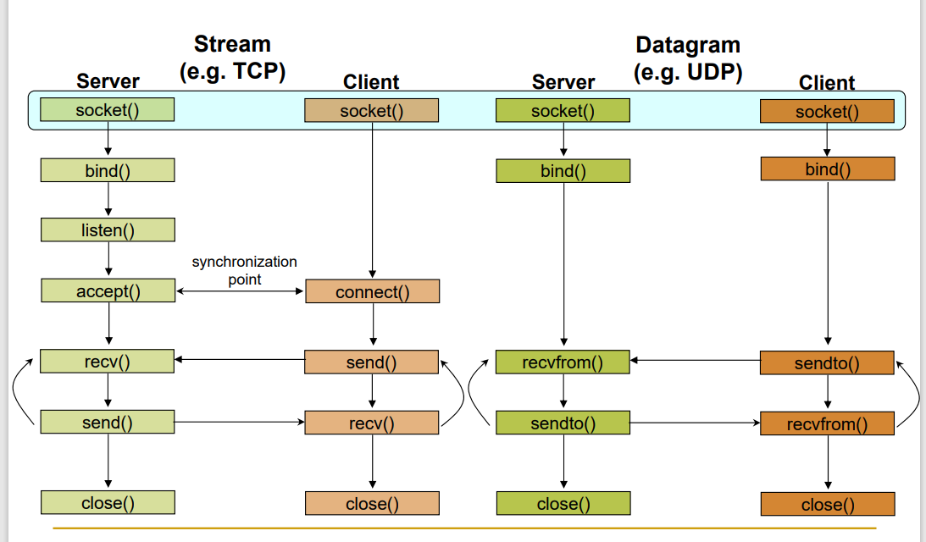
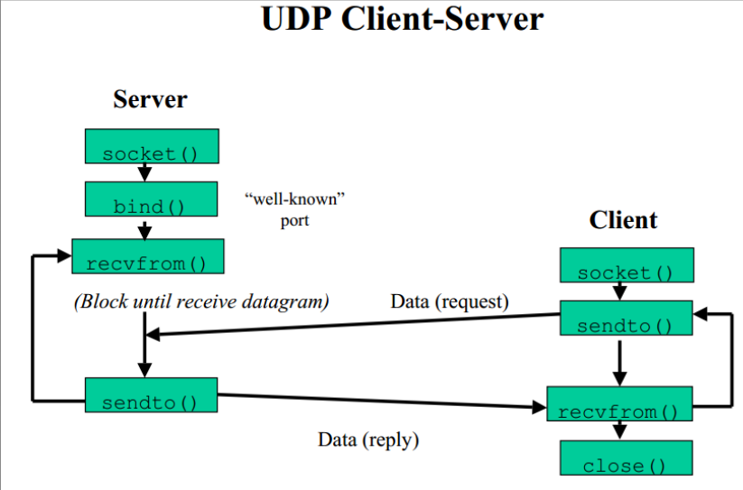
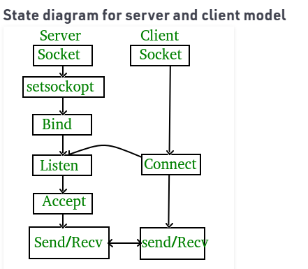

GENERAL
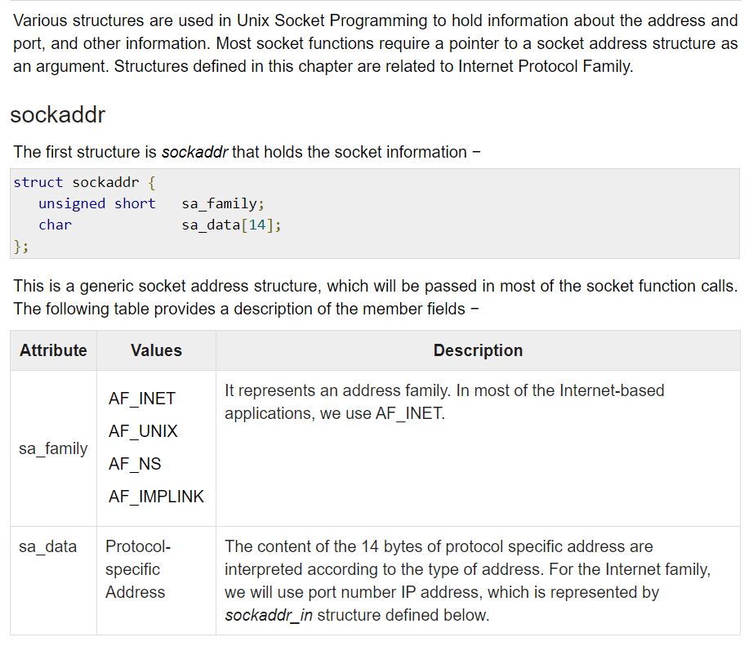

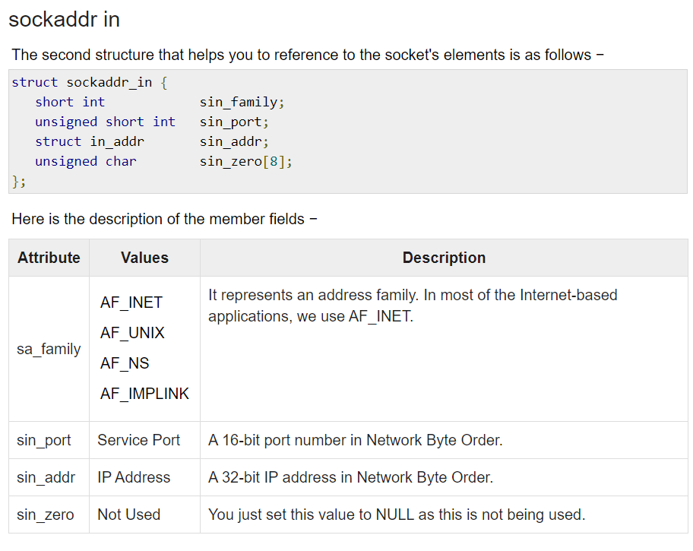
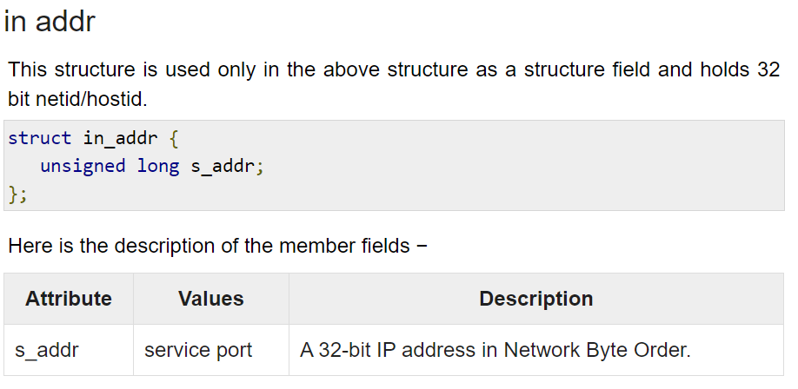
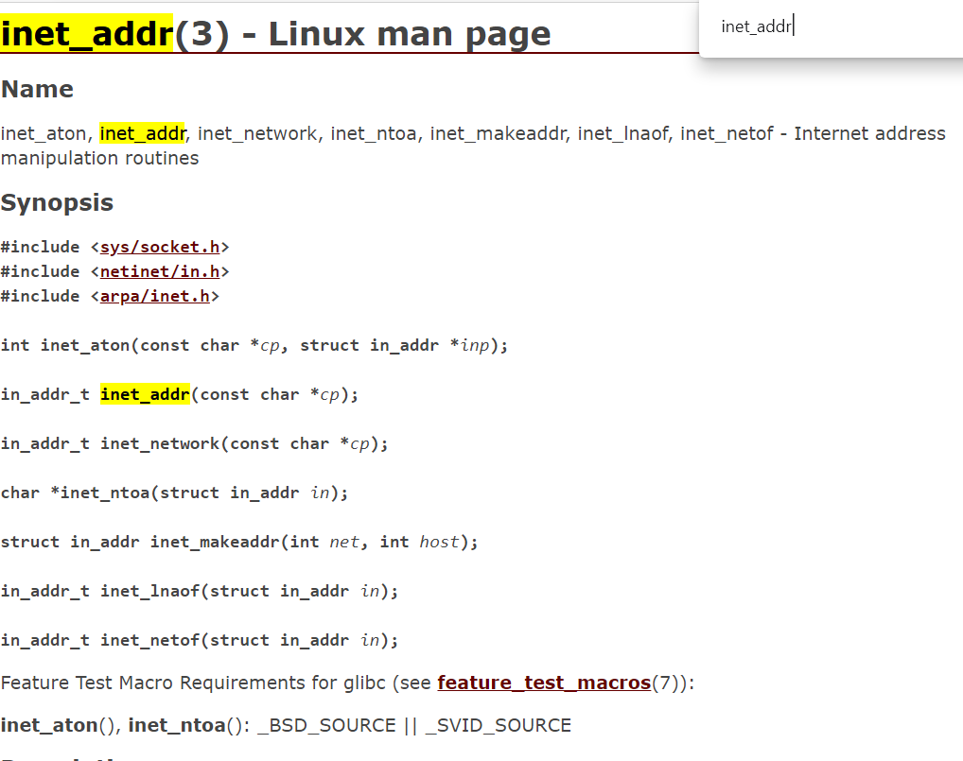General description
The inet_addr() function interprets character strings representing host addresses expressed in standard dotted-decimal notation and returns host addresses suitable for use as an Internet address.
Parameter
Description
cp
A character string in standard dotted-decimal (.) notation.

INADDR_ANY
INADDR_ANY is used when you don't need to bind a socket to a specific IP. When you use this value as the address when calling bind(), the socket accepts connections to all the IPs of the machine.
To bind socket with localhost, before you invoke the bind function, sin_addr.s_addr field of the sockaddr_in structure should be set properly. The proper value can be obtained either by
my_sockaddress.sin_addr.s_addr = inet_addr("127.0.0.1")
or by
my_sockaddress.sin_addr.s_addr=htonl(INADDR_LOOPBACK);
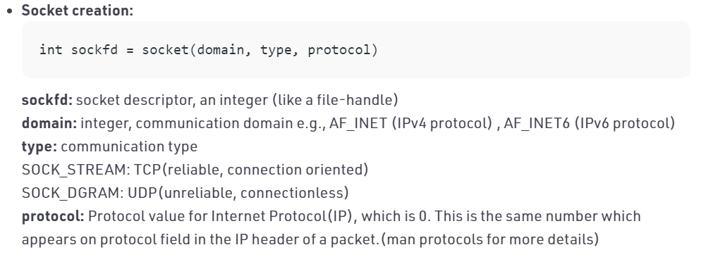
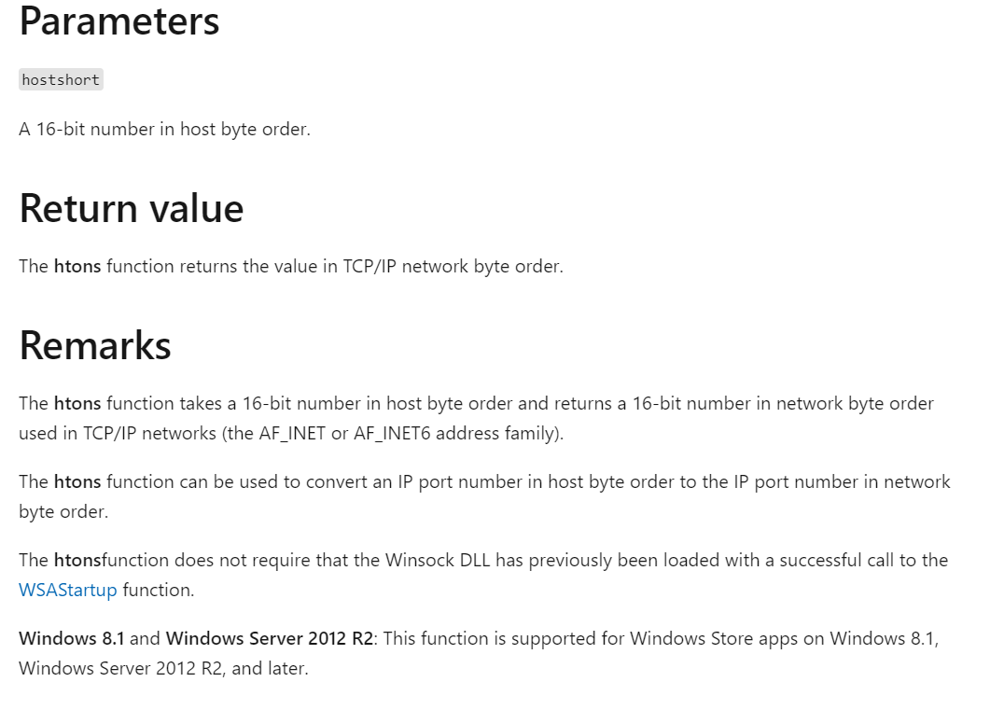

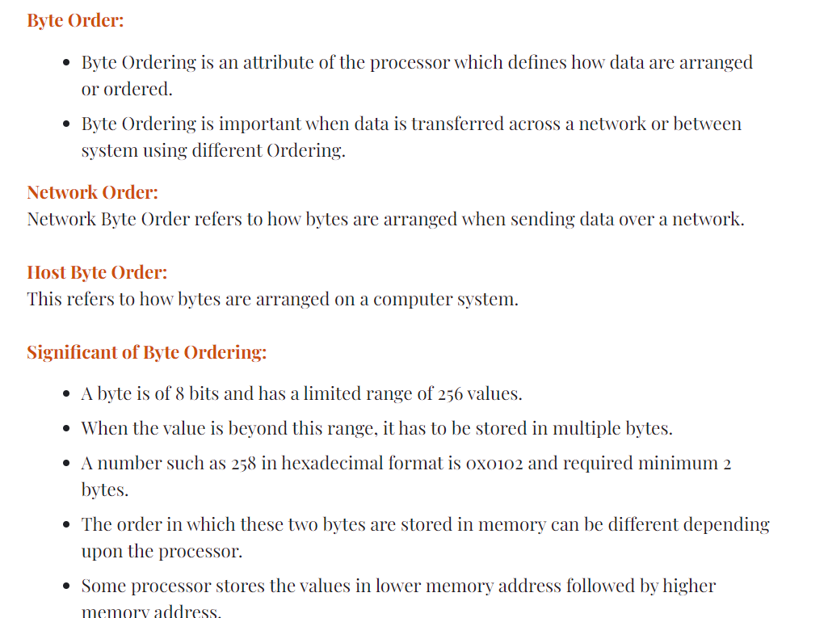
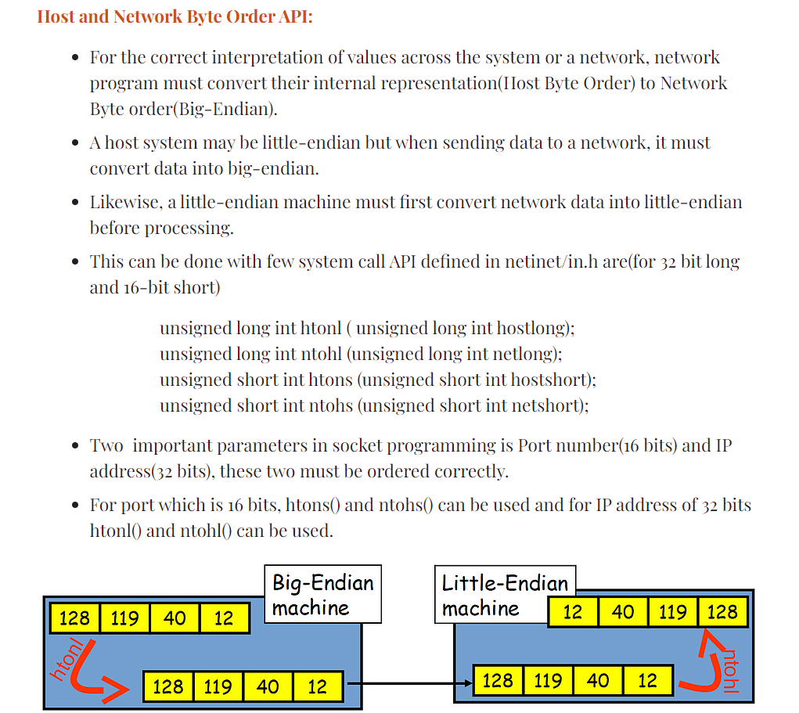

bind() — Bind a name to a socket

Standards
Standards / Extensions | C or C++ | Dependencies
XPG4.2  Single UNIX Specification, Version 3 | both

Format
X/Open
#define _XOPEN_SOURCE_EXTENDED 1
#include <sys/socket.h>

int bind(int socket, const struct sockaddr *address, socklen_t address_len);
Berkeley Sockets
#define _OE_SOCKETS
#include <sys/types.h>
#include <sys/socket.h>

int bind(int socket, struct sockaddr *address, int address_len);

General description
The bind() function binds a unique local name to the socket with descriptor socket. After calling socket(), a descriptor does not have a name associated with it. However, it does belong to a particular address family as specified when socket() is called. The exact format of a name depends on the address family.
Parameter
Description
socket
The socket descriptor returned by a previous socket() call.
address
The pointer to a sockaddr structure containing the name that is to be bound to socket.
address_len
The size of address in bytes.
The socket parameter is a socket descriptor of any type created by calling socket().
The address parameter is a pointer to a buffer containing the name to be bound to socket. The address_len parameter is the size, in bytes, of the buffer pointed to by address. For AF_UNIX, this function creates a file that you later need to unlink besides closing the socket.
Socket Descriptor Created in the AF_INET Domain
If the socket descriptor socket was created in the AF_INET domain, the format of the name buffer is expected to be sockaddr_in, as defined in the include file netinet/in.h:
struct in_addr
{
ip_addr_t s_addr;
};

struct sockaddr_in {
unsigned char sin_len;
unsigned char sin_family;
unsigned short sin_port;
struct in_addr sin_addr;
unsigned char sin_zero[8];

};
The sin_family field must be set to AF_INET.
The sin_port field is set to the port to which the application must bind. It must be specified in network byte order. If sin_port is set to 0, the caller leaves it to the system to assign an available port. The application can call getsockname() to discover the port number assigned.
The sin_addr.s_addr field is set to the Internet address and must be specified in network byte order. On hosts with more than one network interface (called multihomed hosts), a caller can select the interface to which it is to bind. Subsequently, only UDP packets and TCP connection requests from this interface (which match the bound name) are routed to the application. If this field is set to the constant INADDR_ANY, as defined in netinet/in.h, the caller is requesting that the socket be bound to all network interfaces on the host. Subsequently, UDP packets and TCP connections from all interfaces (which match the bound name) are routed to the application. This becomes important when a server offers a service to multiple networks. By leaving the address unspecified, the server can accept all UDP packets and TCP connection requests made for its port, regardless of the network interface on which the requests arrived.
The sin_zero field is not used and must be set to all zeros.
Socket Descriptor Created in the AF_INET6 Domain If the socket descriptor socket was created in the AF_INET6 domain, the format of the name buffer is expected to be sockaddr_in6, as defined in the include file netinet/in.h. The structure is defined as follows:
struct sockaddr_in6 {
uint8_t sin6_len;
sa_family_t sin6_family;
in_port_t sin6_port;
uint32_t sin6_flowinfo;
struct in6_addr sin6_addr;
uint32_t sin6_scope_id;
};
The sin6_len field is set to the size of this structure. The SIN6_LEN macro is defined to indicate the version of the sockaddr_in6 structure being used.
The sin6_family field identifies this as a sockaddr_in6 structure. This field overlays the sa_family field when the buffer is cast to a sockaddr structure. The value of this field must be AF_INET6.
The sin6_port field contains the 16-bit UDP or TCP port number. This field is used in the same way as the sin_port field of the sockaddr_in structure. The port number is stored in network byte order.
The sin6_flowinfo field is a 32-bit field that contains the traffic class and the flow label.
The sin6_addr field is a single in6_addr structure. This field holds one 128-bit IPv6 address. The address is stored in network byte order.
The sin6_scope_id field is a 32-bit integer that identifies a set of interfaces as appropriate for the scope of the address carried in the sin6_addr field. For a link scope sin6_addr, sin6_scope_id, this would be an interface index. For a site scope sin6_addr, sin6_scope_id, this would be a site identifier.
Socket Descriptor Created in the AF_UNIX Domain
If the socket descriptor socket is created in the AF_UNIX domain, the format of the name buffer is expected to be sockaddr_un, as defined in the include file un.h.
struct sockaddr_un {
unsigned char sun_len;
unsigned char sun_family;
char sun_path[108]; /* pathname */
};
The sun_family field is set to AF_UNIX.
The sun_path field contains the NULL-terminated pathname, and sun_len contains the length of the pathname.

Listen()

SYNOPSIS
#include <sys/socket.h>
int listen(int s, int backlog);

DESCRIPTION
The listen() function marks a connection-mode socket (for example, those of type SOCK_STREAM), specified by the socket argument s, as accepting connections, and limits the number of outstanding connections in the socket's listen queue to the value specified by the backlog argument. The socket s is put into 'passive' mode where incoming connection requests are acknowledged and queued pending acceptance by the process.
The backlog parameter of this function is typically used by servers that could have more than one connection request at a time: if a connection request arrives with the queue full, the client receives an error with an indication of ECONNREFUSED.
listen() attempts to continue to function rationally when there are no available descriptors. It accepts connections until the queue is emptied. If descriptors become available, a later call to listen() or accept() re-fills the queue to the current or most recent backlog', if possible, and resume listening for incoming connections.
An application may call listen() more than once on the same socket. This has the effect of updating the current backlog for the listening socket. Should there be more pending connections than the new backlog value, the excess pending connections are reset and dropped.
backlog is limited (silently) to a reasonable value as determined by the underlying service provider. Illegal values are replaced by the nearest legal value.

PARAMETERS
s
Is a descriptor identifying a bound, unconnected socket.
backlog
Is the maximum length that the queue of pending connections may grow to. If this value is SOMAXCONN, then the underlying service provider responsible for socket s sets the backlog to a maximum "reasonable" value.

RETURN VALUES
If successful, listen() returns a value of zero. On failure, it returns -1 and sets errno to one of the following values:

accept()
- accept() — Accept a new connection on a socket - IBM Documentation
- accept(2) - Linux manual page (man7.org)
- The accept() system call with the connection-based socket types(SOCK_STREAM, SOCK_SEQPACKET).
- It extracts the first connection request on queue of pending connections for the listening socket, sockfd, creates a new connected socket, and returns a new file descriptor referring to that socket. The newly created socket is not in the listening state. The original socket sockfd is unaffected by this call.
- The accept() call is used by a server to accept a connection request from a client. When a connection is available, the socket created is ready for use to read data from the process that requested the connection. The call accepts the first connection on its queue of pending connections for the given socket socket.
- The accept() call creates a new socket descriptor with the same properties as socket and returns it to the caller. If the queue has no pending connection requests, accept() blocks the caller unless socket is in nonblocking mode. If no connection requests are queued and socket is in nonblocking mode, accept() returns -1 and sets the error code to EWOULDBLOCK. The new socket descriptor cannot be used to accept new connections. The original socket, socket, remains available to accept more connection requests.
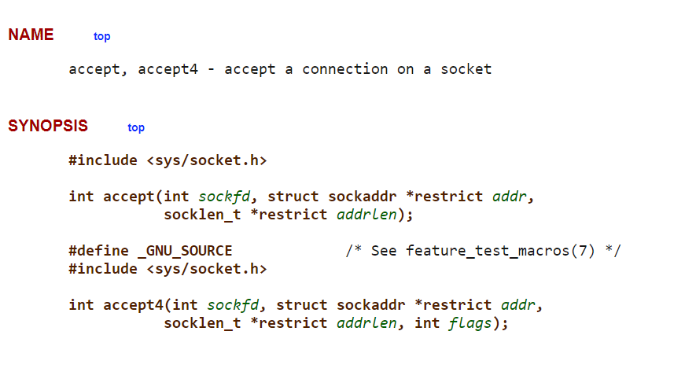
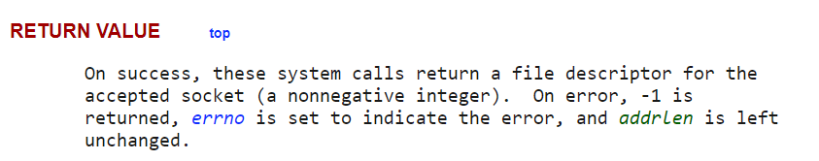

connect()
- connect(2) - Linux manual page (man7.org)
- connect() — Connect a socket - IBM Documentation
- For stream sockets, the connect() call attempts to establish a connection between two sockets. For datagram sockets, the connect() call specifies the peer for a socket. The socket parameter is the socket used to originate the connection request.
- The connect() call performs two tasks when called for a stream socket. First, it completes the binding necessary for a stream socket (in case it has not been previously bound using the bind() call). Second, it attempts to make a connection to another socket.
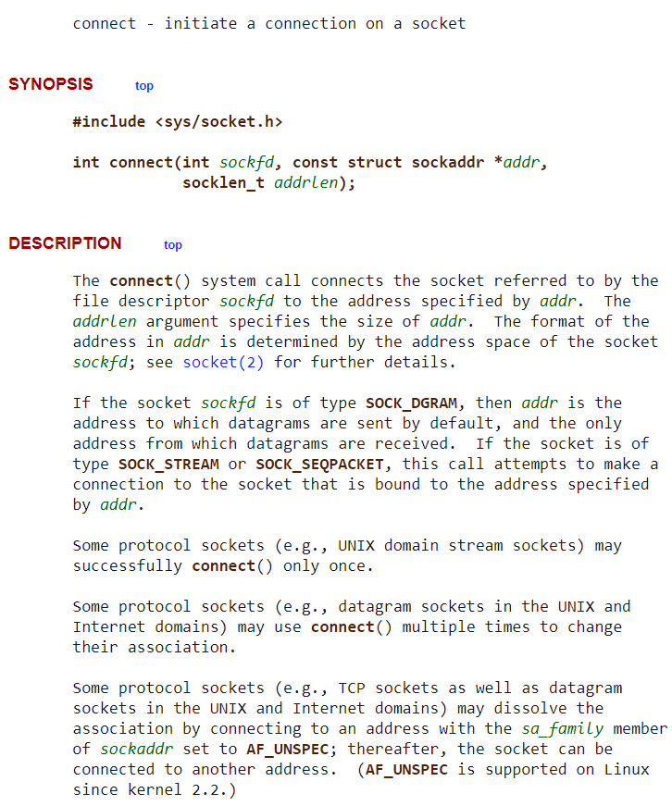
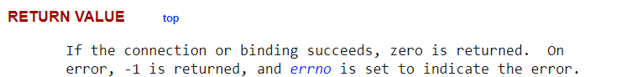

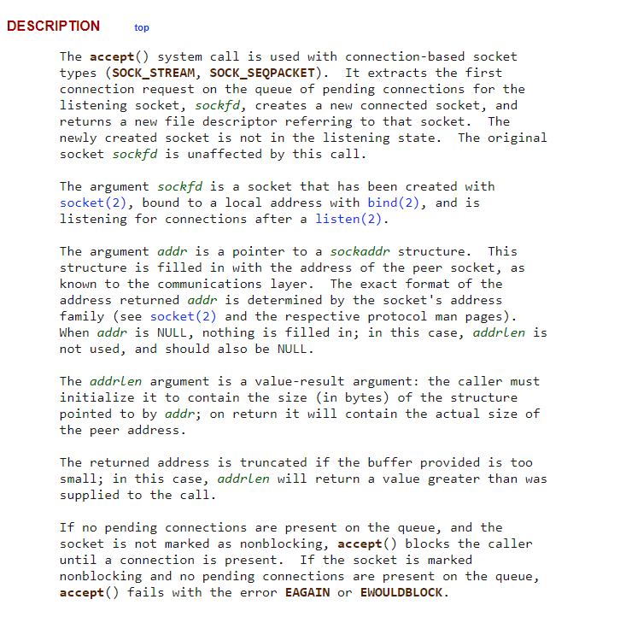

sendto()
sendto(2): send message on socket - Linux man page (die.net)
sendto() — Send data on a socket - IBM Documentation
sendto function (winsock.h) - Win32 apps | Microsoft Docs
- The sendto() call applies to either connected or unconnected sockets.
int sendto(
SOCKET s,
const char *buf,
int len,
int flags,
const sockaddr *to,
int tolen
);
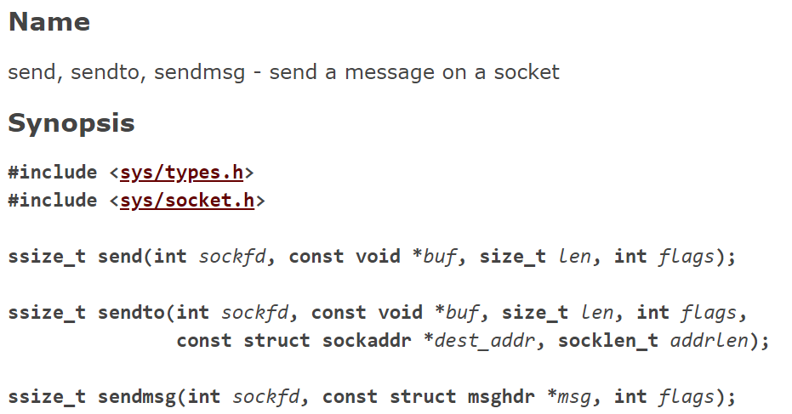
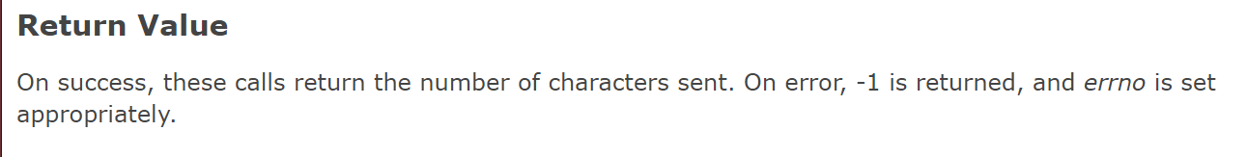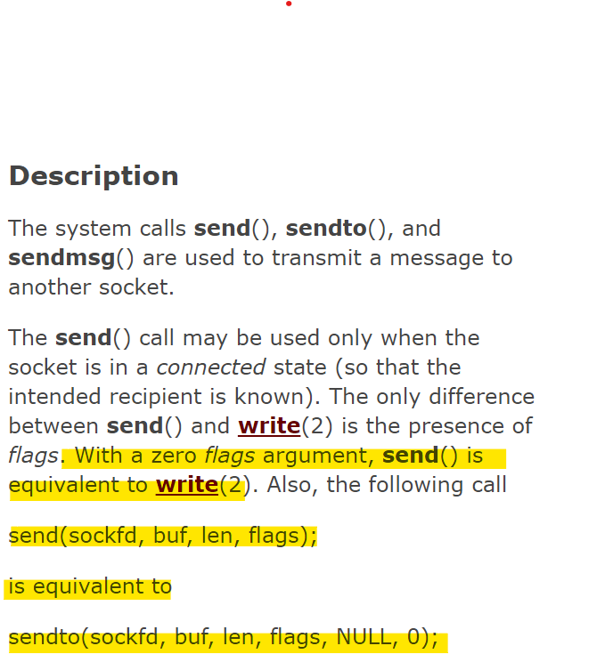
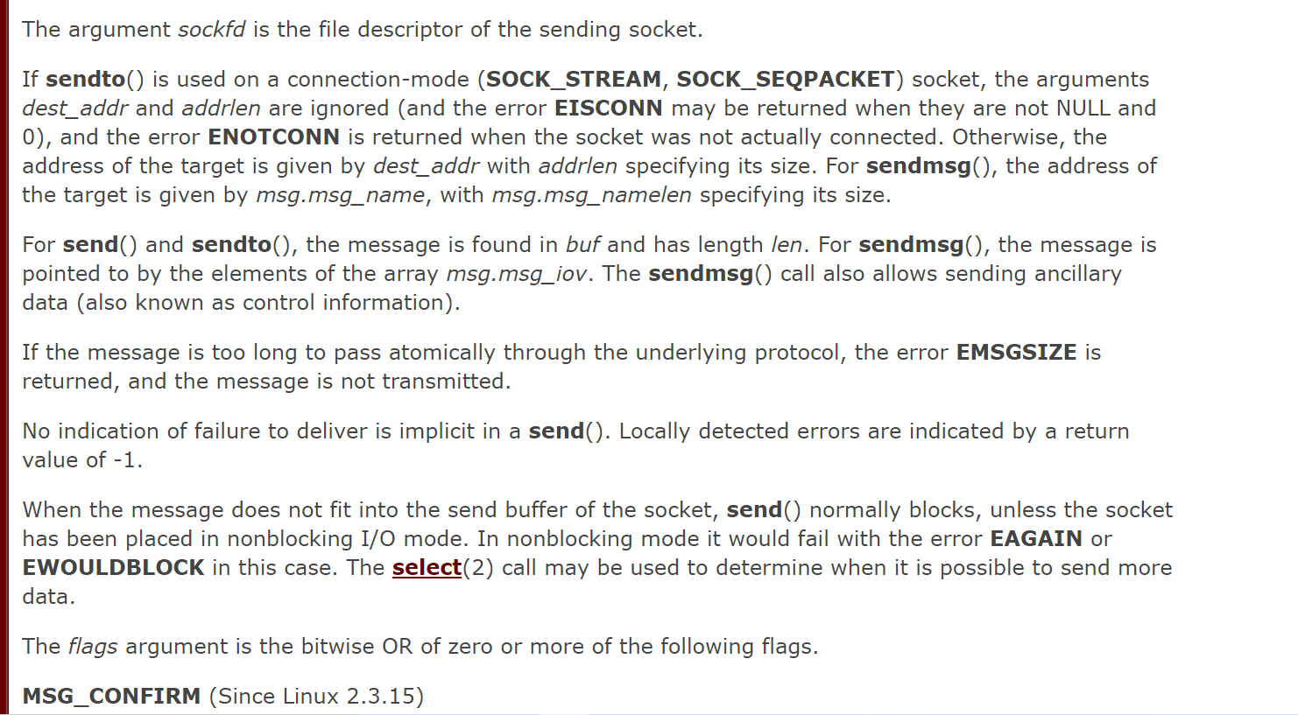

recvfrom()
recvfrom(2): receive message from socket - Linux man page (die.net)
recvfrom() — Receive messages on a socket - IBM Documentation
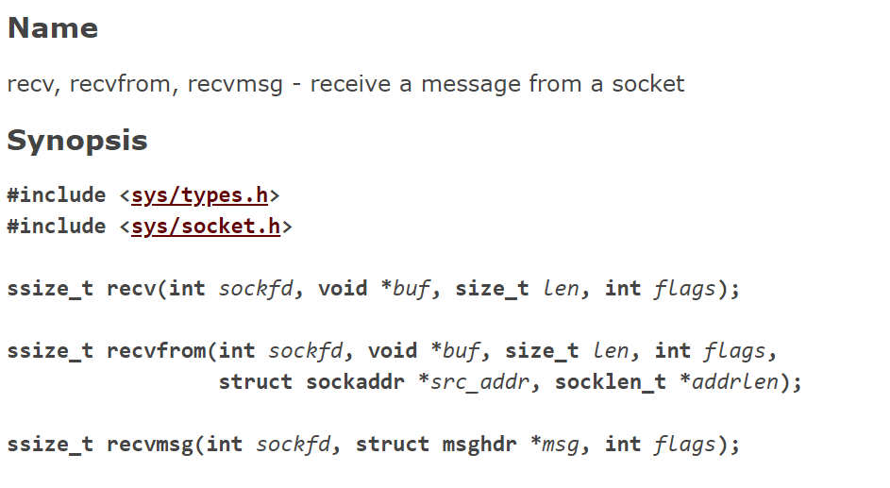
- The recvfrom() function applies to any datagram socket, whether connected or unconnected.
- If address is nonzero the source address of the message is filled. address_length must first be initialized to the size of the buffer associated with address and is then modified on return to indicate the actual size of the address stored there.
- If either address or address_length is a NULL pointer, then address and address_length are unchanged.
- If address is nonzero, the source address of the message is filled. address_length must first be initialized to the size of the buffer associated with address, and is then modified on return to indicate the actual size of the address stored there.

