  CBS1006 Principles of Operating Systems Lab Assessment 5  27-April-2021 | Siddhartha Purwar  [19BBS0072]

//Siddhartha Purwar 27-April-2021
//Banker algorithm
//Safety algorithm and Request algorithm
#include<stdio.h>
#include<string.h>

#define MAX_RES 100//maximum number of resource type
#define MAX_PRO 100//maximum number of process

int resource_type = 0, process_total = 0;
int seq[MAX_PRO], finish[MAX_PRO], available[MAX_RES], temp_work[MAX_RES], work[MAX_RES], resource[MAX_RES];
int process_alc[MAX_PRO][MAX_RES], process_max[MAX_PRO][MAX_RES], need[MAX_PRO][MAX_RES];

void input_data();
void safety_algorithm();
void request_algorithm();

int main(){
printf("Banker's Algorithm\n\n");
input_data();
safety_algorithm();
request_algorithm();
return 0;
}

void input_data(){
printf("Input the following data\n");
printf("Enter total type of resource\n");
scanf("%d", &resource_type);
for(int i = 0; i < resource_type; i++){
printf("Total number of instances for resource %d\n", i + 1);
scanf("%d", &resource[i]);
available[i] = resource[i];
}
printf("Enter total number of process\n");
scanf("%d", &process_total);
for(int i = 0; i < process_total; i++){
printf("\nEnter max resource for PROCESS %d\n", i + 1);
for(int j = 0; j < resource_type; j++){
scanf("%d", &process_max[i][j]);
}
}
for(int i = 0; i < process_total; i++){
printf("\nEnter allocated resource for PROCESS %d\n", i + 1);
for(int j = 0; j < resource_type; j++){
scanf("%d", &process_alc[i][j]);
available[j] -= process_alc[i][j];
need[i][j] = process_max[i][j] - process_alc[i][j];
}
}
memcpy(work, available, sizeof(work));//work = available
printf("Total available reouces are \n");
for(int i = 0; i < resource_type; i++){
printf("%d\n", work[i]);
}
for(int i = 0; i < process_total; i++){
printf("Need for process %d-->\t", i + 1);
for(int j = 0; j < resource_type; j++){
printf("%d\t", need[i][j]);
}
printf("\n");
}
}

void safety_algorithm(){
int flag[process_total], h = 0, l = process_total;
int temp_work[MAX_RES];
memcpy(temp_work, work, sizeof(temp_work));
for(int i = 0; i < process_total; i++){
finish[i] = -1;// using -1 to indicate false
}
for(int a = 0; a < l; a++){
int i = (a % process_total);
for(int j = 0; j < resource_type; j++){
if(need[i][j] > temp_work[j]){
flag[i] = -1;
break;
}
flag[i] = 1;
}
if(finish[i] == 1){
continue;
}
if(flag[i] == -1){
continue;
}
for(int j = 0; j < resource_type; j++){
temp_work[j] += process_alc[i][j];
}
printf("\ntemp_work -->\t");
for(int q = 0; q < resource_type; q++){
printf("%d\t", temp_work[q]);
}
l += process_total;
finish[i] = 1;
seq[h++] = i;

}
for(int i = 0; i < process_total; i++){
if(finish[i] == -1){
printf("\nDEADLOCK EXITS\n");
return;
}
}
printf("\nNO DEADLOCK EXIT\nSequence of execurion can be\n");
for(int i = 0; i < process_total; i++){
printf("Process %d\t", seq[i] + 1);
}
printf("\n");
return;
}

void request_algorithm(){
int reques_id = -1, request[resource_type];
printf("\nEnter the Requesting Process Number (%d....%d)\t", 0, process_total - 1);
scanf("%d", &reques_id);
printf("\nEnter requested resources\n");
for(int i = 0; i < resource_type; i++){
scanf("%d", &request[i]);
if(request[i] > need[reques_id][i]){
printf("\nCannot accept the request [Error: REQUEST is more than NEED]");
return;
}
if(request[i] > available[i]){
printf("\nCannot accept the request [Error: REQUEST is more than AVAILABLE]");
return;
}
}
for(int i = 0; i < resource_type; i++){
available[i] -= request[i];
process_alc[reques_id][i] += request[i];
need[reques_id][i] -= request[i];
}
memcpy(work, available, sizeof(work));
safety_algorithm();

}

OUTPUT:
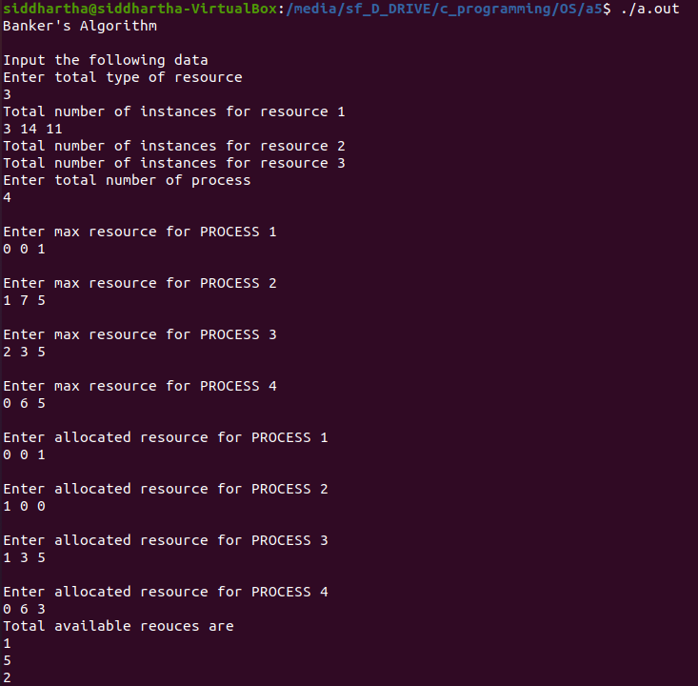
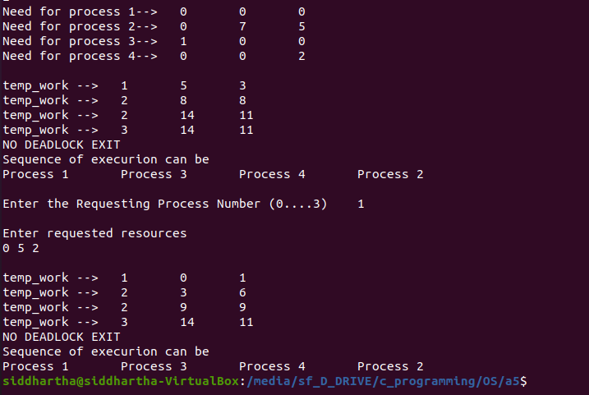


#include <pthread.h>
#include <semaphore.h>
#include <stdlib.h>
#include <stdio.h>
#include <math.h>//for using sin function for generating buffer data

#define total_producer 2
#define total_consumer 2
#define Buffer 5

sem_t empty; //keep track of the number of empty spots
sem_t full; //keep track of the number of full

int in = 0; //buffer[in%Buffer] is the first empty position
int out = 0; //buffer[out%Buffer] is the first empty position
int buffer[Buffer]; //shared buffer
pthread_mutex_t mutex; //for ensuring mutual exclusion to shared data

void *producer(void *arg){
int data;
for(int i = 0; i < Buffer; i++, in = (in + 1) % Buffer){
data = (int)((sin((i + 9) * (i * 11))) * 100) ; // Produce an random integer
sem_wait(&empty);
pthread_mutex_lock(&mutex);
//critical section starts
buffer[in] = data;
printf("Producer writing data %d at position%d\n", buffer[in],in);
//ctitical section ends
pthread_mutex_unlock(&mutex);
sem_post(&full);
}
pthread_exit(NULL);
}

void *consumer(void *arg){
for(int j = 0; j < Buffer; j++, out = (out + 1) % Buffer){
sem_wait(&full);
pthread_mutex_lock(&mutex);
//critical section starts
int item = buffer[out];
printf("\t\t\t\t\tConsumer reading data %d from position %d\n",item, out);
//critical section ends
pthread_mutex_unlock(&mutex);
sem_post(&empty);
}
pthread_exit(NULL);
}

int main(){
sem_init(&full, 0, 0);
sem_init(&empty, 0, Buffer);
pthread_t prod[total_producer], cons[total_consumer];
pthread_mutex_init(&mutex, NULL);
for(int p = 0; p < total_producer; p++){
if(pthread_create(&prod[p], NULL, (void *)producer, NULL)){
perror("Producer thread");
exit(-1);
}
}
for(int c = 0; c < total_consumer; c++){
if(pthread_create(&cons[c], NULL, (void *)consumer, NULL)){
perror("Consumer thread");
exit(-1);
}
}
for(int p = 0; p < total_producer; p++){
pthread_join(prod[p], NULL);
}
for(int c = 0; c < total_consumer; c++){
pthread_join(cons[c], NULL);
}
pthread_mutex_destroy(&mutex);
sem_destroy(&empty);
sem_destroy(&full);
return 0;
}

OUTPUT
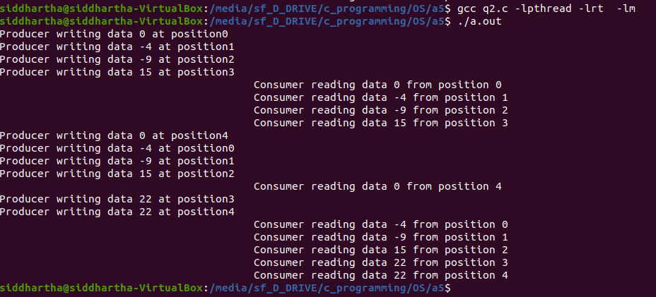

#include<stdio.h>
#include<string.h>

#define MAX_PARTITION 1000
#define MAX_PROCESS 1000

int total_part, total_proc, part_size[MAX_PARTITION], process_size[MAX_PROCESS];

void input();
void first_fit();
void best_fit();
void worst_fit();

int main(){
int choice = -1;
input();
printf("\nSelect the method:\n1-) First fit\n2-) Best fit\n3-) Worst fit\n");
scanf("%d", &choice);
printf("\n");
switch(choice){
case 1:
first_fit();
break;
case 2:
best_fit();
break;
case 3:
worst_fit();
break;
default:
printf("INVALID CHOICE\n");
break;
}
return 0;
}

void input(){
printf("Enter total number of PARTITION\n");
scanf("%d", &total_part);
for(int i = 0; i < total_part; i++){
printf("Enter size of PARTITION %d\t", i + 1);
scanf("%d", &part_size[i]);
}
printf("Enter total number of PROCESS\n");
scanf("%d", &total_proc);
for(int i = 0; i < total_proc; i++){
printf("Enter size of PROCESS %d\t", i + 1);
scanf("%d", &process_size[i]);
}
}

void first_fit(){
int j = 0;
int flag = 1;
for(int i = 0; i < total_proc; i++){
flag = 1;
for(j = 0; j < total_part; j++){
if(process_size[i] <= part_size[j] && flag == 1){
part_size[j] = part_size[j] - process_size[i];
printf("Process %d is allocated in partition %d\n", i + 1, j + 1);
printf("Memory space available\n");
for(int k = 0; k < total_part; k++){
printf("Partion %d --> %dkb\n", k + 1, part_size[k]);
}
flag = -1;
break;
}
}
if(j == total_part){
printf("Not sufficient Memory space to accomadate PROCESS %d\n", i + 1);
return;
}
}
}

void worst_fit(){
int j = 0;
for(int i = 0; i < total_proc; i++){
int flag = -1;
int temp[total_part];
memcpy(temp, part_size, sizeof(temp));
int max = -1;
for(j = 0; j < total_part; j++){
if(process_size[i] <= temp[j]){
temp[j] = temp[j] - process_size[i];
if(max < temp[j]){
max = temp[j];
flag = j;
}
}
}
if(flag == -1){
printf("Not sufficient Memory space to accomadate PROCESS %d\n", i + 1);
return;
}
else{
printf("Process %d is allocated in partition %d\n", i + 1, flag + 1);
part_size[flag] = part_size[flag] - process_size[i];
printf("Memory space available\n");
for(int k = 0; k < total_part; k++){
printf("Partion %d --> %dkb\n", k + 1, part_size[k]);
}
}

}
}

void best_fit(){
int j = 0;
for(int i = 0; i < total_proc; i++){
int flag = -1;
int temp[total_part];
memcpy(temp, part_size, sizeof(temp));
int min = 99999;
for(j = 0; j < total_part; j++){
if(process_size[i] <= temp[j]){
temp[j] = temp[j] - process_size[i];
if(min >= temp[j]){
min = temp[j];
flag = j;
}
}
}
if(flag == -1){
printf("Not sufficient Memory space to accomadate PROCESS %d\n", i + 1);
return;
}
else{
printf("Process %d is allocated in partition %d\n", i + 1, flag + 1);
part_size[flag] = part_size[flag] - process_size[i];
printf("Memory space available\n");
for(int k = 0; k < total_part; k++){
printf("Partion %d --> %dkb\n", k + 1, part_size[k]);
}
}

}
}

OUTPUT(First_fit) (when all process cannot accommodate)
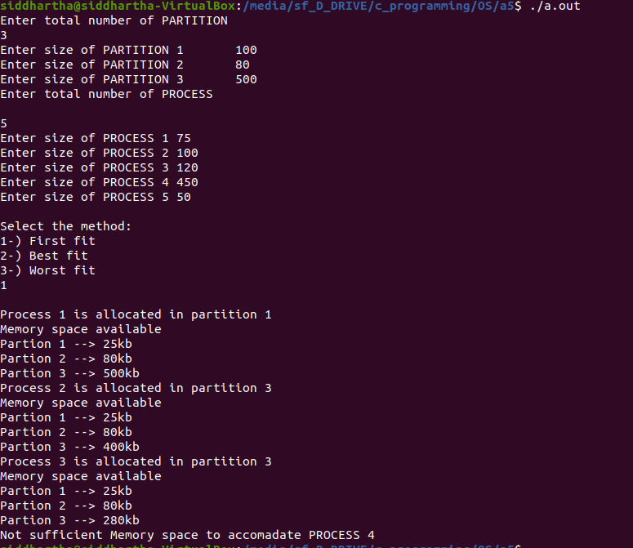

OUTPUT(Best_fit) (when all process can be accommodate)
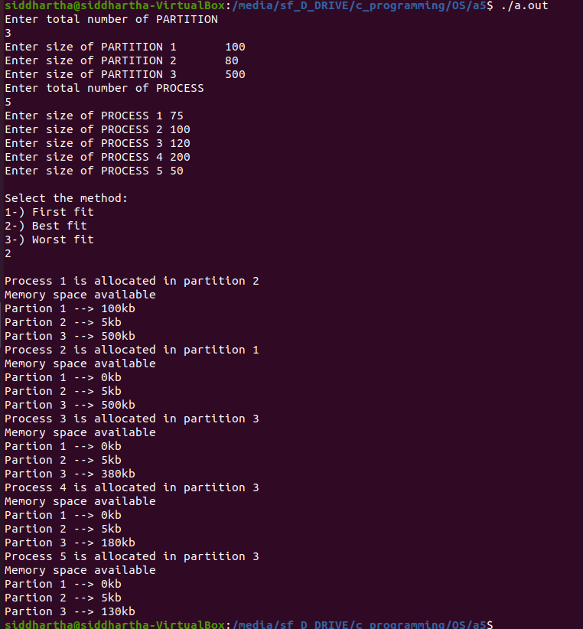

OUTPUT(Worst_fit) (when all process can be accommodate)
