|  |  |
| --- | --- |
| A picture of a winding road and trees  **CBS1006**  **Principles of Operating System**  **LAB CAT 1**  Date 23-march -2021 | **Siddhartha Purwar**  **19BBS0072** |

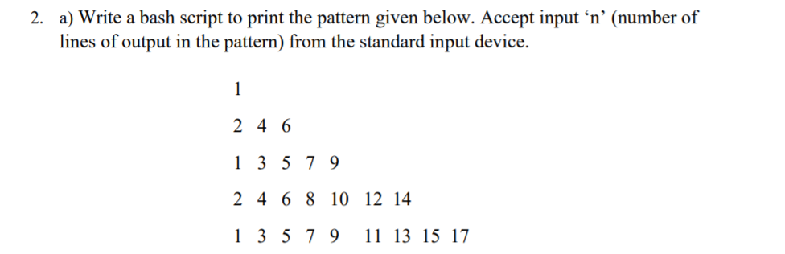

**CODE**

**#author siddhartha purwar**

**#date: 23-mar-2021**

**echo "Enter the number of lines"**

**read nums1**

**for(( i=1; $i<=$nums1; i++))**

**do**

**echo -e "\n"**

**if [ $(($i % 2)) != 0 ]**

**then**

**for((k = 1, k1 = 1; $k1 <= $(((2 * i) -1)); k = k + 2, k1++))**

**do**

**echo -e -n "$k\t"**

**done**

**else**

**for((j = 2, j1 = 1; $j1 <= $(((2 * i) -1)); j = j + 2, j1++))**

**do**

**echo -e -n "$j\t"**

**done**

**fi**

**done**

**echo -e "\n"**

**OUTPUT**

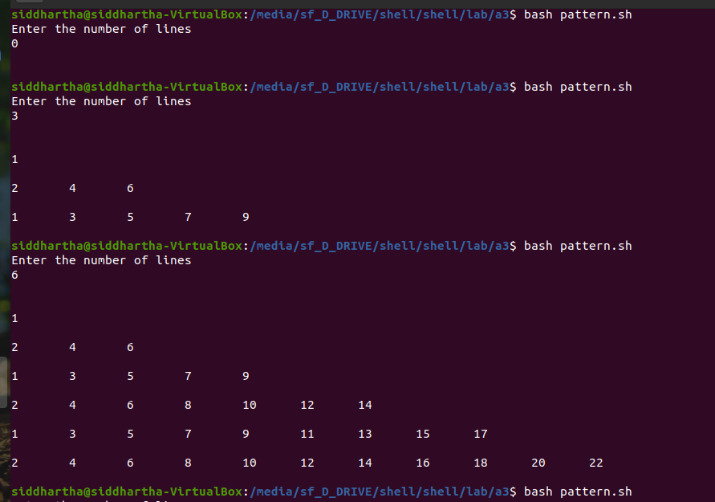

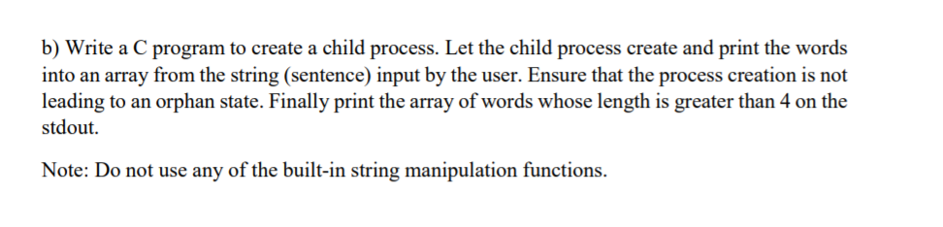**CODE**

**#include <sys/types.h>**

**#include <stdio.h>**

**#include <unistd.h>**

**#include <sys/wait.h>**

**#define MAXCHARACTER 1000**

**void array_operation();**

**int main()**

**{**

**pid_t pid;**

**pid = fork();**

**if (pid < 0) {**

**fprintf(stderr, "Fork Failed");**

**return 1;**

**}**

**else if (pid == 0) {**

**printf("\nChild Process is executing\n");**

**printf("Enter the sentence\n");**

**array_operation();**

**}**

**else**

**{**

**wait(NULL);//this will ot stop child from becoming orphan**

**printf("\nParent Process is executing\n");**

**}**

**return 0;**

**}**

**void array_operation(){**

**int c, i, j, k, l, m;**

**char ncharcte1[MAXCHARACTER][MAXCHARACTER];**

**i = j = k = l = m = 0;**

**fflush(stdin);**

**while((c = getchar()) != '\n'){**

**if(c == ' '){**

**ncharcte1[i][j] = '\0';**

**i++;**

**j = 0;**

**fflush(stdin);**

**fflush(stdout);**

**}**

**ncharcte1[i][j] = c;**

**j++;**

**}**

**fflush(stdin);**

**fflush(stdout);**

**printf("Printing word with length more than 4\n");**

**for(k = 0; k <= i; k++){**

**for(l = 0; ncharcte1[k][l] != '\0'; l++){**

**}**

**l--;**

**if(l > 4){//for printing only those aray whose length is more than 4**

**for(m = 0; ncharcte1[k][m] != '\0'; m++){**

**fflush(stdout);**

**fflush(stdin);**

**printf("%c",ncharcte1[k][m]);**

**}**

**m = 0;**

**}**

**}**

**}**

**OUTPUT**

