Fundamentals of Data Science
Assignment 4
Siddhant Sah
11962
Submission Date: 17th April 2026
GitHub URL: https://github.com/siddSah2913/FODSTakeHomeAssessments

Question 1: NumPy Array Operations
Program Description
This program works with a NumPy array to carry out some basic but commonly needed statistical operations. It generates an array using np.arange(), which produces values starting from 10 up to 60 in steps of 10, giving the array [10, 20, 30, 40, 50, 60]. Once the array is set up, the program finds the sum of all its elements, calculates the mean, and identifies both the largest and smallest values. The output is printed in a formatted way using f-strings.
Logic and Approach
The starting point was to use np.arange() instead of a manually typed array because it is cleaner and scales better. The start, stop, and step values were set to 10, 70, and 10 respectively, which produces six evenly spaced numbers. From there, NumPy's built-in functions handled everything else. np.sum() adds all elements together, np.mean() divides the total by the count to get the average, and np.max() and np.min() scan through the array to return the highest and lowest values. The mean is formatted to two decimal places using :.2f to keep the output readable.
Key Concepts Used
np.arange() for generating an array with a defined range and step. np.sum(), np.mean(), np.max(), and np.min() for array-level computations. f-strings for clean formatted output. Basic NumPy array structure and how functions operate across the whole array at once rather than element by element.
Testing and Output
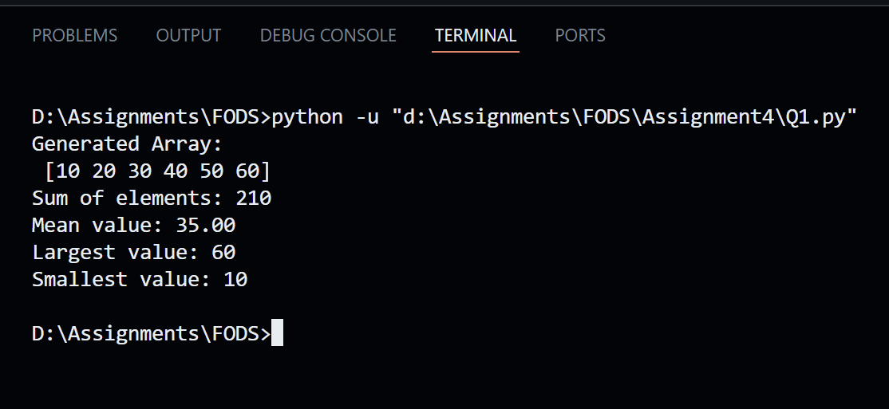

Question 2: List Input, Sorting, and Slicing
Program Description
This program takes a series of numbers typed in by the user, stores them in a list, sorts the list in ascending order, and then pulls out specific groups of elements using slice notation. The user must enter at least 12 numbers. Once that minimum is reached, the program asks whether they want to keep going or stop. After the list is finalised, it gets sorted and three slices are printed: index 3 to 6, index 6 to 9, and index 4 to 10.
Logic and Approach
A while loop keeps collecting input until the user decides to stop. Inside the loop, each entry is wrapped in a try-except block so that if the user types something that is not a number, the program catches the ValueError and asks for valid input instead of crashing. Once 12 numbers have been collected, the user is prompted with a yes/no question. Entering anything other than 'no' keeps the loop running. After breaking out of the loop, the built-in sort() method arranges the list from lowest to highest. Slicing then works by specifying start and end indices inside square brackets, where the end index is excluded from the result.
Key Concepts Used
while loop for continuous input collection. try-except for handling invalid input with ValueError. list.sort() for in-place sorting. Python list slicing with [start:end] notation. Conditional logic to manage when the input loop should stop. User interaction through input() and conditional checks on the response.
Testing and Output
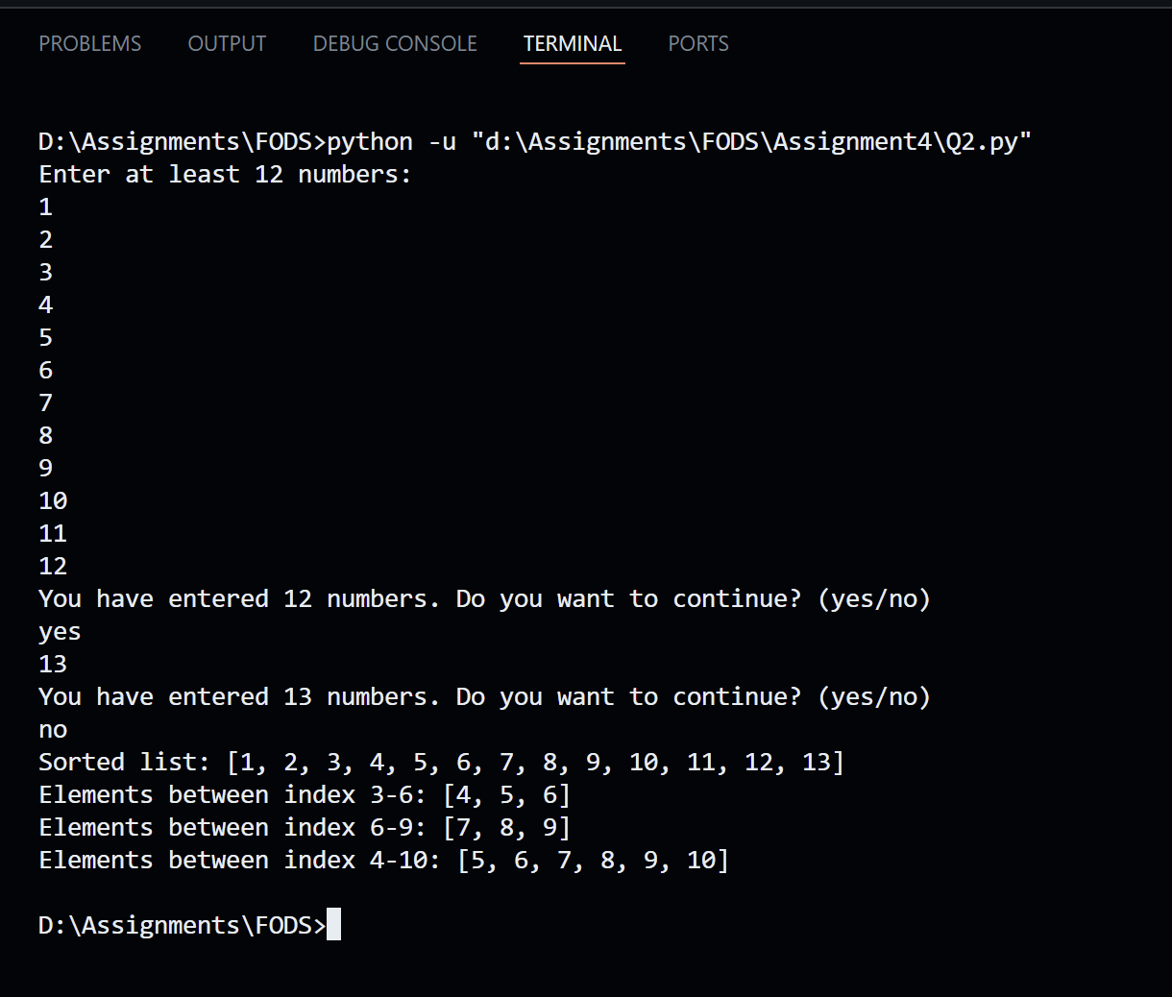

Question 3: Random Array, Sorting, and Reshaping
Program Description
This program generates an array of 12 random integers between 1 and 99 using NumPy, sorts the array from lowest to highest, and then rearranges it into a 3 by 4 matrix. Each run of the program produces a different set of numbers since the values are randomly generated. The original array, the sorted version, and the reshaped matrix are all printed to show the transformation at each stage.
Logic and Approach
np.random.randint(1, 100, 12) was used to generate 12 random integers. The upper bound is set to 100 so values can go up to 99. The array is then sorted in place using the sort() method, which changes the array directly rather than returning a new one. For the reshape, a 3 by 4 layout was chosen because 3 times 4 equals 12, which matches the array size exactly. NumPy requires the total number of elements in the new shape to match the original count, otherwise it raises an error. The reshape() method takes the number of rows and columns as its two arguments.
Key Concepts Used
np.random.randint() to generate random integers within a specified range. In-place sorting with array.sort(). np.reshape() to rearrange a flat array into a 2D matrix structure. Understanding of valid reshape dimensions, meaning the product of rows and columns must equal the total number of elements. Printing NumPy arrays in a readable format.
Testing and Output
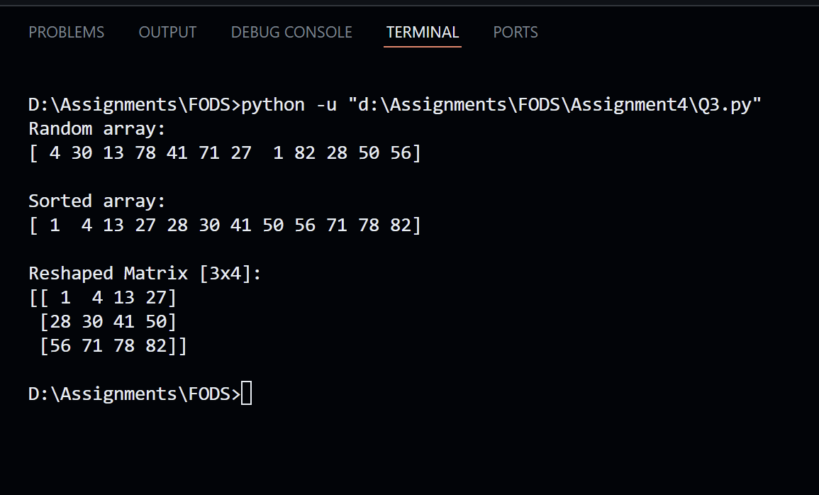
Question 4: Matrix Operations with Dimension Validation
Program Description
This program lets the user input two matrices of their own dimensions and then performs addition, subtraction, and multiplication on them. The user first specifies how many rows and columns each matrix should have, then enters the values row by row. The program checks that the entered row data matches the declared column count. For addition and subtraction, both matrices need to be the same shape. For multiplication, the number of columns in the first matrix must match the number of rows in the second. If these conditions are not met, the program raises and catches a ValueError and displays a clear message.
Logic and Approach
The input process is wrapped in a try-except block to catch unexpected errors like letters being entered instead of numbers. For each matrix, the user states the row and column count first. Then a for loop runs once per row, using map(int, input().split()) to convert a space-separated line of text into a list of integers. A check confirms that the number of values in that line matches the declared column count before adding it to the matrix. Once both matrices are built and converted to NumPy arrays, separate try-except blocks handle addition and subtraction together (both require the same shape), and multiplication separately (which requires A's columns to equal B's rows). Each check raises a ValueError with a descriptive message if the dimensions do not match.
Key Concepts Used
np.array() to convert nested Python lists into NumPy matrices. input().split() and map(int, ...) for parsing multi-value input from a single line. .shape attribute to check matrix dimensions. np.dot() for matrix multiplication. Nested try-except blocks for handling different types of errors at different stages. Raising custom ValueError exceptions with specific messages to indicate what went wrong.
Testing and Output
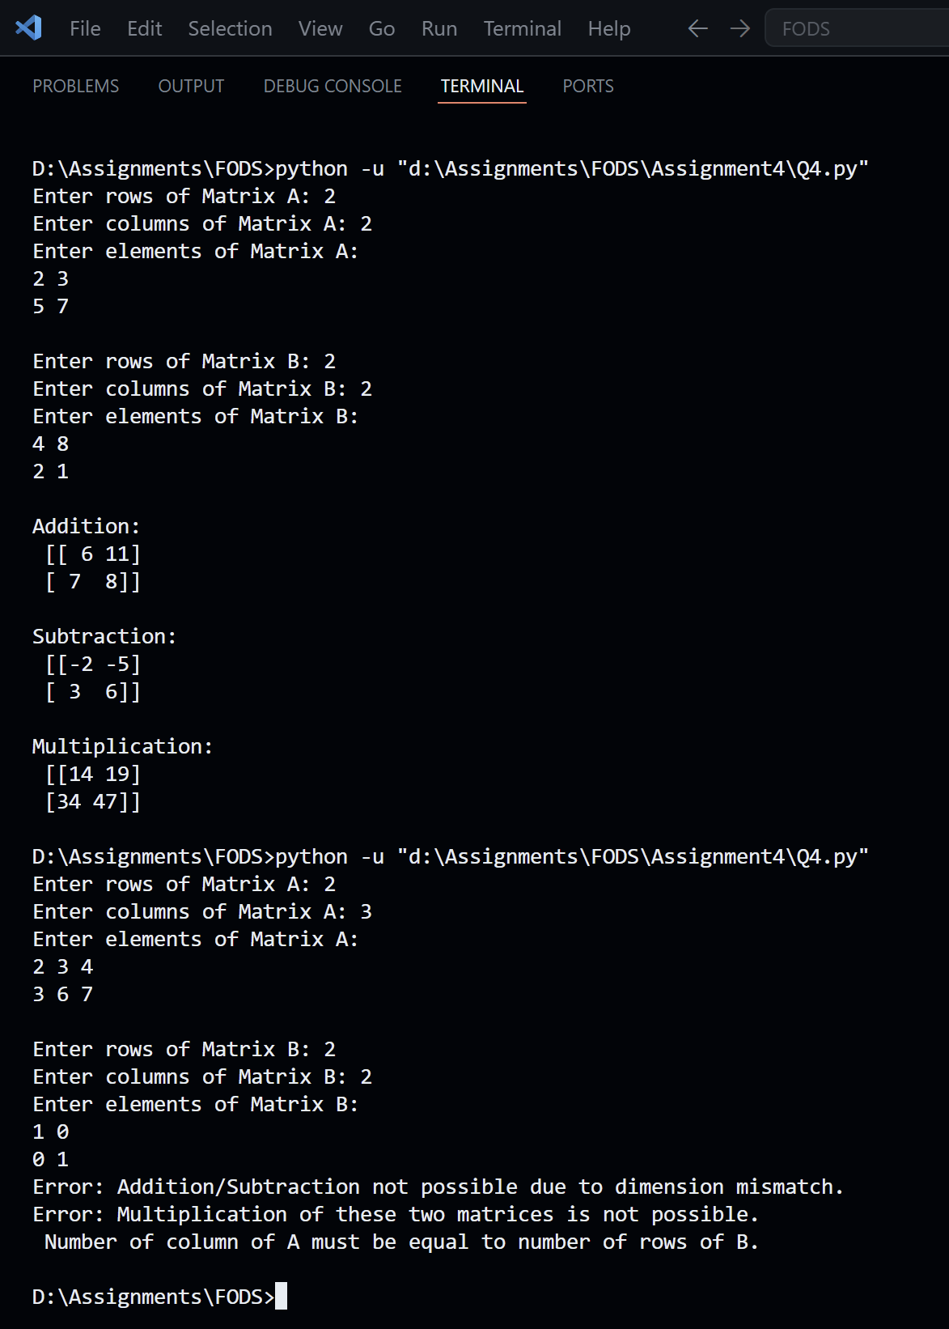

Question 5: Health Data Scatter Plots
Program Description
This program reads a CSV file called health_data.csv using Pandas and then generates a series of scatter plots using Matplotlib. The plots visualise five different relationships from the dataset: weight vs height, age vs weight, height vs age, gender vs height, and gender vs weight. Each plot appears one at a time in a separate window with labelled axes and a title.
Logic and Approach
The file path is built dynamically using os.path.dirname() and os.path.abspath(__file__), which locates the CSV relative to wherever the script is saved rather than relying on a hardcoded directory. After reading the file into a DataFrame, the five column pairs are stored in a list of tuples. A for loop iterates over the list, and for each pair it creates a scatter plot, labels the x and y axes with the column names, sets the title, and calls plt.show() to display it. Organising the pairs in a list and using a loop avoids writing the same plotting code five times.
Key Concepts Used
pd.read_csv() to load data from a CSV file into a Pandas DataFrame. os.path for building file paths dynamically and portably. plt.scatter() from Matplotlib for creating scatter plots. Looping over a list of tuples to avoid repetitive code. plt.xlabel(), plt.ylabel(), plt.title(), and plt.show() for customising and displaying each plot.
Testing and Output
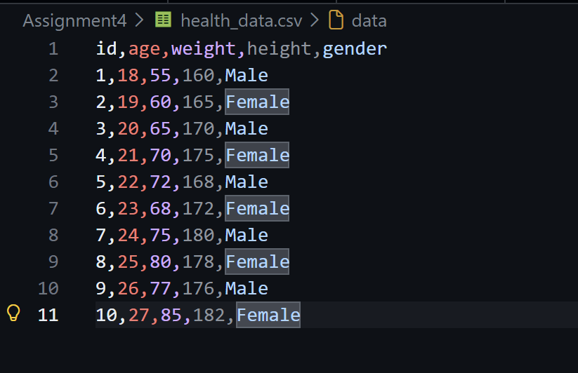
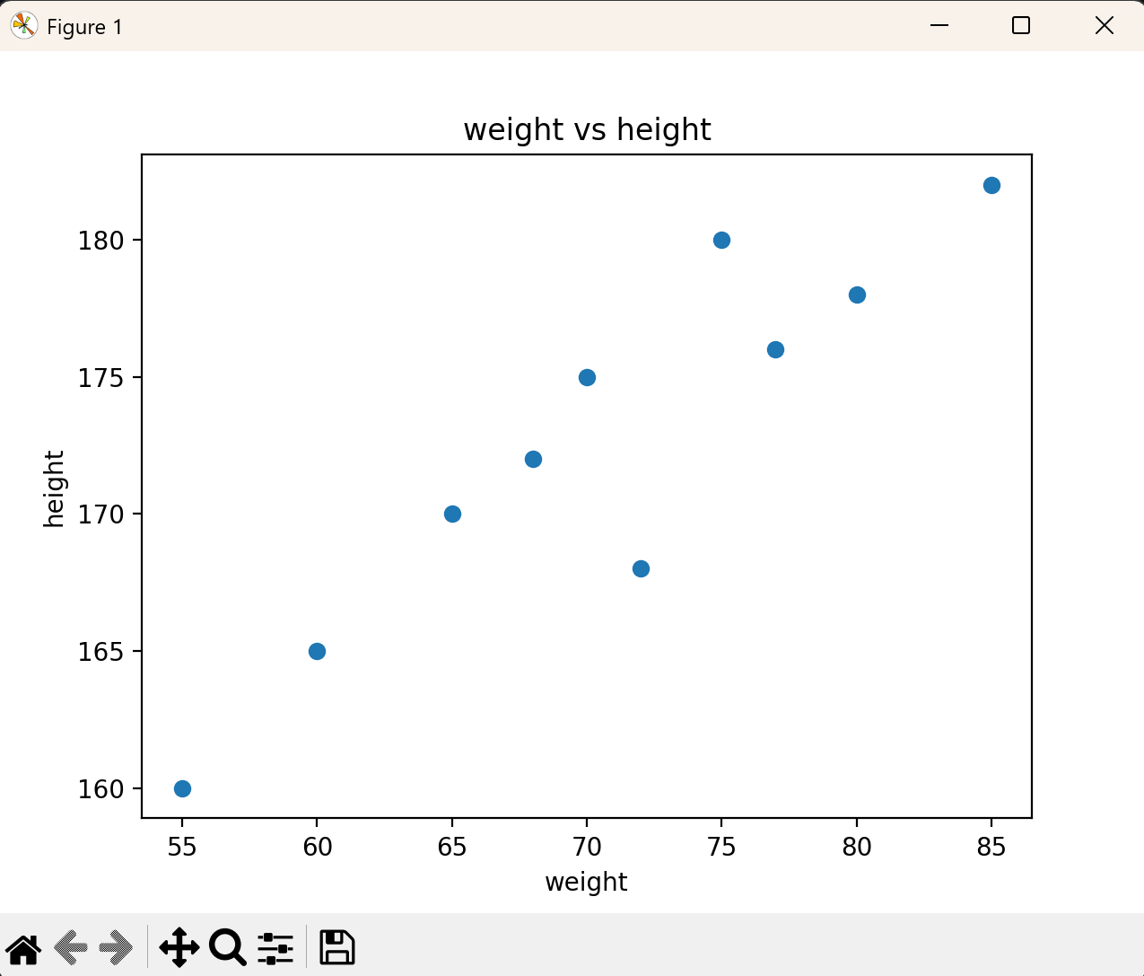
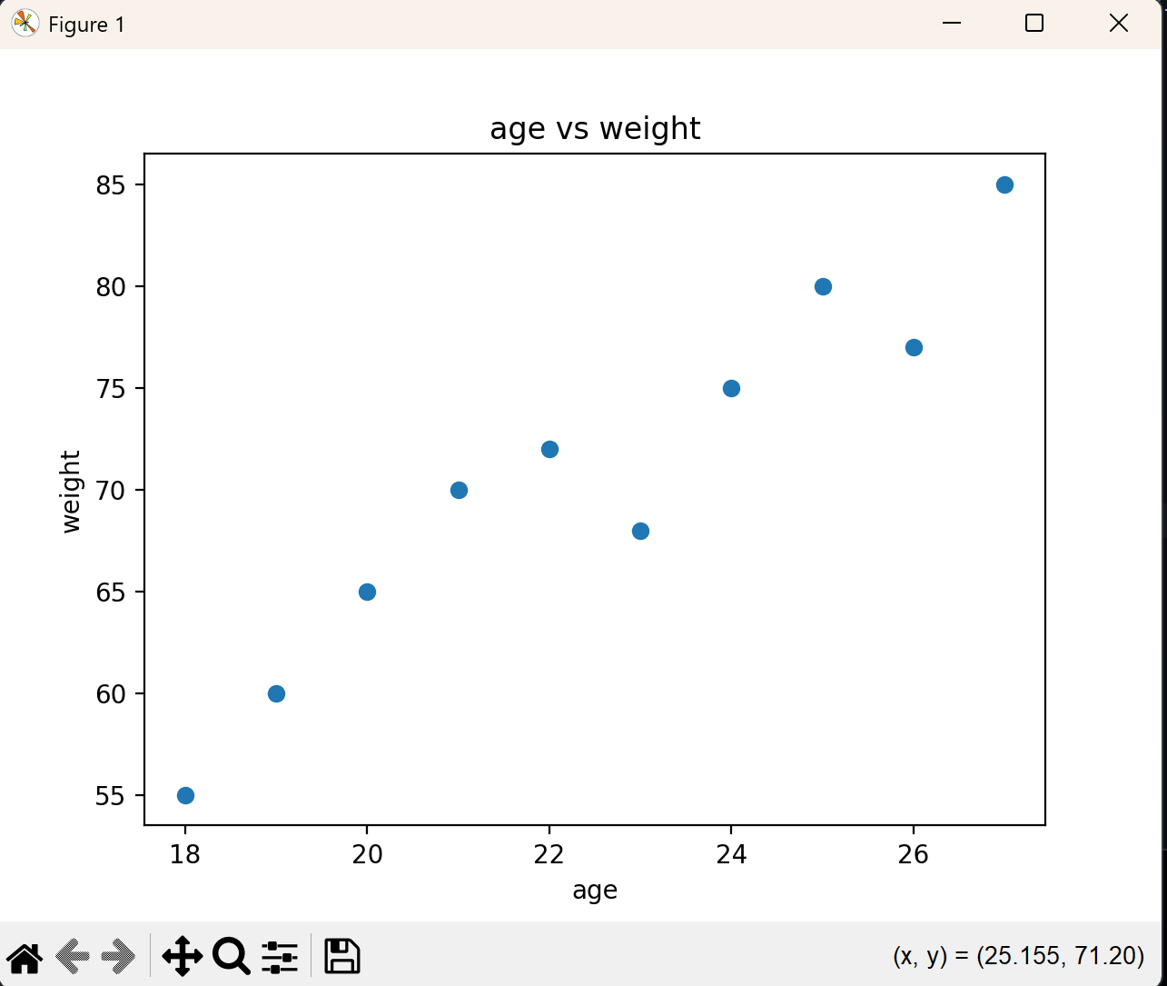
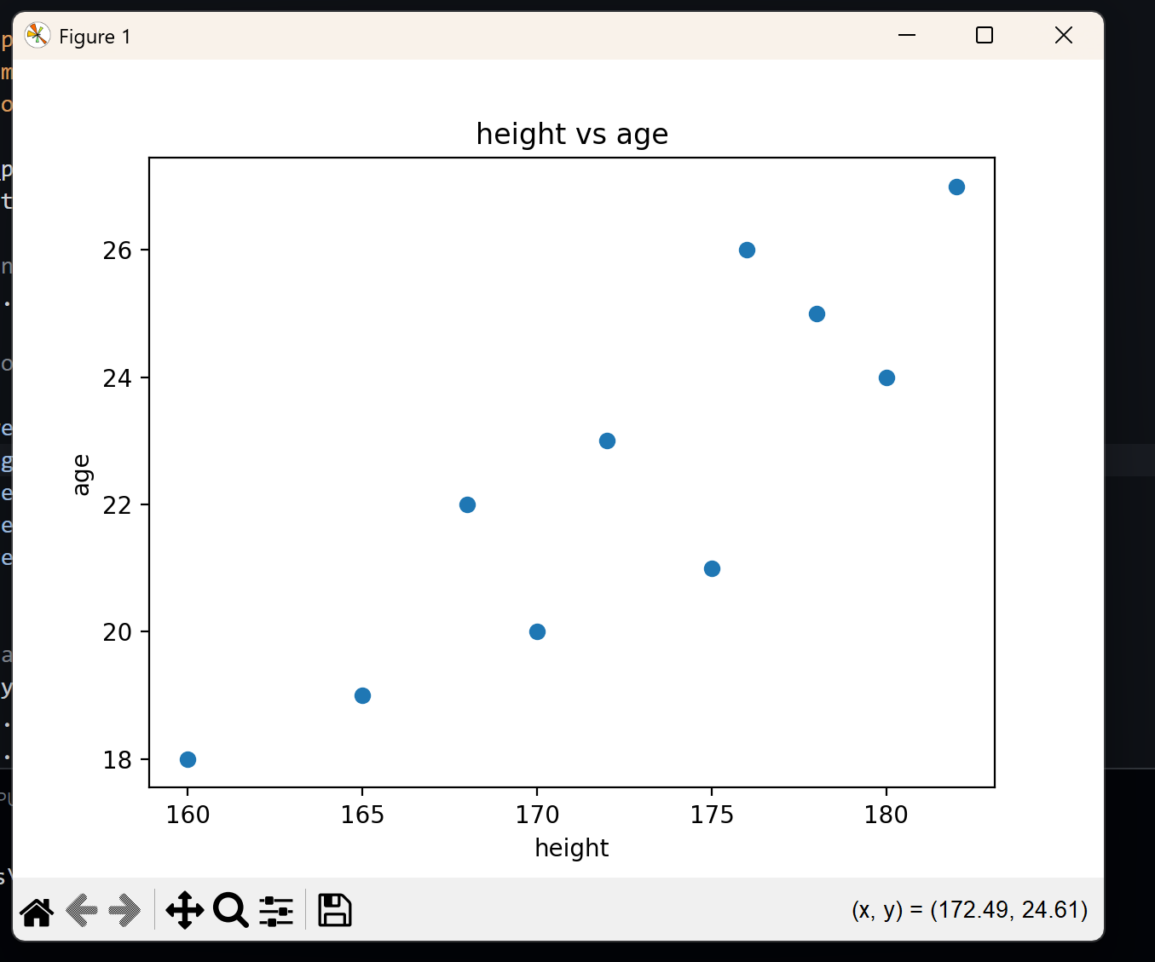
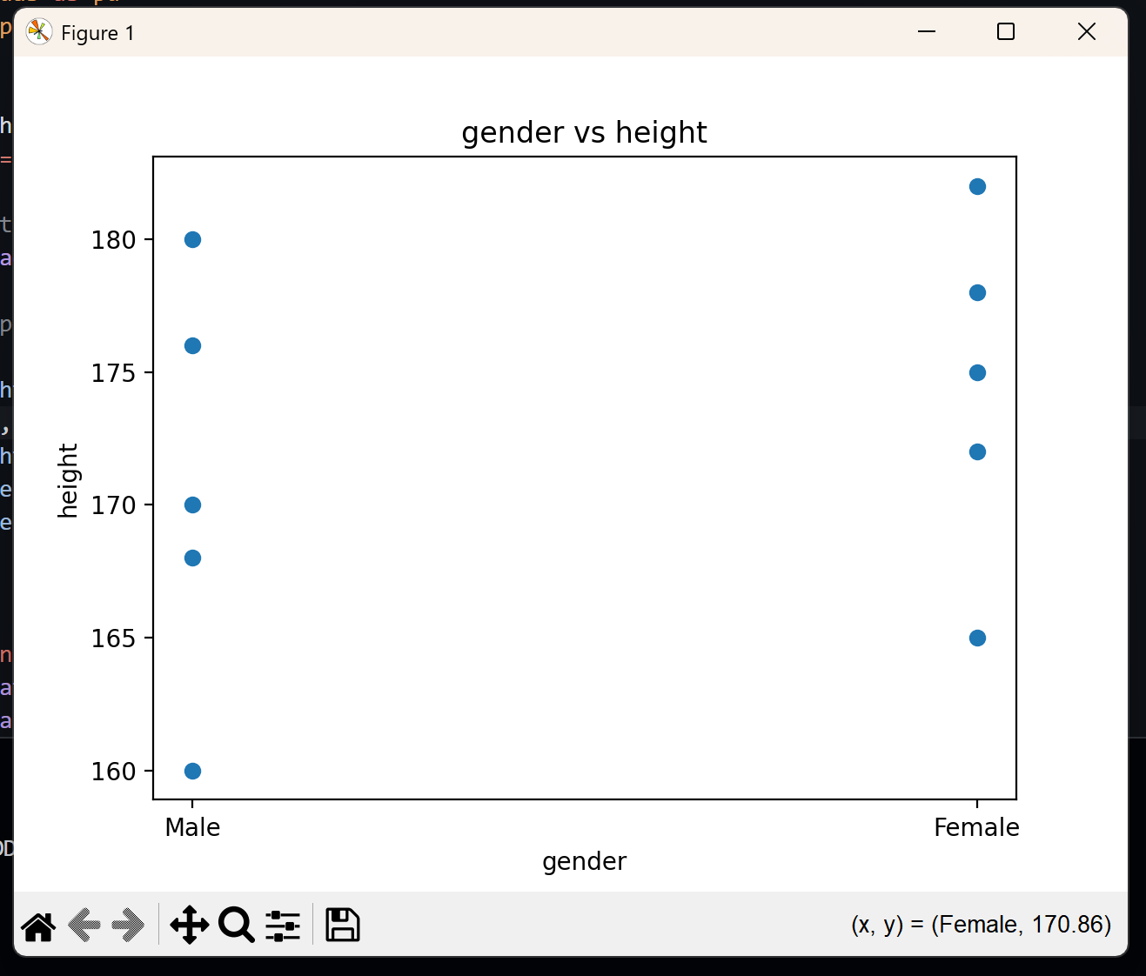
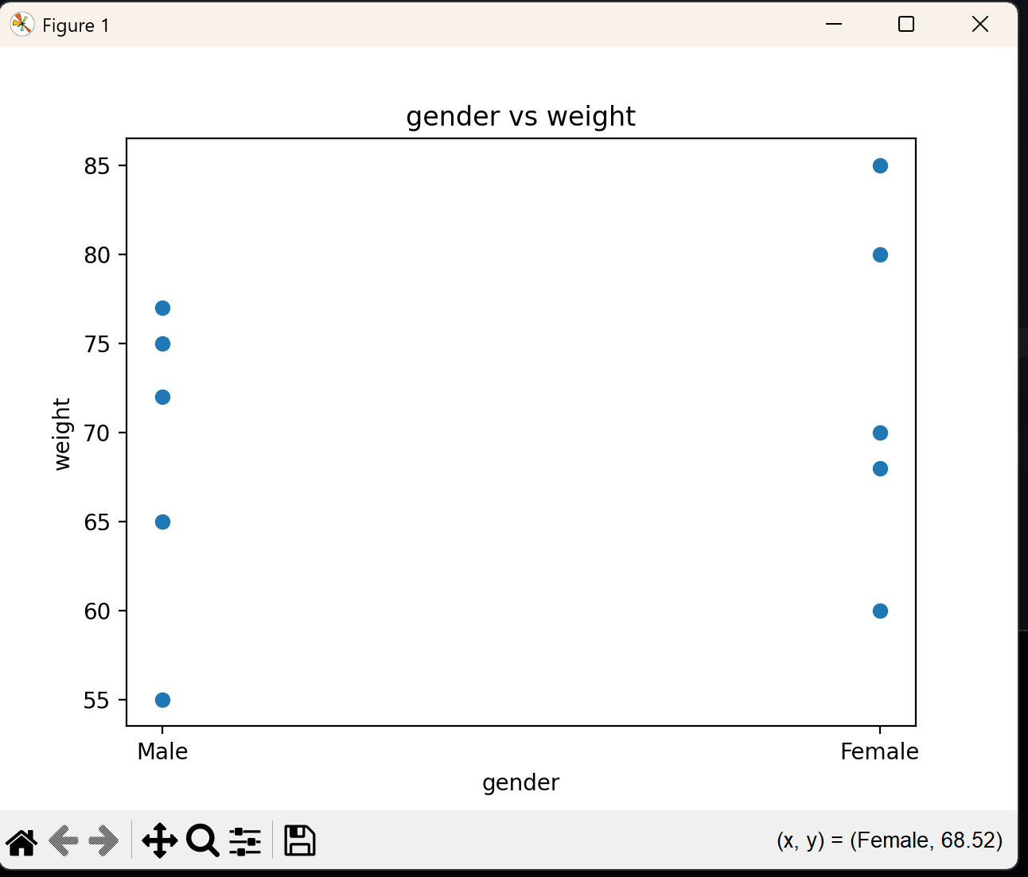

Question 6: BMI Calculation and Health Status Classification
Program Description
This program extends the health_data.csv dataset by adding two new columns: BMI and Health_Status. BMI is calculated by dividing each person's weight by their height. The Health_Status column is then populated based on where the BMI value falls across five defined ranges, going from Underweight at the low end up to Critical health condition for very high values. The updated DataFrame with all original columns plus the two new ones is printed to the console.
Logic and Approach
The BMI column is added in a single line by dividing the weight column by the height column directly on the DataFrame. Pandas handles this element by element automatically across all rows. For the Health_Status column, a separate function called health_status() was written that takes a single BMI value and returns the appropriate label based on a series of if and elif conditions. This function is then applied to the BMI column using .apply(), which runs the function once for every row and stores the result. Separating the classification logic into its own function keeps the code clean and easy to update if the ranges ever change.
Key Concepts Used
DataFrame column arithmetic to calculate BMI across all rows at once. Defining a custom function for multi-condition classification logic. .apply() to run a function across every value in a column. if-elif-else conditions to map numerical ranges to string labels. pd.read_csv() and os.path for file handling. Viewing the full updated DataFrame by printing it.
Testing and Output
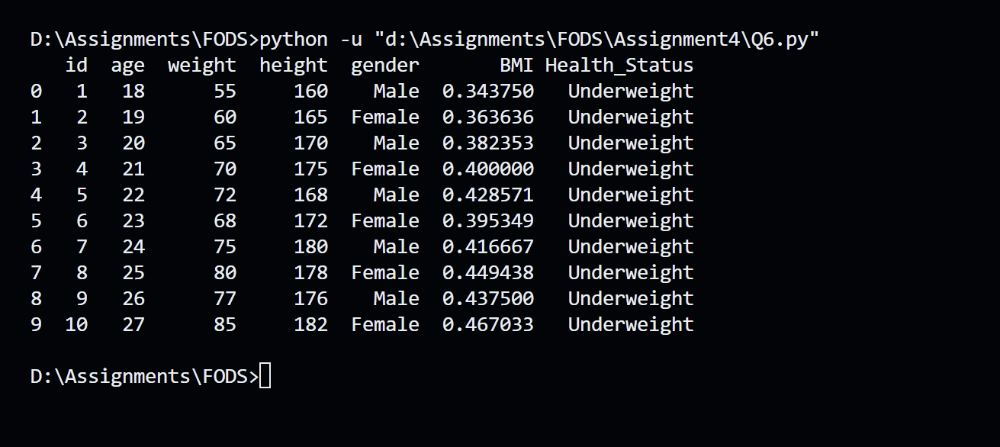

Conclusion
Overall, working through these six questions gave me a much clearer picture of how Python handles data and mathematical operations in practice. Doing basic array math and list sorting felt simple at first, but making sure matrix dimensions lined up for multiplication and avoiding shape mismatches took more thought than expected. The data visualization part was a step up, especially seeing how Pandas and Matplotlib work together to read a CSV and generate multiple scatter plots. Error handling was something I had to pay close attention to across the programs. It was easy to assume the user would type valid numbers or the right row and column counts but adding those try-except blocks to catch errors made the code feel much more complete. Thus, the programs are simple individually but taken together they cover a good range of real data science use cases, like classifying a person's health status based on their BMI. The skills from this assignment such as matrix validation and handling datasets are things I expect to keep using in future work.

