Assignment 3
Siddhant Sah
11962
Submission Date: 17th April 2026
Github URL: https://github.com/siddSah2913/FODSTakeHomeAssessments

Question 1: Reading a CSV File
Program Description
This program reads a CSV file called records.csv and displays the student information stored inside it. The fields it reads are student_name, roll_no, program, year and group. The csv module is used to handle the file reading, and the os module is used to make sure the file path works correctly no matter which directory the program is run from.
Logic and Approach
The program first gets the folder path of the current script file using os.path.dirname and os.path.abspath, then joins that path with the filename records.csv. This prevents the common issue of the program failing when run from a different directory.
The file is opened inside a try block so that if records.csv is missing, the program catches the FileNotFoundError and shows a clear message instead of crashing. The csv.DictReader is used to read the file because it lets each row be accessed as a dictionary using column names, which makes the code easier to read and understand.
Each row is then printed using an f-string to show all five fields in a neat format, separated by a divider line at the top.
Key Concepts Used
csv module (DictReader), os module (path handling), try/except for FileNotFoundError, f-string formatting.
Testing and Output
The program was tested with a records.csv file containing multiple student records. The output correctly displayed all fields for each student entry.

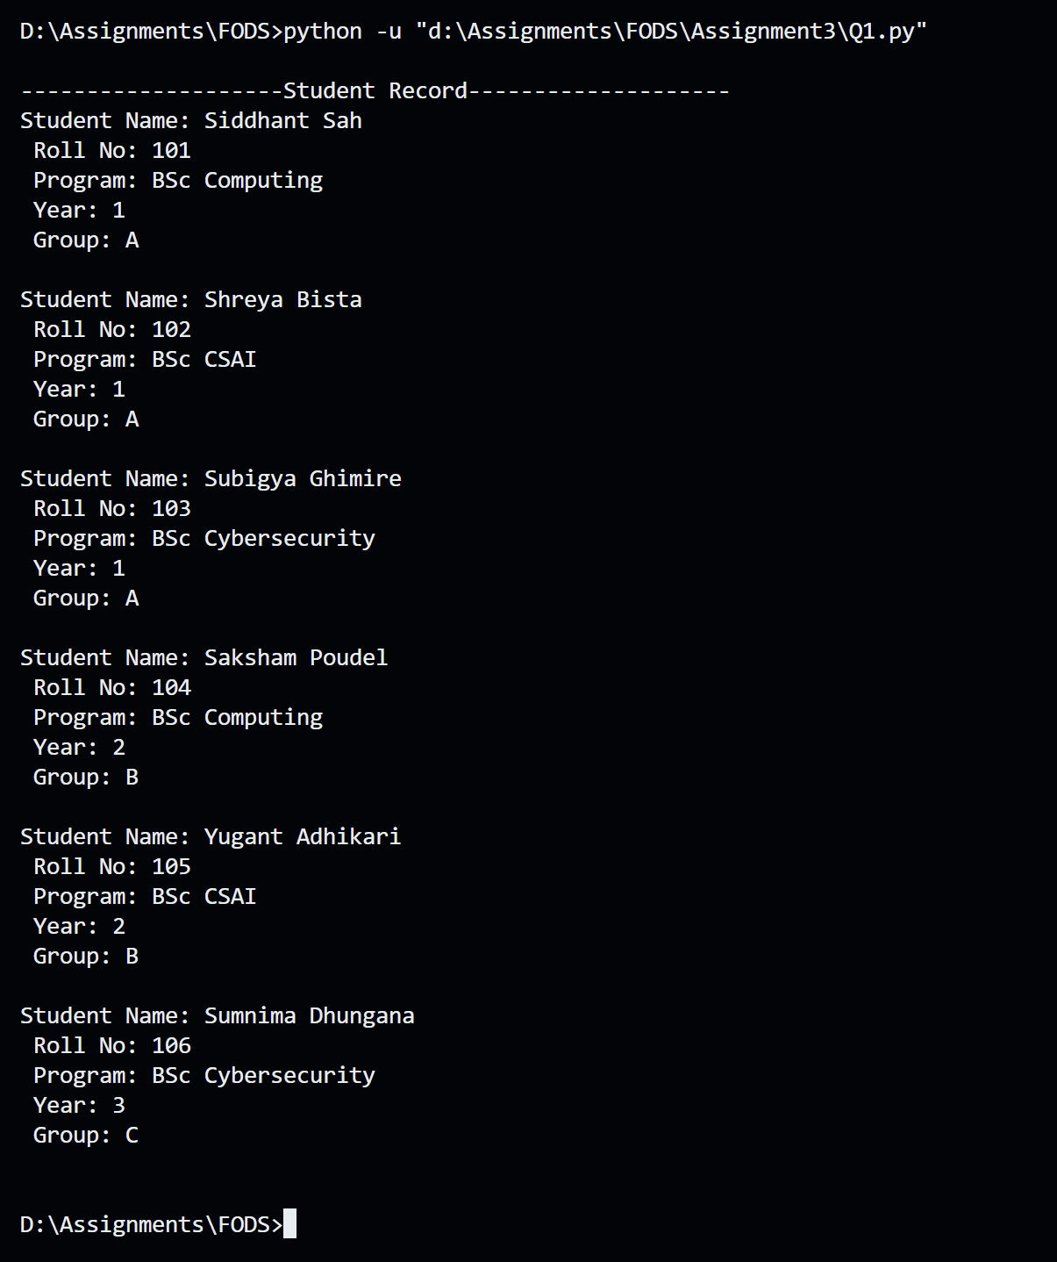
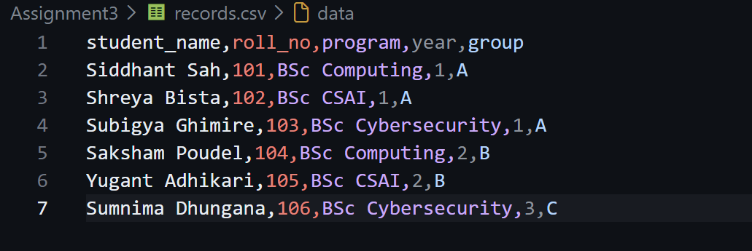
Question 2: Appending Student Details to CSV
Program Description
This program takes a new student's details as input from the user and appends that data to the existing records.csv file. The fields collected are student_name, roll_no, program, year and group. The program makes sure the data is added to the file without overwriting what was already there.
Logic and Approach
The path handling is the same as in Question 1, using os.path to construct the correct file path dynamically. The key difference here is the file open mode. The file is opened with mode='a' which stands for append, so new rows are always added at the end of the file rather than replacing the existing content.
The csv.writer is used to write the row in the correct CSV format. This is wrapped inside a try/except block that handles the case where records.csv does not exist, giving the user a friendly error message instead of a traceback.
Input prompts are shown clearly with labels so the user knows exactly what to enter for each field.
Key Concepts Used
csv.writer, append mode file handling, os path joining, try/except for FileNotFoundError, user input collection.
Testing and Output
The program was tested by entering a new student record. After running, the records.csv file was checked and the new entry was found appended at the bottom without affecting the previous data.
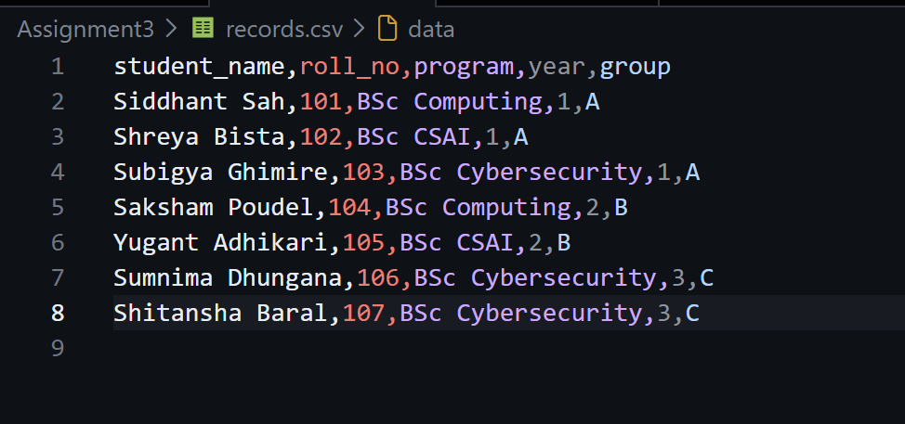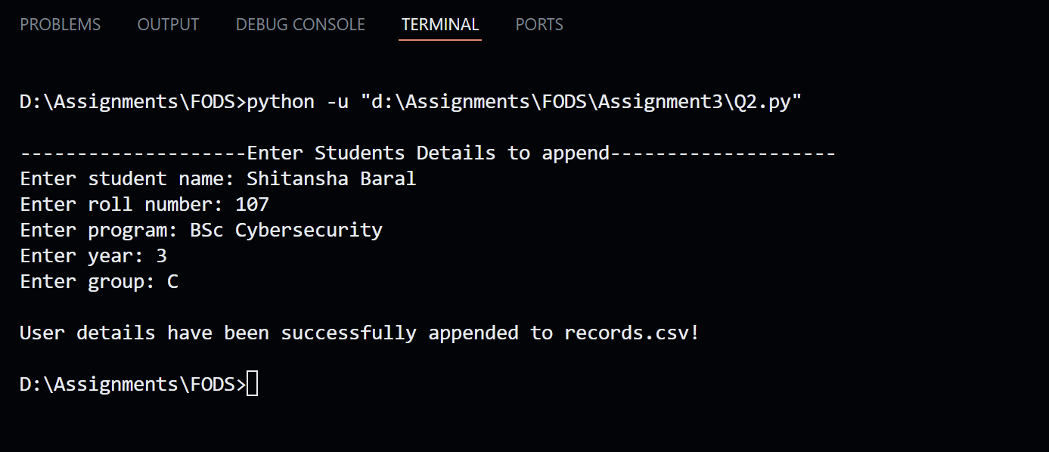

Question 3: Arithmetic Operations with File Logging
Program Description
This program takes a list of integers from the user, performs four arithmetic operations on them which are addition, subtraction, multiplication and division, and saves the results to a file called results.txt with a timestamp. The program keeps running until the user chooses to exit, and when they do, the contents of the results file are displayed on screen.
Logic and Approach
The program runs inside a while loop that checks whether the user wants to exit. The user enters integers separated by commas, and the input string is split and converted into a list of integers using a list comprehension.
For addition, the built-in sum() function is used. For subtraction and multiplication, a loop iterates through the list starting from the second element. Division follows the same pattern but is placed inside a try/except block to handle ZeroDivisionError. If any number in the list is zero and causes a division error, the division result is set to infinity to show that the operation was not possible.
Each result is saved to results.txt using append mode so that multiple runs are all logged together. The datetime module provides the current timestamp for each entry. When the user exits, the file is read and printed so they can see all logged results.
Key Concepts Used
While loop with exit condition, list comprehension, arithmetic logic with loops, ZeroDivisionError handling, datetime module, file append and read, formatted output.
Testing and Output
The program was tested with two sets of numbers. The first was 3, 5, 6, 7 and the second was 2, 4. Results were saved to results.txt with timestamps and displayed when the user chose to exit.

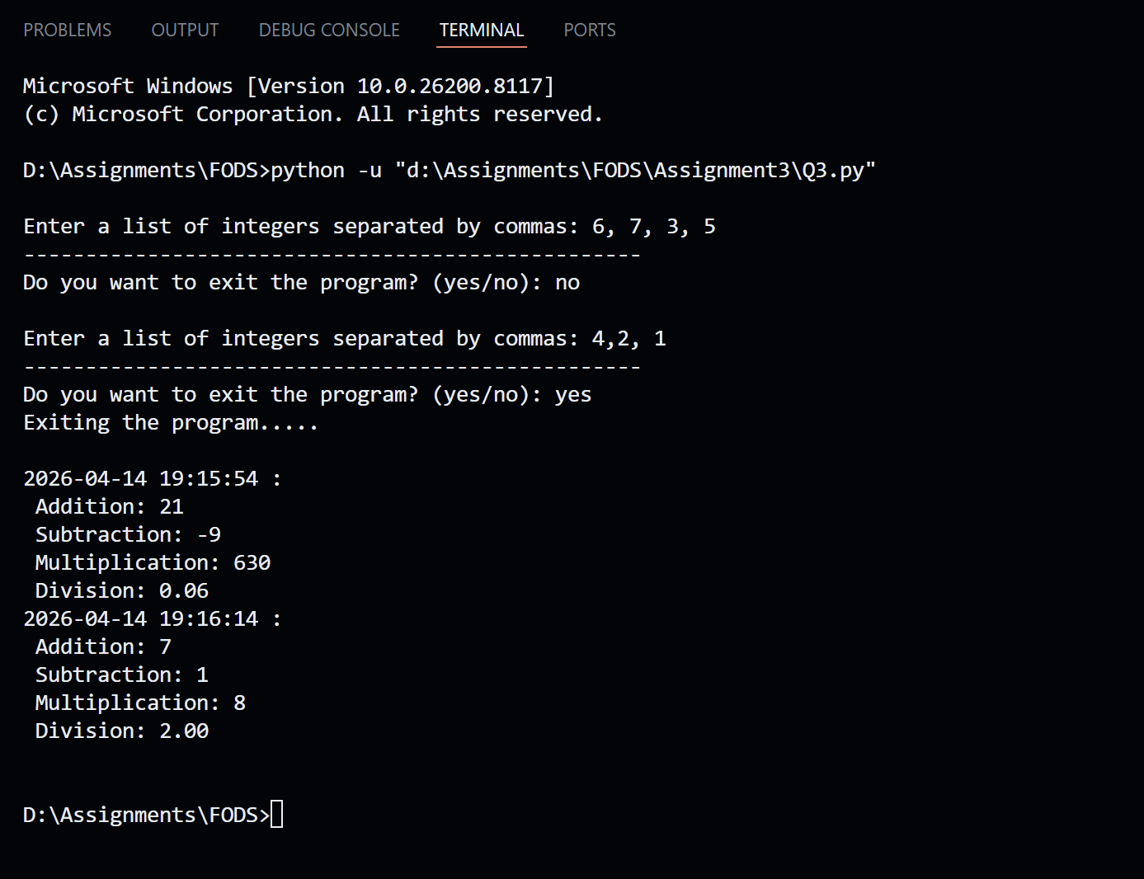
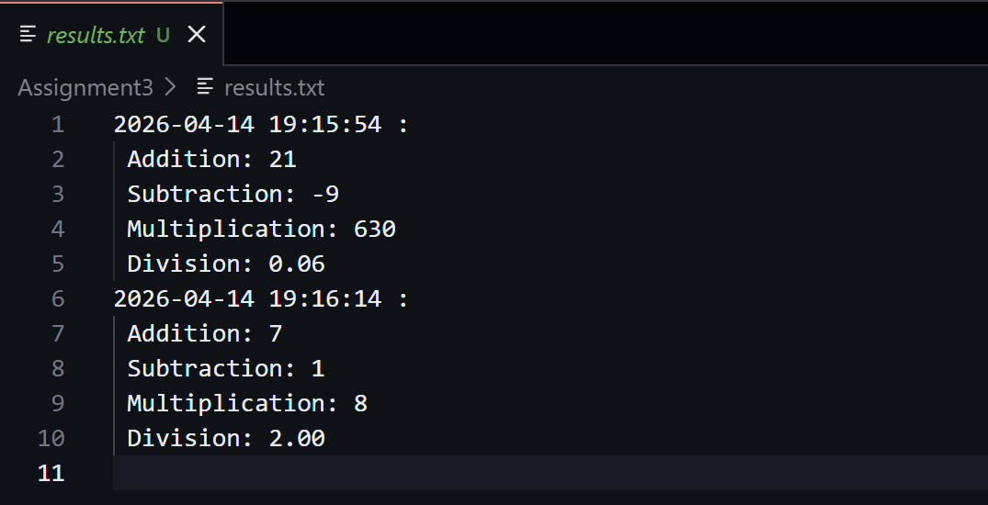

Question 4: Copying File Contents
Program Description
This program reads the content of one file and copies it into another file. The user provides both the input file name and the output file name. If the input file does not exist, or if the output file already exists, the program shows an appropriate error message. No data is overwritten by accident.
Logic and Approach
The program uses os.path to build the full file paths from just the file names. The input file is opened in read mode and its content is stored in a variable. Then the output file is opened using mode 'x', which is the exclusive creation mode in Python. This mode creates a new file and raises a FileExistsError if the file already exists, which is exactly the behaviour required.
Both file operations are inside a single try block. The except section handles two specific errors separately. FileNotFoundError is caught when the input file does not exist, and FileExistsError is caught when the output file name is already taken. Each case shows a clear and helpful message to guide the user.
Key Concepts Used
File read and exclusive creation mode ('x'), os path building, FileNotFoundError and FileExistsError exception handling, two-stage file operation inside try/except.
Testing and Output
Tested in three ways: successful copy of records.csv to a new file, attempting to copy a file that does not exist, and attempting to write to a file that already exists.

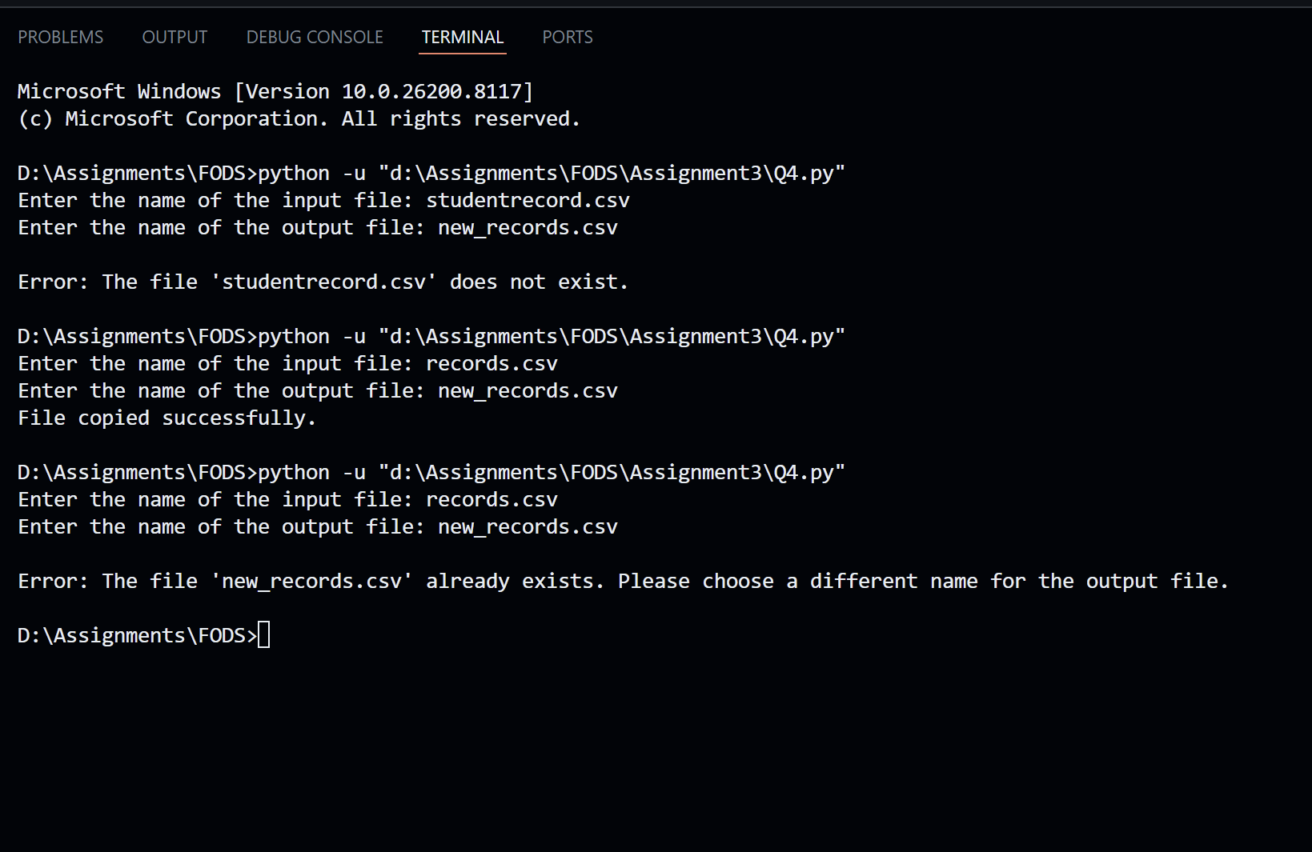
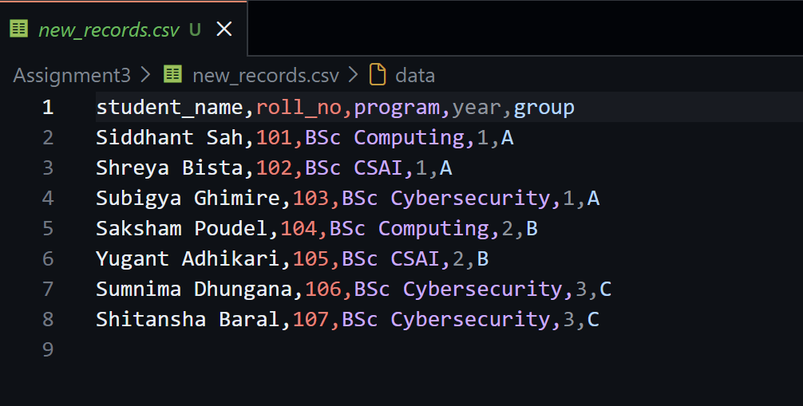

Question 5: Learner Class with OOP
Program Description
This program defines a class called Learner that holds six attributes: roll_no, full_name, address, enrollment_year, program and group. An object of the class is created and the user is asked to input values for all six attributes. The details are then displayed using a dedicated method.
Logic and Approach
The Learner class is designed following basic OOP principles. The constructor method __init__ sets all attributes to None initially. Two separate methods are defined inside the class: input_details() handles collecting all inputs from the user, and display_details() handles printing them in a readable format.
Inside display_details(), the strip() method is applied to all string values to remove any extra whitespace from user input. The capitalize() method is applied to full_name to ensure consistent formatting regardless of how the user typed it. A divider line is printed at the top to separate the output clearly.
At the bottom of the program, an object named learner1 is created, input_details() is called to fill its attributes, and display_details() is called to print them out.
Key Concepts Used
Class definition, __init__ constructor, instance attributes, instance methods (input_details and display_details), object instantiation, string methods (strip and capitalize).
Testing and Output
An object was created and details were entered for a test student. The output correctly displayed all six fields in a clean format with the name properly capitalised.
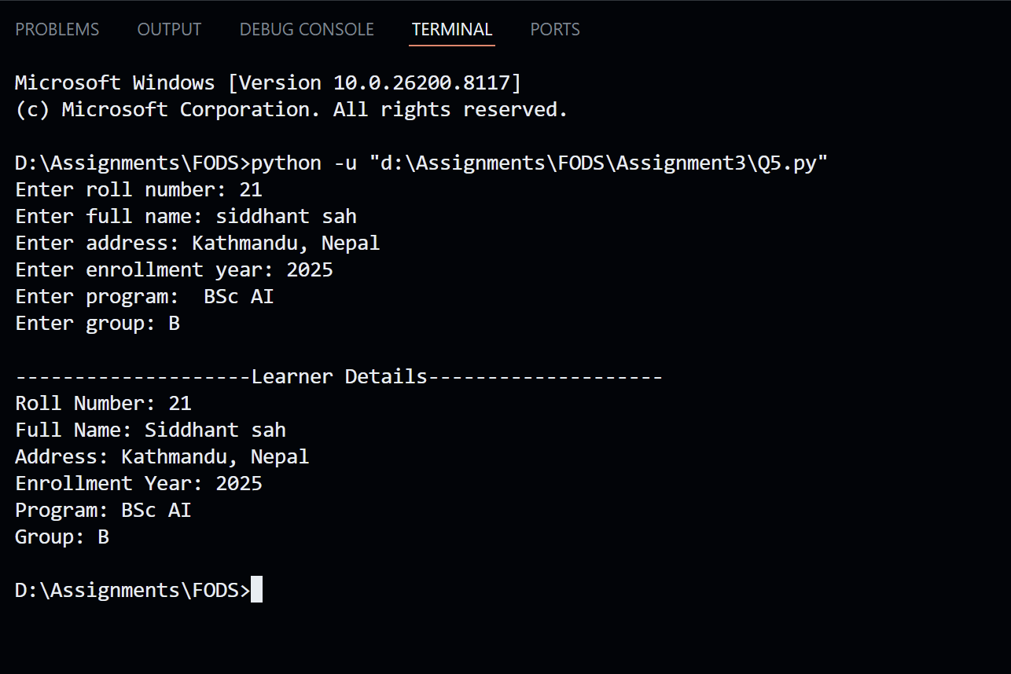
Question 6: Dish and Cookbook Classes
Program Description
This program defines two classes. The Dish class holds information about a single dish including dish_id, dish_name, ingredients and instructions. The Cookbook class manages a collection of dishes and supports adding, removing, displaying and searching for dishes. A menu-driven interface lets the user interact with the cookbook.
Logic and Approach
The Dish class stores ingredients and instructions as lists. In the constructor, strip() and capitalize() are applied to each item in these lists using list comprehensions so all data is cleanly formatted when stored. The display_details() method uses join() to convert the ingredient and instruction lists into a single printable string.
The Cookbook class holds a list of Dish objects. The add_dish() method loops through existing dishes and checks if the same dish_id already exists before appending, preventing duplicate entries. The remove_dish() method searches for a dish by ID and removes it from the list. The search_dish() method does a case-insensitive search using lower() on both the search term and the stored dish names.
The main program runs a while loop with a numbered menu, and the user enters a choice to trigger the corresponding method. The loop breaks when the user selects option 5.
Key Concepts Used
Two-class OOP design, list comprehension with strip and capitalize, join() for list to string, duplicate checking, case-insensitive search, menu-driven loop with break condition.
Testing and Output
The program was tested by adding two dishes, displaying all dishes, searching by name, removing one dish and displaying again to confirm removal.
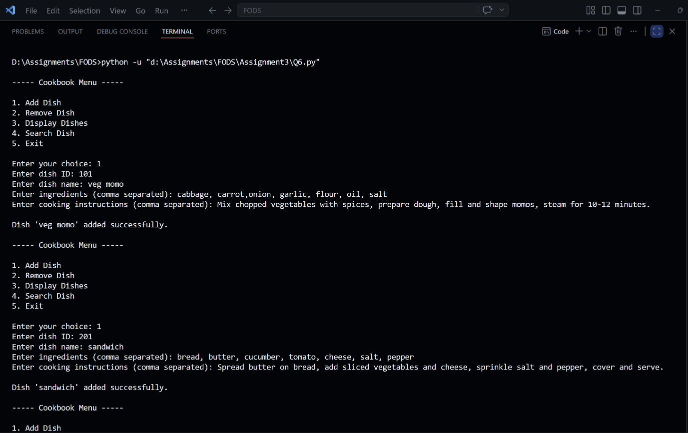
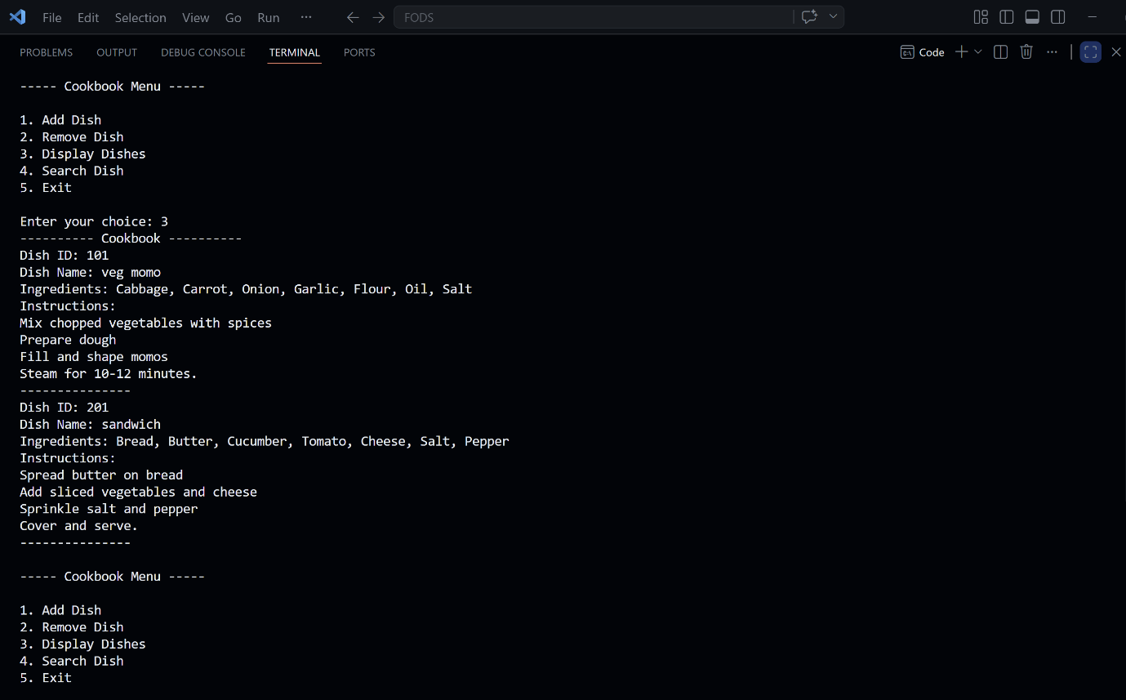
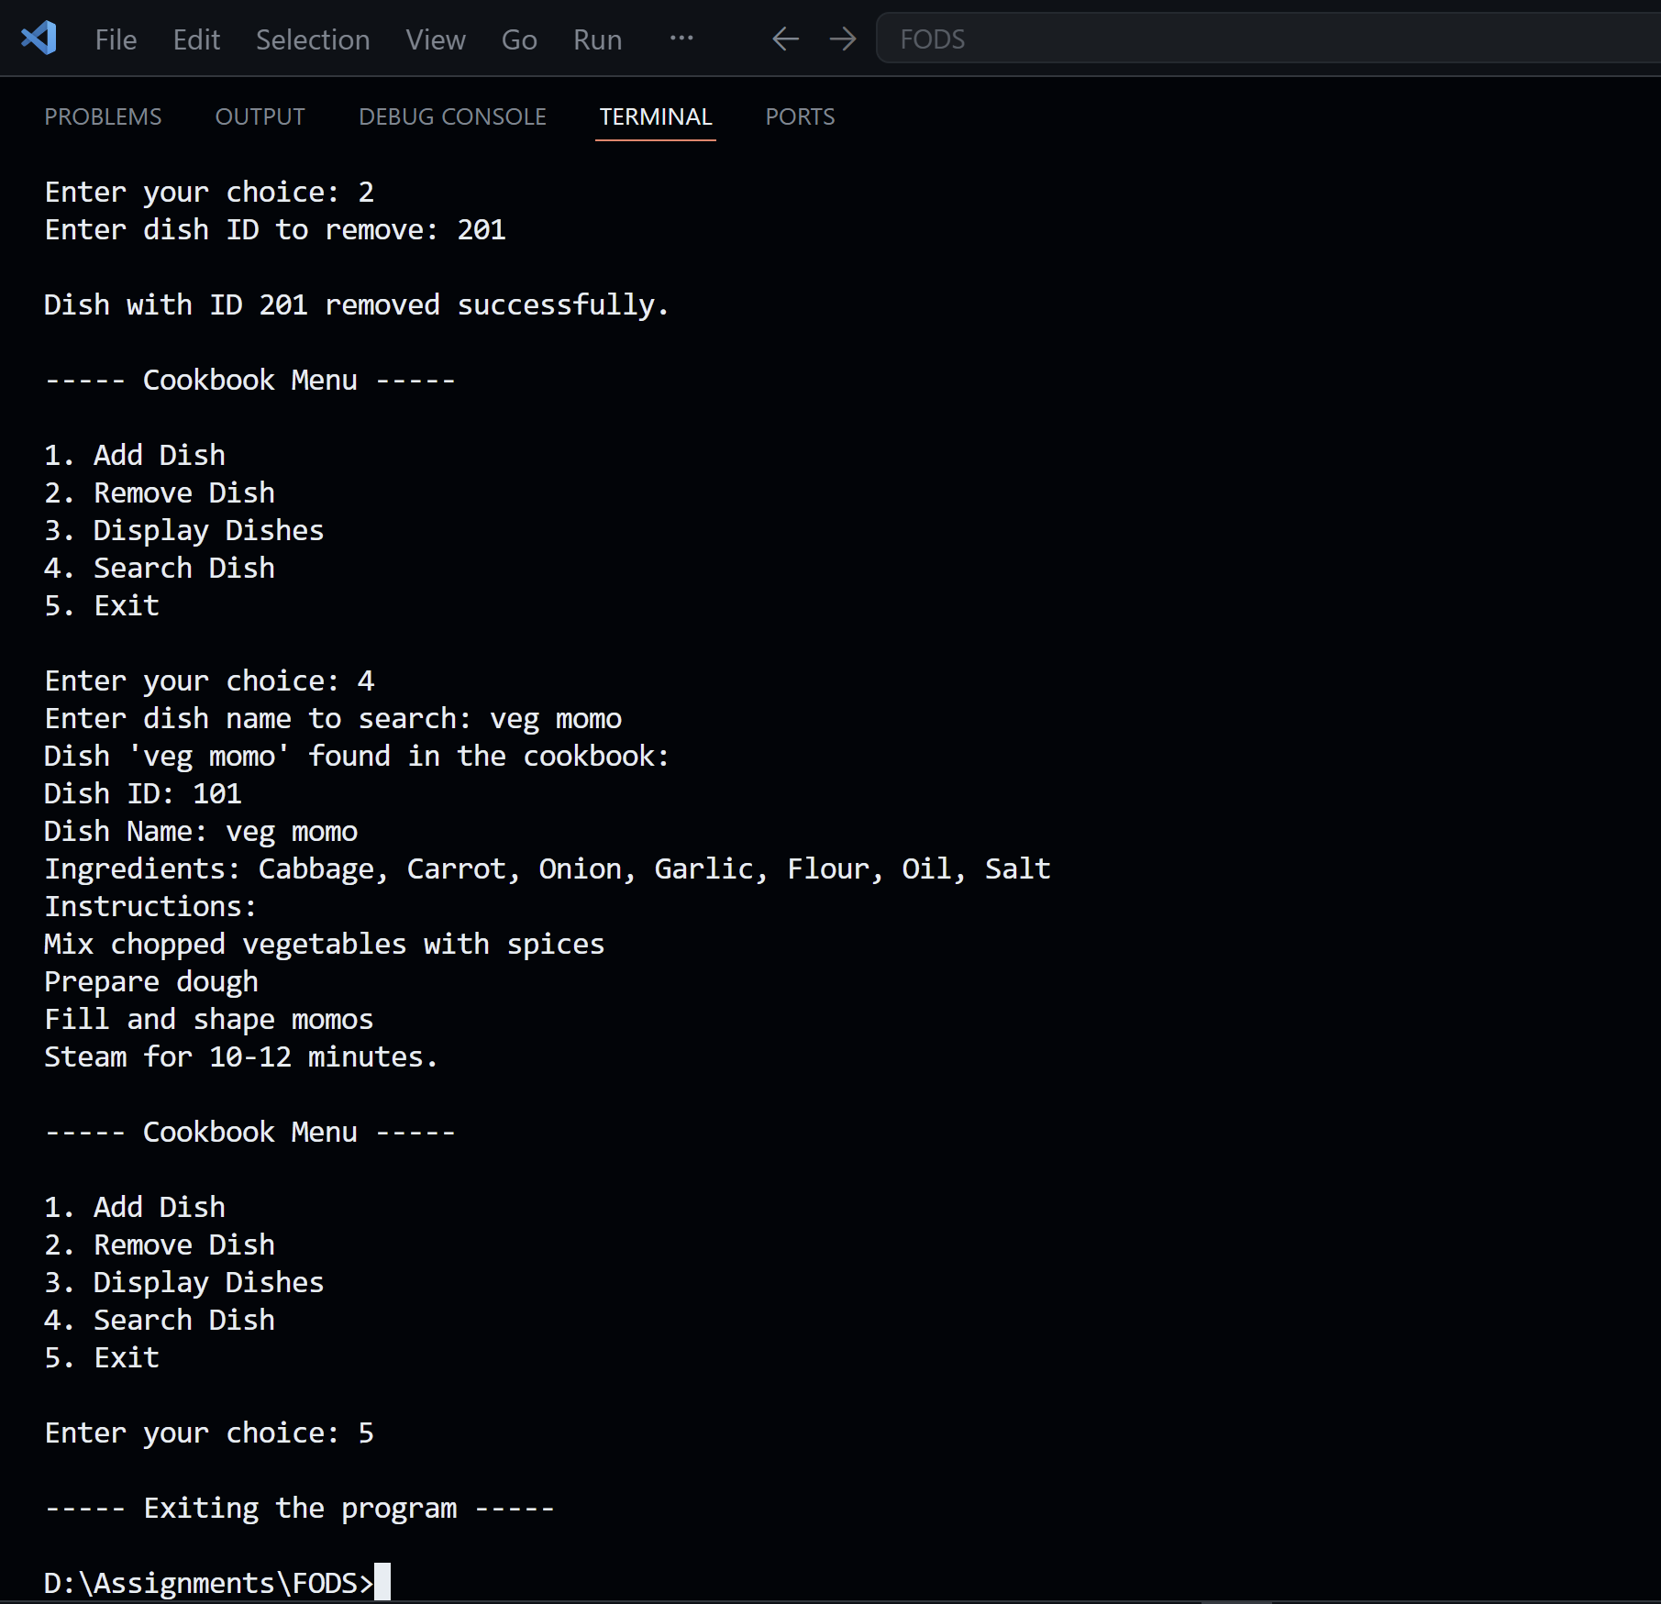

Question 7: Staff Management System
Program Description
This program defines a Staff class with seven attributes: emp_id, full_name, address, phone_number, marital_status, dependents and salary. The program allows the user to add multiple staff members and save their data to a CSV file called staff.csv. It also lets the user view the saved records. All operations include proper error handling.
Logic and Approach
The Staff class uses encapsulation to group all the staff member data together. A to_list() method returns all attributes as a list, which is then passed directly to csv.writer to write each row. This keeps the class responsible for its own data representation.
The add_staff() function runs a while loop that collects input for one staff member at a time. Integer and float conversions for emp_id, dependents and salary are inside a try/except that catches ValueError, so the user gets an error message instead of a crash if they type something invalid. After each entry, the user is asked whether to add another staff member. Once done, all collected entries are written to staff.csv using append mode.
The display_staff() function first checks if the file exists and is not empty before attempting to read it. It uses a general except block to catch any unexpected errors during file reading as well.
The main program runs a while loop with three menu options and routes the user to add or display functions based on their choice.
Key Concepts Used
Class with to_list() method, csv.writer with append mode, ValueError handling for type conversion, os.path.exists and os.path.getsize for file checks, while loop menu, multiple staff entry loop.
Testing and Output
Two staff members were added in one session. The display option was then used to confirm both were saved correctly to staff.csv. An invalid input (text entered for salary) was also tested to verify error handling.
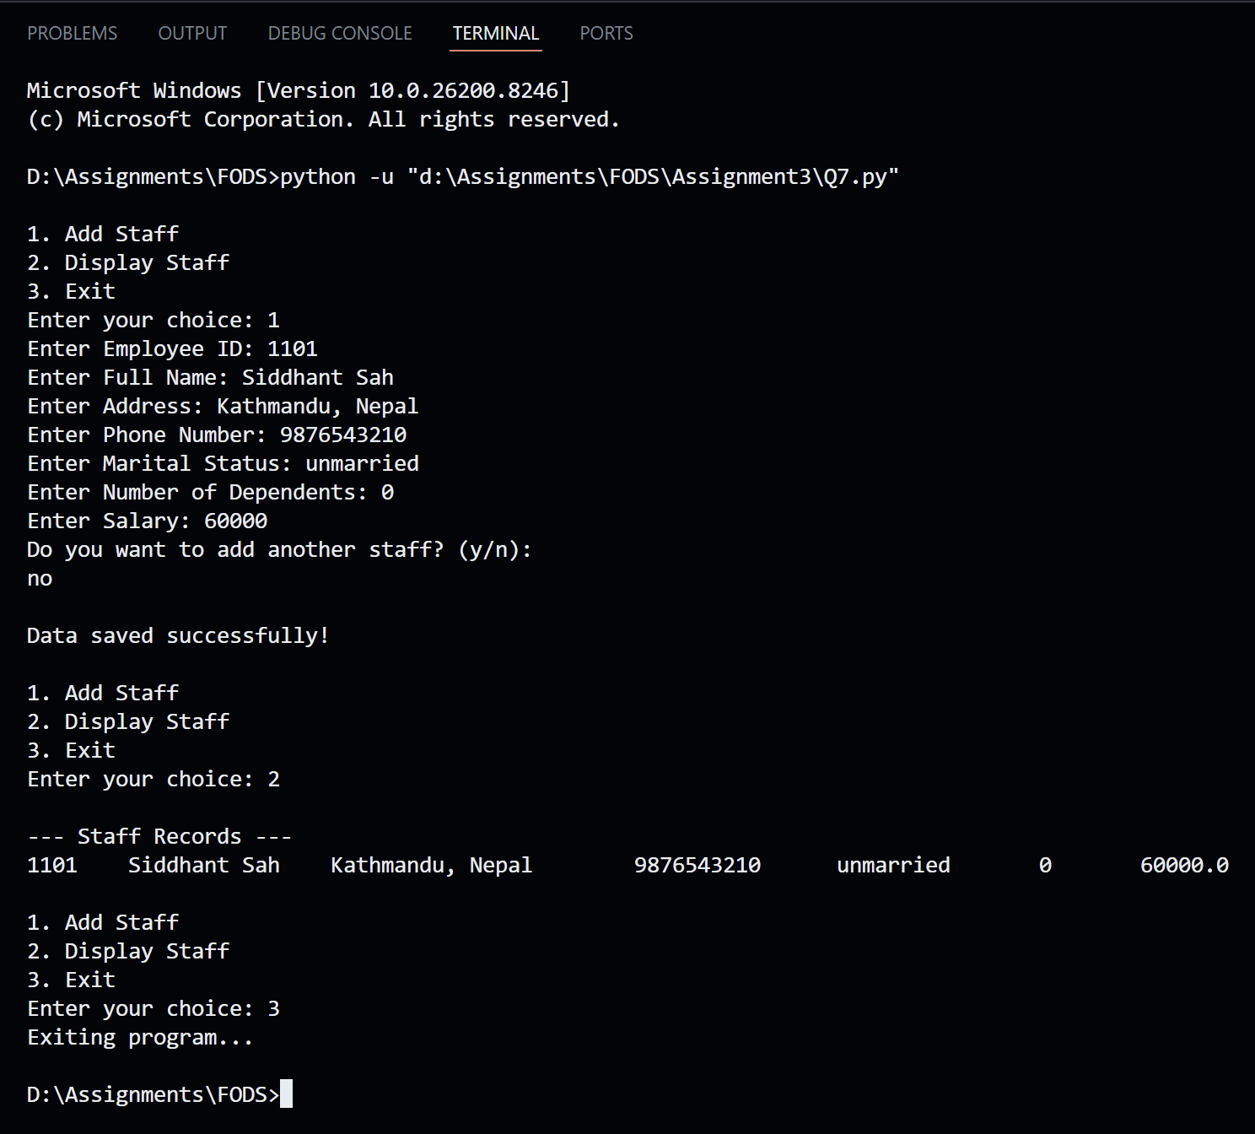
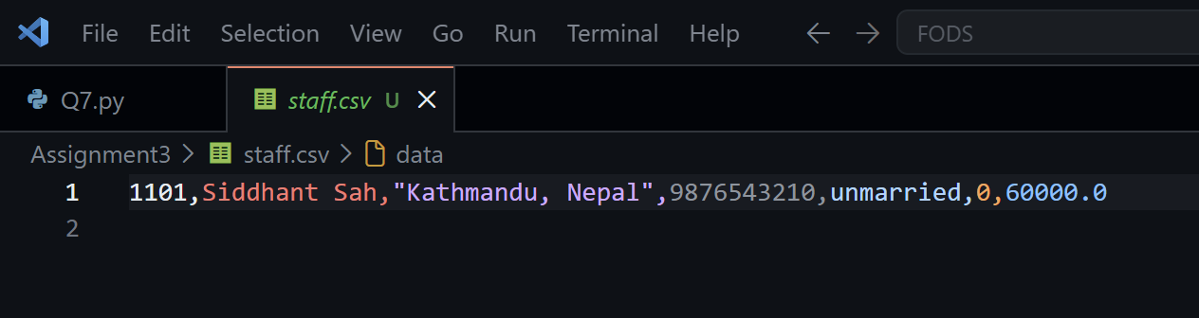

Question 8: Library Management System
Program Description
This program is a basic library management system. It allows the user to add books, display all books, search for a book, borrow a book and return a book. The system uses two classes and stores all book data in a CSV file called library.csv. OOP concepts including encapsulation are applied throughout.
Logic and Approach
The Book class uses private attributes (with double underscore prefix) to implement encapsulation. Attributes like __book_id, __title, __author, __genre and __status cannot be accessed directly from outside the class. The to_list() method provides a controlled way to retrieve the data for writing to the CSV file.
The Library class handles all file operations and is responsible for managing the collection. Each method opens the file, performs its operation and closes it. The add_book() method checks for duplicate book IDs within the current session. The display_books() method checks if the file is empty before trying to read. The search_book() method converts each field in every row to lowercase before comparing it to the search term, allowing flexible searches by either book ID or title.
The borrow_book() and return_book() methods both read the entire file into memory first, modify the status of the matching row, and then rewrite the entire file. This is necessary because CSV files cannot be partially updated in place. A check is done in each method to avoid borrowing an already borrowed book or returning a book that was never borrowed.
A while loop with a six-option menu controls the main flow of the program.
Key Concepts Used
Encapsulation with private attributes, two-class design (Book and Library), csv read/write with status update, full file rewrite for in-place editing, flexible search using lower(), file existence check before reading, FileNotFoundError and general Exception handling.
Testing and Output
The system was tested through all five operations: adding two books, displaying them, searching by title, borrowing one, and returning it. Edge cases tested include searching for a book that does not exist and attempting to borrow an already borrowed book.
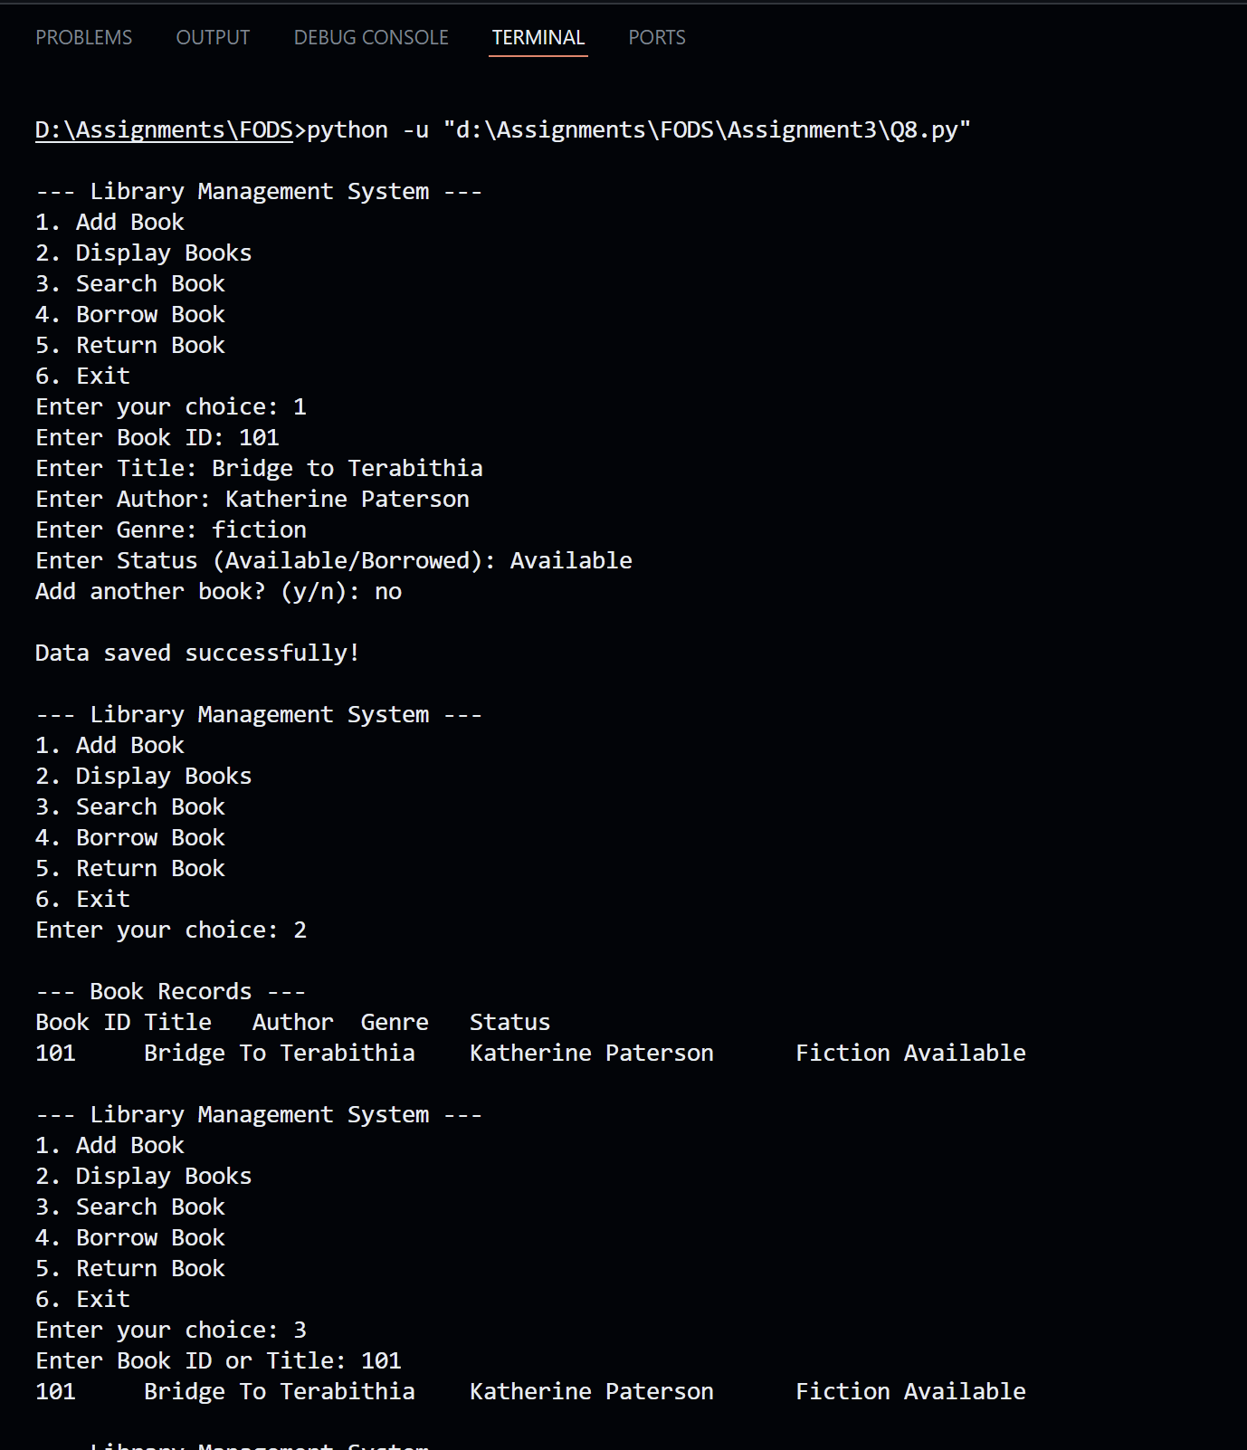
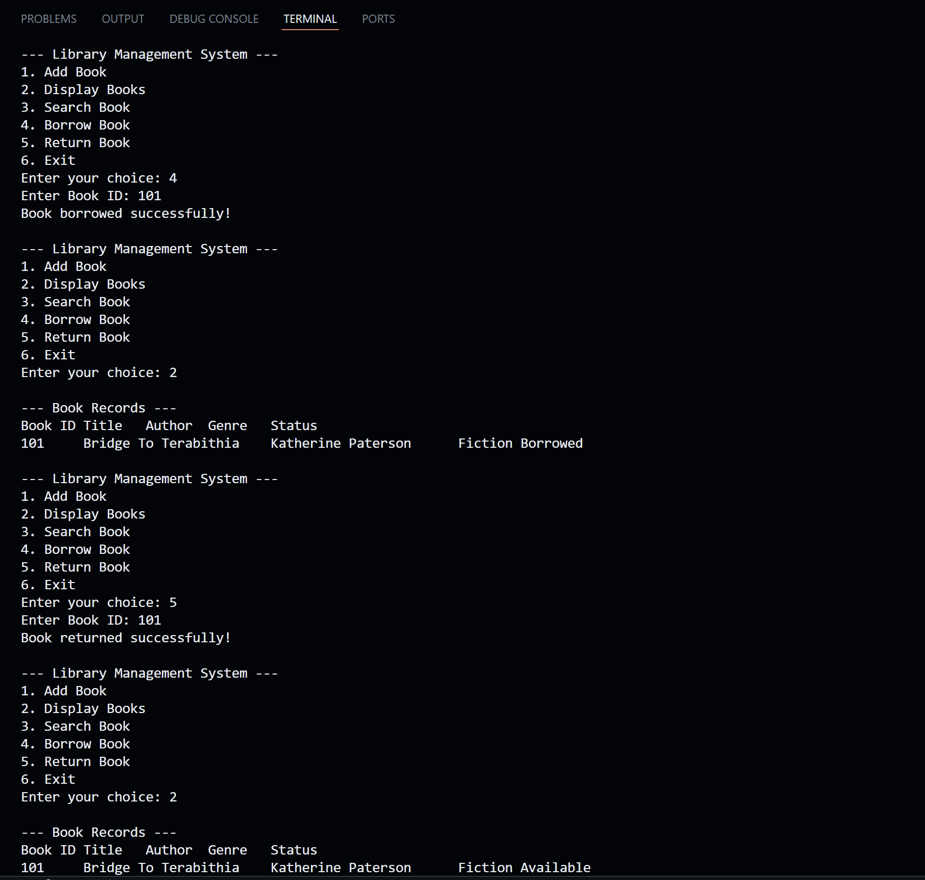
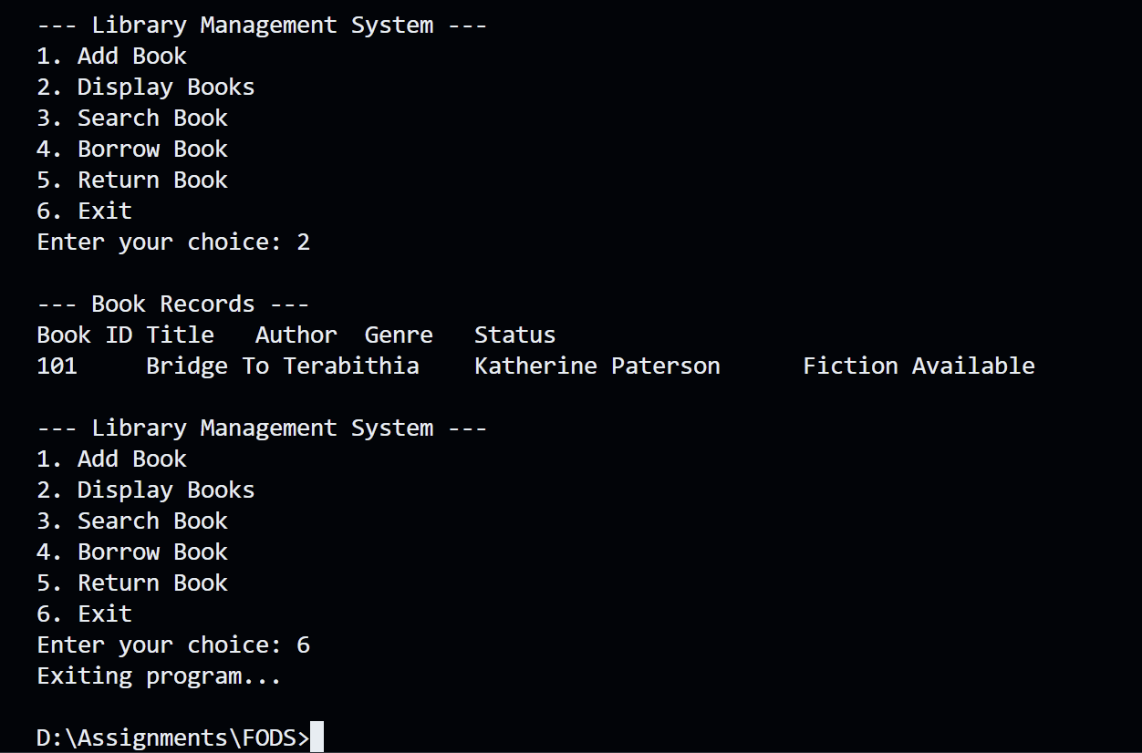

Conclusion
Overall, working through these eight questions gave me a much clearer picture of how Python handles files and objects in practice. Reading and writing CSVs felt simple at first, but getting the path handling right to avoid FileNotFoundError and making sure data does not get overwritten accidentally took more thought than expected. The OOP questions were a step up in complexity, especially once the classes started depending on each other, like in the Cookbook and Library systems where one class had to manage a collection of another.
Error handling was something I had to pay close attention to across almost every question. It was easy to assume the file would exist or the input would be valid, but adding those checks made the programs feel much more complete. The library system in particular pushed me to think about things like private attributes and rewriting entire files just to update one field, which is not something you think about until you actually run into the problem.
Thus, the programs are fairly simple individually, but taken together they cover a good range of real use cases. The skills from this assignment such as file operations and class design are things I expect to keep using in future work.

