**SQL ASSIGNMENT-1**

**PROBLEM STATEMENT 1: - Employee Management System**

Creating Database of Employee Management System:-

Query:- CREATE DATABASE EmployeeManagementSystem;

1. Creating a Table:-

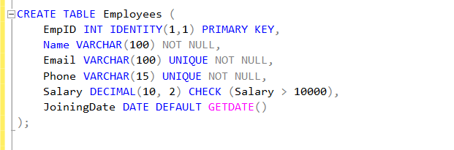

1. Inserting 5 sample Records

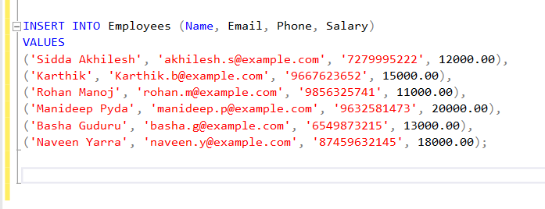

1. Retrieve all employees who joined after 2020.

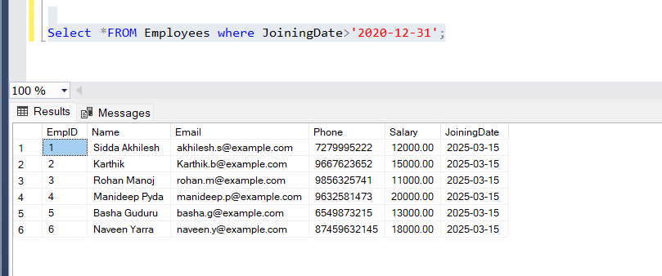

**PROBLEM STATEMENT 2: : Product Inventory System**

Creating a Product Inventory System Database

Query:- create database ProdcutInventorySystem;

1. Creation of Products table

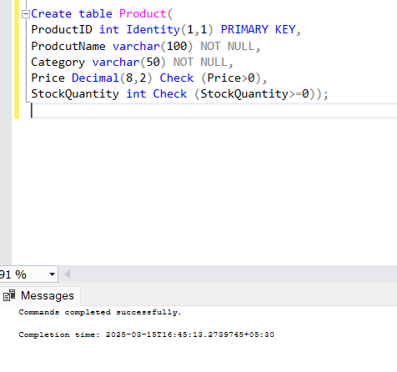

1. Insert at least 10 sample records

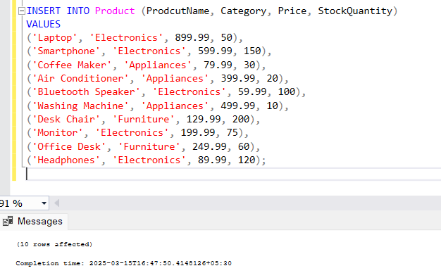

1. Retrieve all products that are out of stock

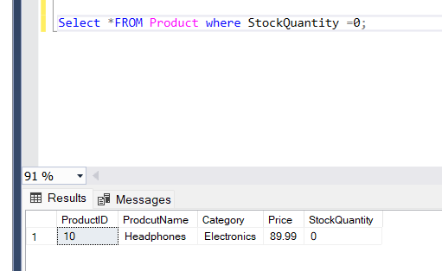

**PROBLEM STATEMENT 3: Student Enrollment System**

1. Create a Table Students

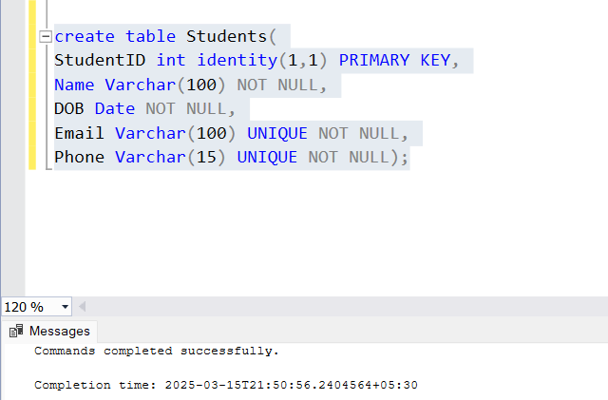

1. Insert 10 Student Records

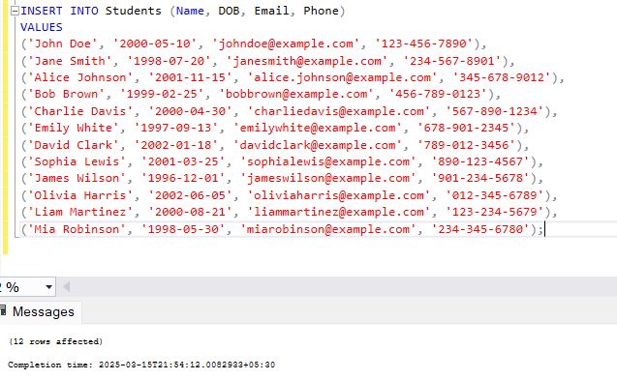

1. Fetch Students who were born before the year 2000.

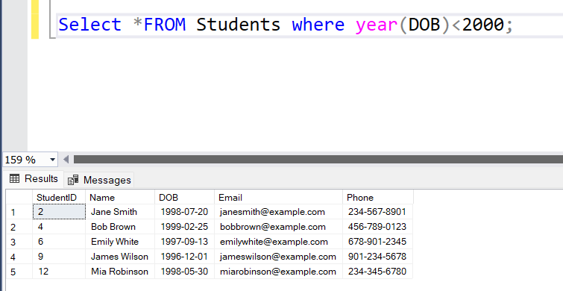

**PROBLEM STATEMENT 4: LIBRARY MANAGEMENT SY**STEM

1.Create Tables

Query to create Books Table:

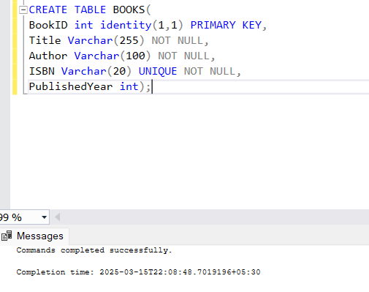

Query to Create Members Table:

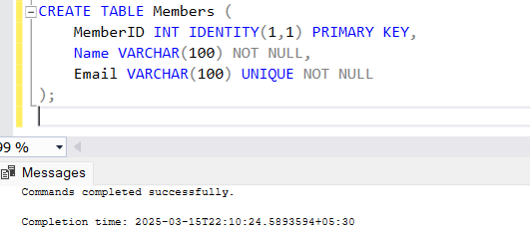

Query to create Issued Books Table:

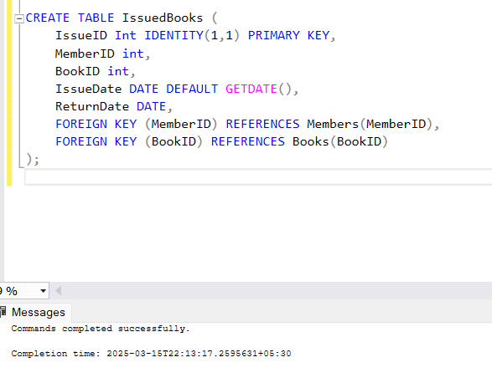

2. INSERT 5 Books, 5 members and 3 Issued Books

Inserting Books:

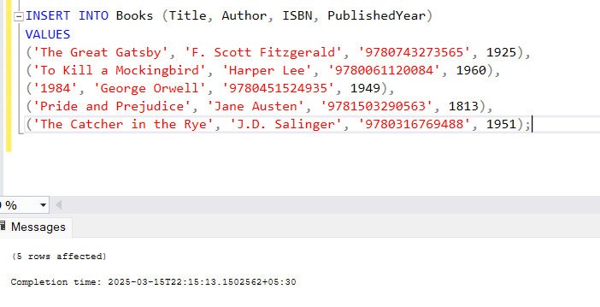

Inserting 5 orders in a table:

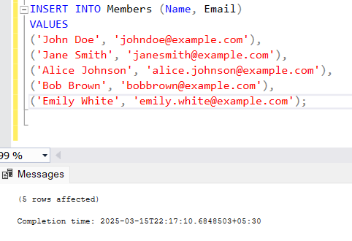

Inserting 3 Issued book details in Issued books Table:

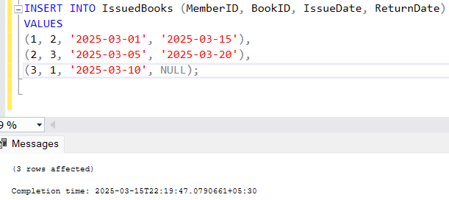

3.Retrieve all Books issued to a specific number:

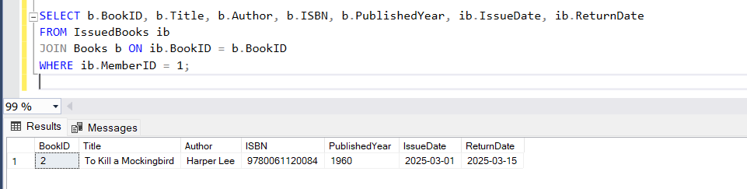

**PROBLEM STATEMENT 5: ONLINE SHOPPING SYSTEM**

1. Creation of tables:

Customers Table:

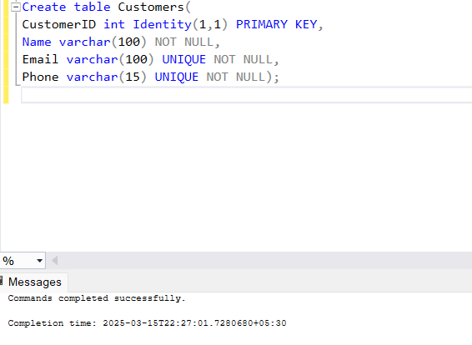

Orders Table:

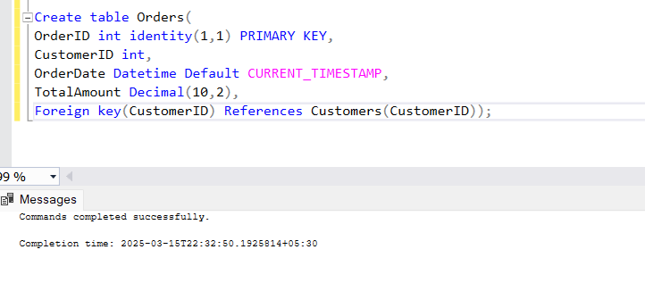

OrderDetails Table:

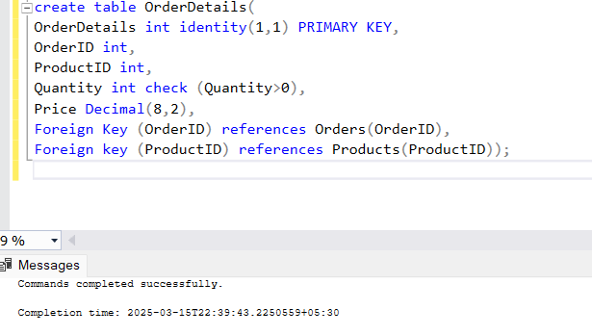

I created a Product Table which contains productid, price and name

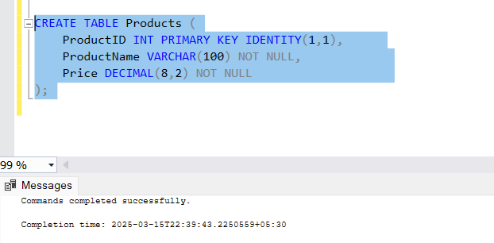

1. Inserting Data into Customers, Orders, OrderDetails and Product Tables

Customers:-

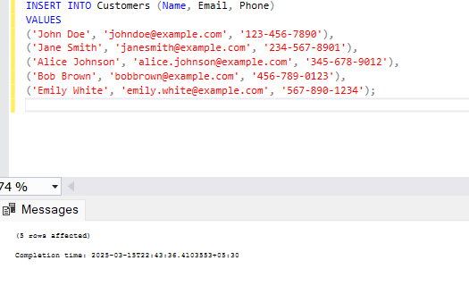

Products:

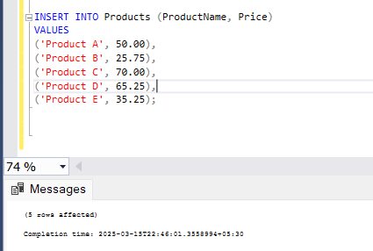

Orders:

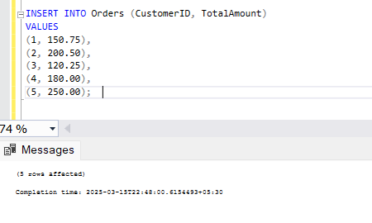

Order Details:

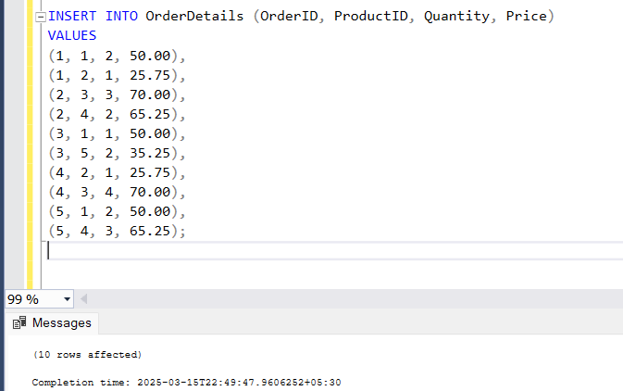

1. Retrieve all order placed by a specific Customer

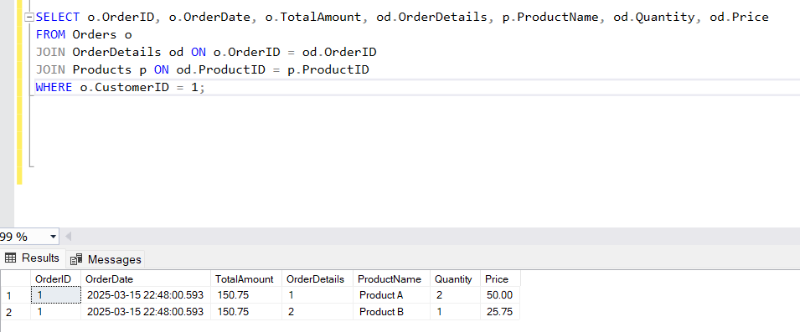

PROBLEM STATEMENT 6: BANK TRANSACTION SYSTEM

1. Creation of Tables

Accounts Table:



Transactions Table:

Remark: I forgot to add TransactionType, Amount, TransactionDate So by using alter table I added these columns to Transactions Table.

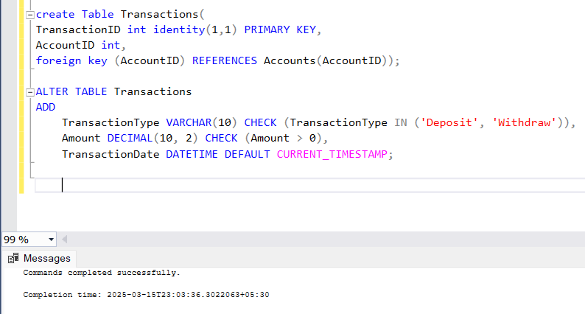

1. Insert 5 accounts and 10 Transactions details in the tables

Accounts:

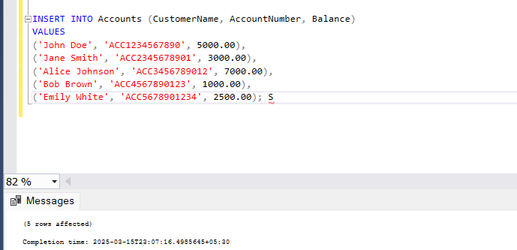

Transactions:

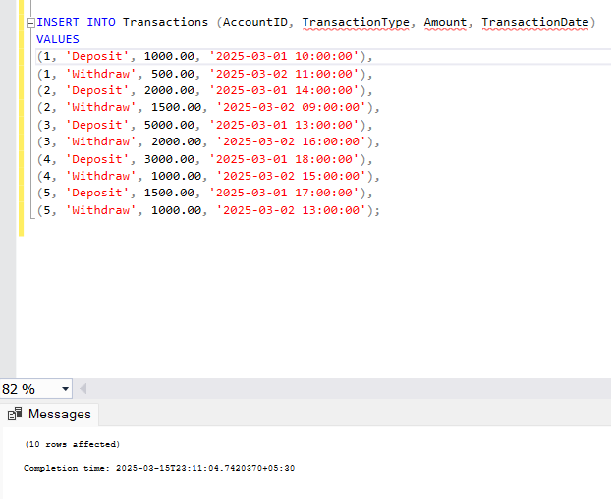

1. Retrieve the total balance available across all accounts

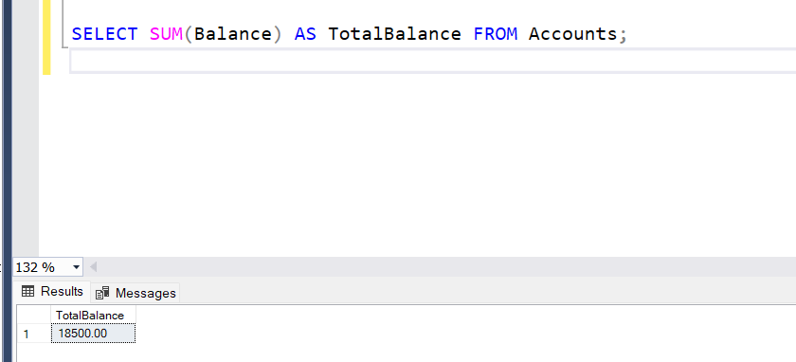

**PROBLEM STATEMENT 7:**

**EMPLOYEE HIERARCHY SYSTEM ( SELF-REFERENCING TABLE)**

1. Create a table Employees Hierarchy where an employee can have a manager

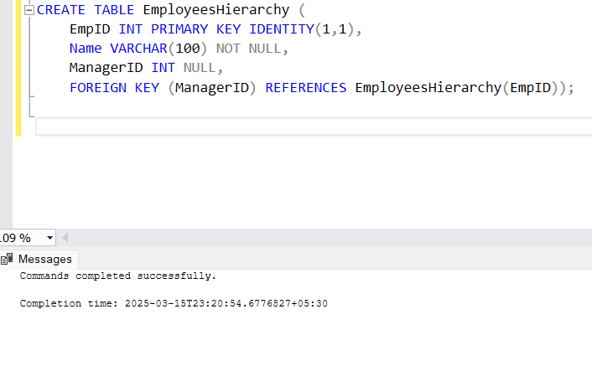

1. Insert at least 10 employees with some having managers

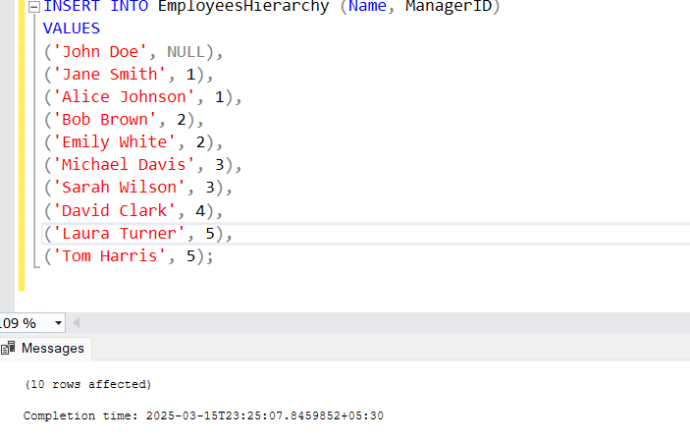

1. Retrieve all employees who reports to a specific manager

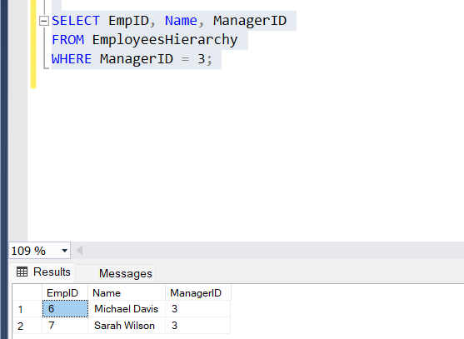

**Problem Statement 8: Partitioning for Large Data Handling**

1. Create a table Sales to store daily sales data:

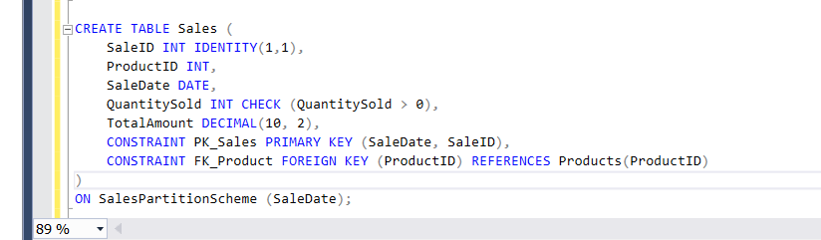

2.Partition the table by SaleDate into:

Sales before 2020, sales between 2020-2023 and sales after 2023

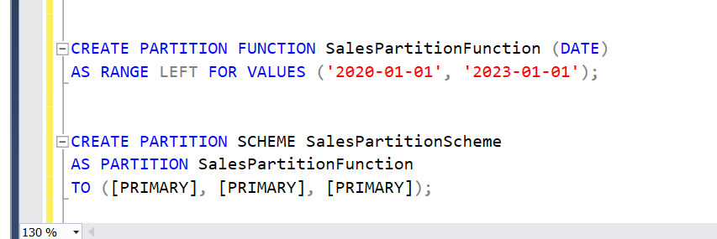

3. Retrieve sales for each partition separately:

Sales before 2020:-

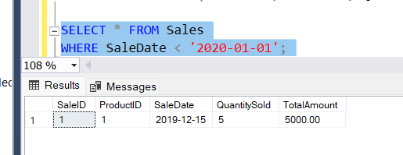

Sales between 2020 – 2023:-

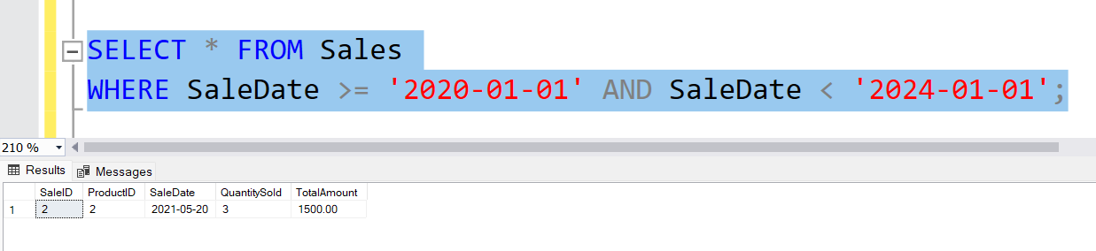Sales after 2023:-

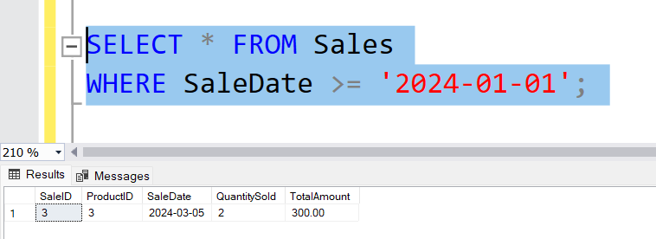

**PROBLEM STATEMENT 9:**

**INDEXING FOR PERFORMANCE IMPROVEMENT**

1. Create indexes on appropriate columns in the employees and Orders tables to improve search speed

Employees Table:-

Taken indexes for Salary column to improve performance while checking the condition

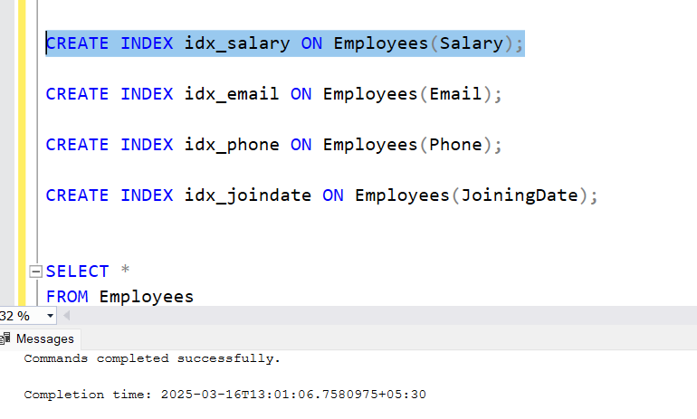

Orders Table:-

Taken indexes for OrderDate column to improve performance while checking the condition.



1. Analyze the performance of the following queries before and after indexing

Employees Analyzing before and after indexing:

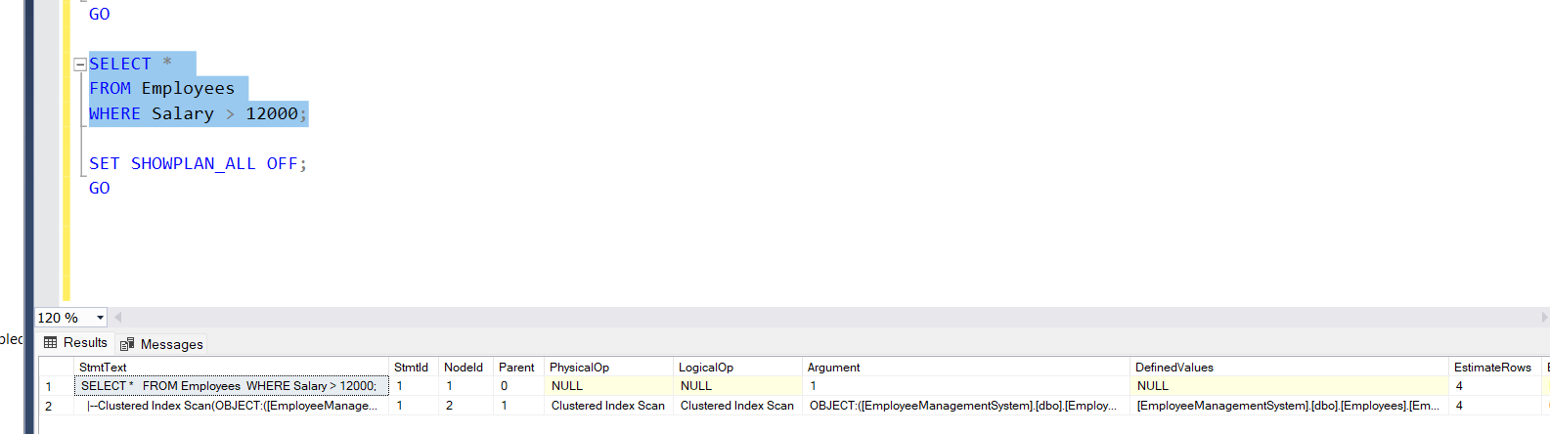

Orders placed before indexing and after indexing:

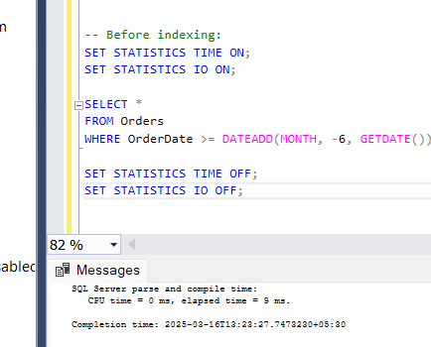

1. Get Employees with salary greater than 12000

(In My data there are no employees who have salary greater than 80000 So I considered 12000 instead of 80000 to analyze)

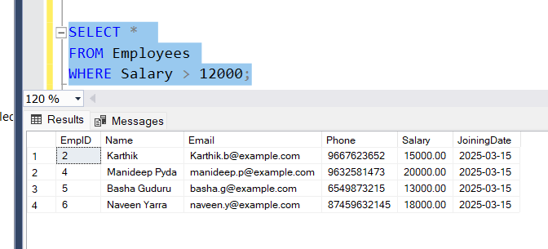

1. Find all orders placed within the last 6 months

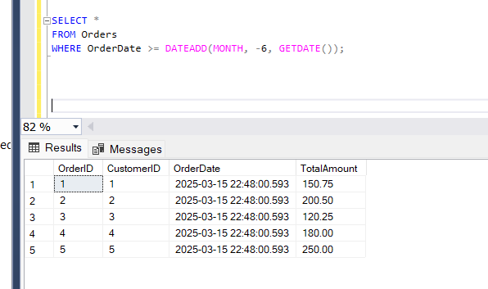

**PROBLEM STATEMENT 10: TRIGGERS FOR DATA CONSTISTENCY**

Using Bank Transaction Database and its tables to create triggers for data constituency.

1. Create a trigger on the Transactions table that prevents withdrawals if the balance is insufficient.

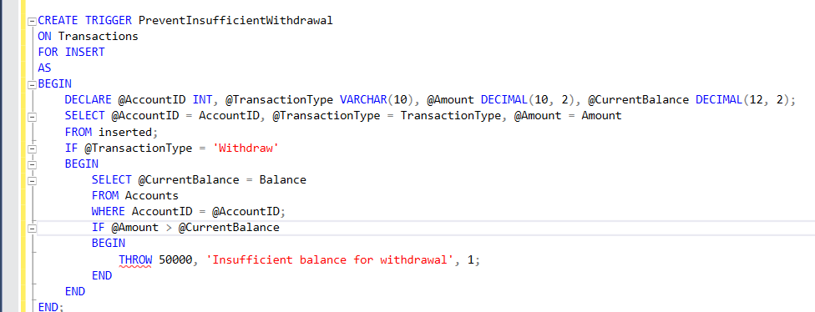

1. Test by attempting a withdrawal greater than the account balance.

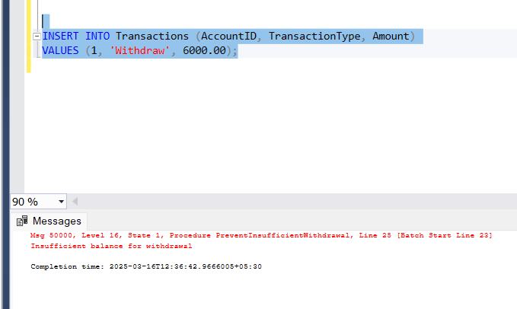

Remark:- Since the balance in John Doe's account is 5000, and we are attempting to withdraw 6000, the trigger you created will be fired. This error message is raised by the THROW statement inside the trigger, preventing the transaction from being inserted into the Transactions table.