MongoDb Commands:
cd CollegeDB
db.createCollection(“Students”)
CRUD Opeartions:
1)Create Data:
Java Code:
import com.mongodb.client.*;
import com.mongodb.client.model.Filters;
import com.mongodb.client.model.Updates;
import org.bson.Document;
public class MongoDB_CRUD {
public static void main(String[] args) {
// Connect to MongoDB
MongoClient mongoClient = MongoClients.create("mongodb://localhost:27017");
// Access database
MongoDatabase database = mongoClient.getDatabase("CollegeDB");
// Access collection
MongoCollection<Document> collection = database.getCollection("Students");
//Create Data
Document student = new Document("id", 101).append("name", "John").append("department", "CSE").append("cgpa", 8.7);
collection.insertOne(student);
System.out.println("Document Inserted Successfully");
}
}
Output:
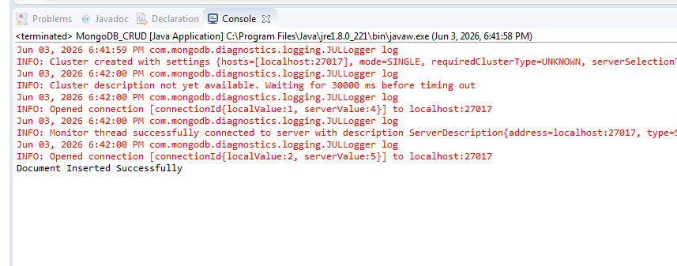

2)Read Data:
Java Code:
import com.mongodb.client.*;
import com.mongodb.client.model.Filters;
import com.mongodb.client.model.Updates;
import org.bson.Document;
public class MongoDB_CRUD {
public static void main(String[] args) {
// Connect to MongoDB
MongoClient mongoClient = MongoClients.create("mongodb://localhost:27017");
// Access database
MongoDatabase database = mongoClient.getDatabase("CollegeDB");
// Access collection
MongoCollection<Document> collection = database.getCollection("Students");
//Read Data
System.out.println("\nStudent Records:");
FindIterable<Document> students = collection.find();
for (Document doc : students) {
System.out.println(doc.toJson());
}
}
}
Output:
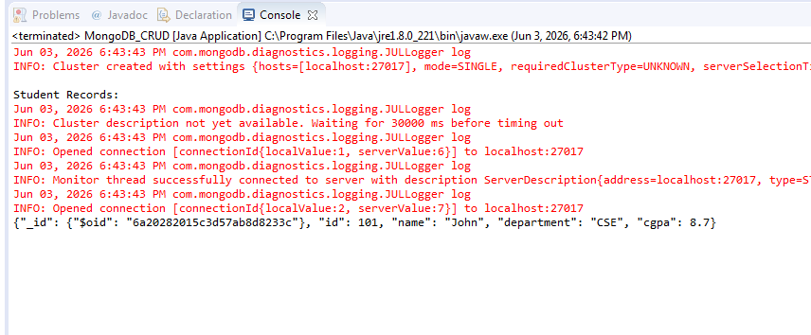

3)Update Data:
Java Code:
import com.mongodb.client.*;
import com.mongodb.client.model.Filters;
import com.mongodb.client.model.Updates;
import org.bson.Document;
public class MongoDB_CRUD {
public static void main(String[] args) {
// Connect to MongoDB
MongoClient mongoClient = MongoClients.create("mongodb://localhost:27017");
// Access database
MongoDatabase database = mongoClient.getDatabase("CollegeDB");
// Access collection
MongoCollection<Document> collection = database.getCollection("Students");
//Update
collection.updateOne(
Filters.eq("id", 101),
Updates.set("cgpa", 9.2)
);
System.out.println("\nDocument Updated Successfully");
//Reading Updated Data
Document updatedStudent=collection.find(Filters.eq("id", 101)).first();
System.out.println("\nUpdated Record:");
System.out.println(updatedStudent.toJson());
}
}

Output:
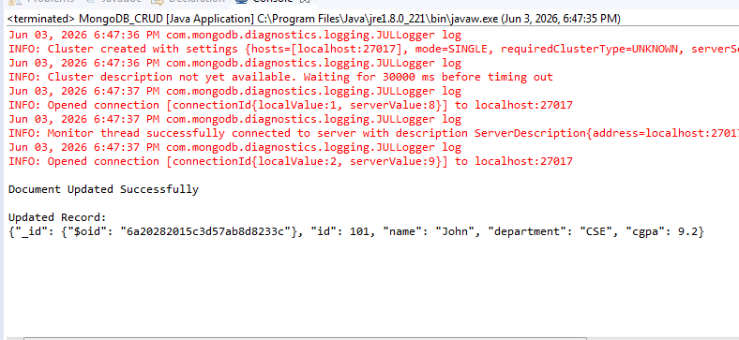

4)Delete Data:
Java Code:
import com.mongodb.client.*;
import com.mongodb.client.model.Filters;
import com.mongodb.client.model.Updates;
import org.bson.Document;
public class MongoDB_CRUD {
public static void main(String[] args) {
// Connect to MongoDB
MongoClient mongoClient = MongoClients.create("mongodb://localhost:27017");
// Access database
MongoDatabase database = mongoClient.getDatabase("CollegeDB");
// Access collection
MongoCollection<Document> collection = database.getCollection("Students");
//Delete
collection.deleteOne(Filters.eq("id", 101));
System.out.println("\nDocument Deleted Successfully");
// Close connection
mongoClient.close();
}
}

Output:
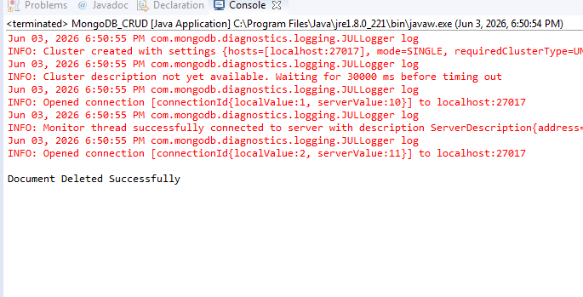

5)Multiple Records:
JavaCode:
import com.mongodb.client.*;
import com.mongodb.client.model.Filters;
import com.mongodb.client.model.Updates;
import org.bson.Document;
public class MongoDB_CRUD {
public static void main(String[] args) {
// Connect to MongoDB
MongoClient mongoClient = MongoClients.create("mongodb://localhost:27017");
// Access database
MongoDatabase database = mongoClient.getDatabase("CollegeDB");
// Access collection
MongoCollection<Document> collection = database.getCollection("Students");
//Create
collection.insertMany(java.util.Arrays.asList(
new Document("id", 1).append("name", "Alice"),
new Document("id", 2).append("name", "Bob"),
new Document("id", 3).append("name", "Charlie")
));
//Reading Specific Document
Document doc = collection.find(Filters.eq("id", 2)).first();
System.out.println(doc.toJson());
//Updating Data
collection.updateOne( Filters.eq("id", 2), Updates.set("name", "Bobby") );
System.out.println("Updated Successfully");
//Deleting Data
collection.deleteOne(Filters.eq("id", 2));
System.out.println("Deleted Successfully");
//Reading Final Data
FindIterable<Document> students = collection.find();
for (Document x : students) {
System.out.println(x.toJson());
}
}
}

Output:
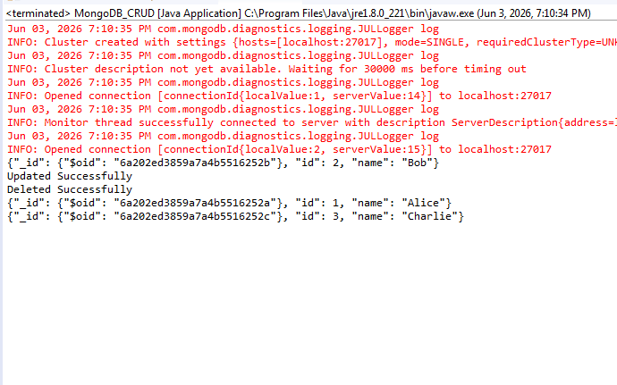
6)CRUD Operations with MANY:
JavaCode:
import com.mongodb.client.*;
import com.mongodb.client.model.Filters;
import com.mongodb.client.model.Updates;
import org.bson.Document;
public class MongoDB_CRUD {
public static void main(String[] args) {
// Connect to MongoDB
MongoClient mongoClient = MongoClients.create("mongodb://localhost:27017");
// Access database
MongoDatabase database = mongoClient.getDatabase("CollegeDB");
// Access collection
MongoCollection<Document> collection = database.getCollection("Students");
//Create
collection.insertMany(java.util.Arrays.asList(
new Document("id", 1).append("name", "Alice"),
new Document("id", 2).append("name", "Bob"),
new Document("id", 3).append("name", "Charlie")
));
System.out.println("Data Inserted Successfully");
//Reading Specific Document
System.out.println("Reading Data");
FindIterable<Document> students = collection.find();
for (Document doc : students) {
System.out.println(doc.toJson());
}
//Updating Data
collection.updateMany( Filters.in("id",1,2), Updates.set("name", "Bobby") );
System.out.println("Updated Successfully,UpdatedData:");
//Reading After Updating
students = collection.find();
for (Document x : students) {
System.out.println(x.toJson());
}
//Deleting Data
collection.deleteMany(Filters.in("id",2,3));
System.out.println("Deleted Successfully,Data After Deleting:");
//Reading After Deleting
students = collection.find();
for (Document x : students) {
System.out.println(x.toJson());
}
}
}

Output:
