|  |  |  |  |  |  |  |  |  |  |
| --- | --- | --- | --- | --- | --- | --- | --- | --- | --- |
| **SCHOOL OF COMPUTER SCIENCE AND ARTIFICIAL INTELLIGENCE** | | | | | **DEPARTMENT OF COMPUTER SCIENCE ENGINEERING** | | | | |
| **ProgramName:**B. Tech | | | | **Assignment Type: Lab** | | | **AcademicYear:**2025-2026 | | |
| **CourseCoordinatorName** | | | | Venkataramana Veeramsetty | | | | | |
| **Instructor(s)Name** | | | | |  | | --- | | Dr. V. Venkataramana (Co-ordinator) | | Dr. T. Sampath Kumar | | Dr. Pramoda Patro | | Dr. Brij Kishor Tiwari | | Dr.J.Ravichander | | Dr. Mohammand Ali Shaik | | Dr. Anirodh Kumar | | Mr. S.Naresh Kumar | | Dr. RAJESH VELPULA | | Mr. Kundhan Kumar | | Ms. Ch.Rajitha | | Mr. M Prakash | | Mr. B.Raju | | Intern 1 (Dharma teja) | | Intern 2 (Sai Prasad) | | Intern 3 (Sowmya) | | NS_2 ( Mounika) | | | | | | |
| **CourseCode** | | | 24CS002PC215 | **CourseTitle** | | AI Assisted Coding | | | |
| **Year/Sem** | | | II/I | **Regulation** | | R24 | | | |
| **Date and Day**  **of Assignment** | | | Week3 - Thursday | **Time(s)** | |  | | | |
| **Duration** | | | 2 Hours | **Applicableto**  **Batches** | |  | | | |
| **AssignmentNumber:5.4**(Present assignment number)/**24**(Total number of assignments) | | | | | | | | | |
|  | | | | | | | | | |
|  | **Q.No.** | **Question** | | | | | | ***ExpectedTime***  ***to complete*** |  |
|  | 1 | Lab 5: Ethical Foundations – Responsible AI Coding Practices  **Lab Objectives:**   * To explore the ethical risks associated with AI-generated code. * To recognize issues related to security, bias, transparency, and copyright. * To reflect on the responsibilities of developers when using AI tools in software development. * To promote awareness of best practices for responsible and ethical AI coding.   **Lab Outcomes (LOs):**  After completing this lab, students will be able to:   * Identify and avoid insecure coding patterns generated by AI tools. * Detect and analyze potential bias or discriminatory logic in AI-generated outputs. * Evaluate originality and licensing concerns in reused AI-generated code. * Understand the importance of explainability and transparency in AI-assisted programming. * Reflect on accountability and the human role in ethical AI coding practices..   **Task Description #1:**  **•** Prompt GitHub Copilot to generate a Python script that collects user data (e.g., name, age, email). Then, ask Copilot to add comments on how to anonymize or protect this data.  **Expected Output #1:**  **•** A script with inline Copilot-suggested code and comments explaining how to safeguard or anonymize user information (e.g., hashing emails, not storing data unencrypted).  **Task Description #2:**  **•** Ask Copilot to generate a Python function for sentiment analysis. Then prompt Copilot to identify and handle potential biases in the data.  **Expected Output #2:**  **•** Copilot-generated code with additions or comments addressing bias mitigation strategies (e.g., balancing dataset, removing offensive terms).  **Task Description #3:**  **•** Use Copilot to write a Python program that recommends products based on user history. Ask it to follow ethical guidelines like transparency and fairness.  **Expected Output #3:**  **•** Copilot suggestions that include explanations, fairness checks (e.g., avoiding favoritism), and user feedback options in the code.  **Task Description #4:**  • Prompt Copilot to generate logging functionality in a Python web application. Then, ask it to ensure the logs do not record sensitive information.  **Expected Output #4:**  • Logging code that avoids saving personal identifiers (e.g., passwords, emails), and includes comments about ethical logging practices.  **Task Description #5:**  **•** Ask Copilot to generate a machine learning model. Then, prompt it to add documentation on how to use the model responsibly (e.g., explainability, accuracy limits).  **Expected Output #5:**  **•** Copilot-generated model code with a README or inline documentation suggesting responsible usage, limitations, and fairness considerations.  **Note: Report should be submitted a word document for all tasks in a single document with prompts, comments & code explanation, and output and if required, screenshots**  **Evaluation Criteria:**   |  |  | | --- | --- | | **Criteria** | **Max Marks** | | How to anonymize or protect this data | 0.5 | | Identify and handle potential biases in the data. | 0.5 | | Follow ethical guidelines like transparency and fairness. | 0.5 | | logs do not record sensitive information. | 0.5 | | How to use the model responsibly | 0.5 | | **Total** | **2.5 Marks** | | | | | | | Week3 - Thursday |  |

**Task Description #1:**

**•** Prompt GitHub Copilot to generate a Python script that collects user data (e.g., name, age, email). Then, ask Copilot to add comments on how to anonymize or protect this data.

**Expected Output #1:**

**•** A script with inline Copilot-suggested code and comments explaining how to safeguard or anonymize user information (e.g., hashing emails, not storing data unencrypted).

PROMPT:

Write a Python script that collects user data like name, age, and email. After the code, add comments on how to protect or anonymize the data

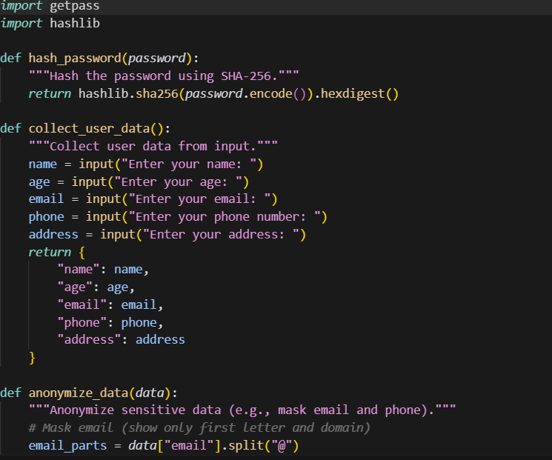

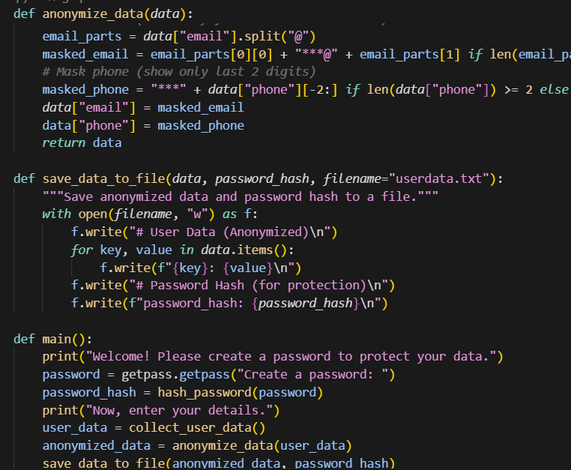

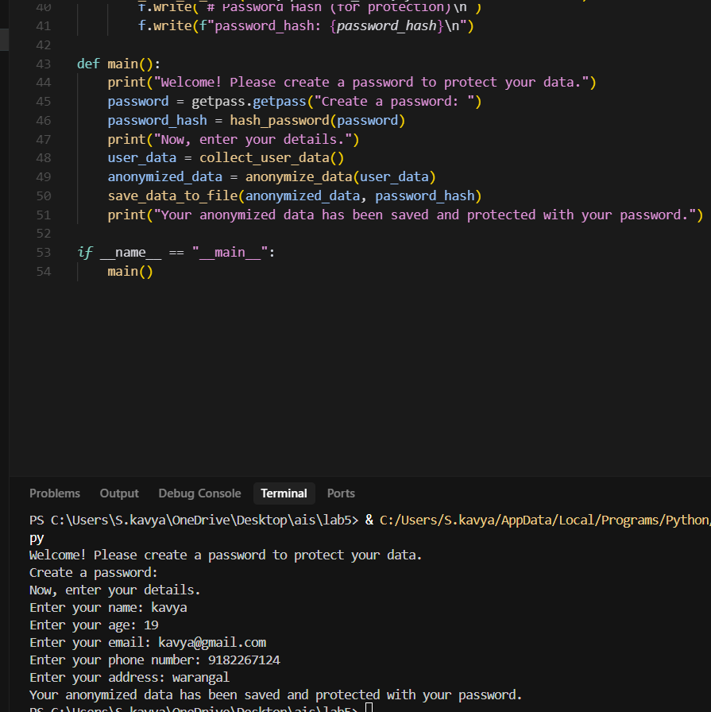

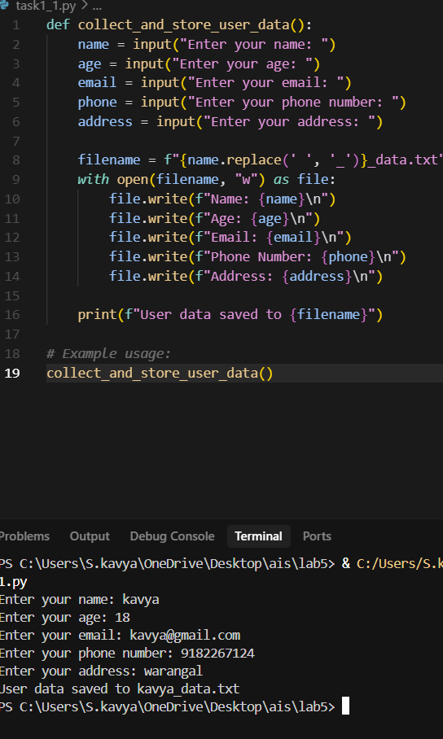

**Task Description #2:**

**•** Ask Copilot to generate a Python function for sentiment analysis. Then prompt Copilot to identify and handle potential biases in the data.

**Expected Output #2:**

**•** Copilot-generated code with additions or comments addressing bias mitigation strategies (e.g., balancing dataset, removing offensive terms).

Prompt:

Make a Python function for sentiment analysis. After the code, add comments about bias in the data (like unbalanced samples or offensive words) and how to fix it.

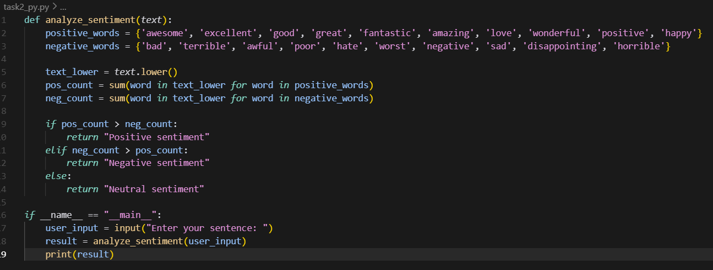

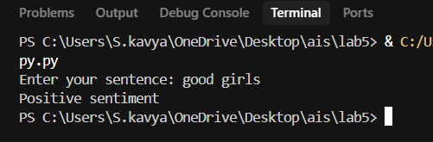

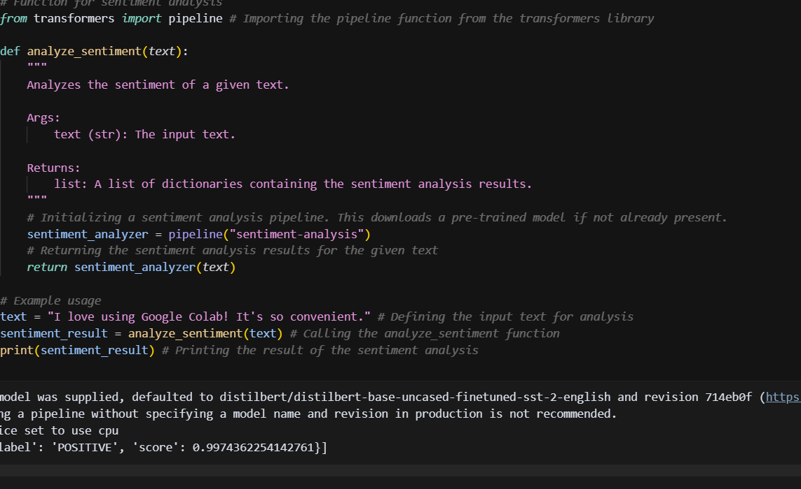

**Task Description #3:**

**•** Use Copilot to write a Python program that recommends products based on user history. Ask it to follow ethical guidelines like transparency and fairness.

**Expected Output #3:**

**•** Copilot suggestions that include explanations, fairness checks (e.g., avoiding favoritism), and user feedback options in the code.

Prompt:

Write a Python program that recommends products based on user history. Add comments or code that explain ethical guidelines like transparency, fairness (avoid favoritism), and give users an option to give feedback on recommendations.

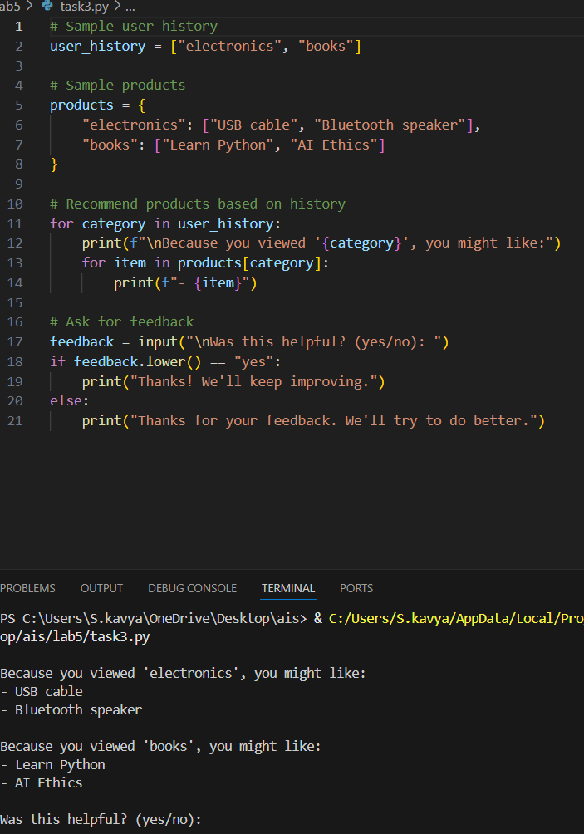

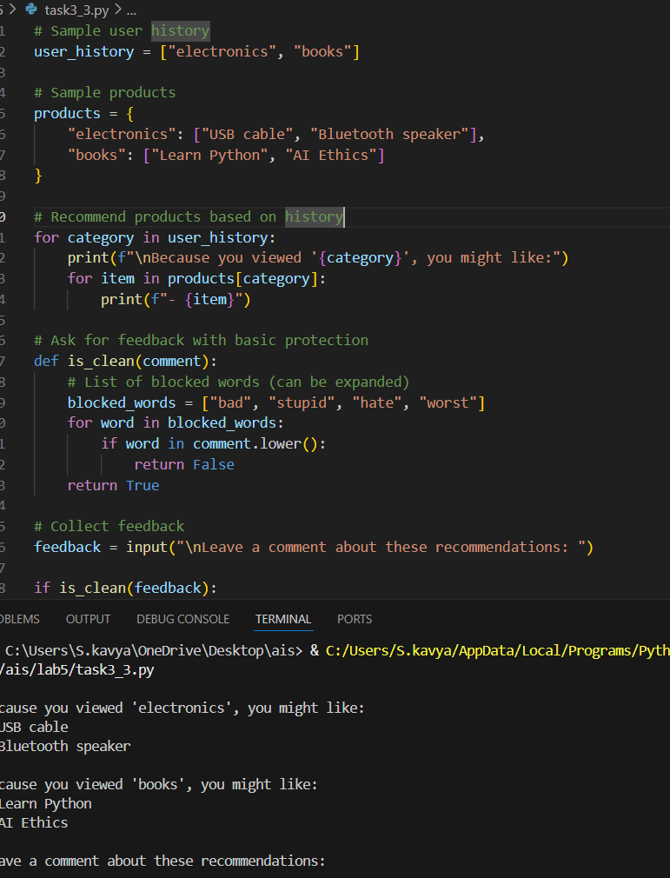

**Task Description #4:**

• Prompt Copilot to generate logging functionality in a Python web application. Then, ask it to ensure the logs do not record sensitive information.

**Expected Output #4:**

• Logging code that avoids saving personal identifiers (e.g., passwords, emails), and includes comments about ethical logging practices.

Prompt:

Write logging functionality for a Python web application. Make sure the logs do not record sensitive information like passwords, emails, or personal identifiers. Add comments explaining ethical logging practices.

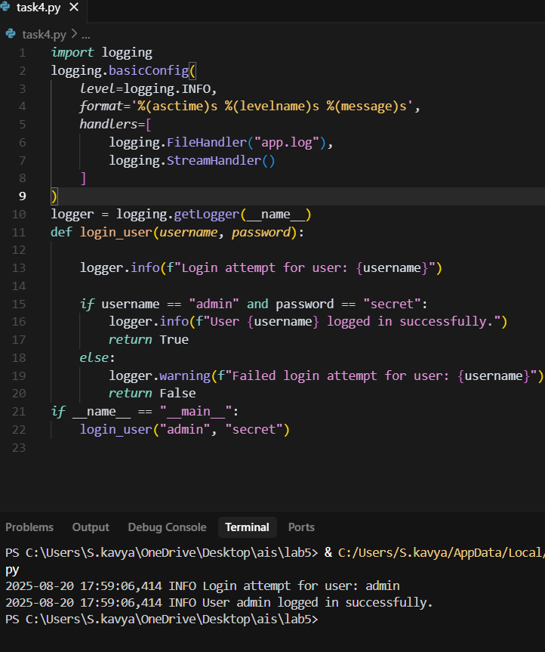

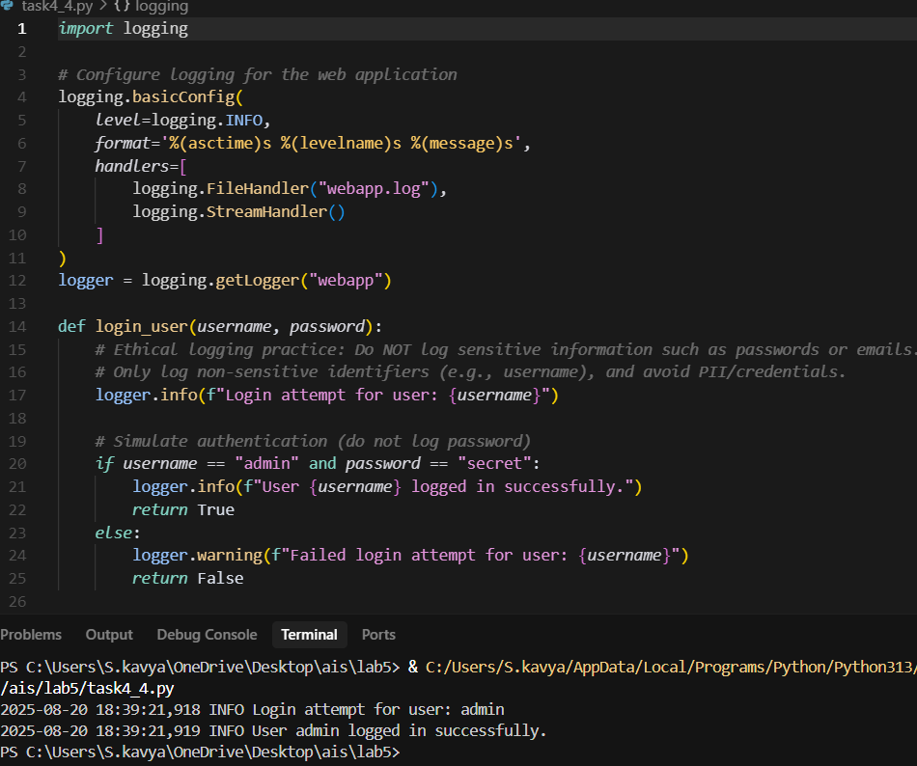

**Task Description #5:**

**•** Ask Copilot to generate a machine learning model. Then, prompt it to add documentation on how to use the model responsibly (e.g., explainability, accuracy limits).

**Expected Output #5:**

**•** Copilot-generated model code with a README or inline documentation suggesting responsible usage, limitations, and fairness considerations.

Prompt: Make a simple machine learning model in Python. After the code, add notes on how to use it responsibly, what its limits are, and fairness issues like bias.

